Examples:

code:
counter = 100 # An integer assignment
miles = 1000.0 # A floating point
name = "John" # A string
print (counter)
print (miles)
print (name)
a = b = c = 1
a, b, c = 1, 2, "john"
a=5
b=4.56
print(5*a)
print(a/2)
print(a**2)
str = 'Hello World!'
print (str) # Prints complete string
print (str[0]) # Prints first character of the string
print (str[2:5]) # Prints characters starting from 3rd to 5th
print (str[2:]) # Prints string starting from 3rd character
print (str * 2) # Prints string two times
print (str + "TEST") # Prints concatenated string

output:
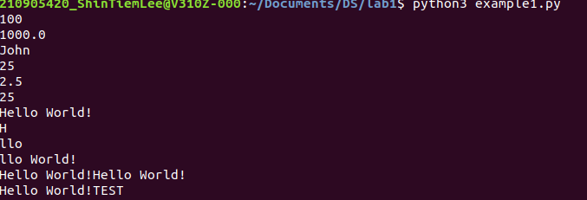

var1 = 'Hello World!'
print ("Updated String :", var1[:6] + 'Python')
print( "My name is %s and weight is %d kg!" % ('Abay', 55))
str = "this is string example wow!!!"
print (str.capitalize())
str = "this is string example ... wow!!!"
str.count( ‘s’)
Str.find(‘example’)
str = "THIS IS STRING EXAMPLE ... WOW!!!"
print (str.lower())
this is string example... wow!!!
str = "this is string example ... wow!!! this is really string"
print (str.replace("is", "was"))
str = "this is string example ... wow!!!"
print (str.swapcase())
str = "this is string example ... wow!!!"
print (str.title())

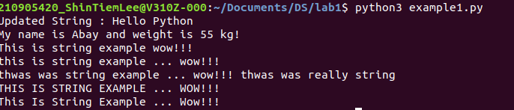
List:

list = ['physics', 'chemistry', 1997, 2000]
list.append('maths')
print(list)
del list[2] #will remove 1997 record from the list.
print(list)
print('physics' in list)
print('english' in list)
print(len(list)) # will return total items in list
print(list.count('physics'))
list = ['physics', 'chemistry', 1997, 2000]
list.pop()
print(list)
list = ['physics', 'chemistry', 1997, 2000]
list.insert (2, 'maths')
print(list)
list = ['physics', 'chemistry', 1997, 2000]
list.remove('chemistry')
print(list)
list = ['physics', 'chemistry', 1997, 2000]
list.reverse()
print(list)
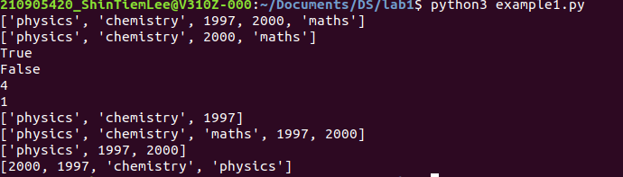
Tuples:

tuple = ( 'abcd', 786 , 2.23, 'john', 70.2 )
list = [ 'abcd', 786 , 2.23, 'john', 70.2 ]
tuple[2] = 1000 # Invalid syntax with tuple
list[2] = 1000 # Valid syntax with list

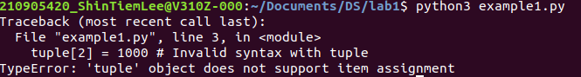

Looping n branching:

num=float(input('Enter a number:'))
if num>0:
print('pos number')
elif num==0:
print('zero')
else:
print('Neg number')

x=float(input('Enter a number:'))
if x<10:
print('smaller')
if x>20:
print('bigger')
print('Finished')

x=5
print('Before 5')
if x==5:
print ('this is 5')
print('still 5')
print('After 5')
print('Before 6')
if x==6:
print('this is 6')
print ('After 6')

x=float(input('Enter a number:'))
if x<20:
print('Below 20')
elif x<10:
print('Below 10')
else:
print('something else')

x=42
if x>1:
print('above one')
if x<100:
print('less than 100')
print('All done')

age=15
b=('kid' if age<18 else 'adult')
print(b)

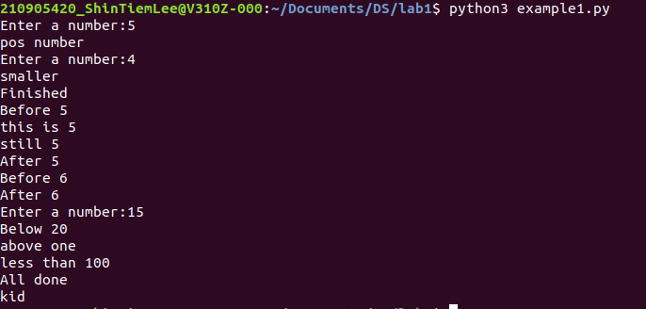

Usage of For-loop

from math import *
import numpy as np
for val in [5,4,3,2,1]:
print(val)
print ('Done')

stud=['Ram','Vijay','Nithya','Anu','Ramesh','suja']
for k in stud:
print('Hello:', k)
print('done')
for i in range(5):
print(i)
if i>2:
print('Bigger than 2')
print('Done with i',i)

x=int(input('Enter a number:'))
for i in range(1,x+1):
if x%i ==0:
print(i)
x=10

x=[9, 41, 12, 3, 74, 15]
largest= -inf
for i in x:
if i>largest:
largest=i
print(largest)

x= [9, 41, 12, 3, 74, 15]
smallest=inf
for i in x:
if i<smallest:
smallest=i
print(smallest)

x= [9, 41, 12, 3, 74, 15]
count=sum=avg=0
for i in x:
count=count+1
sum=sum+i
avg=sum/count
print(count)
print(sum)
print(avg)

x= [9, 41, 12, 3, 74, 15]
for i in x:
if i>20:
print (i)

x= [9, 41, 12, 3, 74, 15]
res=[]
for i in x:
if i>20:
res.append(i)

y=np.zeros(len(x))
for i in range(len(x)):
if x[i]>20:
y[i]=x[i]
print(y)

price = 100
if price > 100:
print("price is greater than 100")
elif price == 100:
print("price is 100")
elif price < 100:
print("price is less than 100")

i = 1
n = 5
# while loop from i = 1 to 5
while i <= n:
print(i)
i = i + 1

total = 0
number = int(input('Enter a number: '))
# add numbers until number is zero
while number != 0:
total += number # total = total + number
# take integer input again
number = int(input('Enter a number: '))
print('total =', total)

