Eg1:
Mapper:

import sys
# input comes from STDIN (standard input)
for line in sys.stdin:
# remove leading and trailing whitespace
line = line.strip()
# split the line into words
words = line.split()
# increase counters
for word in words:
# write the results to STDOUT (standard output);
# what we output here will be the input for the
# Reduce step, i.e. the input for reducer.py
#
# tab-delimited; the trivial word count is 1
print ("%s\t%s" % (word, 1))

reducer:

from operator import itemgetter
import sys
current_word = None
current_count = 0
word = None
# input comes from STDIN
for line in sys.stdin:
# remove leading and trailing whitespace
line = line.strip()
# parse the input we got from mapper.py
word, count = line.split('\t', 1)
# convert count (currently a string) to int
try:
count=int(count)
except ValueError:
# count was not a number, so silently
# ignore/discard this line
continue
# this IF-switch only works because Hadoop sorts map output
# by key (here: word) before it is passed to the reducer
if current_word == word:
current_count += count
else:
if current_word:
# write result to STDOUT
print ('%s\t%s' % (current_word, current_count))
current_count = count
current_word = word
# do not forget to output the last word if needed!
if current_word == word:
print ('%s\t%s' % (current_word, current_count))

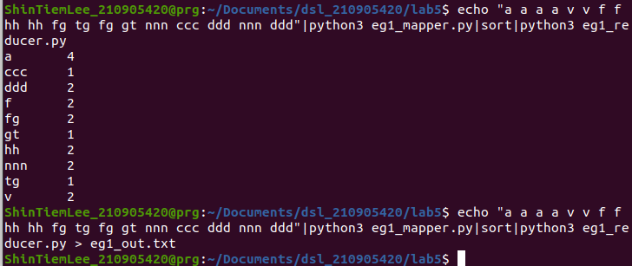
ex1:
import pandas as pd
import numpy as np
import matplotlib.pyplot as plt
df=pd.read_csv('heart_disease_data.csv')
for i in df['age']:
print(i)
df=pd.read_csv('covid_19_data.csv')
for i in df['Province/State']:
print(i)
df=pd.read_fwf('example.txt')
for i in df.iloc[:,0]:
print(i)
df=pd.read_excel('GermanCredit_for_Week2.xlsx')
for i in df['DurationOfCreditInMonths']:
print(i)
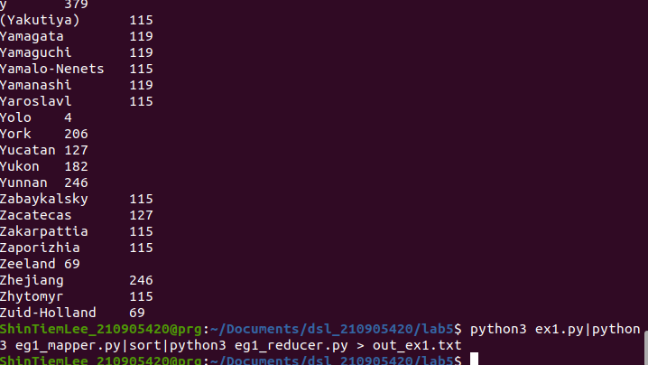

freqmap1.py:

from __future__ import print_function
import sys
# input comes from STDIN (standard input)
for line in sys.stdin:
# create tuples of all words in line
L = [ (word.strip().lower(), 1 ) for word in line.strip().split() ]
# increase counters
for word, n in L:
# write the results to STDOUT (standard output);
# what we output here will be the input for the
# Reduce step, i.e. the input for reducer.py
## tab-delimited; the trivial word count is 1
print( '%s\t%d' % (word, n) )
freered1.py:

from __future__ import print_function
import sys
lastWord = None
sum = 0
for line in sys.stdin:
word, count = line.strip().split('\t', 1)
count = int(count)
if lastWord==None:
lastWord = word
sum = count
continue
if word==lastWord:
sum += count
else:
print( "%s\t%d" % ( lastWord, sum ) )
sum = count
lastWord = word
# output last word
if lastWord == word:
print( '%s\t%s' % (lastWord, sum ) )

freqmap2.py:

from __future__ import print_function
import sys
# input comes from STDIN (standard input)
for line in sys.stdin:
word, count = line.strip().split('\t', 1)
count = int(count)
print( '%d\t%s' % (count, word) )

freeqred2.py:

from __future__ import print_function
import sys
mostFreq = []
currentMax = -1
for line in sys.stdin:
count, word = line.strip().split('\t', 1)
count = int(count)
if count > currentMax:
currentMax = count
mostFreq = [ word ]
elif count == currentMax:
mostFreq.append( word )
# output mostFreq word(s)
for word in mostFreq:
print( '%s\t%s' % ( word, currentMax ) )

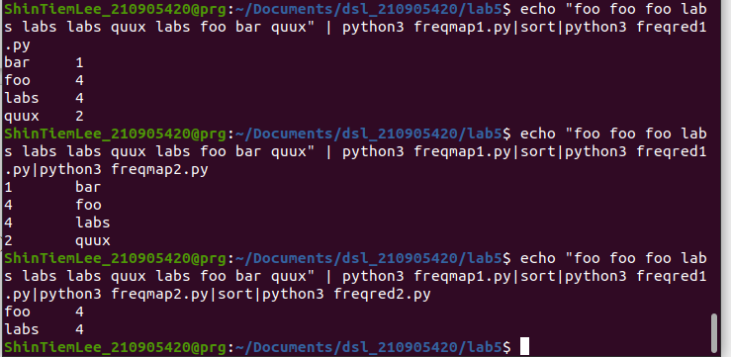
itemmap.py:

#import string
import fileinput
for line in fileinput.input():
data = line.strip().split("\t")
if len(data) == 6:
date, time, location, item, cost, payment = data
print ("{0}\t{1}".format(location, cost))

itemred.py:

import fileinput
transactions_count = 0
sales_total = 0
for line in fileinput.input():
data = line.strip().split("\t")
if len(data) != 2:
# Something has gone wrong. Skip this line.
continue
current_key, current_value = data
transactions_count += 1
sales_total += float(current_value)
print (transactions_count, "\t", sales_total)

