import time
import random
import copy
nodes = [1,2,3,4,5,6,7]

# Election Message
# OK Message
# Coordinator Message Type
# Assuming node 7 as coordinator

coordinator = 7
time_interval = 5
failed_node_index = 6

def bully_algo(nodes,coordinator,time_interval,failed_node_index):
print(coordinator, " is the coordinator right now")
time.sleep(2)
print(coordinator, " has crashed but system isn't aware of crash yet")
temp_nodes = copy.deepcopy(nodes )
temp_nodes.pop(failed_node_index)
current_node = random.choice(temp_nodes)
print(current_node, " has sent a message to coordinator")
time.sleep(time_interval)
print("Time interval expired")
failed_node = coordinator
while True:
for i in range(current_node,failed_node_index):
print(current_node, " sends an Election message to ",nodes[i])
time.sleep(2)
for i in range(current_node,failed_node_index):
print(nodes[i], " sends an OK message to ",current_node)
time.sleep(2)
if nodes[current_node] == failed_node:
break
current_node = nodes[current_node]
coordinator = current_node
print(coordinator, " is the coordinator right now")
for i in range(0,coordinator-1):
print(coordinator, " sends Coordinator message to ",nodes[i])

if __name__ == "__main__":
bully_algo(nodes,coordinator,time_interval,failed_node_index)

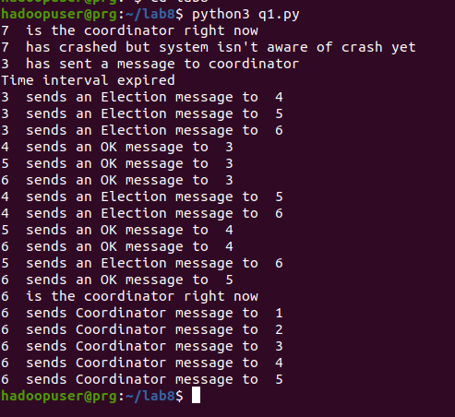
import time
import random
import copy

def ring_algo():
nodes = [1,2,3,4,5,6,7]
coordinator = 4
failed_node_index = 3
noNodes = len(nodes)
time_interval = 5

print(coordinator, " is the coordinator right now")
time.sleep(2)
print(coordinator, " has crashed but system isn't aware of crash yet")
temp_nodes = copy.deepcopy(nodes)
temp_nodes.pop(failed_node_index)
initiator = random.choice(temp_nodes)
print(initiator, " has sent a message to coordinator")
time.sleep(time_interval)
print("Time interval expired")
failed_node = coordinator
print(initiator, " is the initiator")
current_node_index = initiator-1
election_list = [initiator]
current_node_index = current_node_index+1
current_node = nodes[(current_node_index)%noNodes]
print("Election Message List: ",election_list)
while current_node != initiator:
election_list.append(current_node)
current_node_index = current_node_index+1
current_node = nodes[(current_node_index)%noNodes]
if current_node == failed_node:
current_node_index = current_node_index+1
current_node = nodes[(current_node_index)%noNodes]
print("Election Message List: ",election_list)
time.sleep(1)
maxNode = election_list[0]
for i in range(0,len(election_list)):
if(election_list[i] > maxNode):
maxNode = election_list[i]
coordinator = maxNode
print(coordinator, " is the coordinator right now")
current_node_index = initiator - 1
current_node = nodes[(current_node_index+1)%noNodes]
current_node_index = current_node_index+1
time.sleep(1)
while current_node != initiator:
print(initiator, " sends Coordinator message as ",coordinator," as the coordinator to ", current_node)
current_node = nodes[(current_node_index+1)%noNodes]
current_node_index = current_node_index+1
time.sleep(1)
if __name__ == "__main__":
ring_algo()

