EXPERIMENT 2
Create a Basic Interactive Sales Dashboard Using Power BI

OUTPUT:

Final Power BI Sales Performance Dashboard

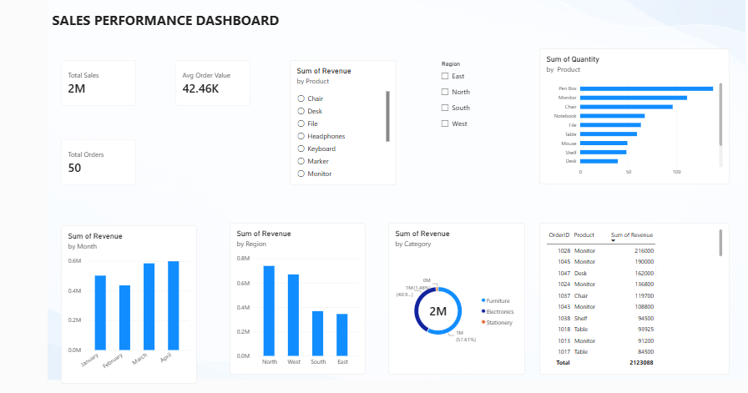

RESULT:
A basic interactive sales dashboard was successfully created in Power BI using a dummy sales dataset.

