Assignment 6

Program 1:
Write a code for implementation of the PIPE IPC and write the complete working of it.

Obervation:

1. In this program one file descripter is used fd[2] have size 2 here
fd[0] ----> read
fd[1] ---->write

2. Create fork() which will create parent and child process store in a variable ret.

3. When ret == 0 which means we are in child process, In this we are performing writing operation while performing operation close fd[0]--->read and
fd[1]---->write must be open use write system call

write(fd[1],&buff,strlen(buff)
After writing close the fd[1] -----> write.

4. When ret > 0 it is in parent process, In this we are performing reading operation while performing close the fd[1] -----> write and open the fd[0] ------> for reading

(read(fd[0],&buff,sizeof(buff))
After reading close the fd[0] -------> read

5. In unnamed pipe while read we have to close the other end of writing and while writing we have to close other end of reading.

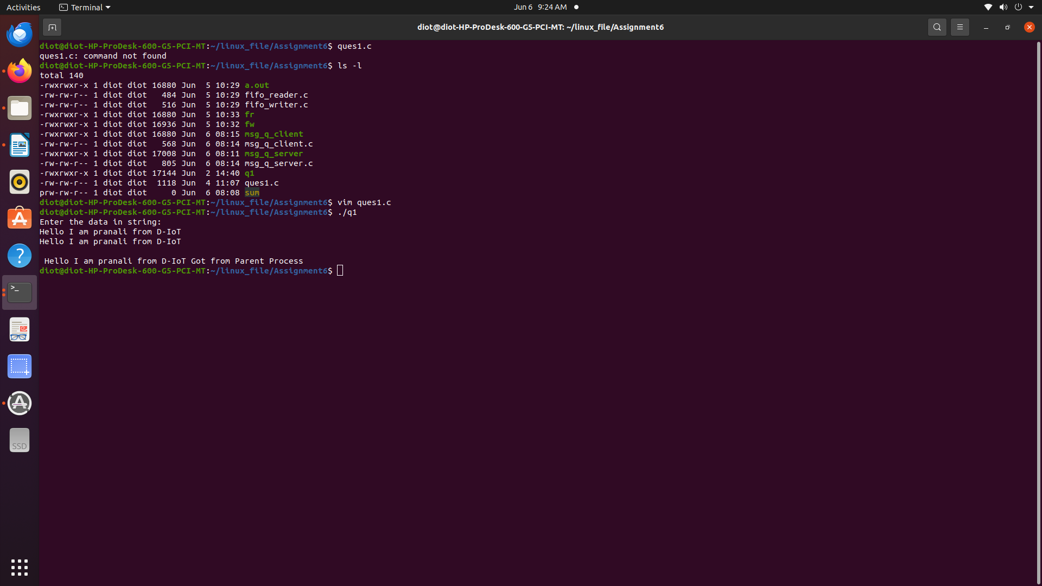

Program 2:
Write a code for implementation of message queue IPC and observe its working. Write down its observations.

Obervation:

1. I had use the library

#include <sys/ipc.h>
#include <sys/msg.h>

2. Create a common key

#define KEY 1552

3. Create a structure , in this initialize mtype as int mtext as buffer

Sending data from server end

4. I had use msgget system call and assign it to a variable

msgget(KEY, 0666 | IPC_CREAT)

Store the data in enter data in buffer
strcpy(msg.mtext,buff)

5. Pass the msessage from sever end use msgsnd() system call

msgsnd(msg_q_id,&msg,sizeof(struct message)

Receving data from client end

6. For receving data from server end use msgrcv() system call

msgrcv(msg_q_id, &msg, sizeof(struct message), 1, 0)

7. The data which has been writing by server end automatically store in msg.mtext with the use of same KEY value which been use in server and client side

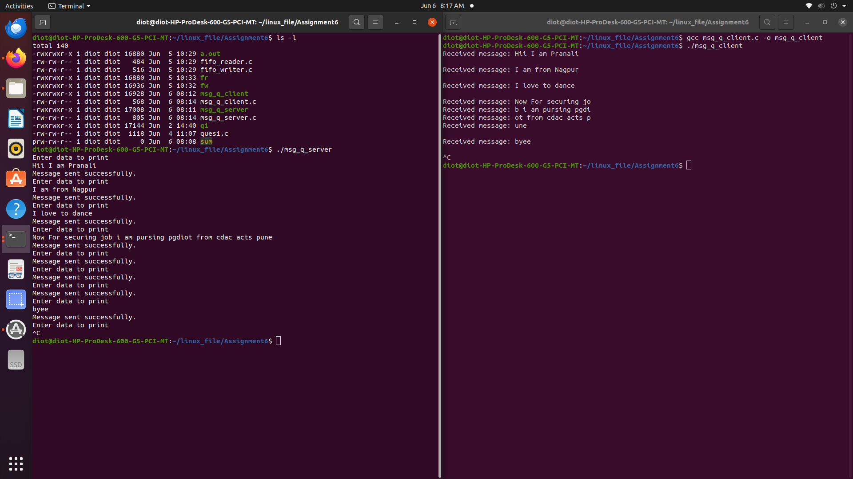

Program 2:
Write a code for implementation of the NAMED PIPE IPC.

Obervation:

