**34 РАЗВЕРТЫВАНИЕ WINDOWS-ПРИЛОЖЕНИЯ**

Задание 1. Возьмите за основы проект Windows Forms и создайте установочный файл Setup.msi изучив Теоретический материал.

Листинг программы:

<?xml version="1.0" encoding="UTF-8"?>

<Wix xmlns="http://schemas.microsoft.com/wix/2006/wi">

<?define ProductName="SetupProject1" ?>

<?define ProductVersion="1.0.0.0" ?>

<?define ProductCode="b7bc7c6f-9a4e-4973-be84-eca8e3427c97"?>

<?define UpgradeCode="06a81104-1e30-463d-87e1-e8a79b4c682a"?>

<?define Manufacturer="MyCompany"?>

<Product Id="$(var.ProductCode)" Name="$(var.ProductName)" Language="1049" Version="$(var.ProductVersion)" Manufacturer="$(var.Manufacturer)" UpgradeCode="$(var.UpgradeCode)">

<Package InstallerVersion="200" Compressed="yes" />

<Media Id="1" Cabinet="media1.cab" EmbedCab="yes" />

<Directory Id="TARGETDIR" Name="SourceDir">

<Directory Id="ProgramFilesFolder">

<Directory Id="INSTALLLOCATION" Name="$(var.ProductName)">

<Component Id="ProductComponent" Guid="b11556a2-e066-4393-af5c-9c9210187eb2">

<File Id='Calc' DiskId='1' Source='C:\WINDOWS\system32\calc.exe'/>

</Component>

</Directory>

</Directory>

<Directory Id="ProgramMenuFolder">

<Directory Id="ApplicationProgramsFolder" Name="$(var.ProductName)">

<Component Id="ApplicationShortcutCalc" Guid="4CEBD68F-E933-47f9-B02C-A4FC69FDB551">

<Shortcut Id="ShortcutCalc"

Name="Calc"

Description="$(var.ProductName)"

Target="[INSTALLLOCATION]Calc.exe"

WorkingDirectory="INSTALLLOCATION"/>

<RemoveFolder Id="ApplicationProgramsFolder" On="uninstall"/>

<RegistryValue Root="HKCU" Key="Software\$(var.Manufacturer)\$(var.ProductName)" Name="installed" Type="integer" Value="1" KeyPath="yes"/>

</Component>

</Directory>

</Directory>

</Directory>

<Feature Id="ProductFeature" Title="SetupProject1" Level="1">

<ComponentRef Id="ProductComponent" />

<ComponentRef Id="ApplicationShortcutCalc" />

</Feature>

<Property Id="WIXUI_INSTALLDIR" Value="INSTALLLOCATION" ></Property>

<UIRef Id="WixUI_InstallDir"/>

</Product>

</Wix>

Анализ результатов:

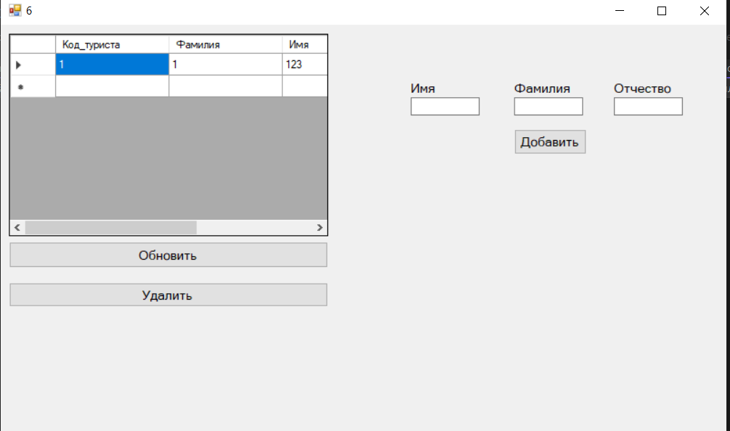

Рисунок 34.1 – Результат работы программы

Источник: собственная разработка