

Myanmar Travellers

By The Power of Code



November 7, 2017

Group Members

1. MR SHINE HTET AUNG - Project Manager
2. MR TUN THIHA - User Interface Designer
3. MR THUREIN MYINT OO - Senior Programmer
4. MR HTUT ARKAR OO - Junior Programmer
5. MR WAI YAN LINN - Tester

Contents

Introduction 1

Objectives 1

Site User Roles 1

Technical Information 2

Project duration 2

Project Plan 2

Success Criteria 3

List of pages (19 pages) 3

Sitemap 5

Wireframes 6

# Introduction

The project is a web portal of bus reservation system. The aim of building this project, named Myanmar Travellers, is to provide online bus reservation system for Myanmar bus operators, which are register to this portal. In order to get electronic tickets (e-tickets), users could access the operators through this web portal. Users can search routes of each operators and choose desire seats and make booking online. By reserving online, it could save both time and energy rather than ordinary booking, which is mostly outdoors. This project will help Myanmar people more efficient in booking and smarter as they are using advanced technology in ticketing.

# Objectives

There are many mile stones in the objectives of this project. At first, we will discover the existing online ticket delivering and developing the innovative technique of online ticket supply. Secondly, we are going to brainstorm the general structure of this project, deciding features and then generating reports such as project specification. Afterwards, drawing diagrams, prototypes and preparing information details for implementing project. Then, implementing the project and bugs fixing and produce another version of project including fully bus ticketing system with QR Code.

To accomplish this project, there would be an interview session where the current ticket selling of bus operators would be investigated along with their business strategy. Afterwards, specification of this project would be generated, which include features such as transactional process, booking ticket and so on Offering bus operators, a better way of improving their reservation system by assigning to this web portals.

# Site User Roles

1. Web Admin

Web admin could be managed the bus operators, the reports of all the bus operator but the admin could check only relevant data and not allowed to edit or modify any other data such as bus information and their sale flows.

1. Bus Operator Admins

Bus Operator Admins could be added their routes, categories, prices along with details information. Bus Admin is the only person who could edit or modify his bus routes, prices and details.

1. Customers

The customers have to add their information and the web portal would save and record each data and probably give promotions if customer purchase tickets several times.

# Technical Information

This project would be implemented by using asp.net framework and Standard Query Language (SQL) for back-end code. For front-end code, Hypertext Markup Language (html), Cascading Style Sheet (CSS) and JavaScript.

# Project duration

Project duration is 114days and the project will be start on 19th November 2017 and will be finished on 21th April 2018.

# Project Plan

|  |  |  |  |
| --- | --- | --- | --- |
| Task Name | Duration | Start | Finish |
| **Myanmar Travellers Project** | **114 days** | **Sun 11/19/17** | **Sat 4/21/18** |
| **Planning** | **5 days** | **Sun 11/19/17** | **Thu 11/23/17** |
| Discussion of the whole project and make solution | 5 days | Sun 11/19/17 | Thu 11/23/17 |
| **Design** | **32 days** | **Sat 11/25/17** | **Sun 12/31/17** |
| Flow Chat, Usecase Diagram | 5 days | Sat 11/25/17 | Wed 11/29/17 |
| Class Diagram | 3 days | Thu 11/30/17 | Sun 12/3/17 |
| Prototype | 5 days | Thu 11/30/17 | Tue 12/5/17 |
| Graphical User Interface | 20 days | Wed 12/6/17 | Thu 12/28/17 |
| Testing | 2 days | Sat 12/30/17 | Sun 12/31/17 |
| **Implementation** | **41 days** | **Tue 1/2/18** | **Sat 3/3/18** |
| Coding Database | 3 days | Tue 1/2/18 | Tue 1/9/18 |
| Coding Back-end | 26 days | Wed 1/10/18 | Thu 2/15/18 |
| Exception Handling | 3 days | Sat 2/17/18 | Mon 2/19/18 |
| Testing | 3 days | Tue 2/20/18 | Thu 2/22/18 |
| Documentation | 3 days | Sat 2/24/18 | Mon 2/26/18 |
| Creating OnScreen help | 3 days | Tue 2/27/18 | Sat 3/3/18 |
| **Testing** | **20 days** | **Sun 3/4/18** | **Mon 3/26/18** |
| Design Test Plan | 4 days | Sun 3/4/18 | Wed 3/7/18 |
| Unit Testing | 4 days | Thu 3/8/18 | Mon 3/12/18 |
| Integration Testing | 4 days | Tue 3/13/18 | Sat 3/17/18 |
| System Testing | 4 days | Sun 3/18/18 | Wed 3/21/18 |
| Technical Documentation | 4 days | Thu 3/22/18 | Mon 3/26/18 |
| **Maintenance** | **2 days** | **Wed 3/28/18** | **Thu 3/29/18** |
| Create Maintenance Plan | 2 days | Wed 3/28/18 | Thu 3/29/18 |
| **Documentation** | **10 days** | **Sat 3/31/18** | **Tue 4/10/18** |
| Group Report | 4 days | Sat 3/31/18 | Tue 4/3/18 |
| Individual Report | 6 days | Wed 4/4/18 | Tue 4/10/18 |
| **Finishing** | **3 days** | **Wed 4/11/18** | **Sat 4/21/18** |
| Publish web portal | 1 day | Tue 4/10/18 | Wed 4/11/18 |
| Invite new operators | 2 days | Thu 4/12/18 | Sat 4/21/18 |

# Success Criteria

This project would be successfully accomplished when designing and implementing would be tested and the product could allow the bus operator to register in this web portal. Afterwards the system testing, the project would be polished and ready to launch online. However, this project is going to be simulated by adding trial bus operator data.

# List of pages (19 pages)

**HomePublic and HomeUser pages**

* Register
* Login
* Search options (categories, routes)

**BusOperators** (Guest) and BusOperatorsPublic pages

* Choose specific bus operators to see information

**Contact (Guest) and ContactUser pages**

* Can send Information and feedback

**WebAdminManage** (Web admin)

* Bus operator’s admin registration and manage

**WebAdminSalesFlow** (Web admin)

* Sales flow

**BusOperatorsAdminManage** (Operators admin)

* Bus information registration (price, routes, time, etc.)

**BusOperatorsSalesFlow** (Operators admin)

* Sales flow

**CompleteOrder page (Users)**

* Choose seats to book

**AddingPayment page (Users)**

* Add payment to pay the cost of tickets

**BookingStatus page (Users)**

* Show the booking status of the page
* A QR code for the customer will be generated with relevant data as an e-ticket.

**Login page (Guests, Users, Web Admin, Bus Operators Admin)**

* Users, Web Admin and Bus Operators Admin can login here to access respective pages
* Can click ‘register new user’ to reach registration page

**Register page (Guests, Users, Web Admin, Bus Operators Admin)**

* Can register new user account in this page

**ManageWebAdmin (Web Admin)**

* Can add and manage bus operators

**SalesFlowWebAdmin (Web Admin)**

* Can see all the sales flow of the bus operators

**ManageBusAdmin (Bus Operators Admin)**

* Can add and manage routes and routes info

**BusAdminSalesFlow (Bus Operators Admin)**

* Can see all the sales flow of the bus operators

# Sitemap

The sitemap of the Myanmar Travellers Bus Reservation System is as follow.

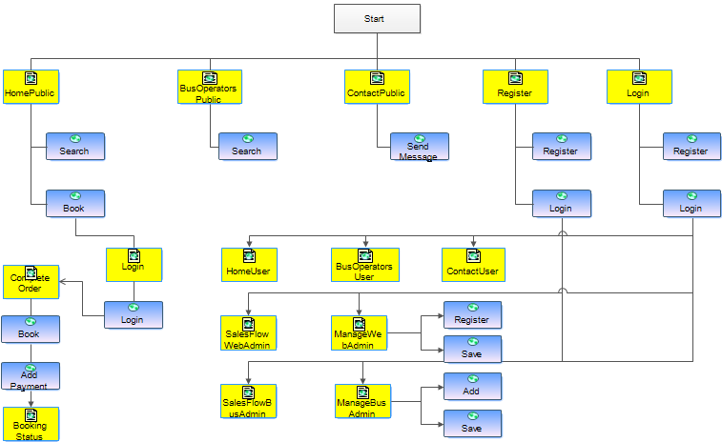

# Wireframes

**HomePublic**

This page is for the guests who haven’t logged into our web page. The customers can search Bus information with date, time and rout.

When bus information is displayed, users can book immediately.

From this Home Page, users can go to “Complete users page” by clicking book.

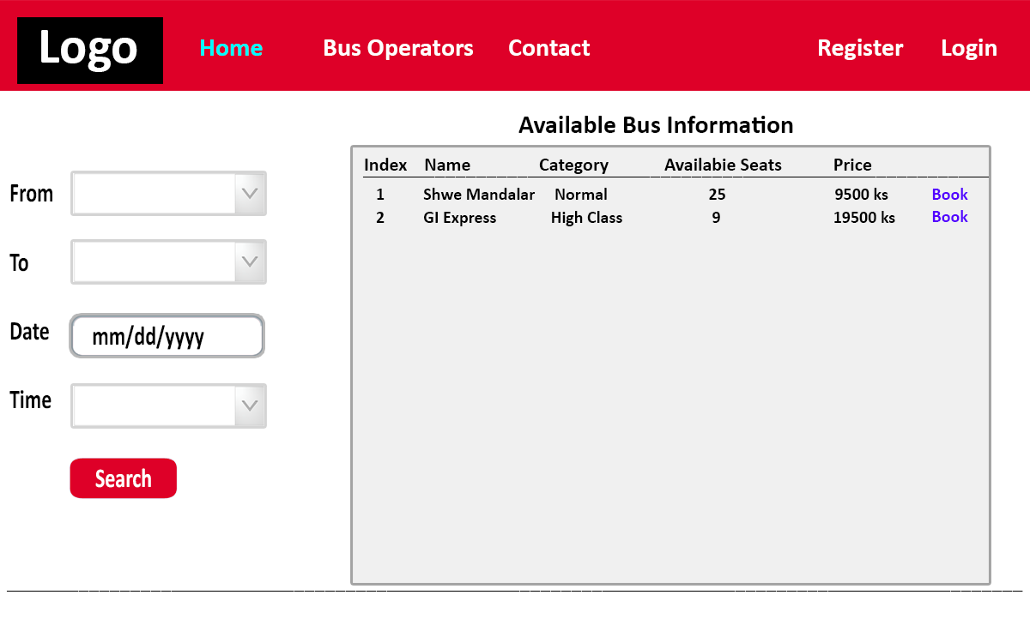

**HomeUser**

This page is for the customers who already logged into our web page. The customers can search Bus information with date, time and rout.

When bus information is displayed, users can book immediately.

From this Home Page, users can go to “Complete users page” by clicking book.

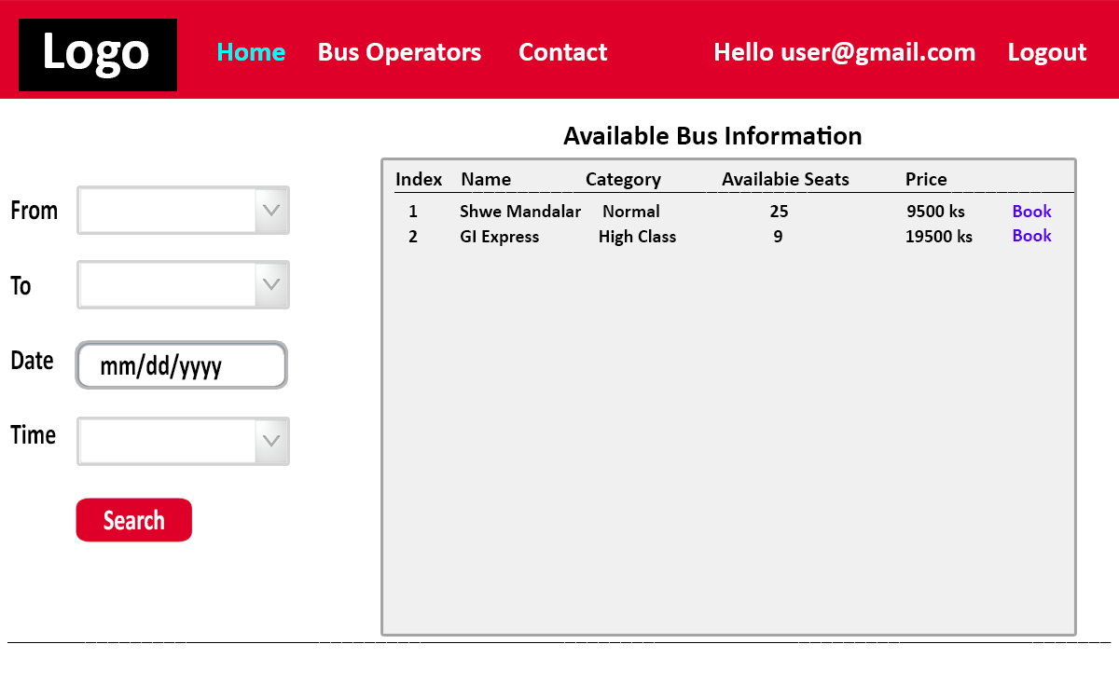

**BusOperatorsPublic**

In this page, customers will be able to search bus stations from drop down list and click on button to display information for every bus routes on table. This page is for the guest who are not already logged in.

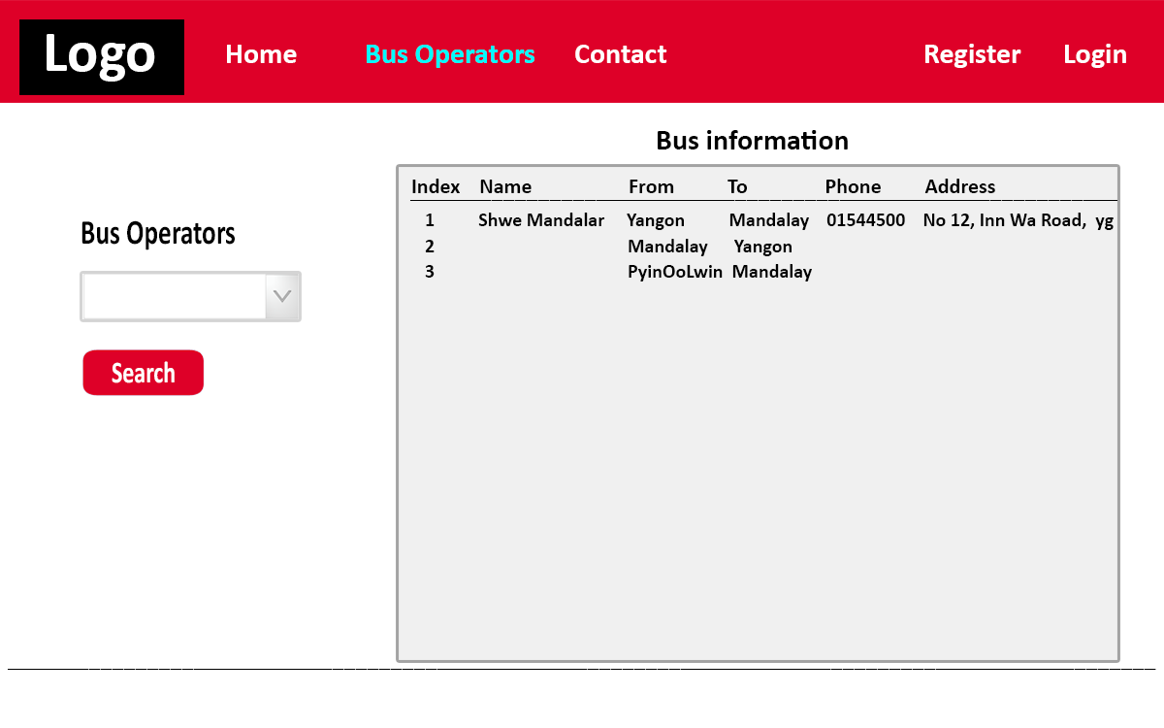

**BusOperatorsUser**

In this page, customers will be able to search bus stations from drop down list and click on button to display information for every bus routes on table. This page is for the people that are already logged in to our website.

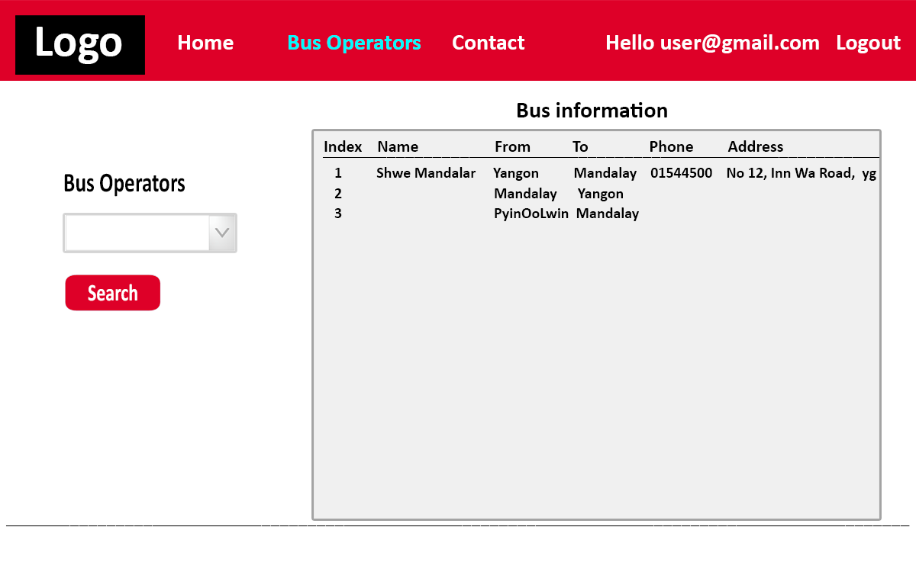

**ContactPublic**

Users will be able to send feedback to our web admin by mail in term of design or process of our product by filling information request from our team. This page is for the people who are not already logged in to our web site.

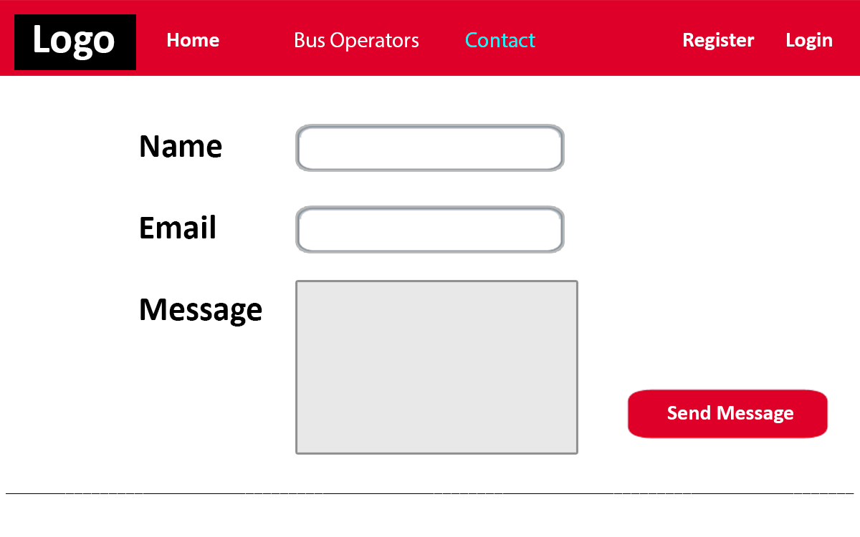

**ContactUsers**

Users will be able to send feedback to our web admin by mail in term of design or process of our product by filling information request from our team. This page is for the people who are already logged in to our web site.

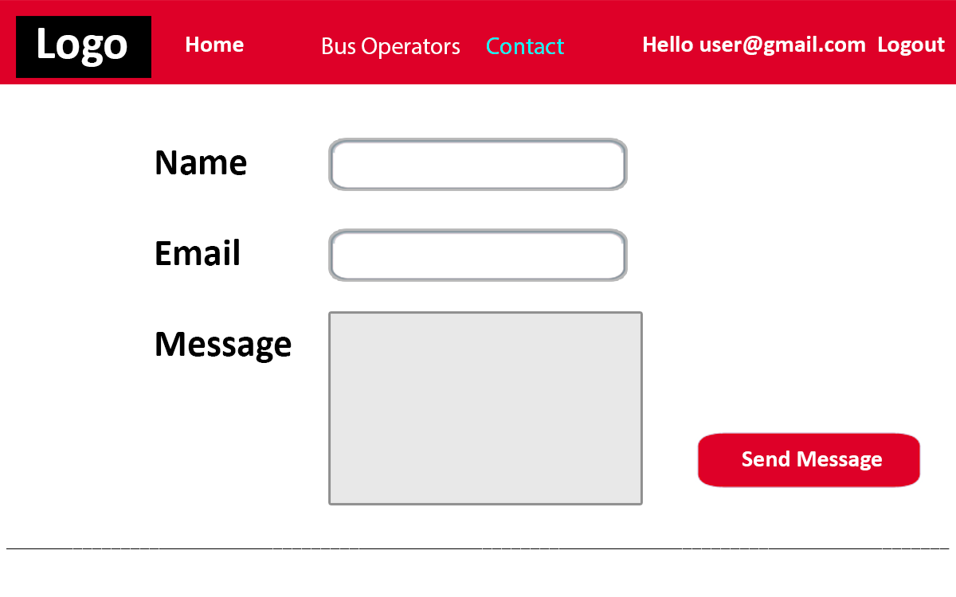

**Login**

All login processes have to be completed from this page.

If the users do not have an account, they can register as new user in this page.

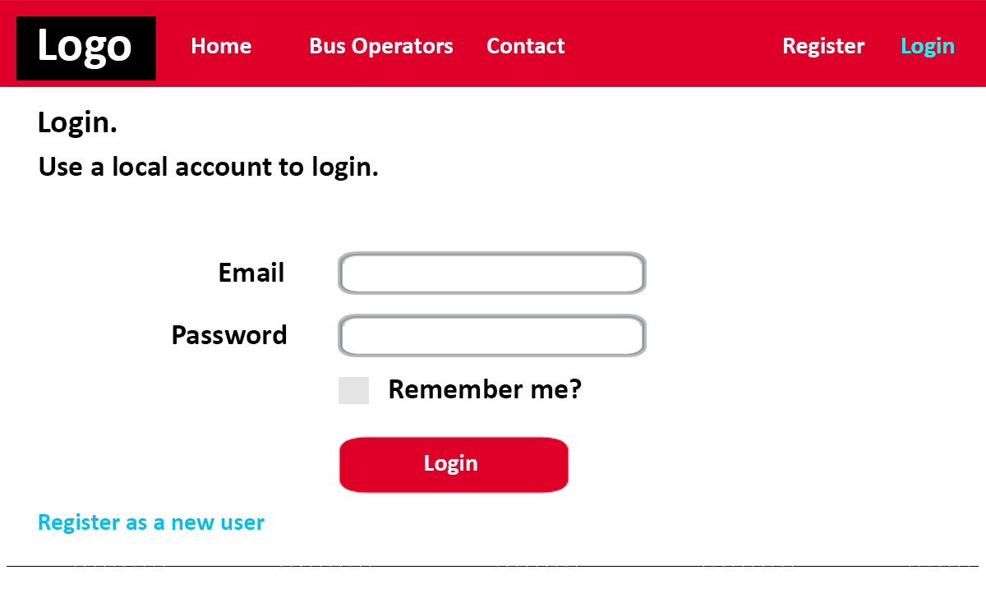

**Register**

Users can register their account by filling relevant information to use booking feature.

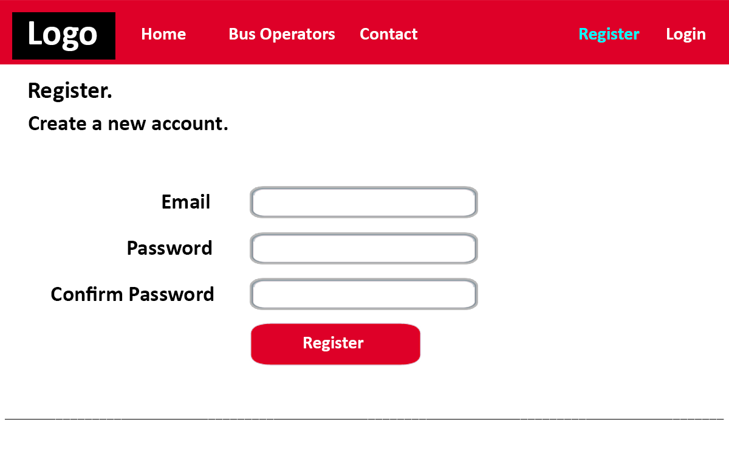

**ManageBusAdmin**

Bus Admins need to set their bus information here to display the information to the customers to serve. Only the bus admin who logged in with bus operator admin account can see this page.

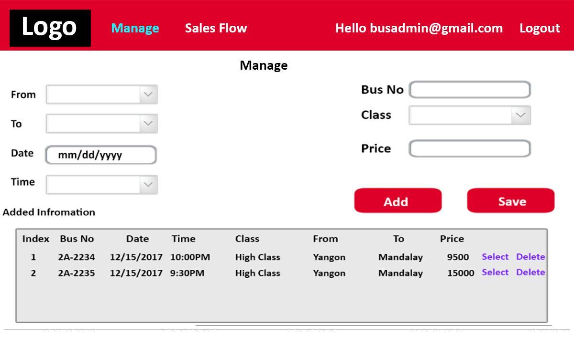

**SalesFlowBusAdmin**

The bus admins can see sales flow information of a bus service. Only the bus admin who logged in with bus operator admin account can see this page. The bus admin can cancel the booking in special case like the person is wanted person by the police if the station got informed.

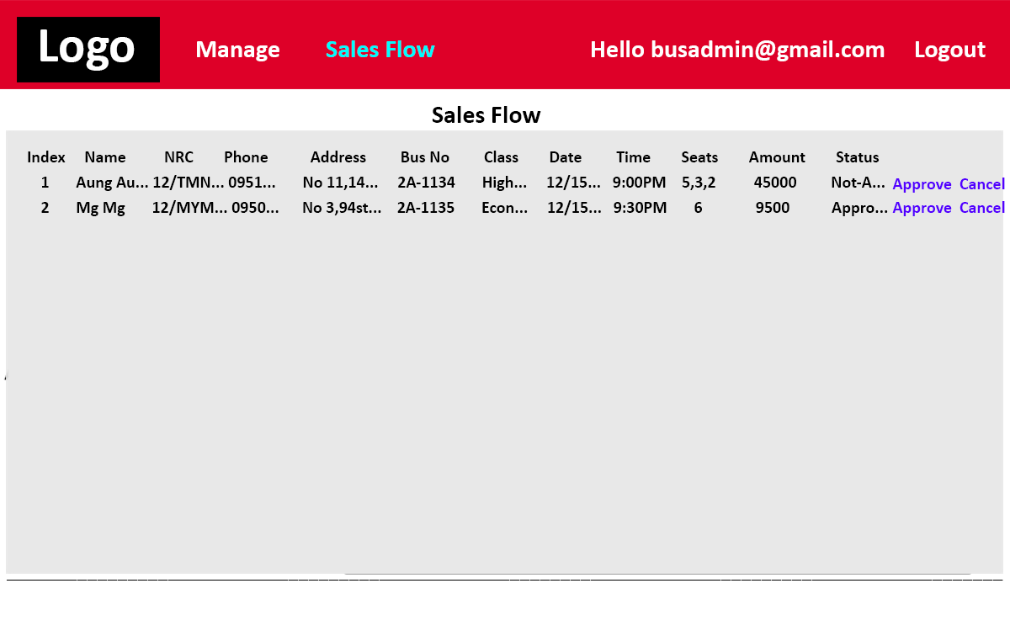

**ManageWebAdmin**

When adding a new BusAdmin, this page will be used by a WebAdmin to complete the process. . Only the web admin who logged in with bus operator admin account can see this page.

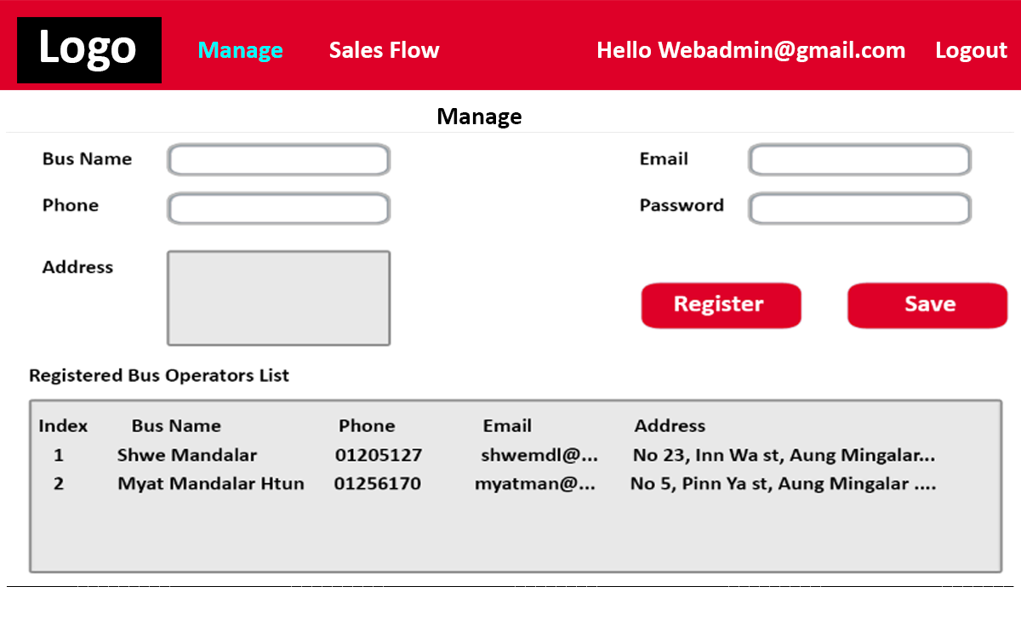

**WebAdminSalesFlow**

WebAdmin can check all SalesFlow information of bus services. Only the bus admin who logged in with bus operator admin account can see this page.

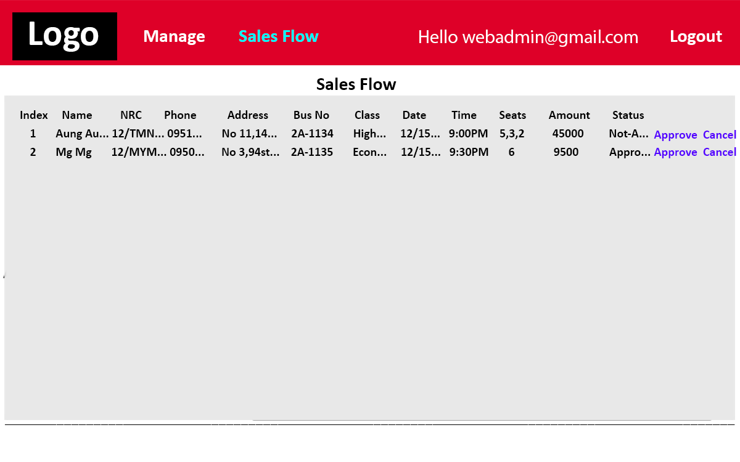

**CompleteOrder**

Page includes functions for booking their seats to bus operator. To complete this process, users must fill their information (name, NRC, Phone, and Address). Moreover, customers can freely book their seat by viewing information on table.

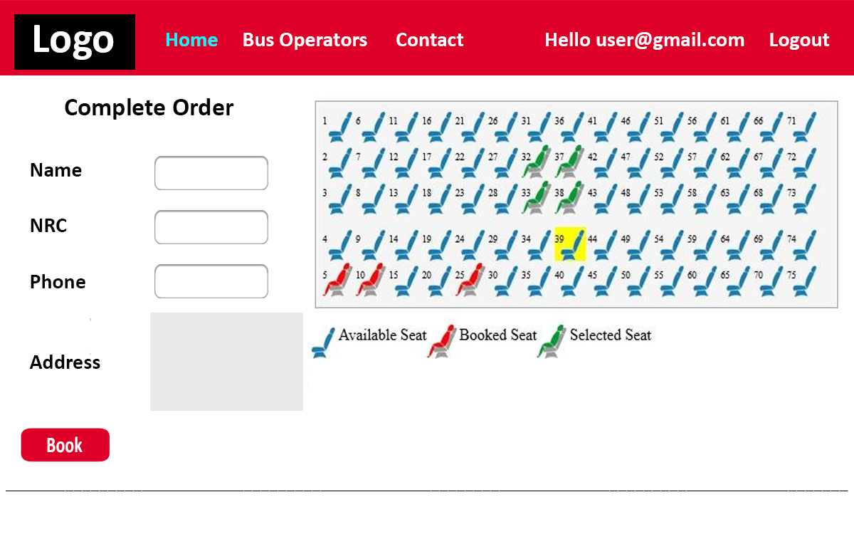

**AddingPayment**

The total cost is calculated and shown here. For the payment, MPU payment will be used as dummy. The customer can pay the cost with MPU. Customer have to add the MPU info to complete order. But in this project, the MPU payment transfer will not work due to the dummy text field. It is hard to get the MPU payment gateway API from the banks in Myanmar. To get the API, we even have to show the business license and others. That’s why we just added the dummy text field in this project. But we can easily add the API if we get as we made a place for that.

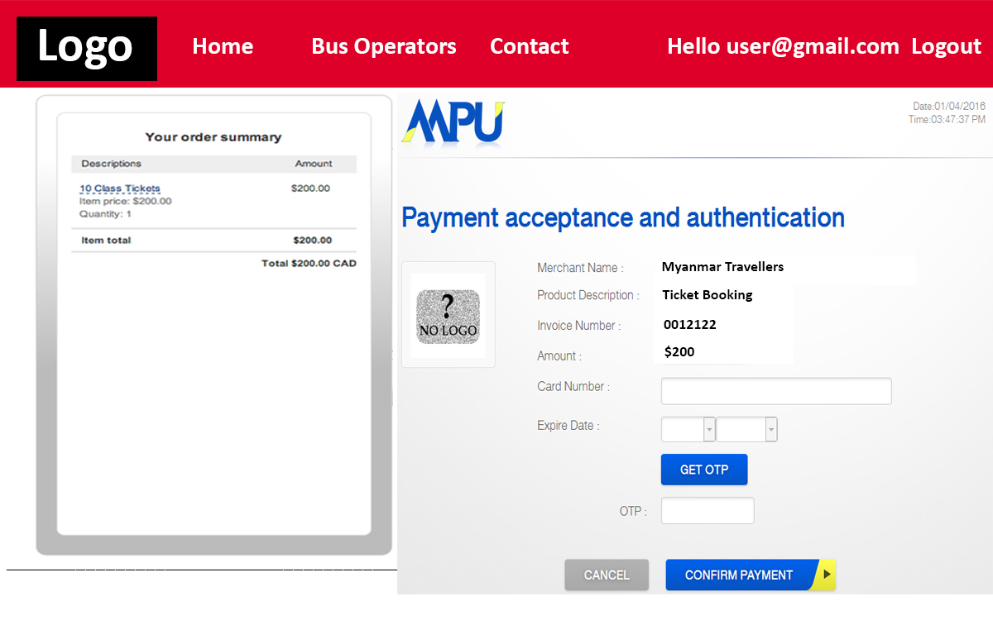

**BookingStatus**

Once the customer completed a booking, this page will be shown with a generated QR code as the electronic ticket. The customer have to save this QR code and show to the office staff when the customer reach the office to start the travel.

