1. Display following messages on your terminal (including quotes and newline).

“God bless us!

We are starting with basic linux command”



2. Read your name from the keyboard and display it.

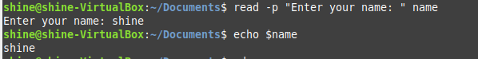

3. Create the directory structure dir1/dir4 and dir1/dir2/dir3 with a single command and then

change directory to dir3

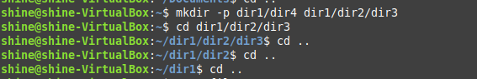

4. Create a file testfile1 using nano.

Display the file

(i) starting with the first 10 lines and

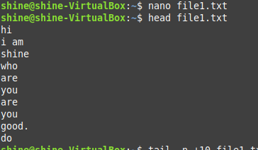

(ii) starting with the 10th line with provision for

a) Scrolling Up

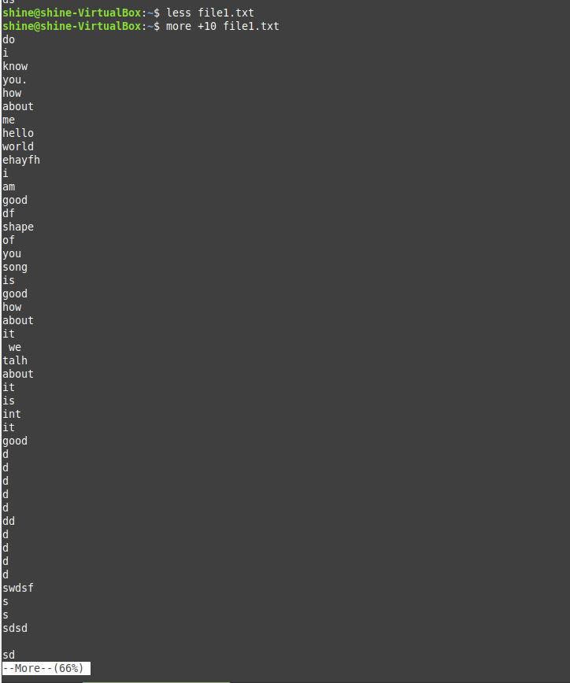

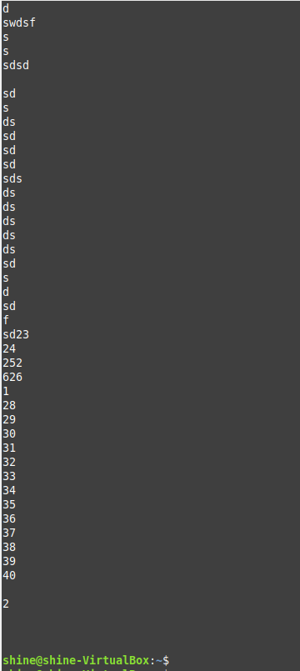

b) Scrolling Up and Down

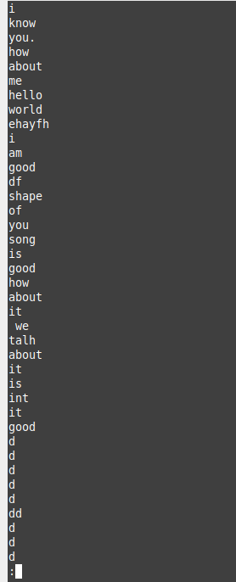

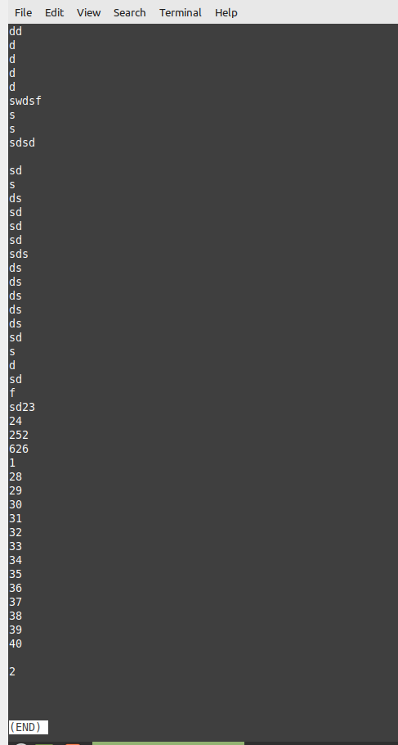

5. Get the manual page of ’ls’ command. Search for the word ”alphabetic”. Find the next

occurrence and then find the previous occurrence.

