Shell Scripting Programs (PART 1)

1. Write a shell program to read a string and display it.

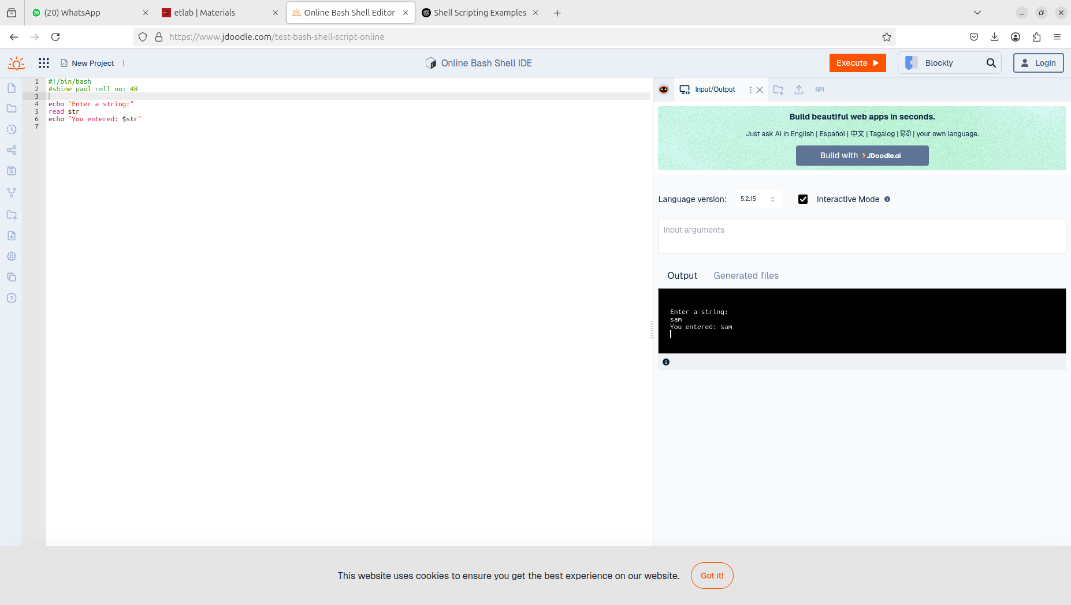

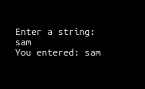

1. Write a shell program to read 2 numbers and find sum, difference, product and quotient.

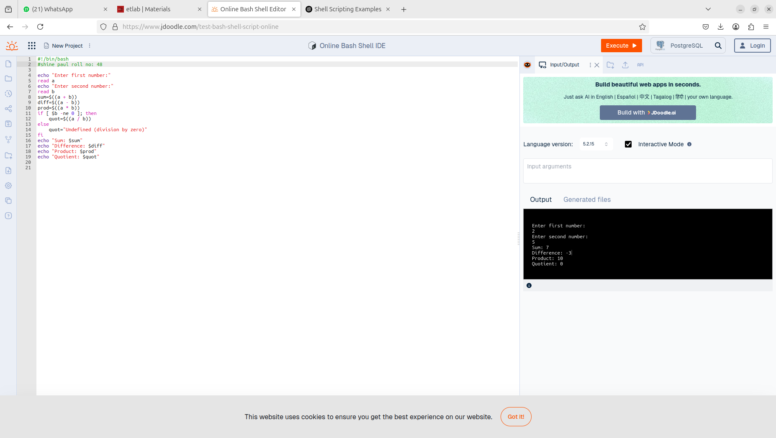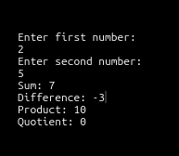

1. Write a shell program to check if a number is odd or even.

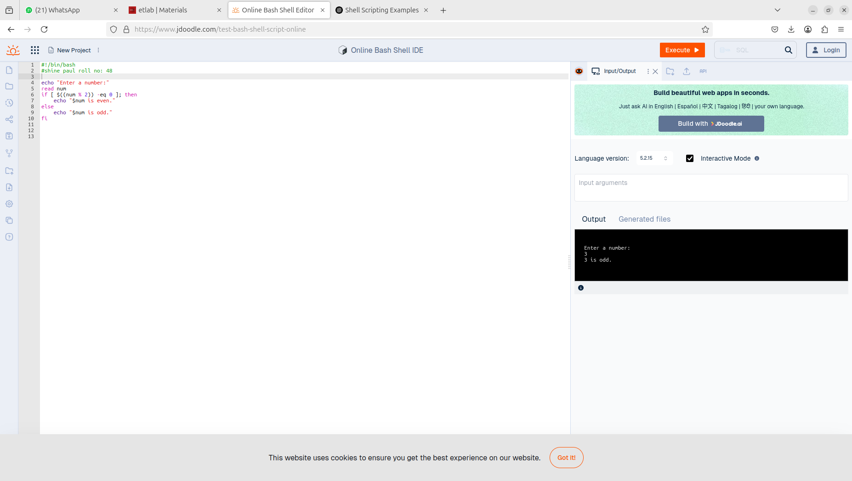

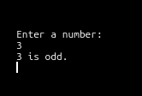

1. Write a shell program to read 3 numbers and find the largest of them.

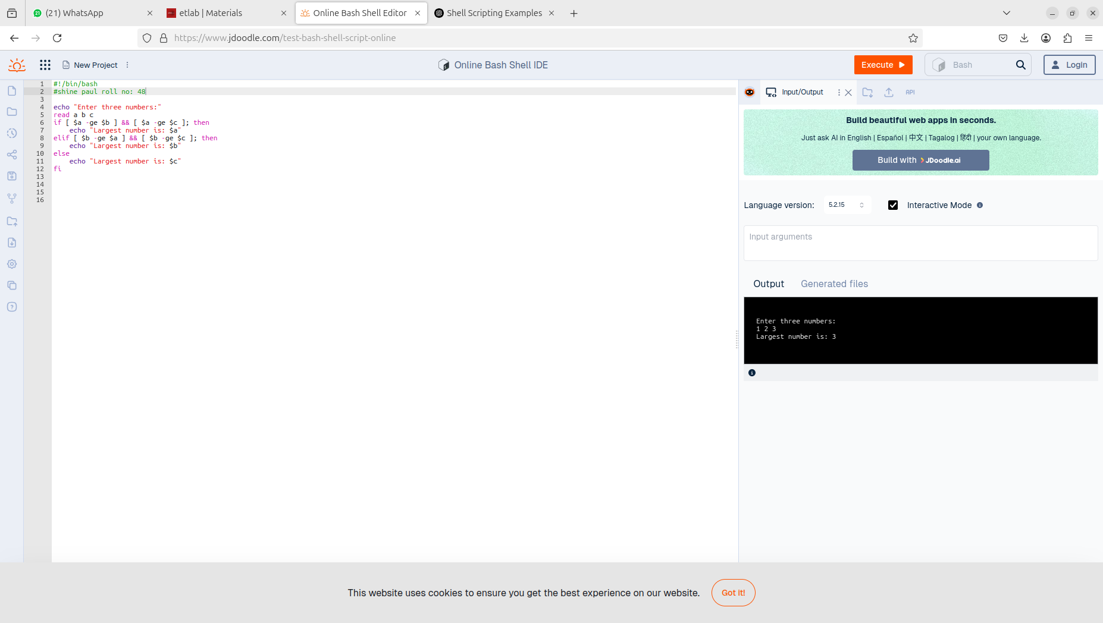

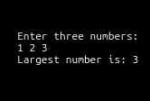

1. Read 3 marks of a student and find the average. Display the grade of the student based on

the average.

• S >= 90%

• A < 90%, but >= 80%

• B < 80%, but >= 60%

• P < 80%, but >= 40%

• F < 40%

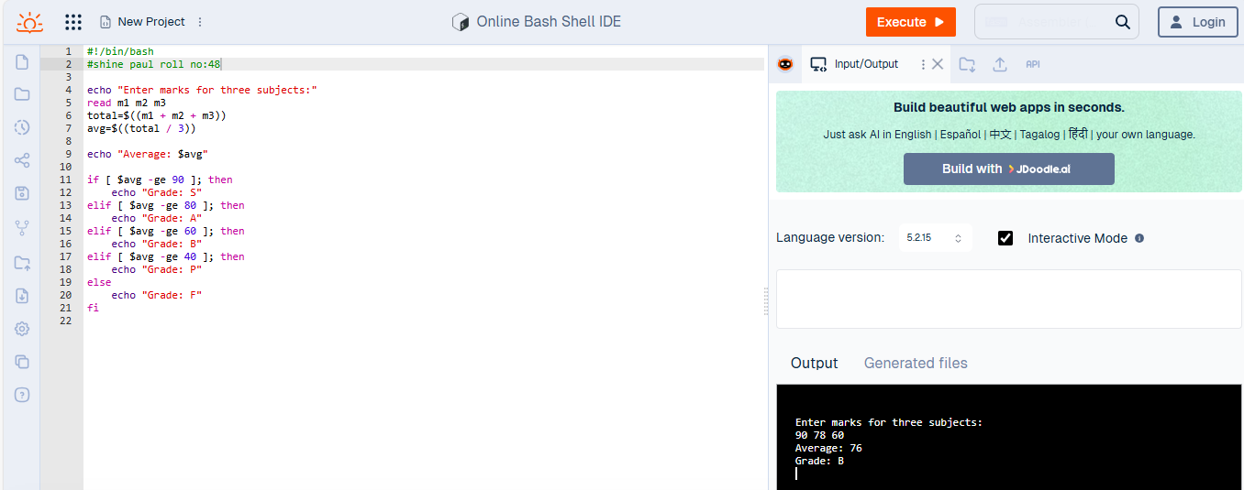

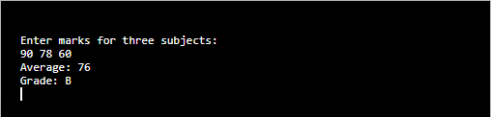

1. Write a shell program to read a filename as command line argument and check whether it

exists or not.

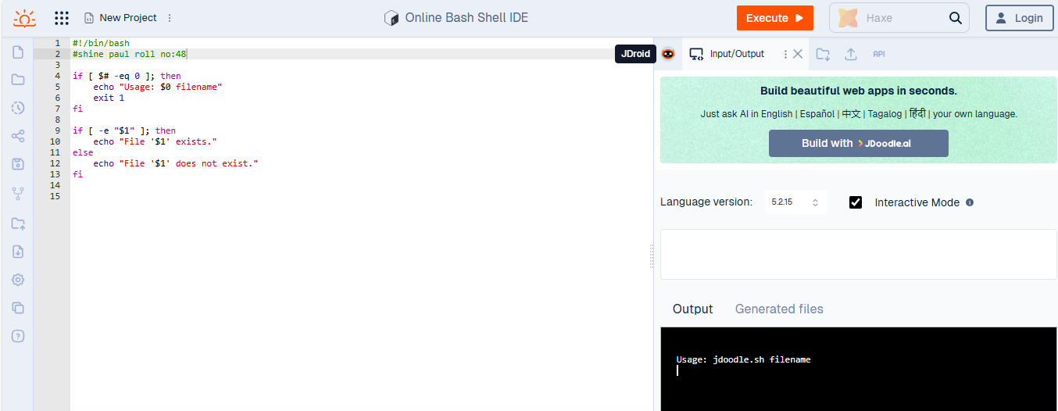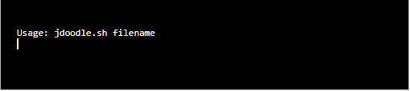

1. Write a shell program to display the multiplication table of a number n.

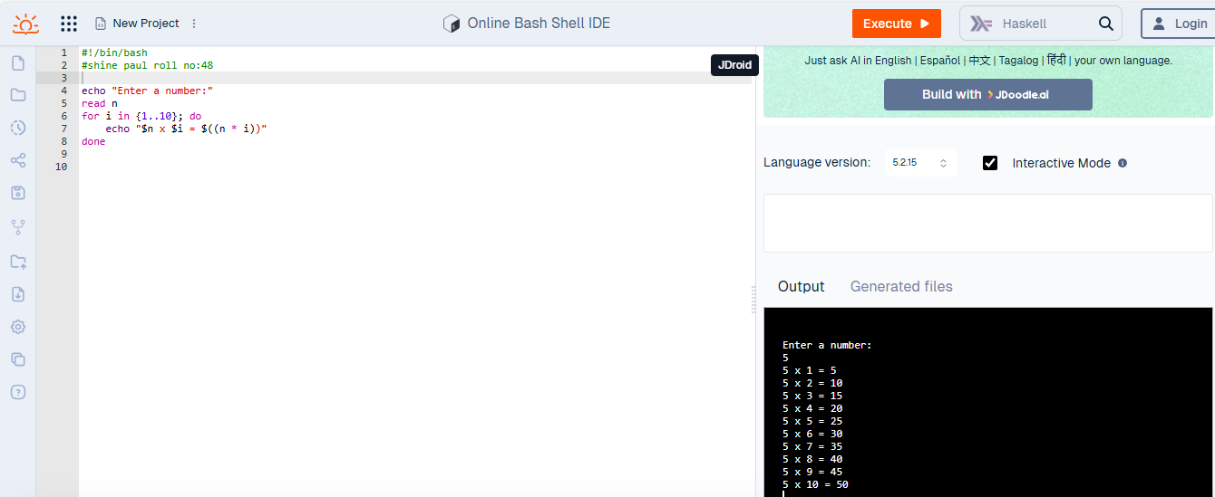

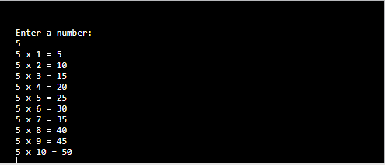

1. Write a shell program to display the contents in your current folder.

