**CYCLE 4**

**Experiment No. : 1 Date: 26/10/2022**

**BASIC HTML TAGS**

**AIM:**

Write a program to print the Fibonacci series using recursion.

**SOURCE CODE:**

def fibonacci(n):

if n <= 1:

return n

else:

return fibonacci(n - 1) + fibonacci(n - 2)

num_terms = int(input("Enter the number of terms: "))

if num_terms <= 0:

print("Please enter a positive integer")

else:

print("Fibonacci sequence:")

for i in range(num_terms):

print(fibonacci(i))

**OUTPUT:**

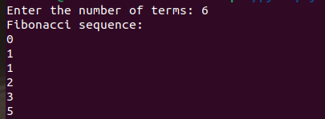

**Experiment No. : 1 Date: 26/10/2022**

**BASIC HTML TAGS**

**PROGRAM 2**

**AIM:**

Write the to implement a menu-driven calculator. Use separate functions for the

different operations.

**SOURCE CODE:**

def add(x, y):

return x + y

def subtract(x, y):

return x - y

def multiply(x, y):

return x * y

def divide(x, y):

if y == 0:

return "Error! Division by zero."

return x / y

while True:

print("\nSelect an operation:")

print("1. Addition")

print("2. Subtraction")

print("3. Multiplication")

print("4. Division")

print("5. Exit")

choice = input("Enter your choice: ")

if choice == '5':

print("Exiting..")

break

if choice in ('1', '2', '3', '4'):

num1 = float(input("Enter first number: "))

num2 = float(input("Enter second number: "))

if choice == '1':

print(f"Result: {num1} + {num2} = {add(num1, num2)}")

elif choice == '2':

print(f"Result: {num1} - {num2} = {subtract(num1, num2)}")

elif choice == '3':

print(f"Result: {num1} * {num2} = {multiply(num1, num2)}")

elif choice == '4':

print(f"Result: {num1} / {num2} = {divide(num1, num2)}")

else:

print("Invalid choice!")

**OUTPUT:**

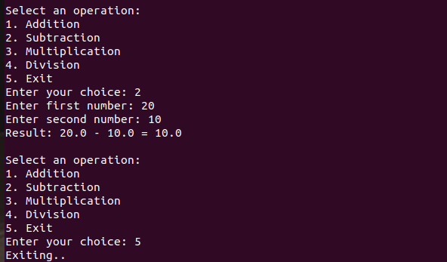

**PROGRAM 3**

**AIM:**

Write a program to print the nth prime number.

[Use function to check whether a number is prime or not]

**SOURCE CODE:**

def is_prime(num):

if num <= 1:

return False

for i in range(2, int(num ** 0.5) + 1):

if num % i == 0:

return False

return True

def nth_prime(n):

count = 0

num = 2

while True:

if is_prime(num):

count += 1

if count == n:

return num

num += 1

n = int(input("Enter the position of the prime number you want to find (n): "))

if n <= 0:

print("Please enter a positive integer greater than 0.")

else:

print(f"The {n}-th prime number is: {nth_prime(n)}")

**OUTPUT:**



**PROGRAM 4**

**AIM:**

Write lambda functions to find the area of square, rectangle and triangle.

**SOURCE CODE:**

area_square = lambda side: side * side

area_rectangle = lambda length, width: length * width

area_triangle = lambda base, height: 0.5 * base * height

while True:

print("\nChoose a shape to calculate the area:")

print("1. Square")

print("2. Rectangle")

print("3. Triangle")

print("4. Exit")

choice = input("Enter your choice: ")

if choice == '1':

side = float(input("Enter the side length of the square: "))

print(f"The area of the square is: {area_square(side)}")

elif choice == '2':

length = float(input("Enter the length of the rectangle: "))

width = float(input("Enter the width of the rectangle: "))

print(f"The area of the rectangle is: {area_rectangle(length, width)}")

elif choice == '3':

base = float(input("Enter the base length of the triangle: "))

height = float(input("Enter the height of the triangle: "))

print(f"The area of the triangle is: {area_triangle(base, height)}")

elif choice == '4':

print("Exiting...")

break

else:

print("Invalid choice!")

**OUTPUT:**

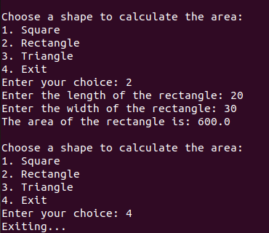

**PROGRAM 5**

**AIM:**

Write a program to display powers of 2 using anonymous function. [ Hint use map and

lambda function)

**SOURCE CODE:**

num_terms = int(input("Enter the number of terms for powers of 2: "))

powers_of_2 = list(map(lambda x: 2 ** x, range(num_terms)))

print(f"Powers of 2 up to {num_terms} terms: {powers_of_2}")

**OUTPUT:**



**PROGRAM 6**

**AIM:**

Write a program to sum the series 1/1! + 4/2! + 27/3! + ..... + nth term. [ Hint

Use a function to find the factorial of a number].

**SOURCE CODE:**

def factorial(num):

if num == 0 or num == 1:

return 1

else:

result = 1

for i in range(2, num + 1):

result *= i

return result

def sum_series(n):

series_sum = 0

for i in range(1, n + 1):

term = (i ** i) / factorial(i)

series_sum += term

return series_sum

n = int(input("Enter the number of terms: "))

print(f"The sum of the series up to {n} terms is: {sum_series(n)}")

**OUTPUT:**



**PROGRAM 7**

**AIM:**

Write a function called compare which takes two strings S1 and S2 and an integer n as

arguments. The function should return True if the first n characters of both the strings

are the same else the function should return False.

**SOURCE CODE:**

def compare(S1, S2, n):

return S1[:n] == S2[:n]

S1 = input("Enter the first string: ")

S2 = input("Enter the second string: ")

n = int(input("Enter the number of characters to compare: "))

result = compare(S1, S2, n)

print("Result:", result)

**OUTPUT:**

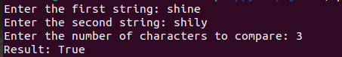

**PROGRAM 8**

**AIM:**

Write a program using functions to implement these formulae for permutations and

combinations.

The Number of permutations of n objects taken r at a time: p(n, r) = n!/(n − r)!.

The Number of combinations of n objects taken r at a time is: c(n, r) = n!/(r! ∗ (n − r)!)

**SOURCE CODE:**

def factorial(num):

if num == 0 or num == 1:

return 1

else:

result = 1

for i in range(2, num + 1):

result *= i

return result

def permutations(n, r):

return factorial(n) // factorial(n - r)

def combinations(n, r):

return factorial(n) // (factorial(r) * factorial(n - r))

n = int(input("Enter the value of n (total objects): "))

r = int(input("Enter the value of r (objects taken at a time): "))

if r > n:

print("Invalid input: r should be less than or equal to n.")

else:

print(f"The number of permutations (P({n}, {r})) is: {permutations(n, r)}")

print(f"The number of combinations (C({n}, {r})) is: {combinations(n, r)}")

**OUTPUT:**

