**Lab Cycle 2**

**Date : 13/03/2025**

**Experiment No: 5**

**AIM : Familiarization of Subquery ,Joins ,Views and Set Operations.**

Subqueries are nested queries used to retrieve data for the main query, often with aggregate functions. Joins combine data from multiple tables based on common keys, with types like INNER JOIN, LEFT JOIN, and RIGHT JOIN. Views are virtual tables that store pre-defined queries, improving readability and security. Set operations like UNION, INTERSECT, and EXCEPT help combine or filter results from multiple queries. Mastering these concepts enhances SQL efficiency and database management

1. Find all employees who locate in the location with the id 1700

SELECT employee_id,first_name,location_id FROM employees WHERE location_id = 1700;

2. Find all employees who do not locate at the location 1700.

SELECT employee_id,first_name,location_id FROM employees WHERE location_id <> 1700;

3.Find the employees who have the highest salary.

SELECT employee_id,first_name,salary FROM employees WHERE salary = (SELECT MAX(salary) FROM employees);

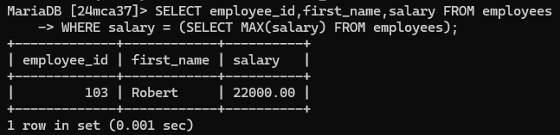

4. Finds all employees who salaries are greater than the average salary of all employees.

SELECT employee_id,first_name,salary FROM employees

WHERE salary > (SELECT AVG(salary) FROM employees);

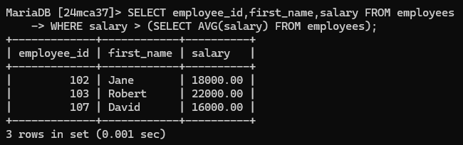

5. Finds all departments (Department Id, Name) which have at least one employee with the salary is greater than 10,000.

SELECT DISTINCT department_id, department_name

FROM departments

WHERE department_id IN (SELECT department_id FROM employees WHERE salary > 10000);

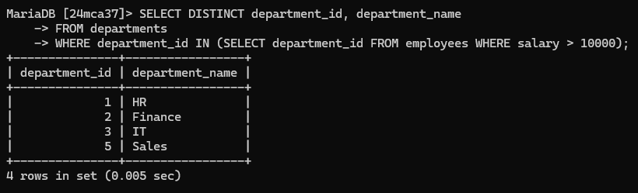

6. Finds all departments (Department Id, Name) that do not have any employee with the salary greater than 10,000.

SELECT department_id, department_name

FROM departments

WHERE department_id NOT IN (SELECT DISTINCT department_id FROM employees WHERE salary > 10000);

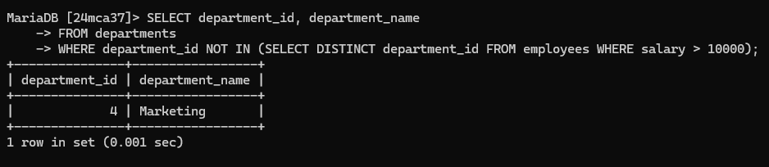

7. Find all employees whose salaries are greater than the lowest salary of every department.

SELECT employee_id,first_name,salary FROM employees

WHERE salary > ANY (SELECT MIN(salary) FROM employees GROUP BY department_id);

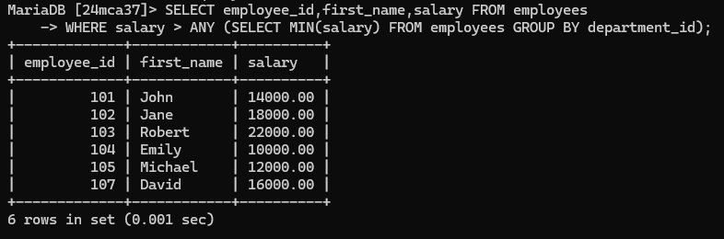

8. Find all employees whose salaries are greater than or equal to the highest salary of every department

SELECT employee_id,first_name,salary FROM employees

WHERE salary >= ALL (SELECT MAX(salary) FROM employees GROUP BY department_id);

9. Calculate the average of average salary of departments. (Hint: SQL subquery in the FROM clause)

SELECT AVG(dept_avg)

FROM (SELECT AVG(salary) AS dept_avg FROM employees GROUP BY department_id) AS temp;

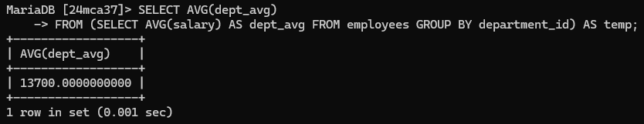

10. Finds the salaries of all employees, their average salary, and the difference between the salary of each employee and the average salary. (Hint: SQL Subquery in the SELECT clause).

SELECT salary, (SELECT AVG(salary) FROM employees) AS avg_salary,

salary - (SELECT AVG(salary) FROM employees) AS salary_difference

FROM employees;

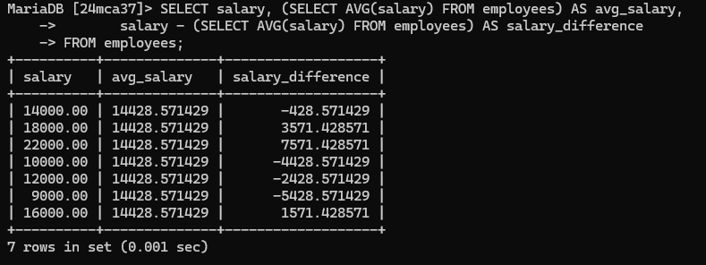

11. Finds all employees whose salary is higher than the average salary of the employees in their departments. (Hint : Use Correlated Subquery).

SELECT e1.employee_id,e1.first_name,e1.salary,e1.department_id

FROM employees e1

WHERE salary > (SELECT AVG(salary) FROM employees e2 WHERE e1.department_id = e2.department_id);

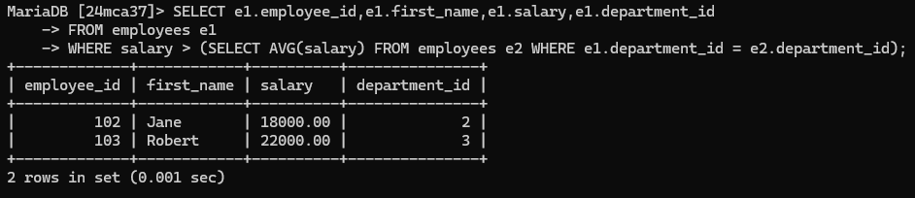

12. Find all employees who have no dependents.

SELECT employee_id,first_name FROM employees WHERE employee_id NOT IN (SELECT employee_id FROM dependents);

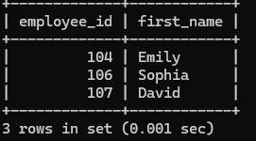

13. . Display first name, last name, department name of employees of the Department with id 1, 2 and 3.

SELECT first_name, last_name, department_name

FROM employees e

JOIN departments d ON e.department_id = d.department_id

WHERE e.department_id IN (1, 2, 3);

14. . Display the first name, last name, job title, and department name of employees who work in department with id 1, 2, and 3 and salary greater than 10000.

SELECT e.first_name, e.last_name, j.job_title, d.department_name

FROM employees e JOIN jobs j ON e.job_id = j.job_id

JOIN departments d ON e.department_id = d.department_id

WHERE e.department_id IN (1, 2, 3) AND e.salary > 10000;

15. Display Department name, street address, postal code, country name and region name of all departments.

SELECT d.department_name, l.street_address, l.postal_code, c.country_name, r.region_name FROM departments d

JOIN locations l ON d.location_id = l.location_id

JOIN countries c ON l.country_id = c.country_id

JOIN regions r ON c.region_id = r.region_id;

16. Write a SQL query to find out which employees have or do not have a department. Return first name, last name, department ID, department name.

SELECT e.first_name, e.last_name, e.department_id, d.department_name

FROM employees e

LEFT JOIN departments d ON e.department_id = d.department_id;

17. Write a SQL query to find those employees whose first name contains the letter ‘Z’. Return first name, last name, department, city, and state province.

SELECT first_name, last_name, department_id, city, state_province

FROM employees

JOIN locations ON employees.location_id = locations.location_id

WHERE first_name LIKE '%Z%';

18**.** Write a SQL query to find all departments, including those without employees Return first name, last name, department ID, department name.

SELECT e.first_name, e.last_name, d.department_id, d.department_name

FROM departments d

LEFT JOIN employees e ON d.department_id = e.department_id;

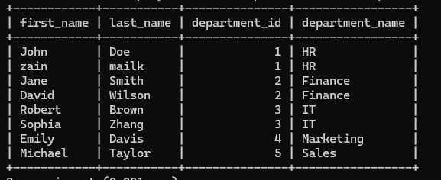

19. Write a SQL query to find the employees and their managers. . Those managers do not work under any manager also appear in the list. Return the first name of the employee and manager.

SELECT e.first_name AS Employee, m.first_name AS Manager

FROM employees e

LEFT JOIN employees m ON e.manager_id = m.employee_id;

20. Write a SQL query to find the employees who work in the same department as the employee with the last name Taylor. Return first name, last name and department ID.

SELECT first_name, last_name, department_id

FROM employees

WHERE department_id = (SELECT department_id FROM employees WHERE last_name = 'Taylor');

21. Write a SQL query to calculate the difference between the maximum salary of the job and the employee's salary. Return job title, employee name, and salary difference

SELECT j.job_title, e.first_name, e.last_name, (j.max_salary - e.salary) AS salary_difference FROM employees e JOIN jobs j ON e.job_id = j.job_id;

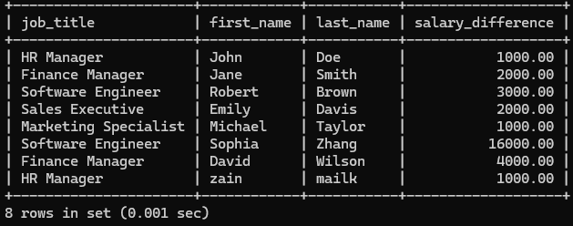

22. Write a SQL query to calculate the average salary, the number of employees receiving commissions in that department. Return department name, average salary and number of employees of all departments.

SELECT d.department_name, AVG(e.salary) AS avg_salary, COUNT(e.commission_pct) AS num_commissioned

FROM employees e JOIN departments d ON e.department_id = d.department_id

GROUP BY d.department_name;

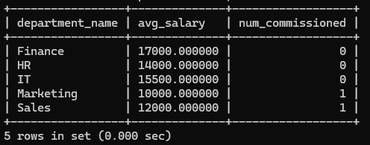

23.Create a view which contains employee name, employee id, phone number, job title, department name, manager name of employees belongs to department whose location is in ‘Delhi’ and display the details,

CREATE VIEW delhi_employees AS

SELECT e.first_name, e.last_name, e.employee_id, e.phone_number, j.job_title, d.department_name, m.first_name AS manager_name

FROM employees e JOIN jobs j ON e.job_id = j.job_id

JOIN departments d ON e.department_id = d.department_id

JOIN locations l ON d.location_id = l.location_id

LEFT JOIN employees m ON e.manager_id = m.employee_id

WHERE l.city = 'Delhi';

SELECT * FROM delhi_employees;

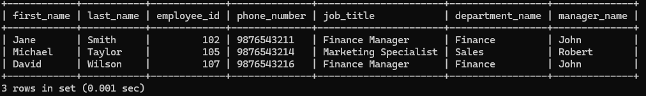

24.Use the above created view to obtain the names of employees whose job title is ‘Manager’ and department is ‘Finance’.

SELECT first_name, last_name FROM delhi_employees

WHERE job_title = 'Finance Manager' AND department_name = 'Finance';

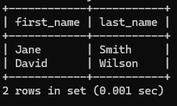

25.Check whether it is possible to update the phone number of employee whose first name is ‘Smith’ by using the above created view.

UPDATE delhi_employees SET phone_number = '1234567890' WHERE first_name = 'Smith';

26.Display the details of employee who have no dependents.

SELECT employee_id,first_name,last_name,email,department_id,salary FROM employees WHERE employee_id NOT IN (SELECT employee_id FROM dependents);

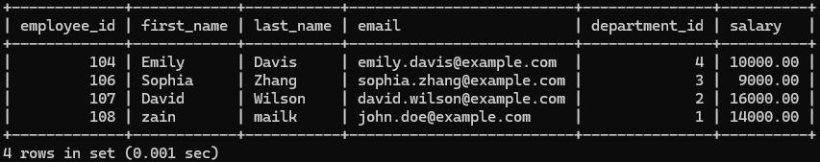

27.Display the details of employee who manager id is 101 or 201. (Use Union Clause)

SELECT employee_id,first_name,last_name,email,department_id,salary FROM employees WHERE manager_id = 101UNION SELECT employee_id,first_name,last_name,email,department_id,salary FROM employees WHERE manager_id = 201;

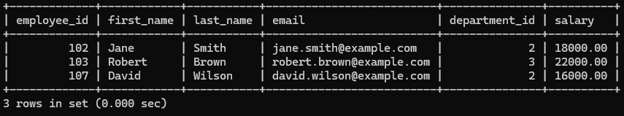

28.Display the details of employees who have at least one dependent.

SELECT employee_id,first_name,last_name,email,department_id,salary FROM employees WHERE employee_id IN (SELECT employee_id FROM dependents);

