1.a)

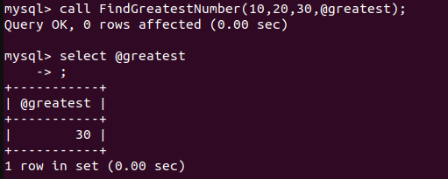

1.b

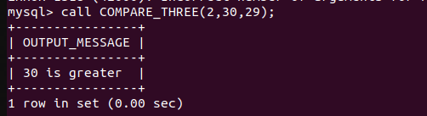

2.

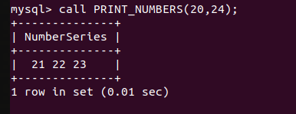

3.

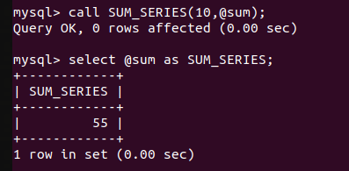

4.

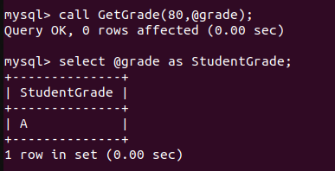

5.

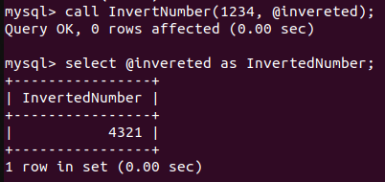

6.

7.

INSERT INTO Customer (name, city, credits)

VALUES

('John Doe', 'New York', 1000.00),

('Jane Smith', 'Los Angeles', 1500.50),

('Alice Johnson', 'Chicago', 1200.75);

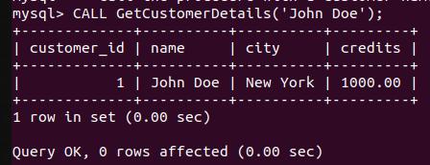

8.

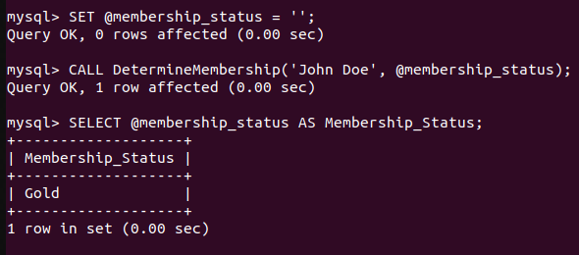

11.

CREATE TABLE Emp_salary ( emp_id INT AUTO_INCREMENT PRIMARY KEY, emp_name VARCHAR(100), no_of_working_days INT, designation VARCHAR(50), salary DECIMAL(10, 2) );

INSERT INTO Emp_salary (emp_name, no_of_working_days, designation)

-> VALUES

-> ('naveen', 22, 'Assistant Professor'),

-> ('mathew', 25, 'Clerk'),

-> ('vishnu', 20, 'Programmer'),

-> ('jerin',18,'clerk');

