20MCA134 ADVANCED DBMS LAB

**LAB CYCLE 1**

**Experiment No: 1**

**Familiarization of DDL Commands**

Data Definition Language (DDL) - These SQL commands are used for creating, modifying,

and dropping the structure of database objects. The commands are CREATE, ALTER,

DROP, RENAME, and TRUNCATE.

**A.** Consider the database for a college. Write SQL commands to implement the following:

1. Create a database

**create database 24mca48;**

2. Select the current database

**use 24mca48;**

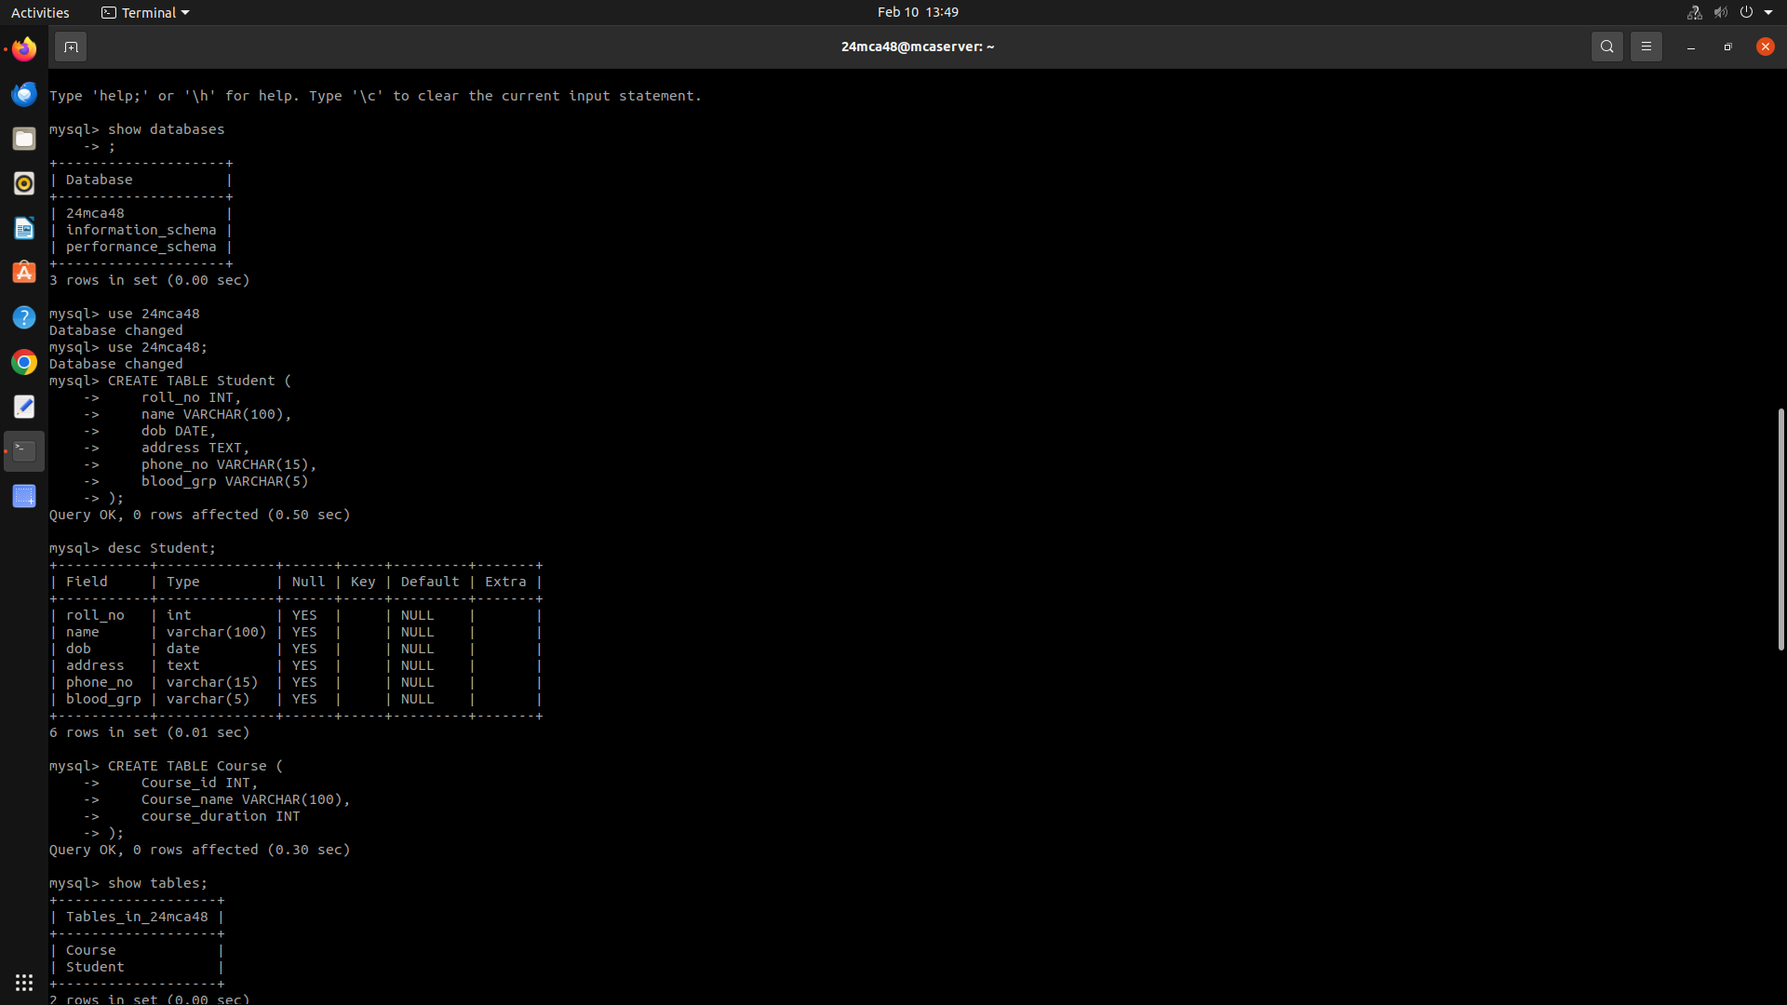

3. Create the following tables:

a) Student (roll_no integer, name varchar, dob date, address text, phone_no varchar, blood_grp varchar)

**create table student( roll_no int, name varchar(30), dob date, address varchar(255), phone_no varchar(11), blood_group char(2));**

b) Course (Course_id integer, Course_name varchar, course_duration

integer)

**create table course(course_id int NOT NULL, course_name varchar(20), course_duration int);**

4. List all tables in the current database.



5. Display the structure of the Student table.



6. Drop the column blood_grp from Student table.

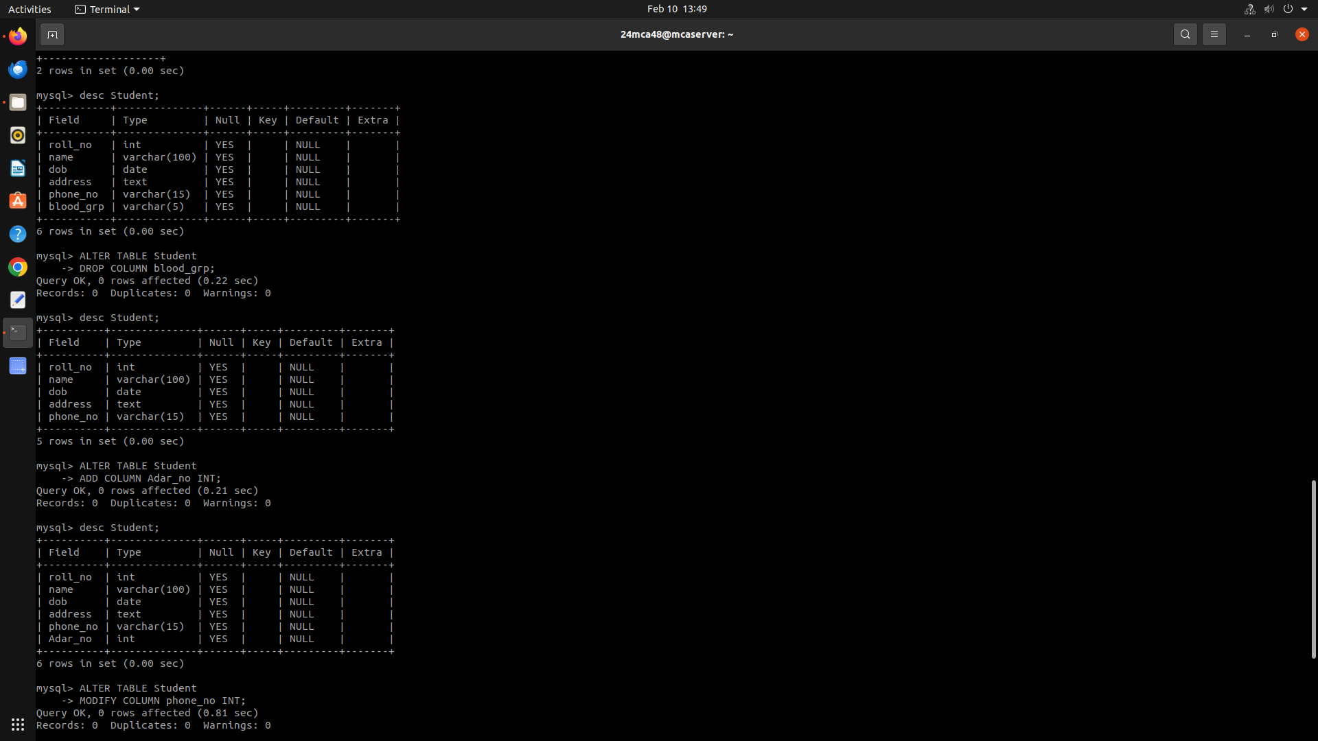

7. Add a new column Adar_no with domain number to the table Student.



8. Change the datatype of phone_no from varchar to int.

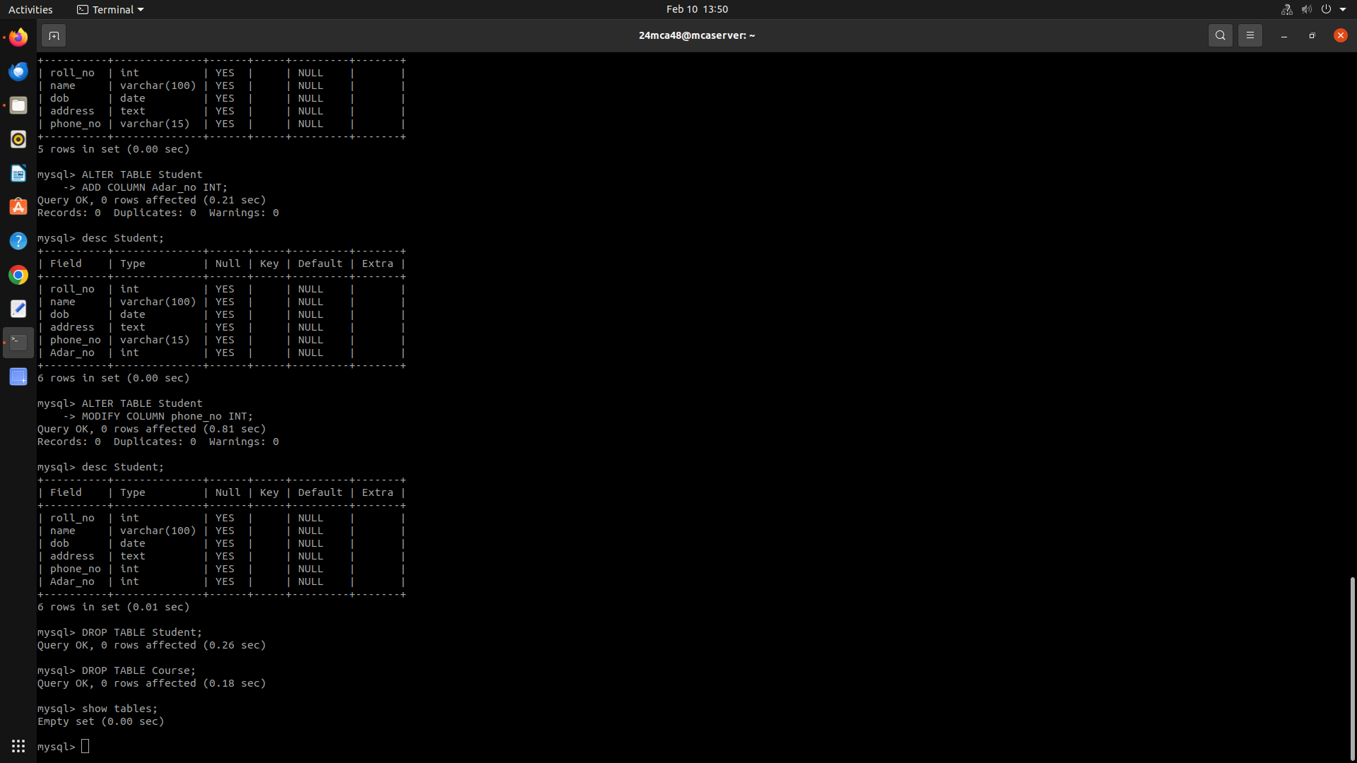

9. Drop the tables.

**Drop table student;**

**Drop table college;**

**10. Delete the database.**

**Drop database 24mca48;**

**B.** Consider the database for an organization. Write SQL commands to implement the following:

1. Create a database

**create database 24mca48;**

2. Select the current database

**use 24mca48;**



3. Create the following tables:

a) Employee (emp_no varchar, emp_name varchar, dob date, address

text, mobile_no integer, dept_no varchar, salary integer)

**CREATE TABLE employee(emp_no varchar(5), emp_name varchar(30), dob date, address varchar(255), mobile_no int, dpt_no varchar(10), salary int);**

b) Department (dept_no varchar, dept_name varchar, location varchar)

**CREATE TABLE department(dpt_no varchar(100), dpt_name varchar(100), location varchar(255));**

4. List all tables in the current database.

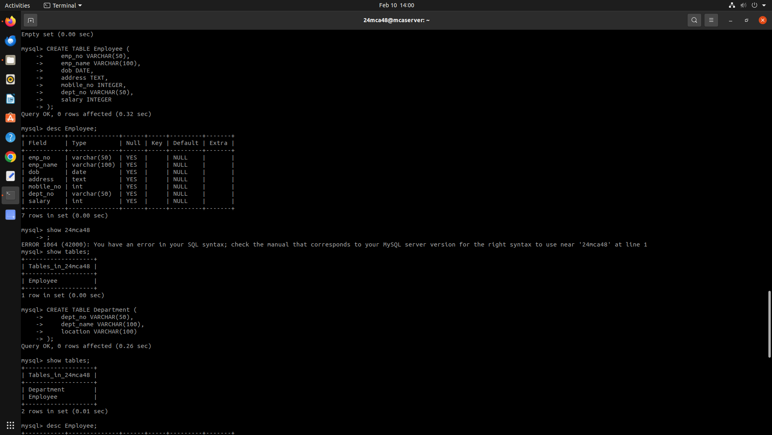

5. Display the structure of the Employee table and Department table.

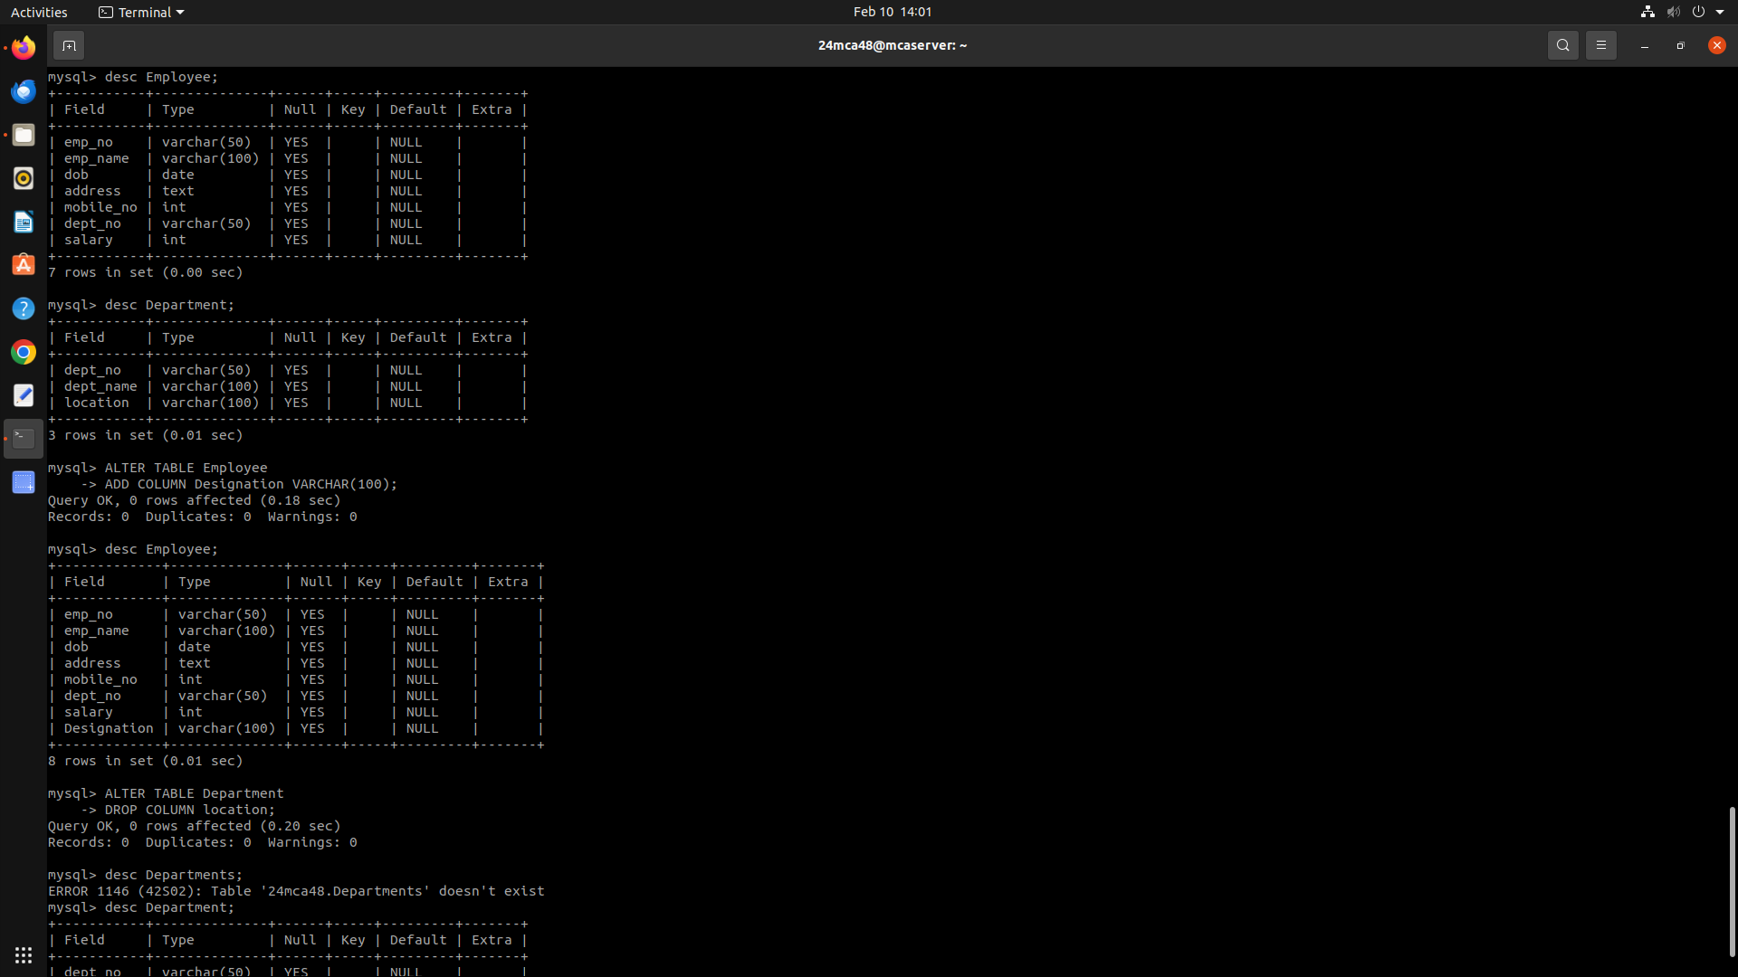



6. Add a new column ‘Designation’ to the table Employee.



7. Drop the column ‘location’ from Department table.

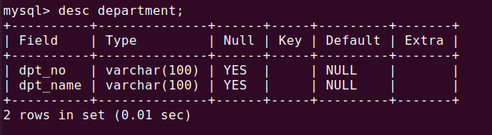

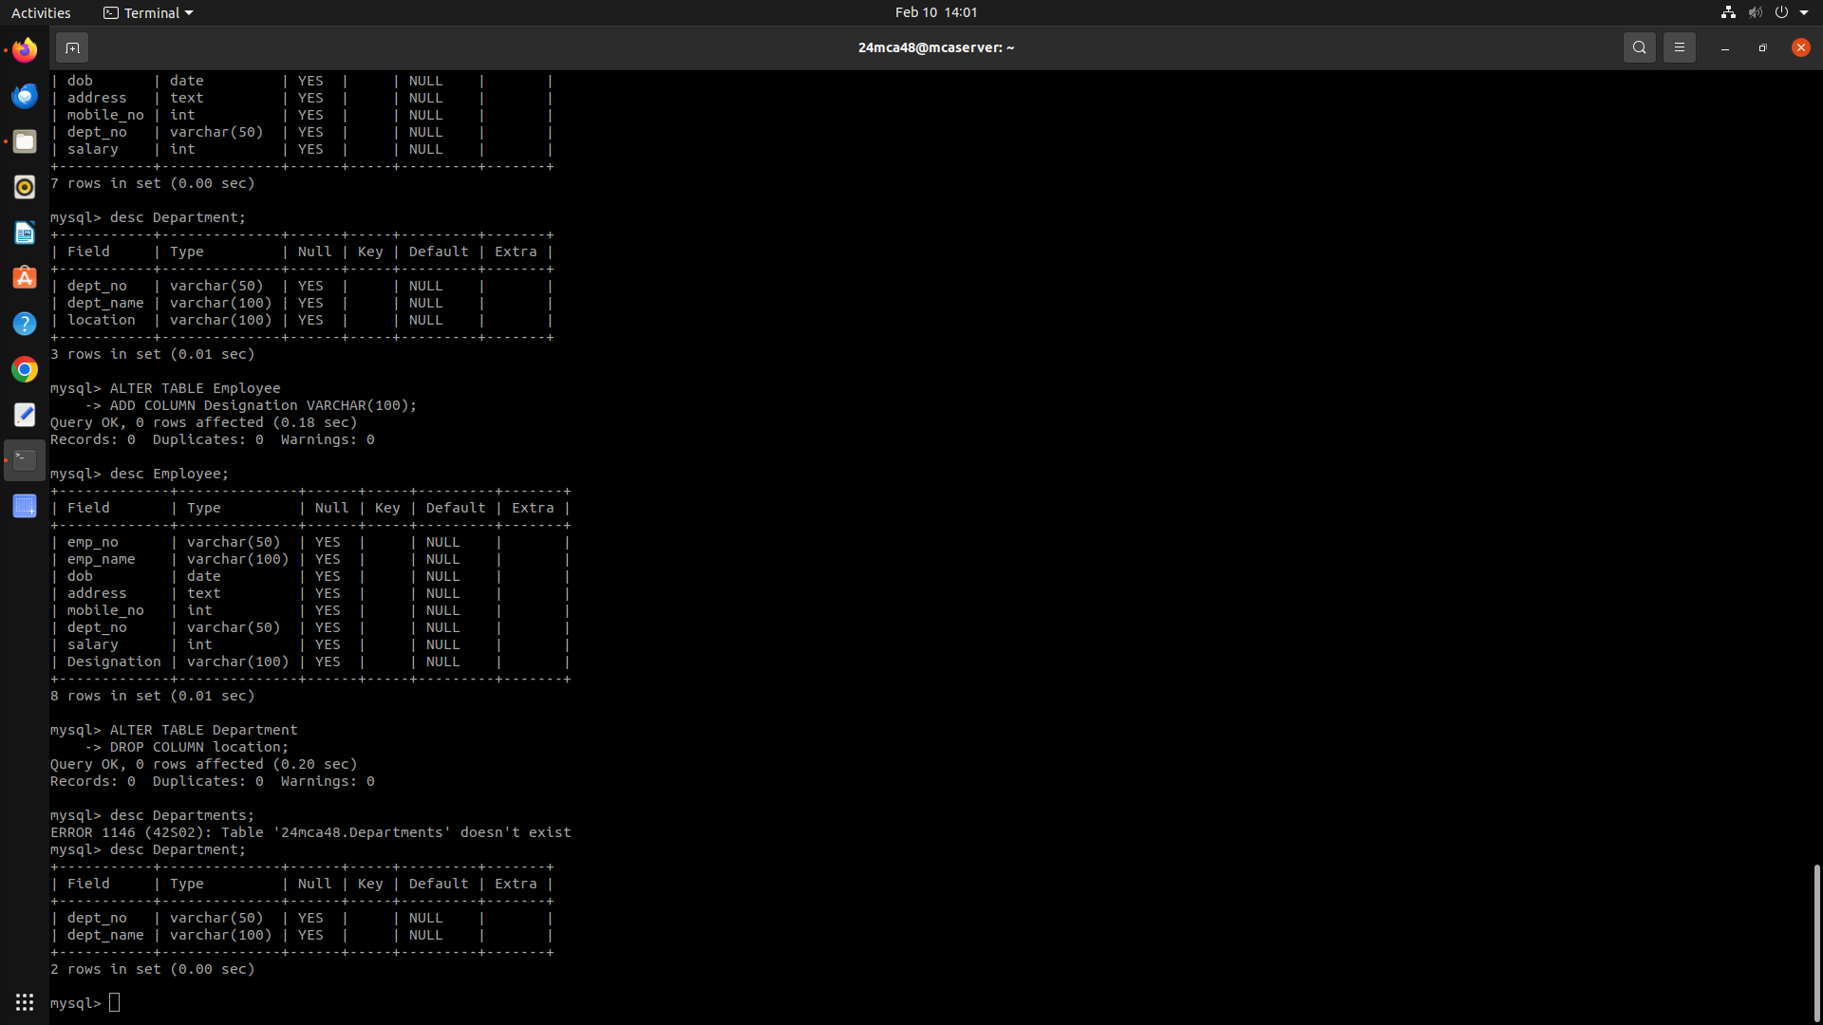

**Experiment No: 2**

**Familiarization of SQL Constraints.**

1. Create new table Persons with attributes PersonID (integer, PRIMARY KEY),

Name (varchar , NOT NULL), Aadhar (Number, NOT NULL, UNIQUE), Age

(integer , CHECK>18).

**CREATE TABLE persons(person_id int primary key, name varchar(200) NOT NULL, aadar INT NOT NULL UNIQUE, age int, CHECK(age > 18));**

2. CREATE TABLE Orders with attributes OrderID (PRIMARY KEY),

OrderNumber(NOT NULL) and PersonID( set FOREIGN KEY on attribute

PersonID referencing the column PersonId of Person table)

**CREATE TABLE orders(order_id int primary key, order_no varchar(255) NOT NULL, person_id int, FOREIGN KEY(person_id) REFERENCES persons(person_id));**

3. Display the structure of Persons tables.

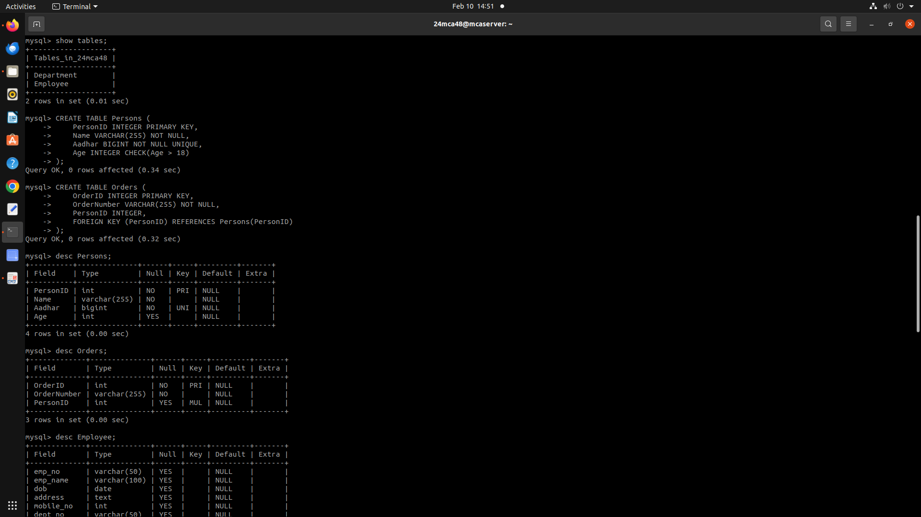

4. Display the structure of Orders tables.



5. Add emp_no as the primary key of the table Employee.

**ALTER TABLE employee MODIFY COLUMN emp_no int primary key;**

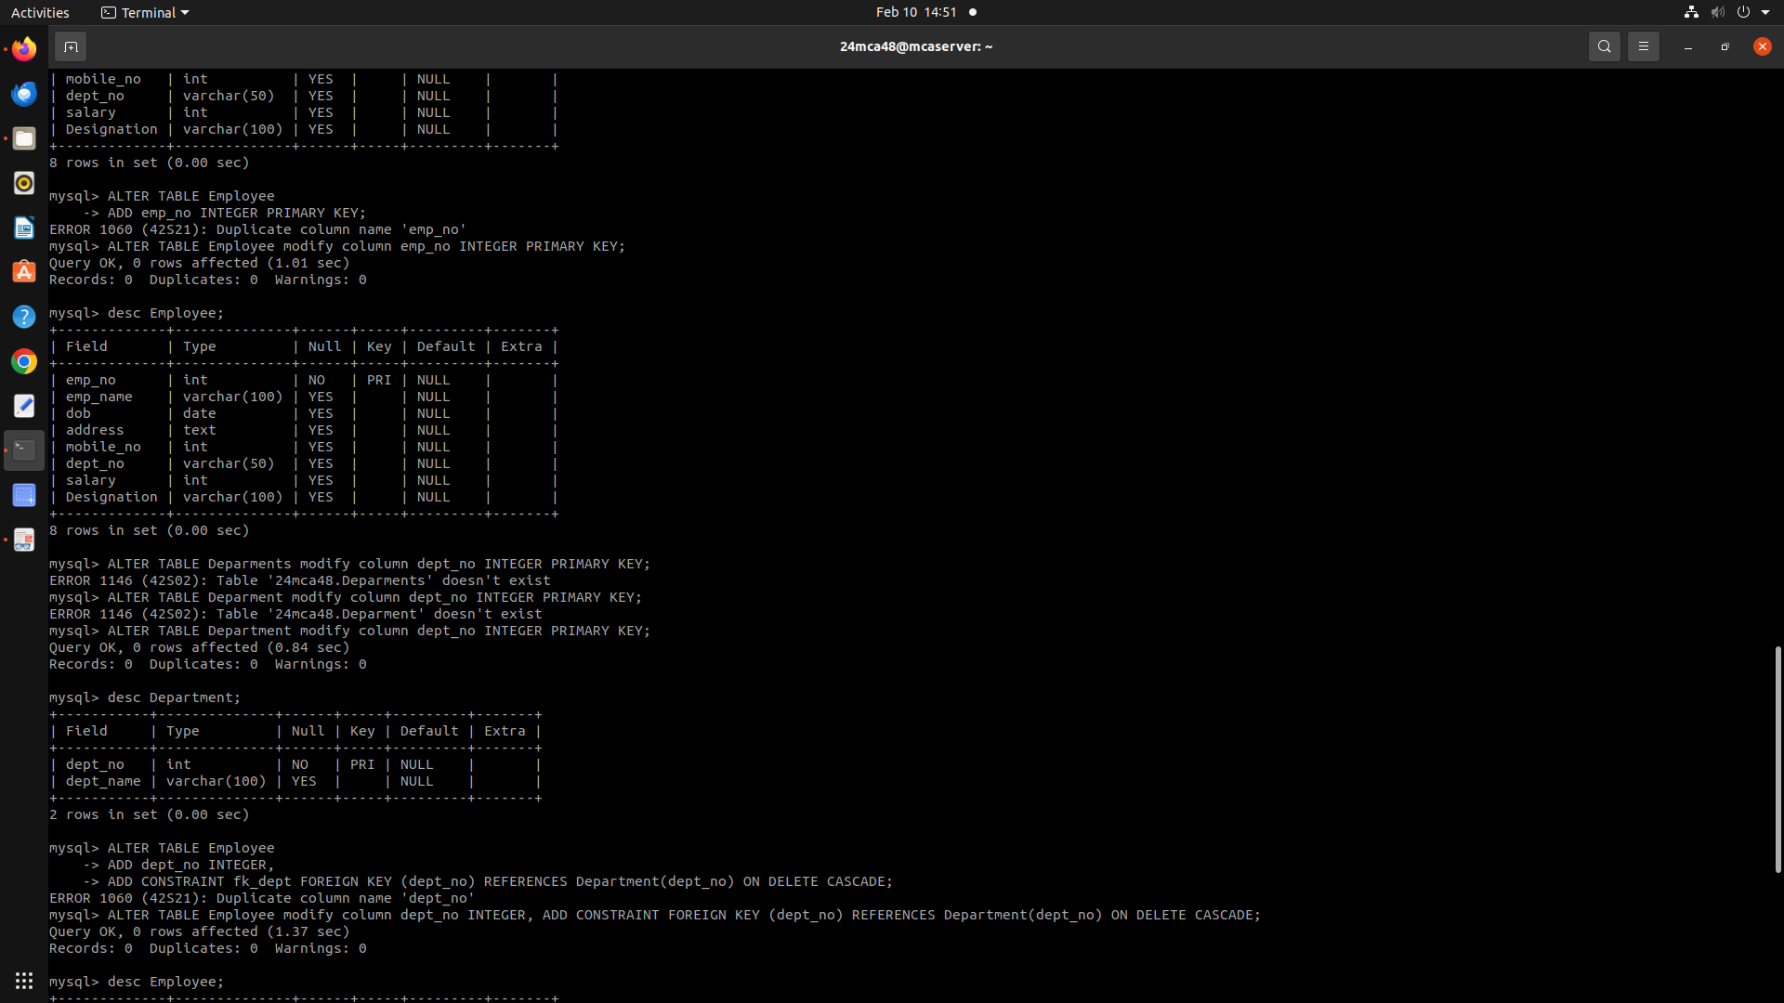

6. Add dept_no as the primary key of the table Department.

**ALTER TABLE department MODIFY COLUMN dpt_no int primary key;**



7. Add dept_no in Employee table as the foreign key reference to the table Department

with on delete cascade.

**ALTER TABLE employee modify column dept_no INTEGER, ADD CONSTRAINT FOREIGN KEY(**DEPT_NO**) REFERENCES Department(dept_no) ON DELETE CASCADE;**

8. Drop the primary key of the table Orders.

**ALTER TABLE orders DROP order_id;**

