Homework 3

提高2101班杨筠松U202115980

function image_out = homomorphic_filter(image_in, high, low, c, d0)

I = double(image_in);

[M, N] = size(I);

a = M / 2;

b = N / 2;

log_img = log1p(I);

log_fft = fftshift(fft2(log_img));

D = zeros(M, N);

H = zeros(M, N);

for i = 1:M

for j = 1:N

D(i, j) = sqrt((i - a)^2 + (j - b)^2);

H(i, j) = (high - low) * (1 - exp(-c * (D(i, j)^2 / d0^2))) + low;

end

end

H = ifftshift(H);

filtered_fft = H .* log_fft;

log_ifft = ifft2(filtered_fft);

image_out = real(expm1(log_ifft));

end

image_in = imread('data/image1.png');

if isempty(image_in)

disp('Image not found');

else

% 转为灰度图，如果需要

if size(image_in, 3) == 3

image_in = rgb2gray(image_in);

end

% 应用同态滤波

image_out = homomorphic_filter(image_in, 2.0, 0, 1.0, max(size(image_in)));

% 显示结果

figure;

subplot(1, 2, 1);

imshow(image_in);

title('Original');

subplot(1, 2, 2);

imshow(image_out, []);

title('After');

end

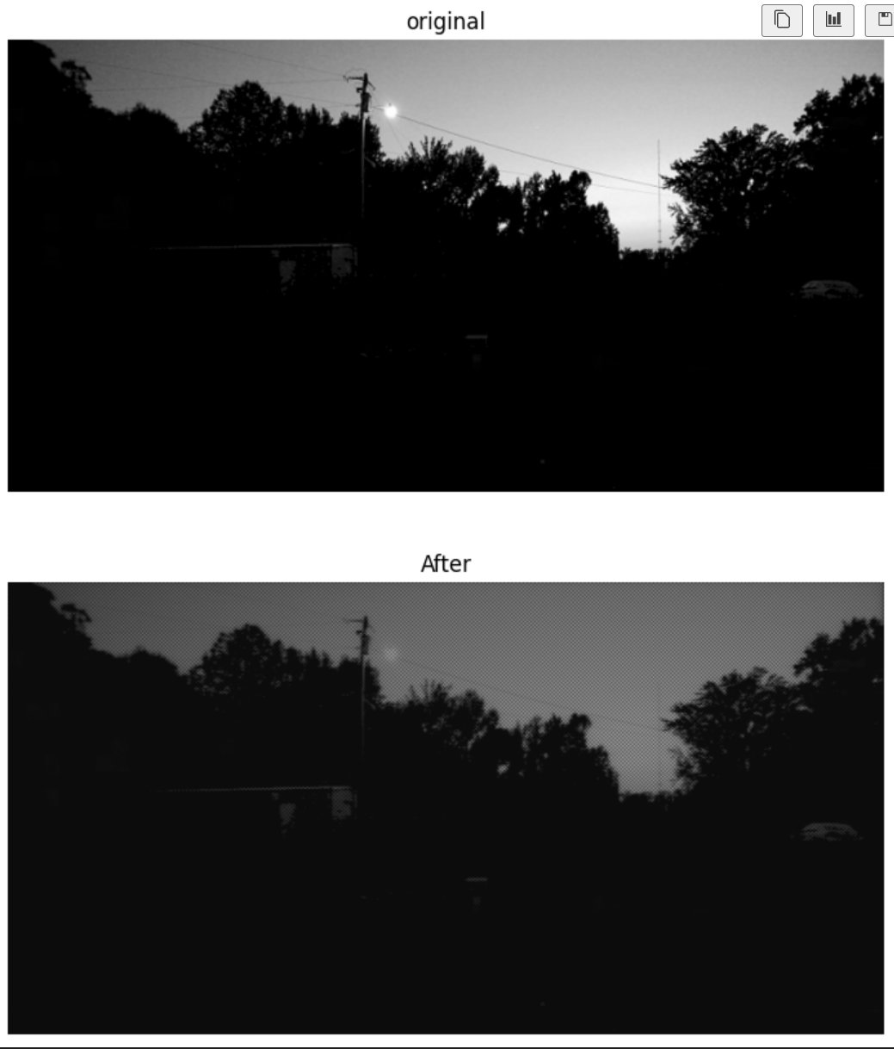

image_path = 'data/image2.png';

img = imread(image_path);

if isempty(img)

disp('Image not found!');

else

if size(img, 3) == 3

img = rgb2gray(img);

end

global_hist_eq = histeq(img);

% CLAHE

clahe_eq = adapthisteq(img, 'ClipLimit', 0.02, 'NumTiles', [8 8]);

figure;

subplot(1, 3, 1);

imshow(img);

title('Original Image');

subplot(1, 3, 2);

imshow(global_hist_eq);

title('Global Histogram Equalization');

subplot(1, 3, 3);

imshow(clahe_eq);

title('CLAHE');

end

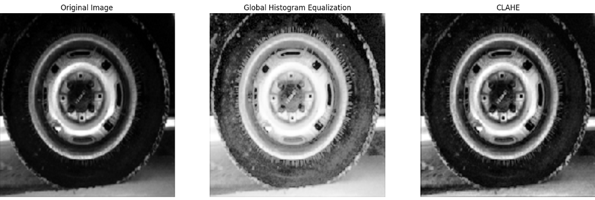

original = imread("cameraman.tif");

figure;

distorted = imread("C:\Users\DELL\Desktop\inclass\DIPlab_source\1.jpg");

subplot(121);imshow(original,[]),title('Original');

subplot(122);imshow(distorted,[]),title('distorted');

[movingPoints,fixedPoints] = cpselect(distorted,original,"Wait",true);

tform = fitgeotform2d(movingPoints,fixedPoints,'polynomial',3);

Roriginal = imref2d(size(original));

recovered = imwarp(distorted,tform,OutputView=Roriginal);

figure;

montage({original,recovered})

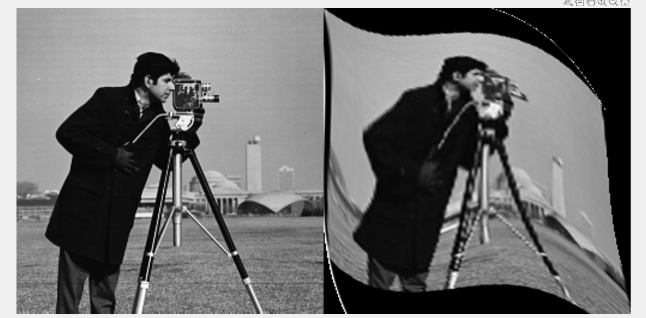

img = imread('redeye.jpg');

% rgb to hsi model, implementation in rgb2hsi

hsi_img = rgb2hsi(img);

% get hue and saturation of img.

hue_channel = hsi_img(:,:,1);

saturation_channel = hsi_img(:,:,2);

% marking red eye region

red_eye_mask = (hue_channel > 0.9) & (hue_channel < 1.0)...

& (saturation_channel > 0.4);

% turn 0 for red eye region

saturation_channel(red_eye_mask) = 0;

hsi_img(:,:,2) = saturation_channel;

% from hsi return to rgb

output_img = hsi2rgb(hsi_img);

figure;

subplot(1,2,1); imshow(img); title('original');

subplot(1,2,2); imshow(output_img); title('alleviating red eye effect');

