Figures

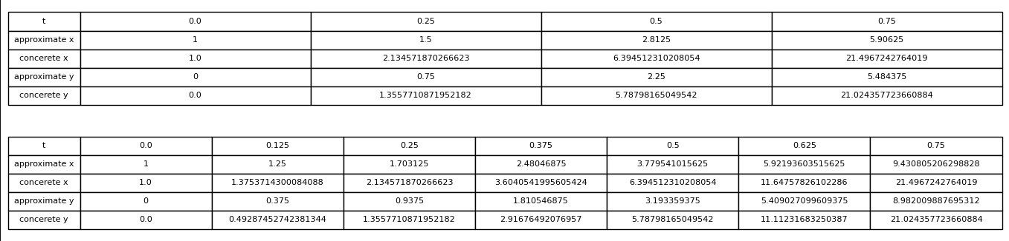

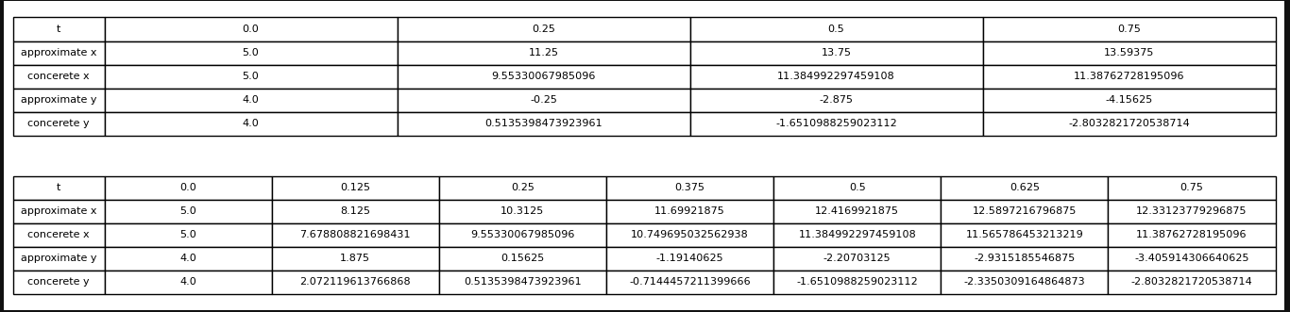

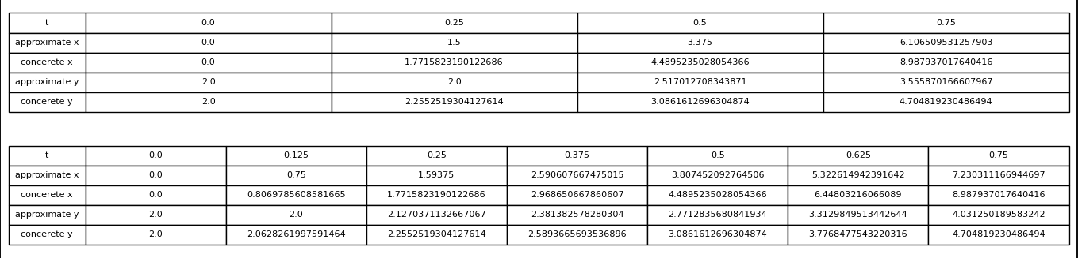

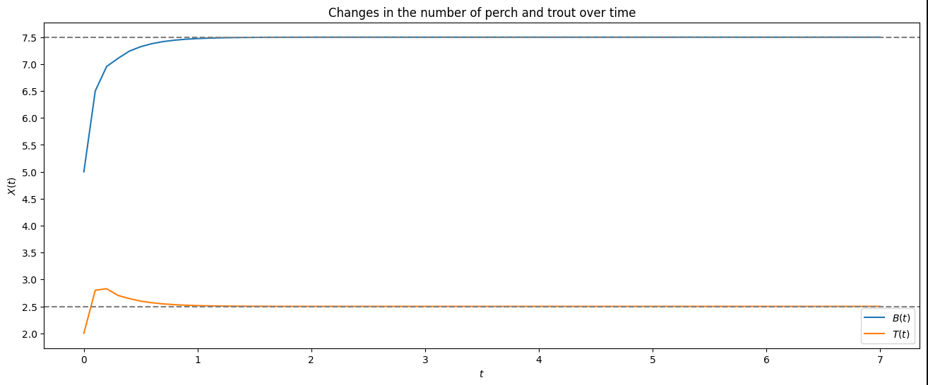

You may have a better view of codes and figures in the ipynb file.