Filling Township Board Vacancies
Due to Death or Resignation



Michigan Townships Association
Member Information Services
December 2015

Revised Statutes of 1846 (EXCERPT) Resignations, Vacancies and Supplying Vacancies.

41.56 Resignations of officers.
Sec. 56.
Resignations of all [township] officers shall be in writing, signed by the officer resigning, and addressed to the township board and shall be delivered to and filed by the township clerk. The resignation shall be effective when accepted by the township board.

MICHIGAN ELECTION LAW (EXCERPT) Act 116 of 1954

168.370 Elective or appointive township office; appointment to fill vacancy; temporary appointment; effect of resignation; special election; vacancy in office of township constable.
Sec. 370.
- Except as provided in section 370a or subsection (2), if a vacancy occurs in an elective or appointive township office, the vacancy shall be filled by appointment by the township board, and the person appointed shall hold the office for the remainder of the unexpired term.
- If 1 or more vacancies occur in an elective township office that cause the number of members serving on the township board to be less than the minimum number of board members that is required to constitute a quorum for the transaction of business by the board, the board of county election commissioners shall make temporary appointment of the number of members required to constitute a quorum for the transaction of business by the township board. An official appointed under this subsection shall hold the office only until the official's successor is elected or appointed and qualified. An official who is temporarily appointed under this subsection shall not vote on the appointment of himself or herself to an elective or appointive township office.
- If a township official submits a written resignation from an elective township office, for circumstances other than a resignation related to a recall election, that specifies a date and time when the resignation is effective, the township board, within 30 days before that effective date and time, may appoint a person to fill the vacancy at the effective date and time of the resignation. The resigning official shall not vote on the appointment.
- Except as provided in subsection (5), if the township board does not make an appointment under subsection (3), or if a vacancy occurs in an elective township office and the vacancy is not filled by the township board or the board of county election commissioners within 45 days after the beginning of the vacancy, the county clerk of the county in which the township is located shall call a special election within 5 calendar days to fill the vacancy. Not later than 4 p.m. on the fifteenth calendar day after the county clerk calls a special election under this section, the township party committee for each political party in the township shall submit a nominee to fill the vacancy. The special election shall be held on the next regular election date that is not less than 60 days after the deadline for submitting nominees under this section or 70 days after the deadline for submitting nominees under this section if the next regular election date is the even year August primary or the general November election. Notice of the special election shall be given in the same manner required by section 653a. A special election called under this section does not affect the rights of a qualified elector to register for any other election. A person elected to fill a vacancy shall serve for the remainder of the unexpired term.
- Subsection (4) does not apply to the office of township constable. If a vacancy occurs in the office of township constable, the township board shall determine if and when the vacancy shall be filled by appointment. If the township board does not fill the vacancy by appointment, the office of township constable shall remain vacant until the next general or special election in which township offices are filled.

MICHIGAN ELECTION LAW (EXCERPT) Act 116 of 1954

168.370a Filling vacancy in township office; term of appointee; term of elected successor.
Sec. 370a.
Notwithstanding the provisions of section 370, if a vacancy occurs in an elective or appointive township office, which vacancy is filled by appointment by the township board or the board of county election commissioners and the vacancy occurs more than 7 days before the nominating petition filing deadline as provided in section 349 for the general November election that is not the general November election at which a successor in office would be elected if no vacancy, then the person appointed shall hold office only until a successor is elected at the next general November election in the manner provided by law and qualifies for office. The successor shall hold the office for the remainder of the unexpired term.

MICHIGAN ELECTION LAW (EXCERPT) Act 116 of 1954

168.363 Township officers; oath of office.
Sec. 363.
All township officers shall, before entering upon the duties of their offices, take and subscribe the oath as provided in section 1 of article 11 of the state constitution before the township clerk or other officer authorized to administer oaths, and file the same with the township clerk who shall record the same; and such oath shall be administered without reward and certified by the officer before whom the same was taken, with the date of taking the same.
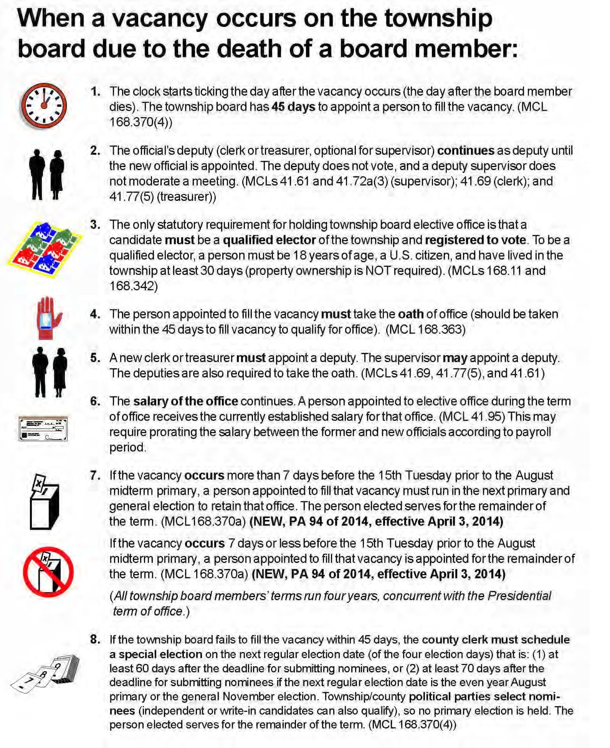
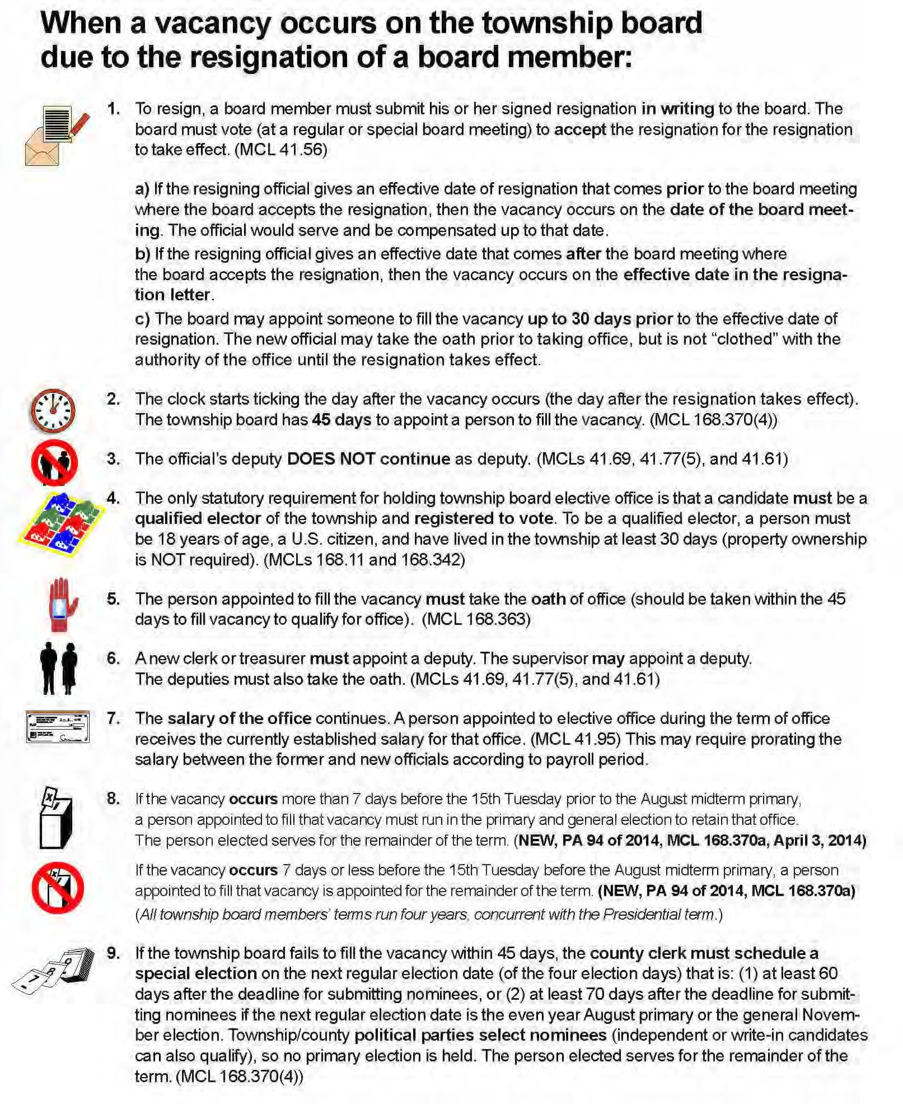

Frequently Asked Questions

Q Our supervisor resigned November 30. What do we do now?
First, you need to confirm that the resignation has actually taken effect.

A resigning township board member must submit a written resignation to the township board, stating the date on which his or her resignation will take effect—the last day they intend to hold office. At a regular or special meeting of the township board, the board must vote to accept the resignation before it can become effective. Once the board accepts the resignation, it takes effect either on the date stated in the letter or the date the board voted to accept it, whichever comes later.

For example, let’s say that the supervisor stated his resignation was effective November 1, but the board doesn’t meet and vote to accept it until November 15. The resignation is not effective until November 15, and the supervisor actually held office and should be paid through that date.

If the supervisor stated his resignation date as November 30, and the board voted to accept it at the November 15 board meeting, then the supervisor holds office until November 30, and is paid through that date.

Q When do we appoint someone to fill the vacancy?
The township board must appoint someone to fill a vacancy on the township board within 45 calendar days after the vacancy is created. The appointee must take the oath of office before assuming the office.

Q How do we choose the appointee?
The township board can appoint anyone who is eligible to hold elective township office—basically any person who has been registered to vote and a resident of the township for at least 30 days. The board is not required to advertise the vacancy or solicit resumes, but doing so may attract a larger or more capable pool of candidates. The township board does not consider a slate of candidates—instead, the first person nominated who receives a second and a majority vote of the board members present and voting is the appointee. All interviews conducted by the township board, and any actions taken by the board to “shorten the list” of candidates, must be done in open session at a public board meeting. As always, the vote to appoint must be a voice vote, not a paper or secret ballot.

Q How long will the appointee serve?
If the vacancy occurs more than 182 days prior to the mid-term general November election (November 4, 2014), then the position must be on the 2014 August primary and November general election ballot. The person appointed to fill the vacancy serves only until the election is certified and the winner takes the oath of office (it can be the person appointed to fill the vacancy). The winner serves out the remainder of the term.

Q Our board is divided, and with the vacancy, we have four members voting on the appointment. What if we can’t agree on a candidate?
If the township board does not appoint someone to fill the vacancy, the county clerk must call a special election at the township’s expense to fill the vacancy. Whoever is elected will fill out the remainder of the term; the position is not also on the mid-term election ballot. It is, however, usually in the best interest of the township for the board to work together, possibly making compromises or concessions, to do their duty as elected officials and fill the vacancy within the 45 days.

Q If the clerk resigns, is her deputy automatically the new clerk?
No, when an elected official resigns, the appointment of his or her deputy also ends.

Q Who can write or issue checks if the clerk or treasurer resigns?
No one. If a clerk or a treasurer resigns, the deputy’s appointment also ends. Until a new clerk or treasurer is appointed, no checks, payments or disbursements can be issued. In other words, no checks can be written, and no paychecks or bill payments can be made.

So it can be important for a township board to consider the implications of voting to accept a clerk or treasurer’s resignation, especially if he or she does not give the board a lot of advance notice. A township board does not have to vote to accept a resignation as soon as it receives it.

Sometimes a resigning official is just having a temporary “bad day,” and a board can consider holding off on accepting the resignation to give them time to cool down.

But even if a resigning official is serious about resigning, and has no intention of staying or working until their resignation is accepted by the board, a board can delay the loss of the deputy by holding off on voting until potential candidates for a vacancy can be identified.

However, a vacancy is not official until the board has voted to accept the resignation—so the resigning official can change their mind and withdraw their resignation if the board has not yet voted to accept it.

And a resignation does not take effect until the board votes to accept it and the last day has been reached. So that means that the resigning official is still legally entitled to the salary of the office until the resignation takes effect, regardless of whether they perform any of the duties of the office in the meantime.

Q Our treasurer is thinking about retiring, but she wants to be available to help train her successor. Is that possible?
Yes. The resigning official can give any date in the future as the effective date of his or her resignation. The township board may appoint the successor up to 30 days prior to that effective date, although the resigning official cannot vote to appoint his or her successor. It is important to note that this can only be done within 30 days prior to the date of resignation and no earlier than that.

The outgoing treasurer is paid through the date of his or her resignation. The new treasurer is not paid the treasurer’s salary until the outgoing treasurer’s resignation takes effect and the new treasurer takes the oath.

Q May another township board member be appointed to fill a vacancy in another board office?
Yes.

Q May a township board member vote to appoint him or herself to another board office vacancy? Yes. MCL 168.370, the section of the Michigan Election Law governing vacancies in elective township office, states that a vacancy shall be filled by appointment by the township board. (MCL 168.370(1)) This means that it is the duty of each board member to vote on the appointments to the township board.

There are two exceptions to that rule:

MCL 168.370(2) specifically states that an official who is temporarily appointed by the board of county election commissioners to restore a quorum when enough vacancies occur to prevent a quorum “shall not vote on the appointment of himself or herself to an elective or appointive township office” (township board offices are “elective” offices).

MCL 168.370(3) also specifically addresses a situation when a township board member submits a written resignation in advance of his or her effective resignation date, and the board appoints a person to fill the vacancy within 30 days prior to that effective date:

“If a township official submits a written resignation from an elective township office, for circumstances other than a resignation related to a recall election, that specifies a date and time when the resignation is effective, the township board, within 30 days before that effective date and time, may appoint a person to fill the vacancy at the effective date and time of the resignation. The resigning official shall not vote on the appointment.”

So the “resigning official shall not vote on the appointment” of his or her successor. According to MTA Legal Counsel, this prohibition is limited to voting, and does not require the person to recuse themselves from discussions on the appointment, just abstaining from voting.

Because the Election Law states specific exceptions to the rule, and does not specifically prohibit a township board member from voting to appoint him or herself to an elective or appointive township office where the vacancy is created by death or resignation and does not involve a temporary appointment to restore quorum, a township official may vote to appoint him or herself to fill a board vacancy.

Q If a board member is appointed to fill a vacancy in another board office, can they vote to appoint the person to succeed them?
Yes. Once a board member is appointed to and takes the oath to assume another board office, then he or she no longer holds the prior office. They do not have to resign their prior office. MCL 168.370(3) states: “The resigning official shall not vote on the appointment.” Because the Election Law specifically prohibits the resigning official from voting on the appointment of their successor, but does not prohibit an official who did not resign, MTA Legal Counsel interpret that to mean that the board member whose appointment created a vacancy may vote on filling that previously held office.

Q Must the person appointed to fill a township board vacancy take the oath of office—even if they are already a board member?
Yes. Every time a person is appointed (or elected) to township board office, they must take the oath of office to qualify to hold the office. This includes a person who is already a trustee, for example, who is appointed to fill a vacancy in another board office.

Q Who has authority to administer oaths to township officials?
The positions that are authorized by law to administer the oath of office are the township clerk/deputy clerk, supervisor/deputy supervisor, county clerk/deputy county clerk, notary public, judge/justice (of any court of record), and state senator or representative.

