Experiment 4
To Implement Mathematical and Geometric Operations
Roll no. 4117

import cv2
image1 = cv2.imread('car.jpg')
print(image1.shape)
image4=cv2.resize(image1, (485,718))
cv2.imshow("first img",image4)
cv2.waitKey(0)

image2 = cv2.imread('nature.png')
print(image2.shape)
cv2.imshow("second img",image2)
cv2.waitKey(0)

addition = cv2.add(image2, image4)
cv2.imshow("Added img",addition)
cv2.waitKey(0)

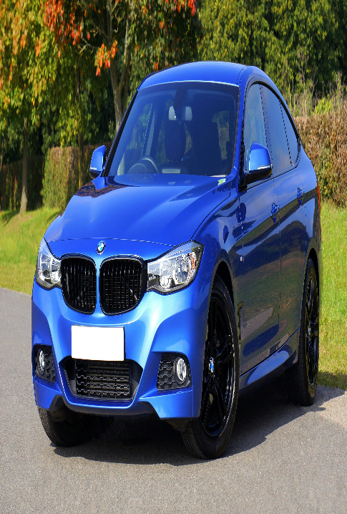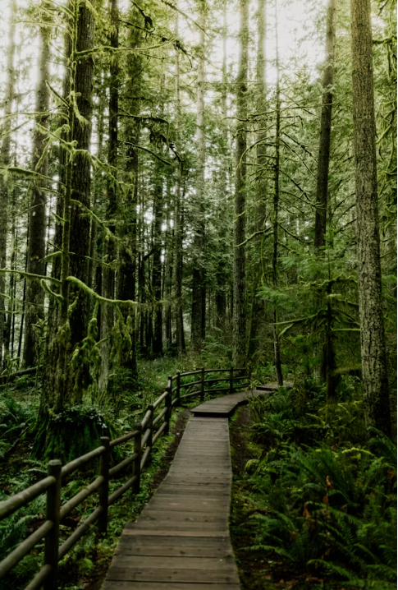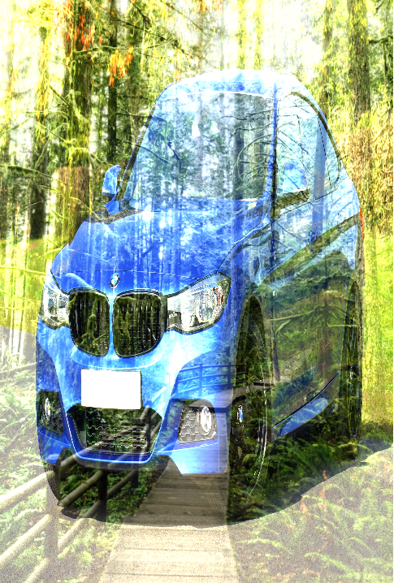
Subtraction:
import cv2
image1 = cv2.imread('car.jpg')
print(image1.shape)
image4=cv2.resize(image1, (485,718))
cv2.imshow("first img",image4)
cv2.waitKey(0)

image2 = cv2.imread('nature.png')
print(image2.shape)
cv2.imshow("second img",image2)
cv2.waitKey(0)

addition = cv2.subtract(image2, image4)
cv2.imshow("Added img",addition)
cv2.waitKey(0)

3. Multiplication.:
import cv2
image1 = cv2.imread('car.jpg')
print(image1.shape)
image4=cv2.resize(image1, (485,718))
cv2.imshow("first img",image4)
cv2.waitKey(0)

image2 = cv2.imread('nature.png')
print(image2.shape)
cv2.imshow("second img",image2)
cv2.waitKey(0)

addition = cv2.multiply(image2, image4)
cv2.imshow("Added img",addition)
cv2.waitKey(0)

Logical operations:
- AND:
import cv2
image1 = cv2.imread('car.jpg')
print(image1.shape)
image4=cv2.resize(image1, (485,718))
cv2.imshow("first img",image4)
cv2.waitKey(0)

image2 = cv2.imread('nature.png')
print(image2.shape)
cv2.imshow("second img",image2)
cv2.waitKey(0)

andop = cv2.bitwise_and(image2, image4)
cv2.imshow("Added img",andop)
cv2.waitKey(0)

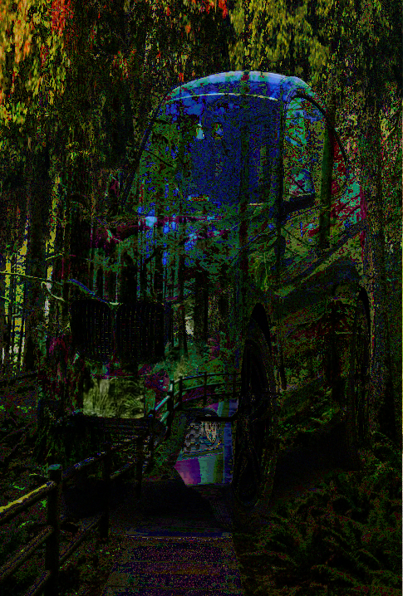

- OR:
- import cv2
- image1 = cv2.imread('car.jpg')
- print(image1.shape)
- image4=cv2.resize(image1, (485,718))
- cv2.imshow("first img",image4)
- cv2.waitKey(0)

- image2 = cv2.imread('nature.png')
- print(image2.shape)
- cv2.imshow("second img",image2)
- cv2.waitKey(0)

- andop = cv2.bitwise_or(image2, image4)
- cv2.imshow("Added img",andop)
- cv2.waitKey(0)

3. Xor:
import cv2
image1 = cv2.imread('car.jpg')
print(image1.shape)
image4=cv2.resize(image1, (485,718))
cv2.imshow("first img",image4)
cv2.waitKey(0)

image2 = cv2.imread('nature.png')
print(image2.shape)
cv2.imshow("second img",image2)
cv2.waitKey(0)

andop = cv2.bitwise_xor(image2, image4)
cv2.imshow("Added img",andop)
cv2.waitKey(0)

4. Not:
import cv2
image1 = cv2.imread('car.jpg')
print(image1.shape)
image4=cv2.resize(image1, (485,718))
cv2.imshow("first img",image4)
cv2.waitKey(0)

image2 = cv2.imread('nature.png')
print(image2.shape)
cv2.imshow("second img",image2)
cv2.waitKey(0)

andop = cv2.bitwise_not(image2, image4)
cv2.imshow("Added img",andop)
cv2.waitKey(0)

