Machine Learning for SOC Alert Triage:

Reducing False-Positive Burden in Security Operations Centres
A Research Report and Prototype Evaluation
Dataset: NSL-KDD | Task: Binary alert classification (true positive vs. false positive)

1. Introduction
Security Operations Centres (SOCs) are responsible for the continuous monitoring, detection, investigation, and response to cyber threats within an organisation. A central operational challenge is alert triage: security tools such as intrusion detection systems (IDS), endpoint detection and response (EDR) platforms, and SIEM correlation rules generate large volumes of alerts, only a small fraction of which correspond to genuine malicious activity. Analysts must manually inspect each alert to separate true positives (real attacks) from false positives (benign activity incorrectly flagged), a process that does not scale with the growth in alert volume, network complexity, and adversary activity.
This project investigates whether supervised machine learning can automate a meaningful portion of this triage decision, reducing the number of alerts that require direct analyst review while preserving an acceptable detection rate for genuine attacks. We treat the task as a binary classification problem — attack vs. normal — and build a working prototype that ingests network connection records, extracts features, trains several candidate models, and evaluates them using metrics chosen specifically for their operational relevance to a SOC context, rather than generic accuracy alone.

1.1 Why accuracy is the wrong headline metric
In a typical SOC alert stream, the base rate of genuine attacks is low relative to benign activity. A model that simply predicts "normal" for every alert can achieve high accuracy while providing zero security value. For this reason, this report foregrounds precision, recall, false positive rate (FPR), and false negative rate (FNR), and explicitly discusses the asymmetric cost of errors: a false negative (missed attack) is materially more dangerous than a false positive (wasted analyst time), even though the latter is the more commonly cited pain point in SOC literature.

2. Related Work and Context
Prior research on ML-based intrusion and alert triage broadly falls into three families: (1) signature/rule-based systems, which are precise but cannot generalise to novel attacks; (2) classical supervised ML (logistic regression, decision trees, random forests, gradient boosting) applied to flow-level or connection-level features, which is the approach taken here; and (3) deep learning approaches (autoencoders for anomaly detection, LSTMs for sequential log data), which can capture more complex patterns but require more data and offer less interpretability — a significant concern in SOC environments where analysts must be able to justify a decision to escalate or dismiss.
This project uses NSL-KDD, a refined and de-duplicated version of the KDD Cup 1999 dataset. NSL-KDD remains widely used as an intrusion-detection benchmark because it is public, well-documented, and — importantly for this evaluation — its official test set deliberately includes attack types absent from the training set. This property is normally cited as a dataset limitation for realism, but we treat it here as a deliberate stress test: it approximates the real SOC problem of facing novel or evolving attack techniques that existing detection logic was not built to catch, and the results below should be interpreted with that in mind.

3. Methodology

3.1 Dataset
NSL-KDD provides 41 features per connection record (basic connection features, content features, and traffic statistics computed over 2-second windows) plus a label identifying the record as normal or one of 22–38 specific attack types across four categories: Denial of Service (DoS), Probe (surveillance/scanning), Remote-to-Local (R2L), and User-to-Root (U2R).
Split | Records | Normal / Attack
Train | 125,973 | 67,343 / 58,630
Test | 22,544 | 9,711 / 12,833
Table 1. NSL-KDD train/test split and class balance used in this study.
For the multi-class breakdown, the training set is composed of 67,343 normal records, 45,927 DoS, 11,656 Probe, 995 R2L, and 52 U2R records — a strong class imbalance that mirrors real-world alert distributions, where volumetric attacks (e.g. DoS, scanning) vastly outnumber rarer, high-skill intrusion types (e.g. privilege escalation).

3.2 Preprocessing
- Categorical features (protocol_type, service, flag) were label-encoded, fitted jointly across train and test to avoid unseen-category errors at inference time.
- Numeric features were standardised (zero mean, unit variance) using a scaler fit only on the training set, to prevent test-set information leaking into preprocessing.
- The label was binarised: any non-"normal" record was treated as an attack (1), all "normal" records as 0 — reframing the multi-class attack taxonomy as the binary true-positive/false-positive decision an analyst actually makes at first triage.

3.3 Models Evaluated
- Logistic Regression — interpretable linear baseline; coefficients are directly inspectable, valuable when analysts need to understand why an alert was flagged.
- Random Forest (200 trees, max depth 20) — non-linear ensemble baseline with built-in feature importance.
- XGBoost (300 trees, depth 6, learning rate 0.1) — gradient-boosted trees, typically state-of-the-art for tabular data of this kind.
- MLP Neural Network (two hidden layers, 64 and 32 units) — a non-linear baseline for comparison against tree ensembles.
All models were trained on identical preprocessed features to isolate the effect of model choice. Hyperparameters were set to reasonable defaults rather than exhaustively tuned, since the objective of this prototype is comparative evaluation and methodology demonstration rather than leaderboard optimisation.

3.4 Evaluation Metrics
- Precision — of alerts flagged as attacks, the proportion that were real attacks. Low precision means analysts keep drowning in false alarms.
- Recall — of all real attacks, the proportion the model actually caught. Low recall means attacks slip through undetected.
- F1 score — harmonic mean of precision and recall.
- ROC-AUC — overall class separability across all decision thresholds.
- False Positive Rate (FPR) — proportion of normal alerts wrongly flagged as attacks; drives analyst workload.
- False Negative Rate (FNR) — proportion of real attacks missed; drives residual organisational risk.
- Alert queue reduction — the proportion of the test alert stream that would NOT need to be escalated to a human analyst if only model-flagged alerts were reviewed.

4. Results

4.1 Model Comparison
Model | Precision | Recall | F1 | ROC-AUC | FPR | FNR
Logistic Regression | 0.9253 | 0.6176 | 0.7408 | 0.8715 | 0.0659 | 0.3824
Random Forest | 0.9668 | 0.6236 | 0.7582 | 0.9707 | 0.0283 | 0.3764
XGBoost | 0.9684 | 0.6727 | 0.7939 | 0.97 | 0.029 | 0.3273
MLP Neural Net | 0.9737 | 0.6665 | 0.7913 | 0.9648 | 0.0238 | 0.3335
Table 2. Core classification metrics on the NSL-KDD test set (22,544 alerts).
XGBoost achieved the best F1 score (0.794) and among the lowest false-positive rates (2.90%), making it the best-balanced model overall. Random Forest and the MLP achieved comparable ROC-AUC (0.97 and 0.965 respectively) with the MLP achieving the lowest false-positive rate of all models (2.38%). Logistic Regression, as expected, trailed the ensemble and neural methods on every metric except training/inference speed, but still substantially outperformed random guessing (AUC 0.87 vs. 0.50), confirming that even a simple, fully interpretable linear model captures much of the separable signal in this feature set.
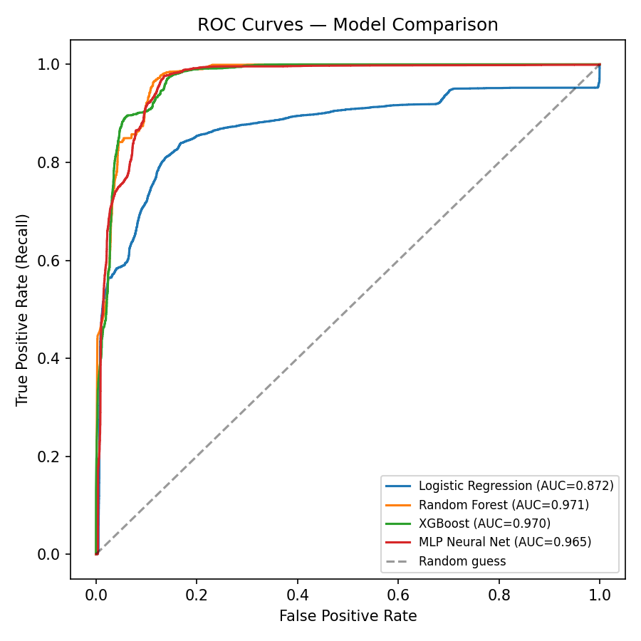
Figure 1. ROC curves for all four models. XGBoost and Random Forest dominate across nearly all thresholds.

4.2 Confusion Matrices
The confusion matrices below break down each model's predictions into the four operationally meaningful outcomes: alerts correctly dismissed, alerts incorrectly escalated (wasted analyst time), attacks incorrectly dismissed (missed attacks — the costliest error), and attacks correctly escalated.
Model | TN | FP | FN | TP | Escalated to Analyst | Queue Reduction
Logistic Regression | 9071 | 640 | 4907 | 7926 | 8566 | 62%
Random Forest | 9436 | 275 | 4830 | 8003 | 8278 | 63.28%
XGBoost | 9429 | 282 | 4200 | 8633 | 8915 | 60.46%
MLP Neural Net | 9480 | 231 | 4280 | 8553 | 8784 | 61.04%
Table 3. Confusion matrix breakdown and estimated impact on analyst workload, per model.
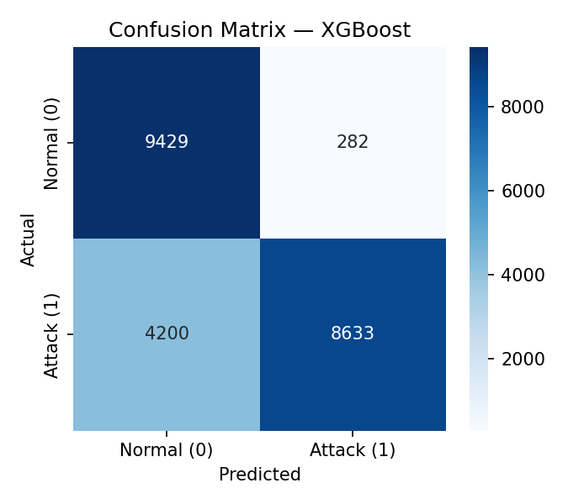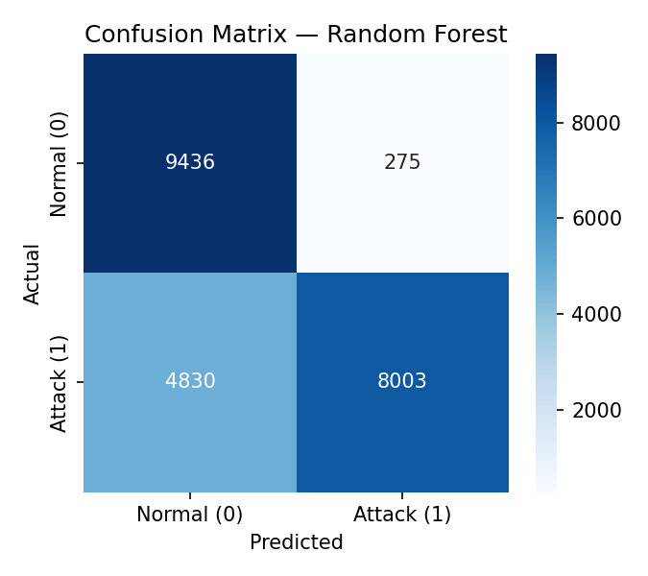
Figure 2. Confusion matrices for XGBoost (left) and Random Forest (right).

4.3 Feature Importance
Random Forest feature importances (Figure 3) highlight which connection attributes are most predictive of an attack. Traffic statistics computed over recent connection windows and service/flag-related features dominate, consistent with the intuition that attacks manifest as statistically unusual patterns of connection behaviour rather than any single feature in isolation — reinforcing why multivariate ML approaches add value over simple single-field threshold rules.
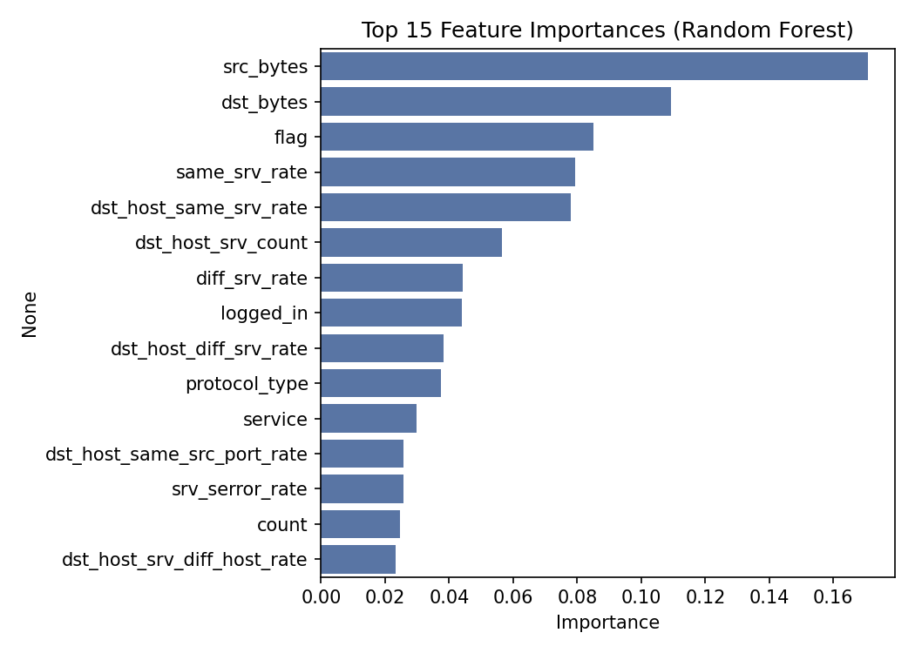
Figure 3. Top 15 most important features, Random Forest.

4.4 Simulated Alert Queue Reduction
To translate these metrics into SOC-relevant terms, we simulated the effect of using each model as a first-pass triage filter: only alerts the model flags as "attack" would be escalated to a human analyst, while alerts flagged "normal" would be auto-dismissed (or routed to a low-priority queue).
Across all four models, the analyst queue would shrink by roughly 60–63% relative to reviewing every alert. Random Forest produced the largest reduction (63.28%), while XGBoost produced a smaller reduction (60.46%) but caught more true attacks in absolute terms (8,633 vs. 8,003) — illustrating the precision/recall trade-off a SOC must make explicitly when selecting and tuning a triage model: XGBoost sacrifices some workload reduction for materially better detection coverage.
It is important to be transparent about the limitation this reveals: recall for every model sits between 62% and 67%, meaning roughly a third of attacks in the test set were missed. This is substantially explained by NSL-KDD's test set containing attack types not present in training — the models have not been given any labelled examples of these variants, and this mirrors the real-world problem of zero-day and novel attack techniques evading detection logic trained only on historical incidents. This is discussed further in Section 5.

5. Discussion

5.1 Interpreting the Recall Gap
A recall of roughly two-thirds across all models is the most important finding to interpret carefully rather than to hide behind an aggregate F1 score. In a live SOC, a triage system with this recall would still miss a substantial share of attacks if deployed as a hard auto-dismiss filter. This does not mean the approach is without value — it means the appropriate deployment pattern is not "auto-close low-confidence alerts" but rather "auto-prioritise and re-rank the queue," keeping a human in the loop for borderline-confidence predictions, and pairing the ML filter with existing signature-based detections for known attack families where recall is close to 100% by construction.

5.2 Precision, Workload, and Analyst Trust
The precision achieved by the tree-based and neural models (0.97 on attacks) is high enough to plausibly rebuild analyst trust in automated flags — a recurring theme in SOC literature is that analysts learn to ignore noisy detection tools ("alert fatigue" in the literal sense), so a triage assistant that is right roughly 97% of the time it raises an alert is far more likely to be adopted than a noisier system, even at the cost of some recall.

5.3 Limitations
- NSL-KDD, though widely used as a benchmark, represents network connection-level data from an older network environment; it does not capture modern attack surfaces such as cloud misconfigurations, container escapes, or living-off-the-land techniques common in current SOC alert streams.
- The binary framing (normal vs. any attack) collapses meaningfully different alert types — a DoS flood and a stealthy R2L credential-guessing attempt have very different triage urgency, which a production system should model as multi-class or severity-scored rather than binary.
- Hyperparameters were not exhaustively tuned; reported figures represent reasonable-default baselines, not a ceiling on achievable performance.
- This prototype is evaluated on a static, offline benchmark. A real deployment would need to handle concept drift (attacker behaviour changing over time), streaming inference, and integration with existing SIEM/SOAR tooling — none of which are addressed here.

5.4 Future Work
- Extend to multi-class classification across DoS / Probe / R2L / U2R to support severity-aware prioritisation rather than a binary escalate/dismiss decision.
- Evaluate on a more contemporary dataset (e.g. CIC-IDS2017/2018) alongside NSL-KDD to test whether findings generalise beyond this benchmark.
- Investigate semi-supervised or anomaly-detection approaches (e.g. autoencoders, isolation forests) to better address the low-recall-on-novel-attacks problem identified in Section 5.1.
- Add model explainability (e.g. SHAP values) so analysts receive a rationale alongside each triage decision, directly supporting the trust and adoption concerns raised in Section 5.2.

6. Conclusion
This project demonstrates that supervised machine learning, even using classical models on a well-established benchmark dataset, can meaningfully reduce the volume of alerts requiring direct human review in a SOC context — in our evaluation, by roughly 60–63% — while maintaining high precision (up to 97%) on the alerts it does escalate. The central trade-off uncovered is between workload reduction and detection recall, particularly against attack types not well represented in training data. Rather than positioning ML as a full replacement for analyst judgment, the results support a triage-assistant deployment model: automatically de-prioritising high-confidence benign alerts, surfacing high-confidence attacks for fast response, and preserving human review for the ambiguous middle band where the models in this study are least reliable.

Appendix A: Reproducibility
Dataset: NSL-KDD (mirrored from public GitHub repository, originally University of New Brunswick / Canadian Institute for Cybersecurity).
Code: Python 3, scikit-learn 1.8, XGBoost, pandas, matplotlib/seaborn. Preprocessing and training pipeline is provided as two scripts (preprocess.py, train_eval.py) accompanying this report, producing all tables and figures shown above from a single run.

