**How IR LINE SENSOR detect black and white:**

// checking interrupt is Rise

1. if (isRise) {

    // checking the white space after scanning the black bar

2.    if (isGap) {

        // stop the timer for detecting white

3.        endTimeWhite = to_ms_since_boot(get_absolute_time());

        // calculate the white width space

4.        whiteWidth = endTimeWhite - startTimeWhite;

        // Print the outcome (Debug purpose)

5.        printf("White Width: %llu\n",whiteWidth);

        // set the space to false

6.        isGap = false

    }

    // detected black start the timer

7.    startTimeBlack = to_ms_since_boot(get_absolute_time());

    // set detect black to false

8.    isRise = false

}

// checking interrupt is Rise

9. if (isFail) {

    // stop the timer for detecting black

10.    endTimeBlack = to_ms_since_boot(get_absolute_time());

    // calculate the black width

11.    blackWidth = endTimeBlack - startTimeBlack;

    // Print the outcome (Debug purpose)

12.    printf("Black Width: %llu\n",blackWidth);

    // set detect white to false

13.    isFail = false

    // set white space to true

14.    isGap = true

}

**Control Flow Graph**:

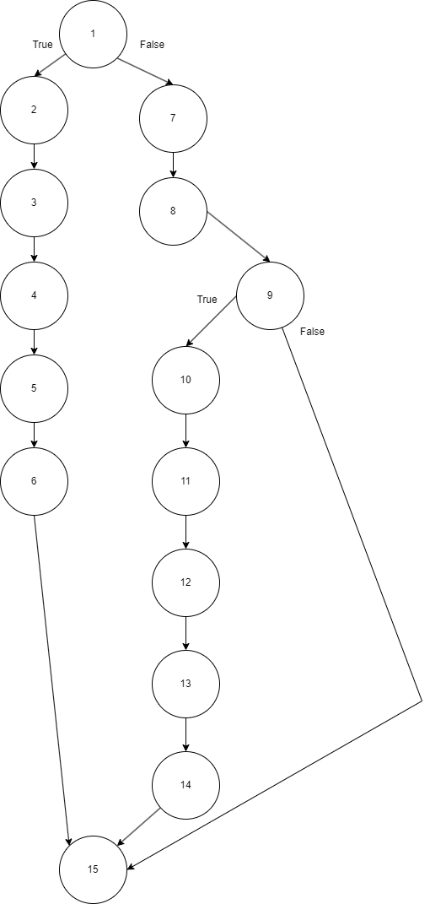

**Cyclomatic Complexity**:

E-N+2(P) = M

16(Edge) - 15(Node)+2(1) = 3

**Basis path**:

**1**, 2, 3, 4, 5, 6, 15

1, 7, 8, **9**, 10, 11, 12, 13, 14, 15

1, 7, 8, **9**, 15

**Doing moving average to determine Thin or Thick**:

// finish scanning the barcode

1. if (count == 29) {

    // for loop to add all the value into 'totalAvg'

2.    for (size_t i = 0; i < count; i++) {

3.        totalAvg += binaryTest[i];

    }

    // Display the total of the array value first before doing the avgerage (Debug Purpose)

4.    printf("Total: %.1f\n", totalAvg);

    // step to do average

5.    totalAvg = totalAvg / count;

    // Display the average value (Debug Purpose)

6.    printf("Avg: %.1f\n", totalAvg);

7.    for (int i = 0; i < count; i++) {

        // checking the width value is greater than total avg is true

        // if true mean is thick

8.        if (binaryTest[i] > totalAvg) {

            // checking is black or white

            // %2 == 0 mean is black

9.            if (i % 2 == 0) {

                // display which thick (Debug Purpose)

10.                printf("Black Thick\n");

            // %2 == 1 mean is white

11.            } else if (i % 2 == 1) {

                // display which thick (Debug Purpose)

12.                printf("White Thick\n");

            }

        // false mean is thin

13.        } else {

            // checking is black or white

            // %2 == 0 mean is black

14.            if (i % 2 == 0) {

                // display value (Debug Purpose)

15.                printf("Black Thin\n");

                // %2 == 1 mean is white

16.            } else if (i % 2 == 1) {

                // display value (Debug Purpose)

17.                printf("White Thin\n");

            }

        }

    }

18. }

**Control Flow Graph**:

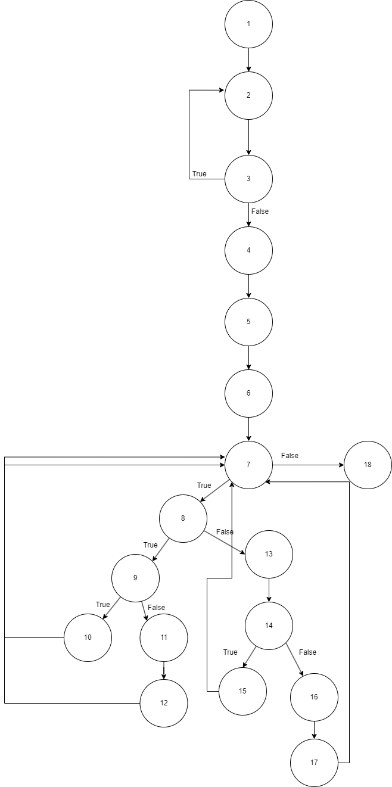

**Cyclomatic Complexity**:

E-N+2(P) = M

21(Edge) - 18(Node)+2(1) = 5

**Basis path**:

1, 2, 3, 4, 5, 6, **7**, 18

1, 2, 3, 4, 5, 6, 7, 8, **9**, 10, 7, 18

1, 2, 3, 4, 5, 6, 7, 8, **9**, 11, 12, 7, 18

1, 2, 3, 4, 5, 6, 7, 8, 13, **14**, 15, 7, 18

1, 2, 3, 4, 5, 6, 7, 8, 13, **14**, 16, 17, 7, 18