Using ultrasonic to measure the distance

float measure_distance()

{

1.    gpio_put(TRIG_PIN, 1);

2.   sleep_us(10);

3.    gpio_put(TRIG_PIN, 0);

    // Wait for the pulse measurement to complete

4.    while (pulse_started)

    {

5.        tight_loop_contents();

    }

6.    sleep_us(1);

7.    if (width > timeout)

8.       return 0;

9.    uint64_t pulse_length = absolute_time_diff_us(startTime, endTime);

    // Speed of sound = 343 m/s

    // Distance = (Pulse * Speed of sound) / 2

10.    return pulse_length * 0.0343 / 2;

11. }

Control Flow Graph:

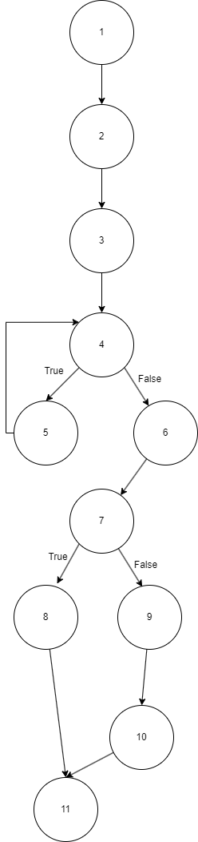

**Cyclomatic Complexity**:

E-N+2(P) = M

12(Edge) - 11(Node)+2(1) = 3

**Basis path**:

1,2,3,4,6,**7**,8,11

1,2,3,4,6,**7**,9,10,11

1,2,3,**4**,5,4,6,7,8,11