Sorting algorithm summary

- Selection sort: O(n²)
Find global min in {0….}, put it at array[0]
Find global min in {1….}, put it at array[1]
Find global min in {2….}, put it at array[2]
….
- Insertion sort: O(n²)
Given a list, take the current element and insert it at the appropriate position of the list, adjusting the list every time you insert.
{0…} compare 0 with 0
{0 1…} compare 1 with 0, 1
{0 1 2…} compare 2 with 0, 1, 2
Adjust the list every time, worst case: it’s a descending list, n². best case: n

- Merge sort: O(nlogn) Space = O(n) (for both array and linked list)

Linked list merge sorting:
- Break the list into two parts recursively
- Merge two sorted linked list recursively
- Remember we need to create new node with same value, because the pointer is changing during the break and merge process, we must return new created node.
- Quick sort: O(nlogn) Space = O(1)
Select an element as a pivot and put all the elements less than it to the left, all the elements larger than it to the right.
The worst case of Quick sort:
When each time the selected pivot is the max or min element, then it would take the swap operation every time.

Rainbow sort:
[0,i) 0
[i,k] unknown area should be closed area
(k,j] 1
(j,n) 2
notice here [i,k] is unknown region, if I swap(i,k), the element nums[k] is still unknown!! So don’t do k- -here.

- Bucket sort: https://leetcode.com/problems/maximum-gap/
The key part is to get the interval:
1. From: interval * (num[i] - min) = 0 and interval * (max -num[i]) = n
2. interval = num.length / (max - min)

1) Project each element of the array to an array of buckets. Some closed elements may be projected to a same location, which mean there are no max gaps between them.
2) Each bucket tracks the maximum and minimum elements. Make a difference between the next low and prev high.
3) Finally, scanning the bucket list, we can get the maximum gap.
- Insert interval
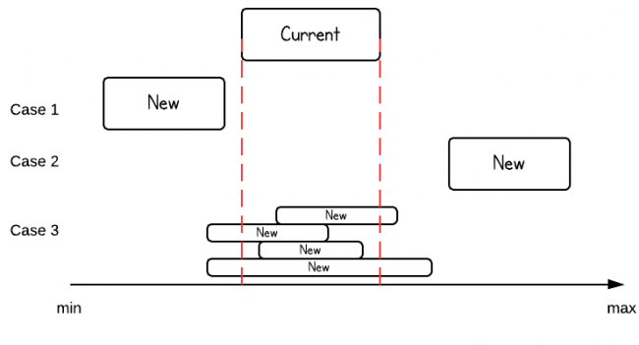
3 cases, each time create a newInterval! Compare the start also the end.

