**Implementation of Neuro Fuzzy Inference System using Python**

**Aim: To implement a Neuro Fuzzy Inference System using Python.**

**Test code& Output:**

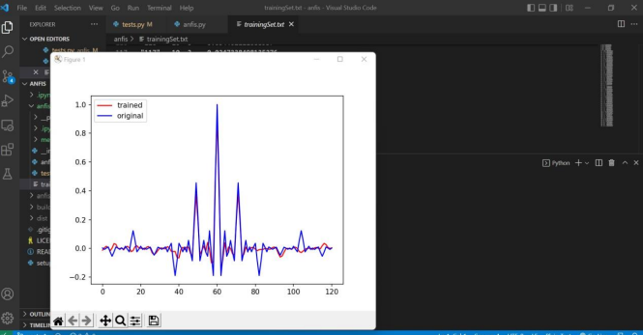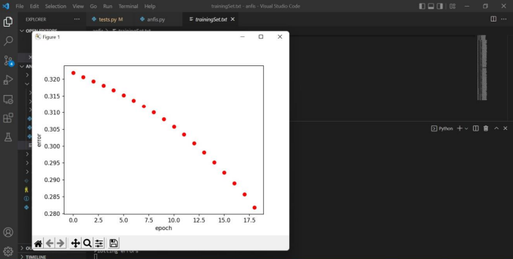

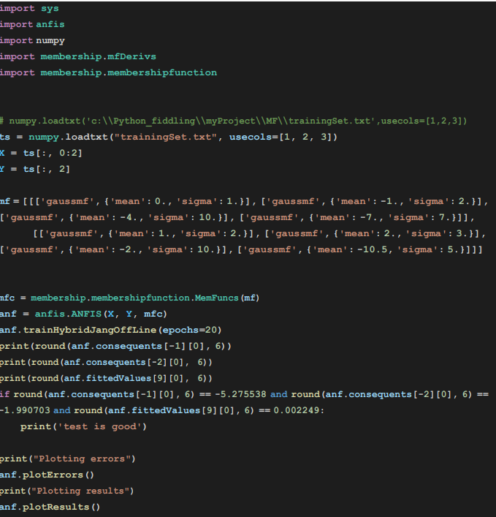

**Result :**

**Thus the Neuro Fuzzy Inference System has been implemented using Python.**