**OUTPUT**

**Server window**

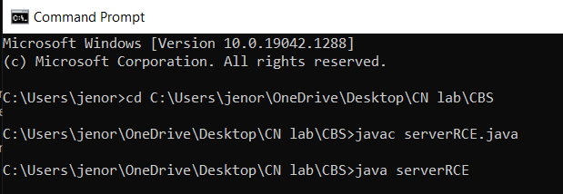**CLIENT WINDOW**

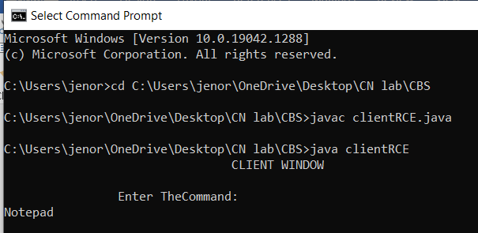**RESULT**

Thus the implementation RCE is done & executed successfully.