Banner[main menu](../synopsys/J_2014.09/tcad/J-2014.09/Sentaurus_Training/index.html)    |   [module menu](../synopsys/J_2014.09/tcad/J-2014.09/Sentaurus_Training/sp/sp_menu.html)    |   [<< previous section](../synopsys/J_2014.09/tcad/J-2014.09/Sentaurus_Training/sp/sp_b.html)    |   [next section >>](../synopsys/J_2014.09/tcad/J-2014.09/Sentaurus_Training/sp/sp_d.html)

# Sentaurus Process 3. Two-dimensional Process Simulation

[3.1 Overview](../synopsys/J_2014.09/tcad/J-2014.09/Sentaurus_Training/sp/sp_c.html#1)  
[3.2 Defining Initial 2D Grid and Simulation Domain](../synopsys/J_2014.09/tcad/J-2014.09/Sentaurus_Training/sp/sp_c.html#2)  
[3.3 Boron Implantations](../synopsys/J_2014.09/tcad/J-2014.09/Sentaurus_Training/sp/sp_c.html#3)  
[3.4 Growing Gate Oxide](../synopsys/J_2014.09/tcad/J-2014.09/Sentaurus_Training/sp/sp_c.html#4)  
[3.5 Defining Polysilicon Gate](../synopsys/J_2014.09/tcad/J-2014.09/Sentaurus_Training/sp/sp_c.html#5)  
[3.6 Polysilicon Reoxidation](../synopsys/J_2014.09/tcad/J-2014.09/Sentaurus_Training/sp/sp_c.html#6)  
[3.7 Saving Snapshots](../synopsys/J_2014.09/tcad/J-2014.09/Sentaurus_Training/sp/sp_c.html#7)  
[3.8 Remeshing for LDD and Halo Implantations](../synopsys/J_2014.09/tcad/J-2014.09/Sentaurus_Training/sp/sp_c.html#8)  
[3.9 LDD and Halo Implantations](../synopsys/J_2014.09/tcad/J-2014.09/Sentaurus_Training/sp/sp_c.html#9)  
[3.10 Spacer Formation](../synopsys/J_2014.09/tcad/J-2014.09/Sentaurus_Training/sp/sp_c.html#10)  
[3.11 Remeshing for Source/Drain Implantations](../synopsys/J_2014.09/tcad/J-2014.09/Sentaurus_Training/sp/sp_c.html#11)  
[3.12 Source/Drain Implantations](../synopsys/J_2014.09/tcad/J-2014.09/Sentaurus_Training/sp/sp_c.html#12)  
[3.13 Contact Pads](../synopsys/J_2014.09/tcad/J-2014.09/Sentaurus_Training/sp/sp_c.html#13)  
[3.14 Saving the Full Structure](../synopsys/J_2014.09/tcad/J-2014.09/Sentaurus_Training/sp/sp_c.html#14)  
[3.15 Extracting 1D Profiles](../synopsys/J_2014.09/tcad/J-2014.09/Sentaurus_Training/sp/sp_c.html#15)  
[3.16 Animated Process Flow](../synopsys/J_2014.09/tcad/J-2014.09/Sentaurus_Training/sp/sp_c.html#16)  
[3.17 Assignment](../synopsys/J_2014.09/tcad/J-2014.09/Sentaurus_Training/sp/sp_c.html#17)

## Objectives

* To perform a 2D process simulation using Sentaurus Process.

# 3.1 Overview

In these sections, many widely used process and control commands are introduced in the context of a nominal 0.18 μm n-channel MOSFET process flow. The MOSFET structure is simulated in two dimensions and processing of the isolation is excluded. A simplified treatment is presented using only default parameters and models.

Command files are available in a Sentaurus Workbench project with two instances of Sentaurus Process: The first instance is for the example described below, and the second instance is for the assignment in [Section 3.17 Assignment](../synopsys/J_2014.09/tcad/J-2014.09/Sentaurus_Training/sp/sp_c.html#17).

The complete project can be investigated from within Sentaurus Workbench in the directory Applications_Library/GettingStarted/sprocess/2DGS.

# 3.2 Defining Initial 2D Grid and Simulation Domain

The initial 2D grid is defined with the line command:

line x location= 0.0 spacing= 1.0<nm> tag=SiTop

line x location=50.0<nm> spacing=10.0<nm>

line x location= 0.5<um> spacing=50.0<nm>

line x location= 2.0<um> spacing= 0.2<um>

line x location= 4.0<um> spacing= 0.4<um>

line x location=10.0<um> spacing= 2.0<um> tag=SiBottom

line y location=0.0 spacing=50.0<nm> tag=Mid

line y location=0.40<um> spacing=50.0<nm> tag=Right

Sentaurus Process uses coordinate systems such that 1D and 2D (and 3D) simulations are consistent. For 1D, the natural choice for x is to point downwards (into the wafer); Sentaurus Process keeps this definition for 2D. Consequently, the y-axis points to the side (parallel to the wafer).

Here, a depth-dependent initial mesh is defined, which is tight at the surface (1 nm) and relaxes up to 2 μm into the depth. For the lateral direction, a constant mesh spacing of 50 nm is used.

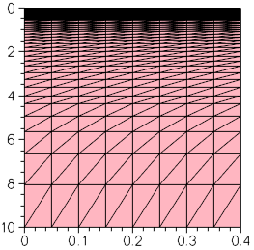

Figure 1. Initial 2D grid.

Note that:

* Sentaurus Process simulates in 1D until the first mask is used. The simulation remains in 1D if the mask covers entirely or is fully outside of the simulation domain.
* Two-dimensional grid initialization must be performed with more care than for 1D to obtain timely solutions because the number of grid points in the x-direction are multiplied by every line in the y-direction.
* The size and dimension of the simulation domain, and its location within a layout, also can be specified using the icwb command (see [Section 3.2 Using a Mask Layout to Build the Structure](../synopsys/J_2014.09/tcad/J-2014.09/Sentaurus_Training/si/si_3.html#2)). An interactive tool to process mask information is the IC WorkBench Edit/View Plus interface (see the [IC WorkBench Edit/View Plus Interface module](../synopsys/J_2014.09/tcad/J-2014.09/Sentaurus_Training/ic/ic_menu.html)). Both methods allow you to separate mask coordinates from the process flow and, therefore, are highly recommended.

HINT: Start with a coarse grid. Automatic meshing adds grid points during the simulation. Starting with too many grid points unnecessarily slows down the earlier parts of the simulation. Gridding after the simulation has started can be controlled by modifying the meshing rules in the mgoals command.

The initial simulation domain is defined with the region command:

region Silicon xlo=SiTop xhi=SiBottom ylo=Mid yhi=Right

init concentration=1.0e+15<cm-3> field=Phosphorus

For a 2D simulation, the substrate region is defined by referring to the tag for the x-direction and y-direction. These tags were defined previously in the line command.

Here, an n-doped substrate with a phosphorus concentration of 1015 cm-3 is used. The wafer orientation is set to be (100), which is the default.

# 3.3 Boron Implantations

First, three sets of boron implantations are performed:

implant Boron dose=2.0e13<cm-2> energy=200<keV> tilt=0 rotation=0

implant Boron dose=1.0e13<cm-2> energy= 80<keV> tilt=0 rotation=0

implant Boron dose=2.0e12<cm-2> energy= 25<keV> tilt=0 rotation=0

The first high-energy implantation creates the p-well, the second medium-energy implantation defines a retrograde boron profile to prevent punch-through, and the third low-energy implantation is for a threshold voltage (Vt) adjustment.

# 3.4 Growing Gate Oxide

The gate oxide is grown at 850°C for 10 minutes in pure oxygen ambient using:

mgoals min.normal.size=1<nm> max.lateral.size=2.0<um> normal.growth.ratio=1.5 \

accuracy=1e-5

diffuse temperature=1050<C> time=10.0<s>

select z=1

layers

Before the diffusion step, a meshing strategy is defined (see [Section 2.5 Setting Up a Meshing Strategy](../synopsys/J_2014.09/tcad/J-2014.09/Sentaurus_Training/sp/sp_b.html#5)).

The keyword O2 is shorthand for a pure oxygen ambient at a pressure of 1 atm.

The layers command shows that the thickness of the grown oxide is 2.9 nm:

{ Top Bottom Integral Material }

{ -2.041381732189e-03 8.183673139457e-04 2.859749046134e-07 Oxide }

{ 8.183673139457e-04 1.000000000000e+01 9.999181632686e-04 Silicon }

See [Section 2.7 Measuring Oxide Thickness](../synopsys/J_2014.09/tcad/J-2014.09/Sentaurus_Training/sp/sp_b.html#7) for details.

# 3.5 Defining Polysilicon Gate

The polysilicon gate is created using:

deposit material= {PolySilicon} type=anisotropic time=1 rate= {0.18}

mask name=gate_mask left=-1 right=90<nm>

etch material= {PolySilicon} type=anisotropic time=1 rate= {0.2} mask=gate_mask

etch material= {Oxide} type=anisotropic time=1 rate= {0.1}

First, 0.18 μm of polysilicon is deposited over the entire structure. The keyword type=anisotropic means that the layer is grown in the vertical direction only.

A mask is defined to protect the gate area with the mask command. In this project, only half of the transistor is simulated. The left edge of the gate mask is, therefore, unimportant. As a shortcut, it is set to -1. The name gate_mask is associated with this mask for later reference.

The first etch command refers to the previously defined mask and, therefore, only the exposed part of the polysilicon is etched. Note that the requested etching depth (0.2 μm) is larger than the deposited layer. This overetching ensures that no residual islands remain. The etching is specified to be anisotropic, that is, the applied mask is transferred straight down, without any undercut.

The second etch statement does not refer to any masks. However, the polysilicon acts naturally as a mask for this selective etching process. Again, a considerable overetching is specified.

Masks can be inverted using the negative parameter, for example:  
  
mask name=gate_mask segments= {-1 0.09} negative

When used in an etch command, it will prevent etching for y > 90 nm.

Using a mask directly in an implant command is obsolete and is strongly discouraged. It is recommended to use the photo command to deposit a layer of photoresist, with flat top surface, to perform the implantation, and then to strip the photoresist. For example:  
  
mask name=gate_mask segments= {-1 0.09} negative  
photo mask=gate_mask thickness=1<um>  
implant Boron energy=100<keV> dose=1e14<cm-2>  
strip PhotoResist

Refer to the Sentaurus™ Process User Guide for details on the photo command.

# 3.6 Polysilicon Reoxidation

To release stresses, a thin oxide layer is grown on the polysilicon before spacer formation:

diffuse temperature=900<C> time=10.0<min> O2

Here, the 1 atm default is overwritten by explicitly specifying a pressure of 0.5 atm. In all diffusion steps, Sentaurus Process accounts for a very thin native oxide layer, which is always present on silicon and quickly forms on newly created interfaces. Its thickness defaults to 1.5 nm.

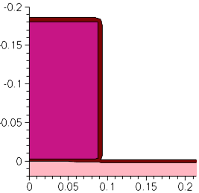

Figure 2. Polysilicon reoxidation.

The edges in the growing oxide, perpendicular to the interface, can be split if their length exceeds a certain value. This value can be set with the following command (unit is cm):

pdbSet Oxide Grid perp.add.dist 1e-7

It defaults to 10e-7 cm. See [Section 4.2 Changing Parameters in Command File](../synopsys/J_2014.09/tcad/J-2014.09/Sentaurus_Training/sp/sp_d.html#2) for details.

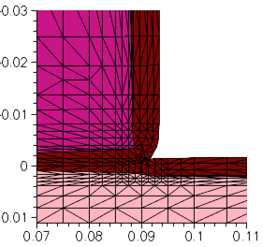

Figure 3. Details of mesh in thin oxide layer and in adjacent polysilicon and silicon. The effect of perp.add.dist is apparent.

# 3.7 Saving Snapshots

To save a snapshot of the current structure, use:

struct tdr=n@node@_NMOS1 ; # p-Well

The keyword tdr specifies that the snapshot is saved in TDR format. The argument specifies the stem used for the file name. Here, the file n1_NMOS1_fps.tdr is created. The figures in this section were generated from such snapshots.

To open a TDR file, open a terminal window and launch the TDR file viewer with the following command:

svisual n1_NMOS1_fps.tdr

# 3.8 Remeshing for LDD and Halo Implantations

Next, the LDD and halo implantations are performed. However, before that, the meshing strategy is updated:

refinebox Silicon min= {0.0 0.05} max= {0.1 0.12} xrefine= {0.01 0.01 0.01} \

yrefine= {0.01 0.01 0.01} add

refinebox remesh

So far, the mesh in the lateral direction was specified with the initial line command to be uniform with a spacing of 50 nm. This was appropriate for the steps performed so far, but it will not be sufficiently fine to resolve the source/drain extensions (also known as low-doped drain (LDD)) as well as the halo implantations.

For this reason, a finer mesh is defined in the area where these profiles are important. This is performed with the refinebox command. The new meshing strategy can be restricted to a material, here Silicon.

The min and max keywords take an x-coordinate and a y-coordinate pair as an argument that is used to define the extent of the refinement box.

The coordinate pair must be enclosed in braces.

The grid spacing is defined with the xrefine and yrefine keywords, which can take up to three numbers as arguments. The first number specifies the spacing at the top or left side of the box, the second number defines the spacing in the center, and the last one specifies the spacing at the bottom or right side of the box.

When two numbers are given, they define the spacing at the top or left side of the box and the spacing at the bottom or right side of the box, respectively. Only one number can be given when uniform spacing is required.

The add keyword adds the refinement box to the current list of refinement boxes. The command refinebox remesh enforces a remeshing using the new meshing strategy.

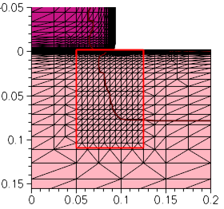

Figure 4. Creating a refinement box to define a finer mesh for LDD and halo implantations.

# 3.9 LDD and Halo Implantations

The LDD and halo implantations are performed using:

implant Arsenic dose=4e14<cm-2> energy=10<keV> tilt=0 rotation=0

implant Boron dose=0.25e13<cm-2> energy=20<keV> tilt=30<degree> \

rotation=0

implant Boron dose=0.25e13<cm-2> energy=20<keV> tilt=30<degree> \

rotation=90<degree>

implant Boron dose=0.25e13<cm-2> energy=20<keV> tilt=30<degree> \

rotation=180<degree>

implant Boron dose=0.25e13<cm-2> energy=20<keV> tilt=30<degree> \

rotation=270<degree>

diffuse temperature=1050<C> time=0.1<s> ; # Quick activation

The LDD implantation uses a high dose of 4 x 1014 cm-2 and a relatively low energy of 10 keV. The halo is created by a quad implantation, that is, the implantation is performed in four steps, each at a different angle. This ensures that the boron penetrates well into the channel at the tips of the source/drain extensions. Again, a relatively high total dose of 1 x 1014 cm-2 is used.

The implantations are activated with a short thermal cycle or rapid thermal anneal (RTA).

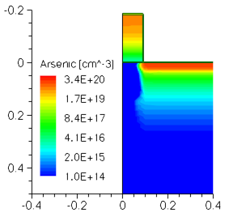

Figure 5. Doping concentration (donor dopants) in the structure after LDD implantations.

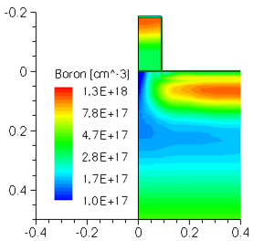

Figure 6. Doping concentration (acceptor dopants) in the structure after halo implantations.

# 3.10 Spacer Formation

The nitride spacers are formed using:

deposit material= {Nitride} type=isotropic time=1 rate= {0.06}

etch material= {Nitride} type=anisotropic time=1 rate= {0.084} \

isotropic.overetch=0.01

etch material= {Oxide} type=anisotropic time=1 rate= {0.01}

First, a uniform, 60-nm thick layer of nitride is deposited over the entire structure. The keyword type=isotropic ensures that the growth rate of the layer is the same in all directions. Then, the nitride is etched again; however, now an anisotropic etching is used. This means that the nitride deposited on the vertical sides of the gate is not fully removed and can serve as a mask for the source/drain implantations. Finally, the thin oxide layer, grown during the poly reoxidation step, is removed.



Figure 7. Animated snapshots of spacer formation and nitride deposition.

# 3.11 Remeshing for Source/Drain Implantations

Next, the source/drain implantations are performed. However, before that, the meshing strategy is updated:

refinebox Silicon min= {0.04 0.12} max= {0.18 0.4} xrefine= {0.01 0.01 0.01} \

yrefine= {0.05 0.05 0.05} add

refinebox remesh

implant Arsenic dose=5e15<cm-2> energy=40<keV> \

This refinement box ensures that the grid is sufficiently fine in the vertical direction to resolve the junction depth.

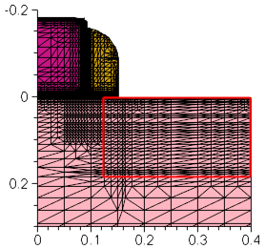

Figure 8. Refinement box for source/drain implantation.

# 3.12 Source/Drain Implantations

The source and drain regions are created using:

implant Arsenic dose=5e15<cm-2> energy=40<keV> \

diffuse temperature=1050<C> time=10.0<s>

To ensure a low resistivity of the source and drain regions, this implantation step uses a very high dose of 5 x 1015 cm-2. A tilt of 7° is used to reduce channeling and a rotation of -90° ensures that the plane of incidence is parallel to the gate stack, such that the 7° tilt angle does not lead to asymmetry between the source and drain.

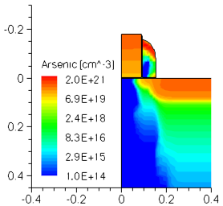

Figure 9. Doping concentration (donor dopants) in the structure after source/drain implantations.

# 3.13 Contact Pads

Finally, metal pads are defined with:

deposit material= {Aluminum} type=isotropic time=1 rate= {0.03}

mask name=contacts_mask left=0.2<um> right=1.0<um>

etch material= {Aluminum} type=anisotropic time=1 rate= {0.25} \

mask=contacts_mask

Here, no real backend simulation is performed. Metal pads are created by deposition and etching to identify the contact areas for later use in the device simulator. The method is very similar to the one used for the polysilicon gate definition.

See [Section 3.5 Defining Polysilicon Gate](../synopsys/J_2014.09/tcad/J-2014.09/Sentaurus_Training/sp/sp_c.html#5).

# 3.14 Saving the Full Structure

To save the full structure, use:

transform reflect left

struct tdr= n@node@_NMOS ; # Final

The structure is first reflected along the left edge with the transform command. Then, the full structure is saved with the struct command. The keyword smesh creates all the files required to transfer the simulated structure to the meshing tool Sentaurus Mesh or the device editor Sentaurus Structure Editor.

In addition to the *_fps.tdr files discussed in [Section 3.7 Saving Snapshots](../synopsys/J_2014.09/tcad/J-2014.09/Sentaurus_Training/sp/sp_c.html#7), other input files for Sentaurus Mesh are saved: a boundary file *_bnd.tdr and a command file *_msh.cmd.

# 3.15 Extracting 1D Profiles

One-dimensional profiles can be saved at any point of interest in the process flow using:

SetPlxList {BTotal NetActive}

WritePlx n@node@_NMOS_channel.plx y=0.0 Silicon

SetPlxList {AsTotal BTotal NetActive}

WritePlx n@node@_NMOS_ldd.plx y=0.1 Silicon

SetPlxList {AsTotal BTotal NetActive}

WritePlx n@node@_NMOS_sd.plx y=0.39 Silicon

See [Section 2.11 Saving As-Implanted Profile](../synopsys/J_2014.09/tcad/J-2014.09/Sentaurus_Training/sp/sp_b.html#11) for details.

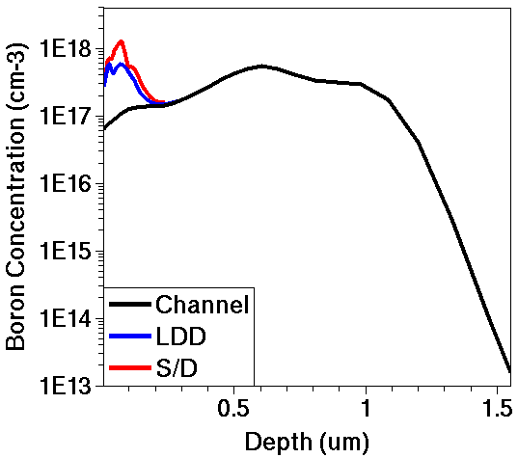

Figure 10. One-dimensional profiles of acceptor concentration (boron) in channel (black), LDD (blue), and source/drain (red) versus depth.

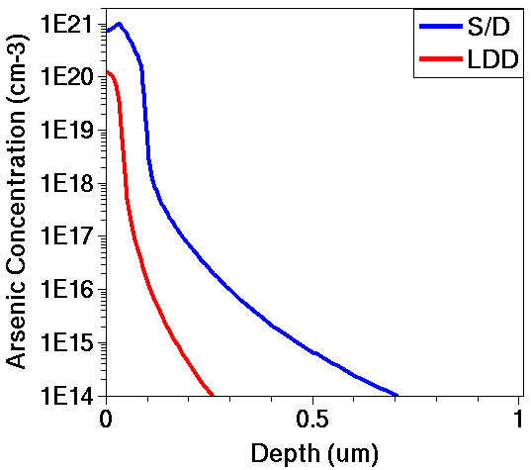

Figure 11. One-dimensional profiles of donor concentration (arsenic) in source/drain (blue) and LDD (red) versus depth.

# 3.16 Animated Process Flow

Figure 12 shows an animation of snapshots taken at important points of the process flow.

The color shading shows the net doping concentration. Red areas are heavily n-doped, and blue areas are heavily p-doped. Concentrations in-between are colored according to the visible spectrum.

Click to view the command file [sprocess_fps.cmd](../synopsys/J_2014.09/tcad/J-2014.09/Applications_Library/GettingStarted/sprocess/2DGS/sprocess_fps.cmd.txt).



Figure 12. Animation of snapshots taken of process flow.

# 3.17 Assignment

Create a command file of Sentaurus Process for simulating a vertical npn bipolar transistor from the process flow outlined here.

You can modify the 1D command file from the 1D npn bipolar assignment (see [Section 2.13 Assignment](../synopsys/J_2014.09/tcad/J-2014.09/Sentaurus_Training/sp/sp_b.html#13)) or you can start from the beginning.

Step 1. Substrate Definition

* Declare a 2 μm deep and 30 μm wide p-type substrate of (100) silicon with a boron concentration of 1.0 x 1015 cm-3.

Step 2. Lay Out Device

* Define a masking layer to allow an implantation (called "sinker") to pass into the silicon from 22.0 to 24.0 μm.
* Define a masking layer to allow an implantation (called "base") to pass into the silicon from 1.5 to 13.0 μm.
* Define a masking layer to allow an implantation (called "emitter") to pass into the silicon from 2.5 to 8.0 μm and from 22 to 24 μm.
* Define a masking layer (called "contact") for the etchant to pass through from 3.5 to 7.0 μm, and 10.0 to 12.0 μm, and 22.5 to 23.5 μm.
* Define a masking layer (called "metal") for the etchant to pass through the negative image from 2.0 to 8.0 μm, 9.0 to 13.0 μm, and 22.0 to 24.0 μm.

Step 3. Buried Layer

* Deposit 25 nm of screening oxide.
* Implant antimony with a dose of 1.5 x 1015 cm-2 and an energy of 100 keV.
* Strip the screening oxide.

Step 4. Epi Layer

* Deposit 4 μm of lightly doped silicon.
* Emulate the thermal budget during the epi growth with another annealing at 1100°C for 60 minutes.

Step 5. Sinker Implantation and Drive-In

* Implant phosphorus with a dose of 5.0 x 1015 cm-2 and an energy of 200 keV.
* Use the mask defined in Step 2 for the "sinker".
* Anneal at 1100°C for 5 hours.

Step 6. Base Implantation and Drive-In

* Deposit 25 nm of screening oxide.
* Implant boron with a dose of 1.0 x 1014 cm-2, an energy of 50 keV, and a tilt angle of 7°.
* Anneal at 1100°C for 35 minutes.

Step 7. Emitter Implantation and Activation

* Implant arsenic with a dose of 5.0 x 1015 cm-2, an energy of 55 keV, and a tilt angle of 7°.
* Anneal at 1100°C for 25 minutes.

Step 8. Etch Oxide

* Anisotropically etch the oxide using the "contact" mask defined earlier.

Step 9. Deposit Aluminum

* Deposit 1 μm of aluminum.

Step 10. Etch Aluminum

* Anisotropically etch the aluminum using the mask "metal" created above.

In this assignment:

* Define an initial mesh and an initial simulation domain before defining the substrate.
* Define a remeshing strategy before the first deposit command.
* Save the 2D structure files after each major implantation and anneal step.
* Remember to use the photo command to deposit photoresist to mask implantation.

Click to view a solution of the command file [sprocess1_fps.cmd](../synopsys/J_2014.09/tcad/J-2014.09/Applications_Library/GettingStarted/sprocess/2DGS/sprocess1_fps.cmd.txt).



Figure 13. Animated snapshots of process flow of npn bipolar transistor.

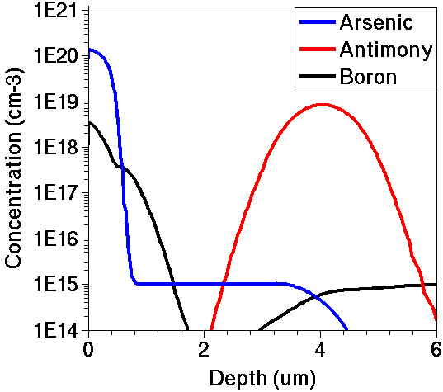

Figure 14. Final doping profiles for cutline at middle of emitter (x = 5 μm).

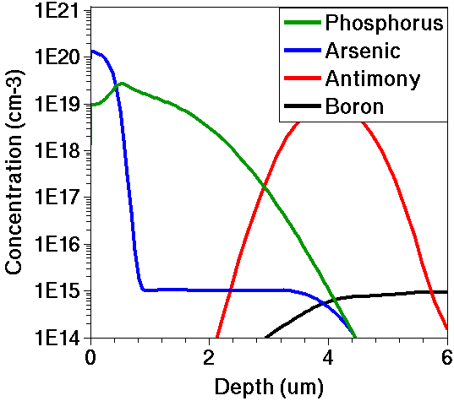

Figure 15. Final doping profiles for cutline at middle of collector sink (x = 23 μm).

[main menu](../synopsys/J_2014.09/tcad/J-2014.09/Sentaurus_Training/index.html)    |   [module menu](../synopsys/J_2014.09/tcad/J-2014.09/Sentaurus_Training/sp/sp_menu.html)    |   [<< previous section](../synopsys/J_2014.09/tcad/J-2014.09/Sentaurus_Training/sp/sp_b.html)    |   [next section >>](../synopsys/J_2014.09/tcad/J-2014.09/Sentaurus_Training/sp/sp_d.html)

Copyright © 2014 Synopsys, Inc. All rights reserved.