***Python – Image Caption Generator***

**We all can see images and can say what the images represent and can also describe about it but while coming to computers it doesn’t work like that. Computer cannot recognize the image and tell about it on its own, but we can make computer learn to do so with the help of the deep learning techniques and the availability of the huge amount of datasets to do so.**

This is what we are going to implement in this Python based project where we will use deep learning techniques of Convolution Neural Networks(CNN) and a type of Recurrent Neural Network (LSTM) together.

The CNN networks were mainly came into vision at 2012 in an imagenet competition. And today most of the famous countries all over the world use it. Facebook uses neural nets for their automatic tagging algorithms, Google for their photo search, Amazon for their product recommendations, Pinterest for their home feed personalization, and Instagram for their search infrastructure.

What is Image Caption Generator?

Image caption generator is a task that involves computer vision and natural language processing concepts to recognize the context of an image and describe them in a natural language like English.

Image classification is the task of taking an input image and outputting a class (a cat, dog, etc) or a probability of classes that best describes the image.

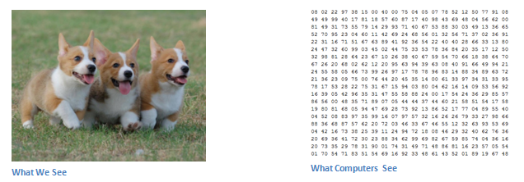

When a computer sees an image (takes an image as input), it will see an array of pixel values. Depending on the resolution and size of the image, it will see a **32 x 32 x 3 array of numbers (The 3 refers to RGB** **values).** Each of these numbers is given a value from 0 to 255 which describes the pixel intensity at that point. These numbers, while meaningless to us when we perform image classification, are the only inputs available to the computer.  The idea is that you give the computer this array of numbers and it will output numbers that describe the probability of the image being a certain class (.80 for cat, .15 for dog, .05 for bird, etc).

The computer is able perform image classification by looking for low level features such as edges and curves, and then building up to more abstract concepts through a series of convolutional layers. This is a general overview of what a CNN does. A more detailed overview of what CNNs do would be that you take the image, pass it through a series of convolutional, nonlinear, pooling (downsampling), and fully connected layers, and get an output.

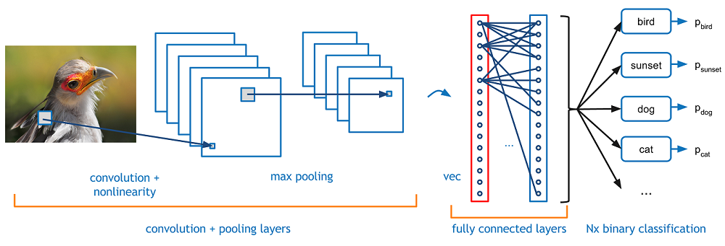

## ****First Layer – Math Part****

                The first layer in a CNN is always a **Convolutional Layer**. First thing to make sure you remember is what the input to this conv (I’ll be using that abbreviation a lot) layer is. Like we mentioned before, the input is a 32 x 32 x 3 array of pixel values. Now, the best way to explain a conv layer is to imagine a flashlight that is shining over the top left of the image. Let’s say that the light this flashlight shines covers a 5 x 5 area. And now, let’s imagine this flashlight sliding across all the areas of the input image. In machine learning terms, this flashlight is called a **filter**(or sometimes referred to as a **neuron**or a **kernel**) and the region that it is shining over is called the **receptive field**. Now this filter is also an array of numbers (the numbers are called **weights** or **parameters**). A very important note is that the depth of this filter has to be the same as the depth of the input (this makes sure that the math works out), so the dimensions of this filter is 5 x 5 x 3. Now, let’s take the first position the filter is in for example.  It would be the top left corner. As the filter is sliding, or **convolving**, around the input image, it is multiplying the values in the filter with the original pixel values of the image (aka computing **element wise multiplications**). These multiplications are all summed up (mathematically speaking, this would be 75 multiplications in total). So now you have a single number. Remember, this number is just representative of when the filter is at the top left of the image. Now, we repeat this process for every location on the input volume. (Next step would be moving the filter to the right by 1 unit, then right again by 1, and so on). Every unique location on the input volume produces a number. After sliding the filter over all the locations, you will find out that what you’re left with is a 28 x 28 x 1 array of numbers, which we call an **activation map** or **feature map**. The reason you get a 28 x 28 array is that there are 784 different locations that a 5 x 5 filter can fit on a 32 x 32 input image. These 784 numbers are mapped to a 28 x 28 array.

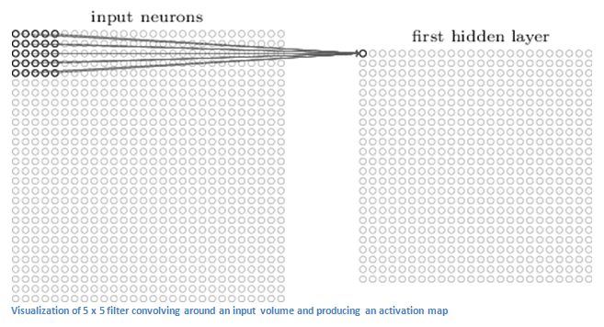

## ****First Layer – High Level Perspective****

                However, let’s talk about what this convolution is actually doing from a high level. Each of these filters can be thought of as **feature identifiers**. When I say features, I’m talking about things like straight edges, simple colors, and curves. Think about the simplest characteristics that all images have in common with each other. Let’s say our first filter is 7 x 7 x 3 and is going to be a curve detector. (In this section, let’s ignore the fact that the filter is 3 units deep and only consider the top depth slice of the filter and the image, for simplicity.)As a curve detector, the filter will have a pixel structure in which there will be higher numerical values along the area that is a shape of a curve (Remember, these filters that we’re talking about as just numbers!).

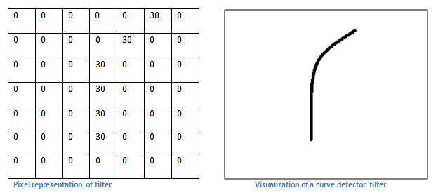

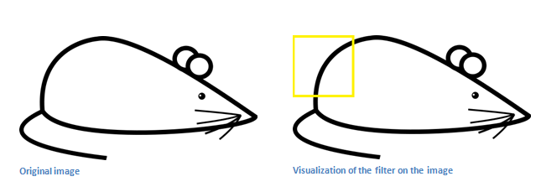

Remember, what we have to do is multiply the values in the filter with the original pixel values of the image.

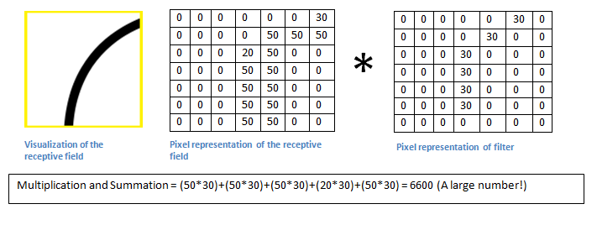

Basically, in the input image, if there is a shape that generally resembles the curve that this filter is representing, then all of the multiplications summed together will result in a large value! Now let’s see what happens when we move our filter.

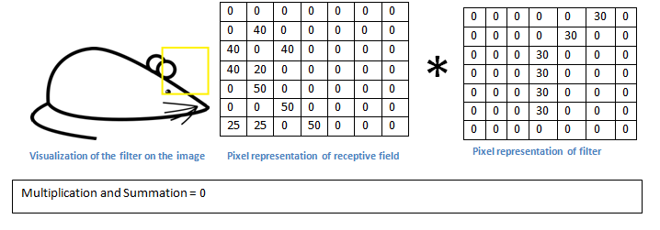

The value is much lower! This is because there wasn’t anything in the image section that responded to the curve detector filter. Remember, the output of this conv layer is an activation map. So, in the simple case of a one filter convolution (and if that filter is a curve detector), the activation map will show the areas in which there at mostly likely to be curves in the picture. In this example, the top left value of our 26 x 26 x 1 activation map (26 because of the 7x7 filter instead of 5x5) will be 6600. This high value means that it is likely that there is some sort of curve in the input volume that caused the filter to activate. The top right value in our activation map will be 0 because there wasn’t anything in the input volume that caused the filter to activate (or more simply said, there wasn’t a curve in that region of the original image). Remember, this is just for one filter. This is just a filter that is going to detect lines that curve outward and to the right. We can have other filters for lines that curve to the left or for straight edges. The more filters, the greater the depth of the activation map, and the more information we have about the input volume.

**Disclaimer:** The filter I described in this section was simplistic for the main purpose of describing the math that goes on during a convolution. In the picture below, you’ll see some examples of actual visualizations of the filters of the first conv layer of a trained network. Nonetheless, the main argument remains the same. The filters on the first layer convolve around the input image and “activate” (or compute high values) when the specific feature it is looking for is in the input volume.

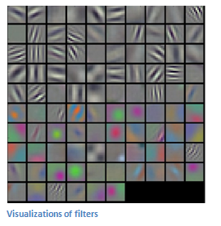

## ****Going Deeper Through the Network****

 A classic CNN architecture would look like this.

https://adeshpande3.github.io/assets/Table.png

The last layer, however, is an important one and one that we will go into later on. Let’s just take a step back and review what we’ve learned so far. We talked about what the filters in the first conv layer are designed to detect. They detect low level features such as edges and curves. As one would imagine, in order to predict whether an image is a type of object, we need the network to be able to recognize higher level features such as hands or paws or ears. So let’s think about what the output of the network is after the first conv layer. It would be a 28 x 28 x 3 volume (assuming we use three 5 x 5 x 3 filters).  When we go through another conv layer, the output of the first conv layer becomes the input of the 2nd conv layer.  Now, this is a little bit harder to visualize. When we were talking about the first layer, the input was just the original image. However, when we’re talking about the 2nd conv layer, the input is the activation map(s) that result from the first layer. So each layer of the input is basically describing the locations in the original image for where certain low level features appear. Now when you apply a set of filters on top of that (pass it through the 2nd conv layer), the output will be activations that represent higher level features. Types of these features could be semicircles (combination of a curve and straight edge) or squares (combination of several straight edges). As you go through the network and go through more conv layers, you get activation maps that represent more and more complex features. By the end of the network, you may have some filters that activate when there is handwriting in the image, filters that activate when they see pink objects, etc. Another interesting thing to note is that as you go deeper into the network, the filters begin to have a larger and larger receptive field, which means that they are able to consider information from a larger area of the original input volume (another way of putting it is that they are more responsive to a larger region of pixel space).

## ****Fully Connected Layer****

               .

Now that we can detect these high level features, the icing on the cake is attaching a **fully connected layer** to the end of the network. This layer basically takes an input volume (whatever the output is of the conv or ReLU or pool layer preceding it) and outputs an N dimensional vector where N is the number of classes that the program has to choose from. For example, if you wanted a digit classification program, N would be 10 since there are 10 digits. Each number in this N dimensional vector represents the probability of a certain class. For example, if the resulting vector for a digit classification program is [0 .1 .1 .75 0 0 0 0 0 .05], then this represents a 10% probability that the image is a 1, a 10% probability that the image is a 2, a 75% probability that the image is a 3, and a 5% probability that the image is a 9 (Side note: There are other ways that you can represent the output, but I am just showing the softmax approach). The way this fully connected layer works is that it looks at the output of the previous layer (which as we remember should represent the activation maps of high level features) and determines which features most correlate to a particular class. For example, if the program is predicting that some image is a dog, it will have high values in the activation maps that represent high level features like a paw or 4 legs, etc. Similarly, if the program is predicting that some image is a bird, it will have high values in the activation maps that represent high level features like wings or a beak, etc. Basically, a FC layer looks at what high level features most strongly correlate to a particular class and has particular weights so that when you compute the products between the weights and the previous layer, you get the correct probabilities for the different classes.

### What is LSTM?

LSTM stands for **Long short term memory**, they are a type of RNN (**recurrent neural network**) which is well suited for sequence prediction problems. Based on the previous text, we can predict what the next word will be. It has proven itself effective from the traditional RNN by overcoming the limitations of RNN which had short term memory. LSTM can carry out relevant information throughout the processing of inputs and with a forget gate, it discards non-relevant information.

This is what an LSTM cell looks like –

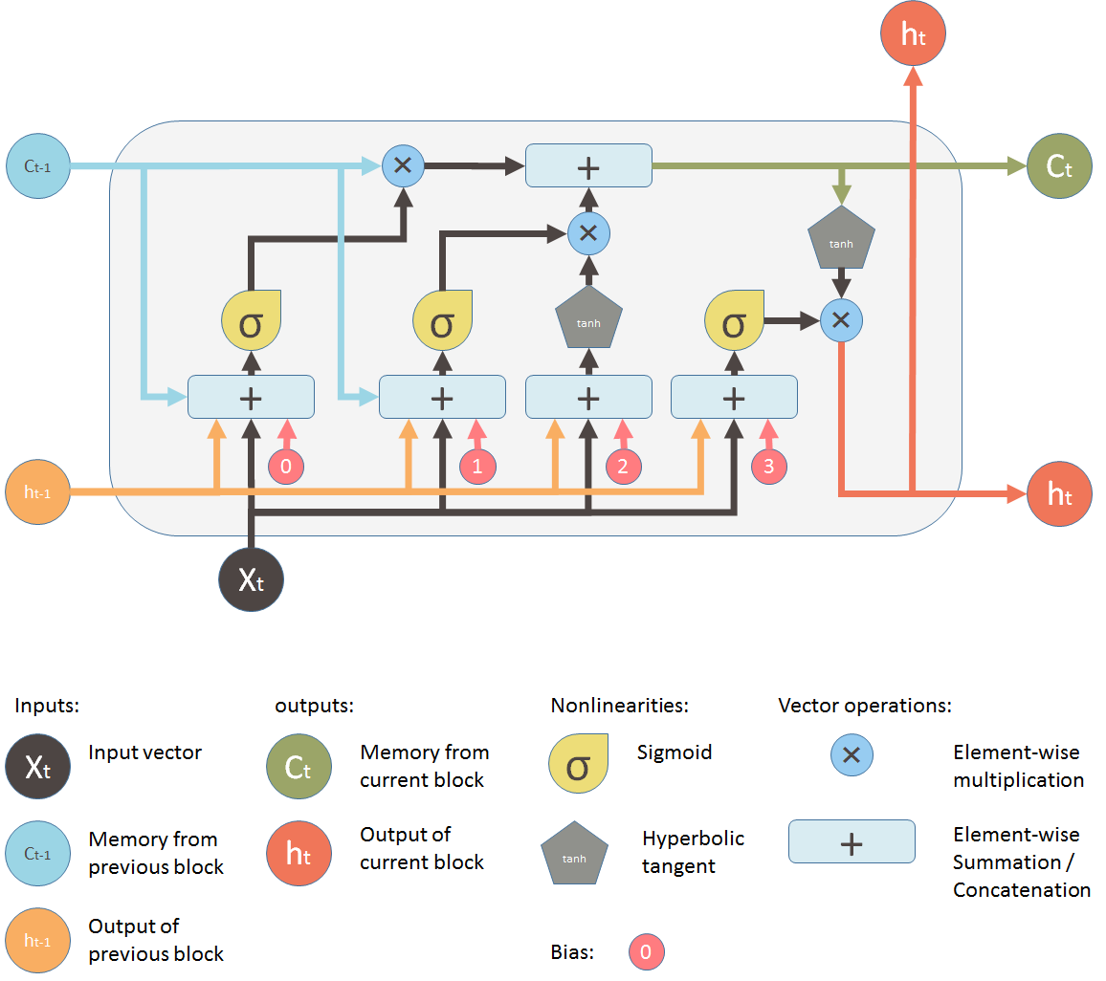

So, to make our image caption generator model, we will be merging these architectures. It is also called a CNN-RNN model.

* CNN is used for extracting features from the image. We will use the pre-trained model Xception.
* LSTM will use the information from CNN to help generate a description of the image.

To know more about LSTM visit this blog

LINK- https://medium.com/mlreview/understanding-lstm-and-its-diagrams-37e2f46f1714