MA 322: Scientific Computing
LAB 2 Report
Abheek Ghosh - 140123047

NOTATION:
Status = 0 implies successful, Status = 1 implies unsuccessful.
tol ==> Error tolerance limit
root ==> Root of the function
fixed ==> Fixed point of function
func_val ==> Function value evaluated at the result found
iterations ==> Iterations taken for comvergence

Question 1
e^{x}=Sin x

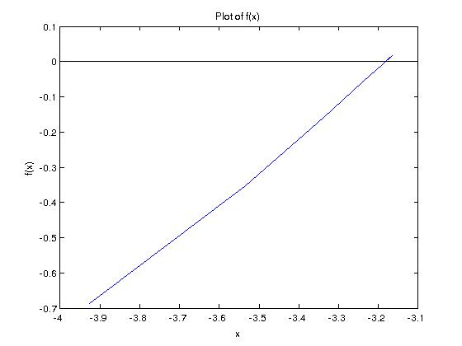

tol = 1.0000e-05
root = -3.1831
func_val = 2.2138e-06
status = 0
iterations = 25
data =
i a b c f(c)
1.00000 -100.00000 100.00000 0.00000 1.00000
2.00000 -100.00000 0.00000 -50.00000 -0.26237
3.00000 -50.00000 0.00000 -25.00000 -0.13235
4.00000 -25.00000 0.00000 -12.50000 -0.06632
5.00000 -12.50000 0.00000 -6.25000 -0.03125
6.00000 -6.25000 0.00000 -3.12500 0.06053
7.00000 -6.25000 -3.12500 -4.68750 -0.99048
8.00000 -4.68750 -3.12500 -3.90625 -0.67217
9.00000 -3.90625 -3.12500 -3.51562 -0.33564
10.00000 -3.51562 -3.12500 -3.32031 -0.14163
11.00000 -3.32031 -3.12500 -3.22266 -0.04113
12.00000 -3.22266 -3.12500 -3.17383 0.00961
13.00000 -3.22266 -3.17383 -3.19824 -0.01579
14.00000 -3.19824 -3.17383 -3.18604 -0.00309
15.00000 -3.18604 -3.17383 -3.17993 0.00326
16.00000 -3.18604 -3.17993 -3.18298 0.00008
17.00000 -3.18604 -3.18298 -3.18451 -0.00150
18.00000 -3.18451 -3.18298 -3.18375 -0.00071
19.00000 -3.18375 -3.18298 -3.18336 -0.00031
20.00000 -3.18336 -3.18298 -3.18317 -0.00012
21.00000 -3.18317 -3.18298 -3.18308 -0.00002
22.00000 -3.18308 -3.18298 -3.18303 0.00003
23.00000 -3.18308 -3.18303 -3.18305 0.00001
24.00000 -3.18308 -3.18305 -3.18307 -0.00000
25.00000 -3.18307 -3.18305 -3.18306 0.00000

Question 2
(a) 2+cos(e^{x}-2)-e^{x}=0 0.5 ≤ x ≤ 1.5

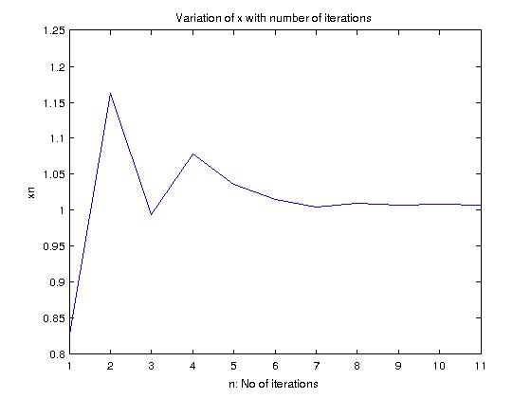
root = 1.0068
func_val = 0.0036093
status = 0
iterations = 10
data =
i a b c f(c)
1.0000e+00 5.0000e-01 1.5000e+00 1.0000e+00 3.4656e-02
2.0000e+00 1.0000e+00 1.5000e+00 1.2500e+00 -1.4100e+00
3.0000e+00 1.0000e+00 1.2500e+00 1.1250e+00 -6.0908e-01
4.0000e+00 1.0000e+00 1.1250e+00 1.0625e+00 -2.6698e-01
5.0000e+00 1.0000e+00 1.0625e+00 1.0312e+00 -1.1115e-01
6.0000e+00 1.0000e+00 1.0312e+00 1.0156e+00 -3.7003e-02
7.0000e+00 1.0000e+00 1.0156e+00 1.0078e+00 -8.6443e-04
8.0000e+00 1.0000e+00 1.0078e+00 1.0039e+00 1.6973e-02
9.0000e+00 1.0039e+00 1.0078e+00 1.0059e+00 8.0734e-03
1.0000e+01 1.0059e+00 1.0078e+00 1.0068e+00 3.6093e-03

(b) e^{x}-x²+3x-2=0 0 ≤ x ≤ 1

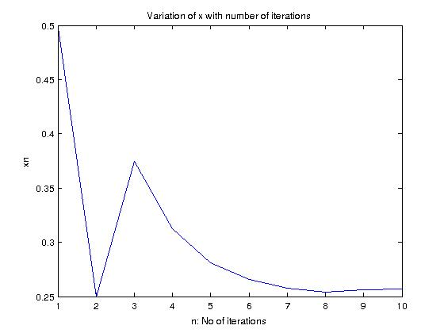
root = 0.25684
func_val = -0.0026239
status = 0
iterations = 10
data =
i a b c f(c)
1.00000 0.00000 1.00000 0.50000 0.89872
2.00000 0.00000 0.50000 0.25000 -0.02847
3.00000 0.25000 0.50000 0.37500 0.43937
4.00000 0.25000 0.37500 0.31250 0.20668
5.00000 0.25000 0.31250 0.28125 0.08943
6.00000 0.25000 0.28125 0.26562 0.03056
7.00000 0.25000 0.26562 0.25781 0.00107
8.00000 0.25000 0.25781 0.25391 -0.01370
9.00000 0.25391 0.25781 0.25586 -0.00631
10.00000 0.25586 0.25781 0.25684 -0.00262

(c) 2x cos(2x)-(x+1)²=0 −3 ≤ x ≤ −2 and −1 ≤ x ≤ 0

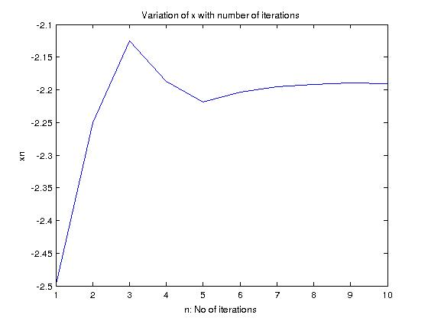
root = -2.1904
func_val = 0.0088019
status = 0
iterations = 10
data =
i a b c f(c)
1.0000e+00 -3.0000e+00 -2.0000e+00 -2.5000e+00 -3.6683e+00
2.0000e+00 -2.5000e+00 -2.0000e+00 -2.2500e+00 -6.1392e-01
3.0000e+00 -2.2500e+00 -2.0000e+00 -2.1250e+00 6.3025e-01
4.0000e+00 -2.2500e+00 -2.1250e+00 -2.1875e+00 3.8076e-02
5.0000e+00 -2.2500e+00 -2.1875e+00 -2.2188e+00 -2.8084e-01
6.0000e+00 -2.2188e+00 -2.1875e+00 -2.2031e+00 -1.1956e-01
7.0000e+00 -2.2031e+00 -2.1875e+00 -2.1953e+00 -4.0279e-02
8.0000e+00 -2.1953e+00 -2.1875e+00 -2.1914e+00 -9.8519e-04
9.0000e+00 -2.1914e+00 -2.1875e+00 -2.1895e+00 1.8574e-02
1.0000e+01 -2.1914e+00 -2.1895e+00 -2.1904e+00 8.8019e-03

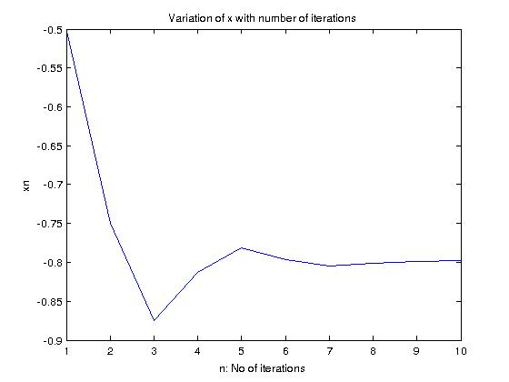
root = -0.79785
func_val = -0.0011242
status = 0
iterations = 10
data =
i a b c f(c)
1.00000 -1.00000 0.00000 -0.50000 -0.79030
2.00000 -1.00000 -0.50000 -0.75000 -0.16861
3.00000 -1.00000 -0.75000 -0.87500 0.29631
4.00000 -0.87500 -0.75000 -0.81250 0.05288
5.00000 -0.81250 -0.75000 -0.78125 -0.06081
6.00000 -0.81250 -0.78125 -0.79688 -0.00468
7.00000 -0.81250 -0.79688 -0.80469 0.02393
8.00000 -0.80469 -0.79688 -0.80078 0.00958
9.00000 -0.80078 -0.79688 -0.79883 0.00244
10.00000 -0.79883 -0.79688 -0.79785 -0.00112

(d) x cos(x)-2x²+3x-1=0 0.2 ≤ x ≤ 0.3 and 1.2 ≤ x ≤ 1.3

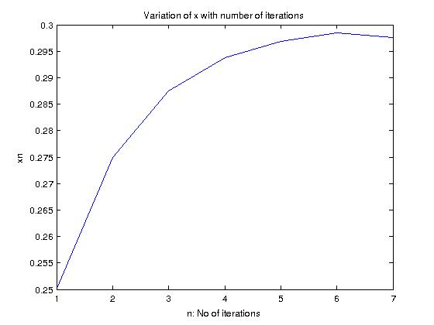
root = 0.29766
func_val = 3.3752e-04
status = 0
iterations = 7
data =
i a b c f(c)
1.0000e+00 2.0000e-01 3.0000e-01 2.5000e-01 -1.3277e-01
2.0000e+00 2.5000e-01 3.0000e-01 2.7500e-01 -6.1583e-02
3.0000e+00 2.7500e-01 3.0000e-01 2.8750e-01 -2.7113e-02
4.0000e+00 2.8750e-01 3.0000e-01 2.9375e-01 -1.0161e-02
5.0000e+00 2.9375e-01 3.0000e-01 2.9688e-01 -1.7562e-03
6.0000e+00 2.9688e-01 3.0000e-01 2.9844e-01 2.4283e-03
7.0000e+00 2.9688e-01 2.9844e-01 2.9766e-01 3.3752e-04

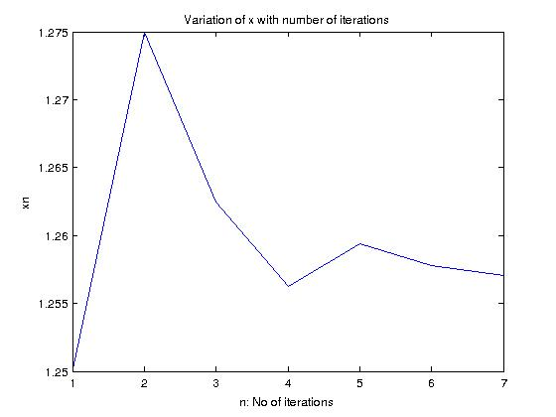

root = 1.2570
func_val = -0.0011886
status = 0
iterations = 7
data =
i a b c f(c)
1.0000000 1.2000000 1.3000000 1.2500000 0.0191530
2.0000000 1.2500000 1.3000000 1.2750000 -0.0545854
3.0000000 1.2500000 1.2750000 1.2625000 -0.0172249
4.0000000 1.2500000 1.2625000 1.2562500 0.0010869
5.0000000 1.2562500 1.2625000 1.2593750 -0.0080383
6.0000000 1.2562500 1.2593750 1.2578125 -0.0034680
7.0000000 1.2562500 1.2578125 1.2570313 -0.0011886

Question 3

g = 32.17;
x = 1.7;
t = 1;
y = x + (g / (2 * w^2)) * ( (exp(w*t) - exp(-w*t)) / 2 - sin(w*t) );

root = -0.31706
func_val = 2.9009e-06
status = 0
iterations = 18
data =
i a b c f(c)
1.0000e+00 -1.0000e+00 1.0000e-01 -4.5000e-01 -7.1287e-01
2.0000e+00 -4.5000e-01 1.0000e-01 -1.7500e-01 7.6171e-01
3.0000e+00 -4.5000e-01 -1.7500e-01 -3.1250e-01 2.4460e-02
4.0000e+00 -4.5000e-01 -3.1250e-01 -3.8125e-01 -3.4419e-01
5.0000e+00 -3.8125e-01 -3.1250e-01 -3.4687e-01 -1.5986e-01
6.0000e+00 -3.4687e-01 -3.1250e-01 -3.2969e-01 -6.7699e-02
7.0000e+00 -3.2969e-01 -3.1250e-01 -3.2109e-01 -2.1619e-02
8.0000e+00 -3.2109e-01 -3.1250e-01 -3.1680e-01 1.4204e-03
9.0000e+00 -3.2109e-01 -3.1680e-01 -3.1895e-01 -1.0100e-02
1.0000e+01 -3.1895e-01 -3.1680e-01 -3.1787e-01 -4.3396e-03
1.1000e+01 -3.1787e-01 -3.1680e-01 -3.1733e-01 -1.4596e-03
1.2000e+01 -3.1733e-01 -3.1680e-01 -3.1707e-01 -1.9599e-05
1.3000e+01 -3.1707e-01 -3.1680e-01 -3.1693e-01 7.0039e-04
1.4000e+01 -3.1707e-01 -3.1693e-01 -3.1700e-01 3.4040e-04
1.5000e+01 -3.1707e-01 -3.1700e-01 -3.1703e-01 1.6040e-04
1.6000e+01 -3.1707e-01 -3.1703e-01 -3.1705e-01 7.0400e-05
1.7000e+01 -3.1707e-01 -3.1705e-01 -3.1706e-01 2.5401e-05
1.8000e+01 -3.1707e-01 -3.1706e-01 -3.1706e-01 2.9009e-06

Question 4
x³ − x − 1 = 0 on [1, 2]. Use x ₀ = 1.

fixed = 1.3239
status = 0
iterations = 4
data =
i x(i-1) g(x(i-1))
1.0000 1.0000 1.4142
2.0000 1.4142 1.3066
3.0000 1.3066 1.3287
4.0000 1.3287 1.3239

Question 5
finding 7^(1/5).

The method used in C is the best one with fastest convergence. D also converges but slowly.

(a)
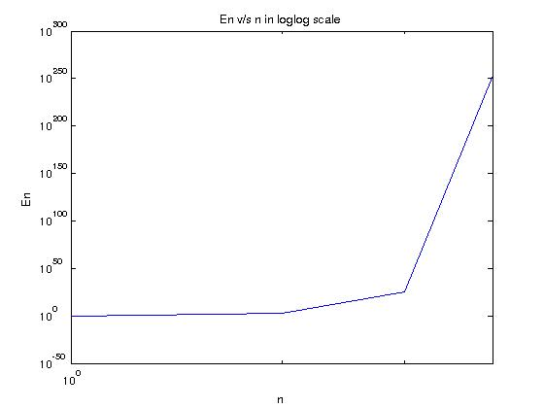
fixed = NaN
status = 1
iterations = 5
data =
i x(i-1) g(x(i-1))
1.0000e+00 1.0000e+00 3.4300e+02
2.0000e+00 3.4300e+02 -2.2539e+25
3.0000e+00 -2.2539e+25 -3.3839e+253
4.0000e+00 -3.3839e+253 NaN
5.0000e+00 NaN NaN

(b)
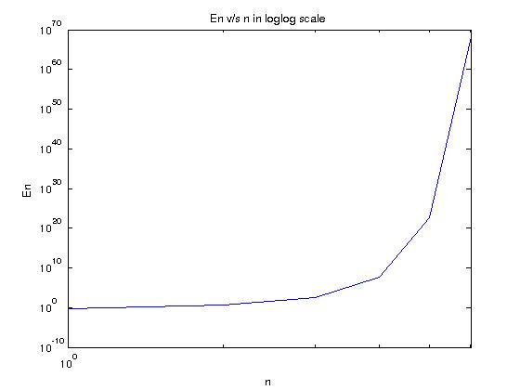
fixed = 1.6075e+68
status = 1
iterations = 5
data =
i x(i-1) g(x(i-1))
1.0000e+00 1.0000e+00 7.0000e+00
2.0000e+00 7.0000e+00 -3.3586e+02
3.0000e+00 -3.3586e+02 3.7884e+07
4.0000e+00 3.7884e+07 -5.4373e+22
5.0000e+00 -5.4373e+22 1.6075e+68

(c)
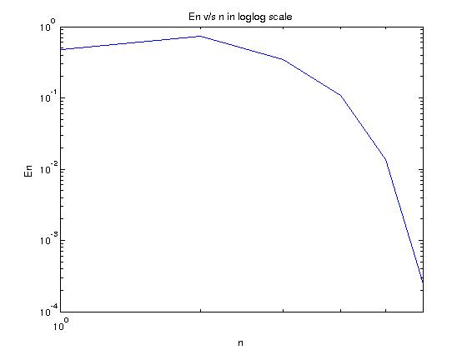
fixed = 1.4760e+00
status = 0
iterations = 5
data =
i x(i-1) g(x(i-1))
1.0000e+00 1.0000e+00 2.2000e+00
2.0000e+00 2.2000e+00 1.8198e+00
3.0000e+00 1.8198e+00 1.5835e+00
4.0000e+00 1.5835e+00 1.4895e+00
5.0000e+00 1.4895e+00 1.4760e+00

(d)
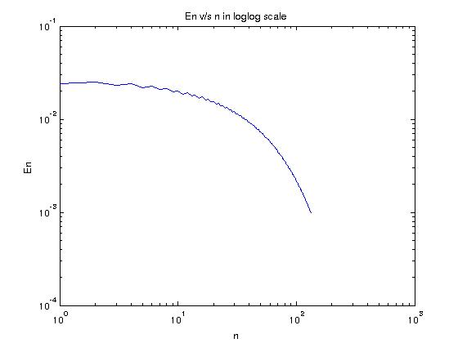
fixed = 1.4976e+00
status = 0
iterations = 5
data =
i x(i-1) g(x(i-1))
1.0000e+00 1.0000e+00 1.5000e+00
2.0000e+00 1.5000e+00 1.4505e+00
3.0000e+00 1.4505e+00 1.4987e+00
4.0000e+00 1.4987e+00 1.4519e+00
5.0000e+00 1.4519e+00 1.4976e+00

Question 6

(a) 3 * x^2 - exp(x)
Interval = [0, 1]
fixed = 0.91000
status = 0
iterations = 15
data =
i x(i-1) g(x(i-1))
1.00000 -0.50000 0.44964
2.00000 0.44964 0.72290
3.00000 0.72290 0.82873
4.00000 0.82873 0.87377
5.00000 0.87377 0.89367
6.00000 0.89367 0.90260
7.00000 0.90260 0.90664
8.00000 0.90664 0.90848
9.00000 0.90848 0.90931
10.00000 0.90931 0.90969
11.00000 0.90969 0.90986
12.00000 0.90986 0.90994
13.00000 0.90994 0.90998
14.00000 0.90998 0.90999
15.00000 0.90999 0.91000

Interval = [-1,0]
fixed = -0.45896
status = 0
iterations = 10
data =
i x(i-1) g(x(i-1))
1.00000 0.50000 -0.74133
2.00000 -0.74133 -0.39853
3.00000 -0.39853 -0.47304
4.00000 -0.47304 -0.45574
5.00000 -0.45574 -0.45970
6.00000 -0.45970 -0.45879
7.00000 -0.45879 -0.45900
8.00000 -0.45900 -0.45895
9.00000 -0.45895 -0.45896
10.00000 -0.45896 -0.45896

Interval = [3,4]
fixed = 3.7331
status = 0
iterations = 16
data =
i x(i-1) g(x(i-1))
1.0000 3.5000 3.6041
2.0000 3.6041 3.6628
3.0000 3.6628 3.6951
4.0000 3.6951 3.7126
5.0000 3.7126 3.7221
6.0000 3.7221 3.7272
7.0000 3.7272 3.7299
8.0000 3.7299 3.7314
9.0000 3.7314 3.7322
10.0000 3.7322 3.7326
11.0000 3.7326 3.7328
12.0000 3.7328 3.7329
13.0000 3.7329 3.7330
14.0000 3.7330 3.7330
15.0000 3.7330 3.7331
16.0000 3.7331 3.7331

(b) x – cos(x)
interval = (-pi, pi)
fixed = 0.73908
status = 0
iterations = 28
data =
i x(i-1) g(x(i-1))
1.00000 0.50000 0.87758
2.00000 0.87758 0.63901
3.00000 0.63901 0.80269
4.00000 0.80269 0.69478
5.00000 0.69478 0.76820
6.00000 0.76820 0.71917
7.00000 0.71917 0.75236
8.00000 0.75236 0.73008
9.00000 0.73008 0.74512
10.00000 0.74512 0.73501
11.00000 0.73501 0.74183
12.00000 0.74183 0.73724
13.00000 0.73724 0.74033
14.00000 0.74033 0.73825
15.00000 0.73825 0.73965
16.00000 0.73965 0.73870
17.00000 0.73870 0.73934
18.00000 0.73934 0.73891
19.00000 0.73891 0.73920
20.00000 0.73920 0.73901
21.00000 0.73901 0.73914
22.00000 0.73914 0.73905
23.00000 0.73905 0.73911
24.00000 0.73911 0.73907
25.00000 0.73907 0.73910
26.00000 0.73910 0.73908
27.00000 0.73908 0.73909
28.00000 0.73909 0.73908

Question 7
Use Newton’s method to find solution accurate to within 10⁻⁵ for the following problems.

(a) f(x) = e^{x} + 2^{-x} + 2cosx – 6 = 0 ; 1 <= x <= 2

fixed = 1.8294
status = 0
iterations = 5
data =
i x(i-1) g(x(i-1))
1.0000 1.5000 1.9565
2.0000 1.9565 1.8415
3.0000 1.8415 1.8295
4.0000 1.8295 1.8294
5.0000 1.8294 1.8294

(b) f(x) = (x-2)² – lnx = 0 ; 1 <= x <= 2 and e <= x <= 4

fixed = 1.4124
status = 0
iterations = 4
data =
i x(i-1) g(x(i-1))
1.0000 1.5000 1.4067
2.0000 1.4067 1.4124
3.0000 1.4124 1.4124
4.0000 1.4124 1.4124

fixed = 3.0571
status = 0
iterations = 3
data =
i x(i-1) g(x(i-1))
1.0000 3.0000 3.0592
2.0000 3.0592 3.0571
3.0000 3.0571 3.0571

(c) f(x) = e^{x} – 3x² = 0 ; 0 <= x <= 1 and 3 <= x <= 5

fixed = 0.91001
status = 0
iterations = 5
data =
i x(i-1) g(x(i-1))
1.00000 0.50000 1.16509
2.00000 1.16509 0.93623
3.00000 0.93623 0.91040
4.00000 0.91040 0.91001
5.00000 0.91001 0.91001

fixed = 3.7331
status = 0
iterations = 4
data =
i x(i-1) g(x(i-1))
1.0000 4.0000 3.7844
2.0000 3.7844 3.7354
3.0000 3.7354 3.7331
4.0000 3.7331 3.7331

(d) f(x) = sinx – e^{x} = 0 ; 0 <= x <= 1, 3 <= x <= 4 and 6 <= x <= 7
fixed = 0.58853
status = 0
iterations = 3
data =
i x(i-1) g(x(i-1))
1.00000 0.50000 0.58564
2.00000 0.58564 0.58853
3.00000 0.58853 0.58853

fixed = 3.0964
status = 0
iterations = 4
data =
i x(i-1) g(x(i-1))
1.0000 3.5000 3.0796
2.0000 3.0796 3.0964
3.0000 3.0964 3.0964
4.0000 3.0964 3.0964

fixed = 6.2850
status = 0
iterations = 3
data =
i x(i-1) g(x(i-1))
1.0000 6.5000 6.2816
2.0000 6.2816 6.2850
3.0000 6.2850 6.2850

Question 8
f(x) = 2^{x2} - 3.7^{x+1} = 0
Plot of f(x)
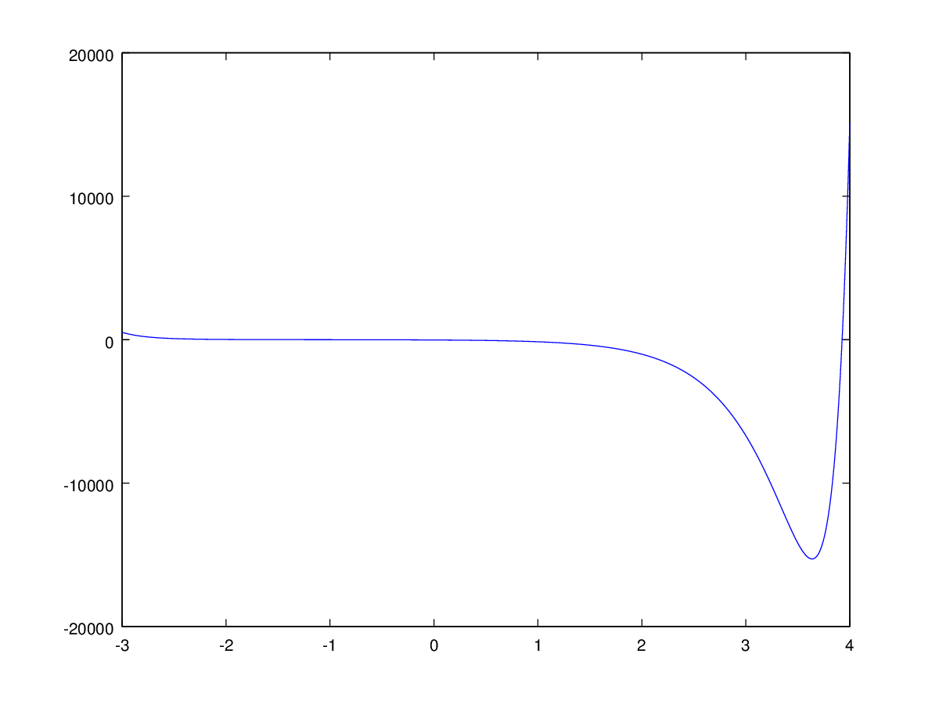
fixed = -1.1187e+00
status = 0.0000e+00
iterations = 4.0000e+00
data =
i x(i-1) g(x(i-1))
1.0000e+00 -1.0000e+00 -1.1161e+00
2.0000e+00 -1.1161e+00 -1.1187e+00
3.0000e+00 -1.1187e+00 -1.1187e+00
4.0000e+00 -1.1187e+00 -1.1187e+00

fixed = 3.9261e+00
status = 0.0000e+00
iterations = 6.0000e+00
data =
i x(i) g(x(i))
1.0000e+00 4.0000e+00 3.9430e+00
2.0000e+00 3.9430e+00 3.9272e+00
3.0000e+00 3.9272e+00 3.9261e+00
4.0000e+00 3.9261e+00 3.9261e+00
5.0000e+00 3.9261e+00 3.9261e+00
6.0000e+00 3.9261e+00 3.9261e+00

Question 9
f(x) = 2.^(x.^2) - 3 * 7.^(x+1);

(a) Newton's Method

fixed = -0.040659
status = 0
iterations = 4
data =
i x(i) g(x(i))
1.000000 -0.500000 -0.150452
2.000000 -0.150452 -0.041817
3.000000 -0.041817 -0.040659
4.000000 -0.040659 -0.040659

fixed = 0.96240
status = 0
iterations = 4
data =
i x(i) g(x(i))
1.00000 0.90000 0.97179
2.00000 0.97179 0.96257
3.00000 0.96257 0.96240
4.00000 0.96240 0.96240

(b) Secant Method

fixed = -0.040659
status = 0
iterations = 6
data =
i x(i) g(x(i))
1.00000 -1.00000 0.00000
2.00000 0.00000 -0.02036
3.00000 -0.02036 -0.04069
4.00000 -0.04069 -0.04066
5.00000 -0.04066 -0.04066
6.00000 -0.04066 -0.04066

fixed = 0.96240
status = 0
iterations = 7
data =
i x(i) g(x(i))
1.00000 0.80000 1.00000
2.00000 1.00000 0.94788
3.00000 0.94788 0.96134
4.00000 0.96134 0.96243
5.00000 0.96243 0.96240
6.00000 0.96240 0.96240
7.00000 0.96240 0.96240

Question 10
Use Secant method to find solution accurate to within 10⁻⁵ for the following problems.

Newton's method has a faster convergence than secant method.

(a) f(x) = e^{x} + 2^{-x} + 2cosx – 6 = 0 ; 1 <= x <= 2

fixed = 1.8294
status = 0
iterations = 8
data =
i x(i) g(x(i))
1.0000 1.0000 2.0000
2.0000 2.0000 1.6783
3.0000 1.6783 1.8081
4.0000 1.8081 1.8323
5.0000 1.8323 1.8293
6.0000 1.8293 1.8294
7.0000 1.8294 1.8294
8.0000 1.8294 1.8294

(b) f(x) = (x-2)² – lnx = 0 ; 1 <= x <= 2 and e <= x <= 4

fixed = 1.4124
status = 0
iterations = 9
data =
i x(i) g(x(i))
1.0000 1.0000 2.0000
2.0000 2.0000 1.5906
3.0000 1.5906 1.2845
4.0000 1.2845 1.4280
5.0000 1.4280 1.4136
6.0000 1.4136 1.4124
7.0000 1.4124 1.4124
8.0000 1.4124 1.4124
9.0000 1.4124 1.4124

fixed = 3.0571
status = 0
iterations = 8
data =
i x(i) g(x(i))
1.0000 2.7183 4.0000
2.0000 4.0000 2.9186
3.0000 2.9186 3.0051
4.0000 3.0051 3.0619
5.0000 3.0619 3.0570
6.0000 3.0570 3.0571
7.0000 3.0571 3.0571
8.0000 3.0571 3.0571

(c) f(x) = e^{x} – 3x² = 0 ; 0 <= x <= 1 and 3 <= x <= 5

fixed = 0.91001
status = 0
iterations = 7
data =
i x(i) g(x(i))
1.00000 0.00000 1.00000
2.00000 1.00000 0.78020
3.00000 0.78020 0.90287
4.00000 0.90287 0.91062
5.00000 0.91062 0.91000
6.00000 0.91000 0.91001
7.00000 0.91001 0.91001

fixed = 3.7331
status = 0
iterations = 12
data =
i x(i) g(x(i))
1.0000 3.0000 5.0000
2.0000 5.0000 3.1722
3.0000 3.1722 3.3172
4.0000 3.3172 4.1916
5.0000 4.1916 3.5690
6.0000 3.5690 3.6743
7.0000 3.6743 3.7432
8.0000 3.7432 3.7325
9.0000 3.7325 3.7331
10.0000 3.7331 3.7331
11.0000 3.7331 3.7331
12.0000 3.7331 3.7331

(d) f(x) = sinx – e^{x} = 0 ; 0 <= x <= 1, 3 <= x <= 4 and 6 <= x <= 7

fixed = 0.58853
status = 0
iterations = 7
data =
i x(i) g(x(i))
1.00000 0.00000 1.00000
2.00000 1.00000 0.67861
3.00000 0.67861 0.56906
4.00000 0.56906 0.58926
5.00000 0.58926 0.58854
6.00000 0.58854 0.58853
7.00000 0.58853 0.58853

fixed = 3.0964
status = 0
iterations = 6
data =
i x(i) g(x(i))
1.0000 3.0000 4.0000
2.0000 4.0000 3.1054
3.0000 3.1054 3.0953
4.0000 3.0953 3.0964
5.0000 3.0964 3.0964
6.0000 3.0964 3.0964

fixed = 6.2850
status = 0
iterations = 6
data =
i x(i) g(x(i))
1.0000 6.0000 7.0000
2.0000 7.0000 6.3005
3.0000 6.3005 6.2836
4.0000 6.2836 6.2850
5.0000 6.2850 6.2850
6.0000 6.2850 6.2850

Question 11
We need to find the root of the equation f(x) = 2x³ + x -1 = 0

Secant method successful
fixed = 0.58975
status = 0
iterations = 7
data =
i x(i) g(x(i))
1.00000 0.00000 1.00000
2.00000 1.00000 0.33333
3.00000 0.33333 0.48571
4.00000 0.48571 0.62701
5.00000 0.62701 0.58515
6.00000 0.58515 0.58956
7.00000 0.58956 0.58976

Question 12

Secant method successful
fixed = 0.10100
status = 0
iterations = 5
data =
i x(i) g(x(i))
1.00000 0.10000 0.30000
2.00000 0.30000 0.10091
3.00000 0.10091 0.10099
4.00000 0.10099 0.10100
5.00000 0.10100 0.10100

