MA 322: Scientific Computing
LAB 3 Report
Abheek Ghosh - 140123047

NOTATION:
Status = 0 implies successful, Status = 1 implies unsuccessful.
tol ==> Error tolerance limit
root ==> Root of the function
fixed ==> Fixed point of function
func_val ==> Function value evaluated at the result found
iterations ==> Iterations taken for comvergence
p ==> order of root of higher multiplicity

Question 1
(a)
fixed_point =
0.44908
0.89816

status = 0
iterations = 7
data =
n x1(n) x2(n) x1(n+1) x2(n+1) f1(x) f2(x)
1.00000 0.00000 1.00000 0.33333 0.50000 -1.00000 -1.00000
2.00000 0.33333 0.50000 0.54167 1.25000 0.19444 -1.00000 <- value after 2 iterations
3.00000 0.54167 1.25000 0.47328 0.97590 -0.38889 1.84375
4.00000 0.47328 0.97590 0.45094 0.90366 -0.05642 0.32969
5.00000 0.45094 0.90366 0.44909 0.89819 -0.00322 0.02201
6.00000 0.44909 0.89819 0.44908 0.89816 -0.00002 0.00013
7.00000 0.44908 0.89816 0.44908 0.89816 -0.00000 0.00000

A =
4 -2
2 3

fixed_point =
0.44908
0.89816

status = 0
iterations = 8
data =
n x1(n) x2(n) x1(n+1) x2(n+1)
1.00000 0.00000 1.00000 0.31250 1.12500
2.00000 0.31250 1.12500 0.44287 0.94824 <- value after 2 iterations
3.00000 0.44287 0.94824 0.44562 0.89642
4.00000 0.44562 0.89642 0.44902 0.89858
5.00000 0.44902 0.89858 0.44905 0.89815
6.00000 0.44905 0.89815 0.44908 0.89816
7.00000 0.44908 0.89816 0.44908 0.89816
8.00000 0.44908 0.89816 0.44908 0.89816
(b)
fixed_point =

1
1

status = 0
iterations = 1
data =
n x1(n) x2(n) x1(n+1) x2(n+1) f1(x) f2(x)
1 1 1 1 1 0 0 <- value after 2 iterations

A =

7 3
-9 3

fixed_point =

1
1

status = 0
iterations = 1
data =

n x1(n) x2(n) x1(n+1) x2(n+1)
1 1 1 1 1 <- value after 2 iterations

Question 2
(a)
fixed_point =

0.50000
2.00000

status = 0
iterations = 5
data =
n x1(n) x2(n) x1(n+1) x2(n+1) f1(x) f2(x)
1.00000 0.00000 0.00000 0.40000 1.76000 8.00000 8.00000
2.00000 0.40000 1.76000 0.49589 1.98342 1.41440 0.61952 <- value after 2 iterations
3.00000 0.49589 1.98342 0.49999 1.99994 0.04926 0.05008
4.00000 0.49999 1.99994 0.50000 2.00000 0.00014 0.00020
5.00000 0.50000 2.00000 0.50000 2.00000 0.00000 0.00000

A =

-16 1
4 -4

fixed_point =

0.50000
2.00000

status = 0
iterations = 6
data =
n x1(n) x2(n) x1(n+1) x2(n+1)
1.00000 0.00000 0.00000 0.66667 2.66667
2.00000 0.66667 2.66667 0.52099 2.11358 <- value after 2 iterations
3.00000 0.52099 2.11358 0.50047 2.00250
4.00000 0.50047 2.00250 0.50000 2.00000
5.00000 0.50000 2.00000 0.50000 2.00000
6.00000 0.50000 2.00000 0.50000 2.00000

(b)
fixed_point =

-0.373698
0.056266

status = 0
iterations = 6
data =
n x1(n) x2(n) x1(n+1) x2(n+1) f1(x) f2(x)
1.00000 0.00000 0.00000 -0.43984 0.21992 0.00000 -1.58155
2.00000 -0.43984 0.21992 -0.51316 -0.01838 -0.93756 0.79703 <- value after 2 iterations
3.00000 -0.51316 -0.01838 -0.38821 0.04285 0.66814 0.62135
4.00000 -0.38821 0.04285 -0.37424 0.05590 0.09497 0.05198
5.00000 -0.37424 0.05590 -0.37370 0.05627 0.00257 0.00202
6.00000 -0.37370 0.05627 -0.37370 0.05627 0.00000 0.00000

A =

0 -6
-4 1

fixed_point =

-0.373698
0.056267

status = 0
iterations = 8
data =
n x1(n) x2(n) x1(n+1) x2(n+1)
1.00000 0.00000 0.00000 -0.39539 0.00000
2.00000 -0.39539 0.00000 -0.36267 0.06590 <- value after 2 iterations
3.00000 -0.36267 0.06590 -0.37474 0.05507
4.00000 -0.37474 0.05507 -0.37357 0.05643
5.00000 -0.37357 0.05643 -0.37371 0.05625
6.00000 -0.37371 0.05625 -0.37370 0.05627
7.00000 -0.37370 0.05627 -0.37370 0.05627
8.00000 -0.37370 0.05627 -0.37370 0.05627

Question 3
fixed_point =

0.44043
-1.09476
-0.55458

status = 0
iterations = 4
data =
n x1(n) x2(n) x3(n) x1(n+1) x2(n+1) x3(n+1) f1(x) f2(x) f3(x)
1 0.00000 0.00000 0.00000 0.50000 -1.08614 -0.52360 -3.00000 10.02956 31.41593
2 0.50000 -1.08614 -0.52360 0.44071 -1.09469 -0.55449 0.31480 0.12472 2.16386
3 0.44071 -1.09469 -0.55449 0.44043 -1.09476 -0.55458 0.00151 0.00086 0.00669
4 0.44043 -1.09476 -0.55458 0.44043 -1.09476 -0.55458 0.00000 0.00000 0.00000

A =

6 0 -1
0 9 0
5 -2 60

fixed_point =

0.44043
-1.09476
-0.55458

status = 0
iterations = 7
data =
n x1(n) x2(n) x3(n) x1(n+1) x2(n+1) x3(n+1)
1.00000 0.00000 0.00000 0.00000 0.40097 -1.11440 -0.59416
2.00000 0.40097 -1.11440 -0.59416 0.43627 -1.09033 -0.55391
3.00000 0.43627 -1.09033 -0.55391 0.44092 -1.09456 -0.55458
4.00000 0.44092 -1.09456 -0.55458 0.44045 -1.09479 -0.55458
5.00000 0.44045 -1.09479 -0.55458 0.44043 -1.09476 -0.55458
6.00000 0.44043 -1.09476 -0.55458 0.44043 -1.09476 -0.55458
7.00000 0.44043 -1.09476 -0.55458 0.44043 -1.09476 -0.55458

Question 4

fixed_point = 2.8047
status = 0
iterations = 23
data =

1.0000 1.0000 1.7909
2.0000 1.7909 3.2796
3.0000 3.2796 3.0417
4.0000 3.0417 2.9274
5.0000 2.9274 2.8691
6.0000 2.8691 2.8387
7.0000 2.8387 2.8227
8.0000 2.8227 2.8143
9.0000 2.8143 2.8098
10.0000 2.8098 2.8074
11.0000 2.8074 2.8061
12.0000 2.8061 2.8055
13.0000 2.8055 2.8051
14.0000 2.8051 2.8049
15.0000 2.8049 2.8048
16.0000 2.8048 2.8048
17.0000 2.8048 2.8048
18.0000 2.8048 2.8047
19.0000 2.8047 2.8047
20.0000 2.8047 2.8047
21.0000 2.8047 2.8047
22.0000 2.8047 2.8047
23.0000 2.8047 2.8047

x = 2.8047
y = 0.18179

Question 5
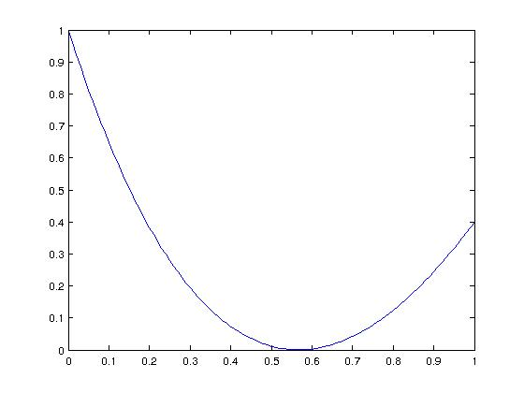
(a) f(x) vs x

fixed_point = 0.56713
status = 0
iterations = 13
data =

1.00000 0.50000 0.53316
2.00000 0.53316 0.55004
3.00000 0.55004 0.55857
4.00000 0.55857 0.56285
5.00000 0.56285 0.56499
6.00000 0.56499 0.56607
7.00000 0.56607 0.56661
8.00000 0.56661 0.56687
9.00000 0.56687 0.56701
10.00000 0.56701 0.56708
11.00000 0.56708 0.56711
12.00000 0.56711 0.56713
13.00000 0.56713 0.56713
p = 2

fixed_point = 0.5671
status = 0
iterations = 3
data =

1.0000 0.5000 0.5663
2.0000 0.5663 0.5671
3.0000 0.5671 0.5671
(b)
f(x) vs x
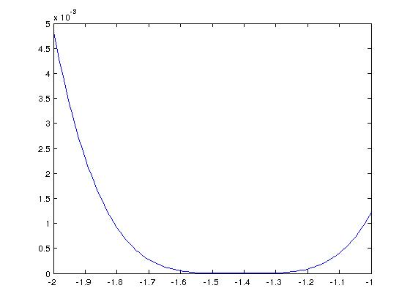
fixed_point = -1.4145
status = 0
iterations = 22
data =

1.0000 -1.5000 -1.4786
2.0000 -1.4786 -1.4625
3.0000 -1.4625 -1.4504
4.0000 -1.4504 -1.4414
5.0000 -1.4414 -1.4346
6.0000 -1.4346 -1.4295
7.0000 -1.4295 -1.4257
8.0000 -1.4257 -1.4228
9.0000 -1.4228 -1.4207
10.0000 -1.4207 -1.4190
11.0000 -1.4190 -1.4178
12.0000 -1.4178 -1.4169
13.0000 -1.4169 -1.4163
14.0000 -1.4163 -1.4157
15.0000 -1.4157 -1.4154
16.0000 -1.4154 -1.4151
17.0000 -1.4151 -1.4149
18.0000 -1.4149 -1.4147
19.0000 -1.4147 -1.4146
20.0000 -1.4146 -1.4145
21.0000 -1.4145 -1.4145
22.0000 -1.4145 -1.4145

p = 4
fixed_point = -1.4142
status = 0
iterations = 2
data =

1.0000 -1.5000 -1.4142
2.0000 -1.4142 -1.4142

(c)
f(x) vs x
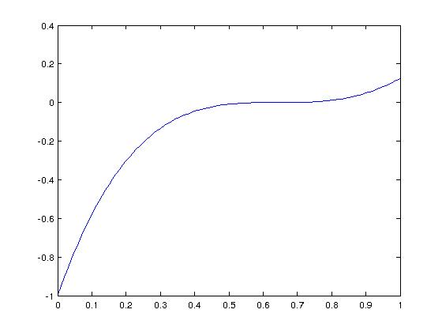

fixed_point = 0.64117
status = 0
iterations = 22
data =

1.00000 0.50000 0.54633
2.00000 0.54633 0.57762
3.00000 0.57762 0.59866
4.00000 0.59866 0.61277
5.00000 0.61277 0.62221
6.00000 0.62221 0.62853
7.00000 0.62853 0.63274
8.00000 0.63274 0.63555
9.00000 0.63555 0.63743
10.00000 0.63743 0.63868
11.00000 0.63868 0.63952
12.00000 0.63952 0.64007
13.00000 0.64007 0.64044
14.00000 0.64044 0.64069
15.00000 0.64069 0.64086
16.00000 0.64086 0.64097
17.00000 0.64097 0.64104
18.00000 0.64104 0.64109
19.00000 0.64109 0.64112
20.00000 0.64112 0.64114
21.00000 0.64114 0.64116
22.00000 0.64116 0.64117

p = 3
fixed_point = 0.6412
status = 0
iterations = 3
data =

1.0000 0.5000 0.6435
2.0000 0.6435 0.6412
3.0000 0.6412 0.6412

(d)
f(x) vs x
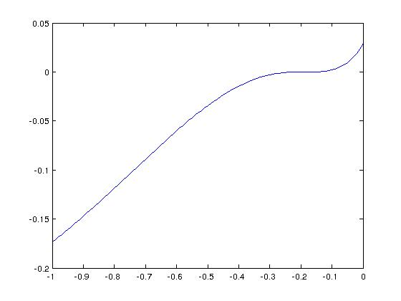

fixed_point = -0.18327
status = 0
iterations = 23
data =

1.00000 -0.50000 -0.35264
2.00000 -0.35264 -0.28544
3.00000 -0.28544 -0.24765
4.00000 -0.24765 -0.22474
5.00000 -0.22474 -0.21032
6.00000 -0.21032 -0.20105
7.00000 -0.20105 -0.19501
8.00000 -0.19501 -0.19105
9.00000 -0.19105 -0.18843
10.00000 -0.18843 -0.18670
11.00000 -0.18670 -0.18555
12.00000 -0.18555 -0.18478
13.00000 -0.18478 -0.18427
14.00000 -0.18427 -0.18393
15.00000 -0.18393 -0.18371
16.00000 -0.18371 -0.18356
17.00000 -0.18356 -0.18346
18.00000 -0.18346 -0.18339
19.00000 -0.18339 -0.18335
20.00000 -0.18335 -0.18332
21.00000 -0.18332 -0.18330
22.00000 -0.18330 -0.18328
23.00000 -0.18328 -0.18327

p = 3
fixed_point = 0.6412
status = 0
iterations = 3
data =

1.0000 0.5000 0.6435
2.0000 0.6435 0.6412
3.0000 0.6412 0.6412

