MA 322: Scientific Computing
LAB 4 Report
Abheek Ghosh - 140123047

Question 1

f(x) = exp(x)
Calculating f(2.25). Exact value = 9.487736

a) Newton’s forward difference interpolation, value = 9.496925
b) Newton’s backward difference interpolation, value = 9.496925

Question 2

Newton forward-difference. f(0.05) = 1.0513e+0
Newton backward-difference. f(0.65) = 1.9156e+00

Question 3
f(x) = atan(x)

Coefficients at Newton form,
7.8540e-01 9.8698e-02 -1.2173e-02 1.3261e-03 -1.2499e-04 1.0070e-05 -6.7622e-07 3.5089e-08 -9.8582e-10 -5.5669e-11 1.2244e-11

The error is very low for the points in the interval [1,6] where the interpolation has been done. But outside it is comparatively large.

x p(x) f(x) error
0.00000 -0.10532 0.00000 0.10532
0.25000 0.21308 0.24498 0.03190
0.50000 0.45640 0.46365 0.00725
0.75000 0.64247 0.64350 0.00103
1.00000 0.78540 0.78540 0.00000
1.25000 0.89609 0.89606 0.00003
1.50000 0.98279 0.98279 0.00000
1.75000 1.05165 1.05165 0.00000
2.00000 1.10715 1.10715 0.00000
2.25000 1.15257 1.15257 0.00000
2.50000 1.19029 1.19029 0.00000
2.75000 1.22203 1.22203 0.00000
3.00000 1.24905 1.24905 0.00000
3.25000 1.27230 1.27230 0.00000
3.50000 1.29250 1.29250 0.00000
3.75000 1.31019 1.31019 0.00000
4.00000 1.32582 1.32582 0.00000
4.25000 1.33971 1.33971 0.00000
4.50000 1.35213 1.35213 0.00000
4.75000 1.36330 1.36330 0.00000
5.00000 1.37340 1.37340 0.00000
5.25000 1.38258 1.38257 0.00000
5.50000 1.39094 1.39094 0.00000
5.75000 1.39860 1.39861 0.00001
6.00000 1.40565 1.40565 0.00000
6.25000 1.41225 1.41214 0.00011
6.50000 1.41877 1.41815 0.00062
6.75000 1.42601 1.42372 0.00230
7.00000 1.43570 1.42890 0.00680
7.25000 1.45121 1.43373 0.01747
7.50000 1.47876 1.43824 0.04051
7.75000 1.52924 1.44247 0.08677
8.00000 1.62079 1.44644 0.17435

Red : Interpolated Polynomial, Blue : atan(x)
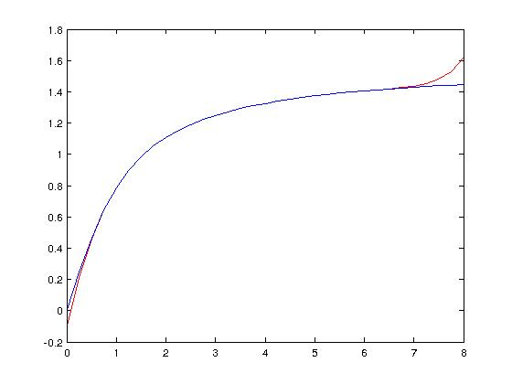

Question 4
By Lagrange interpolating polynomial
Bound of maximum error in 1 to 1.4 = 4.936661705381984e-05

Question 5
By Lagrange interpolating polynomial
(a) f(0.18) = -0.508143074400000 (lagrange)
(b) f(0.25) = 1.188935146875000 (lagrange)

Question 6
Using Newton's divided difference
Population in year 1940 = 1.0239700e+05
Population in year 1975 = 2.1504275e+05
Population in year 2020 = 5.1344300e+05

Question 7
(a)
Degree = 3

Polynomial =
x*(x - 1)*(x - 2) - 1

Coefficients =
0 1 -3 2 -1

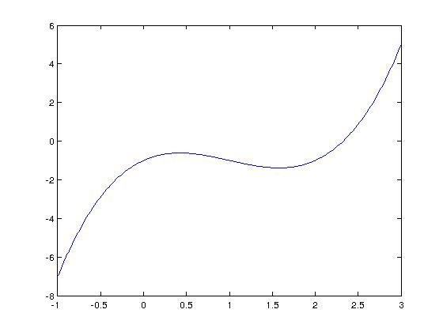

(b)
Degree = 4

Polynomial =
2*x + ((x - 1)*(x - 3))/5 - (7*(x - 1)*(x + 2)*(x - 3))/10 + (37*(x - 1)*(x + 2)*(x - 3)*(x - 4))/70

Coefficients =
0.528571428571429 -3.871428571428572 3.185714285714287 18.442857142857143 -16.285714285714285

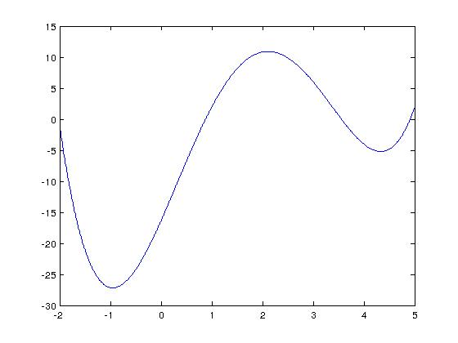
Question 8
Without including point 1.1.
Using Newton's divided difference. f (0.2) = -5.778589587301587
Using Lagrange interpolating polynomial f (0.2) = -5.778589587301588

After including point 1.1 and its respective value f (1.1) = −3.99583
Using Newton's divided difference. f (0.2) = -5.778598649350649
Using Lagrange interpolating polynomial f (0.2) = -5.778598649350648

The results from both the interpolation methods is same because the polynomial generated of is less or equal to degree 4 and it interpolates 5 points. If they are different then their difference will have 5 roots but of order <= 4, which is not possible.

Adding the extra points doesn't affect the solution much.

