MA 322: Scientific Computing
LAB 6 Report
Abheek Ghosh - 140123047

Question 1 and 2

Using Rectangle rule with lower point.

(a) f(x) = x^4

Calculated value of integral = 3.125000e-02
Actual value of integral = 1.937500e-01
Error Bound = 5.000000e-01
Error = 1.625000e-01

(b) f(x) = 2/(x - 4)

Calculated value of integral = -2.500000e-01
Actual value of integral = -2.670628e-01
Error Bound = 2.040816e-02
Error = 1.706279e-02

(c) f(x) = (2*x)/(x^2 - 4)

Calculated value of integral = -4.000000e-01
Actual value of integral = -7.339692e-01
Error Bound = 1.138889e+00
Error = 3.339692e-01

(d) f(x) = sin(2*x)*exp(3*x)

Calculated value of integral = 0.000000e+00
Actual value of integral = 2.588629e+00
Error Bound = 9.762326e+00
Error = 2.588629e+00

(e) f(x) = sin(x)^2 - 2*x*sin(x) + 1

Calculated value of integral = 2.431953e-01
Actual value of integral = -2.037680e-02
Error Bound = 3.187007e-01
Error = 2.635721e-01

(f) f(x) = x*sin(x)

Calculated value of integral = 0.000000e+00
Actual value of integral = 1.517464e-01
Error Bound = 3.893766e-01
Error = 1.517464e-01

(g) f(x) = x*exp(-x)

Calculated value of integral = -8.154845e+00
Actual value of integral = -4.060058e-01
Error Bound = 2.446454e+01
Error = 7.748840e+00

(h) f(x) = 1/(x*log(x))

Calculated value of integral = 3.678794e-01
Actual value of integral = 2.725139e-01
Error Bound = 1.353353e-01
Error = 9.536556e-02

Question 3

(a) f(x) = x^4

Using Mid-point Rule
Calculated value of integral = 1.582031e-01
Actual value of integral = 1.937500e-01
Error Bound = 6.250000e-02
Error = 3.554688e-02

Using Trapezoid Rule
Calculated value of integral = 2.656250e-01
Actual value of integral = 1.937500e-01
Error Bound = 1.250000e-01
Error = 7.187500e-02

Using Simpson Rule
Calculated value of integral = 1.940104e-01
Actual value of integral = 1.937500e-01
Error Bound = 4.166667e-03
Error = 2.604167e-04

Using Corrected-Trapezoid Rule
Calculated value of integral = 1.927083e-01
Actual value of integral = 1.937500e-01
Error Bound = 1.041667e-03
Error = 1.041667e-03

(b) f(x) = 2/(x - 4)

Using Mid-point Rule
Calculated value of integral = -2.666667e-01
Actual value of integral = -2.670628e-01
Error Bound = 4.859086e-04
Error = 3.961186e-04

Using Trapezoid Rule
Calculated value of integral = -2.678571e-01
Actual value of integral = -2.670628e-01
Error Bound = 9.718173e-04
Error = 7.943576e-04

Using Simpson Rule
Calculated value of integral = -2.670635e-01
Actual value of integral = -2.670628e-01
Error Bound = 1.586640e-05
Error = 7.068144e-07

Using Corrected-Trapezoid Rule
Calculated value of integral = -2.670599e-01
Actual value of integral = -2.670628e-01
Error Bound = 3.966601e-06
Error = 2.836269e-06

(c) f(x) = (2*x)/(x^2 - 4)

Using Mid-point Rule
Calculated value of integral = -6.753247e-01
Actual value of integral = -7.339692e-01
Error Bound = 2.808642e-01
Error = 5.864450e-02

Using Trapezoid Rule
Calculated value of integral = -8.666667e-01
Actual value of integral = -7.339692e-01
Error Bound = 5.617284e-01
Error = 1.326975e-01

Using Simpson Rule
Calculated value of integral = -7.391053e-01
Actual value of integral = -7.339692e-01
Error Bound = 7.031131e-01
Error = 5.136164e-03

Using Corrected-Trapezoid Rule
Calculated value of integral = -7.101852e-01
Actual value of integral = -7.339692e-01
Error Bound = 2.531207e-01
Error = 2.378399e-02

(d) f(x) = sin(2*x)*exp(3*x)

Using Mid-point Rule
Calculated value of integral = 1.803915e+00
Actual value of integral = 2.588629e+00
Error Bound = 1.149414e+00
Error = 7.847139e-01

Using Trapezoid Rule
Calculated value of integral = 4.143260e+00
Actual value of integral = 2.588629e+00
Error Bound = 2.298827e+00
Error = 1.554631e+00

Using Simpson Rule
Calculated value of integral = 2.583696e+00
Actual value of integral = 2.588629e+00
Error Bound = 8.448243e-01
Error = 4.932229e-03

Using Corrected-Trapezoid Rule
Calculated value of integral = 2.619014e+00
Actual value of integral = 2.588629e+00
Error Bound = 5.211301e-01
Error = 3.038514e-02

(e) f(x) = sin(x)^2 - 2*x*sin(x) + 1

Using Mid-point Rule
Calculated value of integral = -1.189526e-02
Actual value of integral = -2.037680e-02
Error Bound = 1.222040e-02
Error = 8.481537e-03

Using Trapezoid Rule
Calculated value of integral = -3.702425e-02
Actual value of integral = -2.037680e-02
Error Bound = 2.444081e-02
Error = 1.664746e-02

Using Simpson Rule
Calculated value of integral = -2.027159e-02
Actual value of integral = -2.037680e-02
Error Bound = 1.499651e-03
Error = 1.052061e-04

Using Corrected-Trapezoid Rule
Calculated value of integral = -2.079523e-02
Actual value of integral = -2.037680e-02
Error Bound = 4.536444e-04
Error = 4.184296e-04

(f) f(x) = x*sin(x)

Using Mid-point Rule
Calculated value of integral = 1.180292e-01
Actual value of integral = 1.517464e-01
Error Bound = 4.037276e-02
Error = 3.371722e-02

Using Trapezoid Rule
Calculated value of integral = 2.180895e-01
Actual value of integral = 1.517464e-01
Error Bound = 8.074551e-02
Error = 6.634309e-02

Using Simpson Rule
Calculated value of integral = 1.513826e-01
Actual value of integral = 1.517464e-01
Error Bound = 2.691517e-03
Error = 3.637850e-04

Using Corrected-Trapezoid Rule
Calculated value of integral = 1.531934e-01
Actual value of integral = 1.517464e-01
Error Bound = 1.660263e-03
Error = 1.446992e-03

(g) f(x) = x*exp(-x)

Using Mid-point Rule
Calculated value of integral = 9.097960e-01
Actual value of integral = -4.060058e-01
Error Bound = 9.174201e+00
Error = 1.315802e+00

Using Trapezoid Rule
Calculated value of integral = -3.671417e+00
Actual value of integral = -4.060058e-01
Error Bound = 1.834840e+01
Error = 3.265411e+00

Using Simpson Rule
Calculated value of integral = -6.172750e-01
Actual value of integral = -4.060058e-01
Error Bound = 5.096778e-01
Error = 2.112691e-01

Using Corrected-Trapezoid Rule
Calculated value of integral = 5.075073e-01
Actual value of integral = -4.060058e-01
Error Bound = 4.587101e+00
Error = 9.135132e-01

(h) f(x) = 1/(x*log(x))

Using Mid-point Rule
Calculated value of integral = 2.658386e-01
Actual value of integral = 2.725139e-01
Error Bound = 1.452123e-02
Error = 6.675288e-03

Using Trapezoid Rule
Calculated value of integral = 2.863342e-01
Actual value of integral = 2.725139e-01
Error Bound = 2.904246e-02
Error = 1.382029e-02

Using Simpson Rule
Calculated value of integral = 2.726705e-01
Actual value of integral = 2.725139e-01
Error Bound = 2.133683e-03
Error = 1.565719e-04

Using Corrected-Trapezoid Rule
Calculated value of integral = 2.718629e-01
Actual value of integral = 2.725139e-01
Error Bound = 2.133683e-03
Error = 6.510291e-04

Question 4

Mid-point, trapezoid and one-third simpson rules give correct integrals for polynomials (for non-polynomial functions we take Taylor series expansion) upto degree 2. Corrected trapezoid and Simpson three-eight gives correct results upto degree 4. The coefficients in error bounds is smaller for Simpson one-third < Mid-point < Trapezoid. In the other case, Simpson three-eight < Corrected trapezoid. So we get the following result. For error formulas see code.

f(x) = 4/(x^2 + 1)

Using Mid-point Rule
Calculated value of integral = 1.280000e+00
Actual value of integral = 1.287002e+00
Error Bound = 1.041667e-02
Error = 7.002218e-03

Using Trapezoid Rule
Calculated value of integral = 1.300000e+00
Actual value of integral = 1.287002e+00
Error Bound = 2.083333e-02
Error = 1.299778e-02

Using Simpson one-third Rule
Calculated value of integral = 1.286667e+00
Actual value of integral = 1.287002e+00
Error Bound = 7.031250e-03
Error = 3.355509e-04

Using Corrected-Trapezoid Rule
Calculated value of integral = 1.288333e+00
Actual value of integral = 1.287002e+00
Error Bound = 1.757813e-03
Error = 1.331116e-03

Using Simpson three-eight Rule
Calculated value of integral = 1.286854e+00
Actual value of integral = 1.287002e+00
Error Bound = 4.746094e-02
Error = 1.484975e-04

Question 5

(a) f(x) = sin(3*x)*exp(2*x)

Using Composite Trapezoid Rule
Calculated value of integral = -1.357598e+01
Actual value of integral = -1.421398e+01
Error Bound = 7.347501e+00
Error = 6.379977e-01

(b) f(x) = x/(x^2 + 4)

Using Composite Trapezoid Rule
Calculated value of integral = 4.769769e-01
Actual value of integral = 4.777557e-01
Error Bound = 1.833333e-03
Error = 7.788560e-04

(c) f(x) = 1/(x^2 - 4)^(1/2)

Using Composite Trapezoid Rule
Calculated value of integral = 6.054975e-01
Actual value of integral = 6.043756e-01
Error Bound = 4.099458e-03
Error = 1.121928e-03

(d) f(x) = x^2*exp(-x^2)

Using Composite Trapezoid Rule
Calculated value of integral = 4.215820e-01
Actual value of integral = 4.227251e-01
Error Bound = 2.083333e-02
Error = 1.143019e-03

(e) f(x) = x*log(x + 1)

Using Composite Trapezoid Rule
Calculated value of integral = 9.363014e-02
Actual value of integral = 8.802039e-02
Error Bound = 1.388889e-02
Error = 5.609748e-03

(f) f(x) = sin(x)^2 - 2*x*sin(x) + 1

Using Composite Trapezoid Rule
Calculated value of integral = -4.893227e-01
Actual value of integral = -4.890193e-01
Error Bound = 2.973987e-03
Error = 3.033970e-04

(g) f(x) = 1/(x*log(x))

Using Composite Trapezoid Rule
Calculated value of integral = 4.403450e-01
Actual value of integral = 4.391866e-01
Error Bound = 3.630307e-03
Error = 1.158443e-03

(h) f(x) = x^2*log(x^2 + 1)

Using Composite Trapezoid Rule
Calculated value of integral = 3.159476e+00
Actual value of integral = 3.109291e+00
Error Bound = 9.855065e-02
Error = 5.018483e-02

Question 6

(a) f(x) = sin(3*x)*exp(2*x)

Using Composite Mid-point Rule
Calculated value of integral = -1.453048e+01
Actual value of integral = -1.421398e+01
Error Bound = 3.673751e+00
Error = 3.165056e-01

Using Composite Simpson Rule
Calculated value of integral = -1.421231e+01
Actual value of integral = -1.421398e+01
Error Bound = 1.214033e-02
Error = 1.662201e-03

(b) f(x) = x/(x^2 + 4)

Using Composite Mid-point Rule
Calculated value of integral = 4.781451e-01
Actual value of integral = 4.777557e-01
Error Bound = 9.166667e-04
Error = 3.893385e-04

Using Composite Simpson Rule
Calculated value of integral = 4.777557e-01
Actual value of integral = 4.777557e-01
Error Bound = 8.541667e-07
Error = 5.966143e-08

(c) f(x) = 1/(x^2 - 4)^(1/2)

Using Composite Mid-point Rule
Calculated value of integral = 6.038165e-01
Actual value of integral = 6.043756e-01
Error Bound = 2.049729e-03
Error = 5.590967e-04

Using Composite Simpson Rule
Calculated value of integral = 6.043768e-01
Actual value of integral = 6.043756e-01
Error Bound = 9.084026e-06
Error = 1.244755e-06

(d) f(x) = x^2*exp(-x^2)

Using Composite Mid-point Rule
Calculated value of integral = 4.232959e-01
Actual value of integral = 4.227251e-01
Error Bound = 1.041667e-02
Error = 5.708580e-04

Using Composite Simpson Rule
Calculated value of integral = 4.227246e-01
Actual value of integral = 4.227251e-01
Error Bound = 6.510417e-05
Error = 4.344599e-07

(e) f(x) = x*log(x + 1)

Using Composite Mid-point Rule
Calculated value of integral = 8.522287e-02
Actual value of integral = 8.802039e-02
Error Bound = 6.944444e-03
Error = 2.797518e-03

Using Composite Simpson Rule
Calculated value of integral = 8.802530e-02
Actual value of integral = 8.802039e-02
Error Bound = 1.200274e-04
Error = 4.904192e-06

(f) f(x) = sin(x)^2 - 2*x*sin(x) + 1

Using Composite Mid-point Rule
Calculated value of integral = -4.888669e-01
Actual value of integral = -4.890193e-01
Error Bound = 1.486993e-03
Error = 1.523974e-04

Using Composite Simpson Rule
Calculated value of integral = -4.890189e-01
Actual value of integral = -4.890193e-01
Error Bound = 1.446247e-06
Error = 4.659403e-07

(g) f(x) = 1/(x*log(x))

Using Composite Mid-point Rule
Calculated value of integral = 4.386086e-01
Actual value of integral = 4.391866e-01
Error Bound = 1.815154e-03
Error = 5.779861e-04

Using Composite Simpson Rule
Calculated value of integral = 4.391874e-01
Actual value of integral = 4.391866e-01
Error Bound = 4.167350e-06
Error = 8.236511e-07

(h) f(x) = x^2*log(x^2 + 1)

Using Composite Mid-point Rule
Calculated value of integral = 3.084203e+00
Actual value of integral = 3.109291e+00
Error Bound = 4.927533e-02
Error = 2.508799e-02

Using Composite Simpson Rule
Calculated value of integral = 3.109294e+00
Actual value of integral = 3.109291e+00
Error Bound = 6.510417e-05
Error = 2.947289e-06

Question 7

(a) f(x) = 4/(x^2 + 1)

Using Composite Simpson Rule
n = 1, error bound = 1.333333e-01
n = 2, error bound = 8.333333e-03
n = 3, error bound = 1.646091e-03
n = 4, error bound = 5.208333e-04
n = 5, error bound = 2.133333e-04
n = 6, error bound = 1.028807e-04
n = 7, error bound = 5.553242e-05
n = 8, error bound = 3.255208e-05
n = 9, error bound = 2.032211e-05
n = 10, error bound = 1.333333e-05
n = 11, error bound = 9.106846e-06
n = 12, error bound = 6.430041e-06
n = 13, error bound = 4.668371e-06
Number of sub-intervals = 13
Calculated value of integral = 3.141593e+00
Actual value of integral = 3.141593e+00
Error Bound = 4.668371e-06
Error = 1.284555e-10

Number of intervals (n) vs Error plot
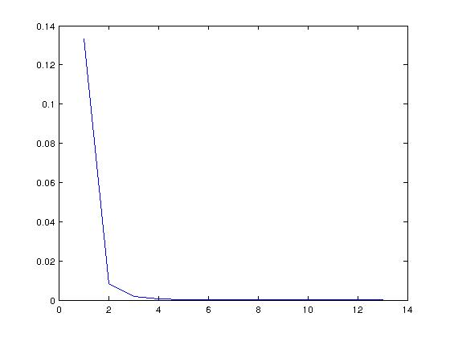
loglog plot: Number of intervals (n) vs Error
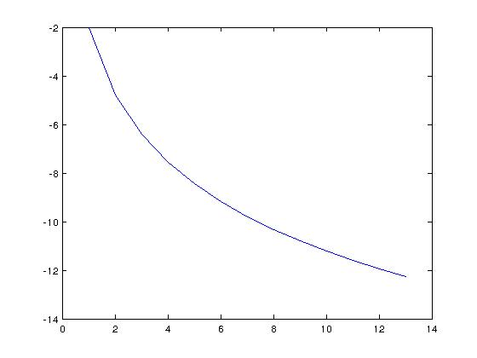
(b) f(x) = (1 - x^2)^(1/2) - x

Using Composite Simpson Rule
n = 1, error bound = 5.000000e-02
n = 2, error bound = 3.125000e-03
n = 3, error bound = 6.172840e-04
n = 4, error bound = 1.953125e-04
n = 5, error bound = 8.000000e-05
n = 6, error bound = 3.858025e-05
n = 7, error bound = 2.082466e-05
n = 8, error bound = 1.220703e-05
n = 9, error bound = 7.620790e-06
n = 10, error bound = 5.000000e-06
Number of sub-intervals = 10
Calculated value of integral = 3.926990e-01
Actual value of integral = 3.926991e-01
Error Bound = 5.000000e-06
Error = 1.026709e-07

Number of intervals (n) vs Error plot
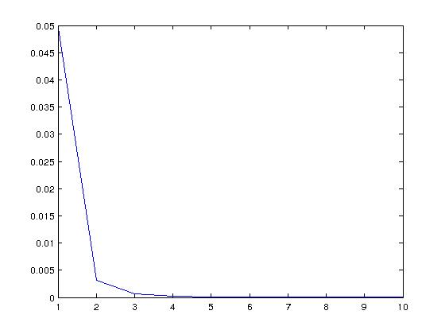

loglog plot: Number of intervals (n) vs Error
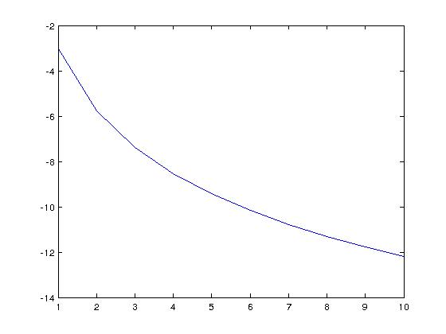

Question 8
X = [1, 5/4, 3/2, 7/4, 2];
Y = [10, 8, 7, 6, 5];

Using Composite Trapezoid Rule
Calculated value of integral = 7.12500

Question 9

f(x) = x*log(x)

Using Composite Trapezoid Rule
n = 5, error bound = 3.333333e-03, error = 2.308836e-03
n = 10, error bound = 8.333333e-04, error = 5.775187e-04
n = 15, error bound = 3.703704e-04, error = 2.567006e-04
n = 20, error bound = 2.083333e-04, error = 1.443992e-04
n = 25, error bound = 1.333333e-04, error = 9.241696e-05
n = 30, error bound = 9.259259e-05, error = 6.417901e-05
n = 35, error bound = 6.802721e-05, error = 4.715218e-05
n = 40, error bound = 5.208333e-05, error = 3.610101e-05
n = 45, error bound = 4.115226e-05, error = 2.852432e-05
n = 50, error bound = 3.333333e-05, error = 2.310474e-05
n = 55, error bound = 2.754821e-05, error = 1.909485e-05
n = 60, error bound = 2.314815e-05, error = 1.604499e-05
n = 65, error bound = 1.972387e-05, error = 1.367148e-05
n = 70, error bound = 1.700680e-05, error = 1.178817e-05
n = 75, error bound = 1.481481e-05, error = 1.026881e-05
n = 80, error bound = 1.302083e-05, error = 9.025328e-06
n = 85, error bound = 1.153403e-05, error = 7.994757e-06
n = 90, error bound = 1.028807e-05, error = 7.131128e-06
Number of sub-intervals = 92
Length of sub-interval = 0.010870
Calculated value of integral = 6.363012e-01
Actual value of integral = 6.362944e-01
Error Bound = 9.845621e-06
Error = 6.824450e-06
Number of intervals (n) vs Error plot
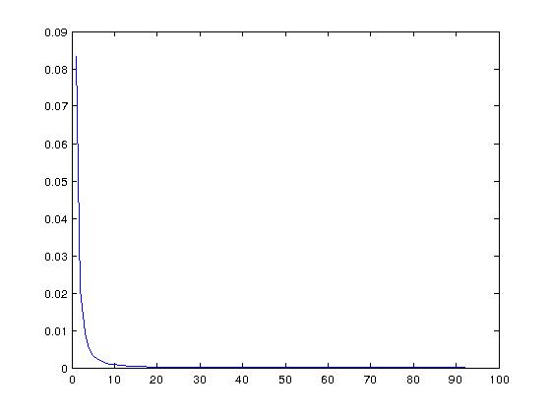
loglog plot: Number of intervals (n) vs Error
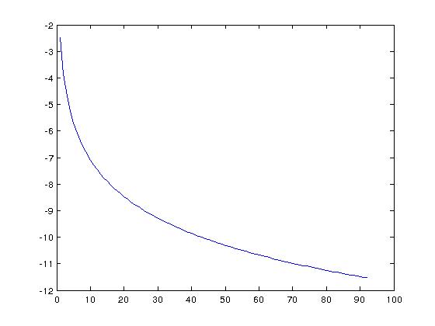
Using Composite Simpson Rule
n = 5, error bound = 4.444444e-06, error = 4.130251e-07
Number of sub-intervals = 5
Length of sub-interval = 0.200000
Calculated value of integral = 6.362948e-01
Actual value of integral = 6.362944e-01
Error Bound = 4.444444e-06
Error = 4.130251e-07
Number of intervals (n) vs Error plot
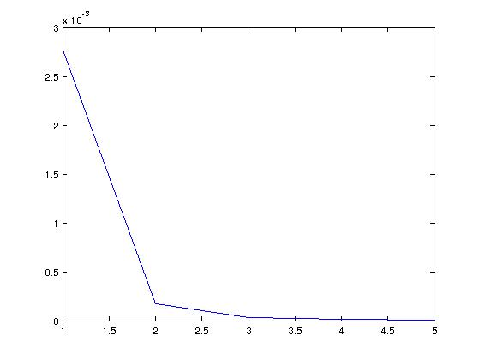
loglog plot: Number of intervals (n) vs Error
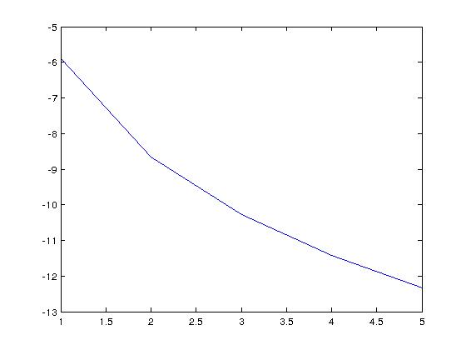
Using Composite Mid-Point Rule
n = 5, error bound = 1.666667e-03, error = 1.153798e-03
n = 10, error bound = 4.166667e-04, error = 2.887204e-04
n = 15, error bound = 1.851852e-04, error = 1.283426e-04
n = 20, error bound = 1.041667e-04, error = 7.219714e-05
n = 25, error bound = 6.666667e-05, error = 4.620748e-05
n = 30, error bound = 4.629630e-05, error = 3.208902e-05
n = 35, error bound = 3.401361e-05, error = 2.357583e-05
n = 40, error bound = 2.604167e-05, error = 1.805035e-05
n = 45, error bound = 2.057613e-05, error = 1.426207e-05
n = 50, error bound = 1.666667e-05, error = 1.155231e-05
n = 55, error bound = 1.377410e-05, error = 9.547382e-06
n = 60, error bound = 1.157407e-05, error = 8.022466e-06
n = 65, error bound = 9.861933e-06, error = 6.835720e-06
Number of sub-intervals = 65
Length of sub-interval = 0.015385
Calculated value of integral = 6.362875e-01
Actual value of integral = 6.362944e-01
Error Bound = 9.861933e-06
Error = 6.835720e-06
Number of intervals (n) vs Error plot
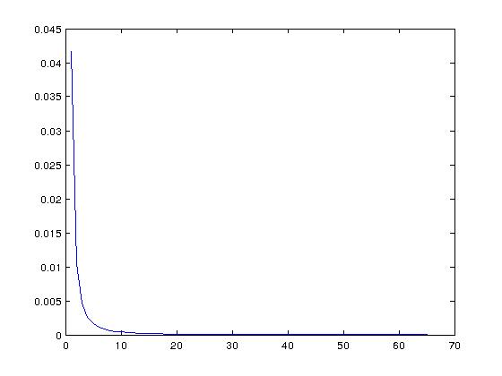

loglog plot: Number of intervals (n) vs Error
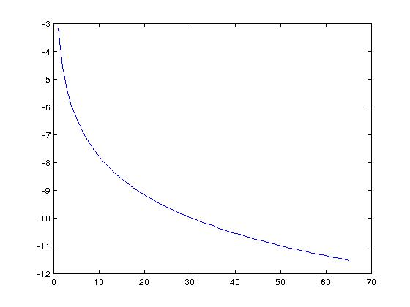

Question 10

f(x) = (4*cos(x)^2 + 9*sin(x)^2)^(1/2)

Using Composite Simpson Rule
n = 5, error bound = 1.067994e-02
n = 10, error bound = 6.674962e-04
n = 15, error bound = 1.318511e-04
n = 20, error bound = 4.171851e-05
n = 25, error bound = 1.708790e-05
n = 30, error bound = 8.240694e-06
n = 35, error bound = 4.448122e-06
n = 40, error bound = 2.607407e-06
n = 45, error bound = 1.627791e-06
n = 50, error bound = 1.067994e-06
Number of sub-intervals = 51
Calculated value of integral = 1.586544e+01

Number of intervals (n) vs Error plot
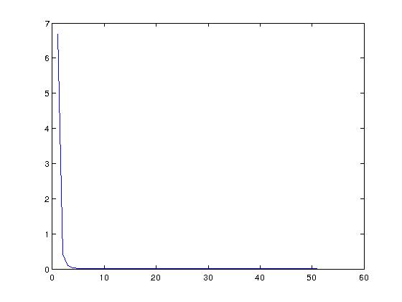
LogLog plot: n vs error
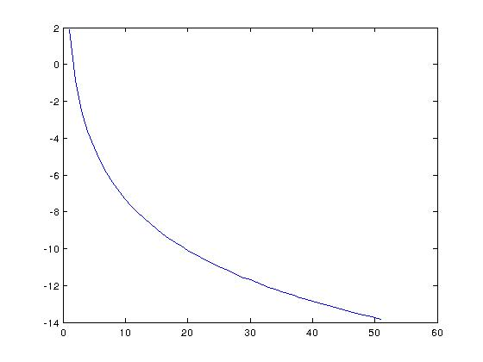

Question 11

X = 0:6:84;
Y = [124, 134, 148, 156, 147, 133, 121, 109, 99, 85, 78, 89, 104, 116, 123];

Using Composite Trapezoid Rule
The length of track = 9.855000e+03

Question 12

(a) f(x) = x^2*log(x)

Using Gaussian quadrature for uniform intervals
Actual value of integral = 1.922594e-01Number of intervals, n = 2
Calculated value of integral = 1.922453e-01
Error = 1.405032e-05

Number of intervals, n = 3
Calculated value of integral = 1.922531e-01
Error = 6.264674e-06

Number of intervals, n = 4
Calculated value of integral = 1.922593e-01
Error = 2.041835e-08

Number of intervals, n = 5
Calculated value of integral = 1.922593e-01
Error = 1.153687e-08

Number of intervals, n = 6
Calculated value of integral = 1.922594e-01
Error = 8.198203e-11

(b) f(x) = sin(2*x)*exp(3*x)

Using Gaussian quadrature for uniform intervals
Actual value of integral = 2.588629e+00Number of intervals, n = 2
Calculated value of integral = 2.583696e+00
Error = 4.932229e-03

Number of intervals, n = 3
Calculated value of integral = 2.585789e+00
Error = 2.839581e-03

Number of intervals, n = 4
Calculated value of integral = 2.587968e+00
Error = 6.601757e-04

Number of intervals, n = 5
Calculated value of integral = 2.588255e+00
Error = 3.739206e-04

Number of intervals, n = 6
Calculated value of integral = 2.588624e+00
Error = 4.656766e-06

(c) f(x) = 2/(x^2 - 4)

Using Gaussian quadrature for uniform intervals
Actual value of integral = -1.768200e-01Number of intervals, n = 2
Calculated value of integral = -1.768216e-01
Error = 1.549122e-06

Number of intervals, n = 3
Calculated value of integral = -1.768207e-01
Error = 6.907986e-07

Number of intervals, n = 4
Calculated value of integral = -1.768200e-01
Error = 2.334191e-09

Number of intervals, n = 5
Calculated value of integral = -1.768200e-01
Error = 1.317139e-09

Number of intervals, n = 6
Calculated value of integral = -1.768200e-01
Error = 5.558137e-12

(d) f(x) = (2*x)/(x^2 - 4)

Using Gaussian quadrature for uniform intervals
Actual value of integral = -7.339692e-01Number of intervals, n = 2
Calculated value of integral = -7.391053e-01
Error = 5.136164e-03

Number of intervals, n = 3
Calculated value of integral = -7.364277e-01
Error = 2.458521e-03

Number of intervals, n = 4
Calculated value of integral = -7.341567e-01
Error = 1.874933e-04

Number of intervals, n = 5
Calculated value of integral = -7.340795e-01
Error = 1.103410e-04

Number of intervals, n = 6
Calculated value of integral = -7.339795e-01
Error = 1.028853e-05

