MA 322: Scientific Computing
LAB 7 Report
Abheek Ghosh - 140123047

NOTE: The right angled triangle is for comparison of the slope. It has been made with the hypotaneuse slope as expected for respective methods.

Question 1
(A)
Explicit-Euler method

N Error Order
10 8.728002e-02 1.026022
20 4.285993e-02 1.015965
40 2.119413e-02 1.007824
80 1.053975e-02 1.003868
160 5.255765e-03 1.001947
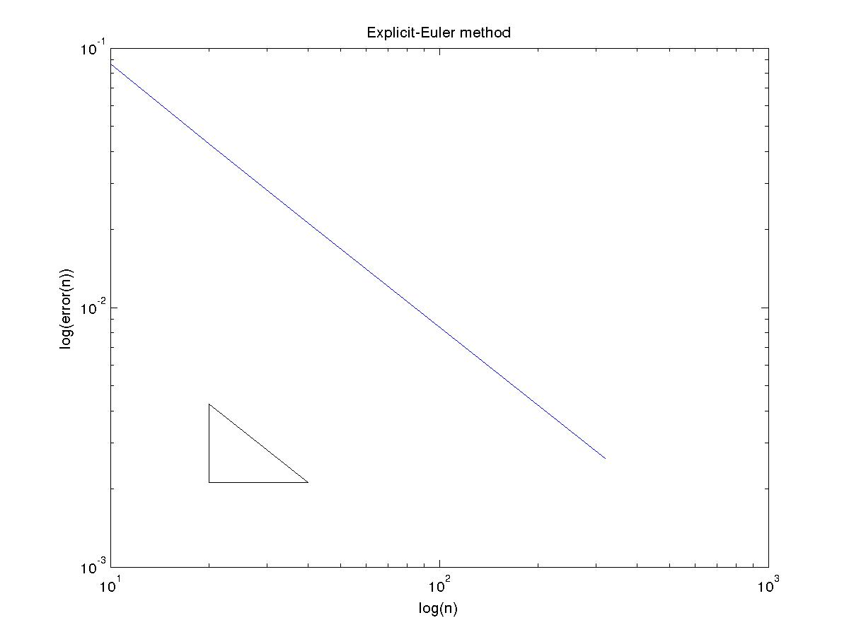

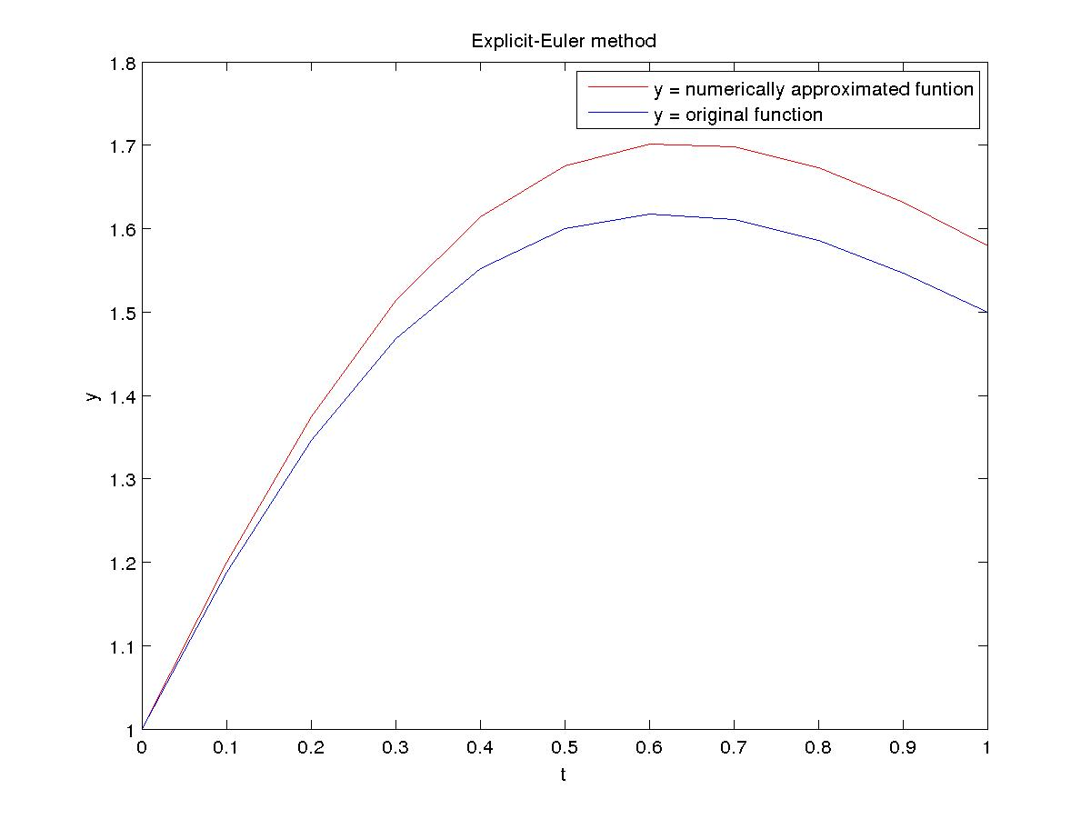

Implicit-Euler method

N Error Order
10 8.022849e-02 0.967347
20 4.103251e-02 0.984525
40 2.073751e-02 0.991968
80 1.042664e-02 0.996121
160 5.227355e-03 0.998028

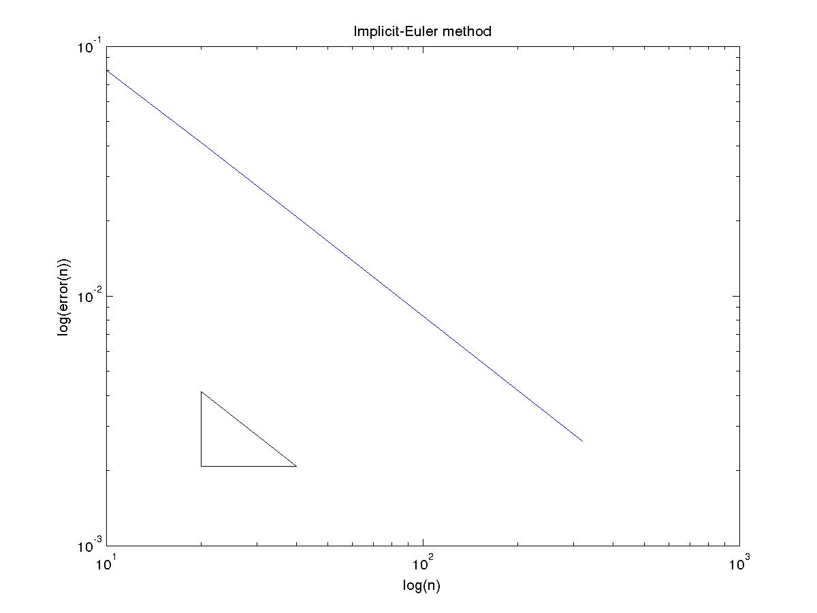
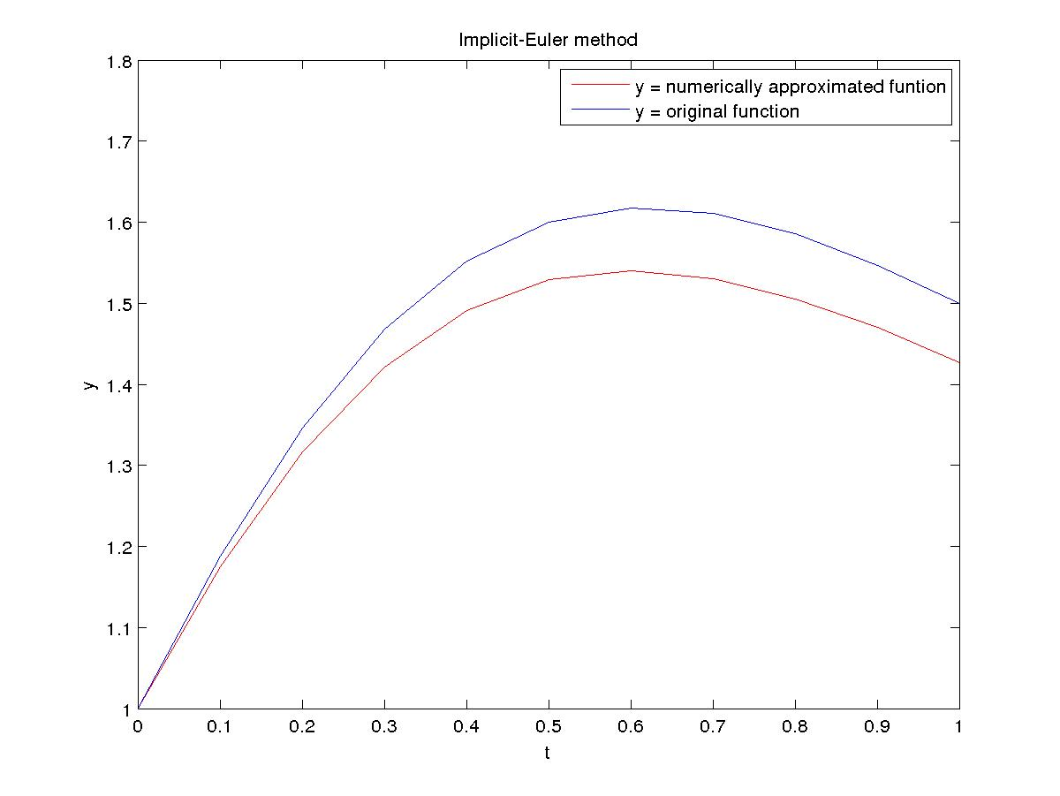

Modified-Euler (trapezoid) method

N Error Order
10 1.414167e-03 1.980782
20 3.582828e-04 1.998082
40 8.968986e-05 1.997962
80 2.245416e-05 2.000010
160 5.613502e-06 1.999948

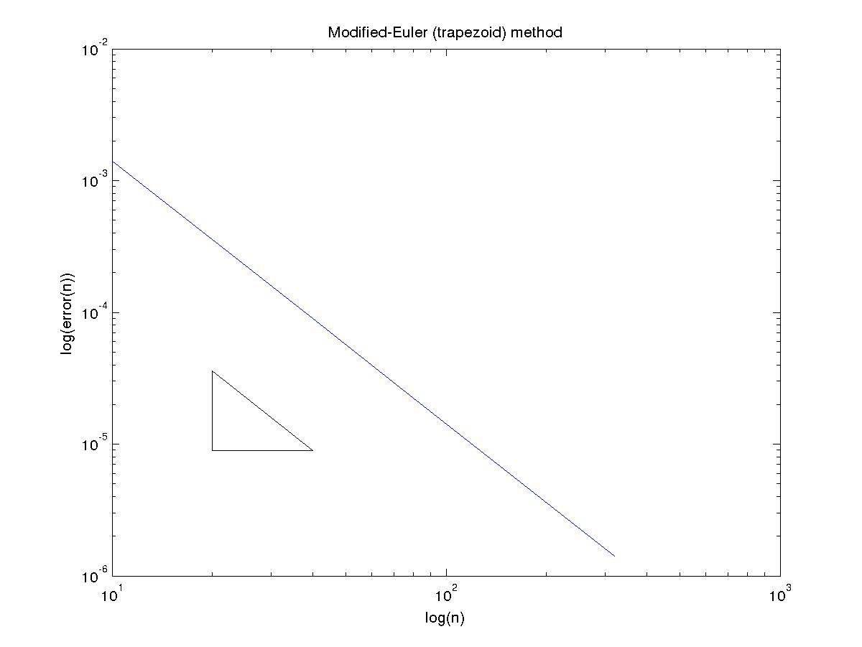

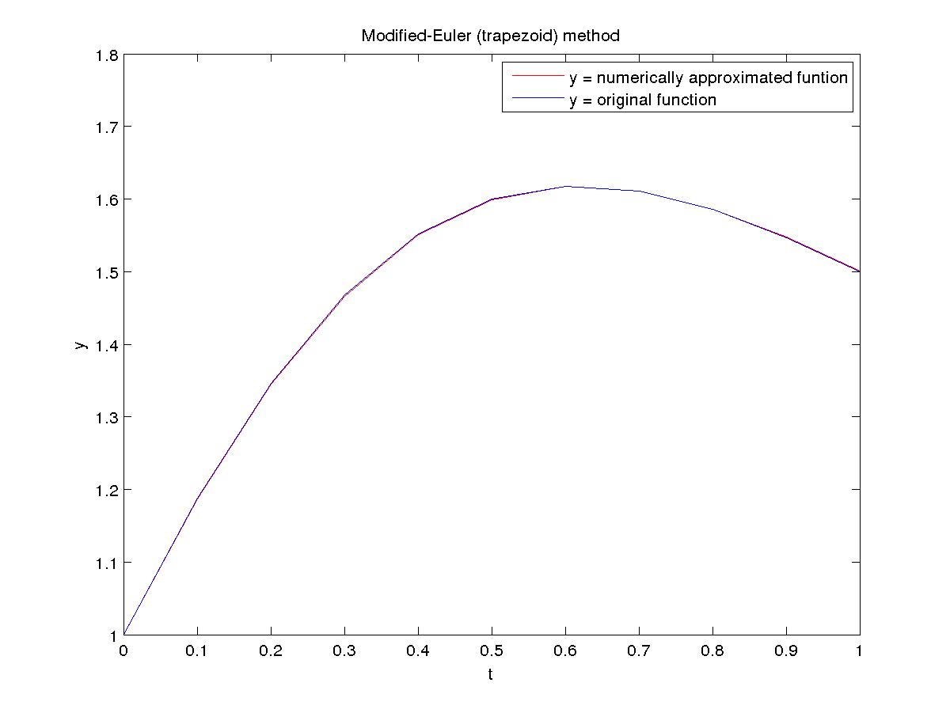
Midpoint method

N Error Order
10 1.202405e-03 1.995053
20 3.016337e-04 2.000562
40 7.537903e-05 1.999535
80 1.885083e-05 2.000036
160 4.712592e-06 2.000004

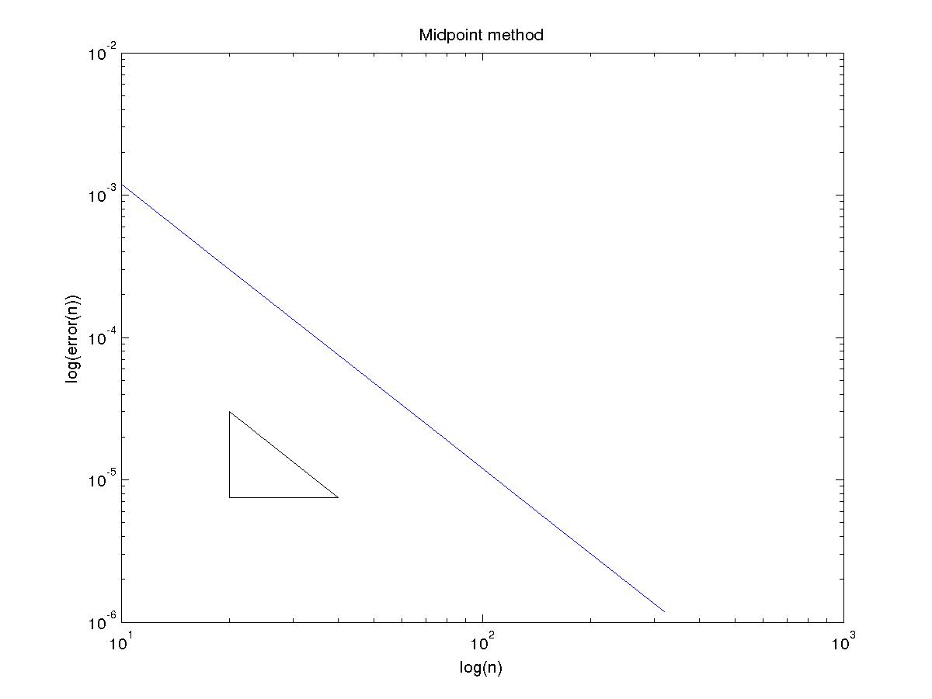
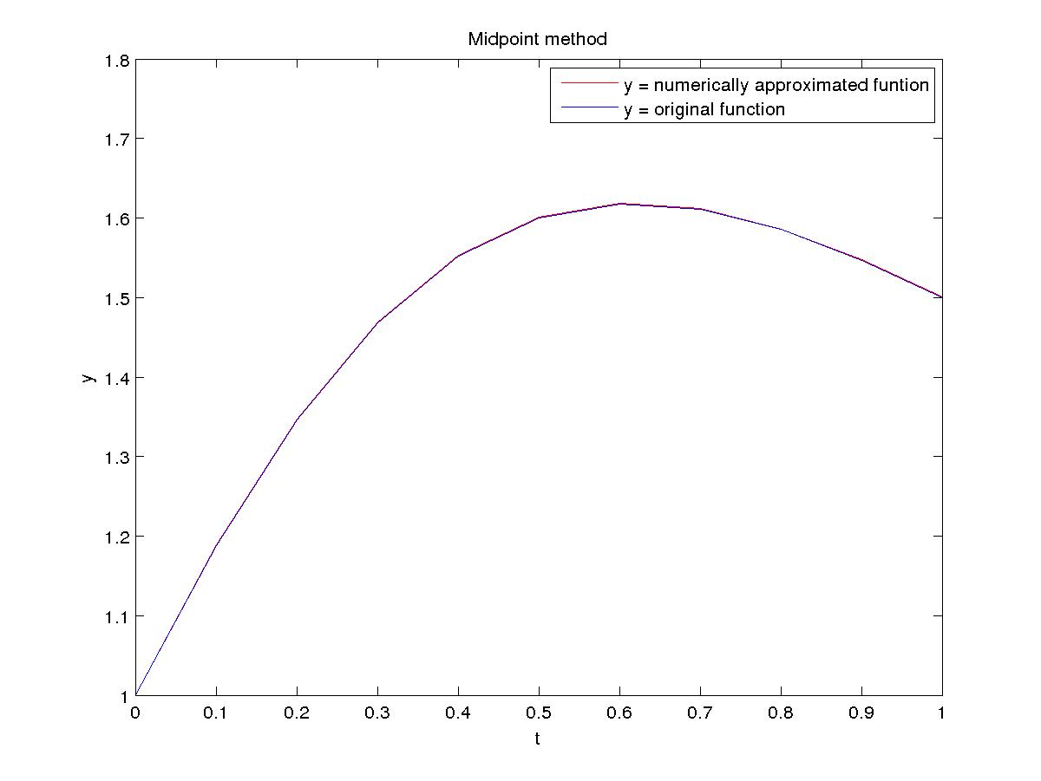

Runge Kutta 2th Order (Optimal) method

N Error Order
10 1.980428e-03 2.092101
20 4.644874e-04 2.049850
40 1.121780e-04 2.025210
80 2.755871e-05 2.012637
160 6.829590e-06 2.006348

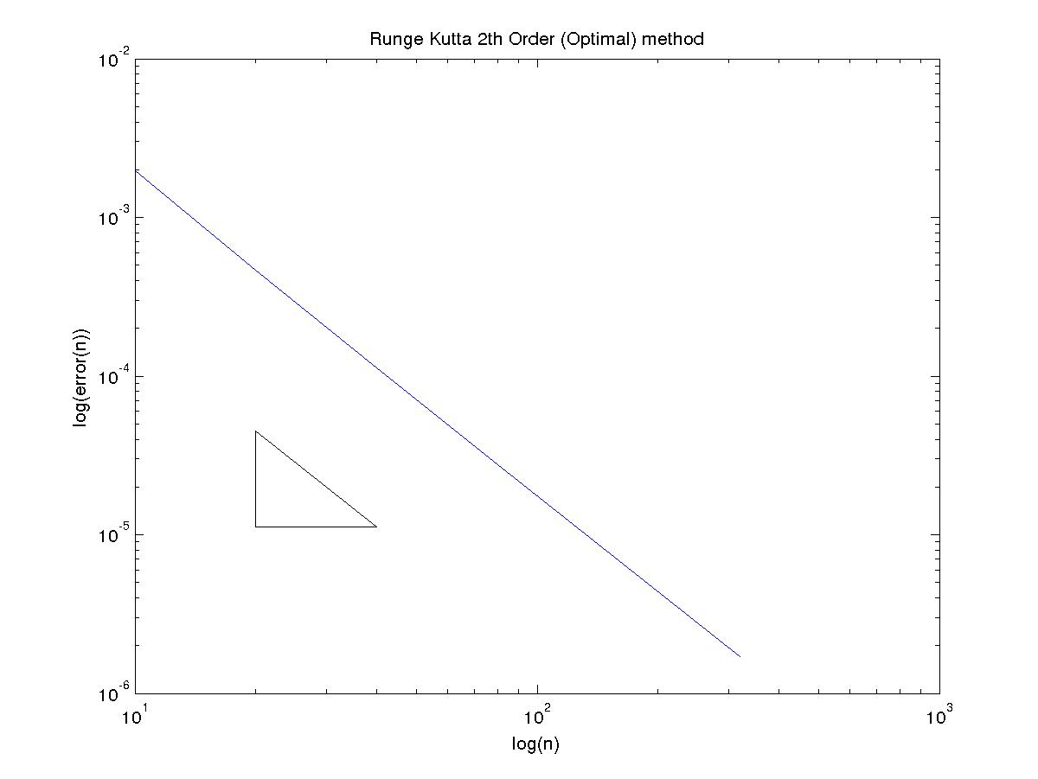

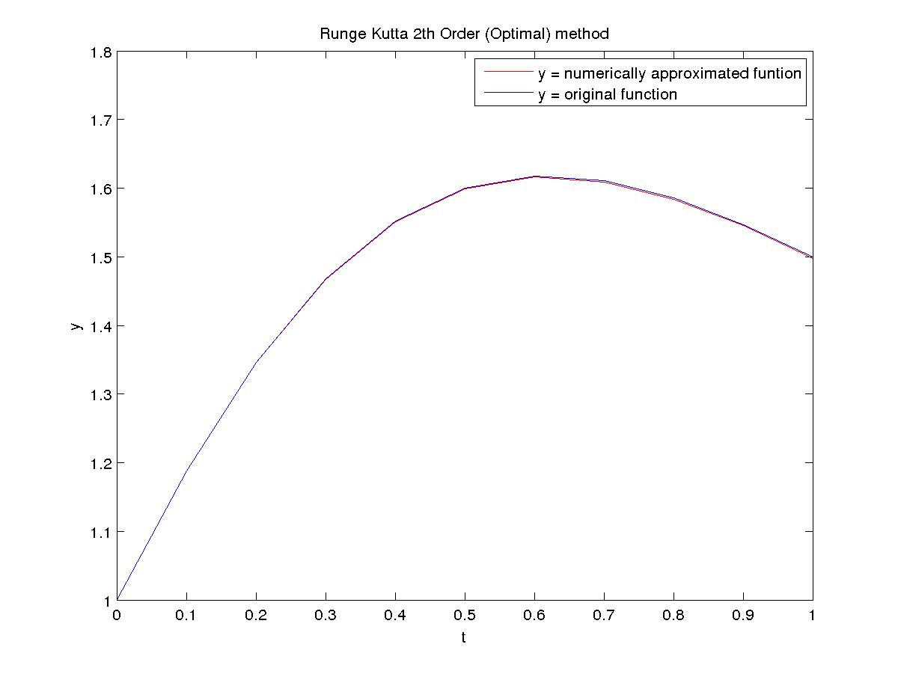

Runge Kutta 4th Order method

N Error Order
10 1.823453e-06 4.036679
20 1.111049e-07 4.018364
40 6.856224e-09 4.008934
80 4.258685e-10 4.004488
160 2.653411e-11 4.002259

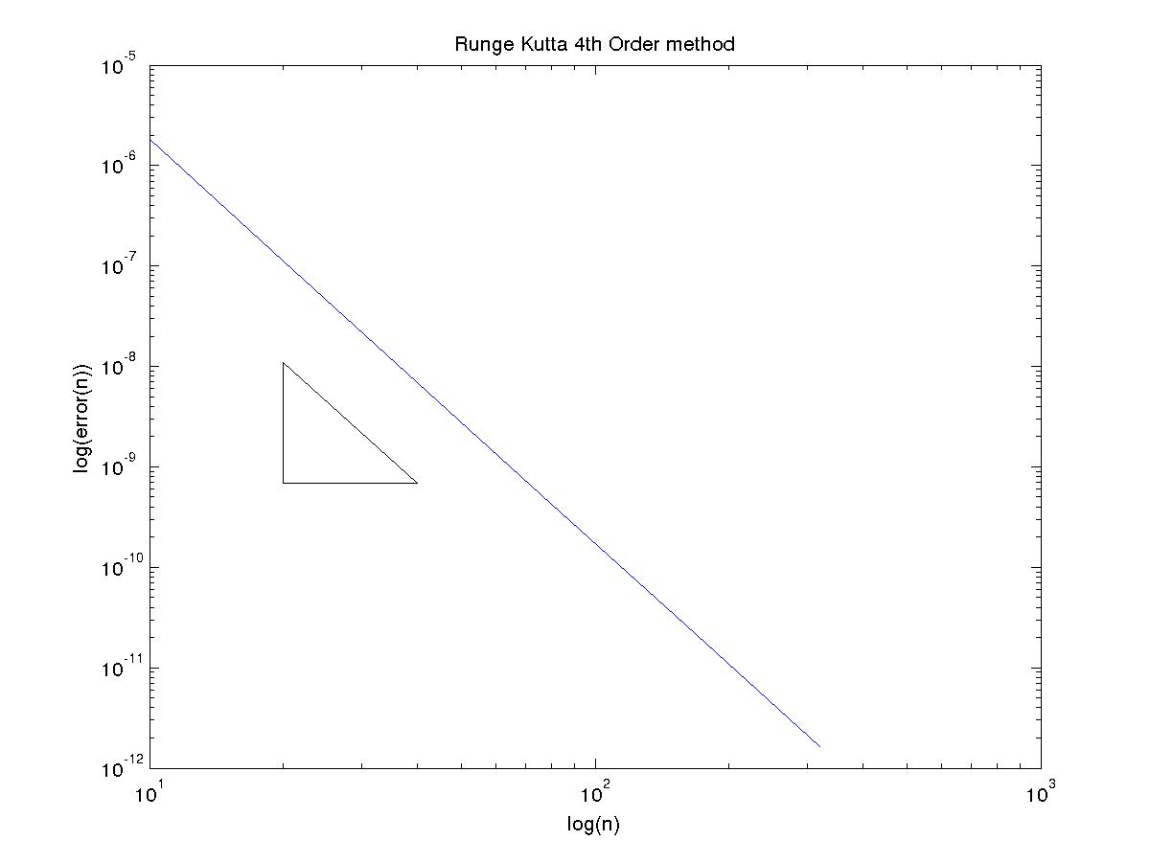
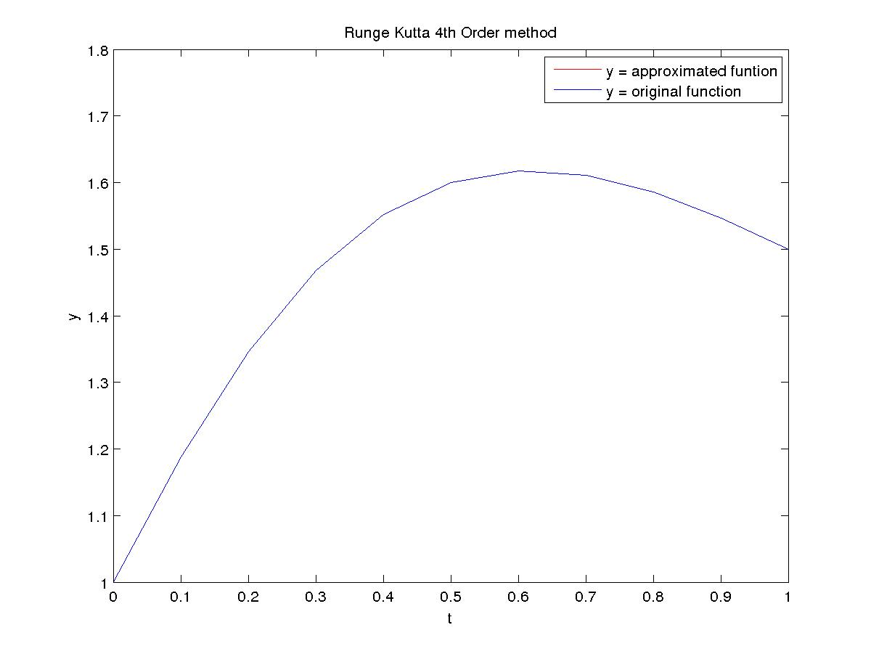

(B)
Explicit-Euler method

N Error Order
10 1.155556e-01 1.227102
20 4.936241e-02 1.096493
40 2.308443e-02 1.044949
80 1.118814e-02 1.021197
160 5.512480e-03 1.010424

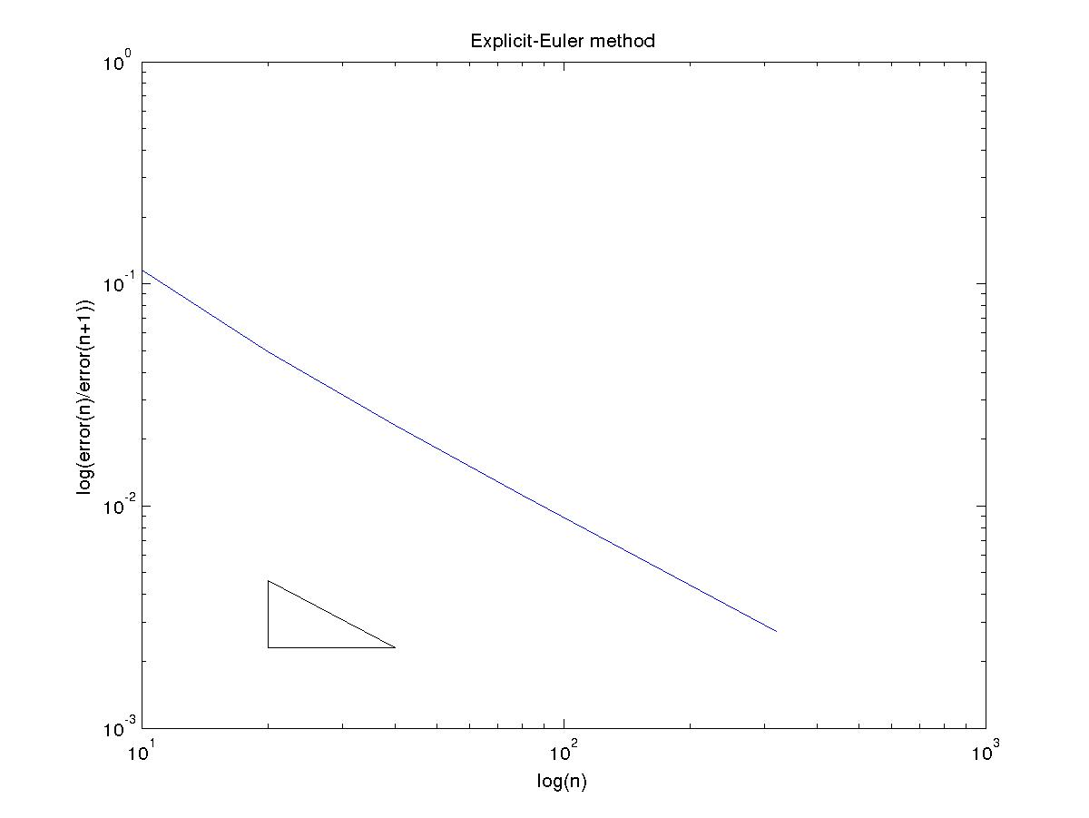

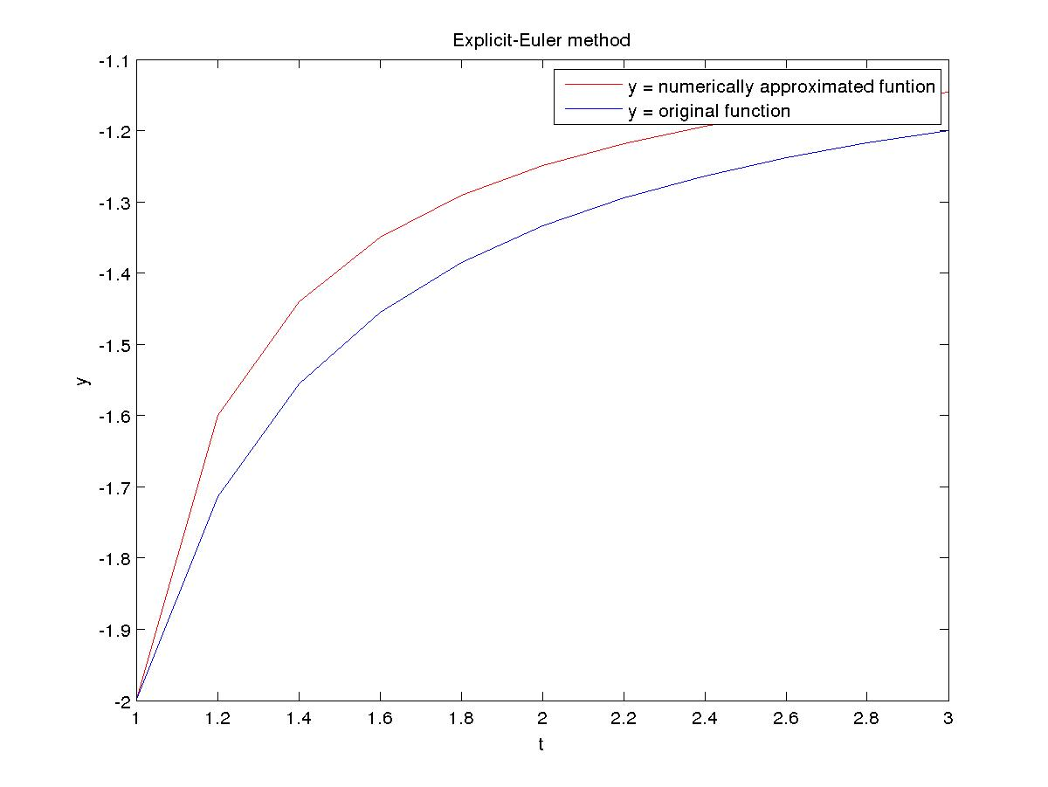

Implicit-Euler method

N Error Order
10 7.154419e-02 0.867985
20 3.919990e-02 0.928349
40 2.059795e-02 0.962450
80 1.057056e-02 0.980201
160 5.358312e-03 0.989956

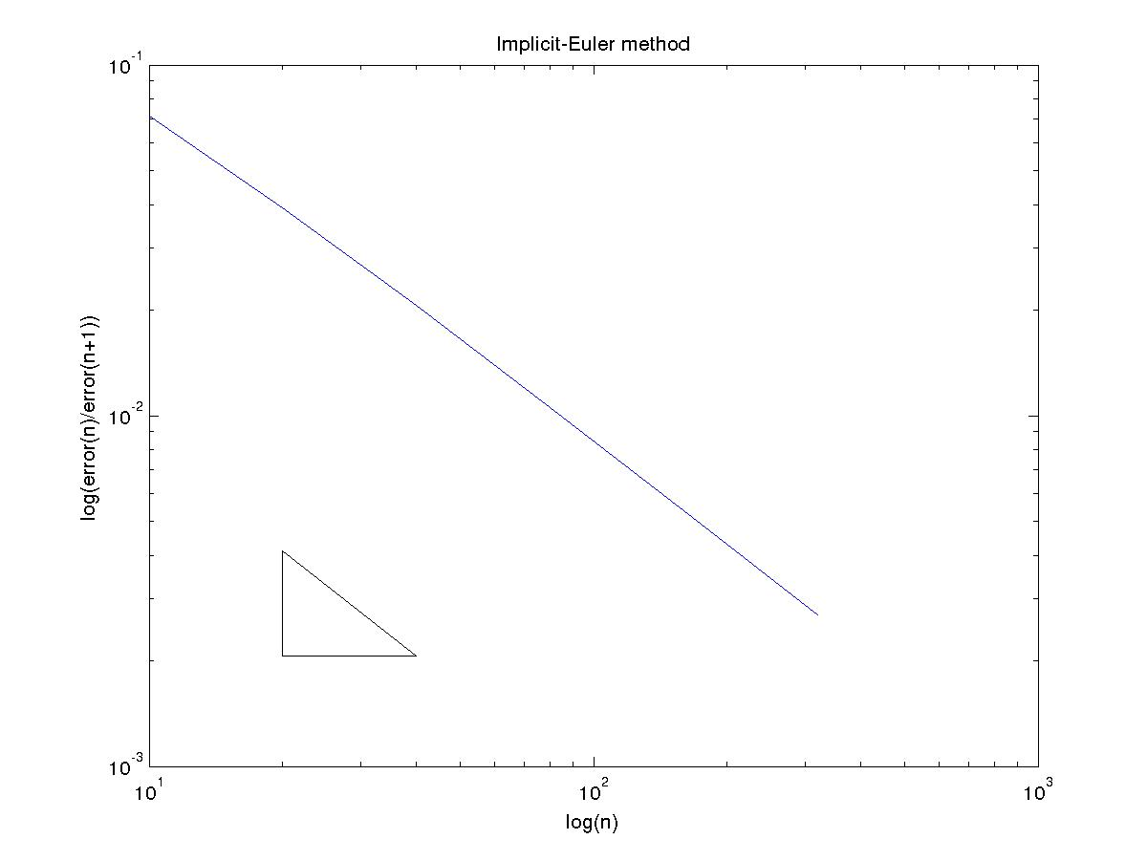
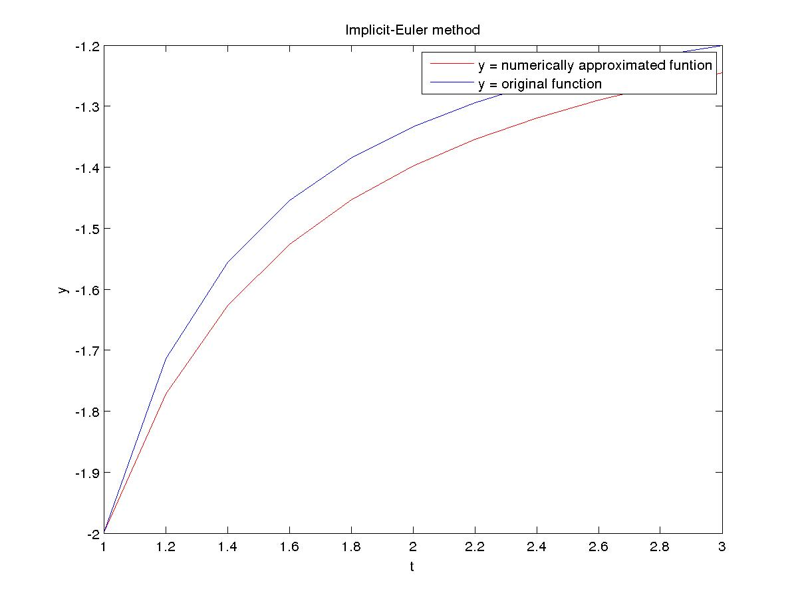

Modified-Euler (trapezoid) method

N Error Order
10 1.382418e-02 2.008651
20 3.435384e-03 2.011356
40 8.521125e-04 2.002841
80 2.126091e-04 2.000262
160 5.314263e-05 2.000172

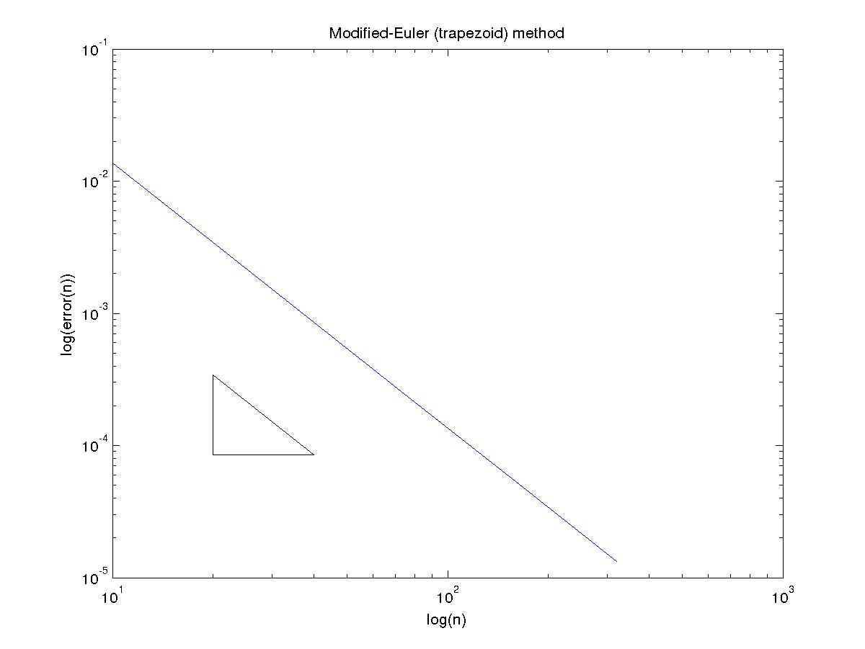

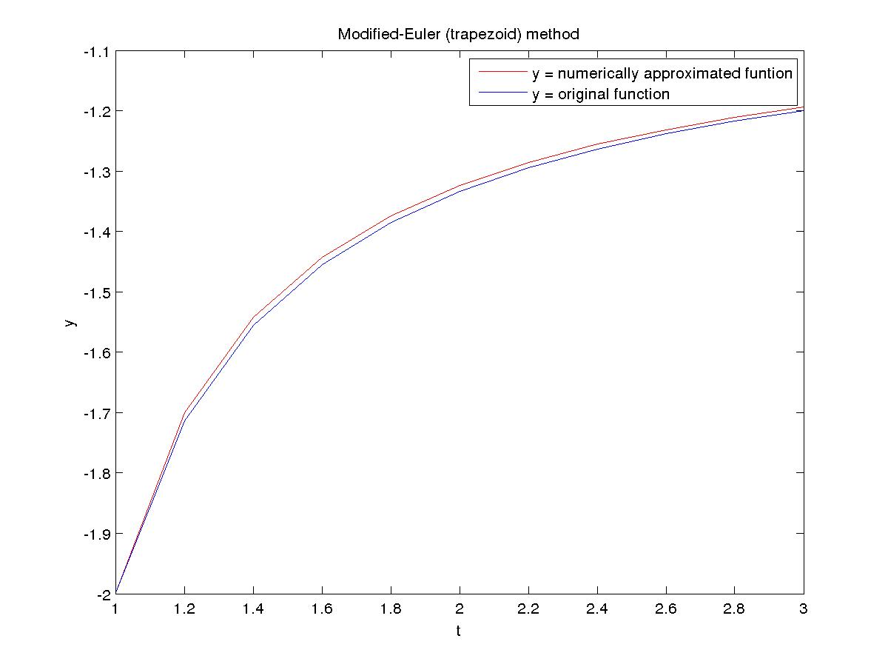
Midpoint method

N Error Order
10 2.976513e-03 1.964880
20 7.624653e-04 1.998627
40 1.907979e-04 1.996826
80 4.780453e-05 1.999980
160 1.195130e-05 1.999991

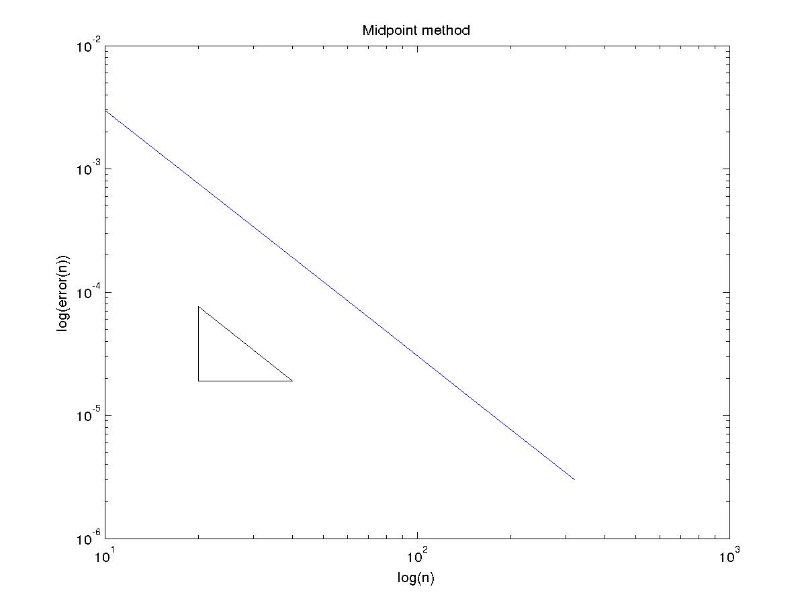
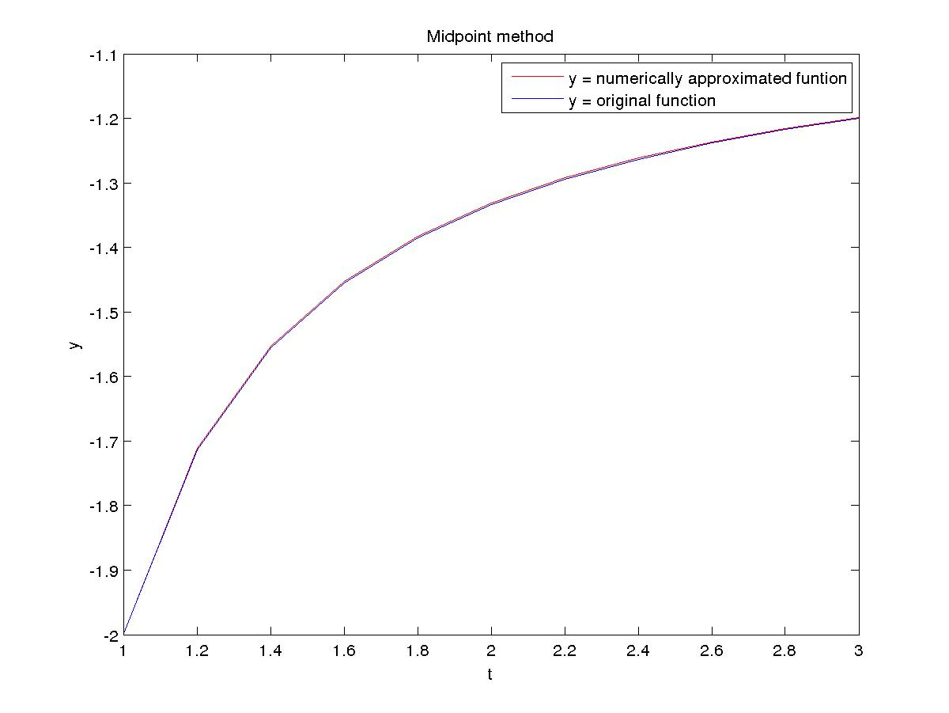

Runge Kutta 2th Order (Optimal) method

N Error Order
10 1.763556e-02 2.167027
20 3.926893e-03 2.125475
40 8.999482e-04 2.065738
80 2.149653e-04 2.033370
160 5.251254e-05 2.016781

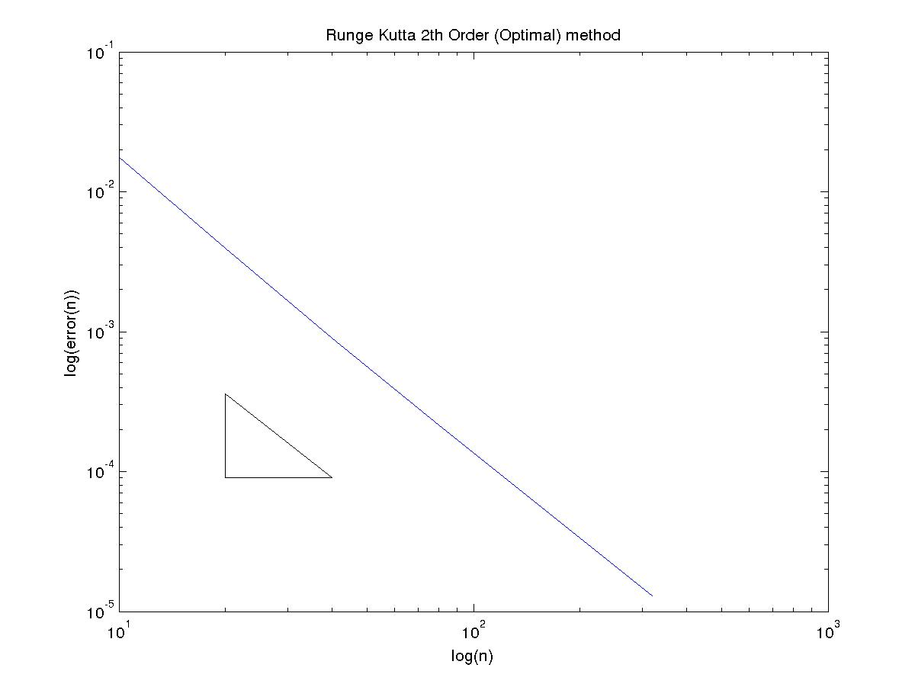

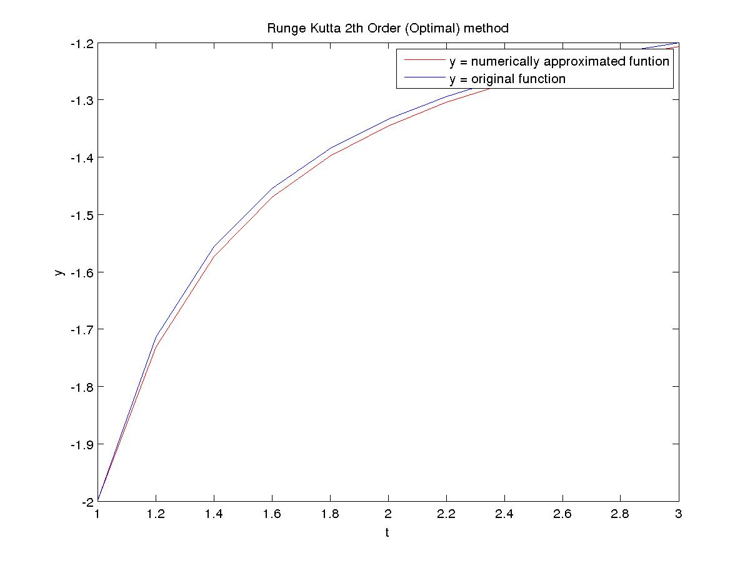

Runge Kutta 4th Order method

N Error Order
10 4.053383e-05 6.218198
20 5.444444e-07 5.271688
40 1.409345e-08 2.718562
80 2.141158e-09 3.661933
160 1.691598e-10 3.864334

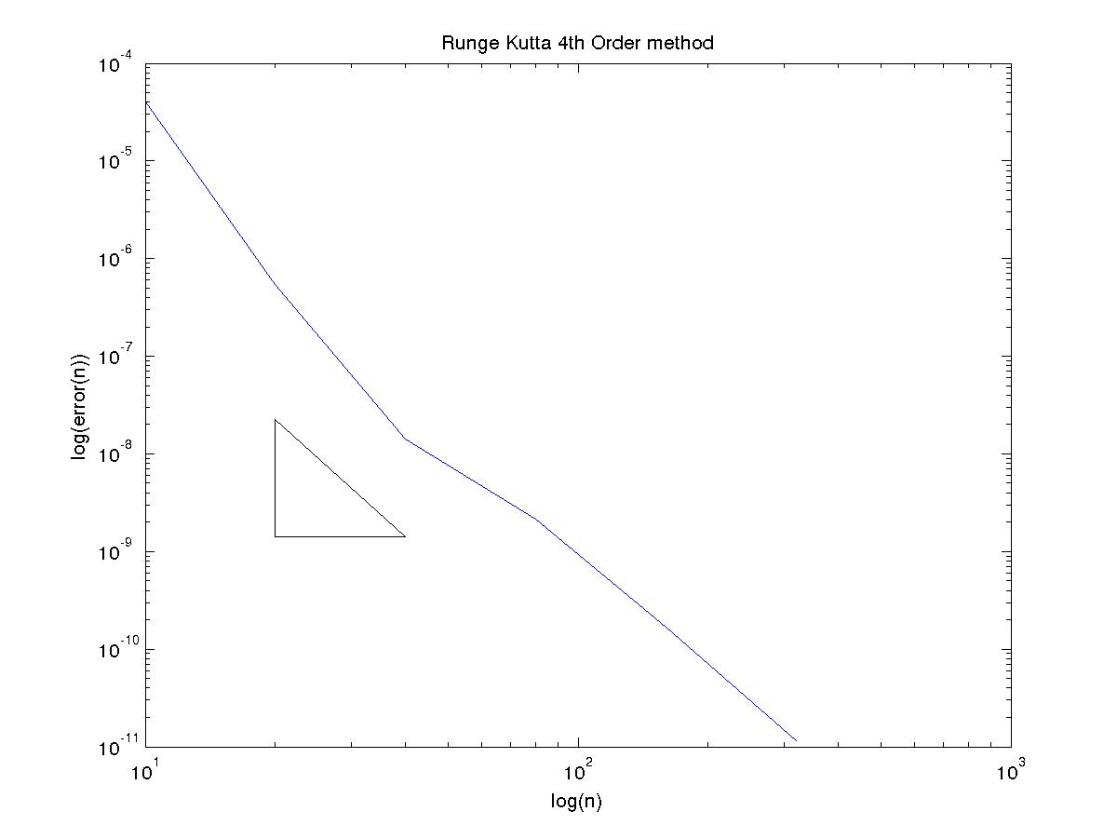
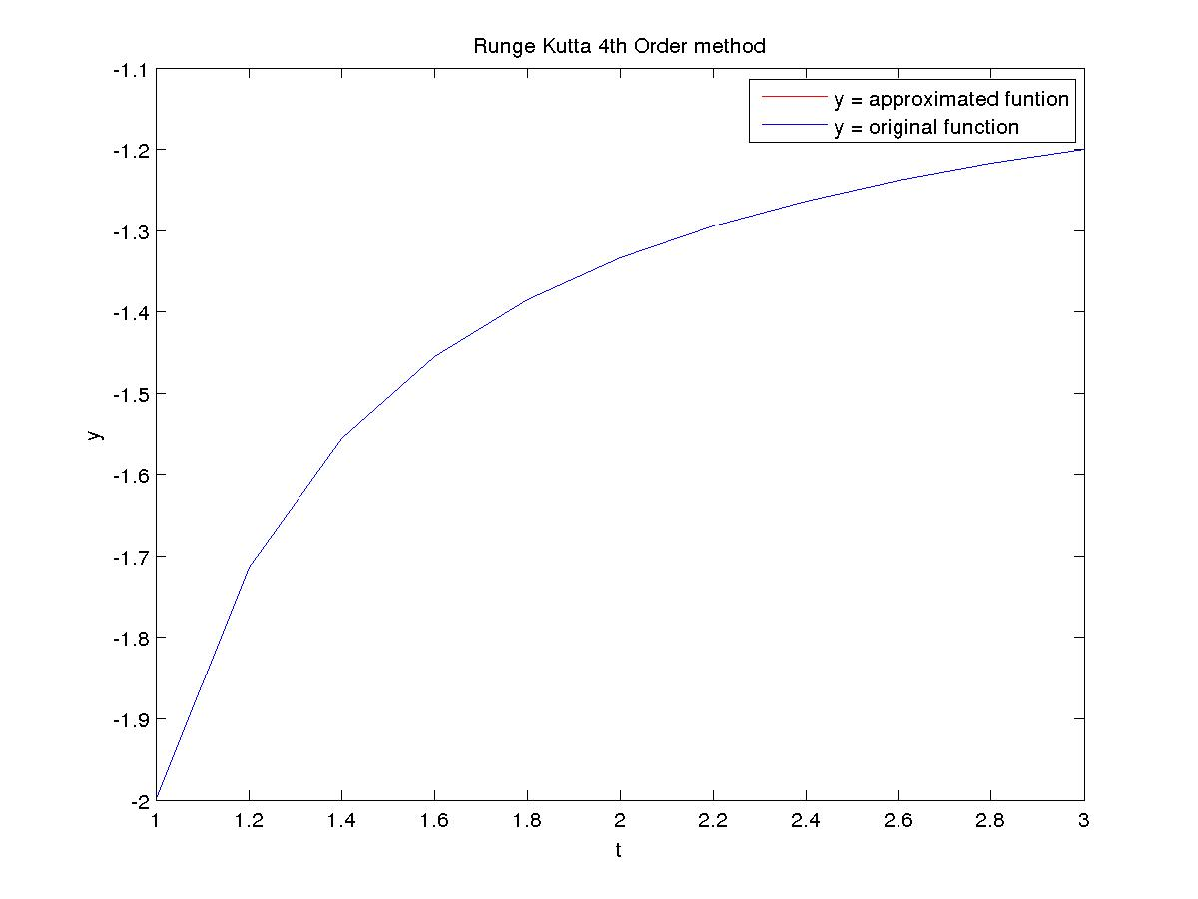

(C)
Explicit-Euler method

N Error Order
10 1.359823e+00 0.739928
20 8.142197e-01 0.843863
40 4.536422e-01 0.913033
80 2.409145e-01 0.953853
160 1.243726e-01 0.976192

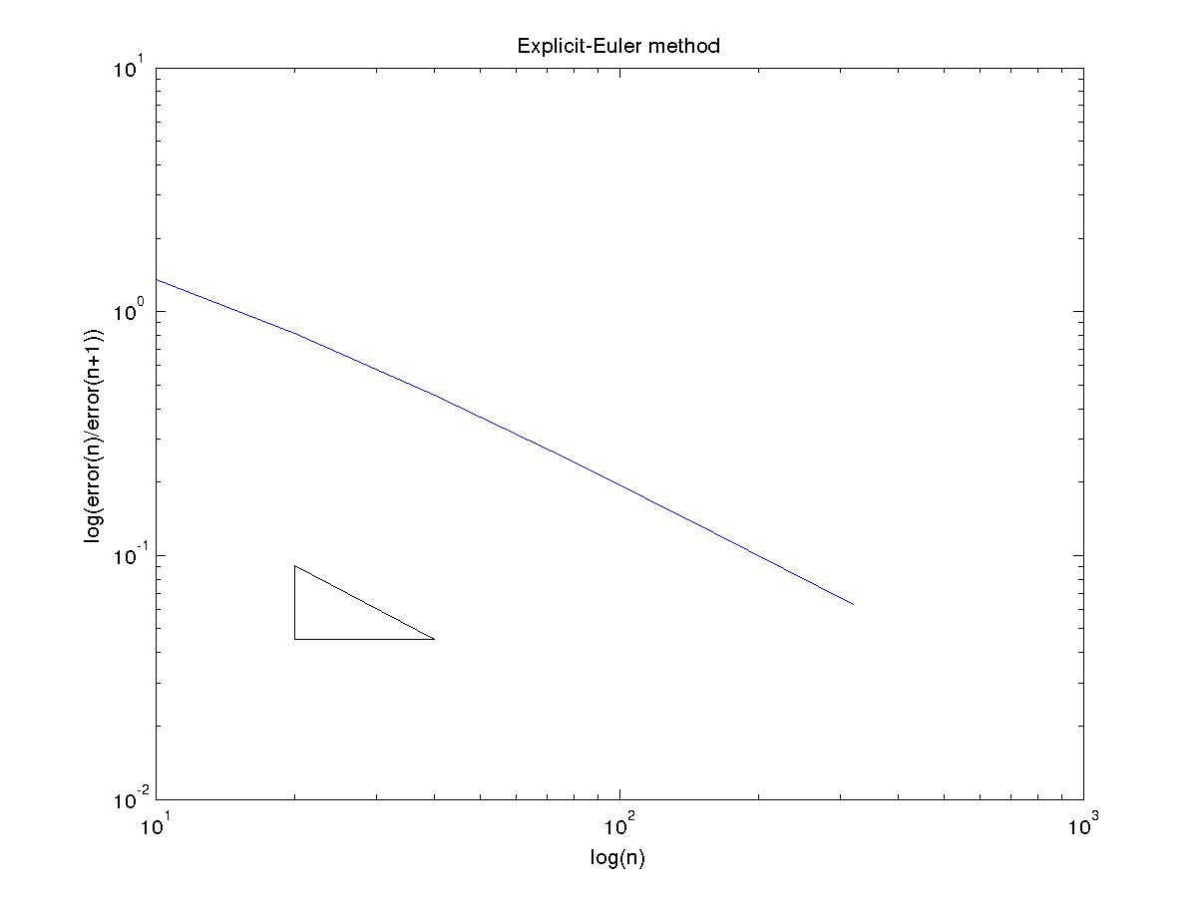

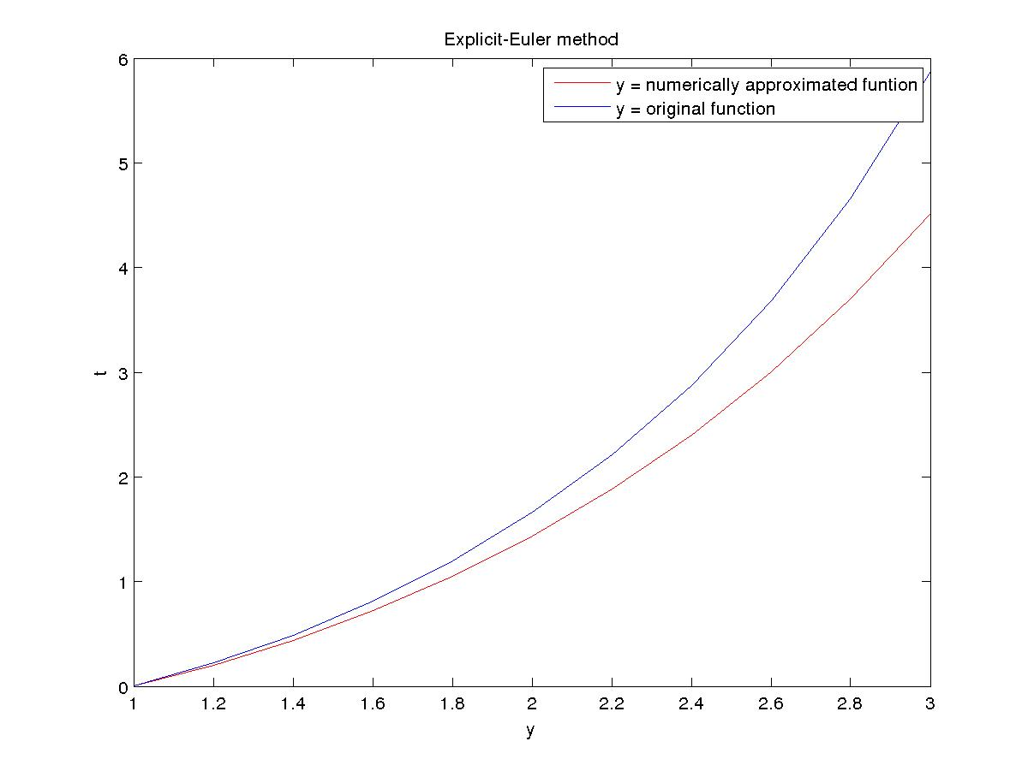
Implicit-Euler method

N Error Order
10 5.674011e+00 1.975610
20 1.442687e+00 1.271163
40 5.977421e-01 1.113688
80 2.762233e-01 1.052714
160 1.331563e-01 1.025443

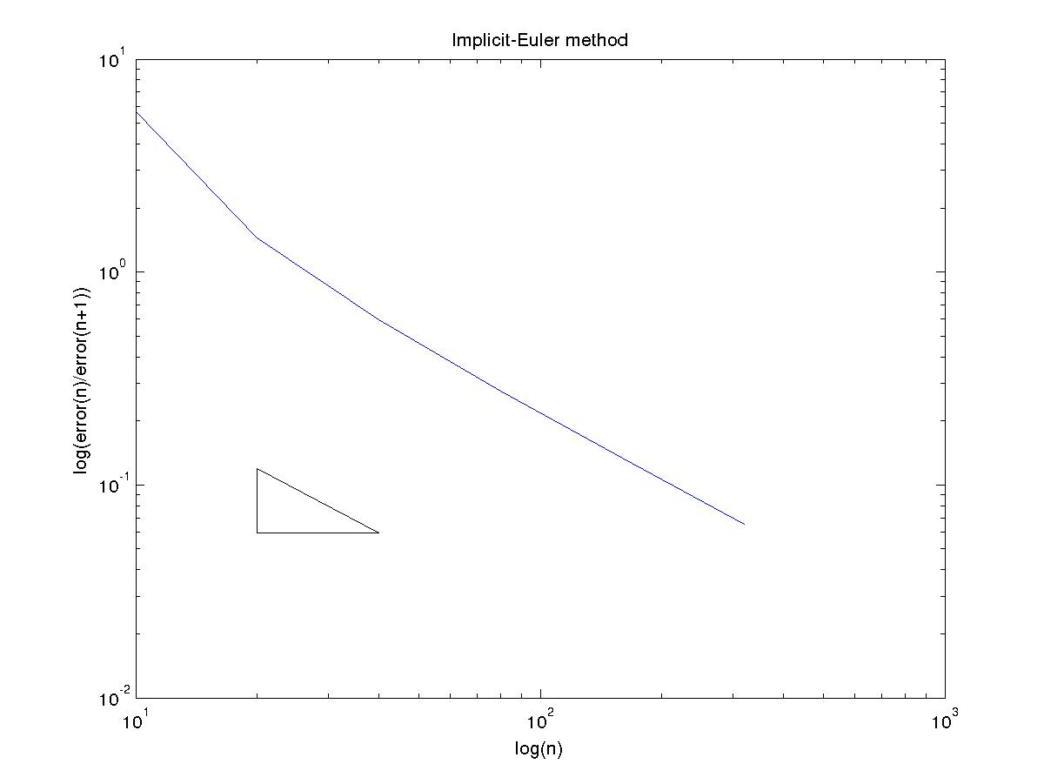
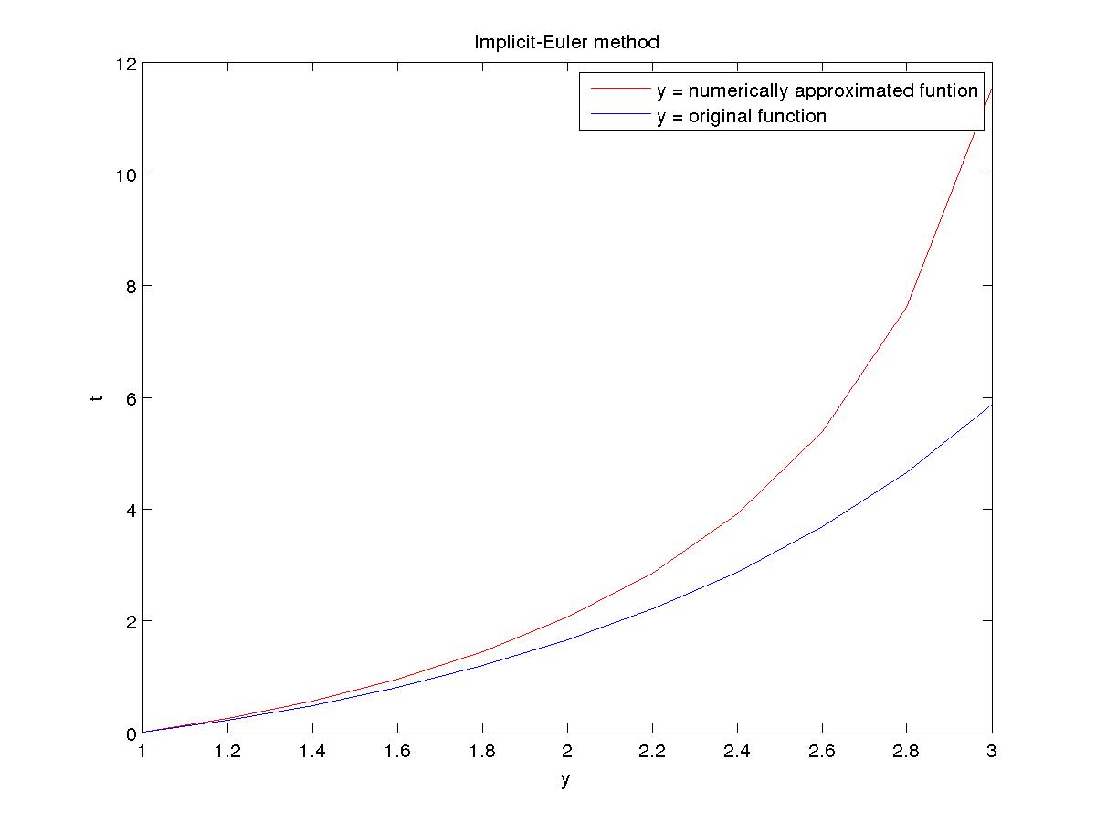

Modified-Euler (trapezoid) method

N Error Order
10 6.985429e-02 2.032640
20 1.707290e-02 2.007953
40 4.244762e-03 2.001976
80 1.059738e-03 2.000494
160 2.648439e-04 2.000123
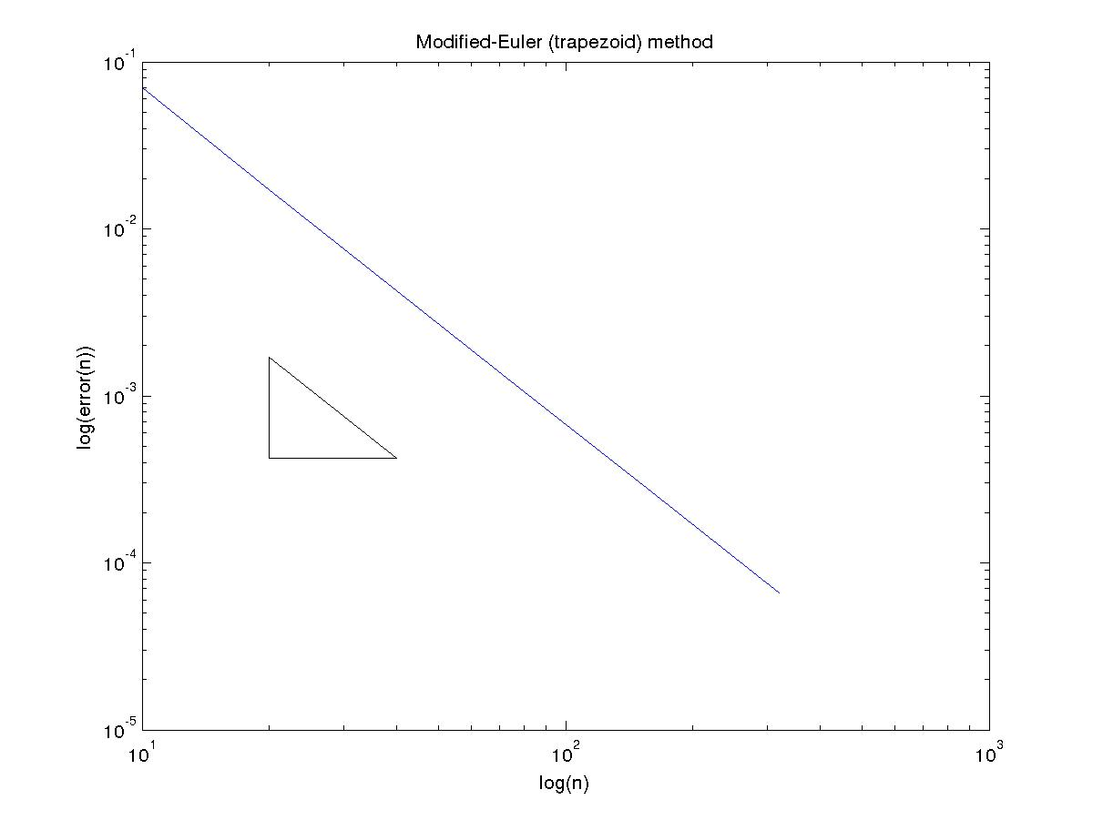

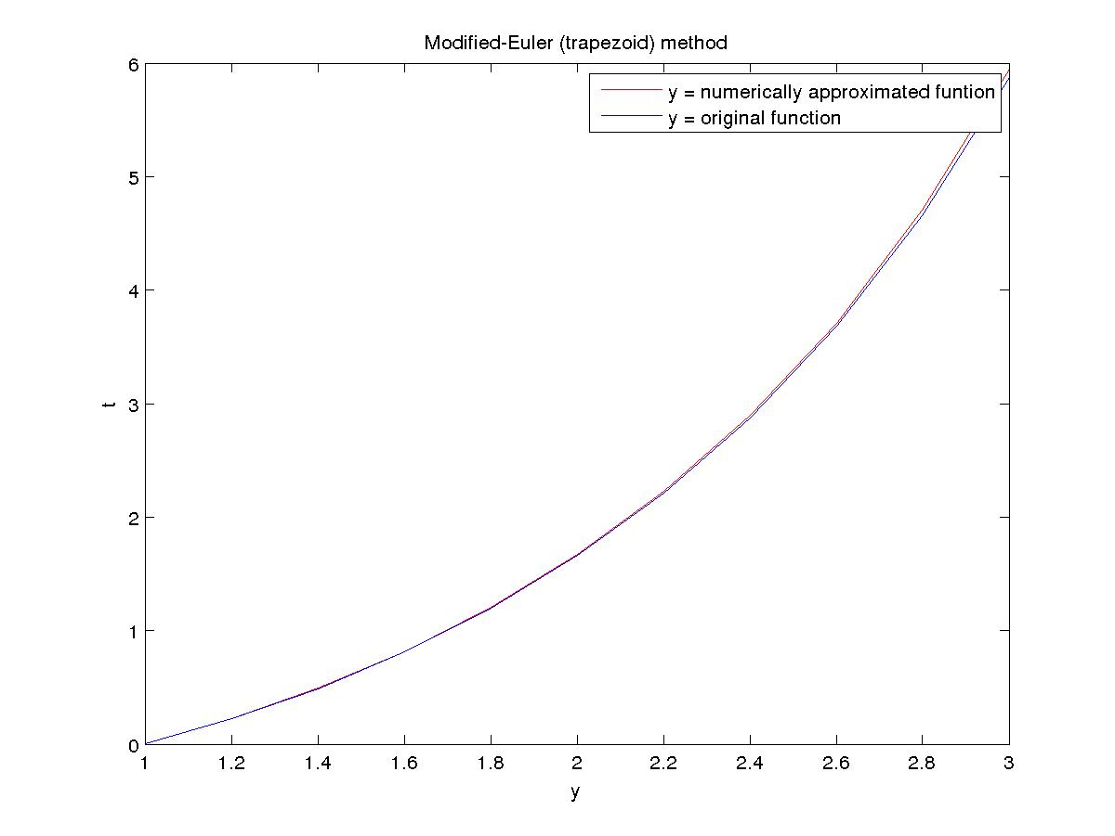

Midpoint method

N Error Order
10 1.045453e-01 2.040836
20 2.540690e-02 2.009994
40 6.307877e-03 2.002486
80 1.574255e-03 2.000621
160 3.933942e-04 2.000155

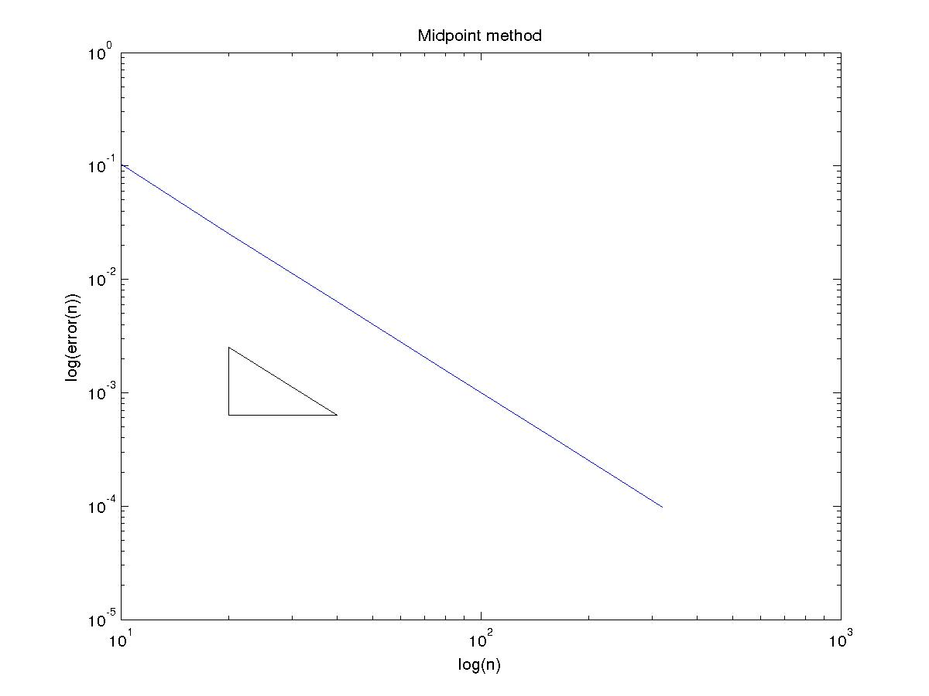
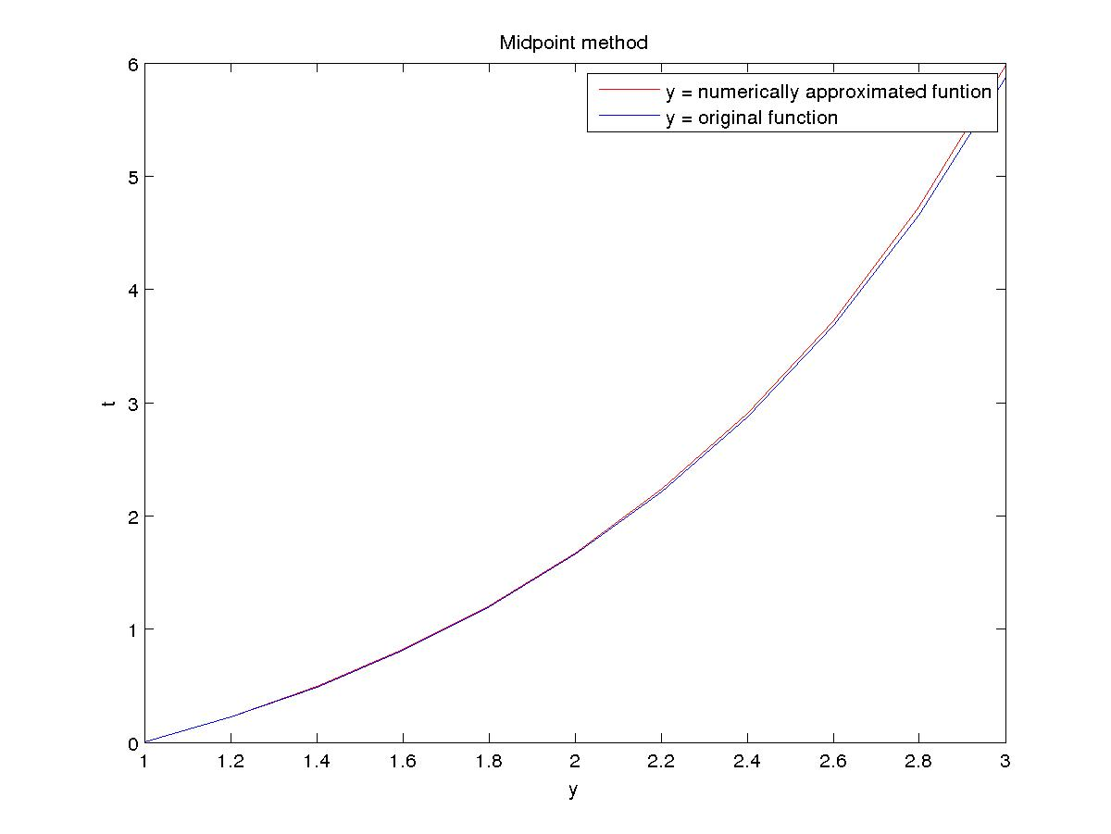

Runge Kutta 2th Order (Optimal) method

N Error Order
10 1.454753e-01 1.838099
20 4.068799e-02 1.926147
40 1.070627e-02 1.965506
80 2.741333e-03 1.983452
160 6.932395e-04 1.991912

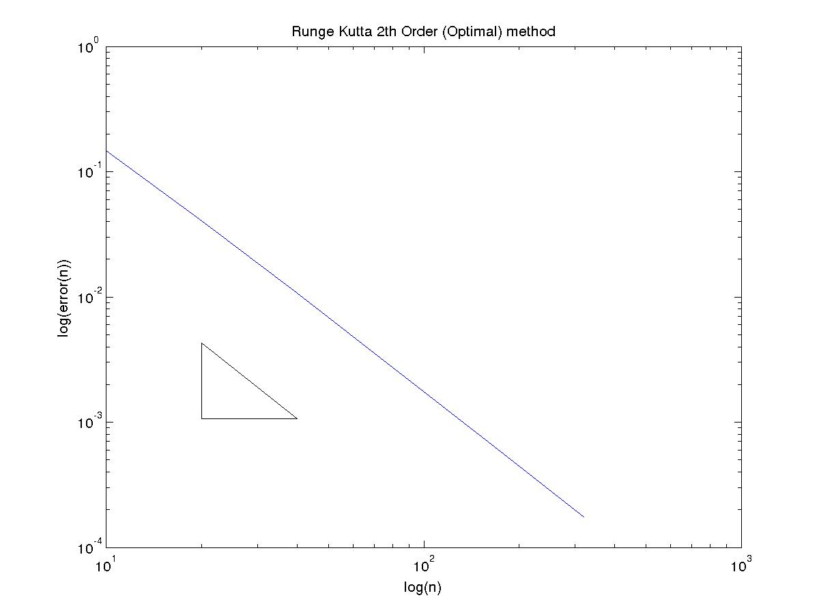

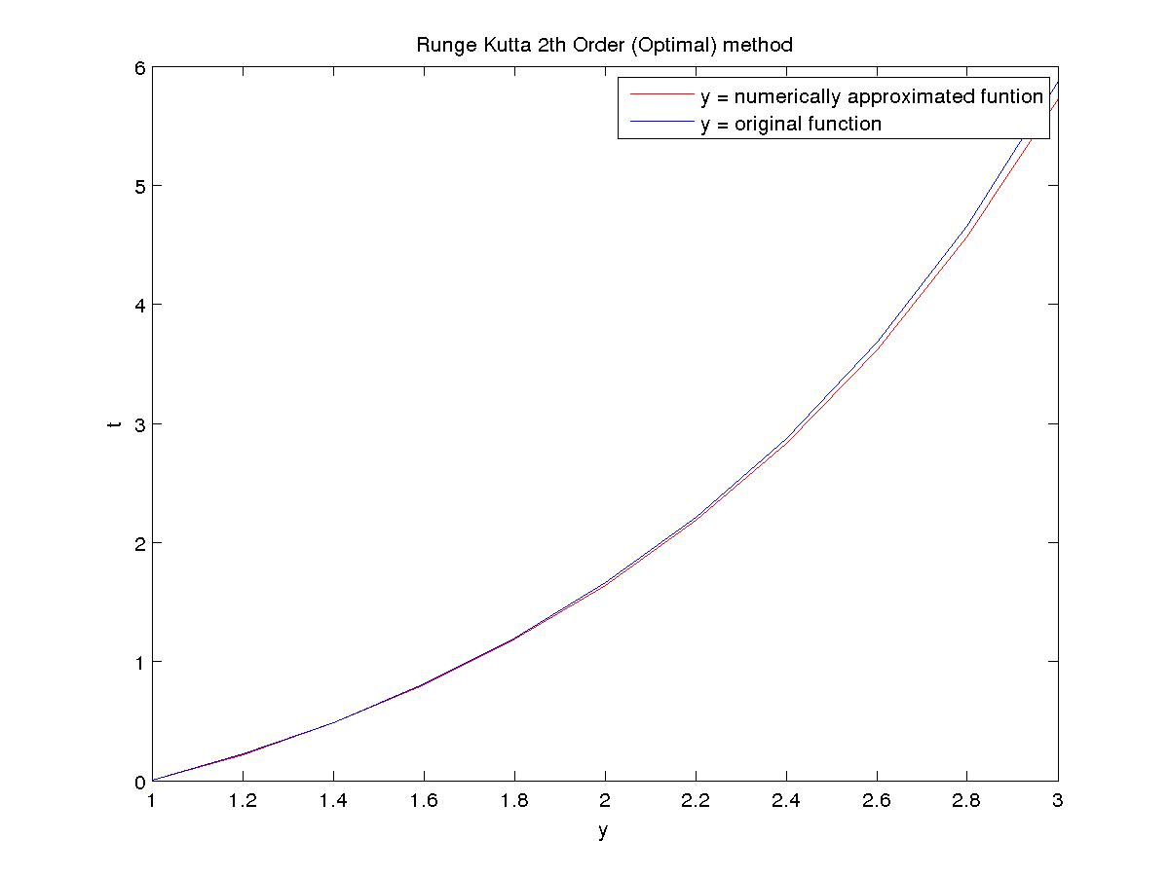

Runge Kutta 4th Order method

N Error Order
10 2.614084e-04 3.904348
20 1.745797e-05 3.951604
40 1.128346e-06 3.975832
80 7.171296e-08 3.987953
160 4.519643e-09 3.993964

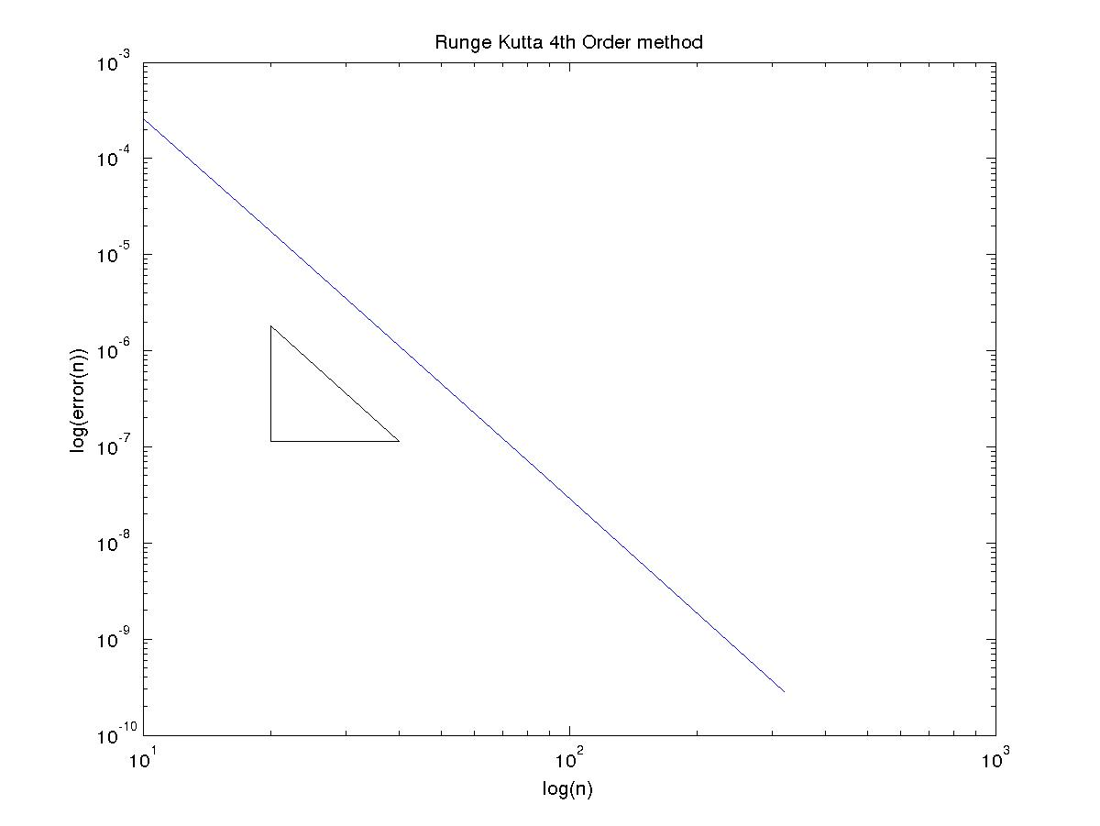
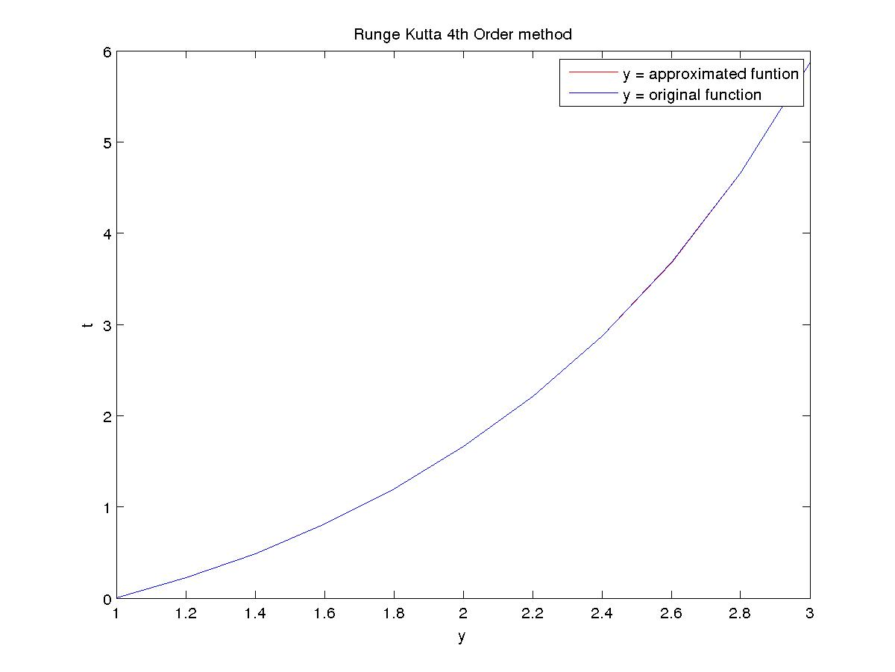
(D)
Explicit-Euler method

N Error Order
10 9.711427e-03 1.017006
20 4.798811e-03 1.008424
40 2.385436e-03 1.004193
80 1.189257e-03 1.002091
160 5.937671e-04 1.001044

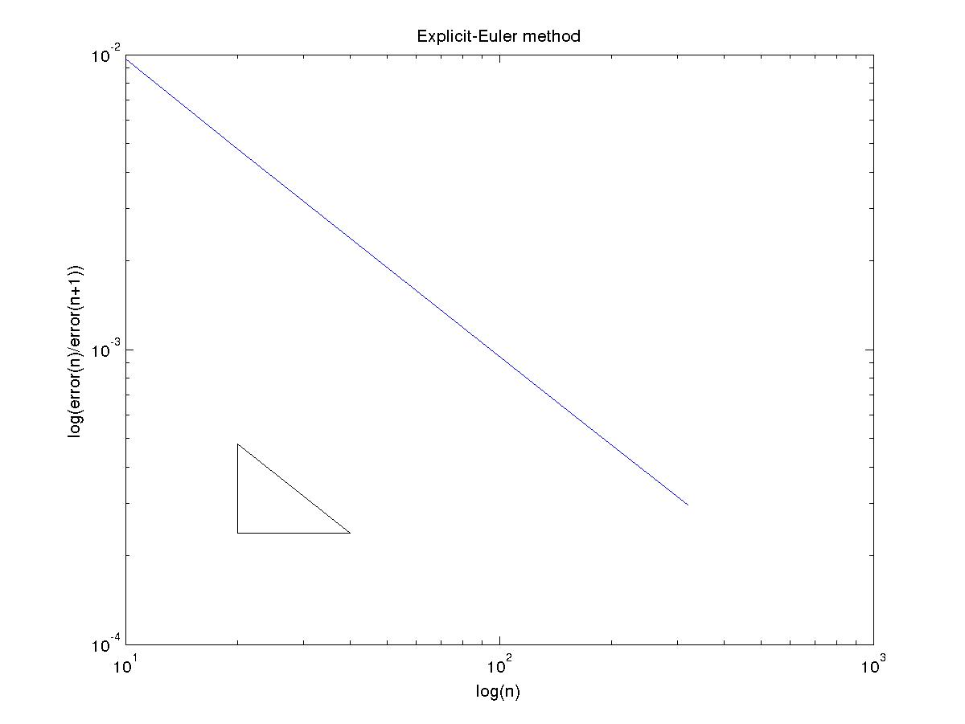

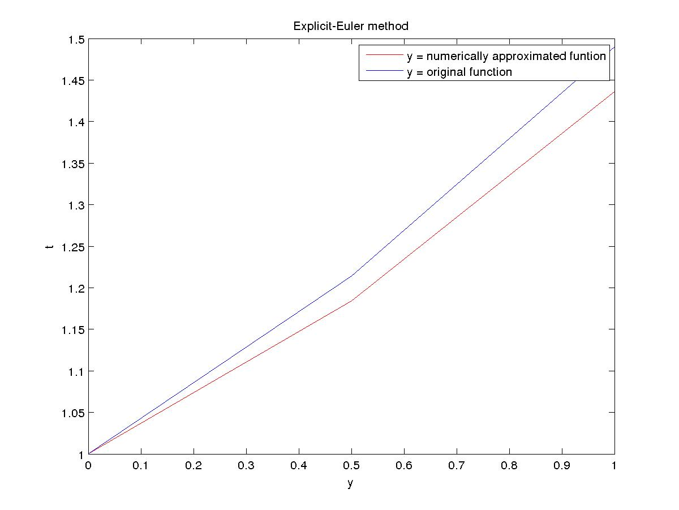

Implicit-Euler method

N Error Order
10 9.272210e-03 0.983620
20 4.689043e-03 0.991732
40 2.357996e-03 0.995847
80 1.182397e-03 0.997918
160 5.920521e-04 0.998958

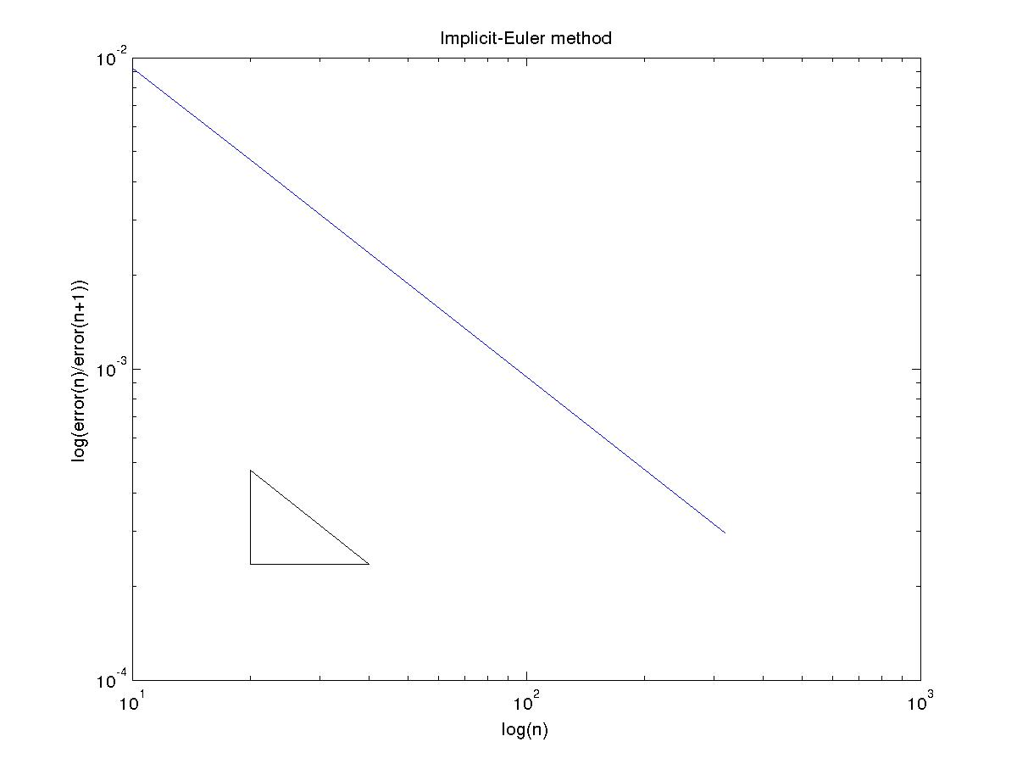
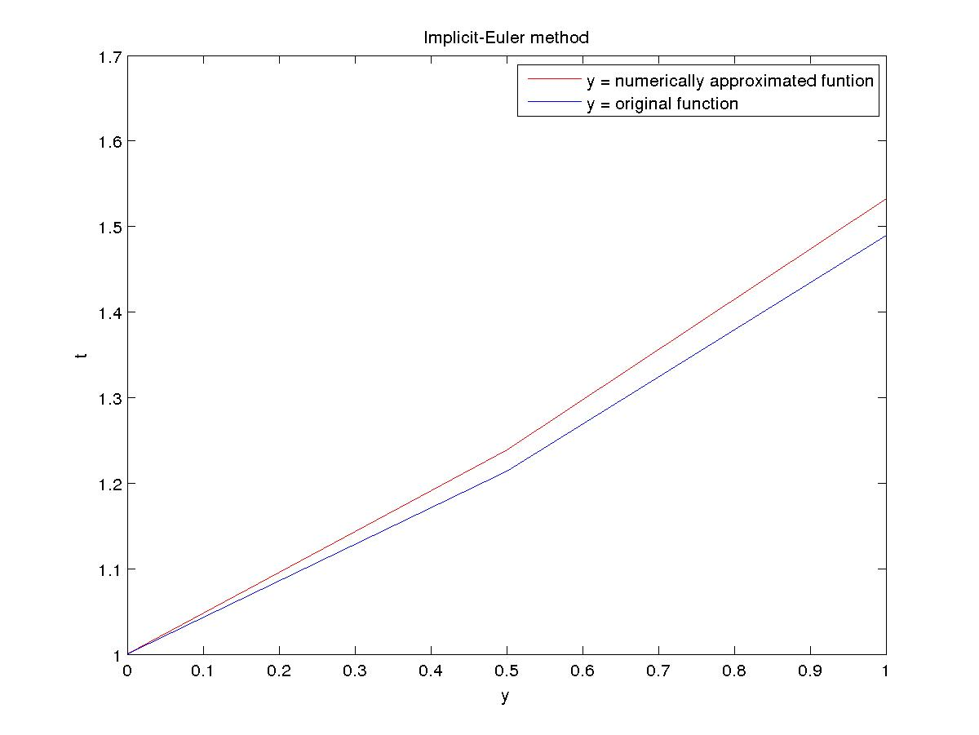

Modified-Euler (trapezoid) method

N Error Order
10 1.258717e-05 2.001433
20 3.143670e-06 1.998869
40 7.865335e-07 1.999899
80 1.966472e-07 1.999883
160 4.916579e-08 1.999991

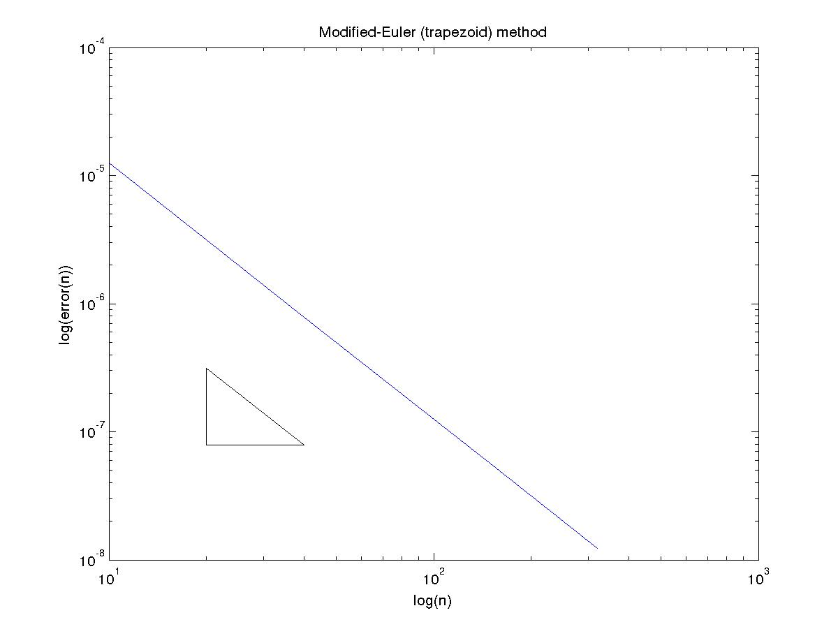

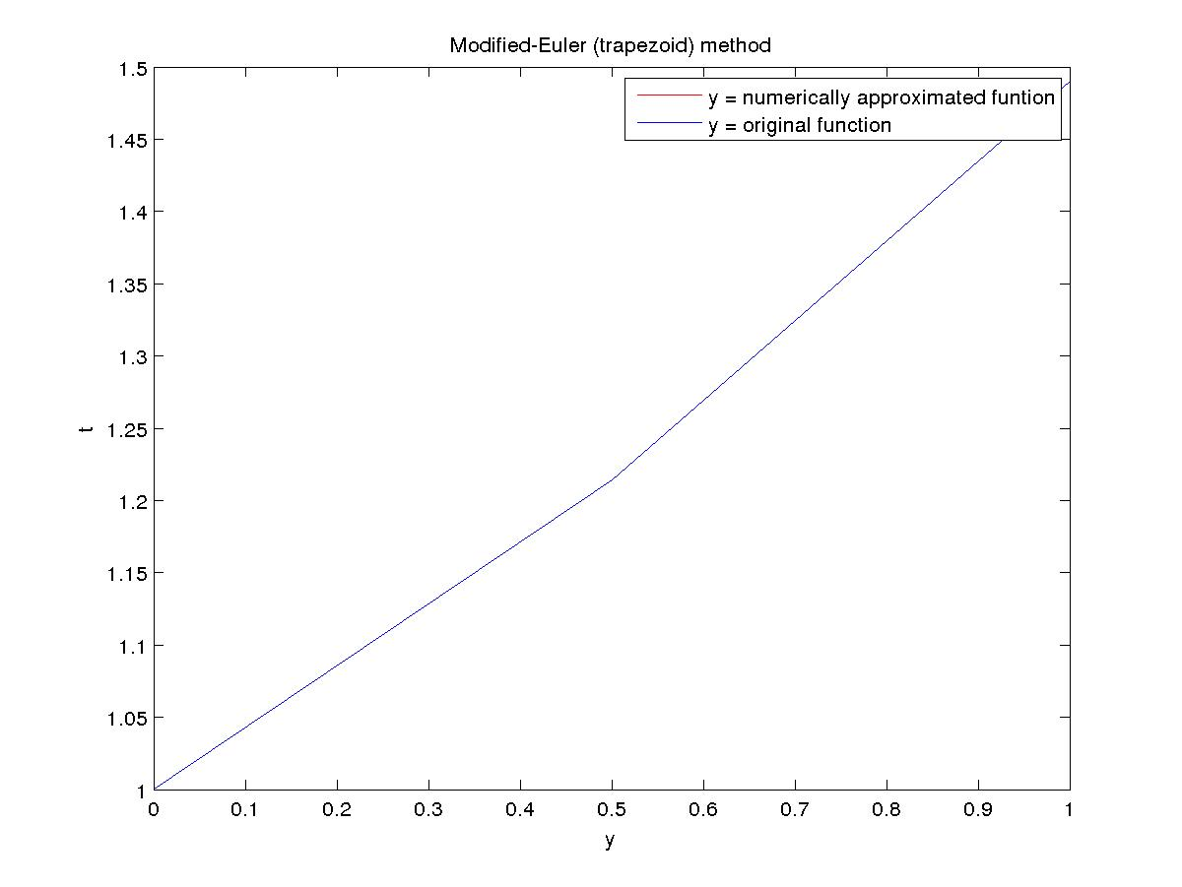

Midpoint method

N Error Order
10 1.186375e-04 2.000333
20 2.965253e-05 2.000084
40 7.412698e-06 2.000018
80 1.853151e-06 1.999998
160 4.632884e-07 2.000008

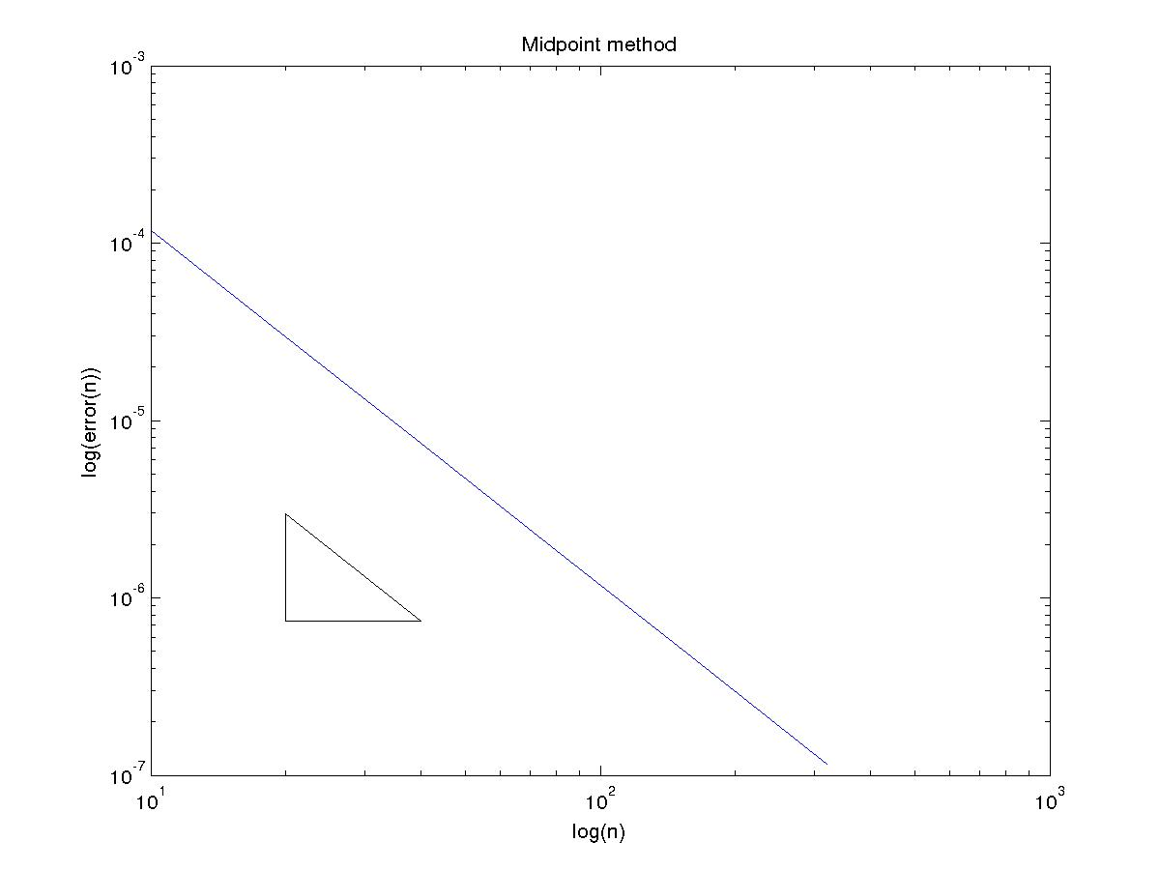
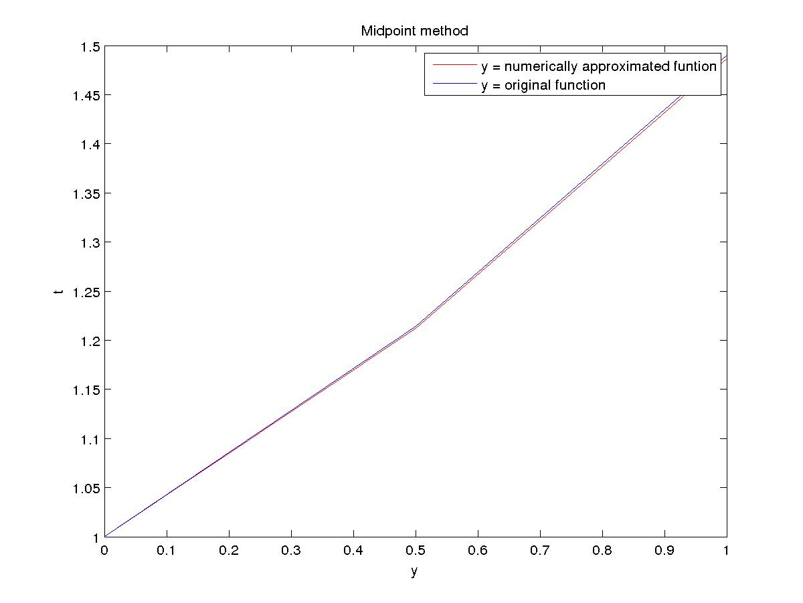

Runge Kutta 2th Order (Optimal) method

N Error Order
10 1.641263e-04 2.026594
20 4.028213e-05 2.013296
40 9.978148e-06 2.006647
80 2.483070e-06 2.003323
160 6.193394e-07 2.001661

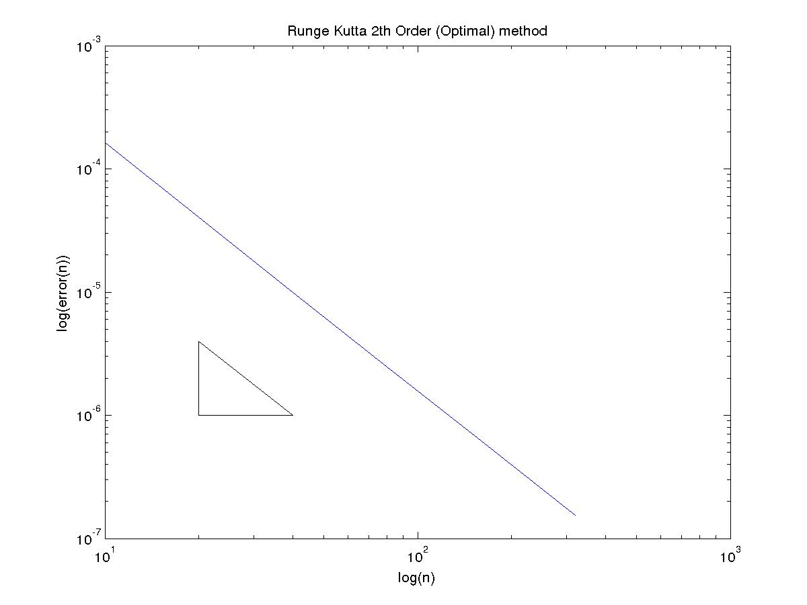

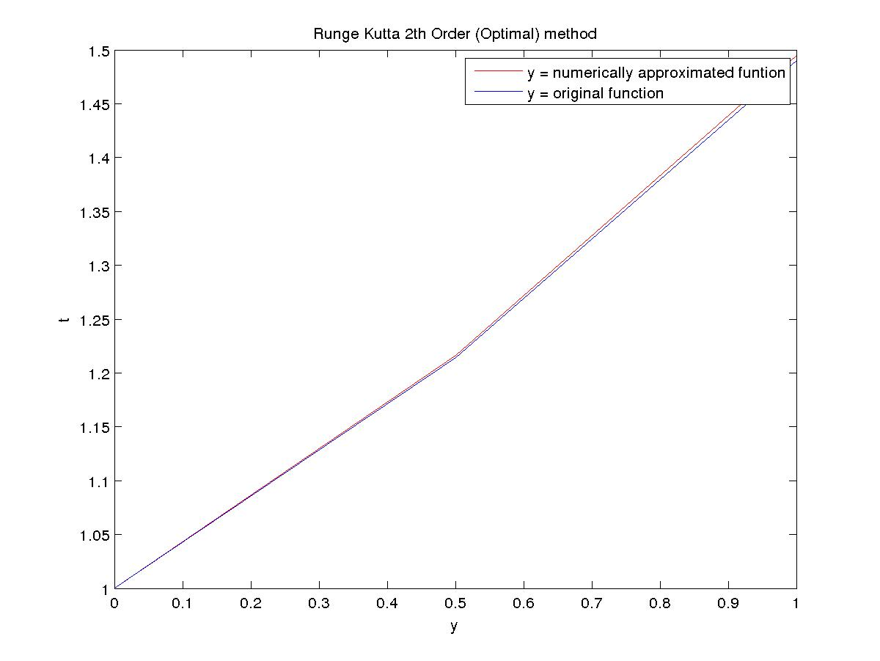

Runge Kutta 4th Order method

N Error Order
10 5.643600e-08 4.029736
20 3.455292e-09 4.014998
40 2.137224e-10 4.007514
80 1.328826e-11 4.005918
160 8.271162e-13 3.986508

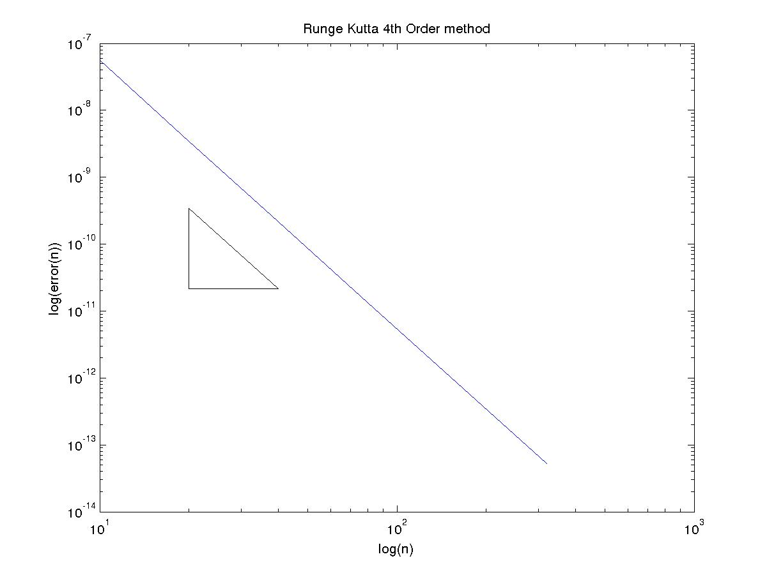
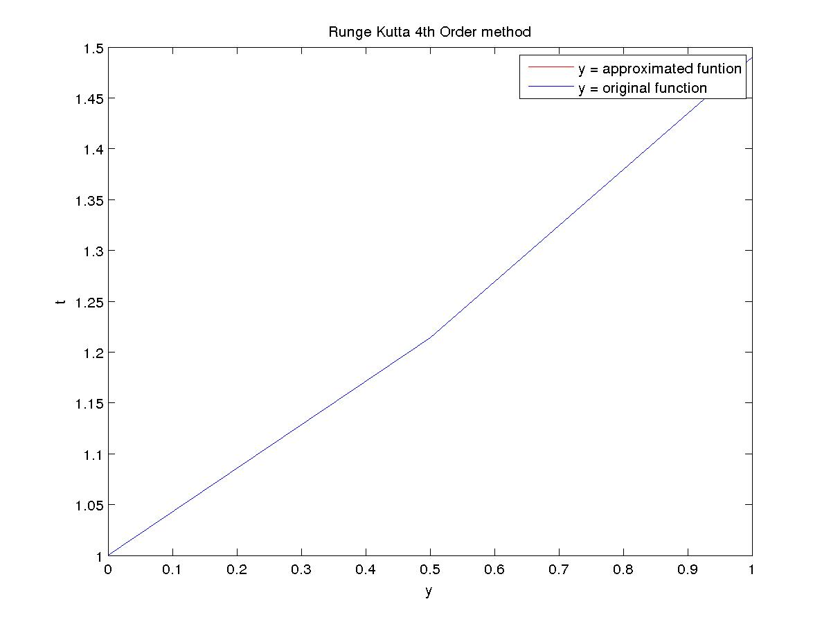

Question 2
Runge Kutta 4th Order method
Max-error = 5.167121e-02

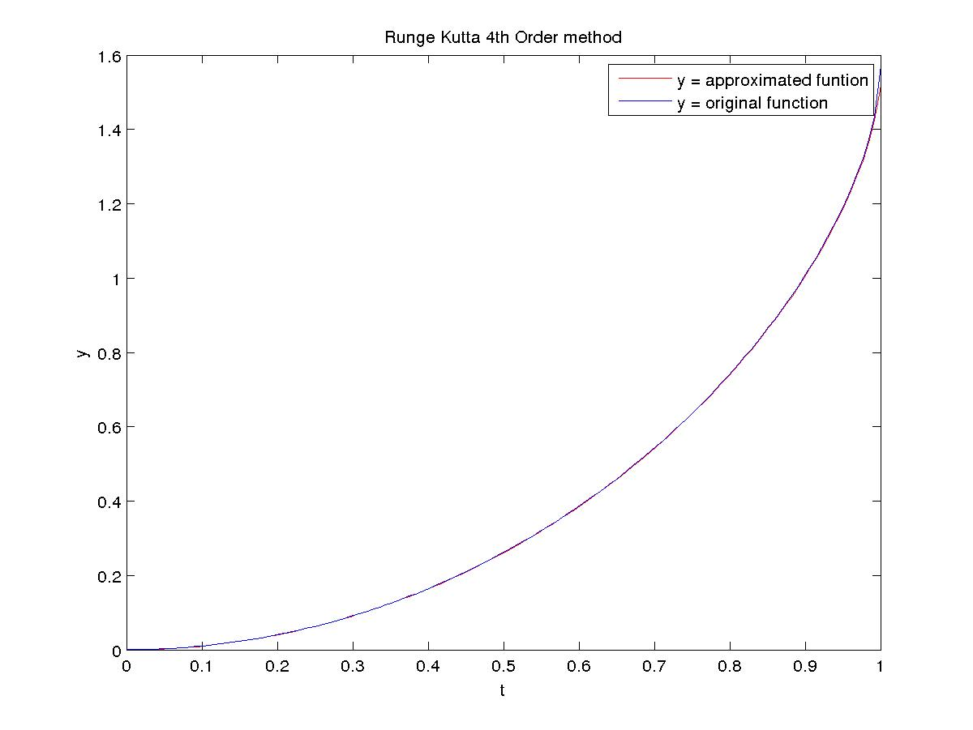

Question 3
Runge Kutta 4th Order method
After 0.200000 seconds amount of KOH formed = 2.079409e+03

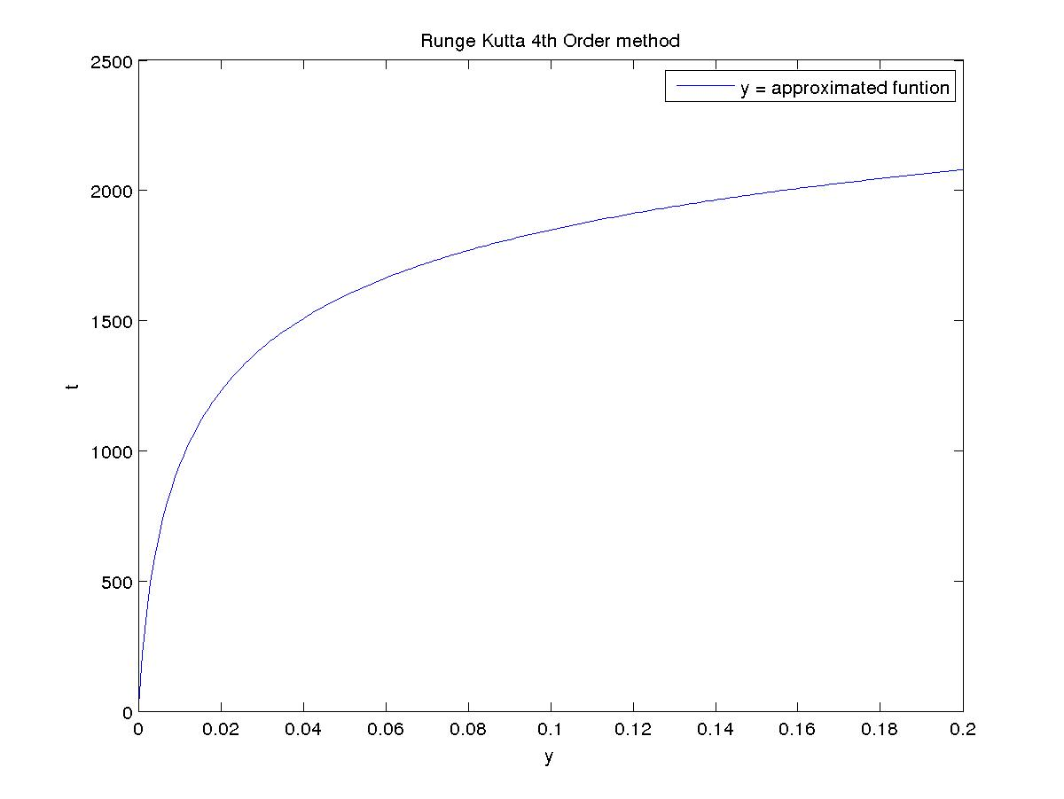

Question 4
(A)
Using exact starting values
Adams-Bashford method

N Error Order
10 1.450997e-03 4.127114
20 8.303887e-05 4.155690
40 4.659016e-06 4.106124
80 2.705377e-07 4.061157
160 1.620681e-08 4.032912
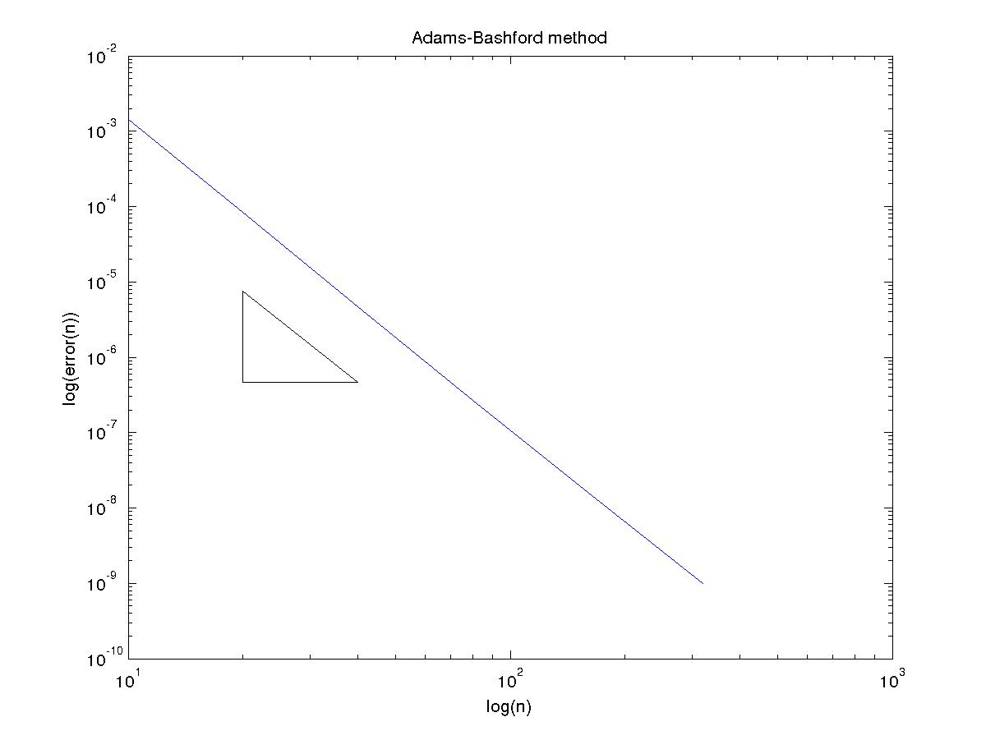

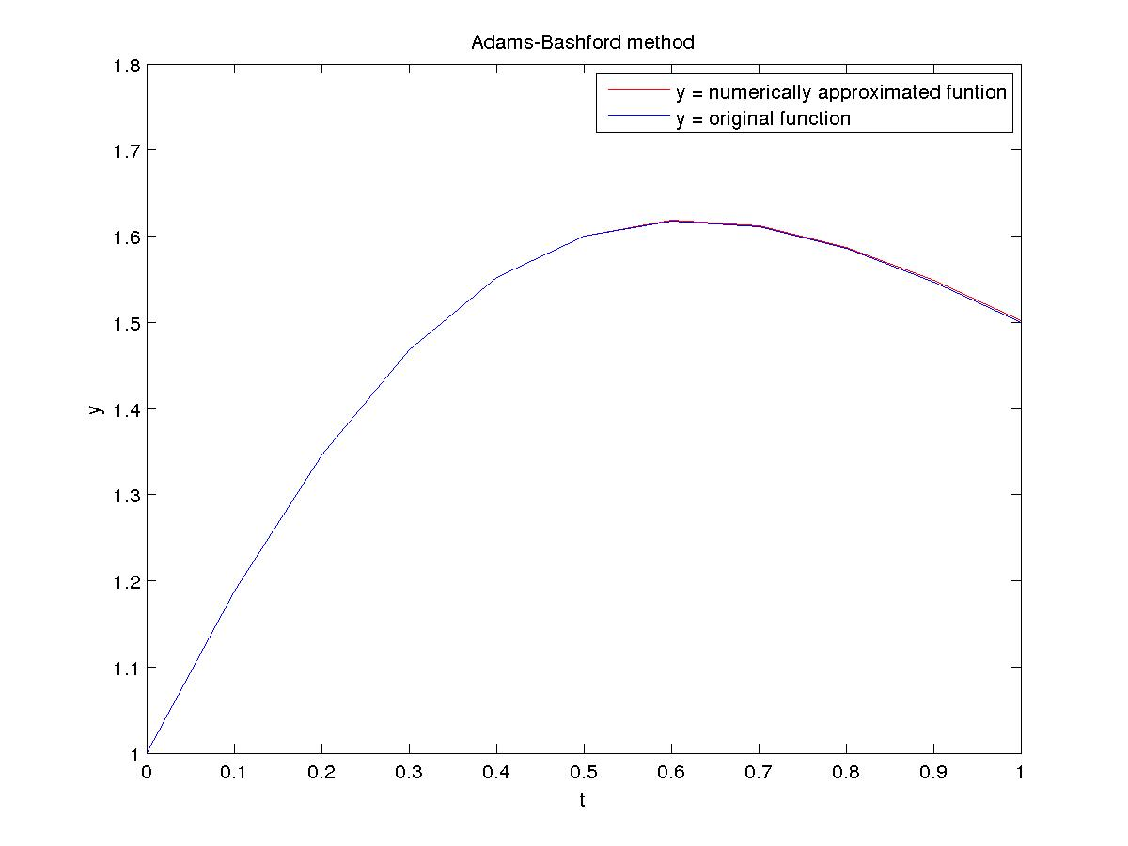
Adams-Moulton method

N Error Order
10 1.099951e-04 4.168575
20 6.116562e-06 4.147725
40 3.450783e-07 4.094071
80 2.020596e-08 4.051972
160 1.218188e-09 4.027468

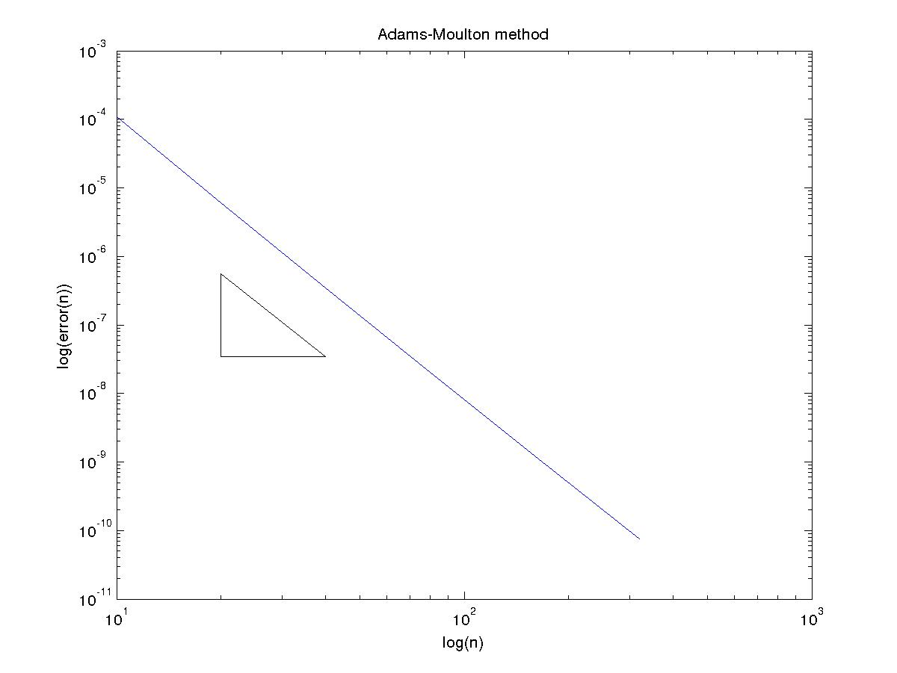
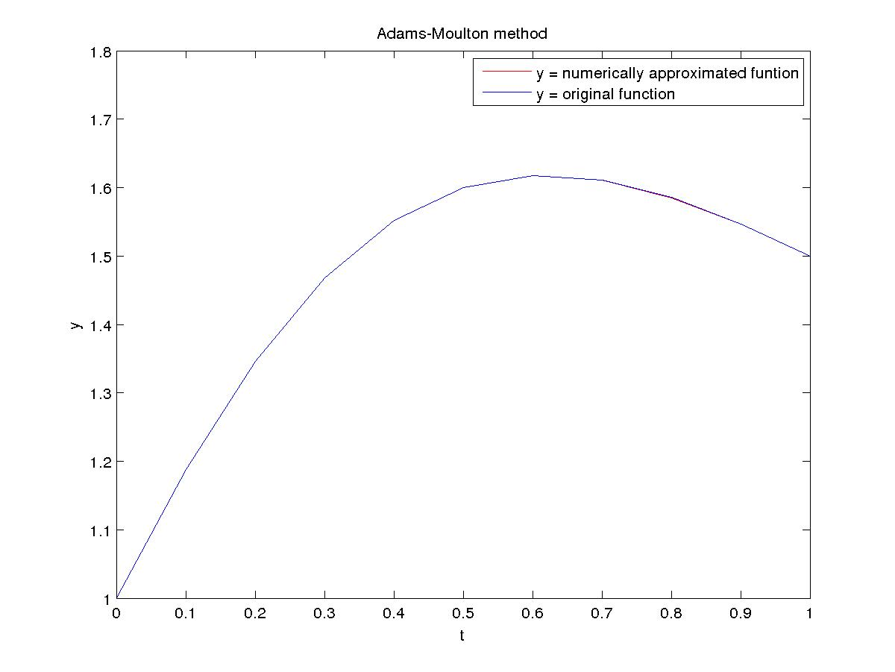

Using starting values from Runge-Kutta 4th order
Adams-Bashford method

N Error Order
10 1.450657e-03 4.126865
20 8.303378e-05 4.155623
40 4.658946e-06 4.106107
80 2.705367e-07 4.061153
160 1.620680e-08 4.032911

Adams-Moulton method

N Error Order
10 1.101454e-04 4.170044
20 6.118685e-06 4.148101
40 3.451081e-07 4.094164
80 2.020640e-08 4.051996
160 1.218195e-09 4.027475

(B)
Using exact starting values
Adams-Bashford method

N Error Order
10 2.079273e-02 2.868599
20 2.846933e-03 3.355458
40 2.781530e-04 3.596418
80 2.299608e-05 3.777475
160 1.676952e-06 3.884273

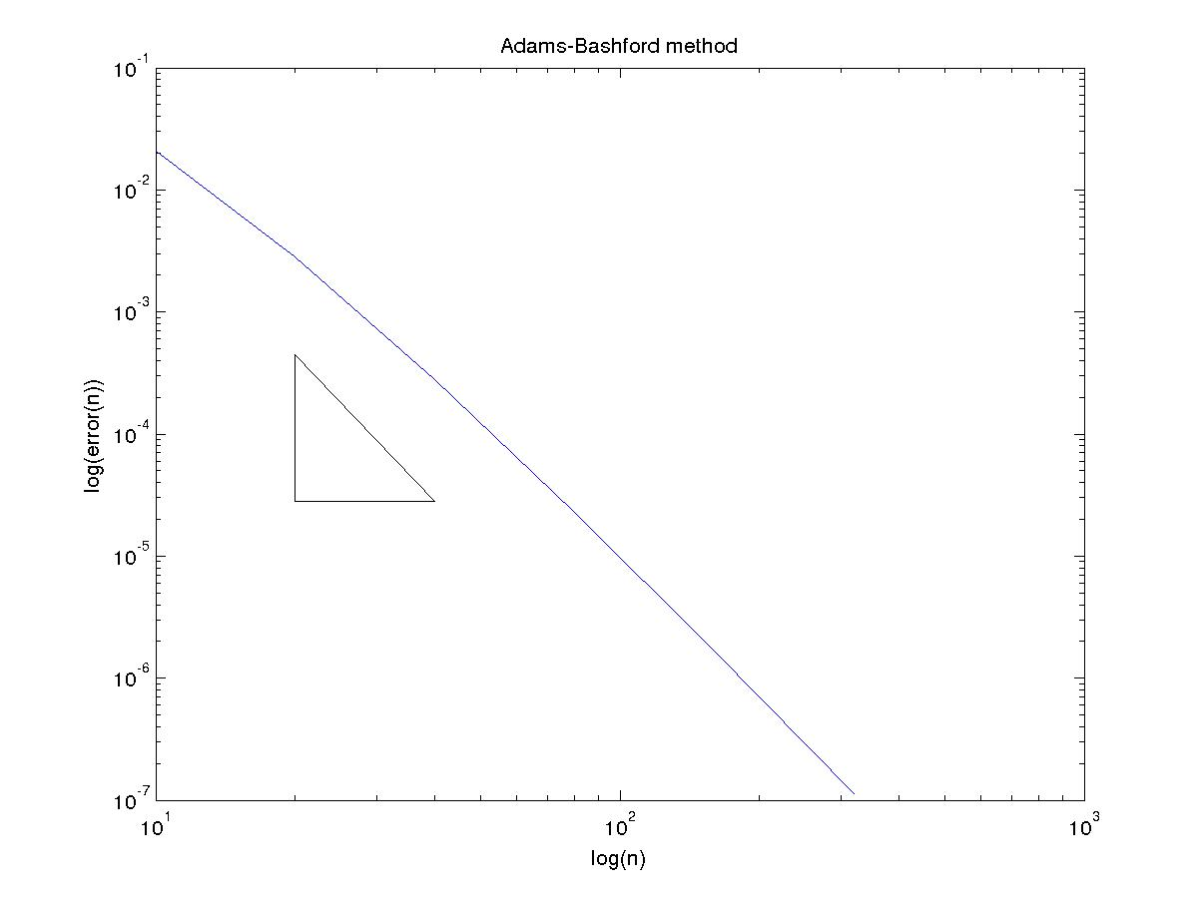

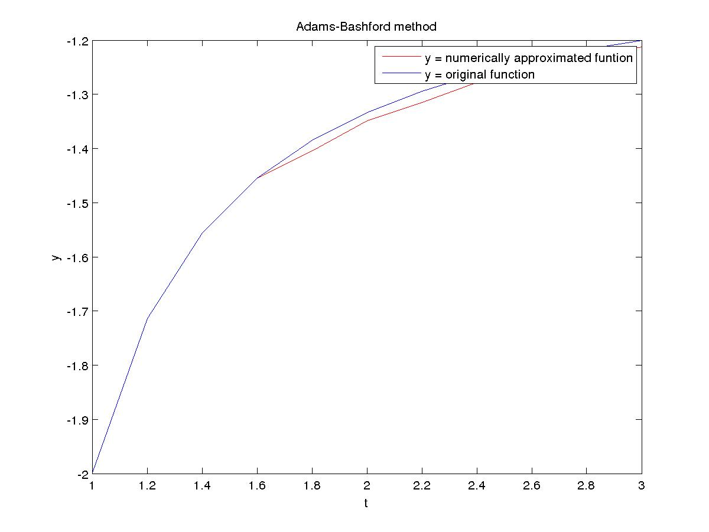

Adams-Moulton method

N Error Order
10 1.732877e-03 2.910375
20 2.304930e-04 3.350827
40 2.259219e-05 3.637163
80 1.815779e-06 3.806457
160 1.297793e-07 3.899485

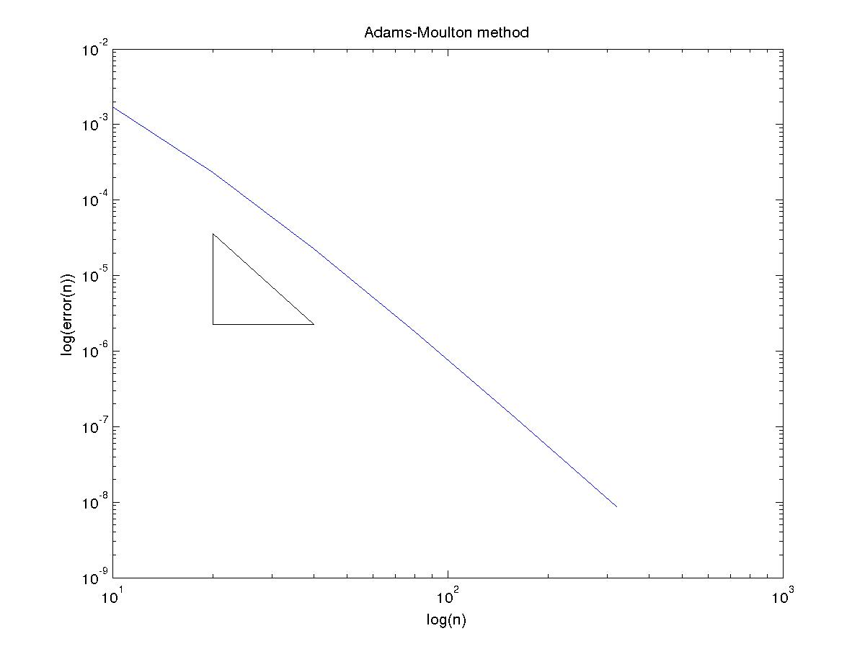
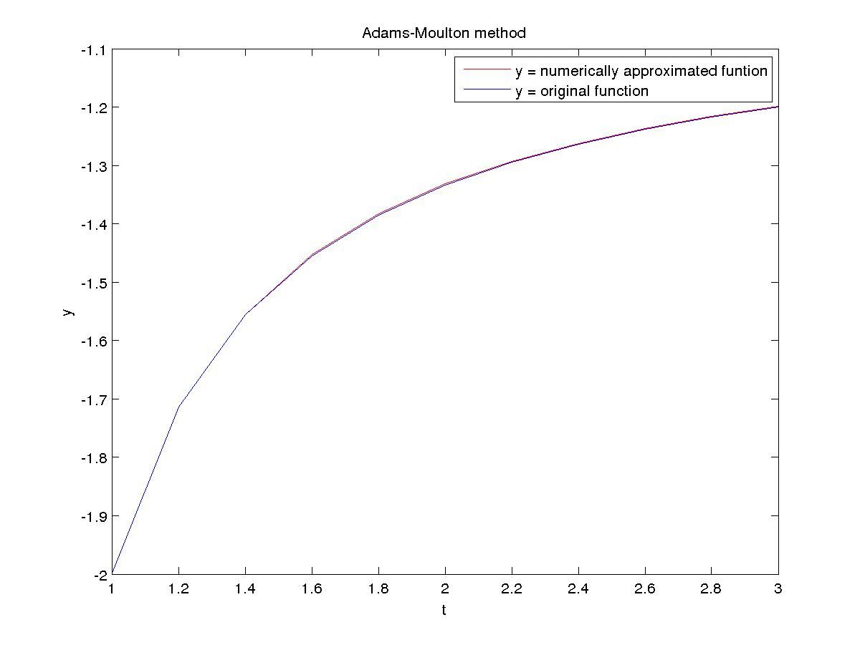

Using starting values from Runge-Kutta 4th order
Adams-Bashford method

N Error Order
10 2.078609e-02 2.868283
20 2.846647e-03 3.355268
40 2.781617e-04 3.596395
80 2.299718e-05 3.777495
160 1.677009e-06 3.884293

Adams-Moulton method

N Error Order
10 1.753780e-03 2.925572
20 2.308289e-04 3.353440
40 2.258418e-05 3.637345
80 1.814907e-06 3.806221
160 1.297381e-07 3.899287

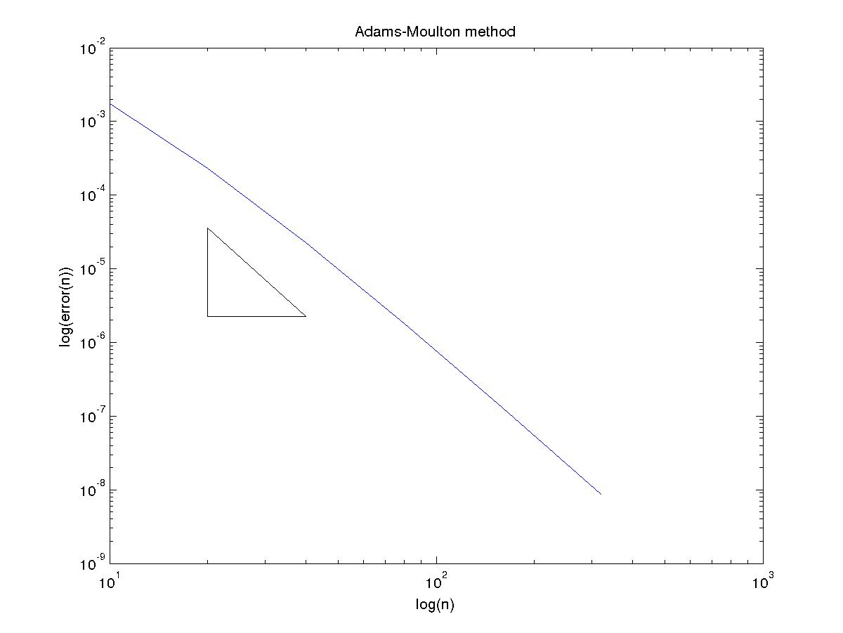

(C)
Using exact starting values
Adams-Bashford method

N Error Order
10 1.510053e-02 3.169750
20 1.678040e-03 3.543827
40 1.438812e-04 3.750966
80 1.068688e-05 3.868520
160 7.316616e-07 3.932281

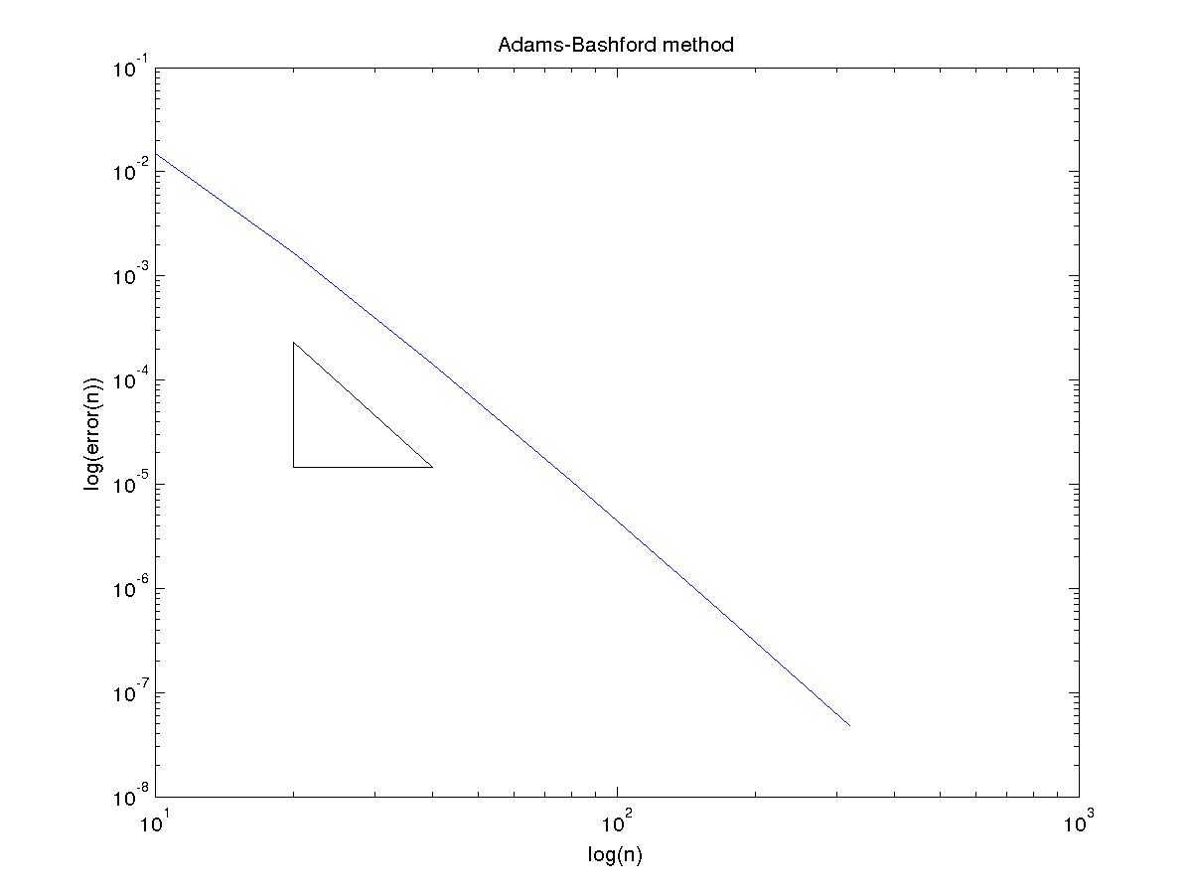

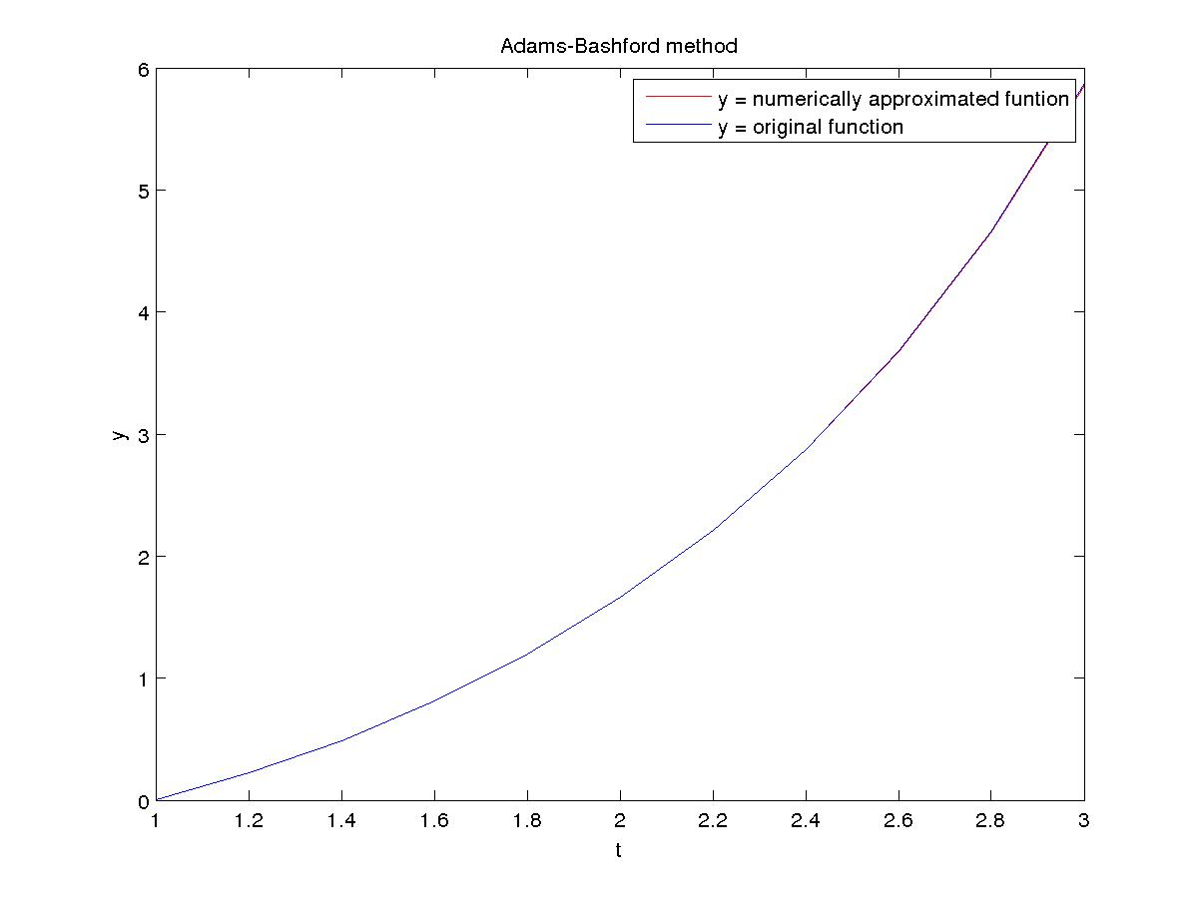

Adams-Moulton method

N Error Order
10 1.792123e-03 3.501697
20 1.582165e-04 3.698841
40 1.218399e-05 3.830313
80 8.565454e-07 3.912484
160 5.688205e-08 3.962129

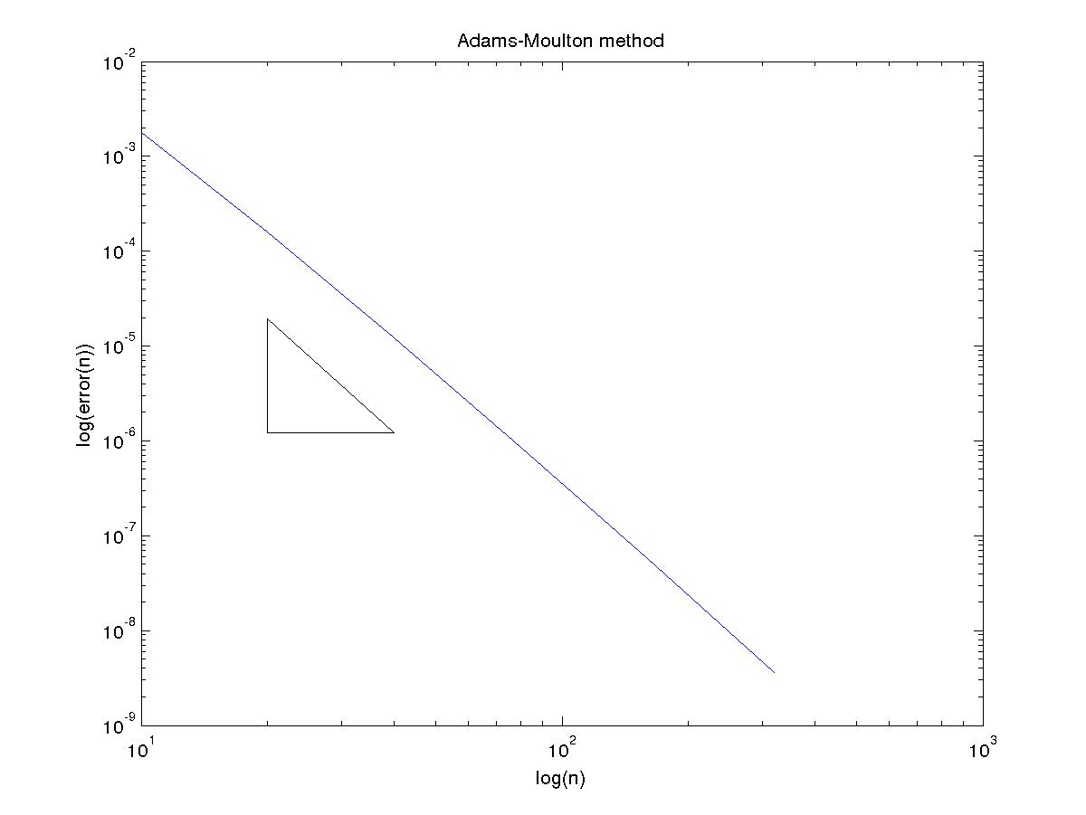
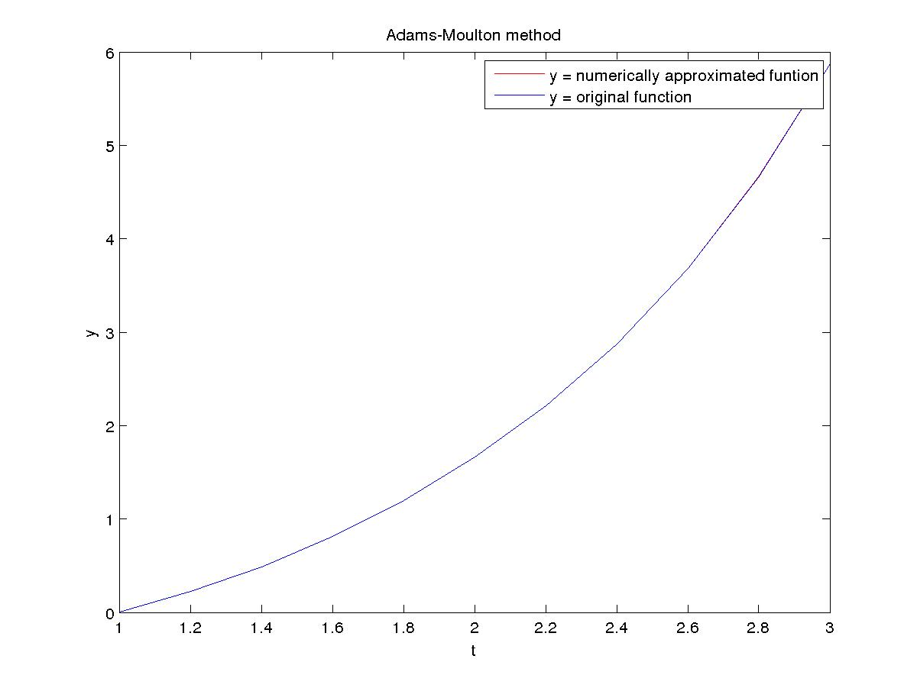

Using starting values from Runge-Kutta 4th order
Adams-Bashford method

N Error Order
10 1.510559e-02 3.172317
20 1.675619e-03 3.543296
40 1.437265e-04 3.750304
80 1.068028e-05 3.868101
160 7.314223e-07 3.932052

Adams-Moulton method

N Error Order
10 1.814826e-03 3.497032
20 1.607398e-04 3.706966
40 1.230879e-05 3.836923
80 8.613634e-07 3.916353
160 5.704882e-08 3.964189

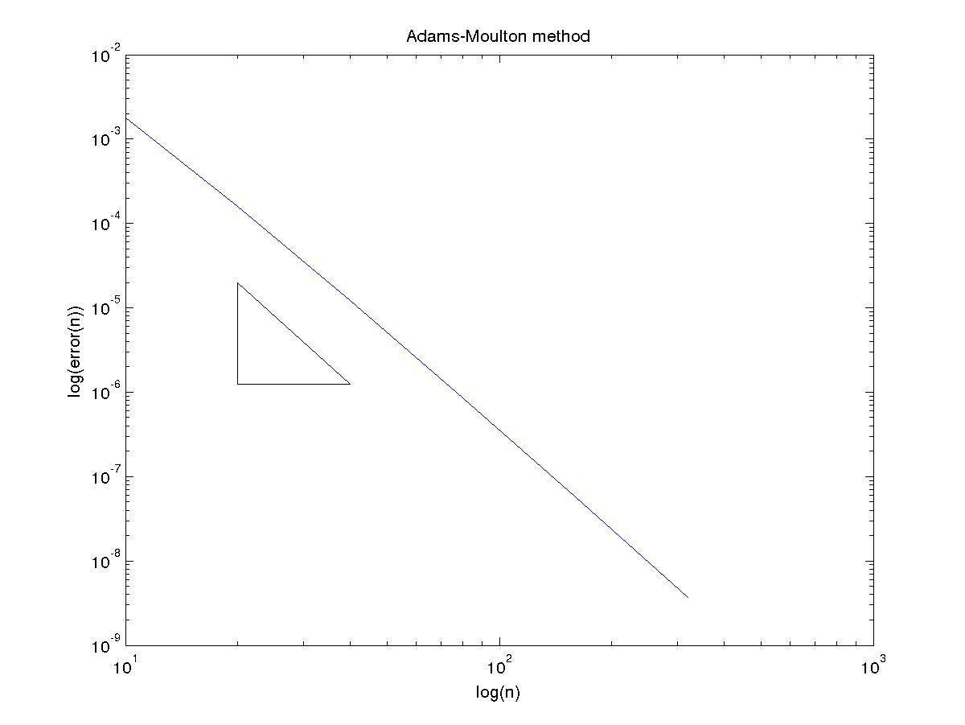

(D)
Using exact starting values
Adams-Bashford method

N Error Order
10 5.663556e-07 3.550004
20 4.835391e-08 3.805645
40 3.457948e-09 3.911109
80 2.298568e-10 3.956812
160 1.480260e-11 3.977859

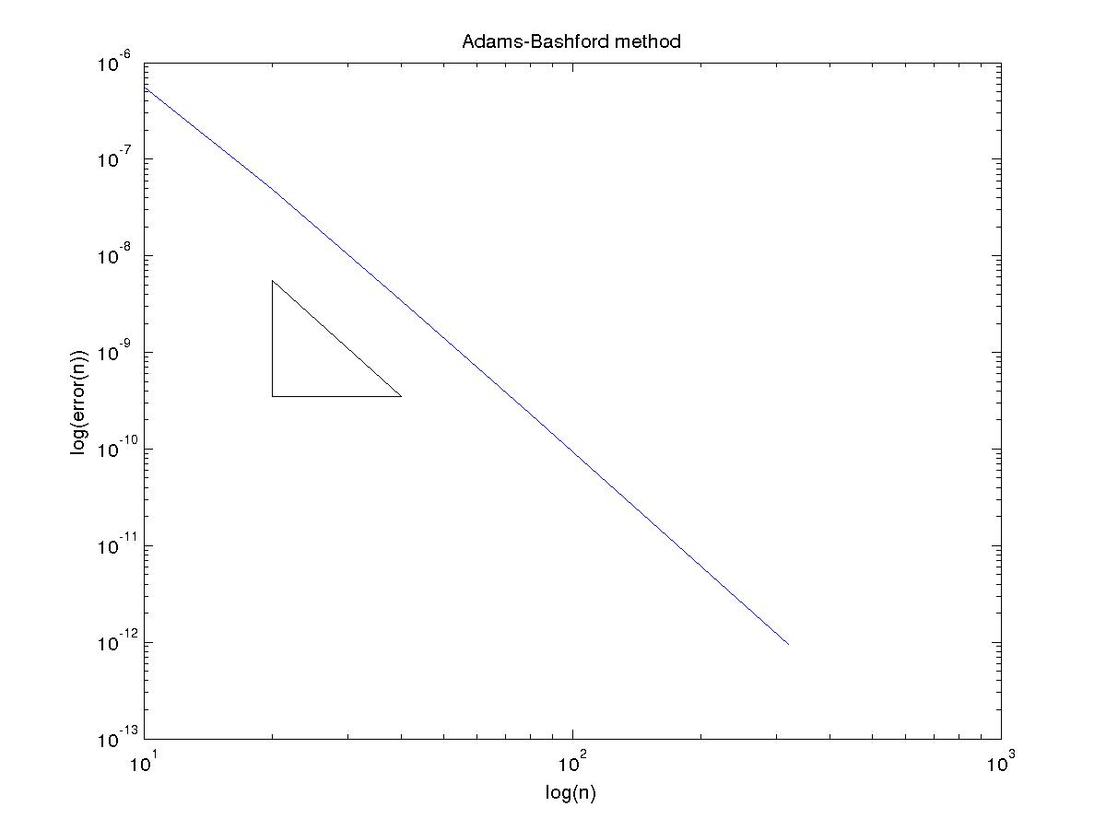

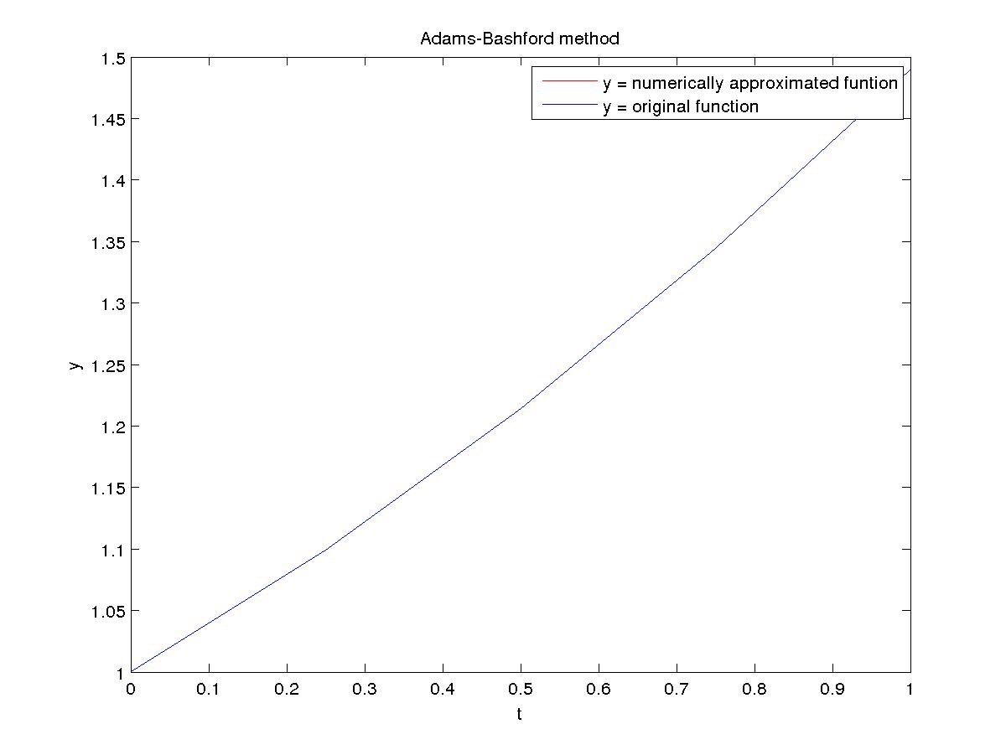

Adams-Moulton method

N Error Order
10 4.832447e-08 3.654039
20 3.838766e-09 3.845347
40 2.670710e-10 3.634761
80 2.150080e-11 3.976811
160 1.365574e-12 4.008942

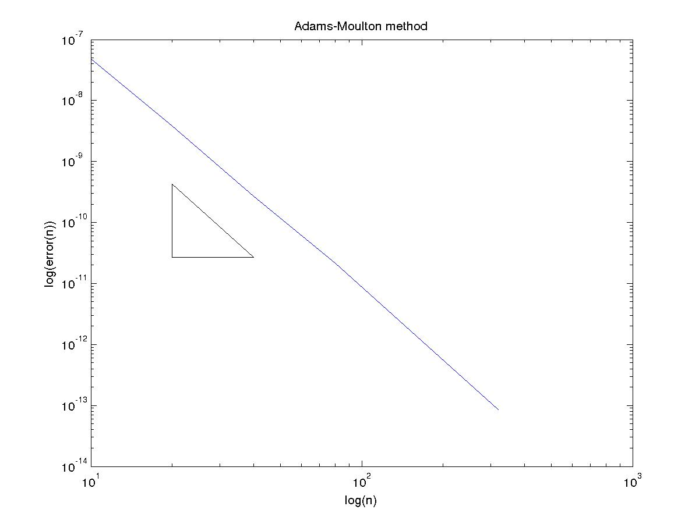
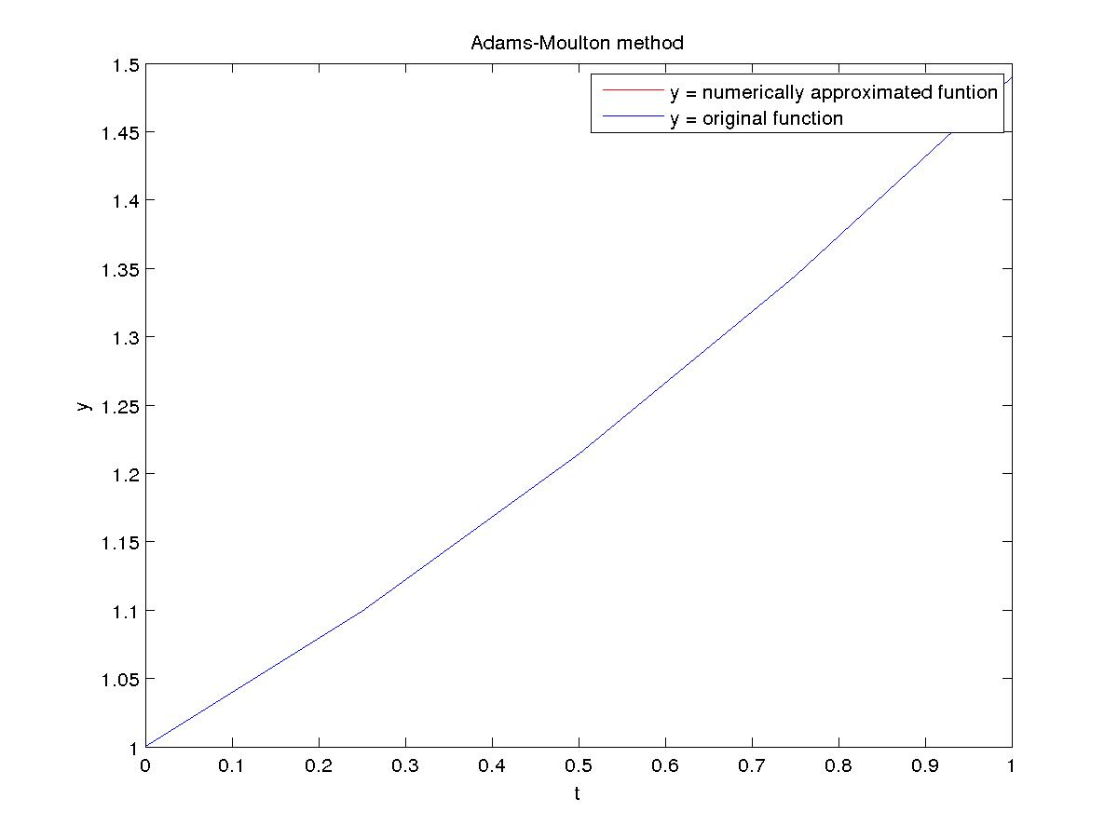

Using starting values from Runge-Kutta 4th order
Adams-Bashford method

N Error Order
10 5.781074e-07 3.569301
20 4.870145e-08 3.811686
40 3.468246e-09 3.913438
80 2.301694e-10 3.957886
160 1.481171e-11 3.978405

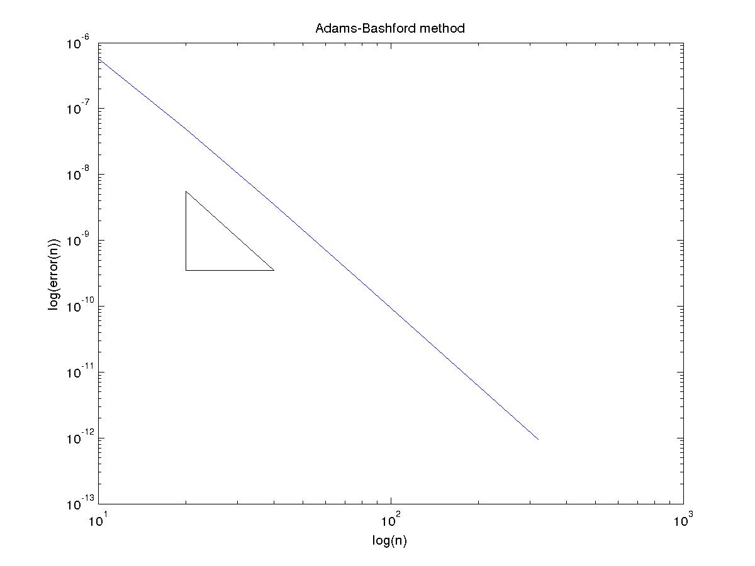

Adams-Moulton method

N Error Order
10 4.070670e-08 3.492774
20 3.616065e-09 3.796419
40 2.602556e-10 3.610879
80 2.130185e-11 3.969982
160 1.359357e-12 4.002359

