MA 322: Scientific Computing
LAB 8 Report
Abheek Ghosh - 140123047

NOTE: The right angled triangle is for comparison of the slope. It has been made with the hypotaneuse slope as expected for respective methods.

Question 1

(A) Dirichlet Boundary Condition

Using Forward-difference for 1st order and Central-difference for 2nd order

N Error Order
5 2.197919e-02 0.792223
10 1.269196e-02 0.864787
20 6.969505e-03 0.935965
40 3.642909e-03 0.967211
80 1.863326e-03 0.982910

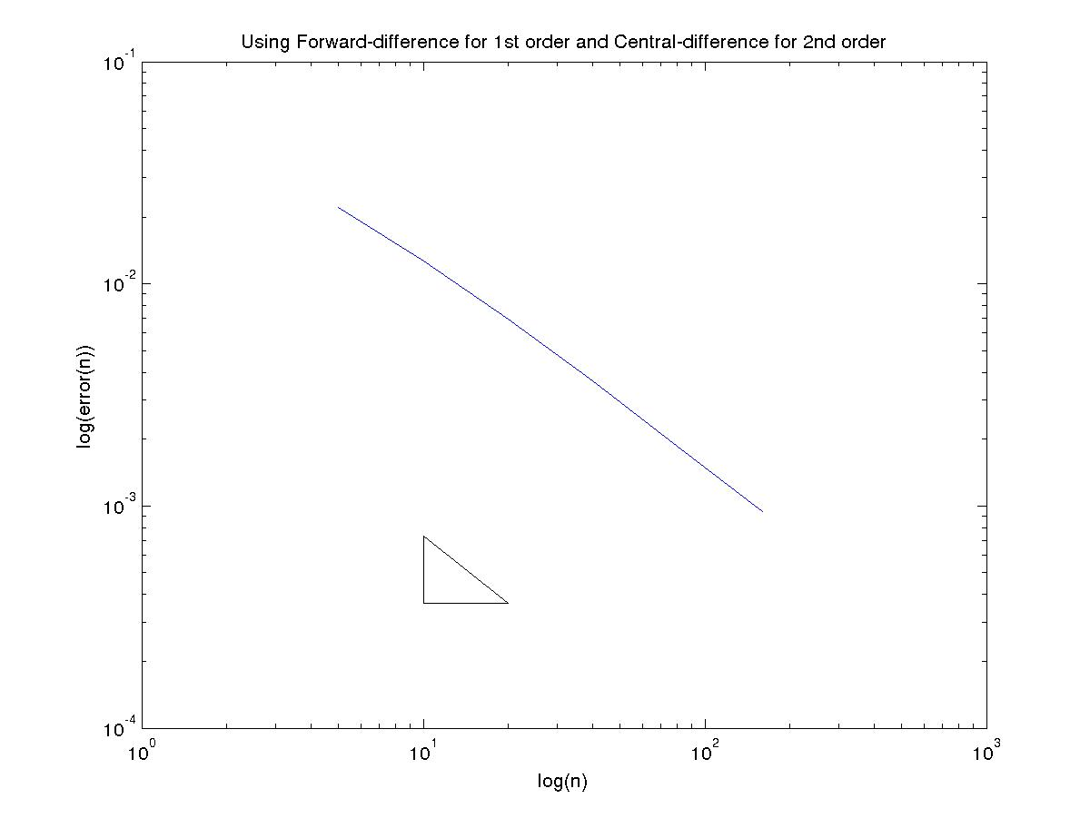

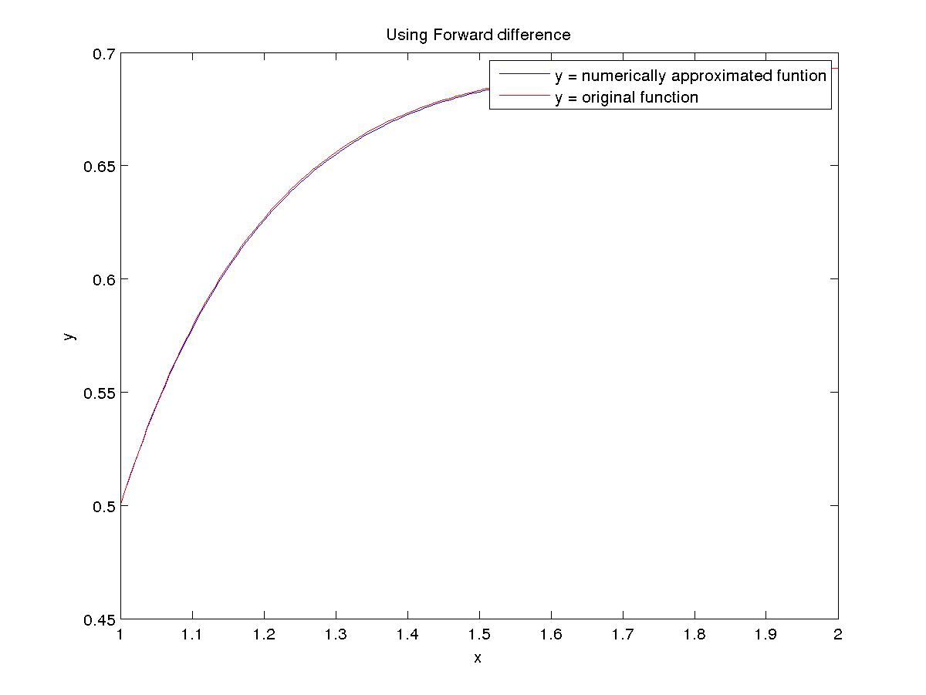

Using Backward-difference for 1st order and Central-difference for 2nd order

N Error Order
5 5.166753e-02 1.448127
10 1.893599e-02 1.172924
20 8.398521e-03 1.067958
40 4.006042e-03 1.035812
80 1.953913e-03 1.017441

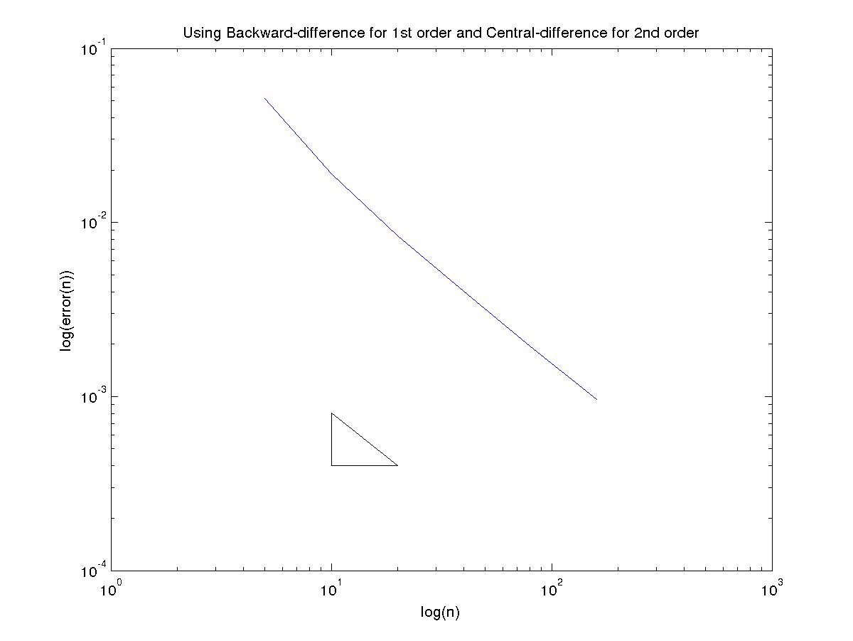
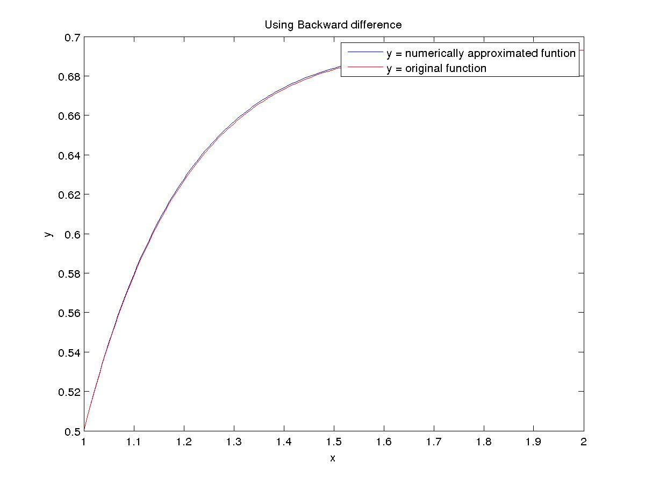

Using Central-difference for 1st order and Central-difference for 2nd order

N Error Order
5 2.311583e-03 2.031265
10 5.655066e-04 2.007719
20 1.406222e-04 2.001924
40 3.510871e-05 1.998787
80 8.784558e-06 2.000152

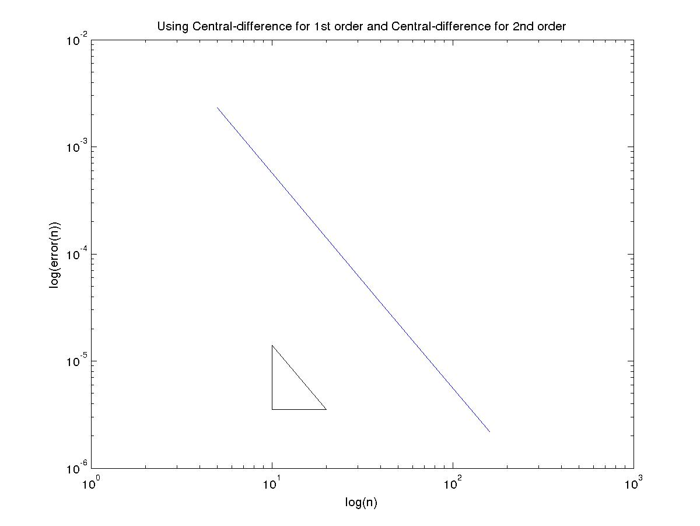
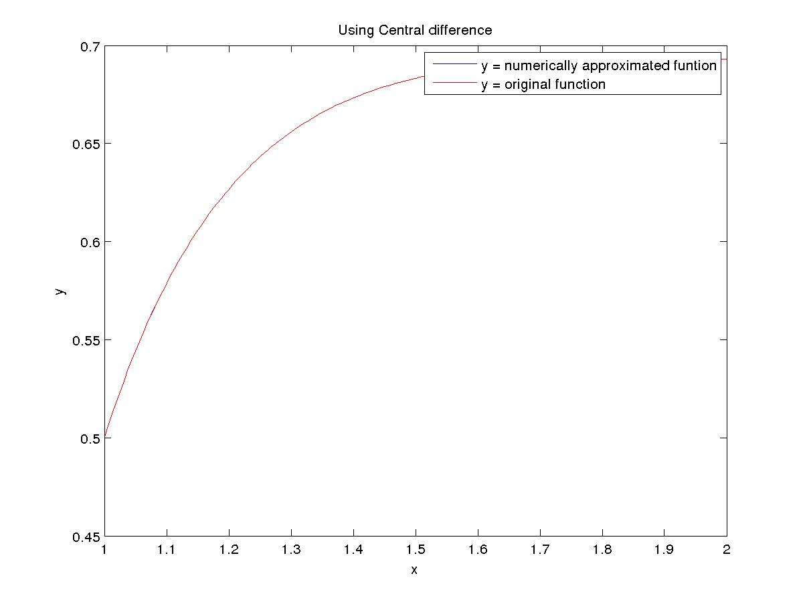
(B) Dirichlet Boundary Condition

Using Forward-difference for 1st order and Central-difference for 2nd order

N Error Order
5 5.851788e-01 1.481215
10 2.096035e-01 1.210517
20 9.057256e-02 1.098021
40 4.231160e-02 1.047158
80 2.047544e-02 1.022947

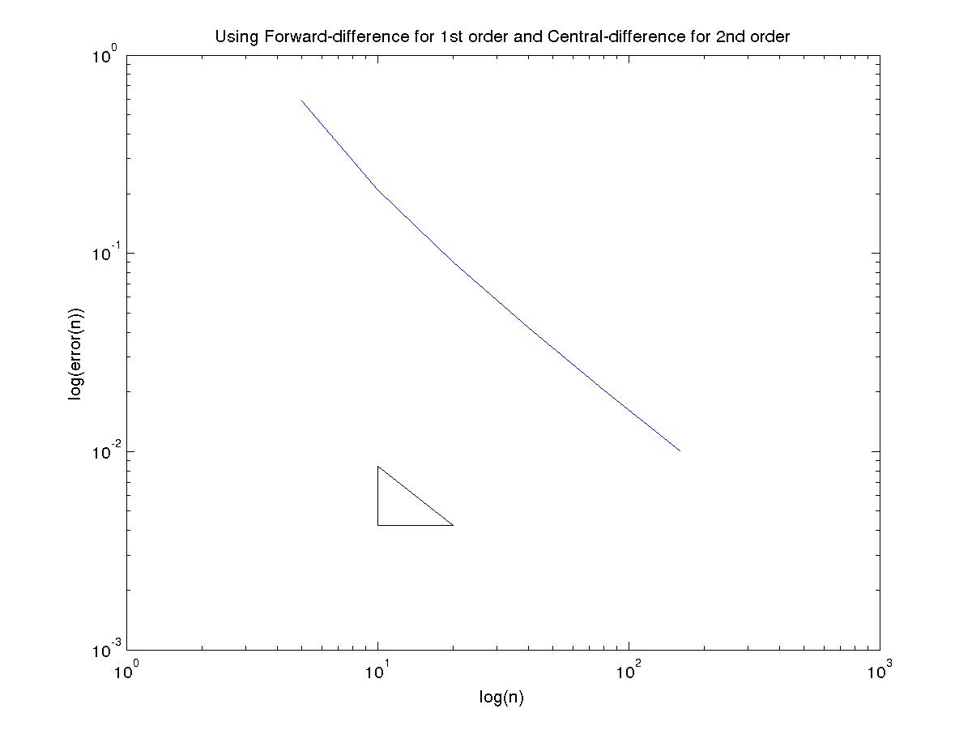
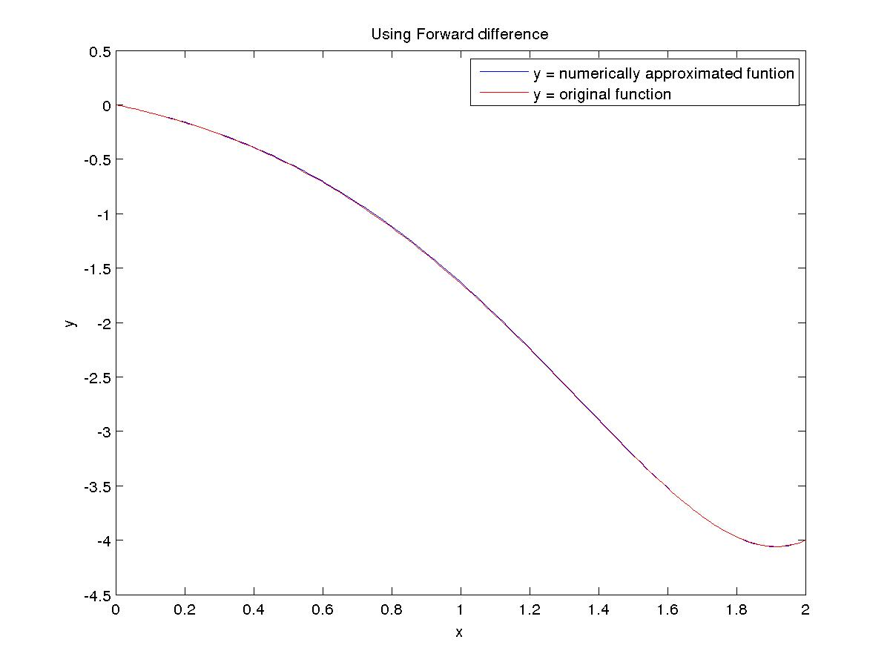

Using Backward-difference for 1st order and Central-difference for 2nd order

N Error Order
5 1.973590e-01 0.661807
10 1.247479e-01 0.832122
20 7.007123e-02 0.911586
40 3.724988e-02 0.954342
80 1.922381e-02 0.977562

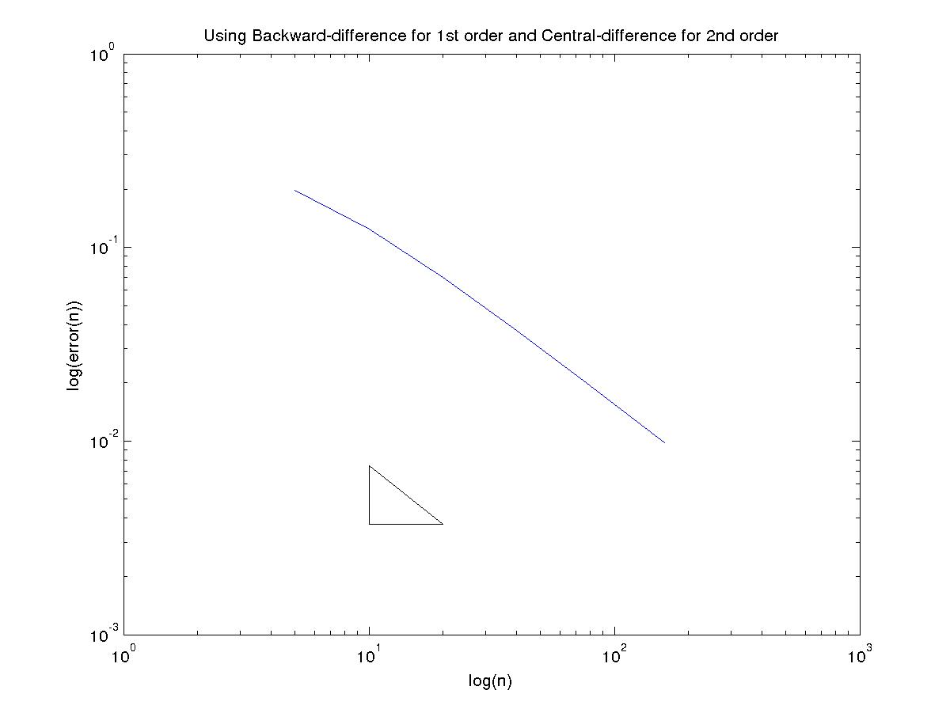

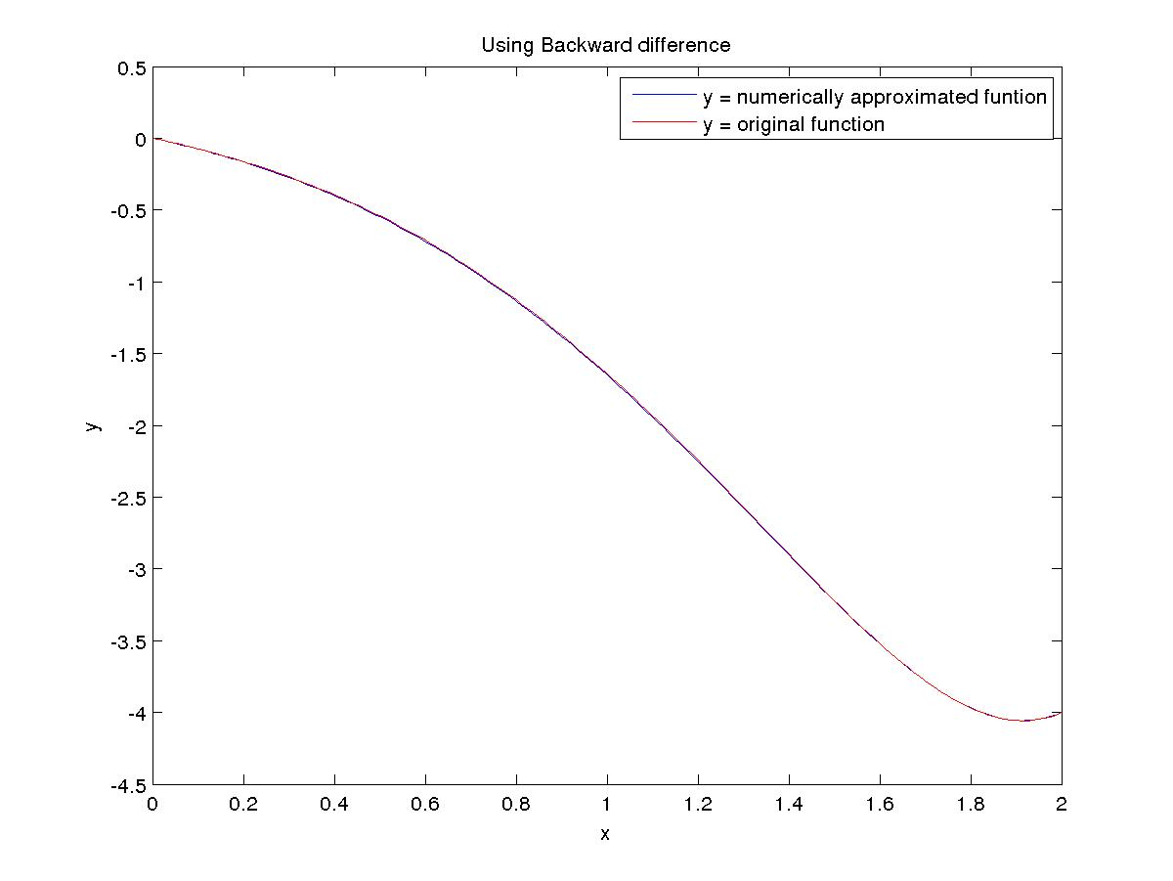

Using Central-difference for 1st order and Central-difference for 2nd order

N Error Order
5 3.999023e-02 2.059519
10 9.593494e-03 2.003573
20 2.392441e-03 1.995024
40 6.001770e-04 2.002832
80 1.497500e-04 1.998718

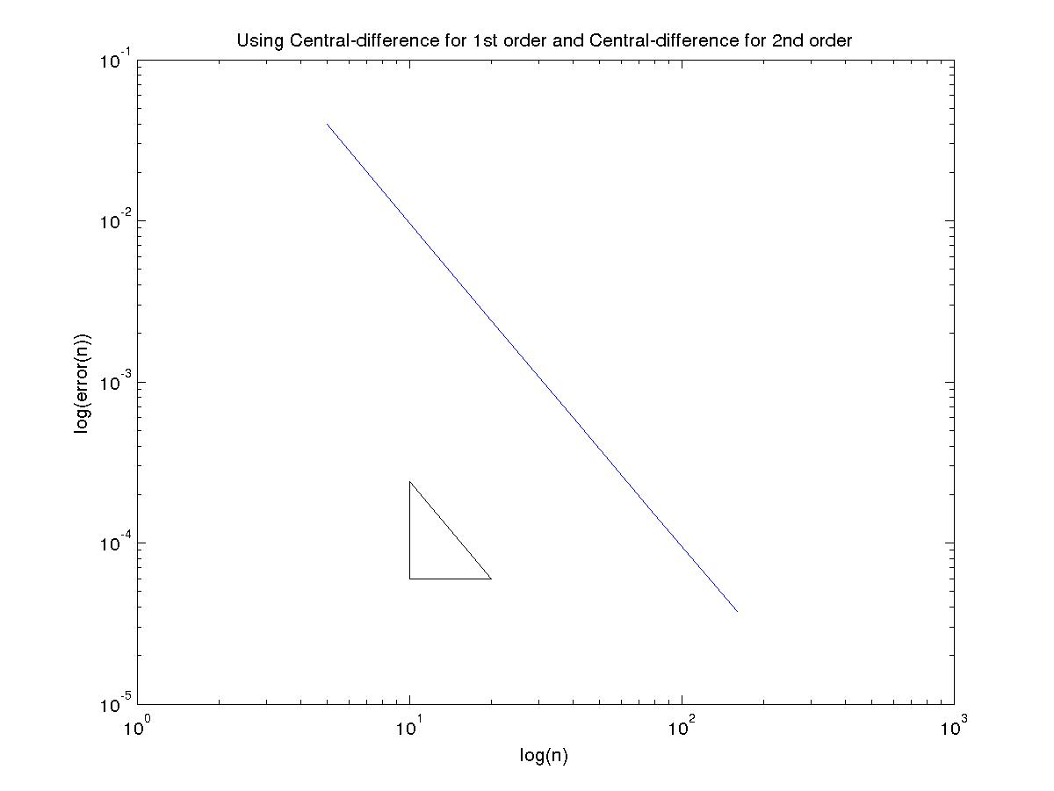
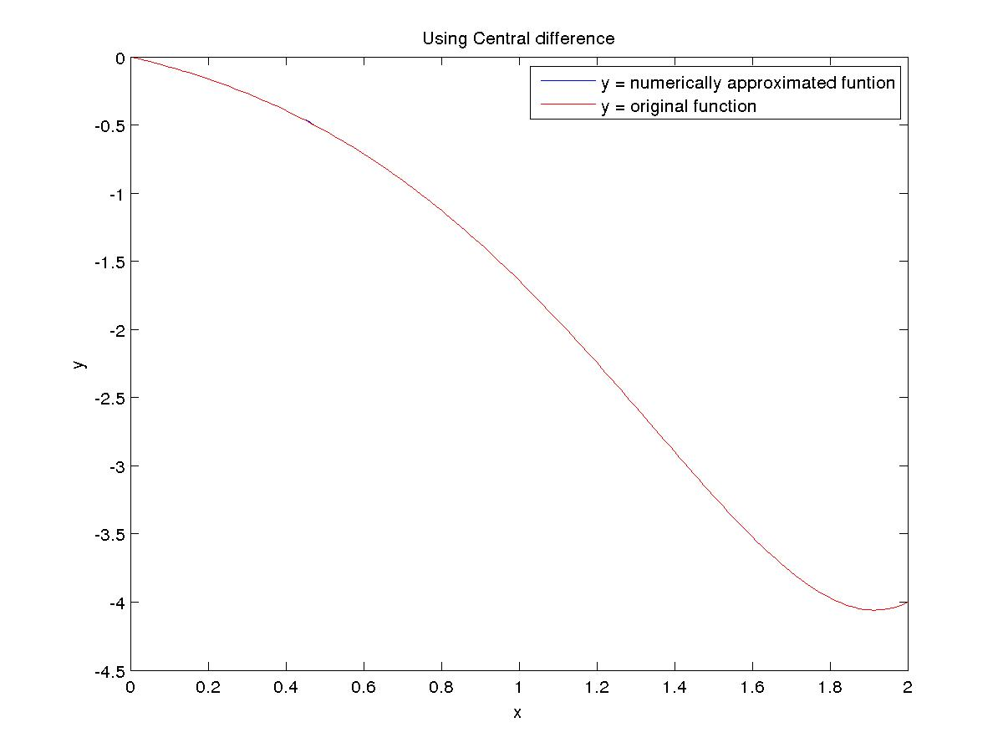

(C) Neumann Boundary Condition
Using Forward-difference for 1st order and Central-difference for 2nd order

N Error Order
5 3.351828e-02 1.193300
10 1.465759e-02 1.092254
20 6.874822e-03 1.044981
40 3.331893e-03 1.022199
80 1.640508e-03 1.011026

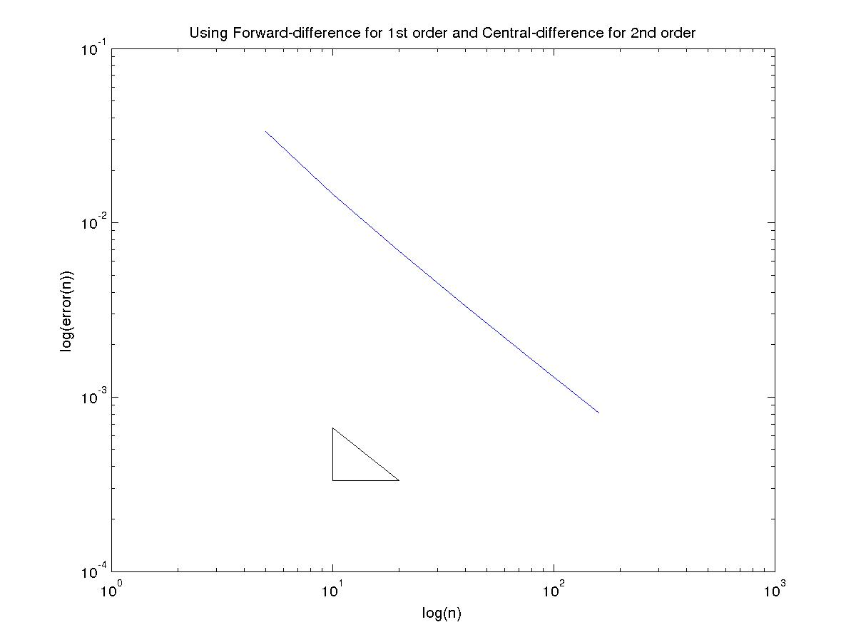

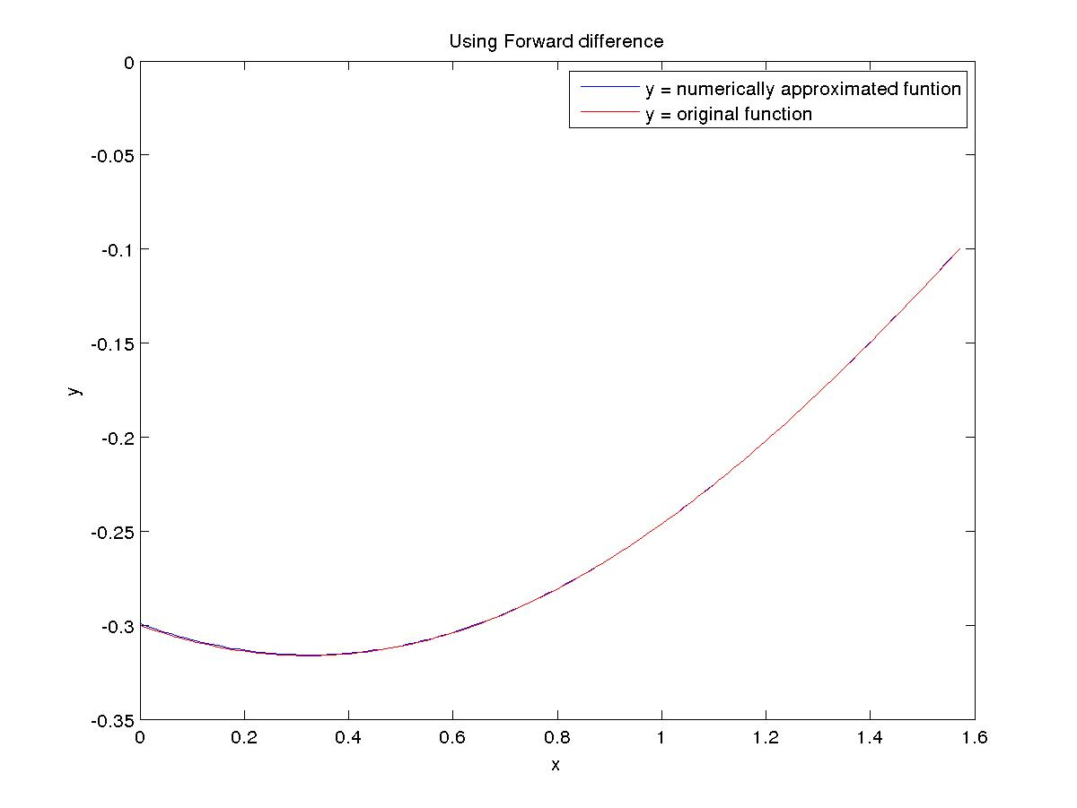

Using Backward-difference for 1st order and Central-difference for 2nd order

N Error Order
5 8.720979e-02 1.148002
10 3.935338e-02 1.068462
20 1.876476e-02 1.033054
40 9.169861e-03 1.016253
80 4.533569e-03 1.008060

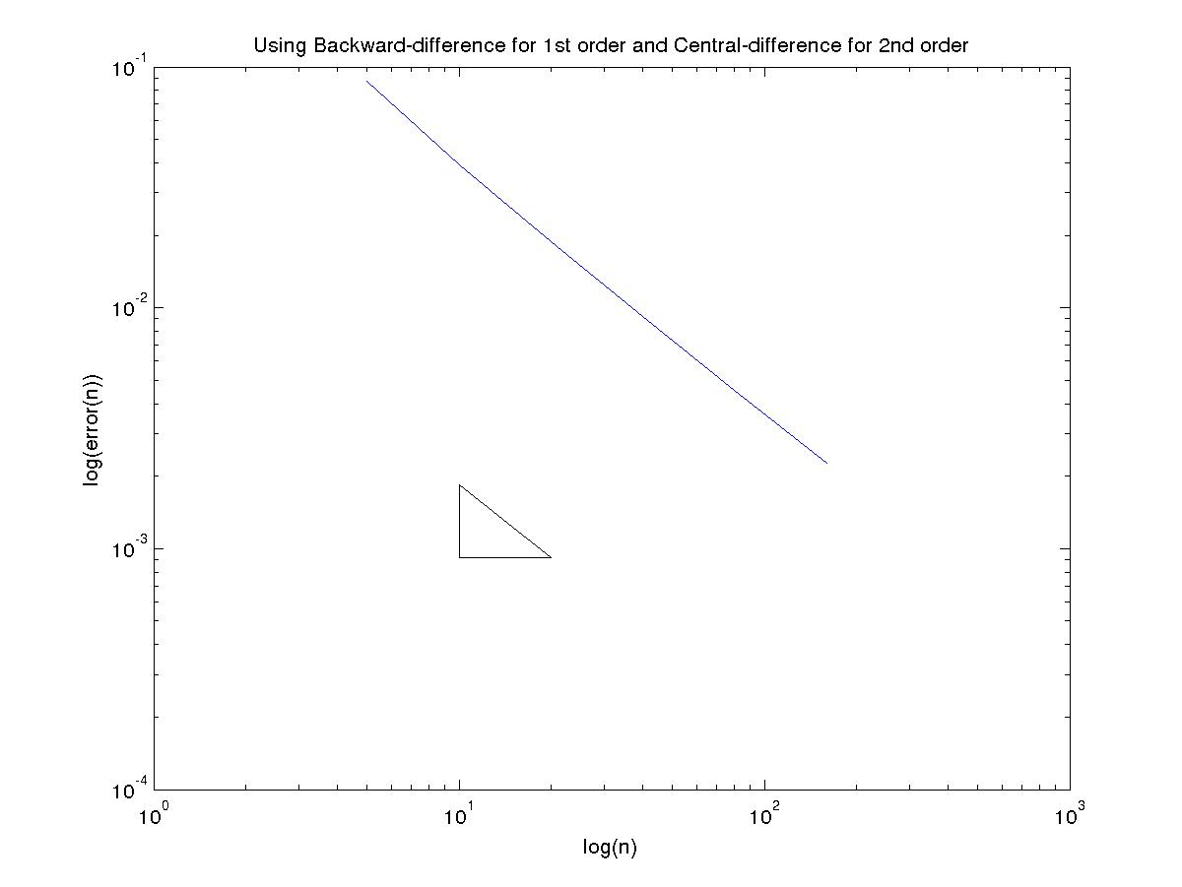
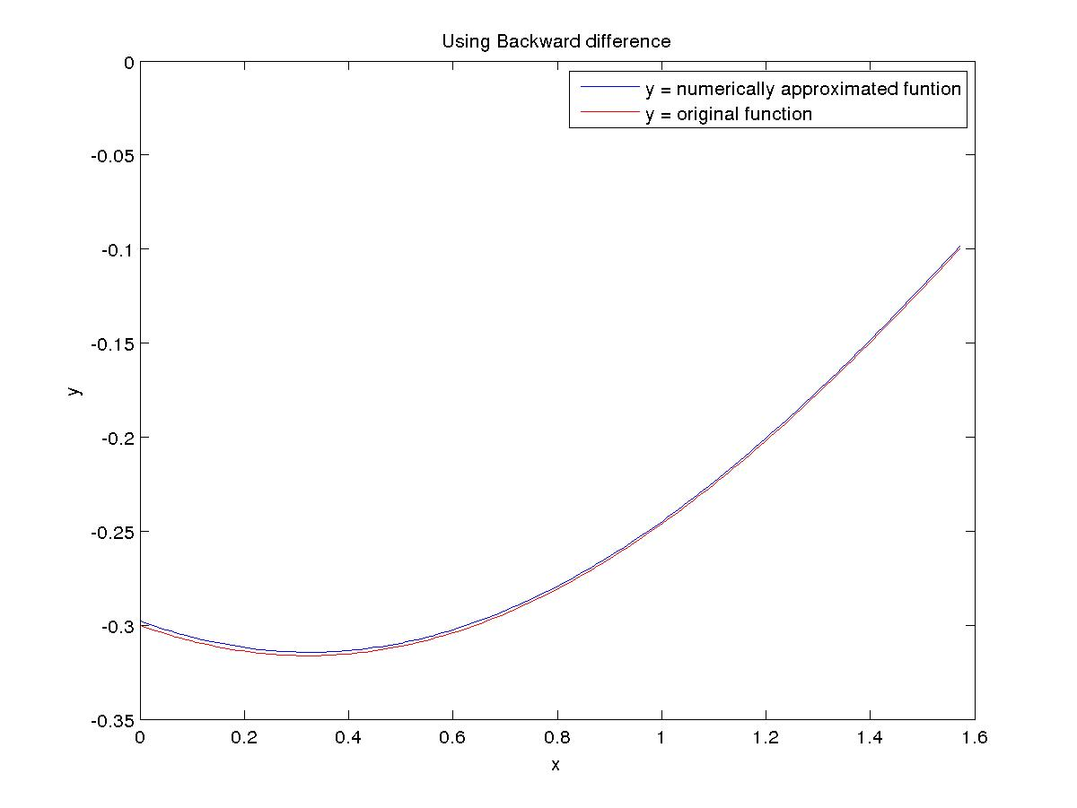

Using Central-difference for 1st order and Central-difference for 2nd order
The central difference method for Neumann and Robin boundary condition gives order 1 accuracy because of the usage of forward and backward difference at the boundary points.

N Error Order
5 6.056224e-02 1.162066
10 2.706358e-02 1.076308
20 1.283466e-02 1.037056
40 6.254597e-03 1.018260
80 3.087967e-03 1.009063

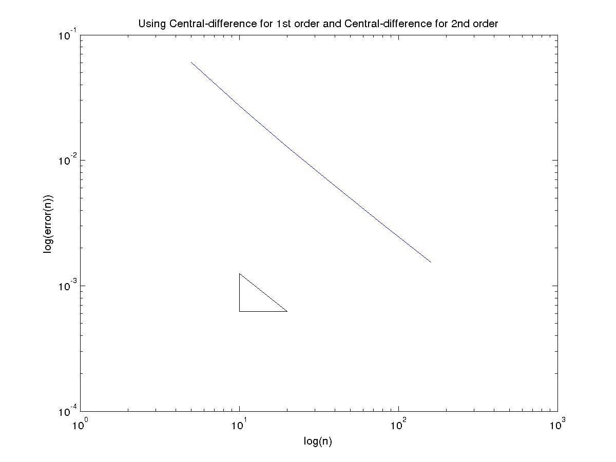

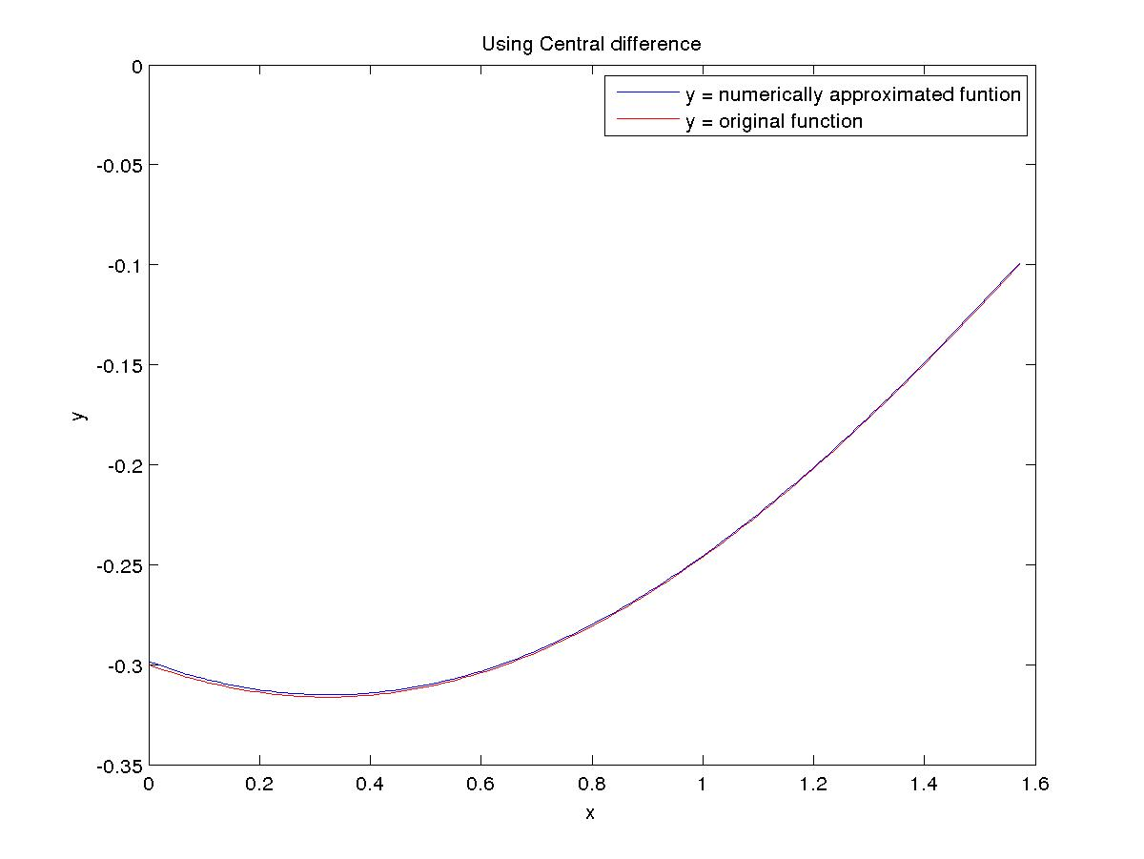

(D) Neumann Boundary Condition
Using Forward-difference for 1st order and Central-difference for 2nd order

N Error Order
5 4.153664e-01 1.138559
10 1.886649e-01 1.062141
20 9.035553e-02 1.029541
40 4.426209e-02 1.014416
80 2.191100e-02 1.007123

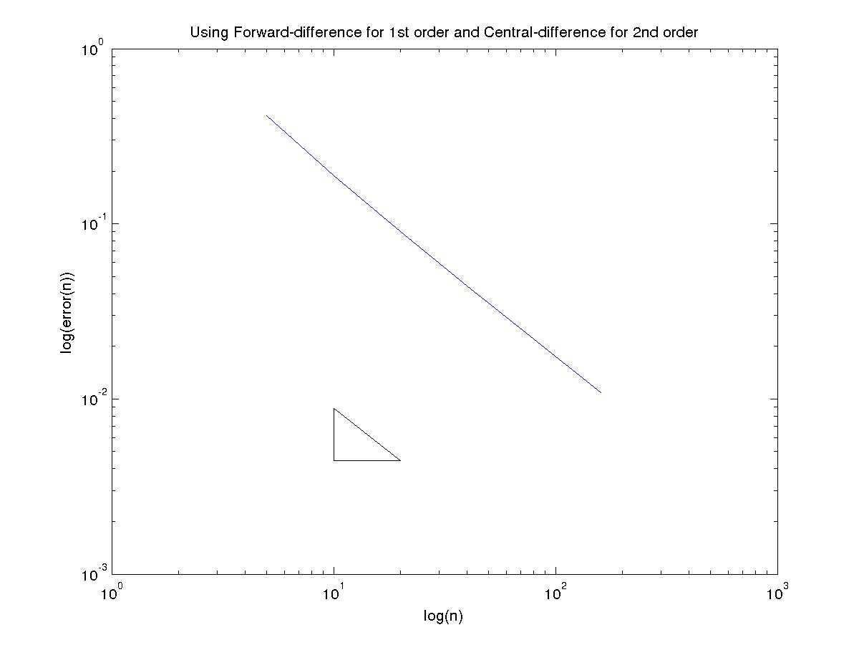
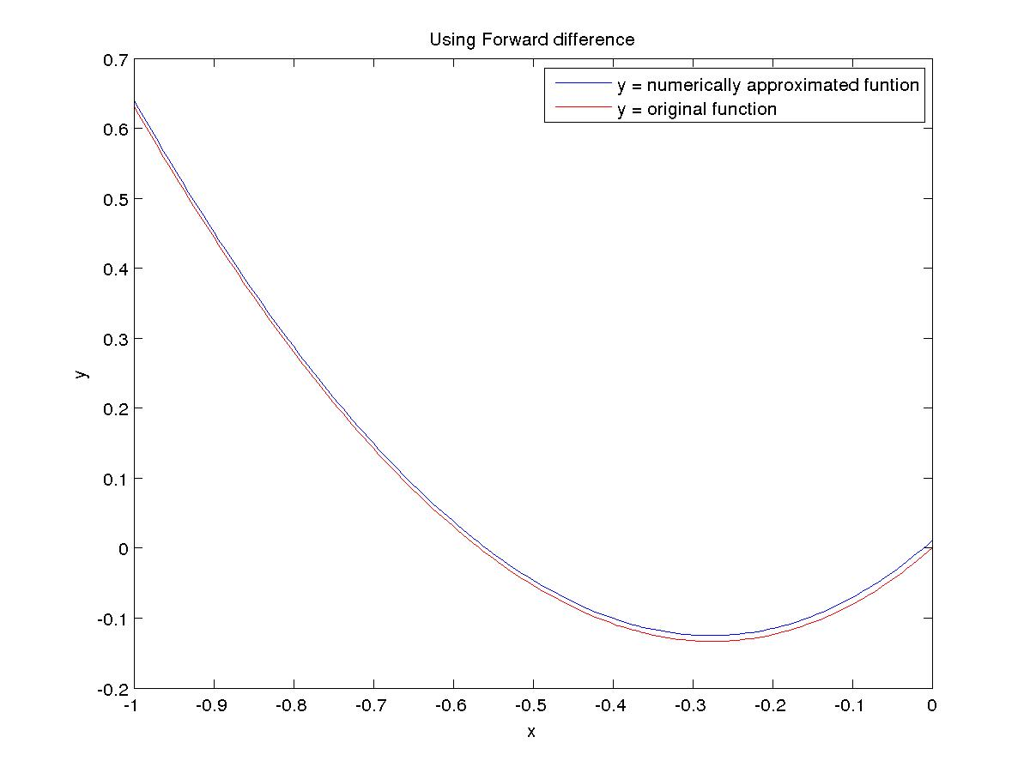

Using Backward-difference for 1st order and Central-difference for 2nd order

N Error Order
5 5.888132e-01 1.164144
10 2.627456e-01 1.075494
20 1.246750e-01 1.036317
40 6.078788e-02 1.017823
80 3.002075e-02 1.008831

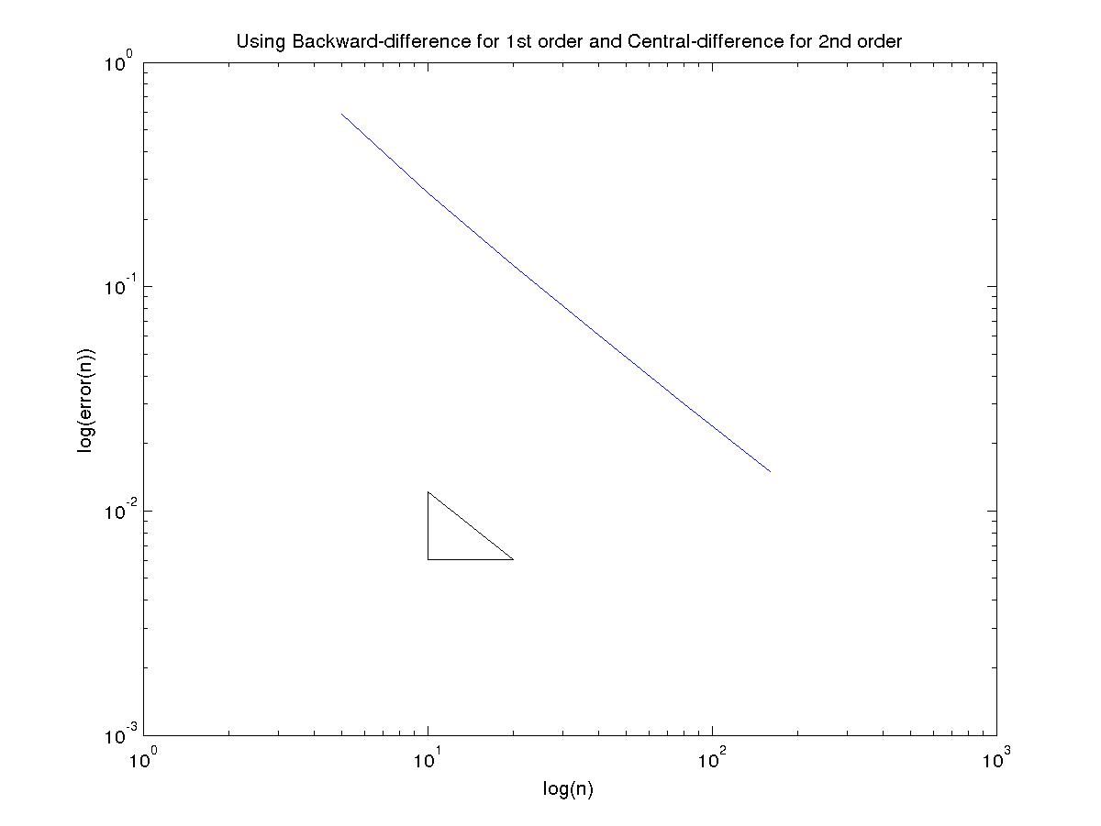

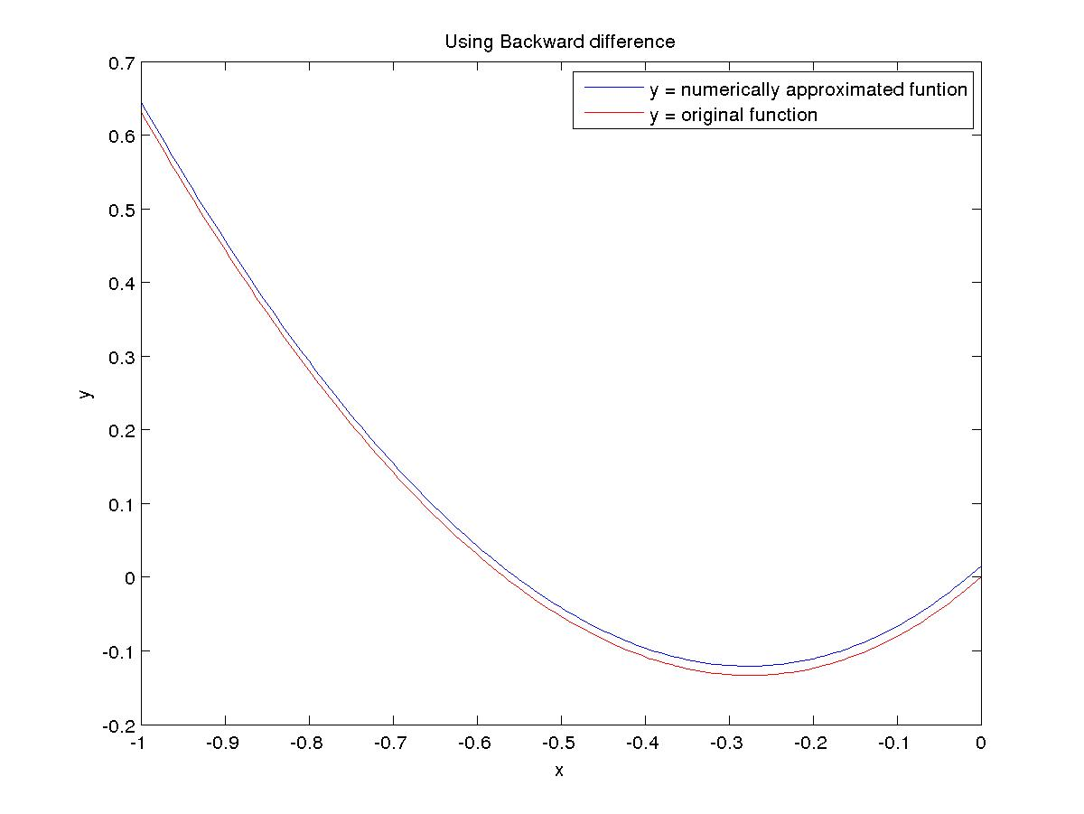

Using Central-difference for 1st order and Central-difference for 2nd order
The central difference method for Neumann and Robin boundary condition gives order 1 accuracy because of the usage of forward and backward difference at the boundary points.

N Error Order
5 5.026561e-01 1.154100
10 2.258667e-01 1.070364
20 1.075575e-01 1.033737
40 5.253572e-02 1.016531
80 2.596858e-02 1.008184

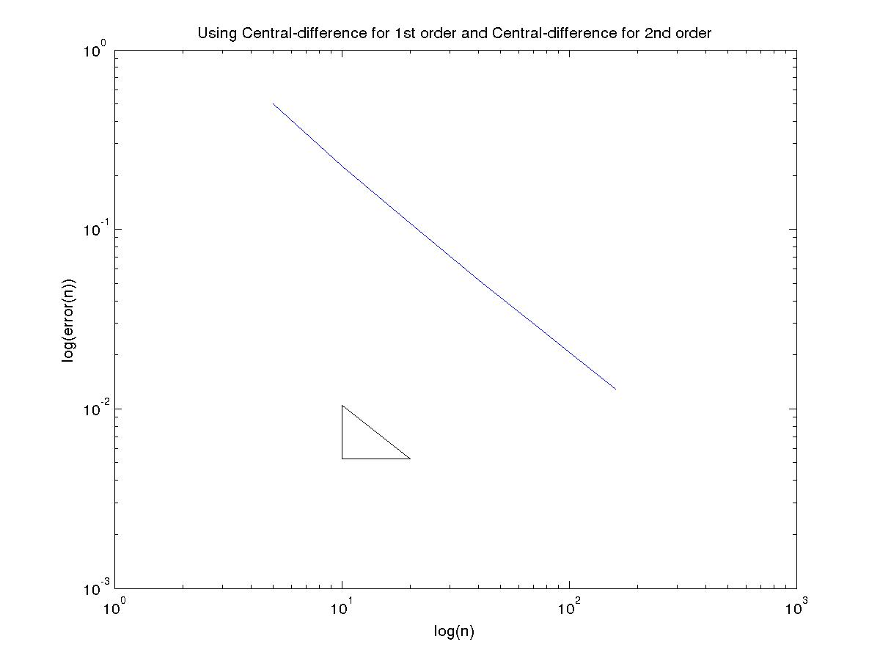
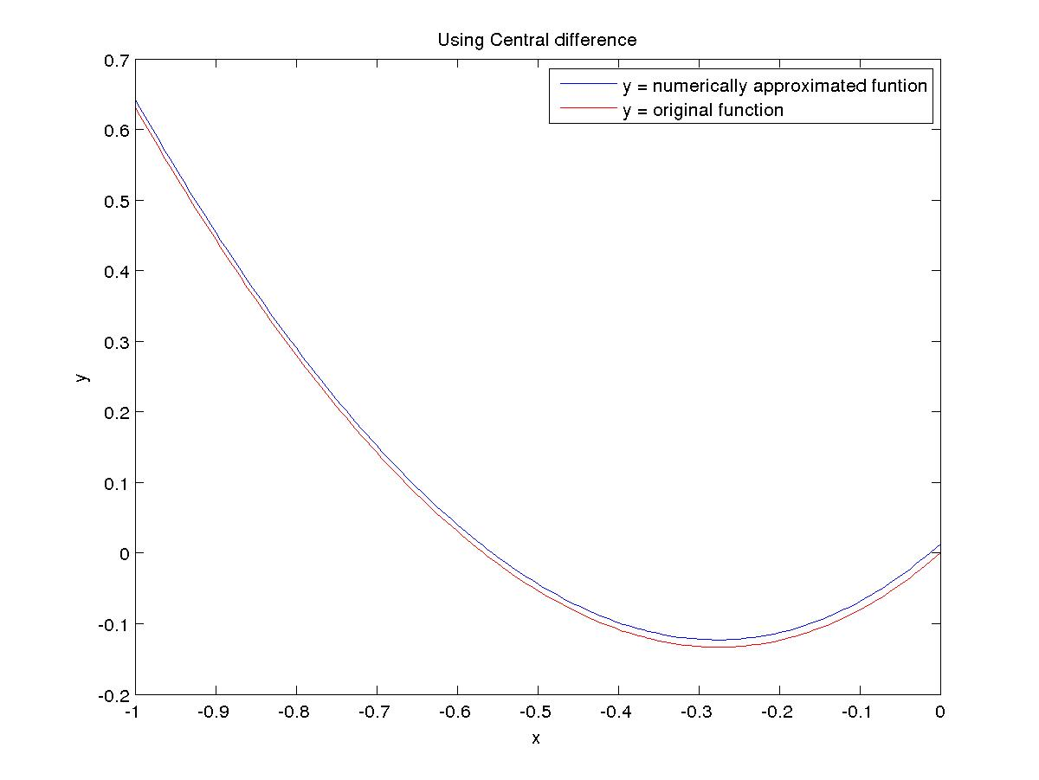
(E) Robin Boundary Condition
Using Forward-difference for 1st order and Central-difference for 2nd order

N Error Order
5 1.512438e-01 0.799801
10 8.687873e-02 0.892967
20 4.678469e-02 0.945379
40 2.429496e-02 0.972441
80 1.238176e-02 0.986163
160 6.250544e-03 0.993068

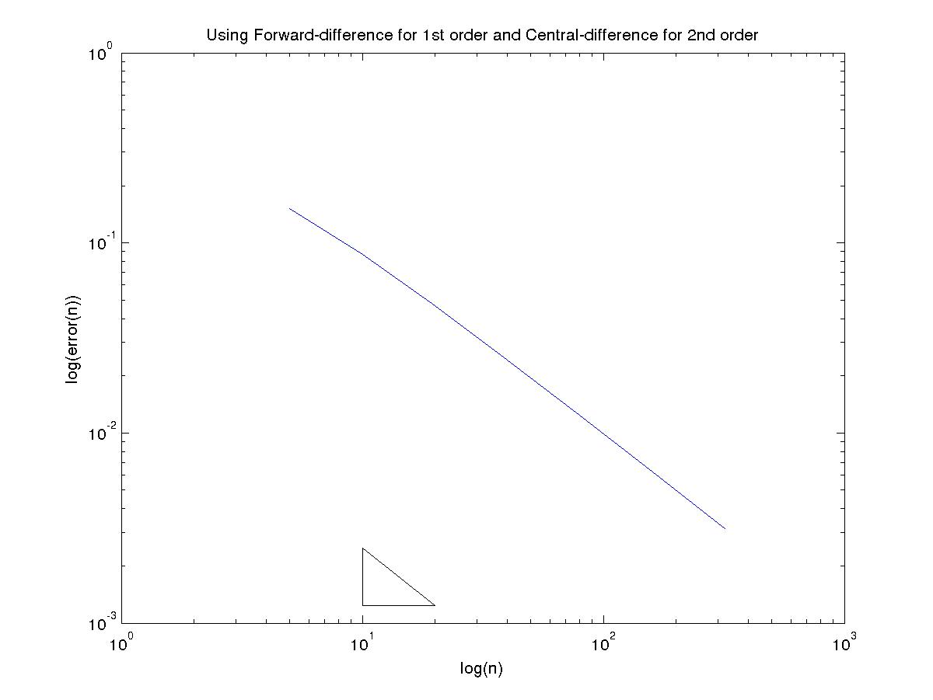

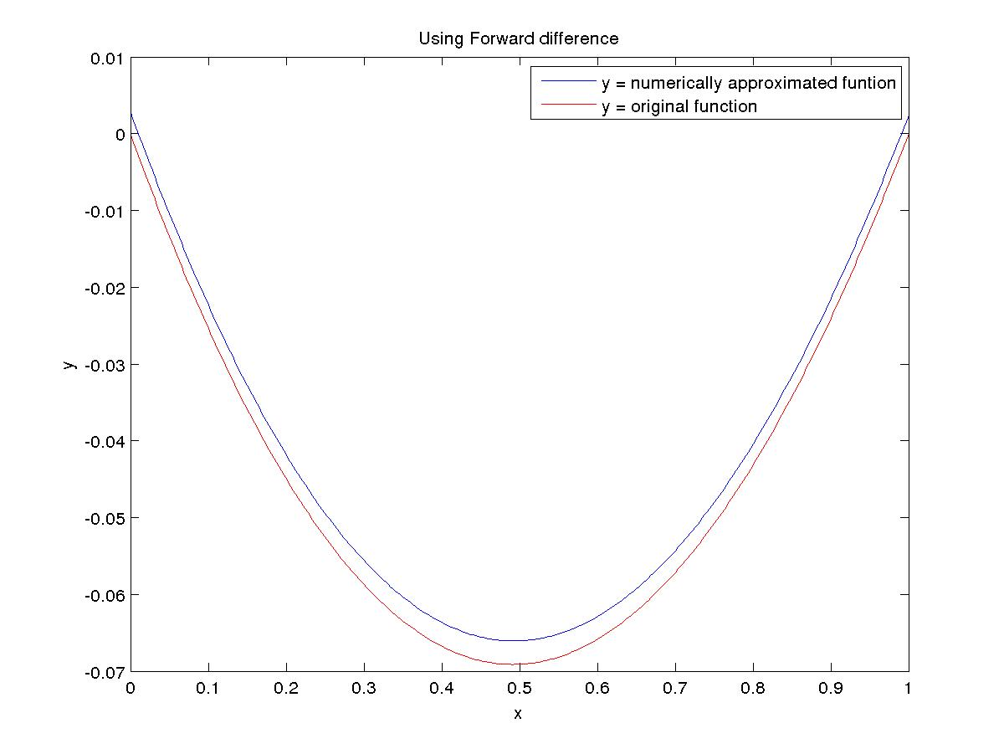

Using Backward-difference for 1st order and Central-difference for 2nd order

N Error Order
5 1.635202e-02 1.536949
10 5.635129e-03 1.222959
20 2.414107e-03 1.107945
40 1.120036e-03 1.052669
80 5.399418e-04 0.986022
160 2.725993e-04 0.992948

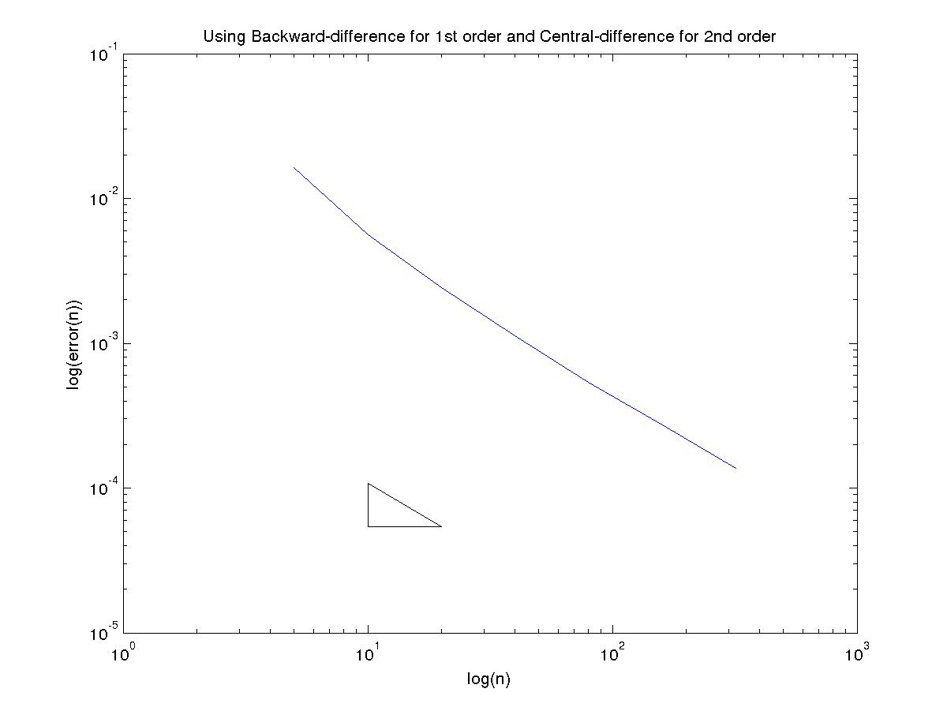
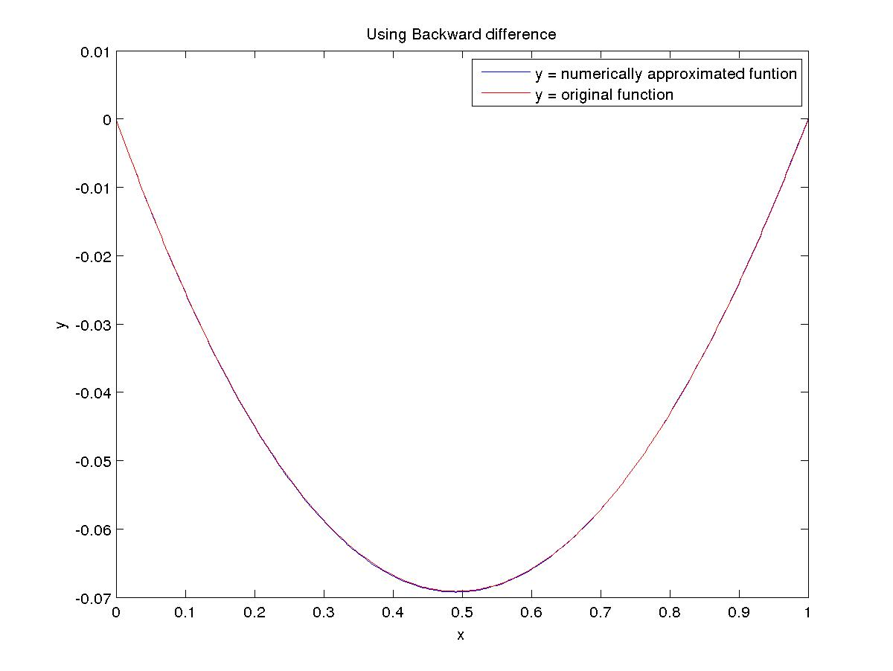

Using Central-difference for 1st order and Central-difference for 2nd order
The central difference method for Neumann and Robin boundary condition gives order 1 accuracy because of the usage of forward and backward difference at the boundary points.

N Error Order
5 8.909580e-02 0.939644
10 4.645111e-02 0.970397
20 2.370705e-02 0.984977
40 1.197760e-02 0.992274
80 6.020960e-03 0.996155
160 3.018515e-03 0.998077

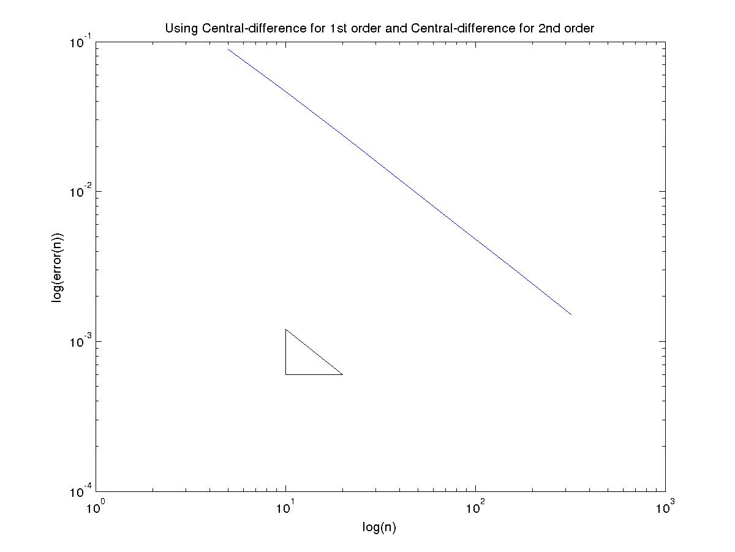

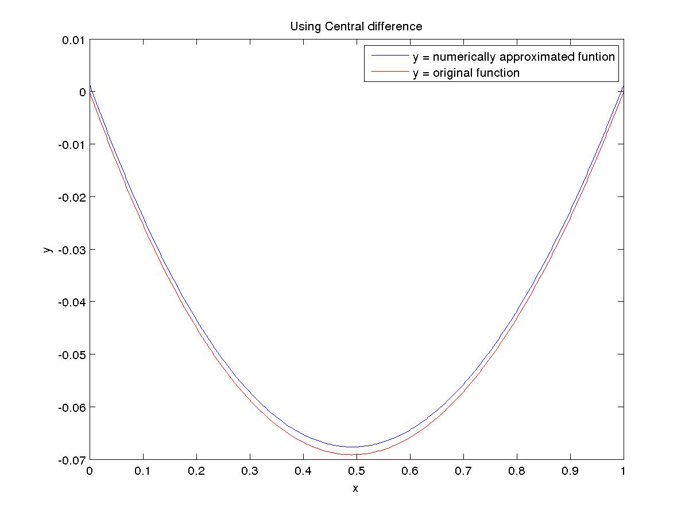

(F) Robin Boundary Condition

Using Forward-difference for 1st order and Central-difference for 2nd order

N Error Order
5 1.653826e-01 0.853243
10 9.154576e-02 0.920826
20 4.835507e-02 0.958658
40 2.488040e-02 0.979068
80 1.262201e-02 0.989410
160 6.357503e-03 0.994680

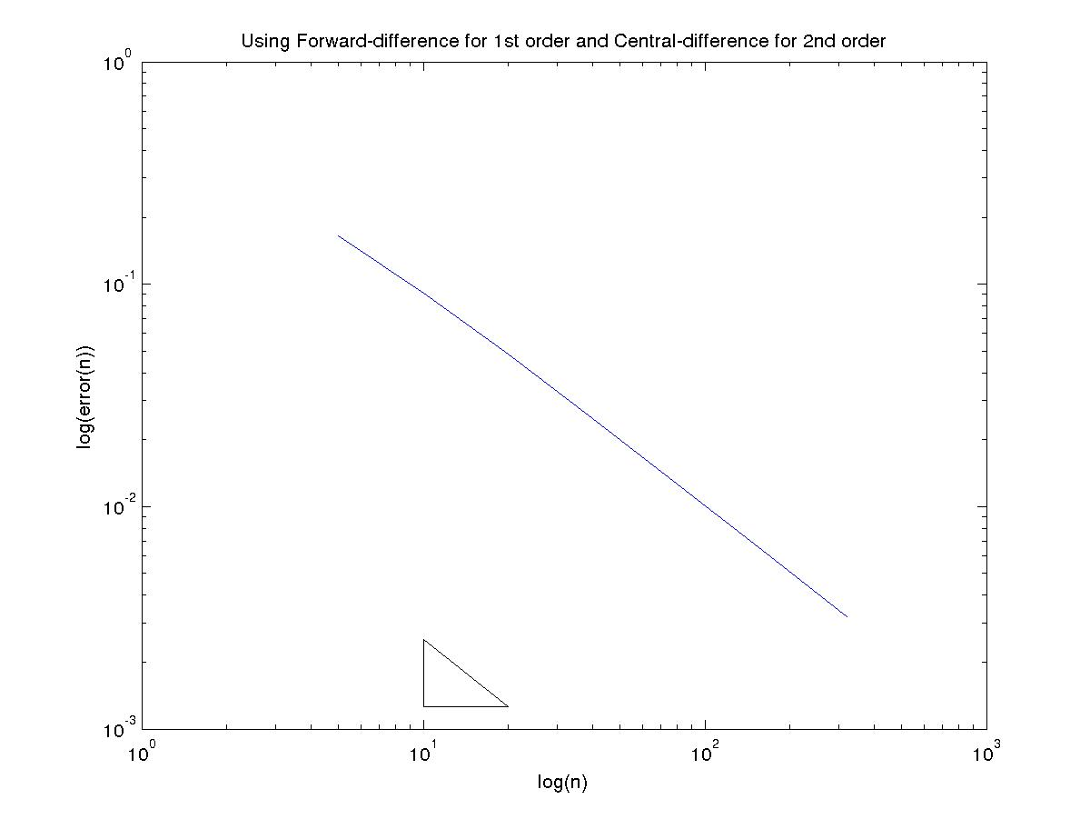
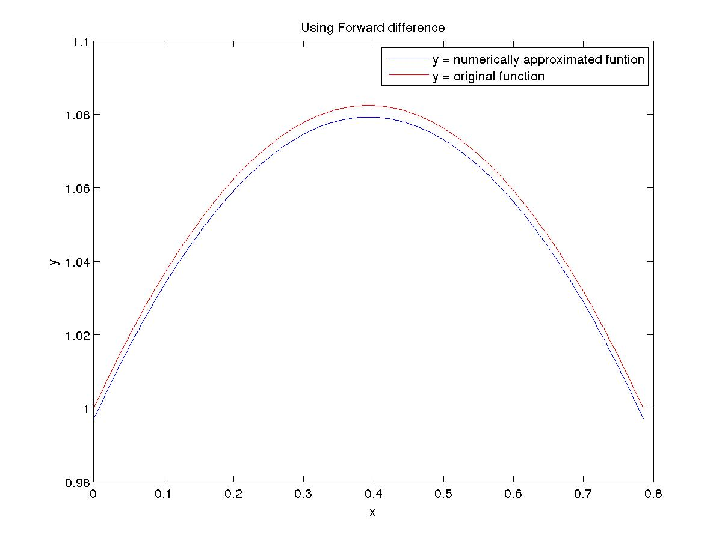

Using Backward-difference for 1st order and Central-difference for 2nd order

N Error Order
5 8.194698e-02 0.994129
10 4.114057e-02 0.996646
20 2.061816e-02 0.998275
40 1.032141e-02 0.999112
80 5.163885e-03 0.999554
160 2.582741e-03 0.999775

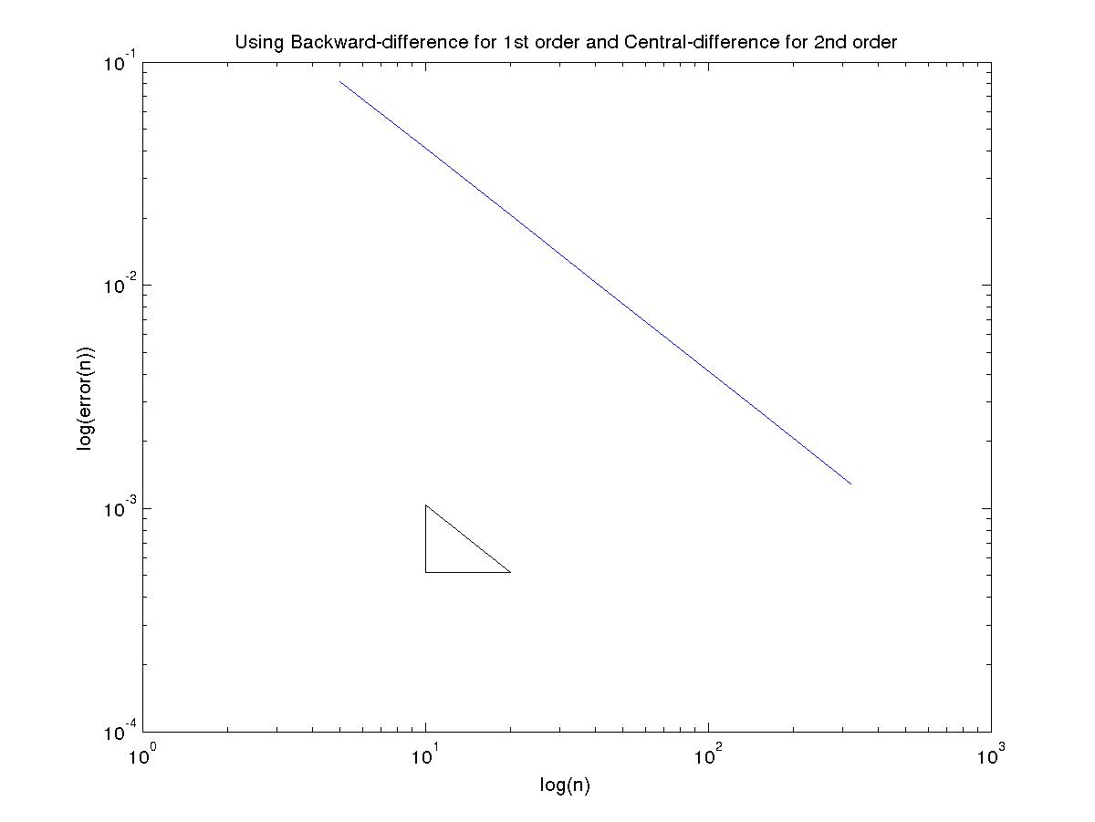

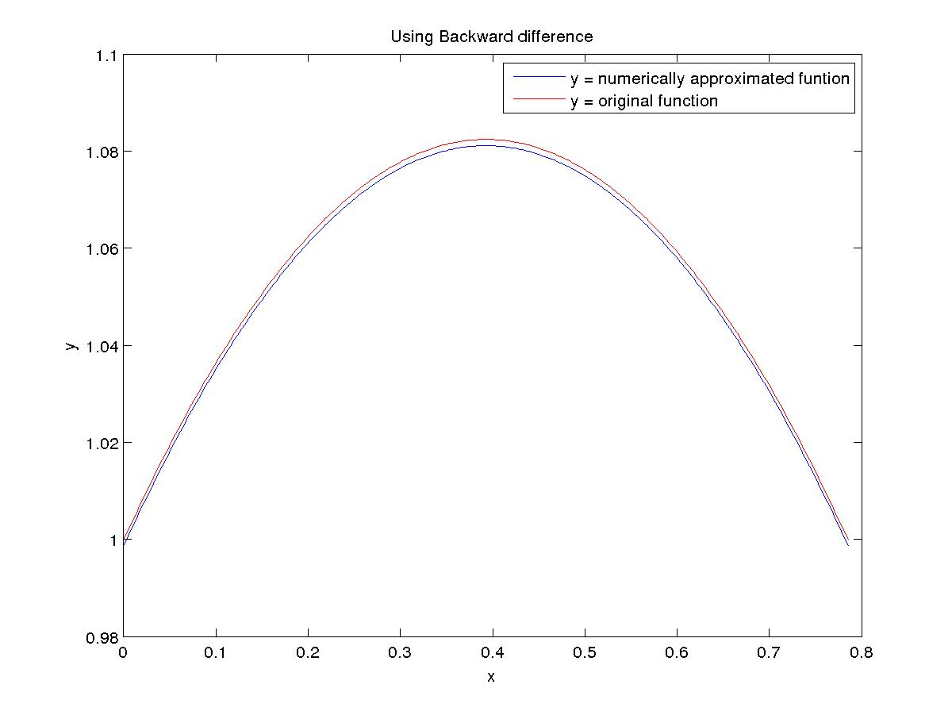

Using Central-difference for 1st order and Central-difference for 2nd order
The central difference method for Neumann and Robin boundary condition gives order 1 accuracy because of the usage of forward and backward difference at the boundary points.

N Error Order
5 1.282023e-01 0.920306
10 6.774171e-02 0.958090
20 3.486922e-02 0.978727
40 1.769359e-02 0.989295
80 8.912681e-03 0.994617
160 4.472999e-03 0.997298

