MA 322: Scientific Computing
LAB 9 Report
Abheek Ghosh - 140123047

NOTE: The right angled triangle is for comparison of the slope. It has been made with the hypotaneuse slope as expected for respective methods.

Question 1

(A) The function is of order 2 so there is no truncation error. The only error is roundoff, and it does not have a order 2 convergence.

N Error Order
3 3.346089e-16 -4.082370
6 5.668305e-15 -3.213053
12 5.256281e-14 -3.778065>

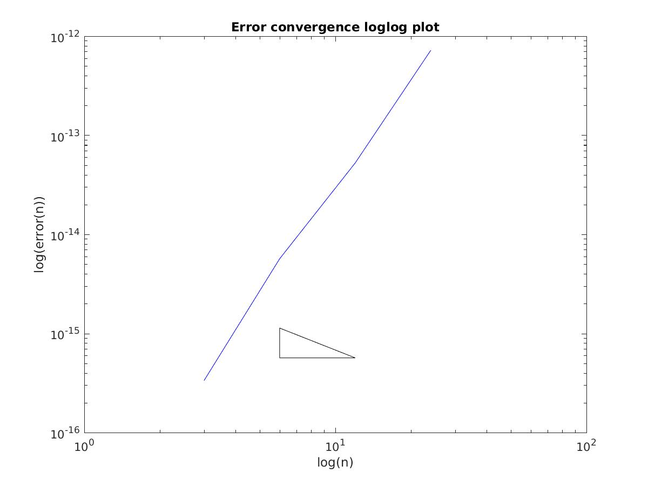

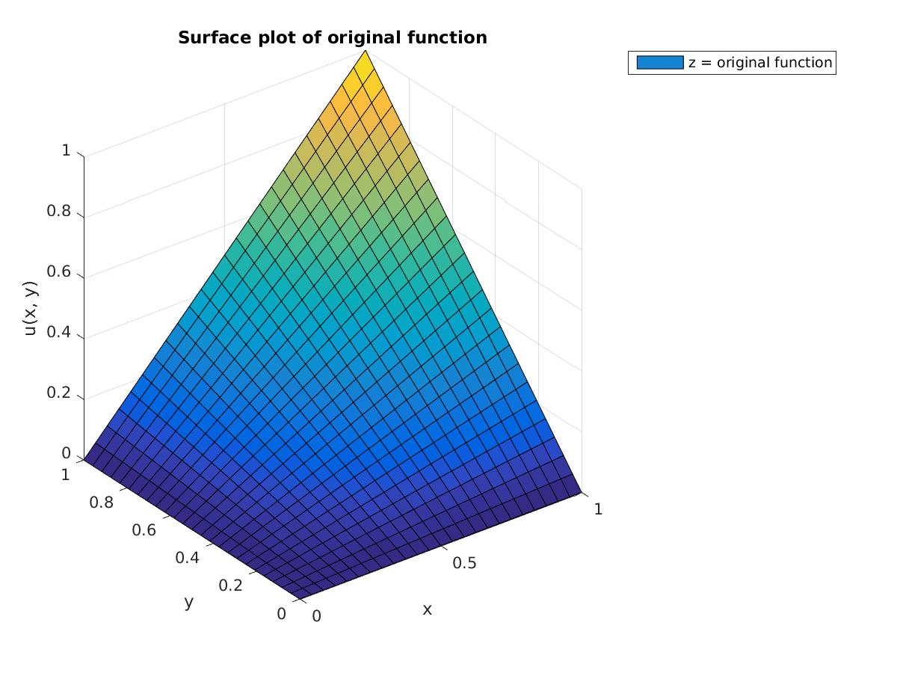
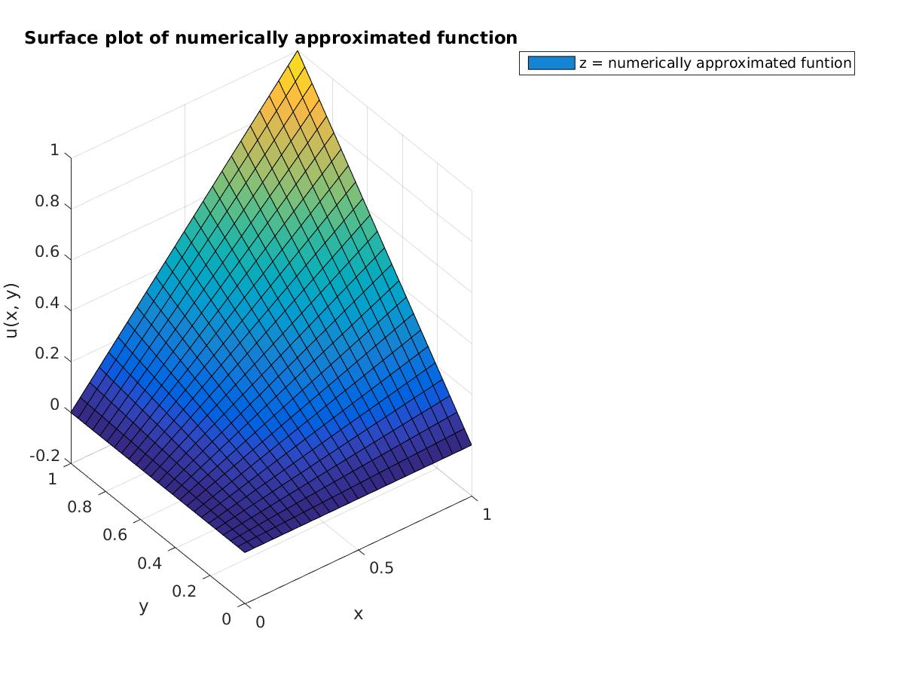
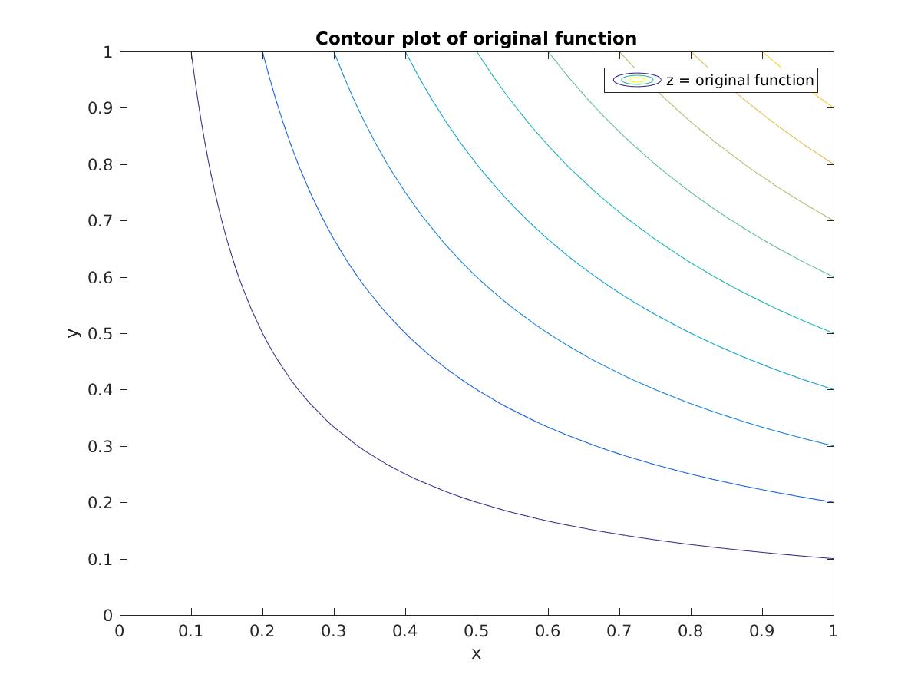
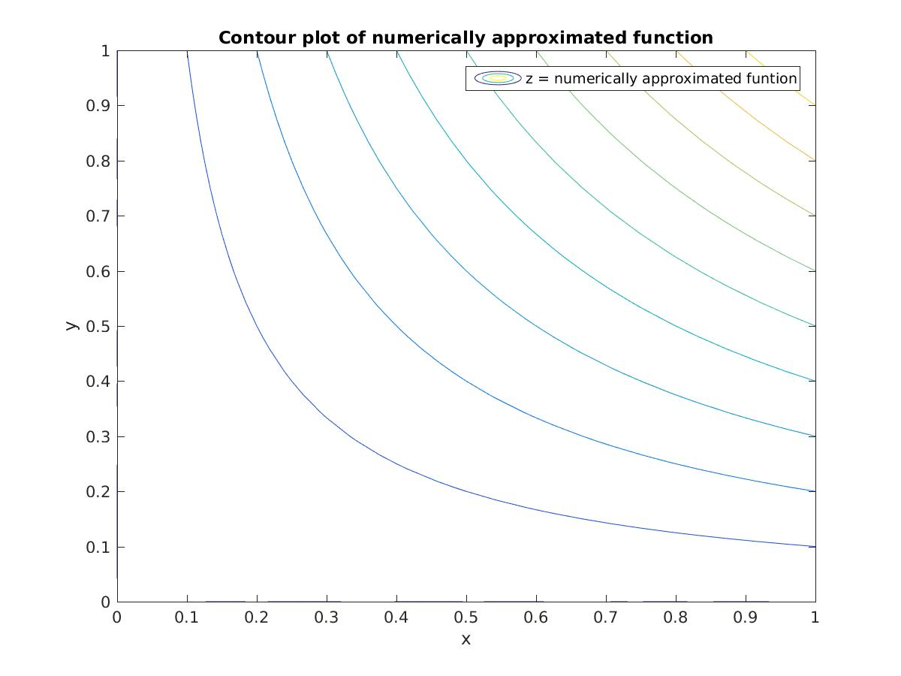
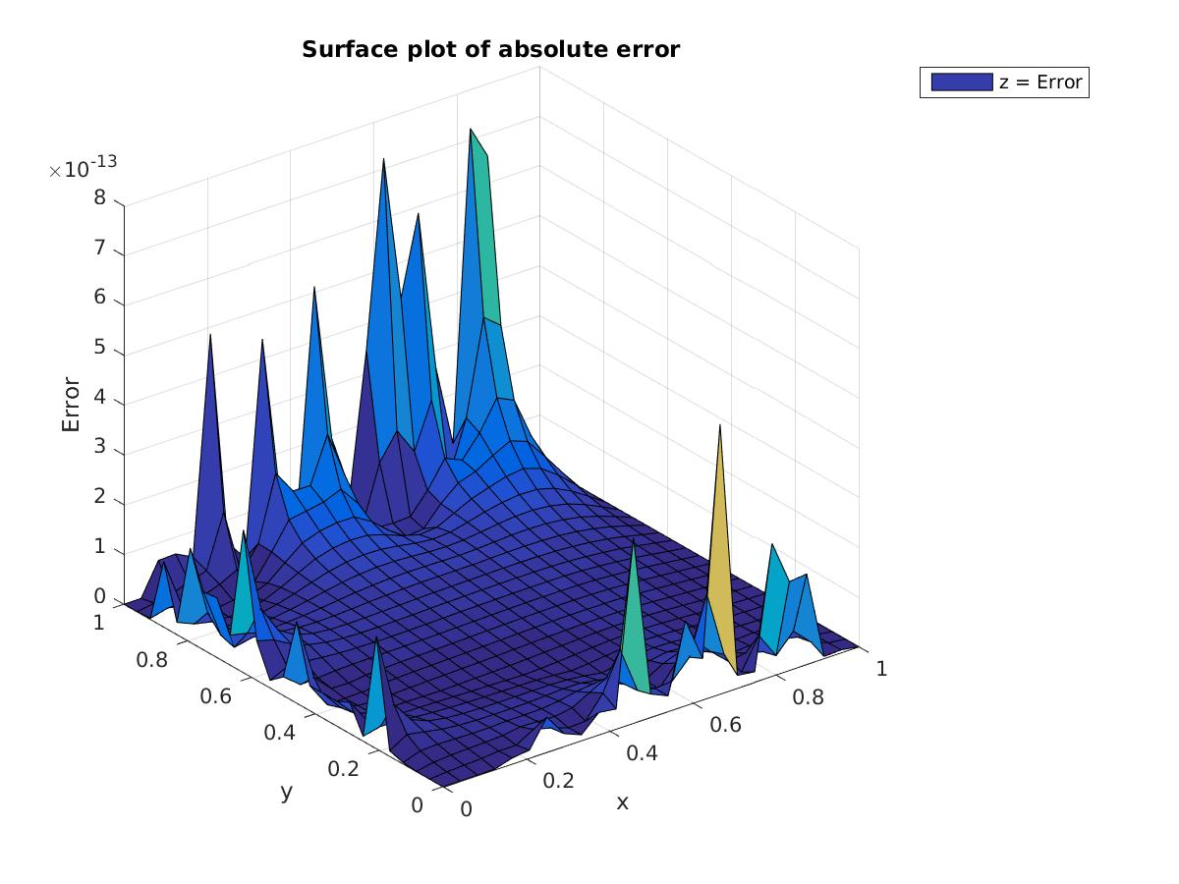
(B)

N Error Order
3 3.527119e-03 1.905469
6 9.414920e-04 1.917445
12 2.492345e-04 1.978597
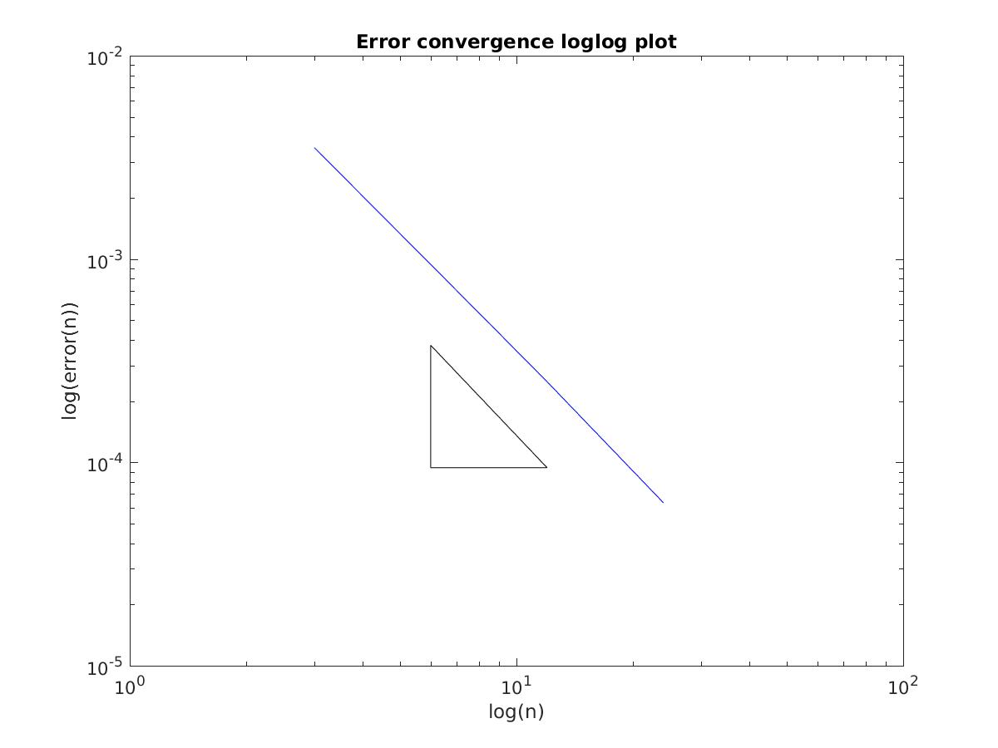
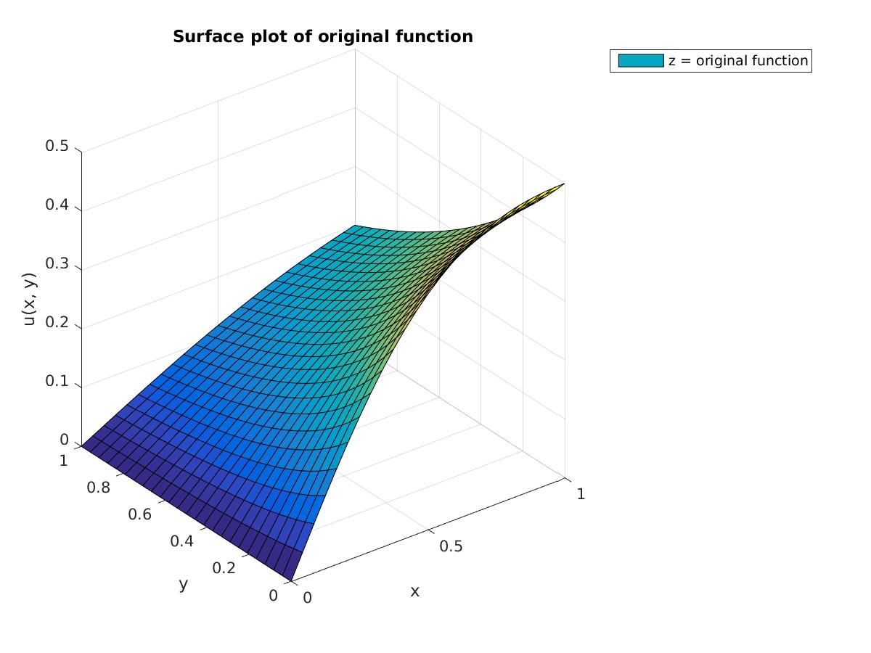
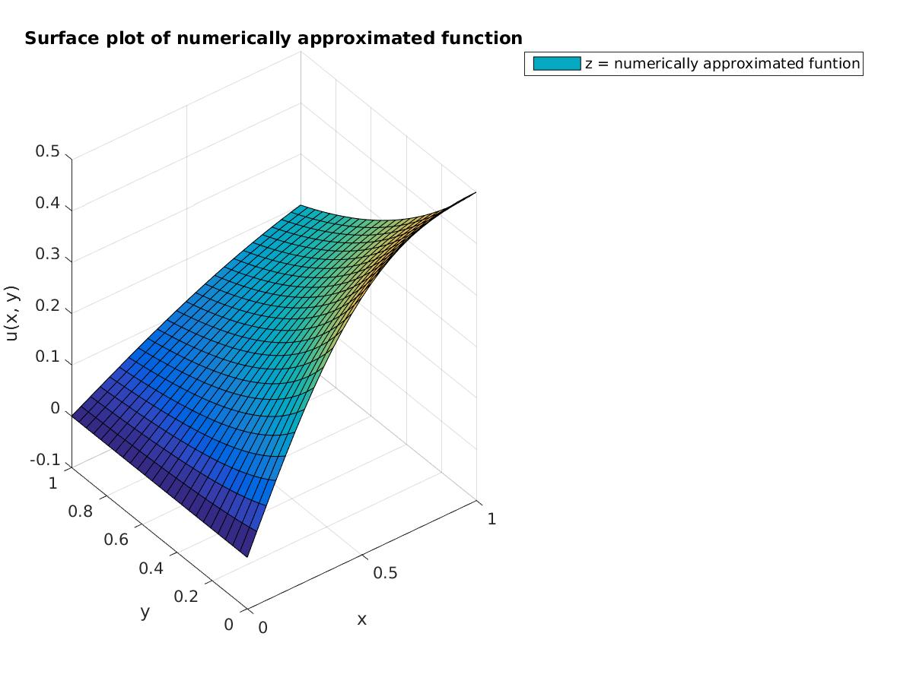
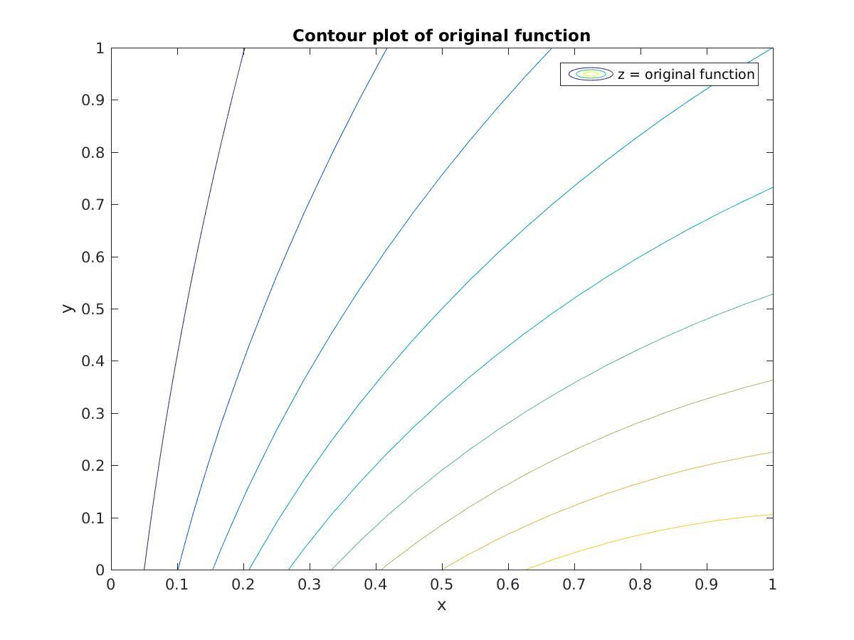
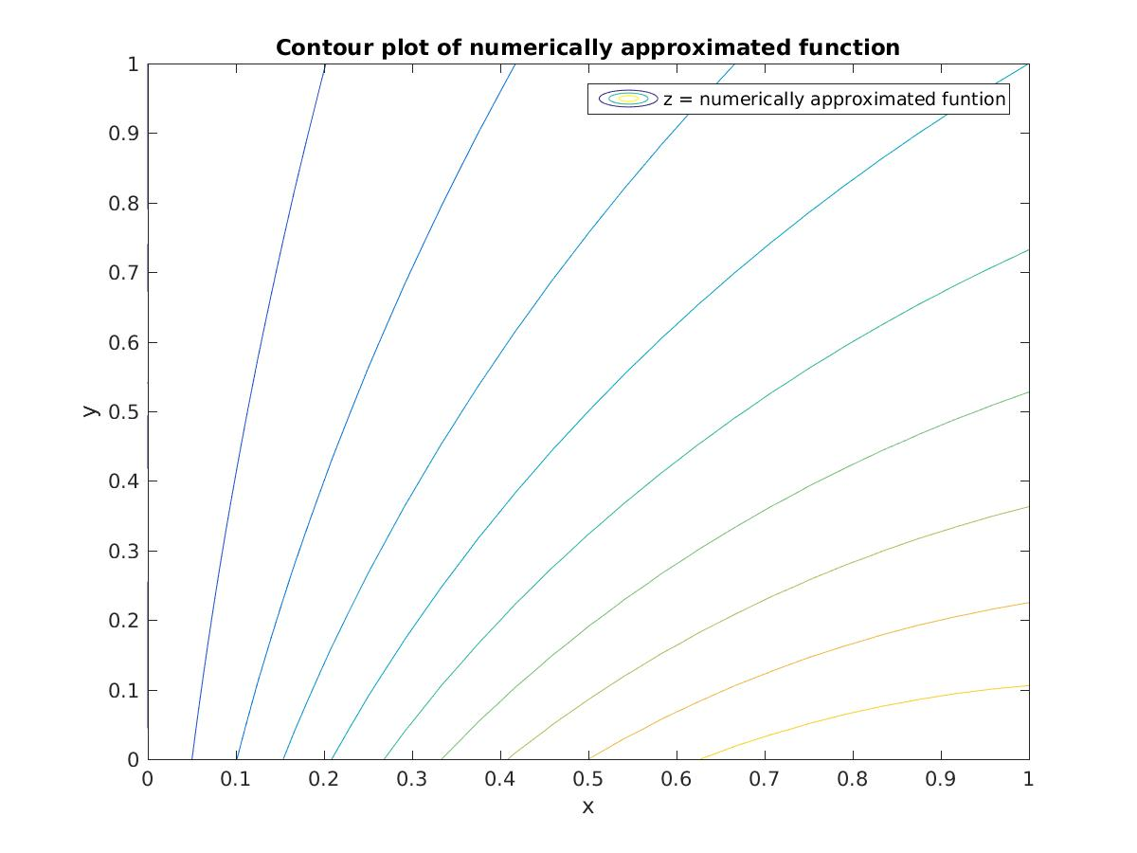
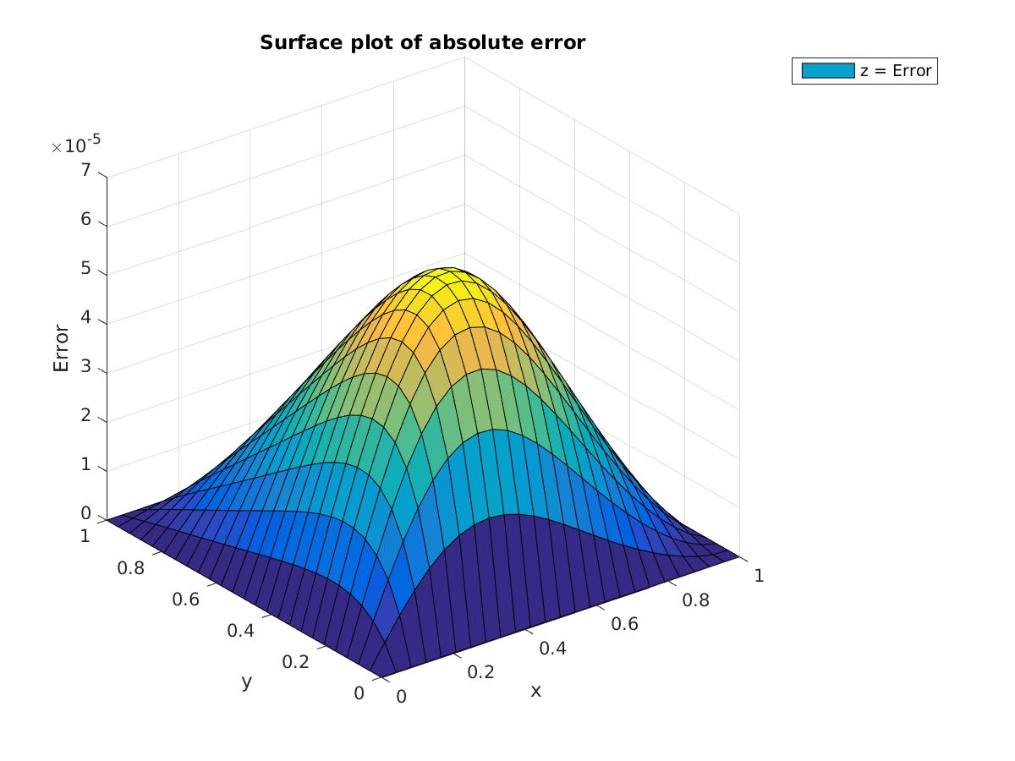

(C) (Original function not available)
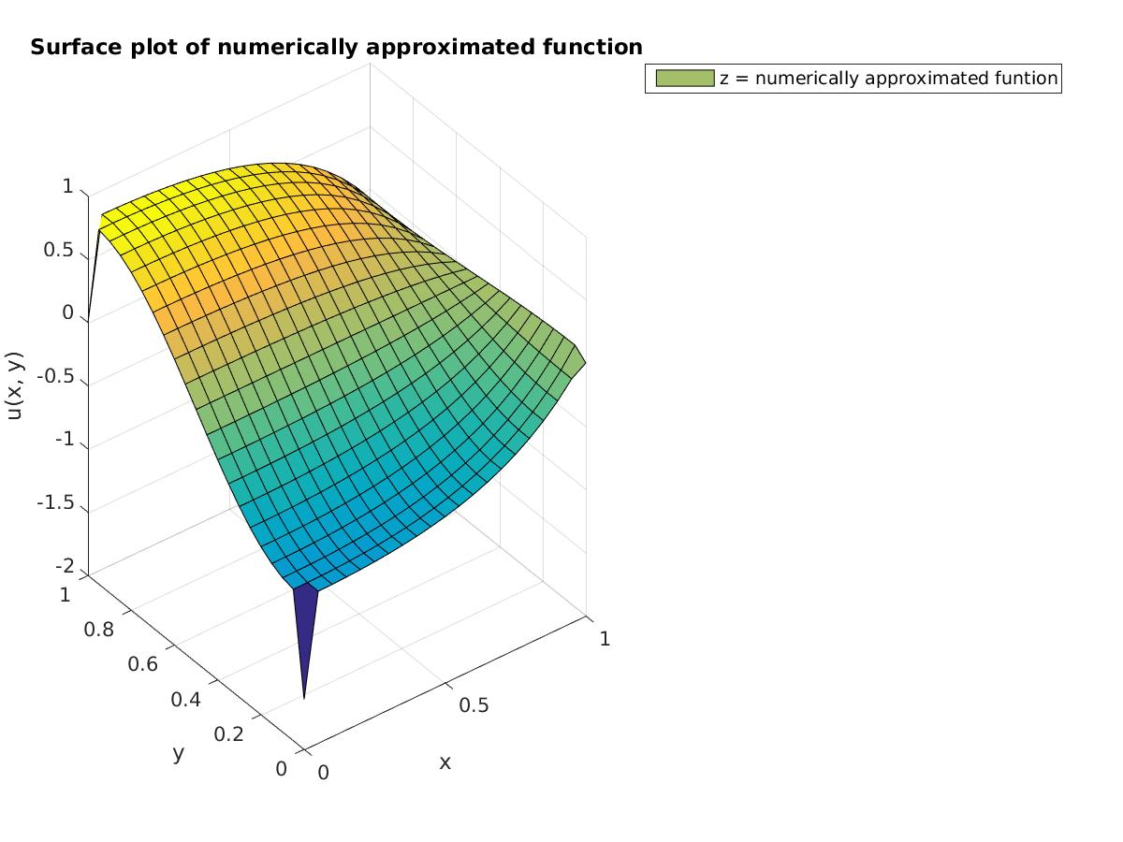
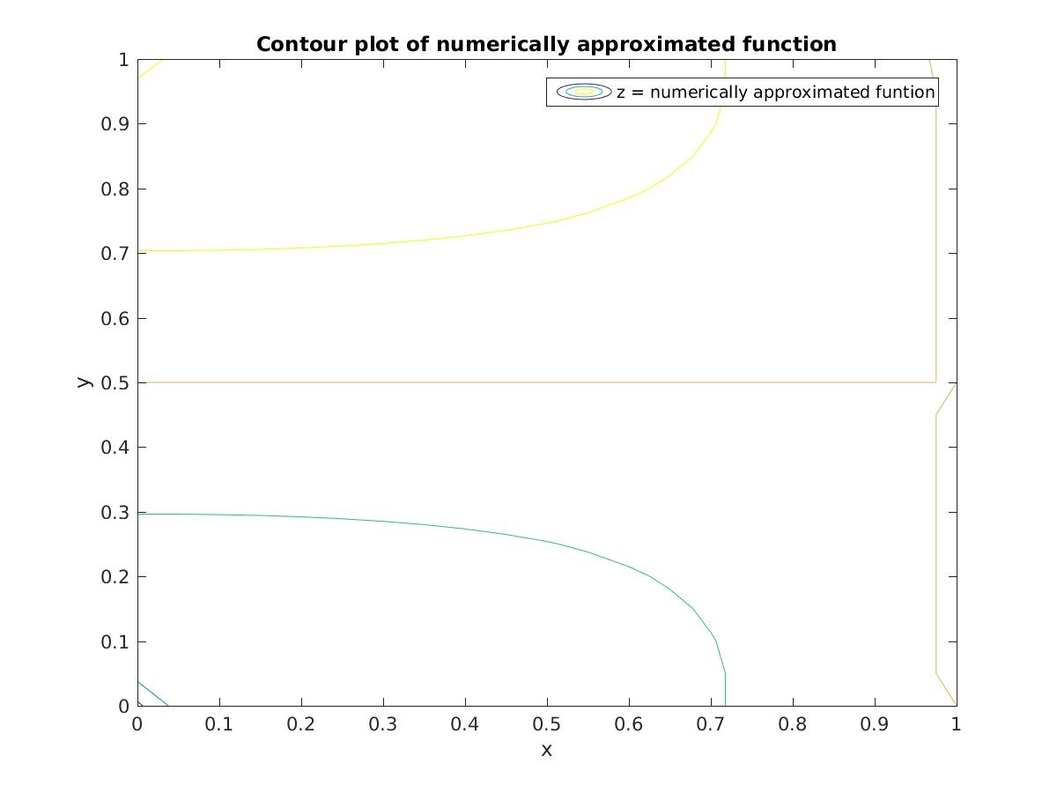

(D)

N Error Order
3 5.908305e-01 1.698461
6 1.820435e-01 1.973942
12 4.634037e-02 1.987778

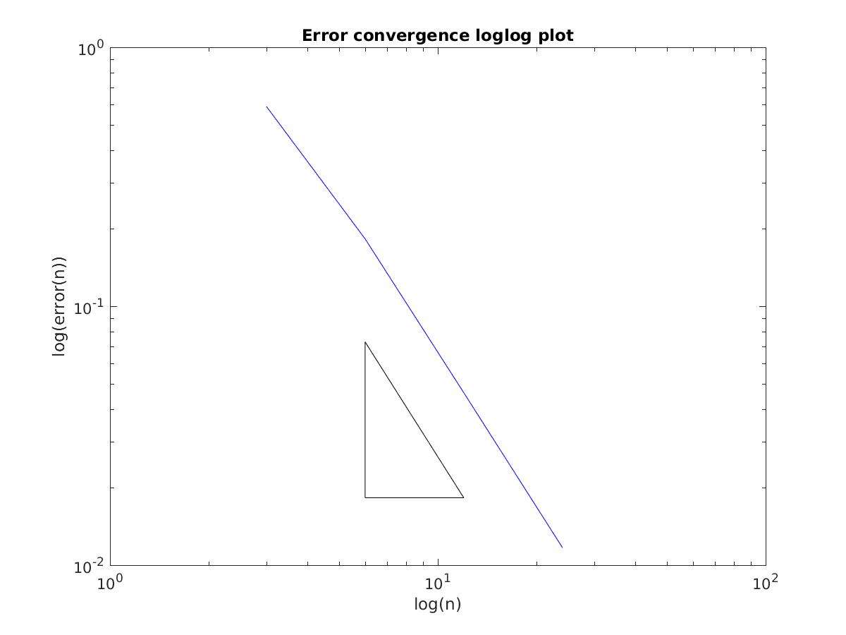

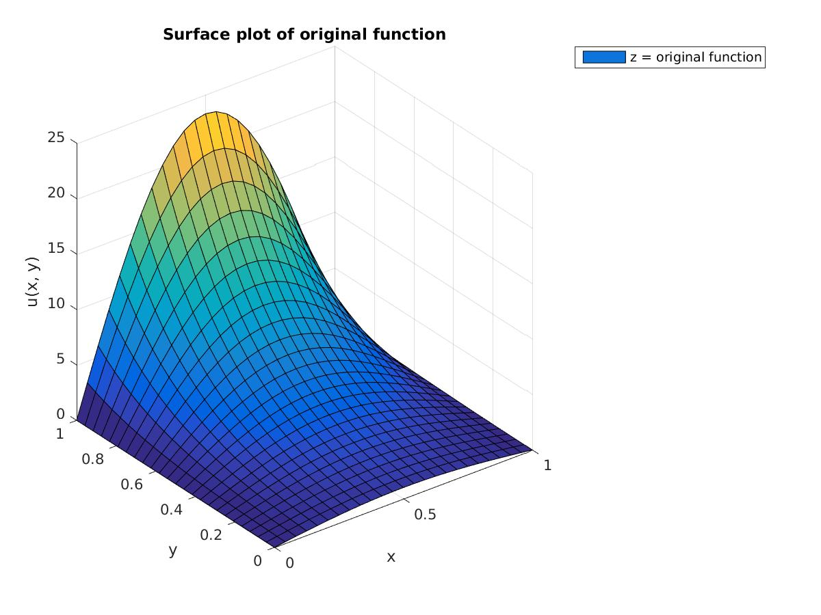
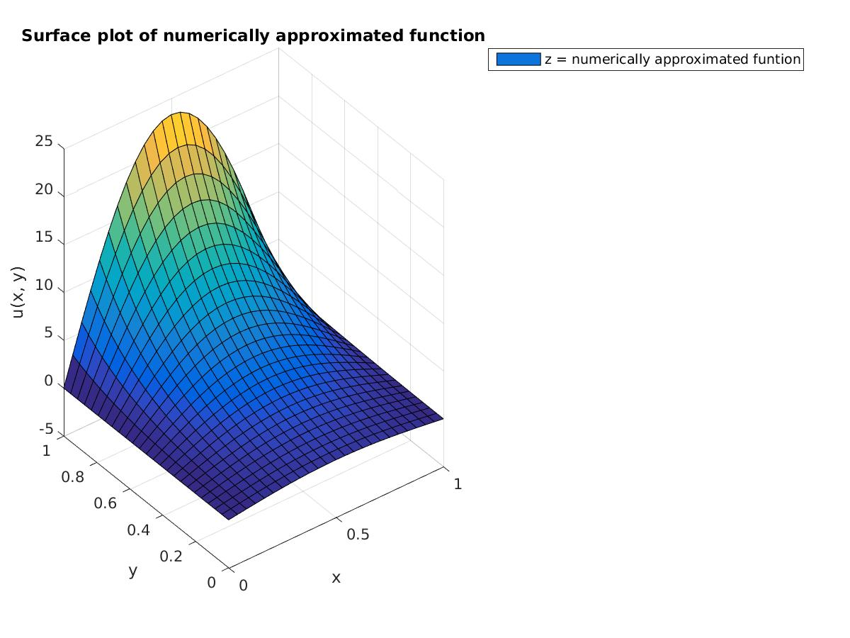
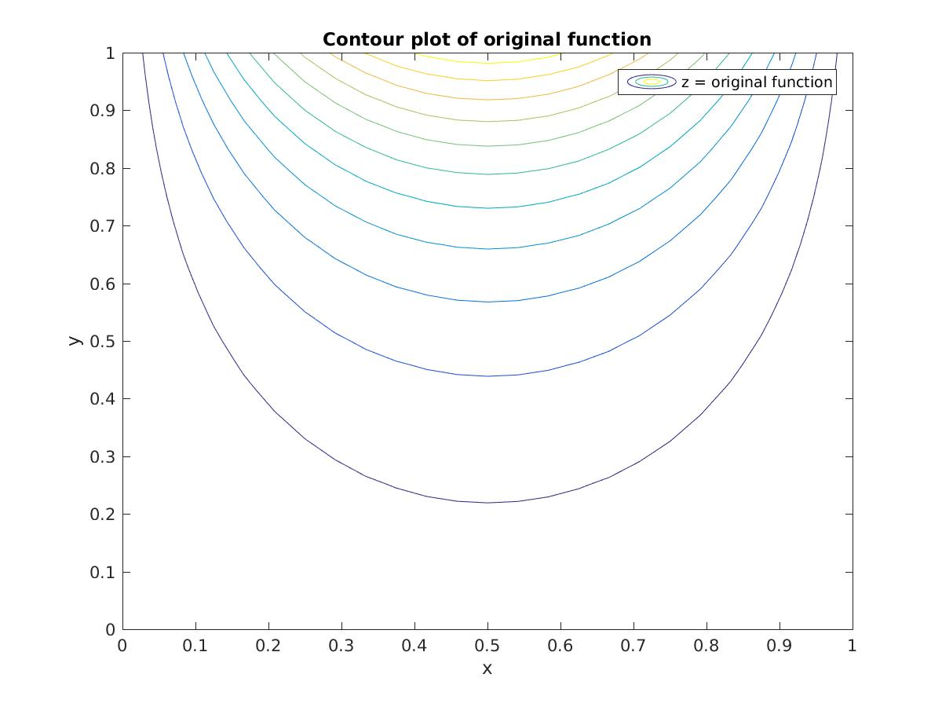
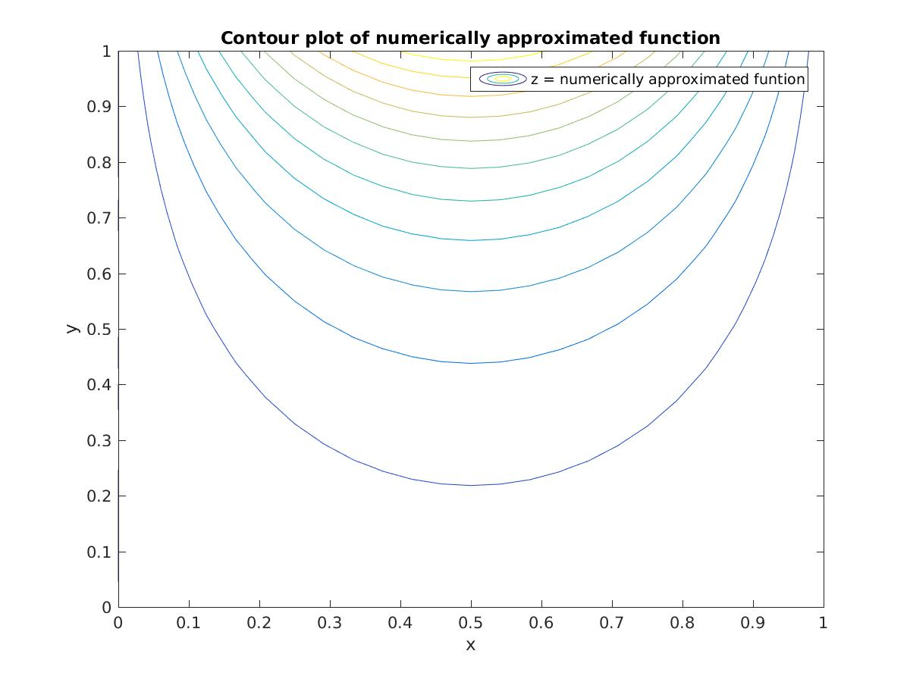
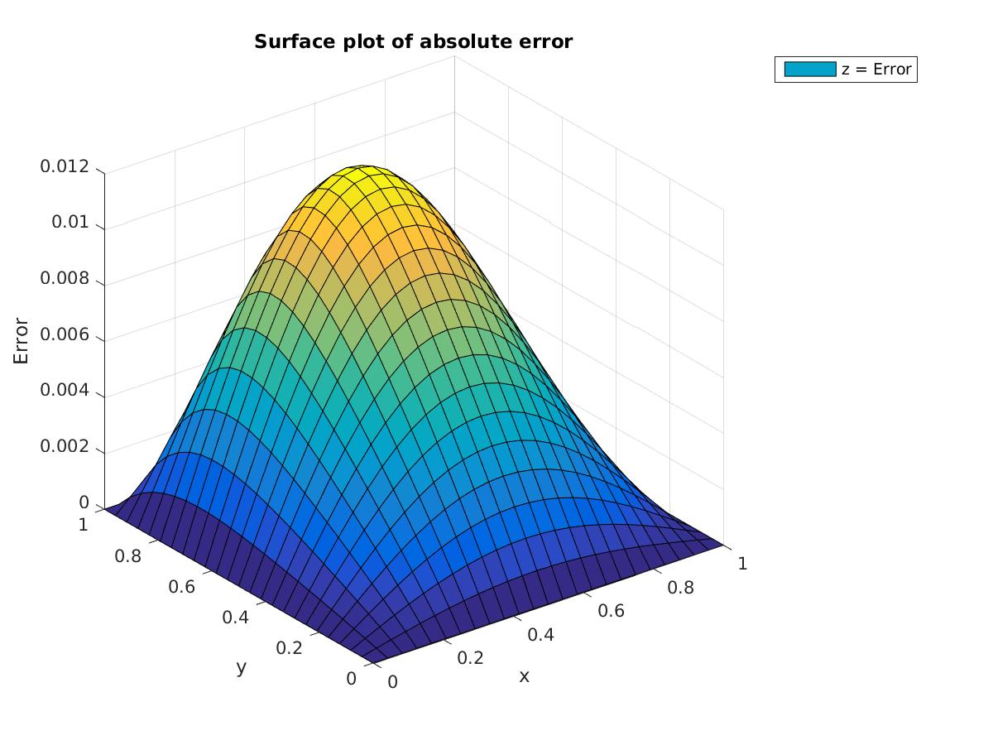
(E) The function is of order 1 so there is no truncation error. The only error is roundoff, and it does not have a order 2 convergence.

N Error Order
3 8.881784e-16 -3.483816
6 9.936496e-15 -3.545471
12 1.160183e-13 -3.745294

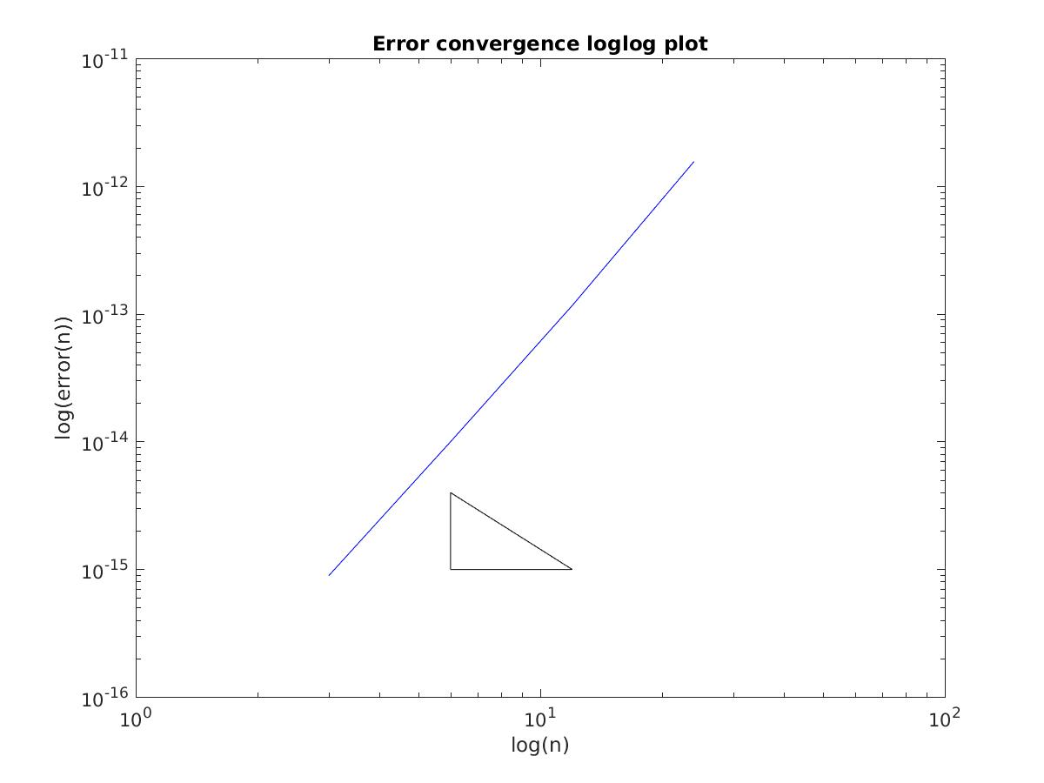
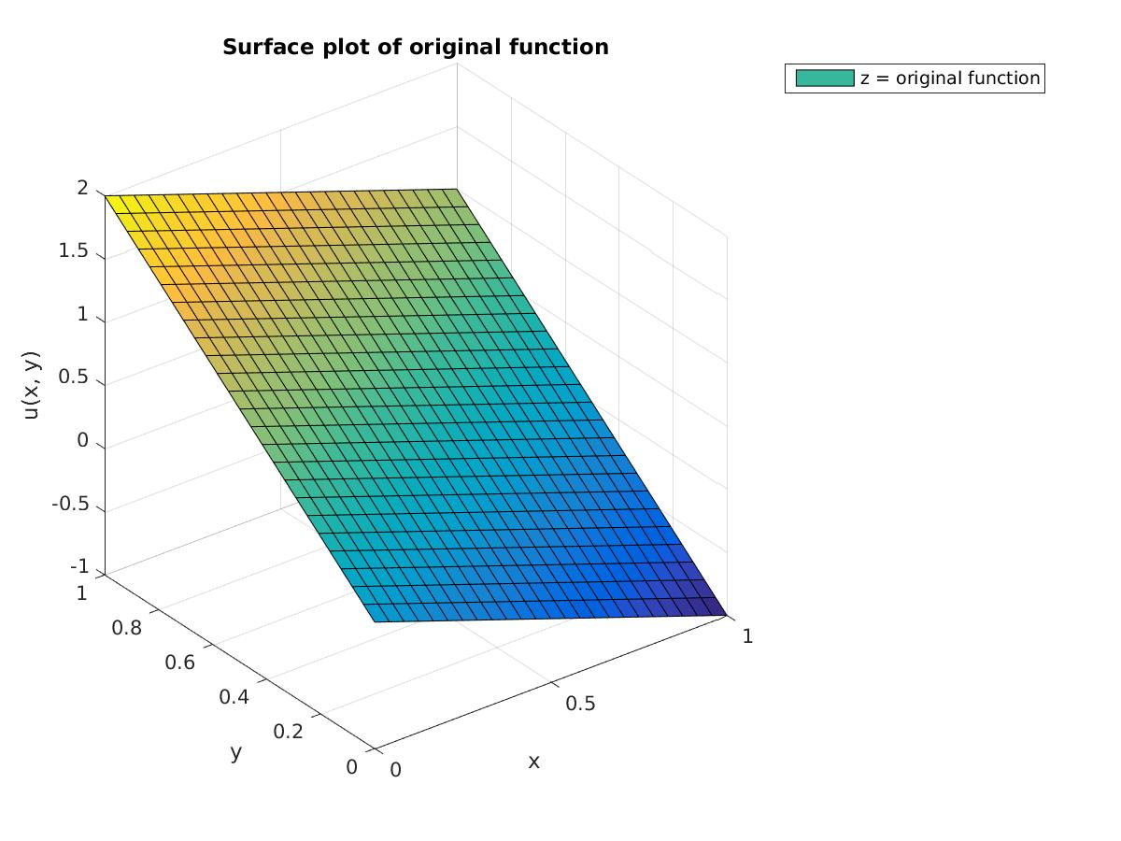
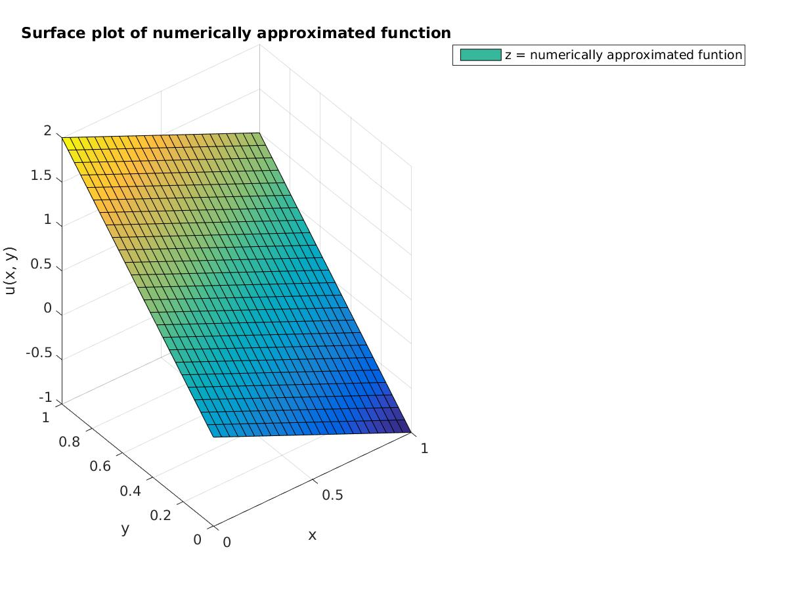
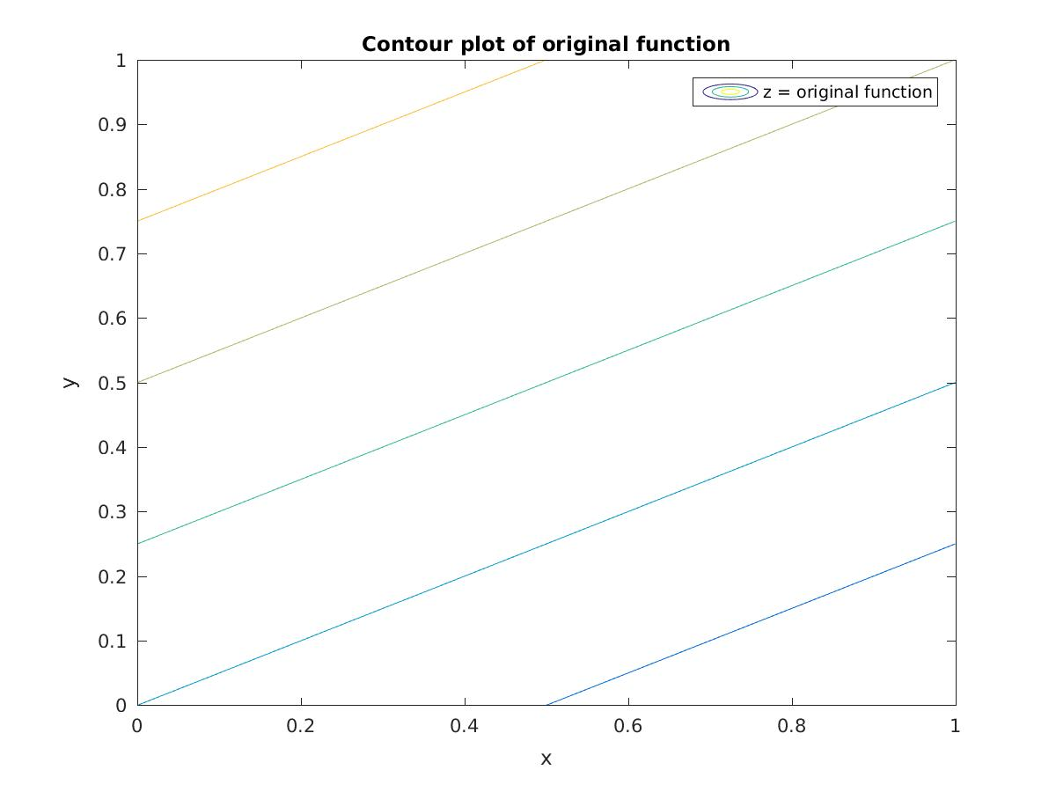
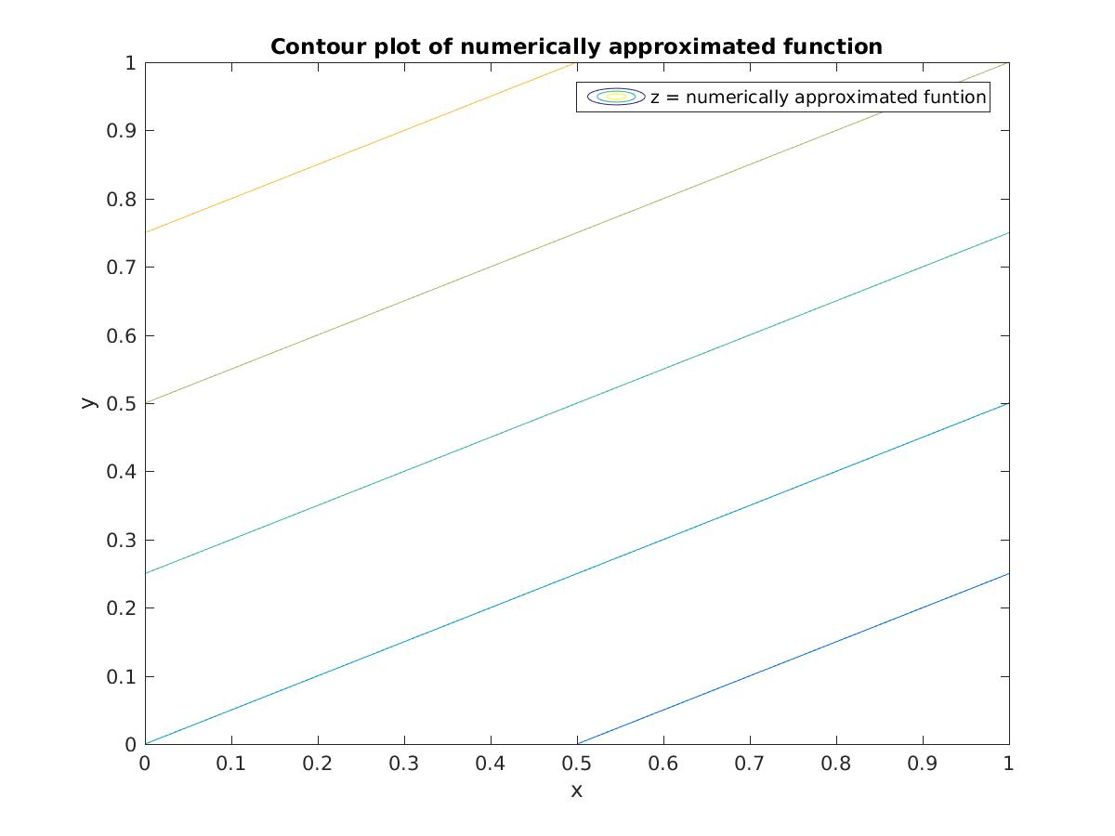
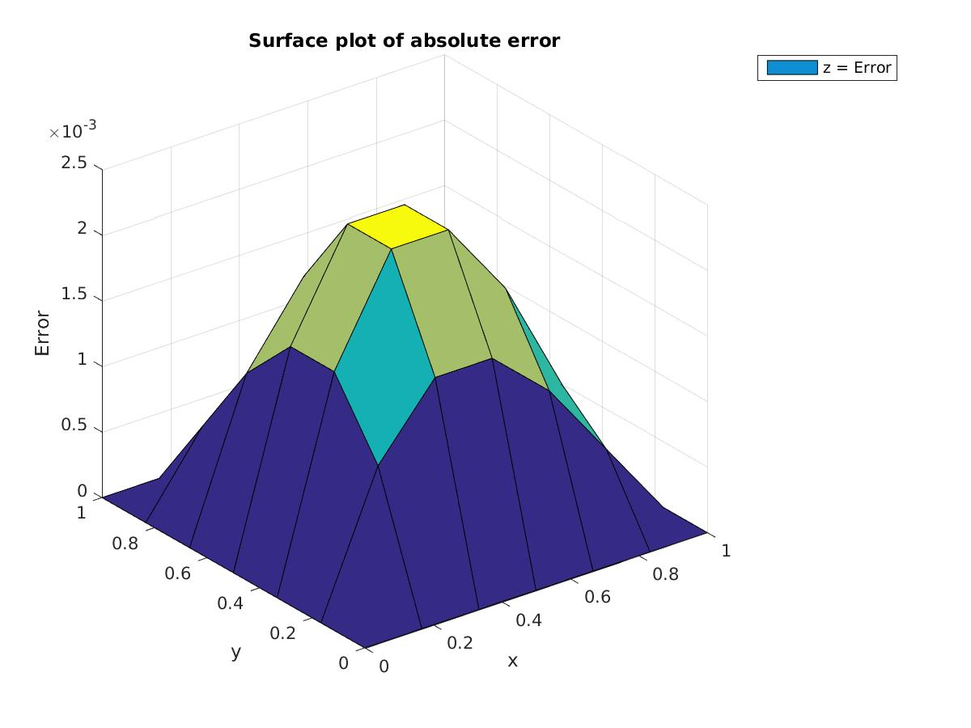
(F)

N Error Order
3 5.903116e-01 1.739355
6 1.768005e-01 2.783537

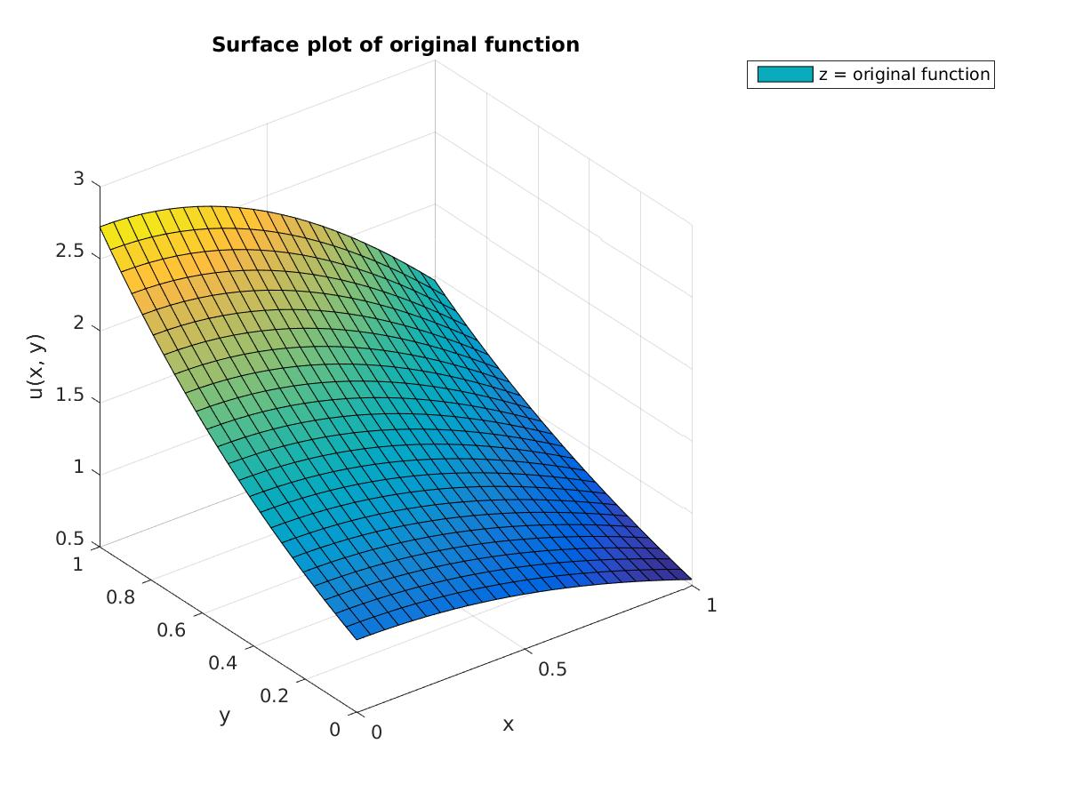
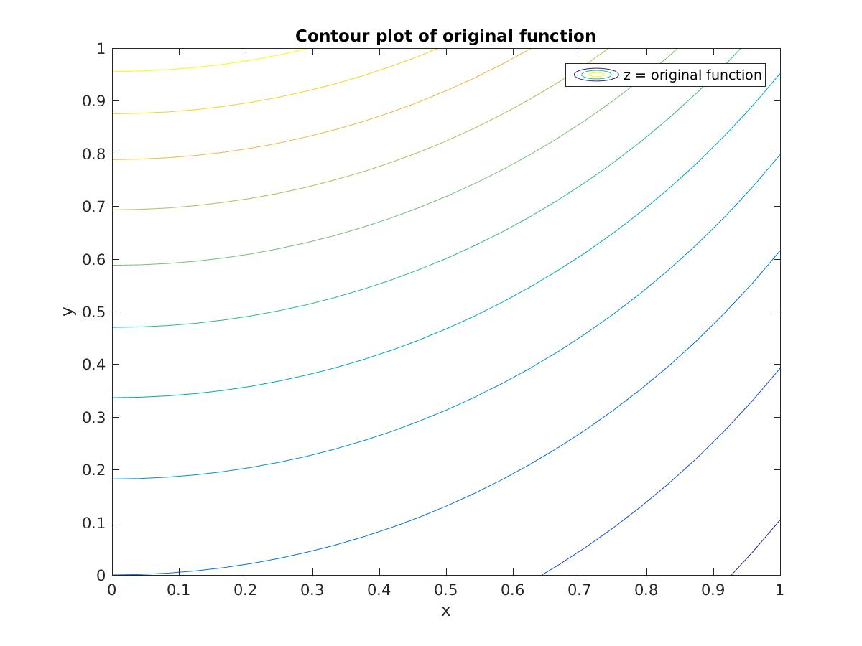
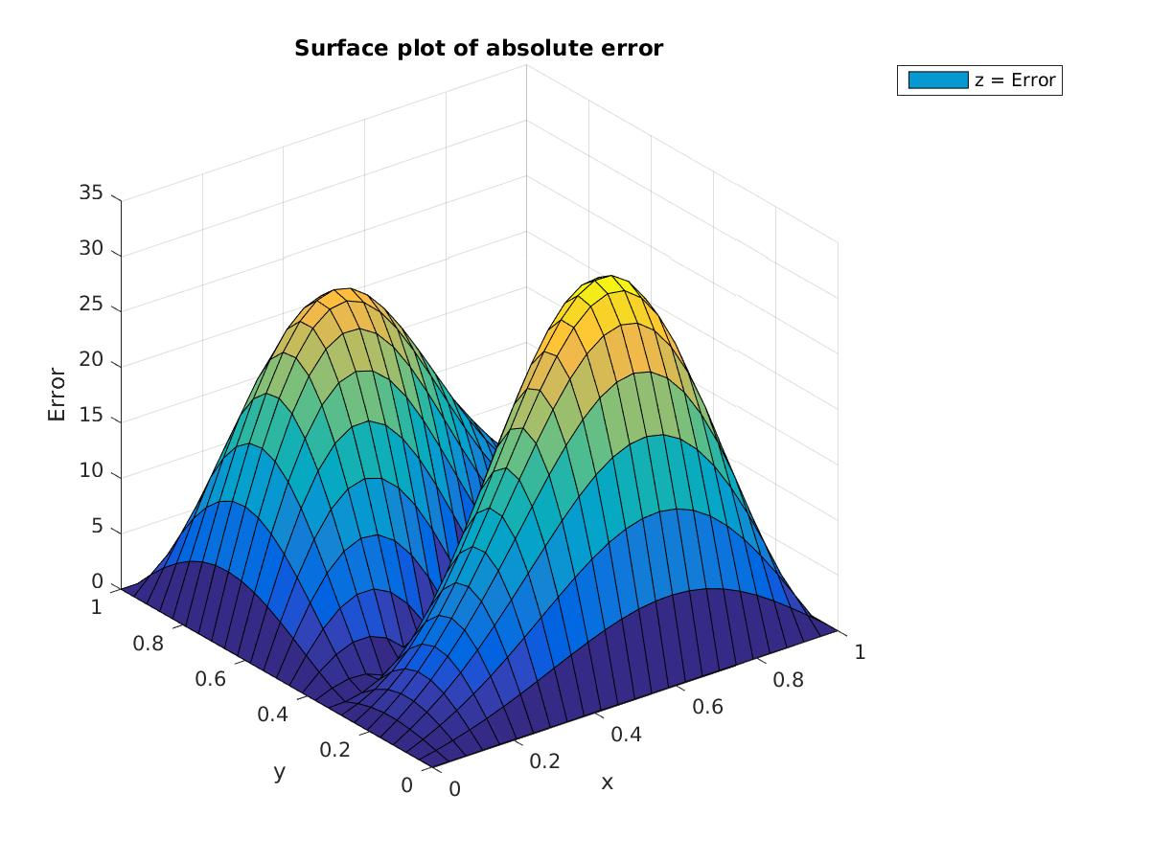
Question 2 (Gauss-Seidel)

A) The function is of order 2 so there is no truncation error. The only error is roundoff, and it does not have a order 2 convergence.

N Error Order
3 3.346089e-16 -4.082370
6 5.668305e-15 -3.213053
12 5.256281e-14 -3.778065>

(B)

N Error Order
3 3.527119e-03 1.905469
6 9.414920e-04 1.917445
12 2.492345e-04 1.978597

(C) (Original function not available)

(D)

N Error Order
3 5.908305e-01 1.698461
6 1.820435e-01 1.973942
12 4.634037e-02 1.987778

(E) The function is of order 1 so there is no truncation error. The only error is roundoff, and it does not have a order 2 convergence.

N Error Order
3 8.881784e-16 -3.483816
6 9.936496e-15 -3.545471
12 1.160183e-13 -3.745294

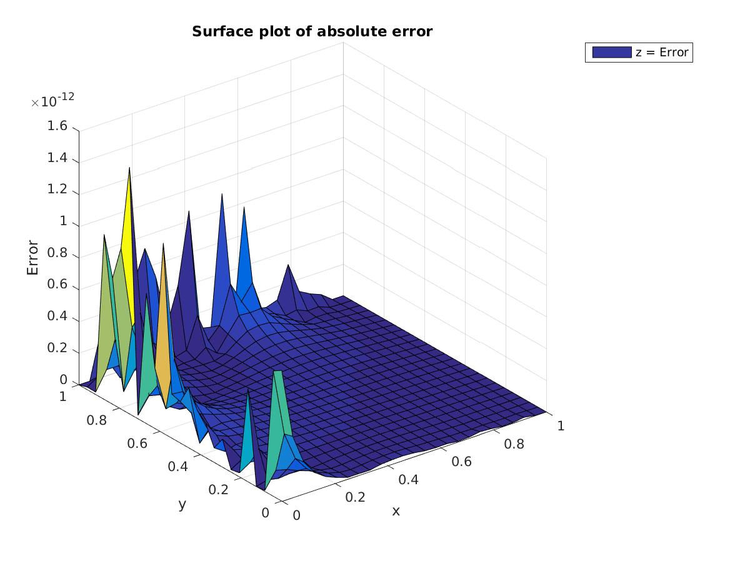
(F)

N Error Order
3 5.903116e-01 1.739355
6 1.768005e-01 2.783537

Question 3 (Jacobi)

A) The function is of order 2 so there is no truncation error. The only error is roundoff, and it does not have a order 2 convergence.

N Error Order
3 3.346089e-16 -4.082370
6 5.668305e-15 -3.213053
12 5.256281e-14 -3.778065>

(B)

N Error Order
3 3.527119e-03 1.905469
6 9.414920e-04 1.917445
12 2.492345e-04 1.978597

(C) (Original function not available)

(D)

N Error Order
3 5.908305e-01 1.698461
6 1.820435e-01 1.973942
12 4.634037e-02 1.987778

(E) The function is of order 1 so there is no truncation error. The only error is roundoff, and it does not have a order 2 convergence.

N Error Order
3 8.881784e-16 -3.483816
6 9.936496e-15 -3.545471
12 1.160183e-13 -3.745294

(F)

N Error Order
3 5.903116e-01 1.739355
6 1.768005e-01 2.783537

