Islington College


MA4001Nl
Logic and Problem Solving
Group Coursework
(50% Weighted)

Submitted By: Submitted To:
Mr. Ashok Dhungana
Module Leader, IT Faculty

Submission Date:

Name of the students | London Met ID

Acknowledgement

We are grateful to everyone who contributed to our successful completion of this coursework on Logic and Problem Solving.
Firstly, we would like to thank our lecturer Mr. Ashok Dhungana for his massive guidance and continuous support throughout this coursework. His clear explanations and motivation helped us understand concepts that we have applied in the coursework which includes Linear Programming Problems and tax calculations.
We would also thank our tutor Mr. Ichchha Babu Bhattarai for his continuous help regarding our coursework. His constant concern with our coursework helped us finish our coursework smoothly and his explanations for all our issues with questions were incredibly helpful. This coursework would not have been possible to finish without errors without his help.
We are also grateful to our group members for their cooperation and teamwork. Taking care of each problem was very helpful for all of us. We would especially like to acknowledge the team’s synergy when discussing, analyzing and solving the questions in our meeting sessions. Each member of the group contributed significantly to the discussions and solving stages.
Finally, we appreciate everyone who indirectly supported us through resources, feedback, and motivation throughout this coursework. The small words of motivation from friends and families were truly helpful during challenging moments.

Table of Contents
No table of contents entries found.

Problem 1
Write a procedure, tax, to calculate (in Nepalese Rupees) the tax a person owes, depending on his/her income. Calculate the tax using this table:
Taxable income (Rs) | Income tax rates (Percent)
0 to 50,000 | 1%
50,000 to 2,00,000 | 10%
2,00,000 to 3,00,000 | 20%
3,00,000 to 10,00,000 | 30%
10,00,000 to 30,00,000 | 36%
30,00,000 and above | 39%

There are various basic terms used we have to understand before we calculate the tax a person owes, depending on his/her income. They are explained below:
- Yearly Income
- Yearly income is the total amount of money a person earns throughout an entire year. This income is the person’s grand total income in a year. We use this yearly income to then calculate yearly taxable income.

- Yearly Taxable Income
- Yearly taxable income is the income of a person on which tax is applied. Yearly taxable income is calculated by deducting the non-taxable income like provident funds, insurance or Citizen Investment Trust from yearly income.

- Deductions
- Deductions are the part of income that is separated as non-taxable income before calculating yearly taxable income. Deductions include provident funds, Citizen Investment Trust or insurance. Total deductions is deducted from yearly income to calculate yearly taxable income.

- Income Tax Bracket
- Income tax bracket is basically the range of income where specific tax rate is applied. The question displays a table showing what rate of tax applies in what range of income. That range is known as income tax bracket.

- Tax Slab
- Tax slab is the amount left in the tax bracket on which tax is applied. For example, For range 0 to 50,000 we have the amount 50,000 where tax of 1% is applied. Then for range 50,000 to 200,000 we have amount 150,000 where 10% tax is applied in this amount. It is calculated by subtracting lower end of tax bracket to higher end of the same tax bracket.
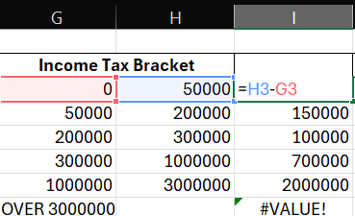

- Tax Rate
- Tax rate is the percentage at which the amount calculated in tax slab is taxed. For example, if a person’s income is 100,000 and we have to calculate tax, for the first 50,000 of his income, he is taxed for 1% tax rate. Then, for remaining 50,000 we move on to second bracket and that amount is taxed for 10% tax rate.

- Tax Amount
- Tax amount is the amount that is taken away from yearly income after the rates are applied according to the tax bracket. Suppose if a person earns Rs. 100,000, then for the first bracket, the tax slab is 50,000 which means 1% is taxed from that amount. This is calculated to be Rs. 500. Then for the remaining 50,000, 10% is taxed from the amount since we have moved on to the second tax bracket. This is calculated to be Rs.5,000. This amount that is calculated to be Rs.500 and Rs.5,000 is our tax amount.

- Formulas
- In this question, we have done our solutions mainly in excel. To calculate values in certain cells, we have used various formulas. These formulas are stated below:

For finding total deductions, we have added all deductions provided as input.
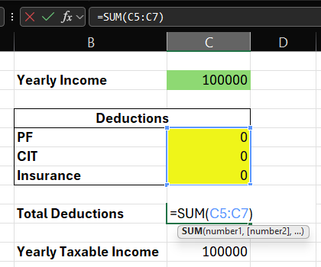
Figure 1: Total Deduction
For finding the amount in tax slab, we have subtracted lower end of tax bracket from higher end of tax bracket.
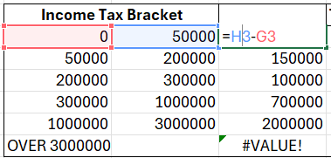
Figure 2: Tax Slab
For finding tax amount, we have made use of IF statement in excel to check the amount in tax bracket and apply tax according to the corresponding tax rate.
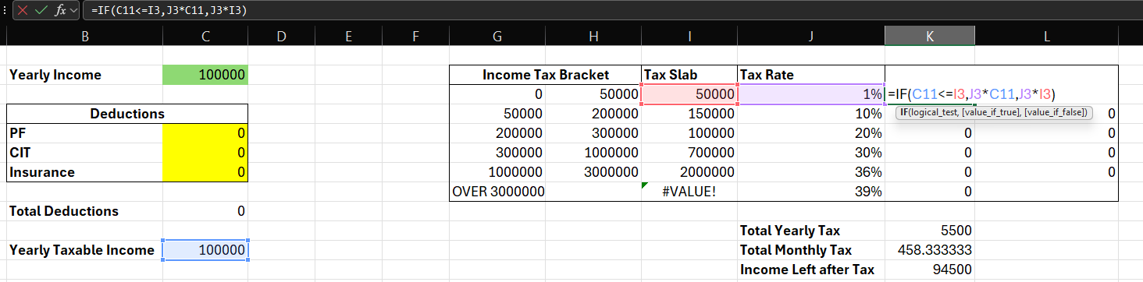
Figure 3: Tax Amount
To calculate the taxable income left in order to move on to the next bracket, we used IF statement to check if the taxable income is higher than the tax slab, and if it happens to be higher, then the tax slab is subtracted from taxable income and for the next bracket, tax slab is subtracted from taxable income left.
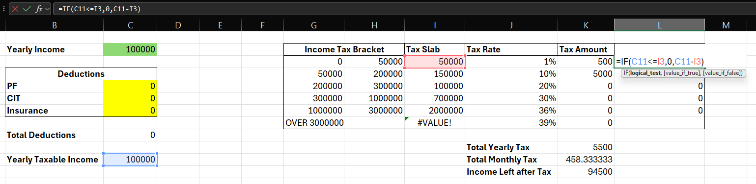
Figure 4: Taxable Income Left

The procedure should show:
i) The salary,
ii) The tax rate,
iii) The amount of tax,
iv) The amount left after tax
v) Be able to deal with any input, valid or not.
Your tests of procedure should include the following values, which should be included in your final presentation.
- Tax (Rs. 4,05,000)
Deductions:
- Employees provident fund organization: (Rs. 10,000)
- Life Insurance premium: (Rs. 68,000)
- Citizen Investment Trust:( Rs. 0)
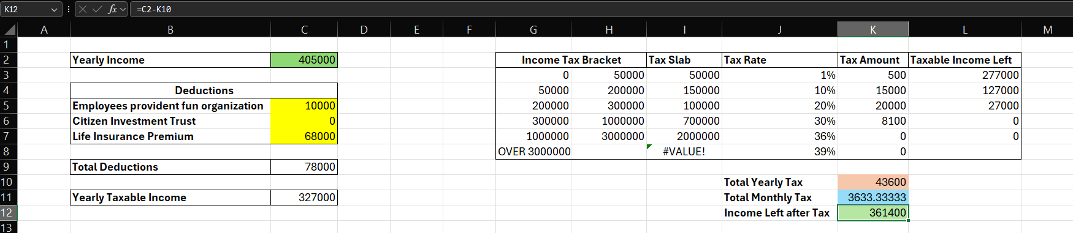
Figure 5: Solution a
Hence, for a yearly income of Rs. 4,05,000 and deductions that sum up to 78000, the total yearly tax was calculated to be Rs. 43,600. The total monthly tax was calculated to be Rs. 3,633.33. The total income that was left after applying the tax is Rs. 3,61,400.

- Tax (Rs. 8,09,090)
Deductions:
- Employees provident fund organization: (Rs. 15,000)
- Life Insurance premium: (Rs. 20,000)
- Citizen Investment Trust:( Rs.5,000)
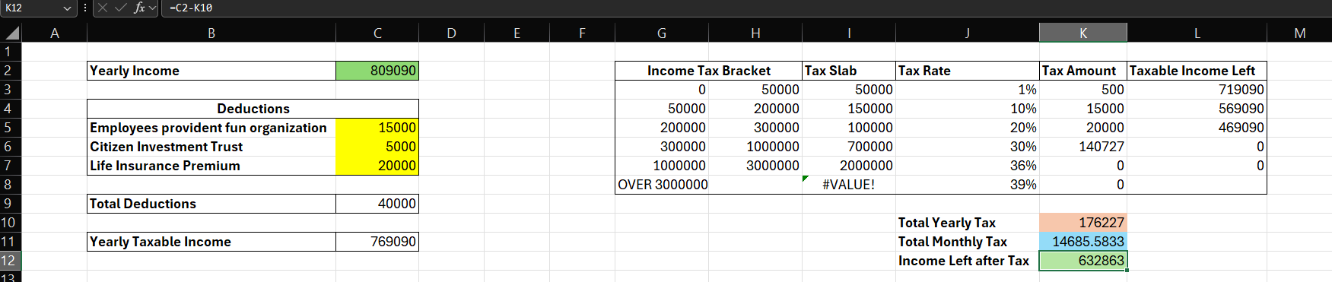
Figure 6: Solution b
Hence, for a yearly income of Rs. 8,09,090 and deductions that sum up to 40000, the total yearly tax was calculated to be Rs. 1,76,227. The total monthly tax was calculated to be Rs. 14,685.5833. The total income that was left after applying the tax is Rs. 6,32,863.

- Tax (Rs. 19,10,000)
Deductions:
- Employees provident fund organization: (Rs. 0)
- Life Insurance premium: (Rs. 2,50,000)
- Citizen Investment Trust:( Rs.50,000)
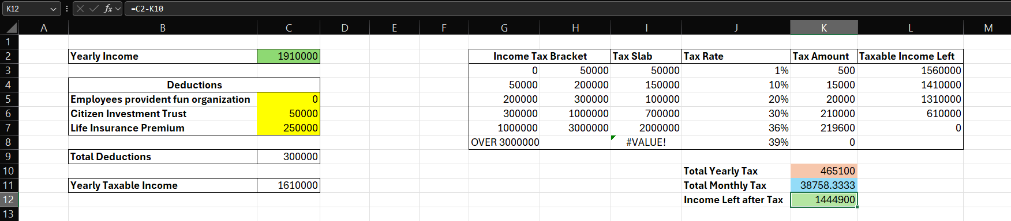
Figure 7: Solution c
Hence, for a yearly income of Rs. 19,10,000 and deductions that sum up to Rs. 3,00,000, the total yearly tax was calculated to be Rs. 4,65,100. The total monthly tax was calculated to be Rs. 38,758.33. The total income that was left after applying the tax is Rs. 14,44,900.

- Tax (Rs. 2,108,790)
Deductions:
- Employees provident fund organization: (Rs. 1,50,000)
- Life Insurance premium: (Rs. 30,000)
- Citizen Investment Trust:( Rs.25,000)
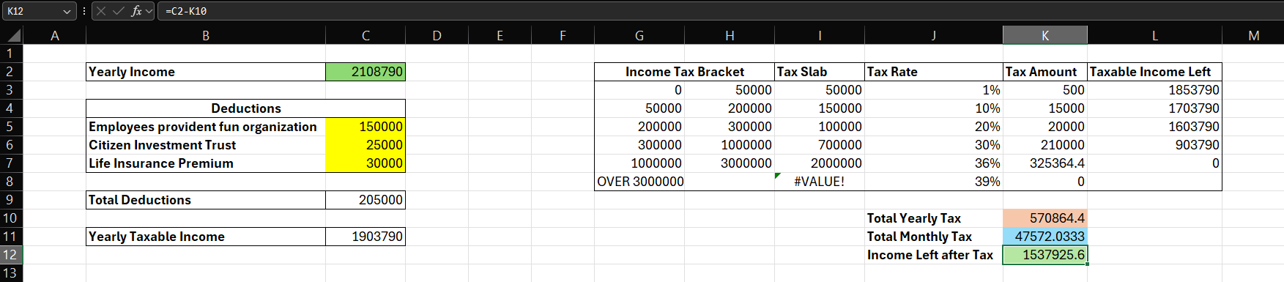
Figure 8: Solution d
Hence, for a yearly income of Rs. 21,08,790 and deductions that sum up to Rs. 2,05,000, the total yearly tax was calculated to be Rs. 5,70,864.4. The total monthly tax was calculated to be Rs. 47,572.03. The total income that was left after applying the tax is Rs. 15,37,925.6.

- Tax (Rs. 31,800)
Deductions:
- Employees provident fund organization: (Rs.0)
- Life Insurance premium: (Rs. 5,000)
- Citizen Investment Trust:( Rs. 0)
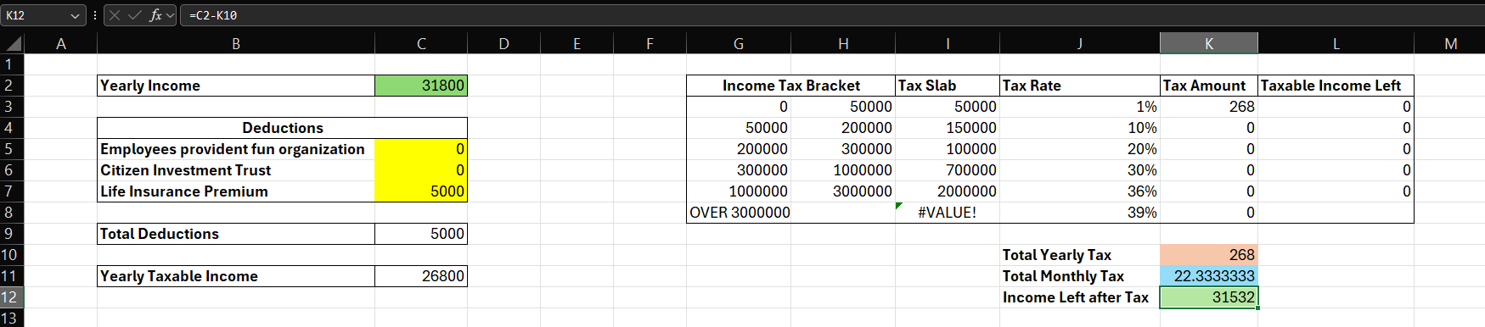
Figure 9: Solution e
Hence, for a yearly income of Rs. 31,800 and deductions that sum up to Rs. 5,000, the total yearly tax was calculated to be Rs. 268. The total monthly tax was calculated to be Rs. 22.33. The total income that was left after applying the tax is Rs. 31,532.

- Tax (Rs. -50,000)
Deductions:
- Employees provident fund organization: (Rs.0)
- Life Insurance premium: (Rs. 0)
- Citizen Investment Trust:( Rs. 0)
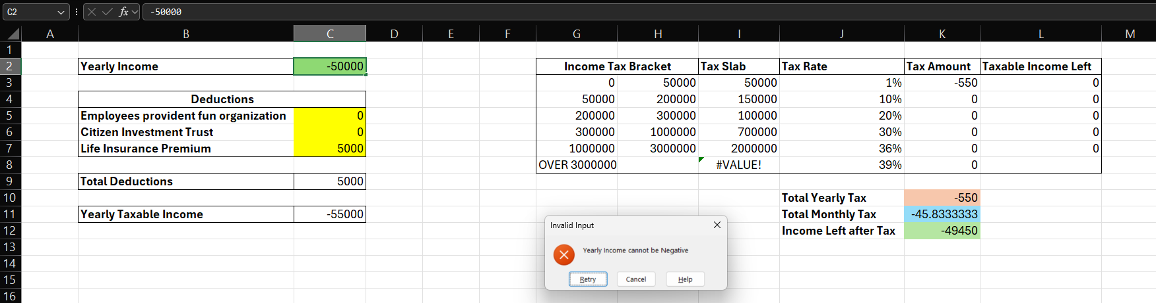
Figure 10: Solution f
Hence, when we provide an invalid value like Rs. -50,000, It displays an error message letting the user know that the input value cannot be negative.

Problem 2 Part A

Berkshire Health Care patient diet is to contain at least 8 units of vitamins, 9 units of minerals, and 10 carbohydrates. Three foods, Food A, Food B, and Food C are to be purchased. Each unit of Food A provides 1 unit of vitamins, 1 unit of minerals, and 2 carbohydrates. Each unit of Food B provides 2 units of vitamins, 1 unit of minerals, and 1 carbohydrate. Each unit of Food C provides 2 units of vitamins, 1 unit of minerals, and 2 carbohydrates. If Food A costs $3 per unit, Food B costs $2 per unit and Food C costs $3 per unit, how many units of each food should be purchased to keep costs at a minimum.
Questions:
a) Formulate the problem as a linear programming model, clearly defining the variables, the objective function, and the constraints.
b) Solve the problem using Simplex method.
c) Solve the problem using the Excel Solver and interpret the results.
d) For the final part of your report, in your capacity as an Adviser, you should present a memorandum to the Berkshire Health Care.

Solution:
Linear Programming is a mathematical technique used to find the optimal (maximum) or minimum solution for a linear function (Dantzig & Thapa, Linear Programming,1: Introduction, 1997). It minimizes the linear function to a finite number of linear relationships to find the optimal solution (Karloff, 2008). It is widely used in economics, logistics, engineering and operations research for optimal usage of resources. Simplex method, first developed by George B. Dantzig, is a very efficient model for solving more complex linear problems through pivoting the problems (Dantzig, 2002). Before solving the given Linear programming problem (LPP), there are many terminologies related to LPP and simplex method that should be clearly defined, those are:
1. Decision variables:
Decision variables are the physical quantities represented by mathematical symbols that can vary according to the nature of the problem (University of Kentucky, 2016).
2. Objective function:
Objective function is the function made up of the decision variables which clearly defines the criterion of the needed solution. It is the function that is operated upon for the solution.
3. Constraints:
Constraints are the functional equalities or inequalities that defines the restrictions for the value of decision variables. These constraints are formulated through the conditions of the real-life problem (University of Kentucky, 2016).
4. Basic feasible solution:
BFS is a solution that satisfies all the constraints and has the least number of non-zero variables (Laws, 2010).

5. Slack/ Surplus variables:
Slack and surplus variables are extra variables added to the inequality constraints convert them into equality. Slack variable is added to ≤ constraints while surplus variables are added to ≥ constraints to convert them to equality constraints.
6. Artificial variables:
Artificial variables are the variables introduced to constraints that may not produce BFS naturally (University of Moratuwa). Artificial variables are introduced in ≥ constraints or equality constraints. They are added to the constraint in maximization problems and subtracted from the constraints in minimization problems.
7. Tableau:
It is the table used to perform the iterations for the simplex method
8. Pivot element:
Pivot element is the key element in the simplex table that is used as a reference point for calculation for that iteration.
10. Maximization/ Minimization:
An objective function in a LPP may need to be maximized or minimized. During Maximization, a basic feasible solution that yields the highest value for the objective function is calculated while during minimization, a basic feasible solution with the lowest value is calculated.

a)

Problem Analysis

According to the question,
The patient’s diet must contain at least 8 units of vitamin, 9 units of minerals and 10 units of carbohydrates.
Food A costs $3 to purchase. The composition of Food A:
Vitamin: 1 unit
Mineral: 1 unit
Carbohydrate: 2 unit
Food B costs $2 to purchase. The composition of Food B:
Vitamin: 2 unit
Mineral: 1 unit
Carbohydrate: 1 unit
Food C costs $3 to purchase. The composition of Food C:
Vitamin: 2 unit
Mineral: 1 unit
Carbohydrate: 2 unit
The following data for the food compositions, cost and patient’s requirements are to be formulated as a linear programming model and solved for optimal solution.

Mathematical Formulation

For Decision Variables:
Let x, y and z be the units of food A, B and C respectively, that needs to be purchased for the patient in order to minimize the cost.
For Objective Function:
Total cost = $3x + 2y + 2z$
Let Total cost = C, so that
$$C = 3x + 2y + 2z$$
Minimize $C = 3x + 2y + 2z$ (objective function)
For Constraints:
$x + 2y + 2z ≥ 8$ (Vitamin constraint)
$x + y + z ≥ 9$ (Mineral constraint)
$2x + y + 2z ≥ 10$ (Carbohydrate constraint)
$x, y, z ≥ 0$ (non-negativity constraint)

Let S₁, S₂ and S₃ be surplus variables. Let A₁, A₂ and A₃ be artificial variables.
Now,
$$x + 2y + 2z- S1 + A1 = 8$$
$$x + y + z - S2 + A2 = 9$$
$$2x + y + 2z - S3 + A3 = 10$$

Standard Equation for Simplex Table:
$$1 C - 3 x - 2 y - 3 z + 0 S_{1} + 0 S_{2} + 0 S_{3} - 10 A_{1} - 10 A_{2} - 10 A_{3}= 0$$
$$0 C + 1 x + 2 y + 2 z - 1 S_{1} + 0 S_{2} + 0 S_{3} + 1 A_{1} + 0 A_{2} + 0 A_{3}= 0$$
$$0 C + 1 x + 1 y + 1 z + 0 S_{1} - 1 S_{2} + 0 S_{3} + 0 A_{1} + 1 A_{2} + 0 A_{3}= 0$$
$0 C + 2 x + 1 y + 2 z + 0 S_{1} + 0 S_{2} - 1 S_{3} + 0 A_{1} + 0 A_{2} + 1 A_{3}= 0$
b)

Simplex Method Solution

Simplex Table 1:
Table 1: Simplex Table 1
Row | Z | x | y | z | S₁ | S₂ | S₃ | A₁ | A₂ | A₃ | Constant
R₀ | $$1$$ | $$-3$$ | $$-2$$ | $$-3$$ | $$0$$ | $$0$$ | $$0$$ | $$-10$$ | $$-10$$ | $$-10$$ | $$0$$
R₁ | $$0$$ | $$1$$ | $$2$$ | $$2$$ | $$-1$$ | $$0$$ | $$0$$ | $$1$$ | $$0$$ | $$0$$ | $$8$$
R₂ | $$0$$ | $$1$$ | $$1$$ | $$1$$ | $$0$$ | $$-1$$ | $$0$$ | $$0$$ | $$1$$ | $$0$$ | $$9$$
R₃ | $$0$$ | $$2$$ | $$1$$ | $$2$$ | $$0$$ | $$0$$ | $$-1$$ | $$0$$ | $$0$$ | $$1$$ | $$10$$

For Identity Matrix:
$$New R_{0} = Old R_{0}+ 10 (R_{1}+ R_{2}+ R_{3})$$

Table 2: Operations Table 1
Old R₀ | 10(R₁ + R₂ + R₃) | New R₀
$$1$$ | $$0$$ | $$1$$
$$-3$$ | $$40$$ | $$37$$
$$-2$$ | $$40$$ | $$38$$
$$-3$$ | $$50$$ | $$47$$
$$0$$ | $$-10$$ | $$-10$$
$$0$$ | $$-10$$ | $$-10$$
$$0$$ | $$-10$$ | $$-10$$
$$-10$$ | $$10$$ | $$0$$
$$-10$$ | $$10$$ | $$0$$
$$-10$$ | $$10$$ | $$0$$
$$0$$ | $$270$$ | $$270$$
Simplex Table 2:

Table 3: Simplex Table 2
Row | Z | x | y | z | S₁ | S₂ | S₃ | A₁ | A₂ | A₃ | Constant | Ratio
R₀ | $$1$$ | $$37$$ | $$38$$ | $$47$$ | $$-10$$ | $$-10$$ | $$-10$$ | $$0$$ | $$0$$ | $$0$$ | $$270$$ | $$-$$
R₁ | $$0$$ | $$1$$ | $$2$$ | $$2$$ | $$-1$$ | $$0$$ | $$0$$ | $$1$$ | $$0$$ | $$0$$ | $$8$$ | $$4$$
R₂ | $$0$$ | $$1$$ | $$1$$ | $$1$$ | $$0$$ | $$-1$$ | $$0$$ | $$0$$ | $$1$$ | $$0$$ | $$9$$ | $$9$$
R₃ | $$0$$ | $$2$$ | $$1$$ | $$2$$ | $$0$$ | $$0$$ | $$-1$$ | $$0$$ | $$0$$ | $$1$$ | $$10$$ | $$5$$

Here, the highest positive number in R₀ is 47 so z is the key column and 4 is the lowest positive ratio, so R₁ is the key row.
∴ 2 is the key element.
We need to update R₁ first using:
$$New R_{1} = \frac{Old R_{1}}{Key element} = \frac{Old R_{1}}{2}$$
Elements in $New R_{1} = 0, \frac{1}{2}, 1, 1, -\frac{1}{2}, 0, 0, \frac{1}{2}, 0, 0, 4$

Similarly, updating other rows with reference to new R₁:
$$New R_{0} =Old R_{0}-47×New R_{1}$$
$$New R_{2} =Old R_{2}-New R_{1}$$
$$New R_{3} =Old R_{3}-2 × New R_{1}$$

Table 4: Operations Table 2
Old R₀ | 47 × New R₁ | New R₀ | Old R₂ | New R₁ | New R₂ | Old R₃ | 2×New R₁ | New R₃
$$1$$ | $$0$$ | $$1$$ | $$0$$ | $$0$$ | $$0$$ | $$0$$ | $$0$$ | $$0$$
$$-3$$ | $$40$$ | $$37$$ | $$1$$ | $$\frac{1}{2}$$ | $$\frac{1}{2}$$ | $$2$$ | $$1$$ | $$1$$
$$-2$$ | $$40$$ | $$38$$ | $$1$$ | $$0$$ | $$0$$ | $$1$$ | $$0$$ | $$-1$$
$$-3$$ | $$50$$ | $$47$$ | $$1$$ | $$1$$ | $$0$$ | $$2$$ | $$2$$ | $$0$$
$$0$$ | $$-10$$ | $$-10$$ | $$0$$ | $$-\frac{1}{2}$$ | $$\frac{1}{2}$$ | $$0$$ | $$-1$$ | $$1$$
$$0$$ | $$-10$$ | $$-10$$ | $$-1$$ | $$0$$ | $$-1$$ | $$0$$ | $$0$$ | $$0$$
$$0$$ | $$-10$$ | $$-10$$ | $$0$$ | $$0$$ | $$0$$ | $$-1$$ | $$0$$ | $$-1$$
$$-10$$ | $$10$$ | $$0$$ | $$0$$ | $$\frac{1}{2}$$ | $$-\frac{1}{2}$$ | $$0$$ | $$1$$ | $$1$$
$$-10$$ | $$10$$ | $$0$$ | $$1$$ | $$0$$ | $$1$$ | $$0$$ | $$0$$ | $$0$$
$$-10$$ | $$10$$ | $$0$$ | $$0$$ | $$0$$ | $$0$$ | $$1$$ | $$0$$ | $$1$$
$$0$$ | $$270$$ | $$270$$ | $$9$$ | $$4$$ | $$5$$ | $$10$$ | $$8$$ | $$2$$

Simplex Table 3:

Table 5: Simplex Table 3
Row | Z | x | y | z | S₁ | S₂ | S₃ | A₁ | A₂ | A₃ | Constant | Ratio
R₀ | $$1$$ | $$\frac{27}{2}$$ | $$-9$$ | $$0$$ | $$\frac{27}{2}$$ | $$-10$$ | $$-10$$ | $$-\frac{47}{2}$$ | $$0$$ | $$0$$ | $$82$$ | $$-$$
R₁ | $$0$$ | $$\frac{1}{2}$$ | $$1$$ | $$1$$ | $$-\frac{1}{2}$$ | $$0$$ | $$0$$ | $$\frac{1}{2}$$ | $$0$$ | $$0$$ | $$4$$ | 8
R₂ | $$0$$ | $$\frac{1}{2}$$ | $$0$$ | $$0$$ | $$\frac{1}{2}$$ | $$-1$$ | $$0$$ | $$-\frac{1}{2}$$ | $$1$$ | $$0$$ | $$5$$ | $$10$$
R₃ | $$0$$ | $$1$$ | $$-1$$ | $$0$$ | $$1$$ | $$0$$ | $$-1$$ | $$-1$$ | $$0$$ | $$1$$ | $$2$$ | $$2$$

Here, the highest positive number in R₀ is ${27}/2$. Both x and y column has this value. In such case, either column can be taken for further calculation so, we take x as the key column. 2 is the lowest positive ratio, so R₃ is the key row.
∴ 1 is the key element.
We need to update R₁ first using:
$$New R_{3} = Old R_{3}$$
Elements in $New R_{3} = 0, 1, -1, 0, 1, 0, -1, -1, 0, 1, 2$ (Same as before)

Similarly, updating other rows with reference to new R₃:
$$New R_{0} =Old R_{0}- {27}/2× New R_{3}$$
$$New R_{1} =Old R_{1}- 1/2 × New R_{3}$$
$$New R_{2} =Old R_{2}- 1/2 × New R_{3}$$

Table 6: Operations Table 3
Old R₀ | ${27}/2$×New R₁ | New R₀ | Old R₁ | $1/2$×New R₃ | New R₁ | Old R₂ | $1/2$×  New R₃ | New R₂
$$1$$ | $$0$$ | $$1$$ | $$0$$ | $$0$$ | $$0$$ | $$0$$ | $$0$$ | $$0$$
$$\frac{27}{2}$$ | $$\frac{27}{2}$$ | $$0$$ | $$\frac{1}{2}$$ | $$\frac{1}{2}$$ | $$0$$ | $$\frac{1}{2}$$ | $$\frac{1}{2}$$ | $$0$$
$$-9$$ | $$-\frac{27}{2}$$ | $$\frac{9}{2}$$ | $$1$$ | $$-\frac{1}{2}$$ | $$\frac{3}{2}$$ | $$0$$ | $$-\frac{1}{2}$$ | $$\frac{1}{2}$$
$$0$$ | $$0$$ | $$0$$ | $$1$$ | $$0$$ | $$1$$ | $$0$$ | $$0$$ | $$0$$
$$\frac{27}{2}$$ | $$\frac{27}{2}$$ | $$0$$ | $$-\frac{1}{2}$$ | $$\frac{1}{2}$$ | $$-1$$ | $$\frac{1}{2}$$ | $$\frac{1}{2}$$ | $$0$$
$$-10$$ | $$0$$ | $$-10$$ | $$0$$ | $$0$$ | $$0$$ | $$-1$$ | $$0$$ | $$-1$$
$$-10$$ | $$-\frac{27}{2}$$ | $$\frac{7}{2}$$ | $$0$$ | $$-\frac{1}{2}$$ | $$\frac{1}{2}$$ | $$0$$ | $$-\frac{1}{2}$$ | $$\frac{1}{2}$$
$$-\frac{47}{2}$$ | $$-\frac{27}{2}$$ | $$-10$$ | $$\frac{1}{2}$$ | $$-\frac{1}{2}$$ | $$1$$ | $$-\frac{1}{2}$$ | $$-\frac{1}{2}$$ | $$0$$
$$0$$ | $$0$$ | $$0$$ | $$0$$ | $$0$$ | $$0$$ | $$1$$ | $$0$$ | $$1$$
$$0$$ | $$\frac{27}{2}$$ | $$-\frac{27}{2}$$ | $$0$$ | $$\frac{1}{2}$$ | $$-\frac{1}{2}$$ | $$0$$ | $$\frac{1}{2}$$ | $$-\frac{1}{2}$$
$$82$$ | $$27$$ | $$55$$ | $$4$$ | $$1$$ | $$3$$ | $$5$$ | $$1$$ | $$4$$

Simplex Table 4:

Table 7: Simplex Table 4
Row | Z | x | y | z | S₁ | S₂ | S₃ | A₁ | A₂ | A₃ | Constant | Ratio
R₀ | $$1$$ | $$0$$ | $$\frac{9}{2}$$ | $$0$$ | $$0$$ | $$-10$$ | $$\frac{7}{2}$$ | $$-10$$ | $$0$$ | $$-\frac{27}{2}$$ | $$55$$ | $$-$$
R₁ | $$0$$ | $$0$$ | $$\frac{3}{2}$$ | $$1$$ | $$-1$$ | $$0$$ | $$\frac{1}{2}$$ | $$1$$ | $$0$$ | $$-\frac{1}{2}$$ | $$3$$ | $$2$$
R₂ | $$0$$ | $$0$$ | $$\frac{1}{2}$$ | $$0$$ | $$0$$ | $$-1$$ | $$\frac{1}{2}$$ | $$0$$ | $$1$$ | $$-\frac{1}{2}$$ | $$4$$ | $$8$$
R₃ | $$0$$ | $$1$$ | $$-1$$ | $$0$$ | $$1$$ | $$0$$ | $$-1$$ | $$-1$$ | $$0$$ | $$1$$ | $$2$$ | $$-2$$

Here, the highest positive number in R₀ is $9/2$ so y is the key column and 2 is the lowest positive ratio, so R₁ is the key row.
∴ 1 is the key element.
We need to update R₁ first using:
$$New R_{1} = \frac{{Old R}_{1}}{3/2}$$
Elements in $New R_{1} = 0, 0, 1, 2/3, -2/3, 0, 1/3, 2/3, 0, -1/3, 2$

Similarly, updating other rows with reference to new R₁:
$$New R_{0} =Old R_{0}- 9/2× New R_{1}$$
$$New R_{2} =Old R_{2}- 1/2 × New R_{1}$$
$$New R_{3} =Old R_{3}+ New R_{1}$$

Table 8: Operations Table 4
Old R₀ | $9/2$×  New R₁ | New R₀ | Old R₂ | $1/2$×  New R₁ | New R₂ | Old R₃ | New R₁ | New R₃
1 | 0 | 1 | 0 | 0 | 0 | 0 | 0 | 0
0 | 0 | 0 | 0 | $$\frac{1}{2}$$ | 0 | 1 | 0 | 1
$$\frac{9}{2}$$ | $$\frac{9}{2}$$ | 0 | $$\frac{1}{2}$$ | $$-\frac{1}{2}$$ | 0 | -1 | 1 | 0
0 | 3 | -3 | 0 | 0 | $$-\frac{1}{3}$$ | 0 | $$\frac{2}{3}$$ | $$\frac{2}{3}$$
0 | -3 | 3 | 0 | $$\frac{1}{2}$$ | $$\frac{1}{3}$$ | 1 | $$-\frac{2}{3}$$ | $$\frac{1}{3}$$
-10 | 0 | -10 | -1 | 0 | -1 | 0 | 0 | 0
$$\frac{7}{2}$$ | $$\frac{3}{2}$$ | 2 | $$\frac{1}{2}$$ | $$-\frac{1}{2}$$ | $$\frac{1}{3}$$ | -1 | $$\frac{1}{3}$$ | $$-\frac{2}{3}$$
-10 | 3 | -13 | 0 | $$-\frac{1}{2}$$ | $$-\frac{1}{3}$$ | -1 | $$\frac{2}{3}$$ | $$-\frac{1}{3}$$
0 | 0 | 0 | 1 | 0 | 1 | 0 | 0 | 0
$$-\frac{27}{2}$$ | $$-\frac{3}{2}$$ | -12 | $$-\frac{1}{2}$$ | $$\frac{1}{2}$$ | $$-\frac{1}{3}$$ | 1 | $$-\frac{1}{3}$$ | $$\frac{2}{3}$$
55 | 9 | 46 | 4 | 1 | 3 | 2 | 2 | 4

Simplex Table 5:

Table 9: Simplex Table 5
Row | Z | x | y | z | S₁ | S₂ | S₃ | A₁ | A₂ | A₃ | Constant | Ratio
R₀ | $$1$$ | $$0$$ | $$0$$ | $$-3$$ | $$3$$ | $$-10$$ | $$2$$ | $$-13$$ | $$0$$ | $$-12$$ | $$46$$ | $$-$$
R₁ | $$0$$ | $$0$$ | $$1$$ | $$\frac{2}{3}$$ | $$-\frac{2}{3}$$ | $$0$$ | $$\frac{1}{3}$$ | $$\frac{2}{3}$$ | $$0$$ | $$-\frac{1}{3}$$ | $$2$$ | $$-$$
R₂ | $$0$$ | $$0$$ | $$0$$ | $$-\frac{1}{3}$$ | $$\frac{1}{3}$$ | $$-1$$ | $$\frac{1}{3}$$ | $$-\frac{1}{3}$$ | $$1$$ | $$-\frac{1}{3}$$ | $$3$$ | $$9$$
R₃ | $$0$$ | $$1$$ | $$0$$ | $$\frac{2}{3}$$ | $$\frac{1}{3}$$ | $$0$$ | $$-\frac{2}{3}$$ | $$-\frac{1}{3}$$ | $$0$$ | $$\frac{2}{3}$$ | $$4$$ | $$12$$

Here, the highest positive number in R₀ is 3 so S₁ is the key column and 9 is the lowest positive ratio, so R₂ is the key row.
∴ $1/3$ is the key element.
We need to update R₁ first using:
$$New R_{2} = \frac{{Old R}_{2}}{1/3}$$
Elements in $New R_{2} = 0, 0, 0, -1, 1, -3, 1, -1, 3, -1, 9$

Similarly, updating other rows with reference to new R₂:
$$New R_{0} =Old R_{0}- 3× New R_{2}$$
$$New R_{1} =Old R_{1}+ 2/3 × New R_{2}$$
$$New R_{3} =Old R_{3}- 1/3 × New R_{2}$$
Table 10: Operations Table 5
Old R₀ | 3×New R₂ | New R₀ | Old R₁ | $2/3$×New R₂ | New R₁ | Old R₃ | $1/3$×New R₂ | New R₃
1 | 0 | 1 | 0 | 0 | 0 | 0 | 0 | 0
0 | 0 | 0 | 0 | 0 | 0 | 1 | 0 | 1
0 | 0 | 0 | 1 | 0 | 1 | 0 | 0 | 0
-3 | -3 | 0 | $$\frac{2}{3}$$ | $$-\frac{2}{3}$$ | 0 | $$\frac{2}{3}$$ | $$-\frac{1}{3}$$ | 1
3 | 3 | 0 | $$-\frac{2}{3}$$ | $$\frac{2}{3}$$ | 0 | $$\frac{1}{3}$$ | $$\frac{1}{3}$$ | 0
-10 | -9 | -1 | 0 | -2 | -2 | 0 | -1 | 1
2 | 3 | -1 | $$\frac{1}{3}$$ | $$\frac{2}{3}$$ | 1 | $$-\frac{2}{3}$$ | $$\frac{1}{3}$$ | -1
-13 | -3 | -10 | $$\frac{2}{3}$$ | $$-\frac{2}{3}$$ | 0 | $$-\frac{1}{3}$$ | $$-\frac{1}{3}$$ | 0
0 | 9 | -9 | 0 | 2 | 2 | 0 | 1 | -1
-12 | -3 | -9 | $$-\frac{1}{3}$$ | $$-\frac{2}{3}$$ | -1 | $$\frac{2}{3}$$ | $$-\frac{1}{3}$$ | 1
46 | 27 | 19 | 2 | 6 | 8 | 4 | 3 | 1

Simplex Table 6:

Table 11: Simplex Table 6
Row | Z | x | y | z | S₁ | S₂ | S₃ | A₁ | A₂ | A₃ | Constant
R₀ | $$1$$ | $$0$$ | $$0$$ | $$0$$ | $$0$$ | $$-1$$ | $$-1$$ | $$-10$$ | $$-9$$ | $$-9$$ | $$19$$
R₁ | $$0$$ | $$0$$ | $$1$$ | $$0$$ | $$0$$ | $$-2$$ | $$1$$ | $$0$$ | $$2$$ | $$-1$$ | $$8$$
R₂ | $$0$$ | $$0$$ | $$0$$ | $$-1$$ | $$1$$ | $$-3$$ | $$1$$ | $$-1$$ | $$3$$ | $$-1$$ | $$9$$
R₃ | $$0$$ | $$1$$ | $$0$$ | $$1$$ | $$0$$ | $$1$$ | $$-1$$ | $$0$$ | $$-1$$ | $$1$$ | $$1$$

Here, all the coefficient of variables in R₀ ≤ 0, so we have reached the optimal solution.
Hence,
Minimum Z = 19
x = 1
y = 8
z = 0 (non - basic)

In conclusion, purchasing 1 unit of food A and 8 units of food B gives the minimum cost, which in this case is $19, to fulfil the patient’s diet.

c)

Excel Solver

Excel Solver is an add-in for Microsoft Excel that allows optimization of particular cells based on changes made by the program in other cells (Cortright, 2023). It is particularly helpful in financial situations to calculate maximum or minimum values for any element.
The following Linear Programming Problem can also be solved using excel solver. The objective here is to minimize the total cost of the food plan while meeting all the nutrition requirements. This can be done by inserting the objective function and the constraints are formula and using solver to get the results.
The sheet with formula and calculated values:
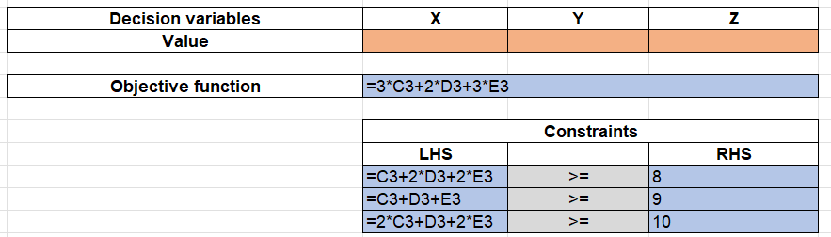
Figure 1: Excel Formula Sheet

With these formula in place, the following values were extracted using the Solver.

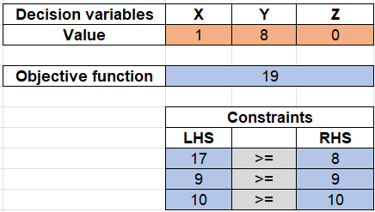
Figure 2: Excel Answer Sheet
Similarly, the following report sheets are generated through the Excel Solver.
Answer Report:

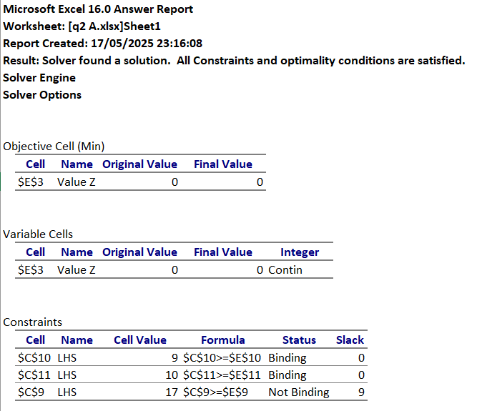
Figure 3: Answer Report

The answer report shows the final value of decision variables and if each constraint is satisfied or not.
From the answer report as well as the answer sheet we can see that the optimal solution for the problem is:
1 unit of Food A (X)
8 units of Food B (Y)
0 units of Food C (Z)
This combination gives a minimum cost of $19 with all the nutritional requirements (constraints) met. Both the carbohydrate and minerals requirements are exactly met.
Sensitivity Report:

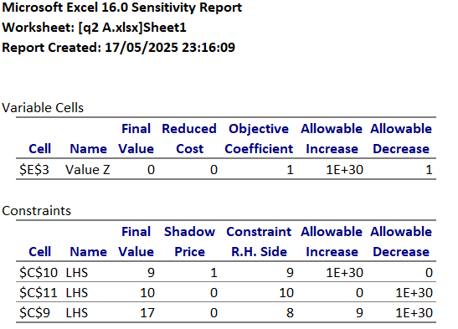
Figure 4: Sensitivity Report

The sensitivity report shows the sensitivity of the LPP. It shows how much the objective function would change in case of change in RHS or constraint coefficients.
Form the report, we can see that
- The requirement for minerals is binding and increase in mineral requirement would also increase the total cost by $1 per unit.
- There is excess supply of vitamin, such that increasing the requirement by at most 9 units would not affect the optimal solution.
- The requirement for carbohydrate is also exactly met but not binding, so any increase in it would not be possible without changing the whole solution.

Limits Report:

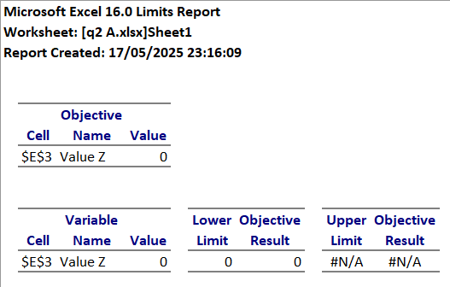
Figure 5: Limits Report

The limits report shows how much change the decision variable can take while keeping the optimal solution.
Following are the take aways from the report:
- The Food C is not part of the optimal solution.
- The Food C does not contribute in lowering the total cost and there is also no point in increasing its quantity meaning Food C is not cost-effective under current prices.

In conclusion, it was found that
- 1 units of Food A and 8 units of Food B results in the optimal solution.
- Food C is not part of the optimal solution as it is not cost-effective.
- The total minimum cost in the optimal solution is $19.
- The minerals constraint is critical and any increase will lead to increase in total cost.

d)

Memorandum

Date: 17th May, 2025
To: Berkshire Health Care
From: Jonny Boi, Nutrition Consultant
Subject: Recommended Food Plan for Minimum Cost
To Director, Nutrition Services Department,
I hope this message finds you well, the following memo is to provide the recommended combination of the available foods that satisfies the patients dietary needs while keeping the cost as low as possible.
After carefully analyzing the nutritional content and cost of each food item, the following quantity of food products was found to be the most optimal:
Food A: 1 Unit per patient (Cost: $3)
Food B: 8 Units per patient (Cost: $16)
Food C: Not required for dietary needs (Cost: $0)
The total cost comes out to be $19.
This food plan ensures the patient gets at least 8 units of Vitamins, 9 units of Minerals and 10 units of Carbohydrates while also keeping the cost minimum.
I recommend implementing this food combination part of standard diet dietary plan. It achieves the right balance between cost-efficiency and nutrition ampleness.
Please feel free to reach out to us if you wish a breakdown of how this plan was calculated or to discover alternative combinations in case of change in guidelines.
Sincerely,
Jonny Boi
Nutrition consultant

Problem 2 Part B
Mr. Harris requires minimum 10,12 and 12 units of chemicals A, B and C respectively for his garden. A liquid product contains 5, 2 and 1 units of A, B and C respectively per jar. A dry product contains 1, 2 and 4 units of A, B and C per carton. If the liquid product cost £ 3 per jar and dry product cost £ 2 per cartoon, how many of each should Harris purchase in order to minimize the cost and meet the requirements.
Formulate this problem and solve it graphically

Solution:
According to the given question,
Mr.Harris requires a minimum of 10, 12, and 12 units of chemicals A, B and C respectively for his garden.
A liquid product contains 5, 2 and 1 units of A, B and C respectively per jar.
A dry product contains 1, 2 and 4 units of A, B and C per cartoon.
Given, liquid product costs £ 3 per jar and dry product costs £ 2 per cartoon.
Formulating the problem,
Let x be the liquid product and y be the dry product.
For liquid product,
5 units of Chemical A
2 units of Chemical B
1 unit of Chemical C
For dry product,
1 unit of Chemical A
2 units of Chemical B
4 units of Chemical C
For Objective function,
Minimize $Z = 3x + 2y$
For Constraints,
$5x+y≥10$ (Chemical A constraint)
$2x+2y≥12$ (Chemical B constraint)
$x+4y≥12$ (Chemical C constraint)
$x, y≥0$ (non-negative constraint)

Let the boundary of inequality for $5x+y≥10$ be $5x+y=10$
X | 0 | 2
Y | 10 | 0

For Origin Test,
$$5x+y≥10$$
$$5*0+0≥10$$
$0≥10$ (False)
Hence, It lies away from origin

Similarly, let the boundary of inequality for $2x+2y≥12$ be $2x+2y=12$
X | 0 | 6
Y | 6 | 0

For Origin test,
$$2x+2y≥12$$
$$2*0+2*0≥12$$
$0≥12$ (False)
Hence, it lies away from origin

Finally, let the boundary of inequality for $x+4y≥12$ be $x+4y=12$
X | 0 | 12
Y | 3 | 0

For Origin test,
$$x+4y≥12$$
$$0+4*0≥12$$
$0≥12$ (False)

Creating a graph
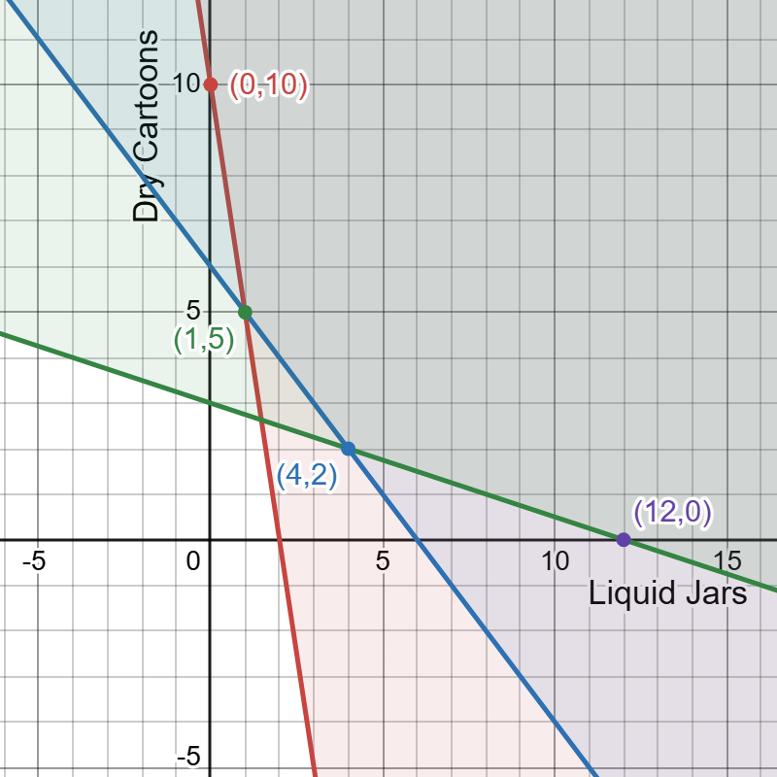
From graph, the common region of all lines away from the origin is the feasible region
Vertex | X | Y | $$Z = 3x + 2y$$
(0,10) | 0 | 10 | 20
(1,5) | 1 | 5 | 13 (Minimum)
(4,2) | 4 | 2 | 16
(12,0) | 12 | 0 | 36

Therefore, Mr. Harris should purchase 1 liquid product and 5 dry products to meet his requirement and minimize the cost.

Problem 3
If the revenue function for a manufacturing company is R(x) = 10 – x and the total cost function is C(x) = x2 - 8x + 20, where x is output.
Questions
a) Find the breakeven points (round in 3 decimal places). Briefly explain the breakeven points in terms of number of items and cost.
b) Plot the revenue and cost functions on graph, showing the accurate break-even output levels and corresponding price.
c) Determine the profit function P(𝑥), for the company and find,
(i) The level production that maximizes the profit.
(ii) The maximum profit
Solution
The breakeven point is the point where the total revenue and the total cost are equal, meaning that there is neither profit nor loss. This point occurs in a graph between the sales and the cost at the point of intersection. Before this point, the sales are less than cost so there is loss and after this point the sales are more than cost so there is profit.
At breakeven point,
$$Total cost=Revenue$$
There are numerous basic terms used while finding the breakeven points, they are explained below:
1. Cost price
The cost price is the original price of the item when it is bought, for example if a clothing shop buys a shirt for Rs. 2000 then the cost price of the shirt is Rs. 2000. The cost price is the price that the shop pays while buying a product.
2. Selling Price
The selling price is the price at which the item is sold to the customers. It is the price, the shopkeepers keep for a product when selling to the customer. As an example, the shirt which the shop bought for Rs. 2000 can be sold for Rs. 3000, so the selling price of the shirt is Rs. 3000.
3. Fixed Cost
The cost that do not change with respect to the number of items sold, they can be various things such as the rent, the initial cost of starting the business or insurance as well. They are the constant cost that do not change.
4. Variable Cost
These costs are the cost that change depending on the number of the items sold or produced, then can be seen as the cost to product the items. For example the making a bicycle make cost Rs 5000 per bicycle, but since the number of bicycle production varies, the cost of production changes as well. Thus this is variable cost.
5. Revenue
The revenue is the total money earned from the sales of the products. Revenue can also be said to be a product of the selling price and the number of items sold.
$$Revenue=Selling Price*Number of items sold$$
6. Profit
The profit is the money after subtracting all costs from the revenue. It is the difference between the total revenue and the total cost.
$$Profit=Revenue-Total Cost$$
According to the question,
The revenue function for a manufacturing company is given by,
$$R\left(x\right)=10-x$$
The total cost function is given by,
$$C\left(x\right)=x^{2}-8x+20$$
Here x is output
a) Find the breakeven points (round in 3 decimal places). Briefly explain the breakeven points in terms of number of items and cost.
Here,
At breakeven point
$$Revenue=Cost$$
$$R\left(x\right)=C\left(x\right)$$
$$10-x=x^{2}-8x+20$$
$$0=x^{2}-8x+x+20-10$$
$$0=x^{2}-7x+10$$
$$x^{2}-7x+10=0$$
Comparing $x^{2}-7x+10=0$ with $ax^{2}+bx+c=0$
We get, a=1, b=-7, c=10
Using quadratic equation formula
$$x=\frac{-b±\sqrt{b^{2}-4ac}}{2a}$$
$$x=\frac{ 7±\sqrt{{\left(-7\right)}^{2}-4*1*10} }{2}$$
$$x=\frac{7±\sqrt{49-40} }{2}$$
$$x=\frac{7+\sqrt{9} }{2}$$
$$x=\frac{7±3 }{2}$$
The value can have two forms.
Positive
$$x_{1}=\frac{ 7+3}{2}$$
$$x_{1}=\frac{10}{2}$$
$$x_{1}=5.000$$
Negative
$$x_{2}=\frac{ 7-3 }{2}$$
$$x_{2}=\frac{4}{2}$$
$$x_{2}=2.000$$
Now, for the corresponding points of x
When x=5.000
$$C\left(x\right)=x^{2}-8x+20$$
$$C\left(5.000\right)={\left(5.000\right)}^{2}-8*5.000+20$$
$$C\left(5.000\right)=5.000$$
When x=2.000
$$C\left(x\right)=x^{2}-8x+20$$
$$C\left(2.000\right)={\left(2.000\right)}^{2}-8*2.000+20$$
$$C\left(2.000\right)=8.000$$
So the breakeven points are (5.000, 5.000) and (2.000, 8.000).
In terms of number of items and costs, the breakeven points occur when the number of items and cost are both 5.000 and breakeven point occurs when number of items in 2.000 and cost is 8.000.
b) Plot the revenue and cost functions on graph, showing the accurate break-even output levels and corresponding price.
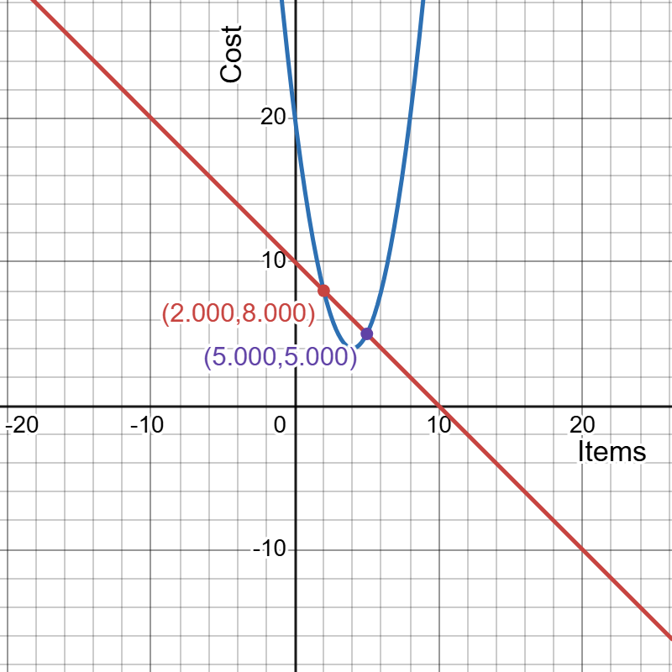
With the help of desmos.com, the revenue and cost functions were plotted in the graph and breakeven points were shown. The breakeven points are (2.000, 8.000) and (5.000, 5.000).
c) Determine the profit function P(𝑥), for the company
We know,
$$Profit=Revenue-Cost$$
So,
$$P\left(x\right)=R\left(x\right)-C\left(x\right)$$
$$P\left(x\right)=10-x-\left(x^{2}-8x+20\right)$$
$$P\left(x\right)=10-x-x^{2}+8x-20$$
$$P\left(x\right)=-x^{2}+7x-10$$
Thus,
$$Profit function, P\left(x\right)=-x^{2}+7x-10$$
(i) The level production that maximizes the profit.
The level production that maximizes the profit is given by,
$$Level of production,x=\frac{ -b}{2a}$$
Comparing $ax^{2}+bx+c to P\left(x\right)=-x^{2}+7x-10,$
$$a=-1, b=7,c=-10$$
Now,
Level of production
$$x=\frac{ -b}{2a}, where a=-1,b=7$$
$$x=-\frac{7}{2*(-1)}$$
$$x=-\frac{7}{-2}$$
$$x=3.5$$
So, the level of production that maximizes the product is 3.5.
(ii) The maximum profit
The maximum profit is given by profit function when Level of production, $x=3.5.$
So,
$$P\left(x\right)=-x^{2}+7x-10$$
$$P\left(3.5\right)={\left(-3.5\right)}^{2}+7*3.5-10$$
$$P\left(3.5\right)=2.25$$
Thus, the maximum profit is 2.25 when the level of production is 3.5.

Overall Conclusion
In this coursework, we use logical reasoning and mathematical techniques to solve problems related to tax system and some Linear Programming calculations. Through proper formulation and analysis, we identified optimal solutions that satisfy the given constraints with question’s requirements.
Overall, this coursework encouraged critical thinking, team synergy, and the ability to convert practical situations into structured mathematical models. The experience has refined our problem-solving skills and decision-making process.

References
Idk bro, find some shi and add references for me :>

Meeting logs

Logbook Entry Sheet

Meeting No: 1 Date: 4th May
Start Time: 10:00 AM Finish Time: 10:45AM

Items Discussed:
General Idea of how we are going to solve each question
We also discussed which member is going to handle which question

Achievements:
Set goals for each member of the group

Problems (if any):
We did not encounter any problem in this meeting

Tasks for Next Meeting:
Discuss and analyse each problem with a rough work in paper
Student’s Name | Student’s Signature
Aashraya Belbase
Suvham Shakya
Rizen Shrestha

Logbook Entry Sheet

Meeting No: 2 Date: 7th May
Start Time: 3:00 PM Finish Time: 4:30 PM

Items Discussed:
Rough solutions for each problem. Deep analysis for problem 2 part A

Achievements:
Complete solution for problem 2 and general idea for problem 1 and 3.

Problems (if any):
Problem 1 part A had different answers for two of us

Tasks for Next Meeting:
Complete solutions for each question in word file.
Student’s Name | Student’s Signature
Aashraya Belbase
Suvham Shakya
Rizen Shrestha

Logbook Entry Sheet

Meeting No: 3 Date: 12th May
Start Time: 1:00 PM Finish Time: 2:00 PM

Items Discussed:
All complete solutions for all questions

Achievements:
Completely discussed each question and cross checked for correct answers

Problems (if any):
No problems were encountered

Tasks for Next Meeting:
Discuss the format of the project and final check for submission report
Student’s Name | Student’s Signature
Aashraya Belbase
Suvham Shakya
Rizen Shrestha

Logbook Entry Sheet

Meeting No: 4 Date: 14th May
Start Time: 3:00 PM Finish Time: 4:30 PM

Items Discussed:
Final word file and format

Achievements:
Completely checked the final word file

Problems (if any):
Acknowledgements were not included

Tasks for Next Meeting:
No further meetings were scheduled
Student’s Name | Student’s Signature
Aashraya Belbase
Suvham Shakya
Rizen Shrestha

Rough work in Paper