**作业1：知识图谱数据模型与查询语言**

**小组成员：___________________________**

1. 使用Jena Fuseki导入music_1000_triples.nt数据集（从智慧树下载），执行课程视频“实战-Jena.mp4”中所演示的所有SPARQL查询，并给出查询结果截图。

**给出music_1000_triples.nt数据集导入成功截图：**

(1) 查询1

**SPARQL语句：**

PREFIX music: <http://kg.course/music/>

SELECT DISTINCT ?trackID

WHERE {

?trackID music:track_artist music:artist_001

}

**查询结果截图：**

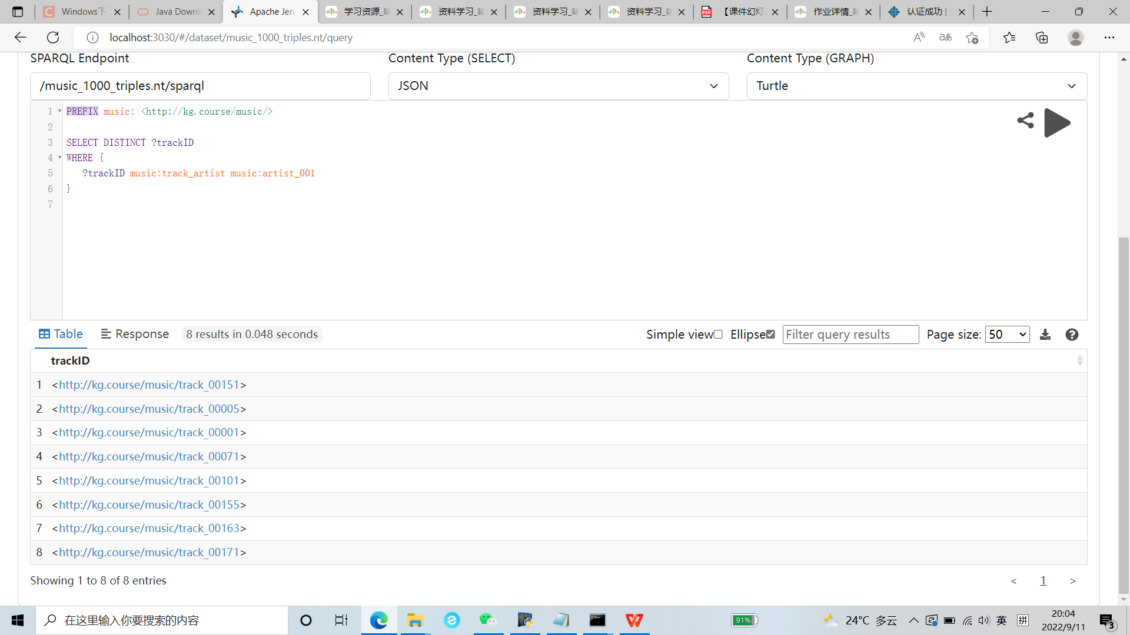

(2) 查询2

**SPARQL语句：**

PREFIX music: <http://kg.course/music/>

SELECT DISTINCT ?trackID ?name

WHERE {

?trackID music:track_artist music:artist_001 .

?trackID music:track_name ?name

}

**查询结果截图：**

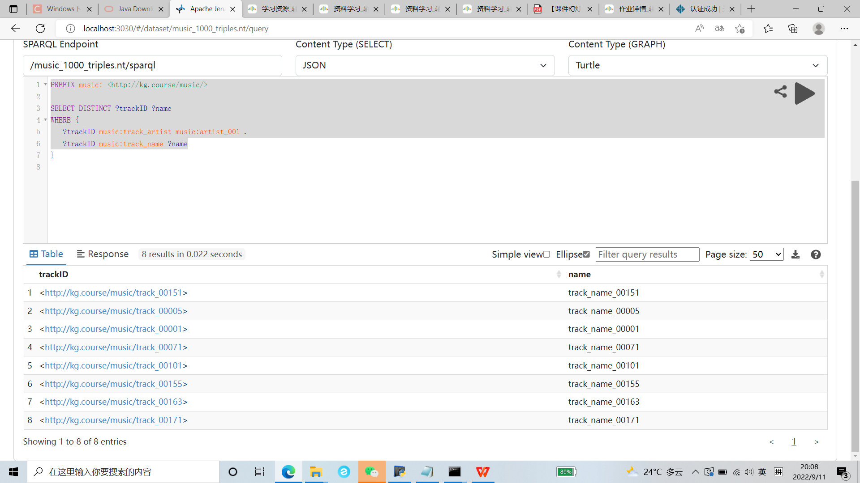

(3) 查询3

**SPARQL语句：**

PREFIX music: <http://kg.course/music/>

SELECT ?trackID ?albumID ?name

WHERE {

?trackID music:track_name "track_name_00001" .

?trackID music:track_album ?albumID .

?albumID music:album_name ?name

}

**查询结果截图：**

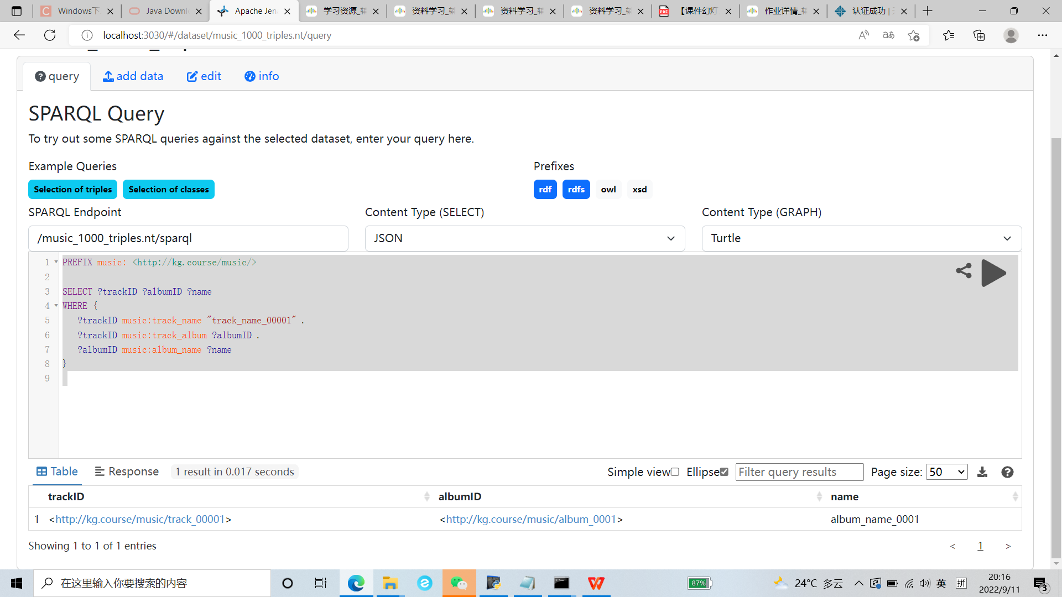

(4) 查询4

**SPARQL语句：**

PREFIX music: <http://kg.course/music/>

SELECT ?歌曲ID ?专辑ID ?专辑名

WHERE {

?歌曲ID music:track_name "track_name_00001" .

?歌曲ID music:track_album ?专辑ID .

?专辑ID music:album_name ?专辑名

}

**查询结果截图：**

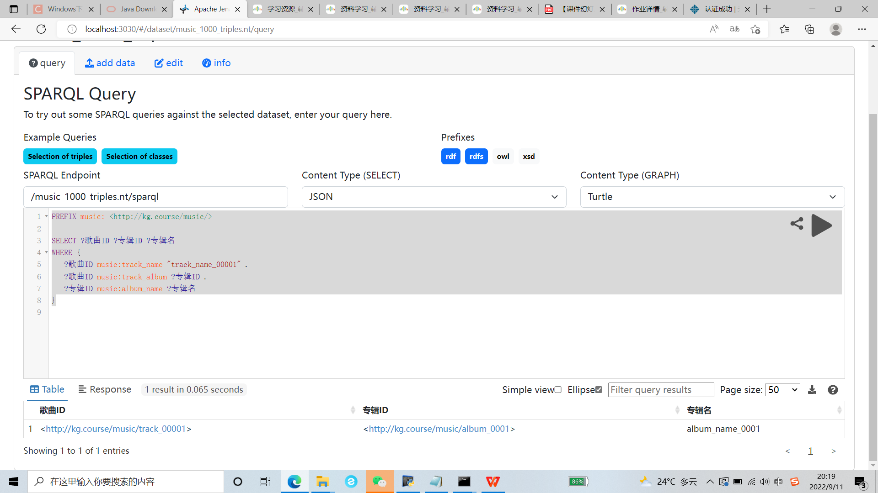

(5) 查询5

**SPARQL语句：**

PREFIX music: <http://kg.course/music/>

SELECT ?歌曲ID ?专辑ID (CONCAT ("专辑名", ":", ?专辑名) AS ?专辑信息)

WHERE {

?歌曲ID music:track_name "track_name_00001" .

?歌曲ID music:track_album ?专辑ID .

?专辑ID music:album_name ?专辑名

}

**查询结果截图：**

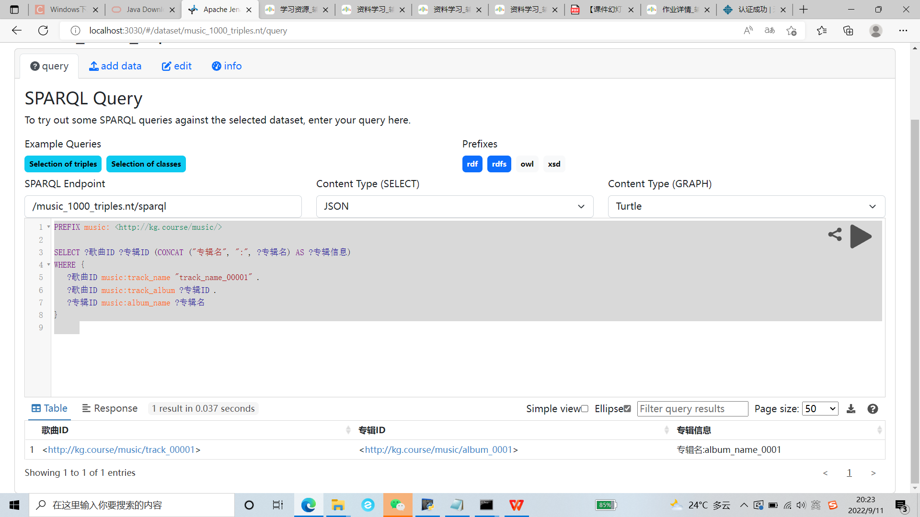

(6) 查询6

**SPARQL语句：**

PREFIX music: <http://kg.course/music/>

SELECT ?trackID

WHERE {

?albumID music:album_name "album_name_0002" .

?trackID music:track_album ?albumID

}

**查询结果截图：**

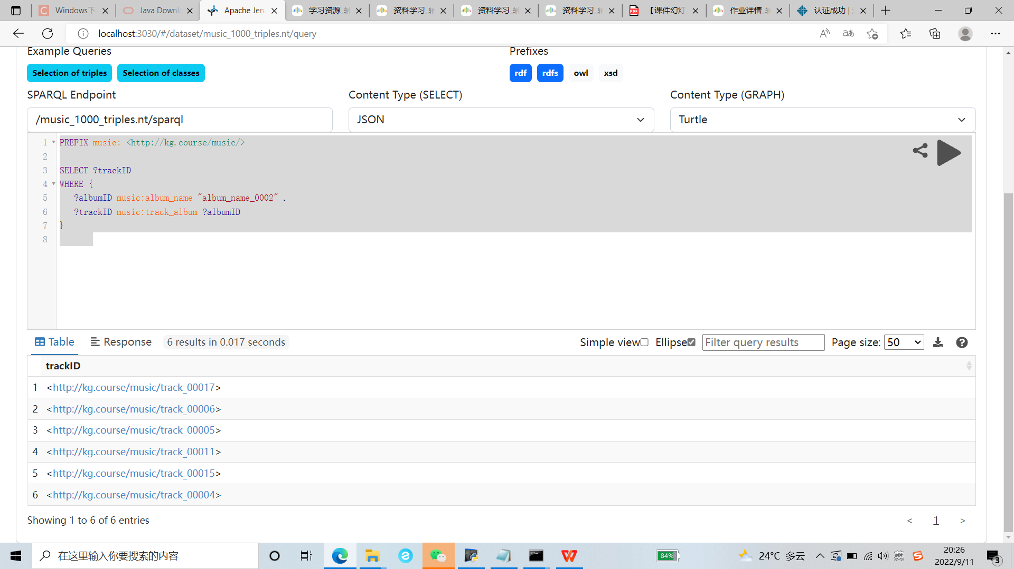

(7) 查询7

**SPARQL语句：**

PREFIX music: <http://kg.course/music/>

SELECT ?trackID

WHERE {

?albumID music:album_name "album_name_0002" .

?trackID music:track_album ?albumID

}

LIMIT 2

**查询结果截图：**

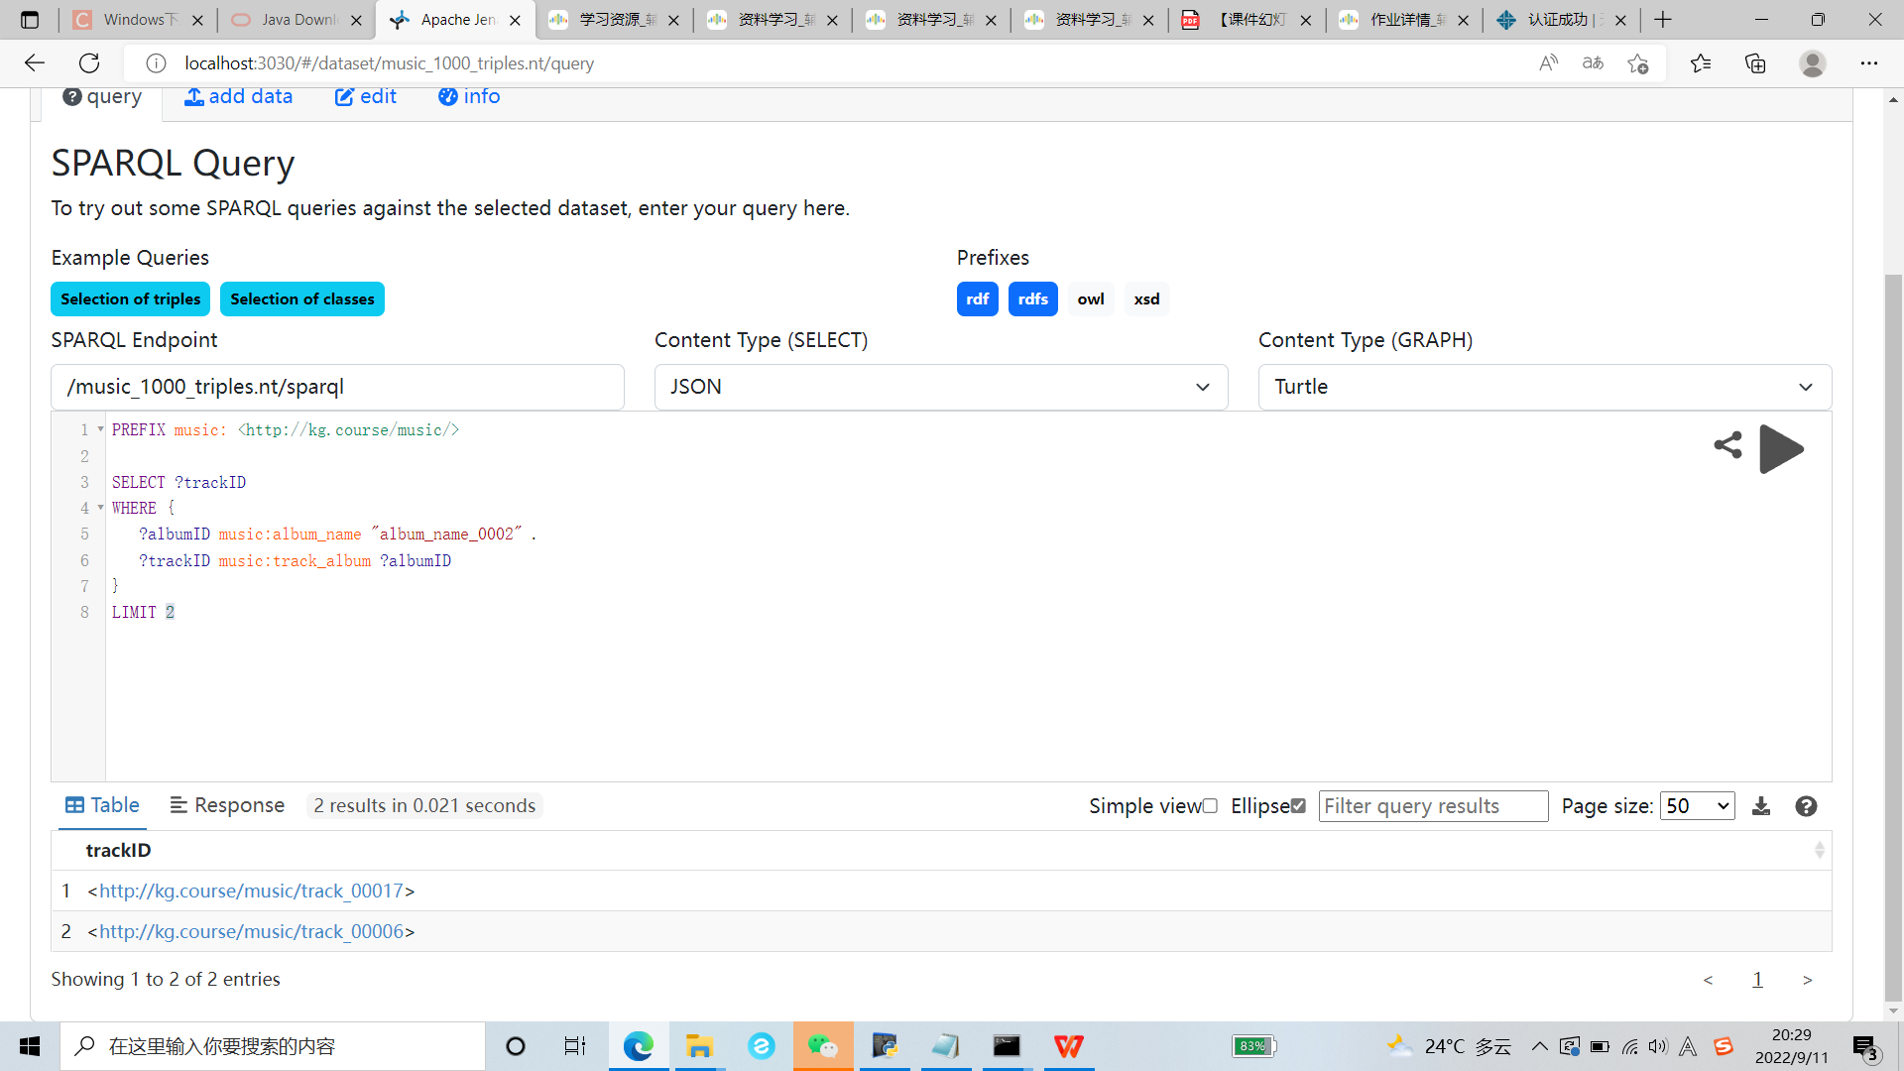

(8) 查询8

**SPARQL语句：**

PREFIX music: <http://kg.course/music/>

SELECT (COUNT(?trackID) AS ?num)

WHERE {

?albumID music:album_name "album_name_0002" .

?trackID music:track_album ?albumID

}

**查询结果截图：**

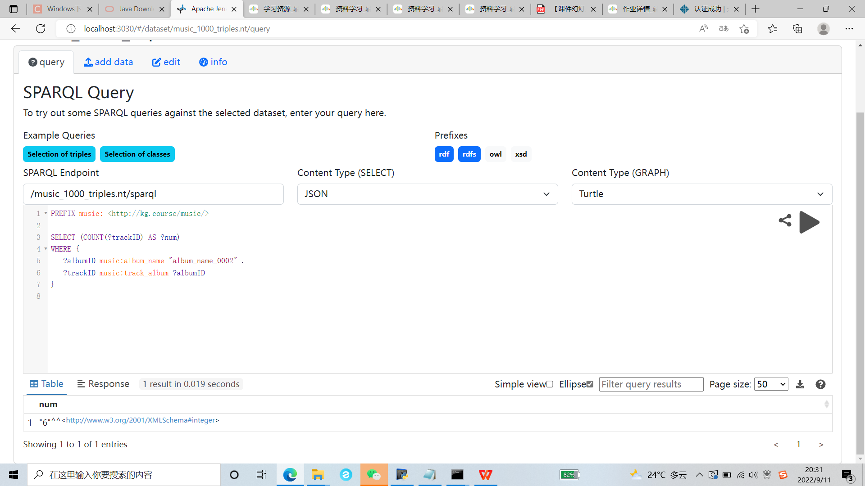

(9) 查询9

**SPARQL语句：**

PREFIX music: <http://kg.course/music/>

SELECT ?trackID ?artistID

WHERE {

?trackID music:track_name "track_name_00001" .

?trackID music:track_artist ?artistID

}

**查询结果截图：**

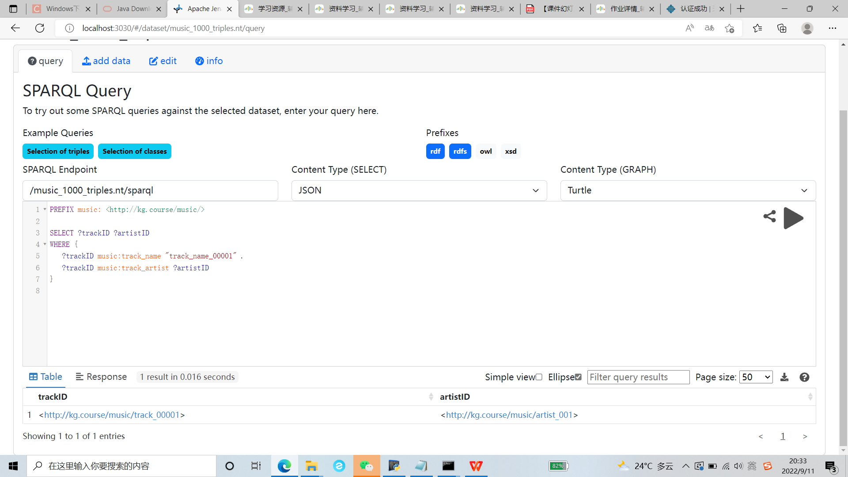

(10) 查询10

**SPARQL语句：**

PREFIX music: <http://kg.course/music/>

SELECT ?trackID ?tag_name

WHERE {

?trackID music:track_name "track_name_00001" .

?trackID music:track_tag ?tag_name

}

**查询结果截图：**

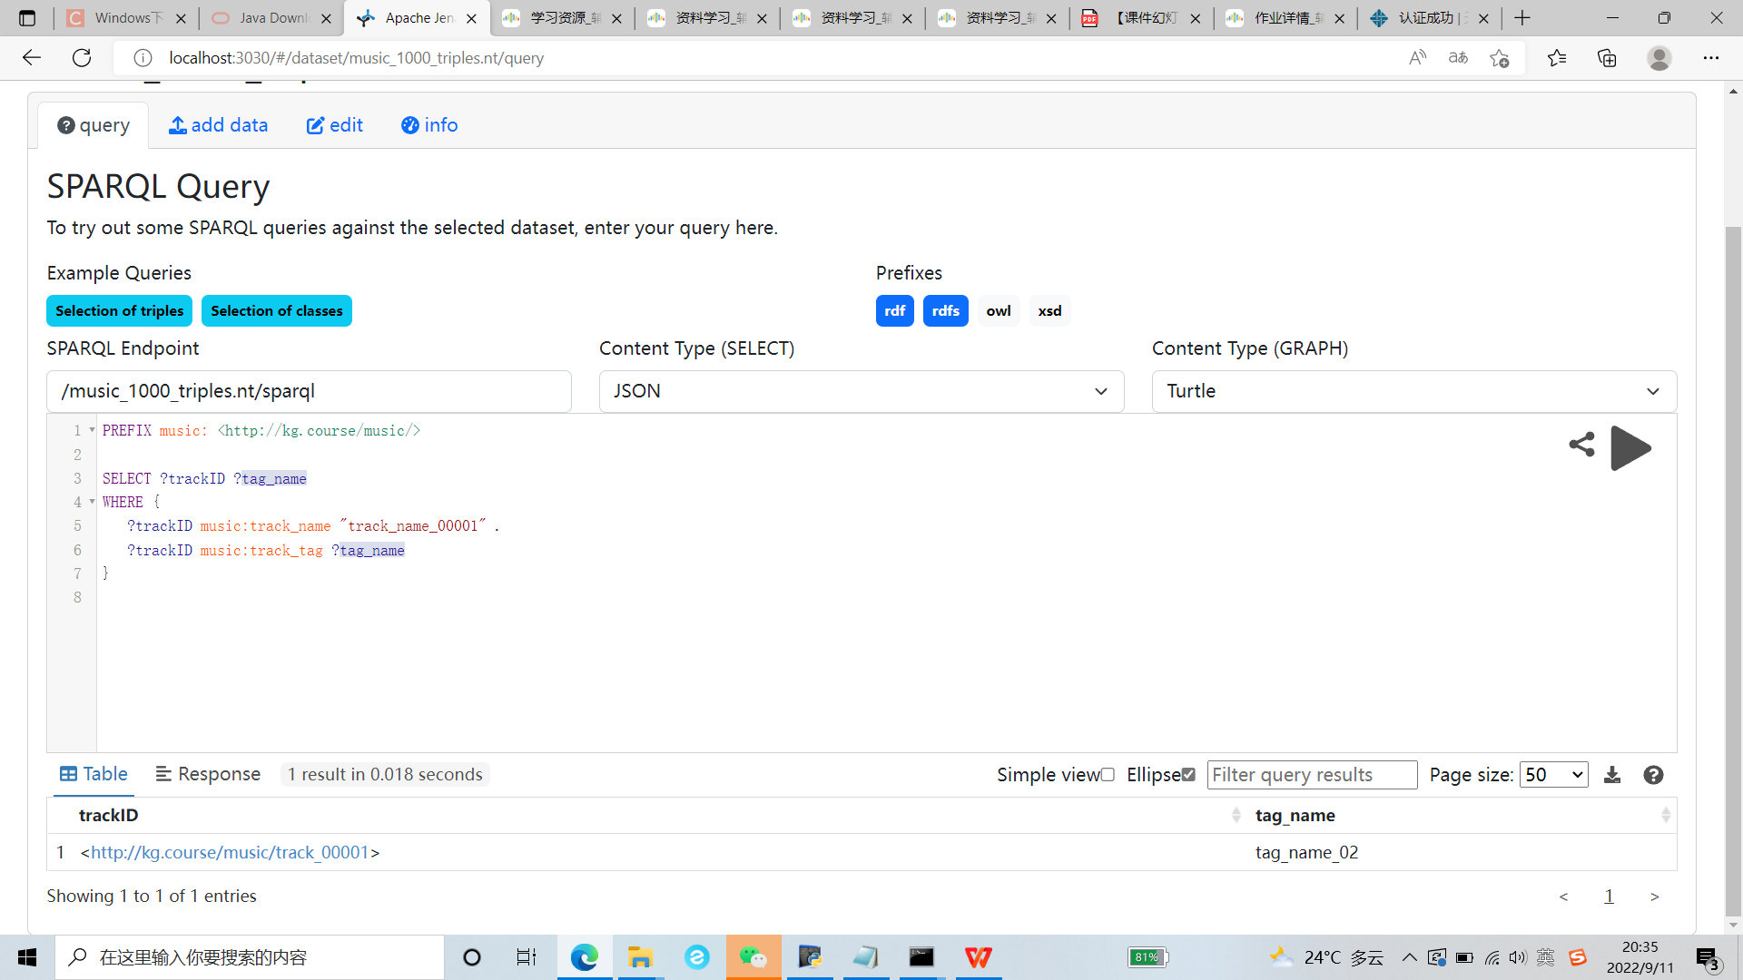

(11) 查询11

**SPARQL语句：**

PREFIX music: <http://kg.course/music/>

SELECT ?tag_name

WHERE {

?trackID music:track_artist music:artist_001 .

?trackID music:track_tag ?tag_name

}

**查询结果截图：**

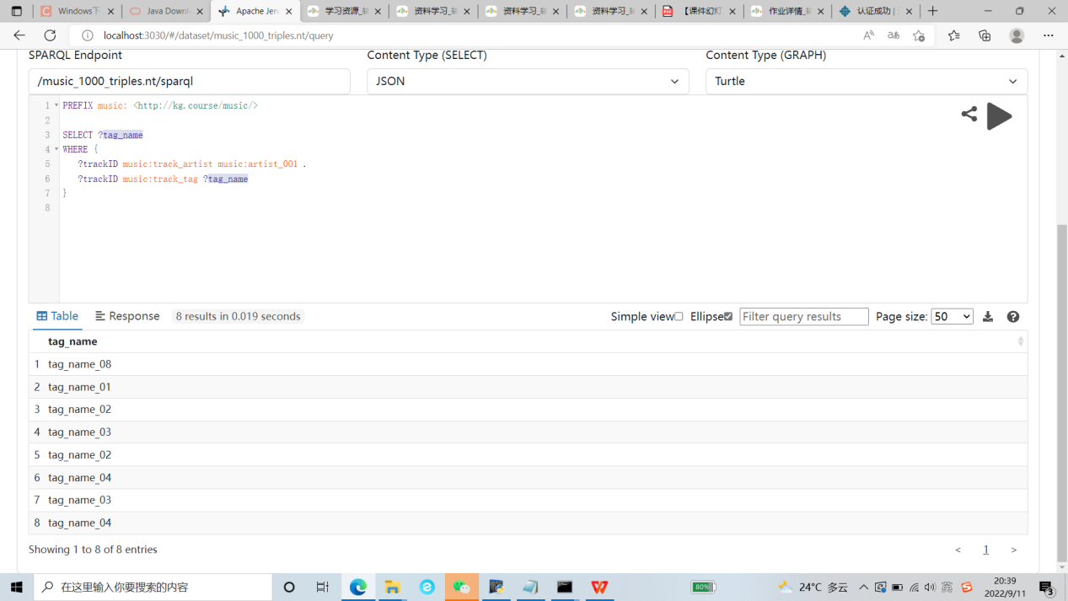

(12) 查询12

**SPARQL语句：**

PREFIX music: <http://kg.course/music/>

SELECT DISTINCT ?tag_name

WHERE {

?trackID music:track_artist music:artist_001 .

?trackID music:track_tag ?tag_name

}

**查询结果截图：**

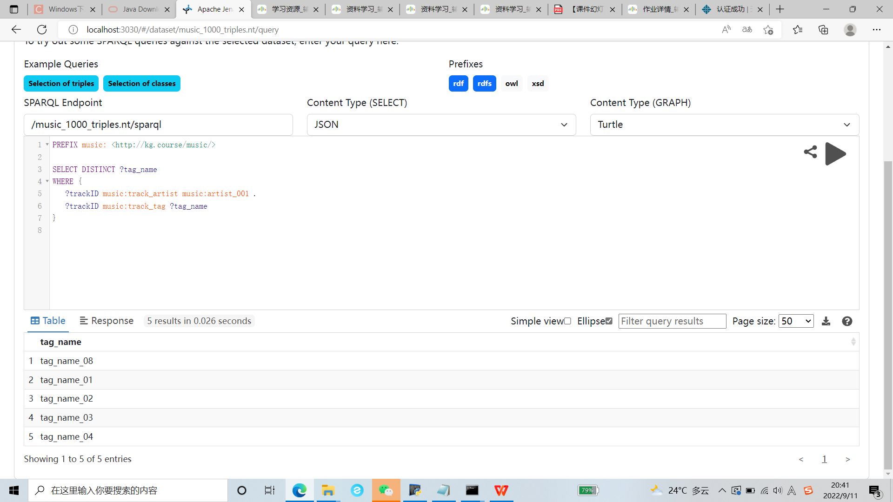

(13) 查询13

**SPARQL语句：**

PREFIX music: <http://kg.course/music/>

SELECT DISTINCT ?tag_name

WHERE {

?trackID music:track_artist music:artist_001 .

?trackID music:track_tag ?tag_name

}

ORDER BY ?tag_name

**查询结果截图：**

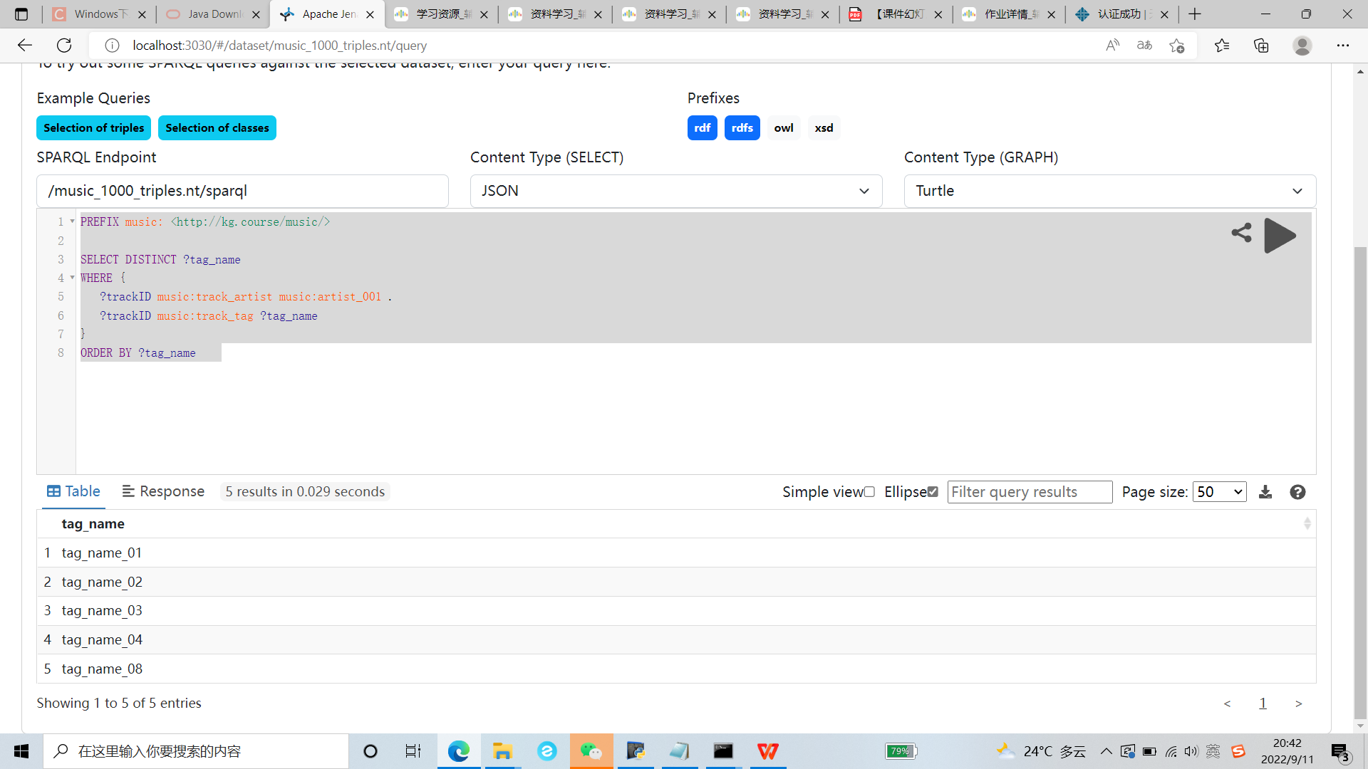

(14) 查询14

**SPARQL语句：**

PREFIX music: <http://kg.course/music/>

SELECT DISTINCT ?tag_name

WHERE {

?trackID music:track_artist music:artist_001 .

?trackID music:track_tag ?tag_name

}

ORDER BY DESC (?tag_name)

**查询结果截图：**

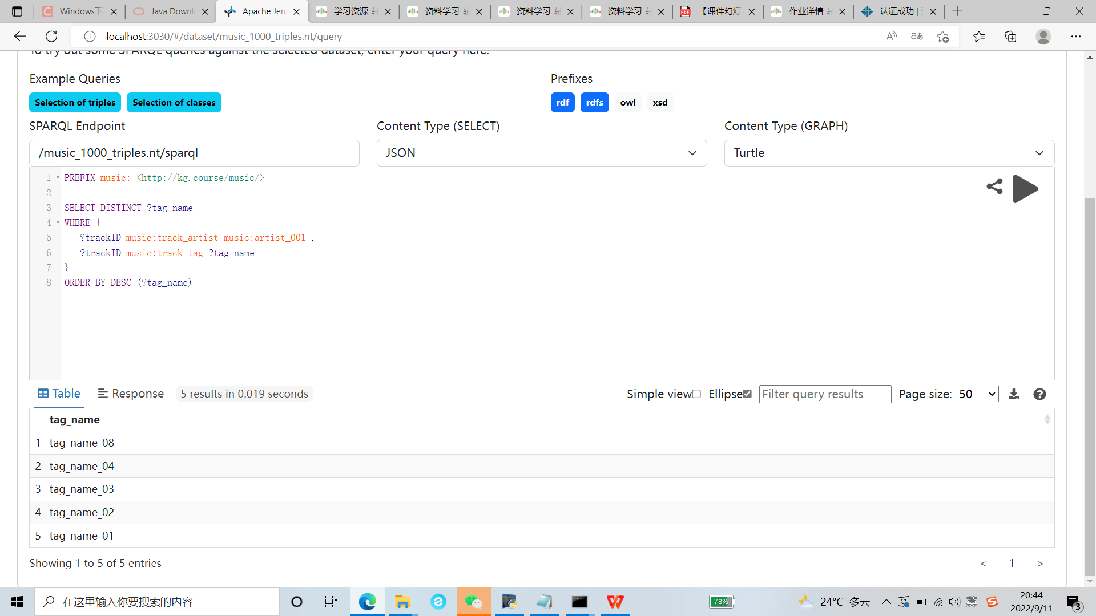

(15) 查询 15

**SPARQL语句：**

PREFIX music: <http://kg.course/music/>

SELECT (COUNT(?trackID) AS ?num)

WHERE {

{?trackID music:track_tag "tag_name_01" .}

UNION

{?trackID music:track_tag "tag_name_02" .}

}

**查询结果截图：**

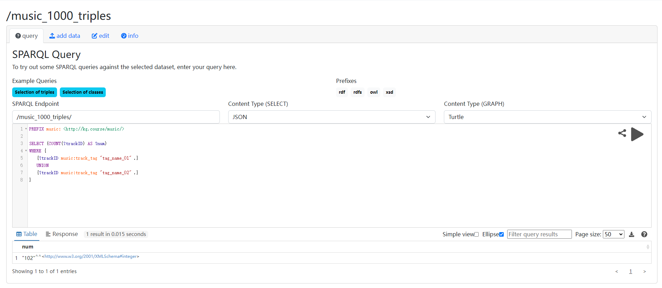

(16) 查询16

**SPARQL语句：**

PREFIX music: <http://kg.course/music/>

SELECT (COUNT(?trackID) AS ?num)

WHERE {

?trackID music:track_tag ?tag_name

FILTER (?tag_name = "tag_name_01" || ?tag_name = "tag_name_02")

}

**查询结果截图：**

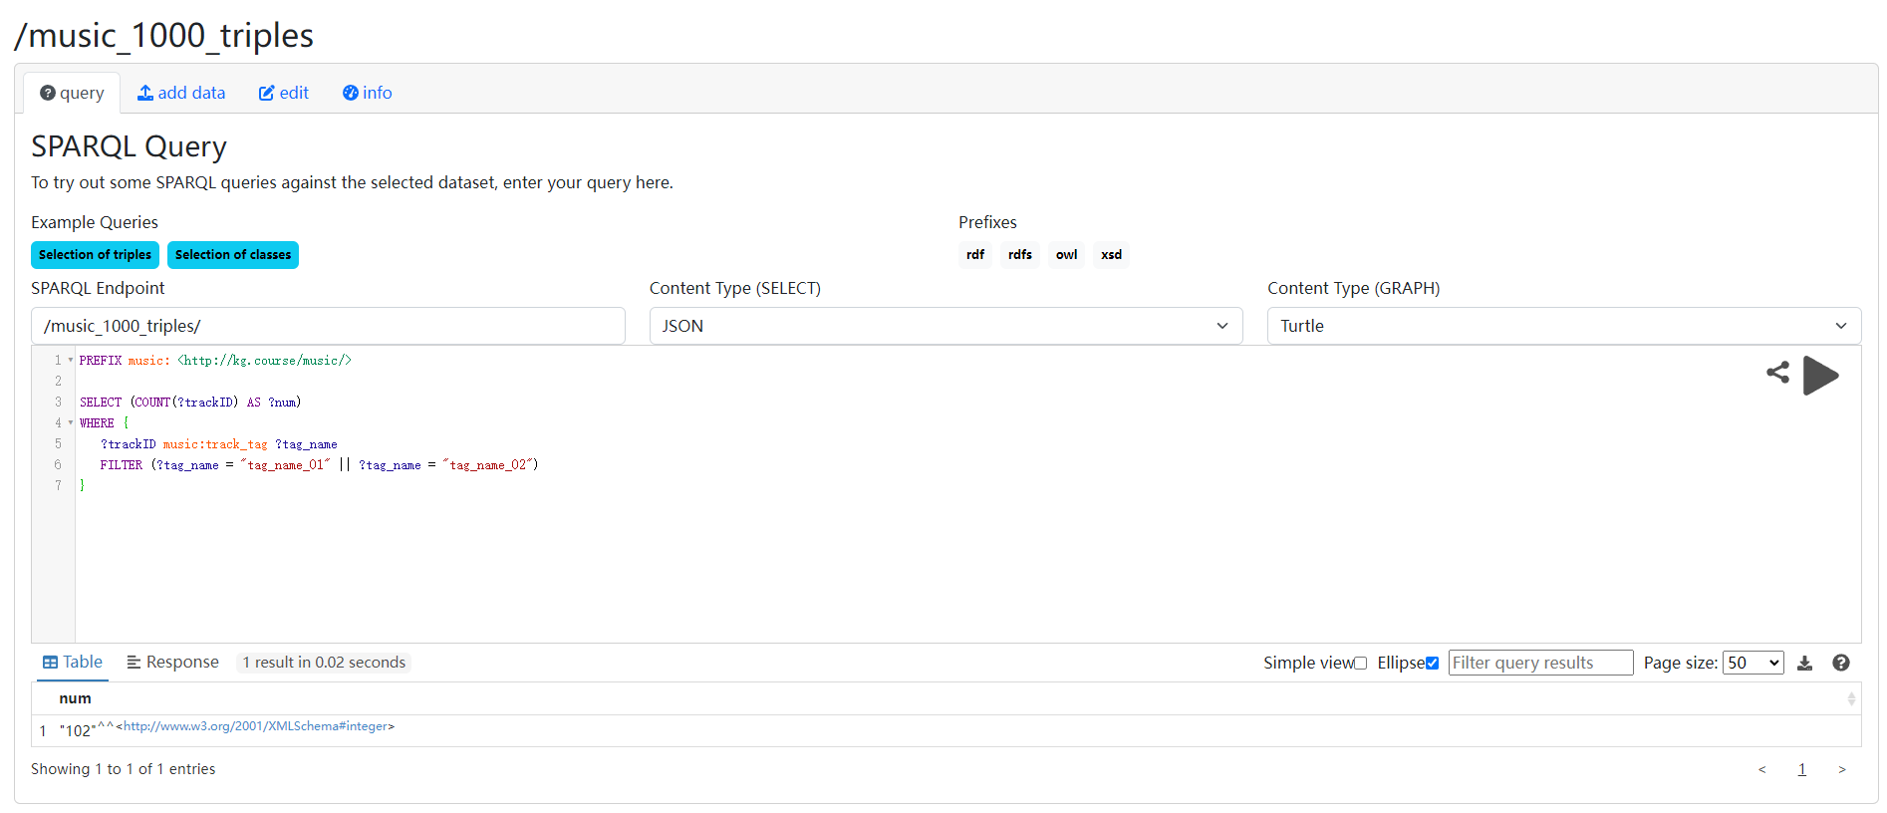

(17) 查询17

**SPARQL语句：**

PREFIX music: <http://kg.course/music/>

ASK {

?trackID music:track_tag ?track_name

FILTER regex (?track_name, "008")

}

**查询结果截图：**

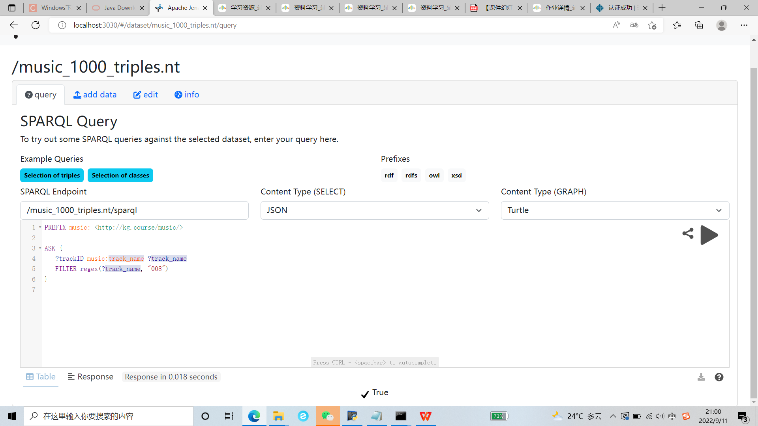

(18) 查询18

**SPARQL语句：**

PREFIX music: <http://kg.course/music/>

INSERT DATA {

music:artist_001 music:artist_name "artist_name_001" .

music:artist_002 music:artist_name "artist_name_002" .

music:artist_003 music:artist_name "artist_name_003" .

}

**查询结果截图：**

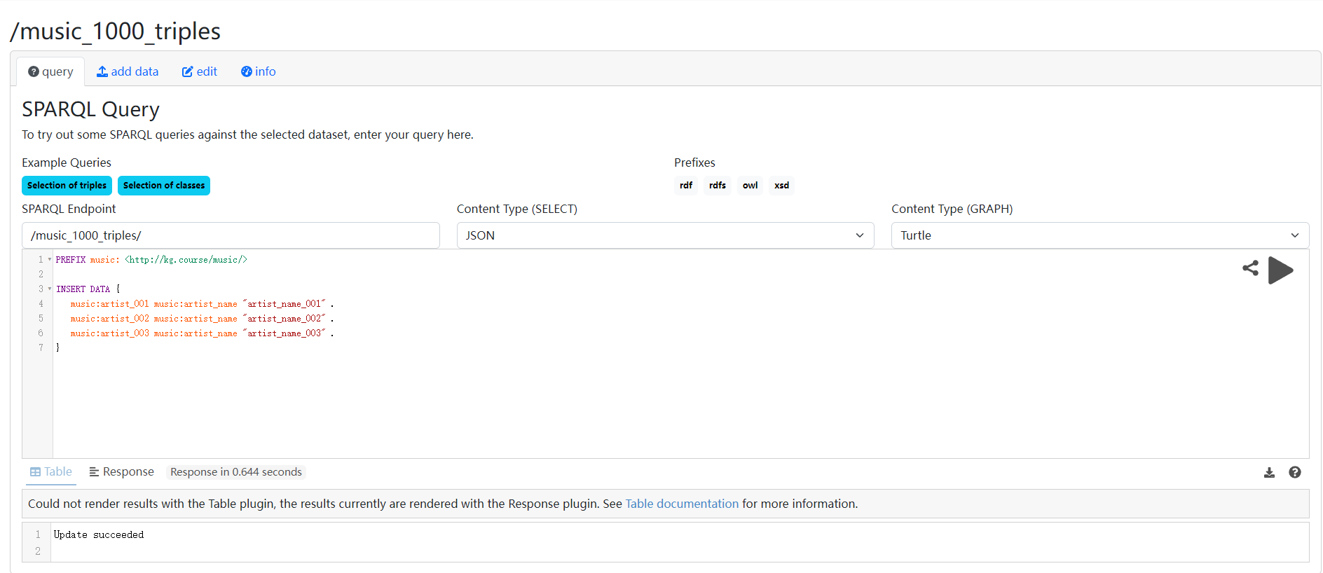

(19) 查询19

**SPARQL语句：**

PREFIX music: <http://kg.course/music/>

SELECT ?artistID ?artist_name {

?artistID music:artist_name ?artist_name

}

**查询结果截图：**

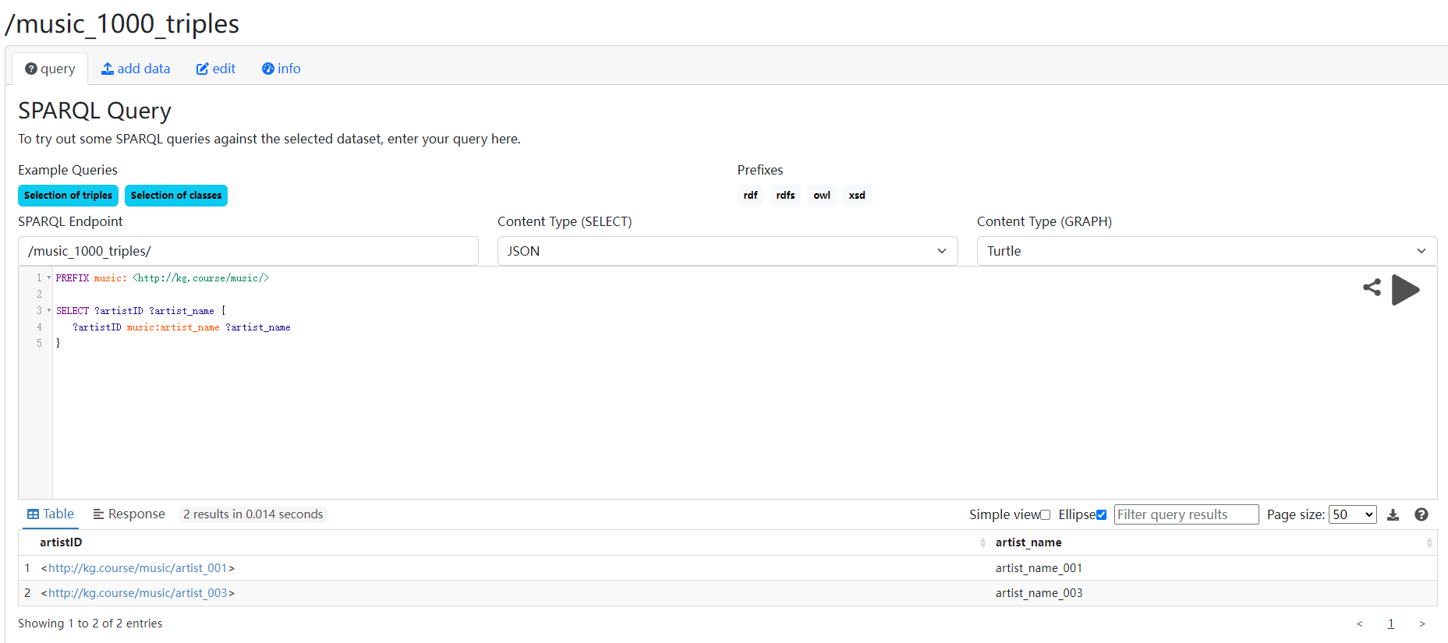

(20) 查询20

**SPARQL语句：**

PREFIX music: <http://kg.course/music/>

DELETE {

music:artist_002 music:artist_name ?x .

}

WHERE{

music:artist_002 music:artist_name ?x .

}

**查询结果截图：**

