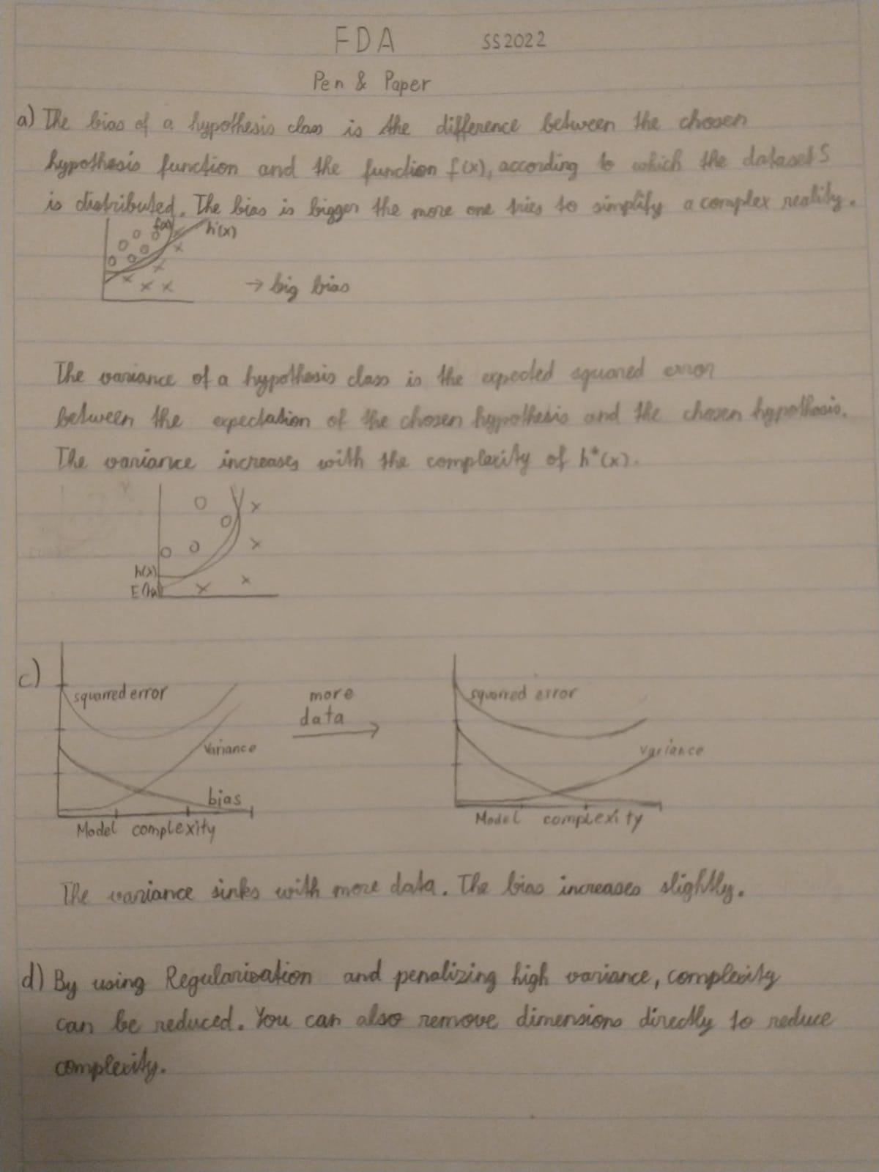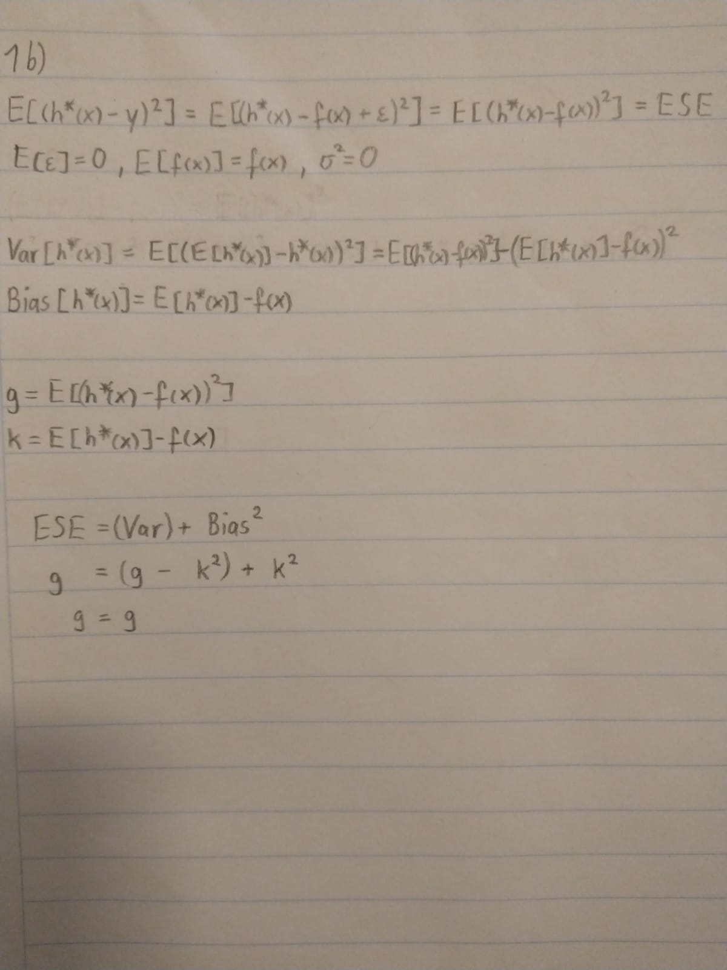

2b)

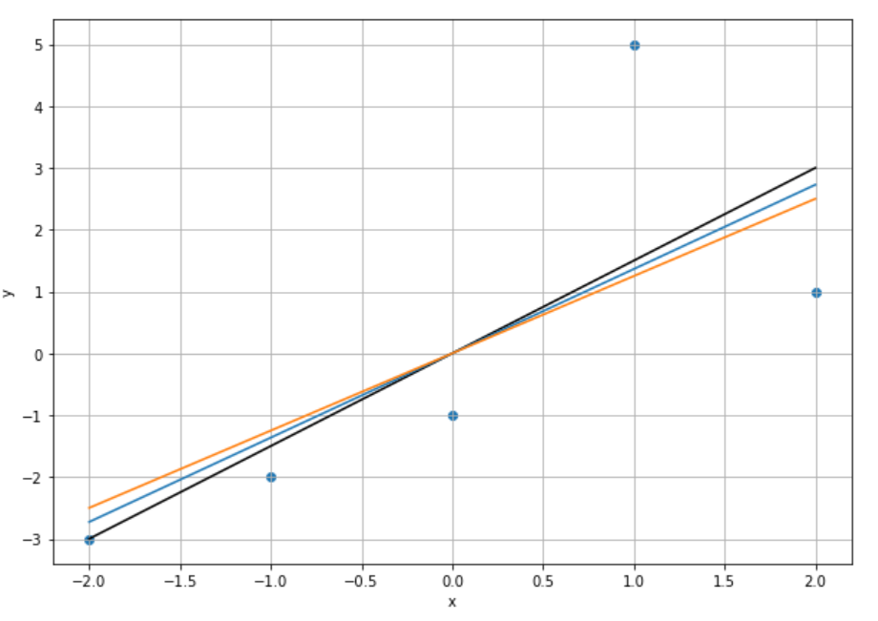

RidgeRegression( lambda =0) => weight = 1.5

RidgeRegression( lambda =1) => weight = 1.36

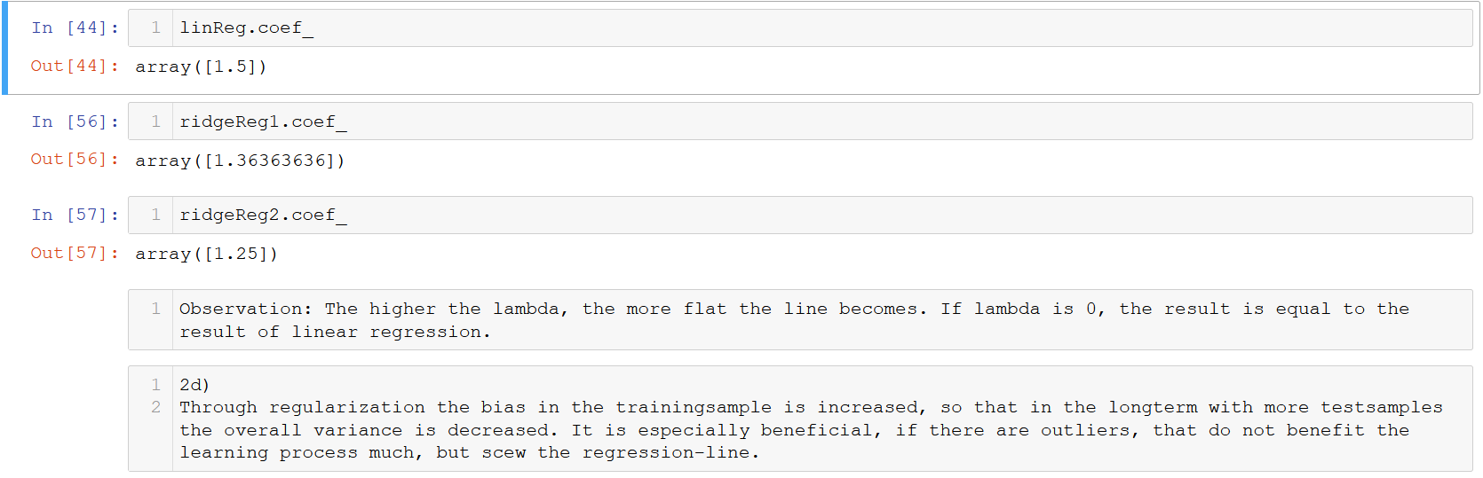RidgeRegression( lambda =2) => weight = 1.25

