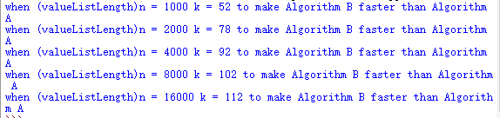

According to the result showing above, we can analyze the table below:

|  |  |  |
| --- | --- | --- |
| ValueListLength(n) | Value to make MB faster(k or F(n)) | F(n)/n |
| 1000 | 52 | 0.052 |
| 2000 | 78 | 0.039 |
| 4000 | 92 | 0.023 |
| 8000 | 102 | 0.01275 |
| 16000 | 112 | 0.007 |

And the line chart below:

For part3,as the line graph analyzed above, As the n increase, the ratio of F(n)/n decreased