Student:Zili Luo

Student#:20001744

CISC 235

Assignment 3

Data Analyze

I confirm that this submission is my own work and is consistent with the Queen's regulations on Academic Integrity.

Part1.

For convert string of lower characters to integer, I convert every character in string to their ASCII and then minus 67 to ensure every character will be converted to two digits (ie. ”a”->30). And put them together (ie. “abc” -> 303132)

Part2 and Part3.

See code part.

Part4.

Run result:

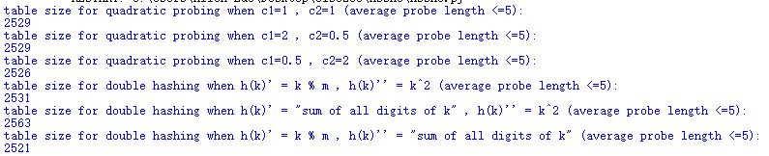

From the result, the average table sizes for double hashing (2538.3) are about 0.4% larger than quadratic probing (2528). So, the result **does not** support the hypothesis that Double Hashing allows us to use smaller tables than Quadratic Probing does, when trying to achieve a particular level of performance.