Student:Zili Luo

Student#:20001744

CISC 235

Assignment 4

Data Analyze

I confirm that this submission is my own work and is consistent with the Queen's regulations on Academic Integrity.

Part1 and Part2.

See code part.

Part3

Running result

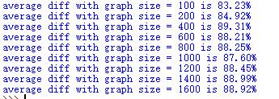

Estimate the expected value of Diff if the graph has 2500 vertices is about 90%