1. 

Well, all information looks like noise until ____________________.

Answer: you break the code

Hint: 0441569595

1. 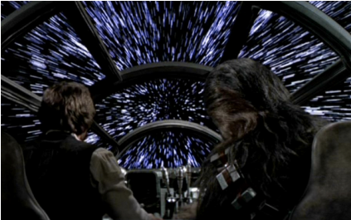

When you finally jump to __________ you win x award

What is X?

Answer- Crazy But Cool

You jump to hyperdrive🡪HyperOs HyperDrive🡪HyperDrive4 (16 GB) won Custom PCs Crazy But Cool award.

HINT: seagate.

1. “We must all try, in every way we can, to send the message that reading is critical to our lives and to the life of our nation.”

/* James H Billngton, created National Book Festival with Laura Bush, wife George bush*/

Answer: George Bush virus

/* This can act as hint:

It starts by boldly stating, "Read my docs....No new files!" on the screen. It proceeds to fill up all the free space on your hard drive with new files, then blames it on the Congressional Virus.*/

1. 

Wake up!

Hint: i) Don’t keep on putting that sound off.

ii) Everything is fair in love

iii) Go for a walk.

Answer: Bletchley Park

1. Ambidextrous

Homonym, erratA, Vernacular, excavatE, Authorization, flinG, Optimistic, hippO, Dangle, trusT, Innocently, triM, Elf

/* Letters are not in caps. This is for our understanding only.*/

/*HAVE A GOOD TIME – goodtime virus- infinite binary loop – binary (novel)*/

Answer: Michael Crichton

Hints: i) Focus on your extremes

ii) Having a bad time?

iii) Apple, Mango, Banana