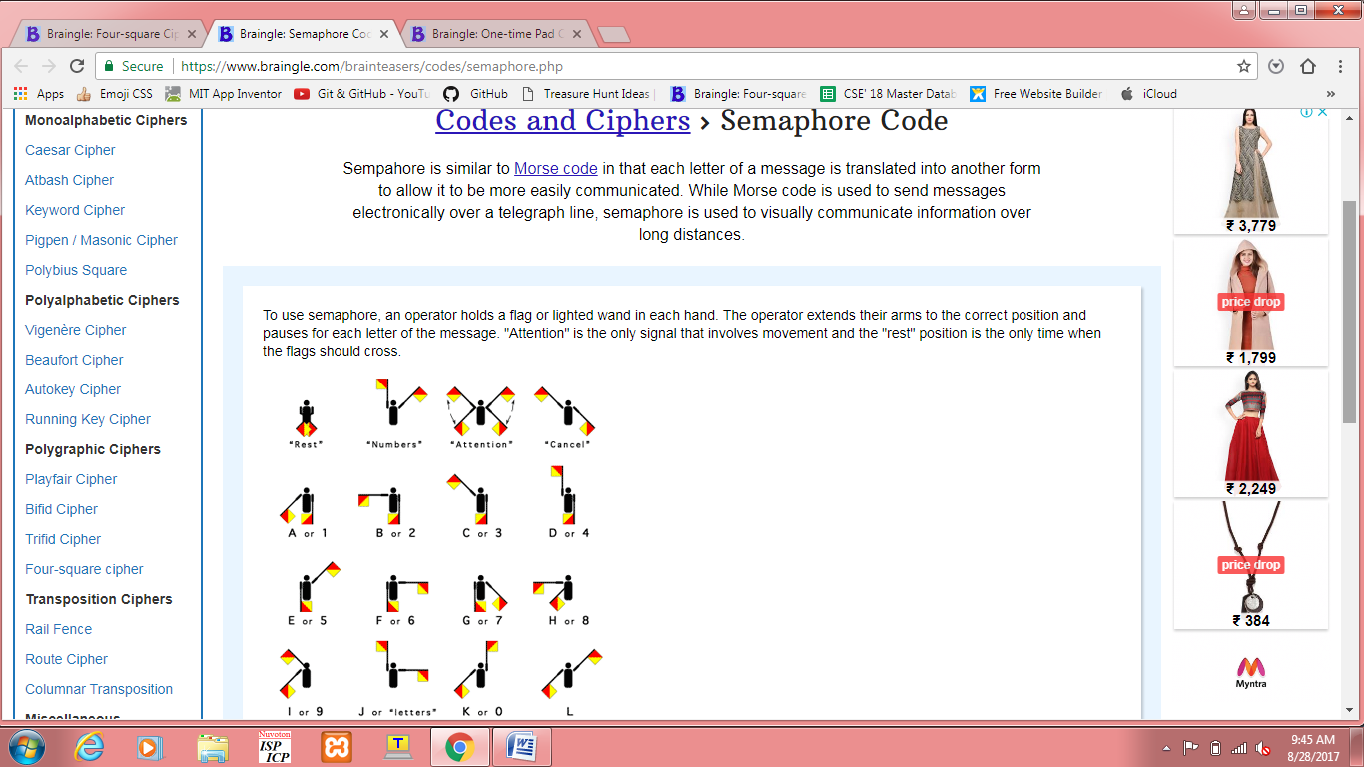

1. We can use some pictures such that the answer is formed by their letters.

This could be the first question. "WELCOME" could be encrypted.

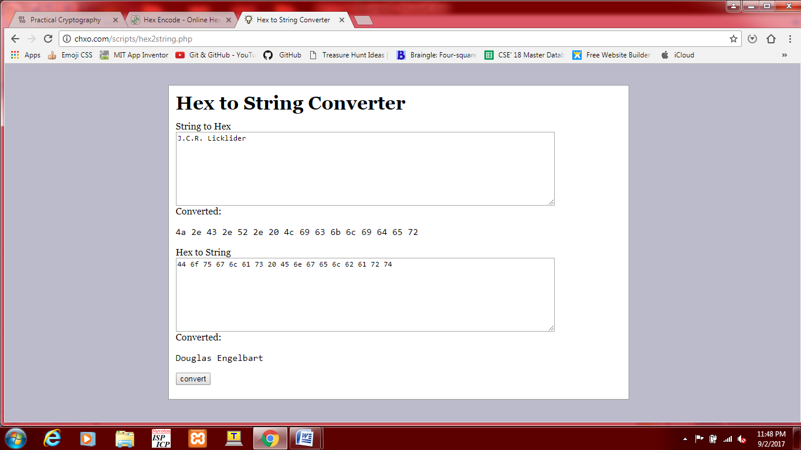

2. We can quote any famous line of some person or book and give the hex pattern. It has to be decoded to get the answer.

ex: *The greatest enemy of knowledge is not ignorance, it is the illusion of knowledge*

This was quoted by Stephen Hawking. When they go to his website, there is a book "George and the blue moon". We can encrypt name of this book.

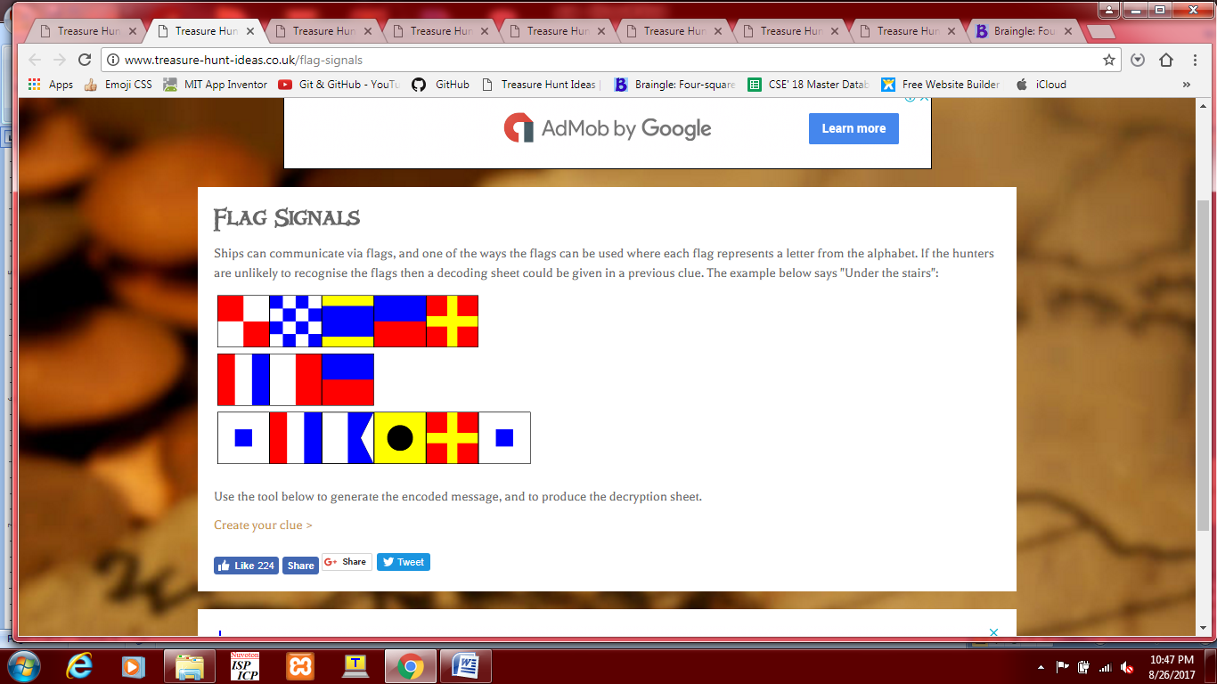

3. We can quote something rare about a country. The name will be hidden by flag signals.

**In Niue, an island nation in the South Pacific, its coins feature Disney and “Star Wars” characters.**

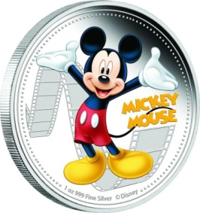We can put this image and four flags below it with "NIUE" encrypted.

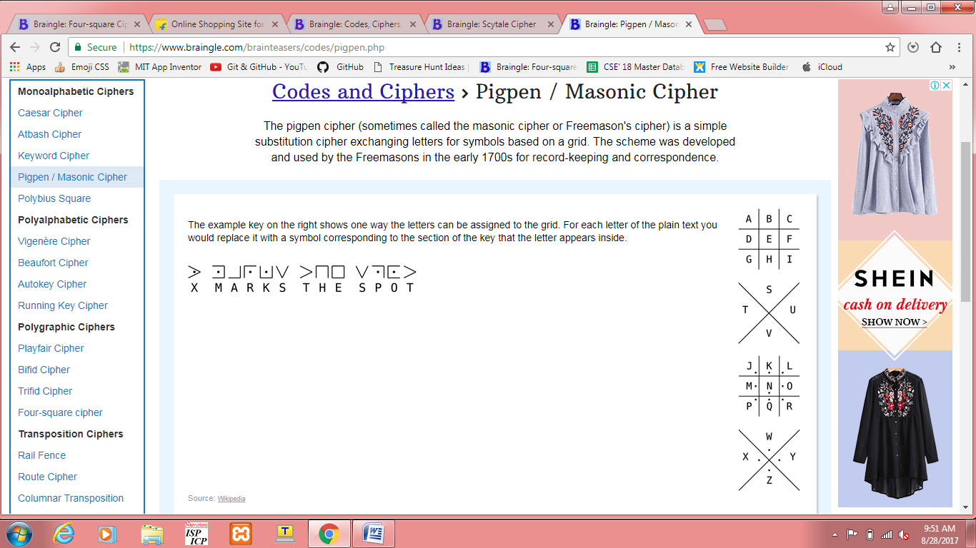

4. We can encode any event of innerve and in the address bar put innerve-website. They have to go to the website and the answer will be the name of event.

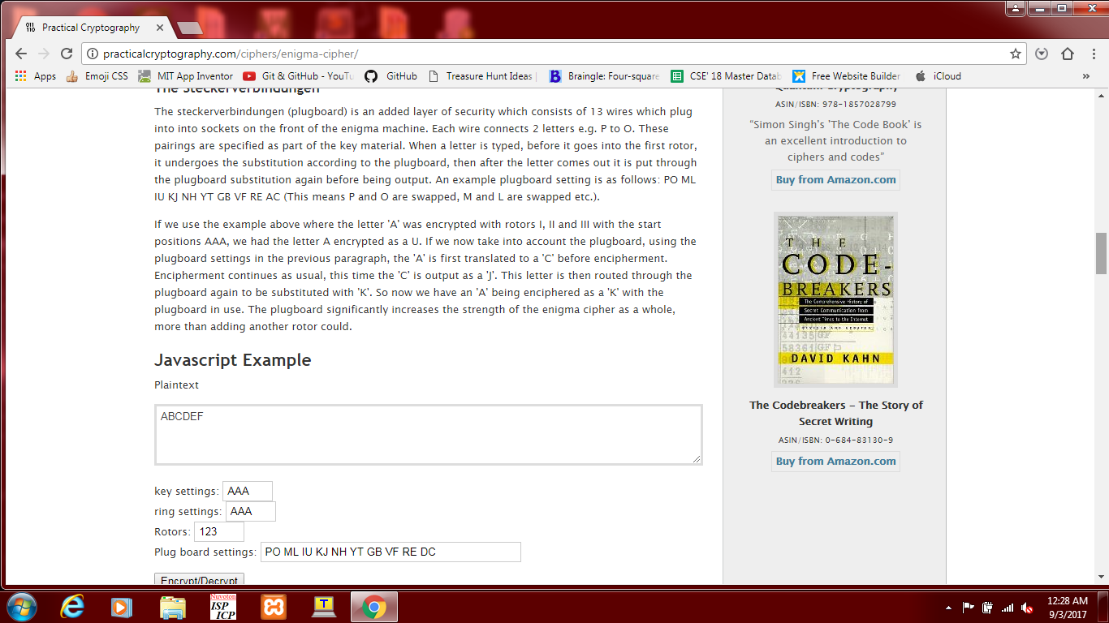

5. We can encrypt the answer of any question in this way.

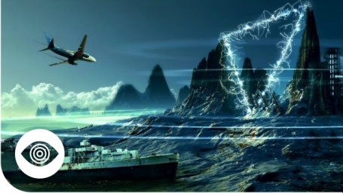 We can put this image of bermuda triangle which is also known as devil's triangle. We could encrypt "devil" in the above manner.