**Iteration 2.**

* **5 points**

In the previous iteration, the replication was blocking for all secondaries, i.e. to return a response to the client we should receive acknowledgements (ACK) from all secondaries.

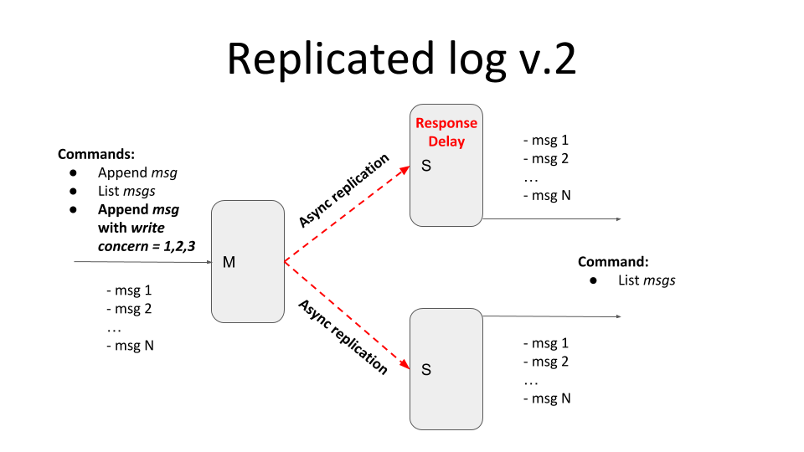

Current iteration should provide tunable semi-synchronicity for replication, by defining *write concern* parameters.

* client POST request in addition to the message should also contain *write concern* parameter *w=1,2,3,..,n*
* *w* value specifies how many ACKs the master should receive from secondaries before responding to the client

*w = 1* - only from master

*w = 2* - from master and one secondary

*w = 3* - from master and two secondaries

Please emulate the replica’s inconsistency (and eventual consistency) with the master by introducing the artificial delay on the secondary node. In this case, the master and secondary should temporarily return different lists of messages.

Add logic for messages deduplication and to guarantee the total ordering of messages.

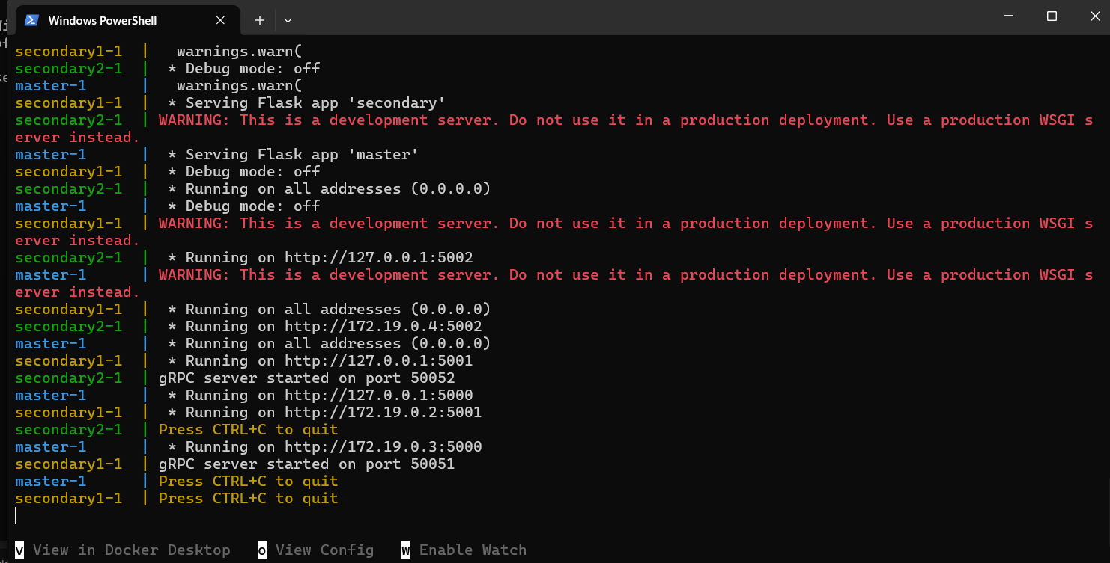

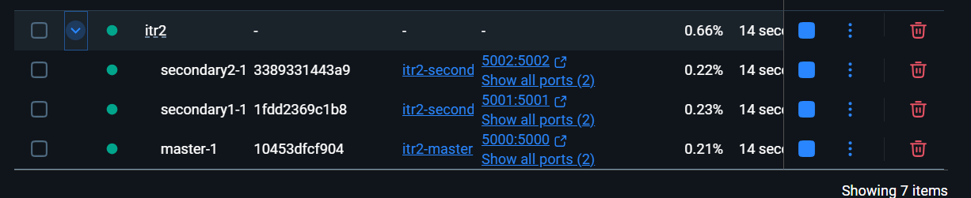

Ми виконаємо POST-запити з різними значеннями w, щоб перевірити semi-synchronicity, а потім GET-запити, щоб продемонструвати тимчасову невідповідність.

POST-запит з w=1 (тільки Master):



Логи:

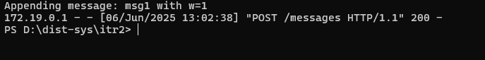

Із завершеною реплікацією:

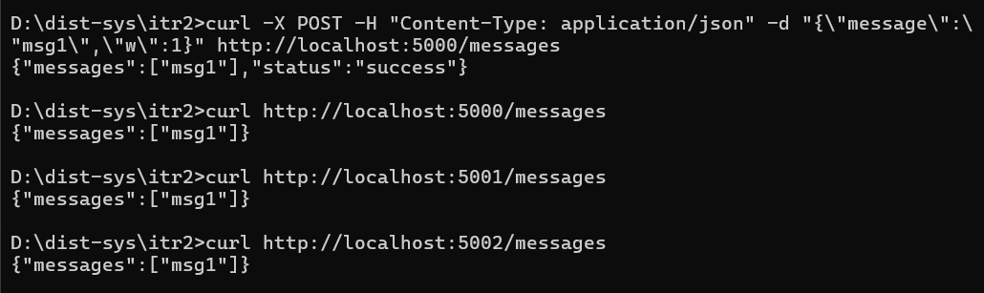

POST-запит з w=2 (Master + 1 Secondary):



GET-запити для перевірки eventual consistency:

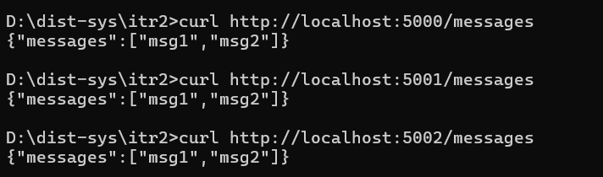

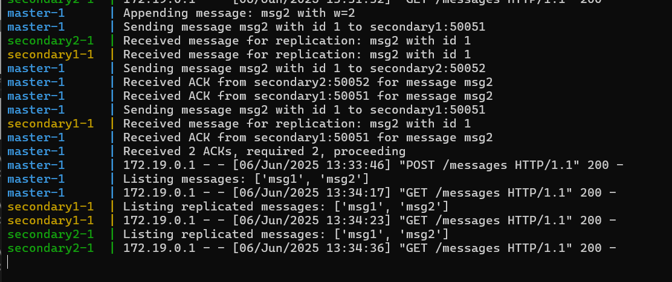

POST-запит з w=3 (Master + 2 Secondary):



