|  |  |  |  |  |  |  |  |  |  |  |  |  |  |  |  |  |  |  |  |  |  |  |  |  |  |  |
| --- | --- | --- | --- | --- | --- | --- | --- | --- | --- | --- | --- | --- | --- | --- | --- | --- | --- | --- | --- | --- | --- | --- | --- | --- | --- | --- |
| |  |  |  |  |  |  |  |  |  |  |  |  |  |  |  |  |  |  |  |  |  |  |  |  |  |  | | --- | --- | --- | --- | --- | --- | --- | --- | --- | --- | --- | --- | --- | --- | --- | --- | --- | --- | --- | --- | --- | --- | --- | --- | --- | --- | | |  |  | | --- | --- | | For office use only | | | T1 | ________________ | | T2 | ________________ | | T3 | ________________ | | T4 | ________________ | | |  | | --- | | Team Control Number **1909399** | |  | | Problem Chosen **C** | | |  |  | | --- | --- | | For office use only | | | F1 | ________________ | | F2 | ________________ | | F3 | ________________ | | F4 | ________________ | |   **The Opioid Crisis Analysis and Modeling** |

## Summary

*The U.S. has been in the grips* of a damaging opioid epidemic recent years, affecting nearly all socio-economic populations at great human and financial costs. In this paper, we analyze the opioid condition in five states: Ohio(OH), Kentucky(KY), West Virginia(WV), Virginia(VA), and Pennsylvania(PA), develop a mathematical model to describe it and give concrete and practical strategies.

First, inspired by Susceptible-Infected-Recovered (SIR) model, considering the addiction of opioid, we construct a Susceptible-Infected- Susceptible(SIS) model. We consider a county as an individual and revise the model over and over again to get appropriate parameters. To judge whether a county is infected, we draw a heat map, directly showing how serious the opioid epidemic is in a county.

Then, we find a threshold for the government, at which they should concern and have extremely strict drug control and take actions immediately. We believe as long as the threshold we calculated is not reached, the impact of opioid is in an acceptable range.

Next, we modify our model with data provided. We preprocess the data first, picking out the observations with no sample or few samples and calculating average value of every influence factor in each county. We tried regression analysis but in the end we choose principal component analysis. Eventually we find 5 indexes have strong negative correlation and 5 indexes have strong positive correlation with opioid epidemic.

Finally, we give government our advice on opioid control based on our model. improving the level of hygiene and reducing the infection rate, and improving medical level and increasing recovery rate are two good strategies. Besides, developing economy and make America great again is a basic way to reduce drug users.

Contents

Summary 1

1 Introduction 4

1.1 Background 4

1.2 Our Work 4

1.3 Assumption 5

2 Model Developing 5

2.1 Model Choosing 5

2.2 Susceptible-infected-recovered(SIR) model 5

2.3 The Revised SIR Model 6

2.4 Model Analysis 9

3 Data Processing And Model Improving 10

3.1 Data preprocessing 10

3.2 Regression analysis 10

3.3 Correlation Test 11

3.4 Principal Component Analysis 12

4 Strategy For The Opioid Crisis 16

Reference 19

Memo 20

## Introduction

### Background

While opioids used as treatment of pain have helped countless patients, the misuse and addiction of opioids has killed thousands of people per year according to the Centers for Disease Control and Prevention, affecting public health as well as social and economic welfare but with no obvious solution. In recent years, opioid epidemic has become a national crisis. Its heartbreaking impact is alarming legislators, medical practitioners, and the general public to take actions immediately.

It seems obvious that the problem should be addressed at its source, but the fact is that there are unknown due to the rate at which the epidemics have merged and dynamics by which abuse begins. For example, limiting the supply of synthetic opioid may drive people to get cheaper and more easily available heroin. The opioids sells for 100 dollars per gram while heroin is roughly 10 dollars per bag, and the latter is much more readily accessible. However, the death rates for heroin are higher, which makes the control action only achieve the object goal.

To describe the spread and characteristics of opioids in and between the five U.S. states: Ohio, Kentucky, West Virginia, Virginia, and Pennsylvania, we have developed a model, aiming to conclude a viable strategy.

### Our Work

Based on our understanding, we have done following work:

* Develop a model to describe the spread and characteristics of opioid in and between the five states and their counties.
* Analyze possible locations where specific opioid might have started.
* Find a threshold level of opioid for the U.S. government at which they should concern and predict possible location and time for them.
* Utilize the data provided to improve our model.
* Give a possible strategy to deal with the opioid crisis.

### Assumption

Assume:

(1) When the heroin reports of five states or counties in a year exceed a certain value in the total drug report of the states or counties, the specific opioid use might have started in this state or county. Besides, the total number N remains unchanged, and the ratios above and below the fixed value are and , respectively;

(2) Each state or county effective transmission number per infection cycle is ***λ***, and the reported proportion of heroin in the transmitted state or county exceeds the fixed value

(3) The proportion of heroin reported by states or counties in each cycle decreased and was lower than the fixed value was ***μ***

(4) The transmission factors in the five states and their counties are not affected by the outside world

## 2 Model Developing

### 2.1 Model Choosing

During the years, preliminary agent-based, differential equation, network spread, and cellular automata models are developed to describe the opioid epidemic. As far as our concerned, the course that the opioids spread has significant similarity to the infectious disease. Therefore, based on SIR model, we have developed our model to describe the course.

### 2.2 Susceptible-infected-recovered(SIR) model

In the SIR models the flows of people between 3 states: susceptible (S), infected (I), and resistant (R), and N represents the total population. There are two parameters to control how people change. To be more specifically, controls the rate of spread between a susceptible and an infectious individual, and controls how fast people move from infected and resistant.

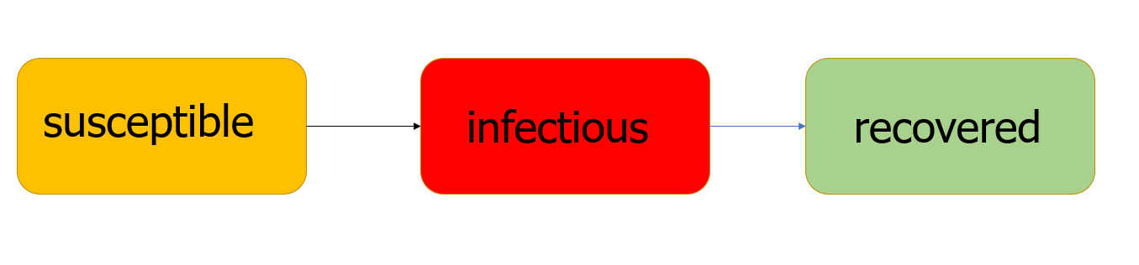

Figure 2-1 SIR Model

First used by Kermack and McKendrick in 1927, the SIR model has been widely applied to a lot of disease such as rubella, mumps and pertussis.

If the infection is not a lifetime course but a short one, and the disease is non-fatal, the birth and death rate can be ignored, so we have following equation:

There is an independent variable time **t**, usually measured in days.

### 2.3 The Revised SIR Model

In this paper, we consider a county as a person. Obviously, it’s impossible for a county to appear suddenly, which means in this situation N is constant. As people can’t easily keep away from heroin in their life time once get addicted and a county may never get away from the border of drugs, we revise the SIR model and establish a SIS model. The SIS model stands for susceptible-infected- susceptible, which can be explained as a susceptible individual can be infected and then become a susceptible individual again. We can use following formula:

In this situation, the time **t** is measured in years. still controls the rate of spread between a susceptible and an infectious individual while controls how fast people move from infected to susceptible again.

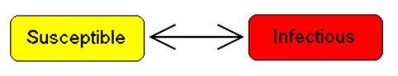

Figure 2-2 SIS Model

To begin with, we decided to analyze situations in each of the five states. We use the result of numbers heroin reports divide numbers of total drug reports in a county as an index named heroin rate to determine whether the county is infected. We calculate the average heroin rate(defined before) of eight years of each county and the numbers of counties at different heroin rate. After a series of calculation, we decide 5% is a reasonable threshold as there are more than 94% counties’ average heroin rate is less than 5%. The result can be shown intuitively in the following heat map.

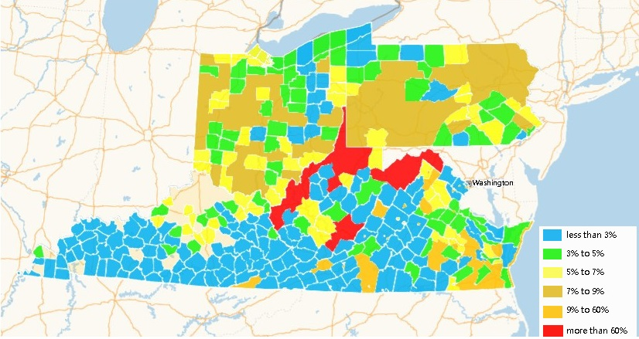

Figure 2-3 Hot Map

We drew the curves of actual value and curves of model fitting value. By adjusting the two parameters(and ), we found the model fits well, showing in the following figure.

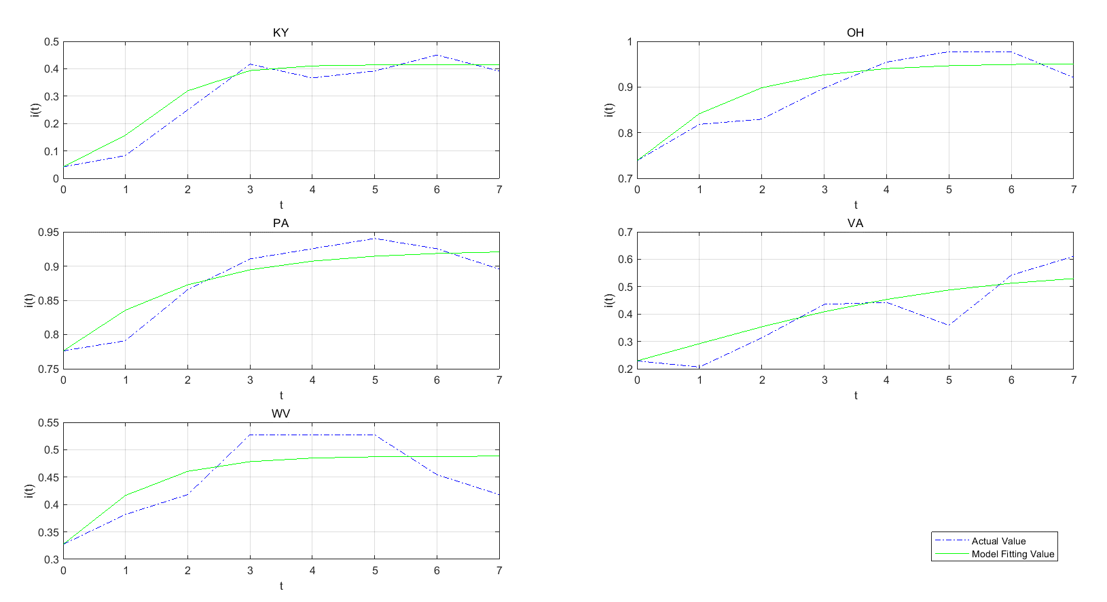

Figure 2-4 Modeling Analysis (1)

To establish the mathematical model, we use MATLAB to adjust the parameters and we get the characteristics of the reported synthetic opioid and heroin incidents in and between the five states and their counties over time, shown as the following table:

|  |  |  |
| --- | --- | --- |
| State | λ | μ |
| KY | 4.1 | 2.4 |
| OH | 0.83 | 0.04 |
| PA | 0.64 | 0.049 |
| VA | 0.8 | 0.35 |
| WV | 2.15 | 1.1 |

Table 2-1 Eigenvalue of Propagation (1)

Similarly, we consider a state as an individual, susceptible or infected. It’s obvious that the characteristics of drug transmission are critical and after a similar course of calculation and simulation, we can get that the threshold level is 13%. The figure below shows the result of model fitting:

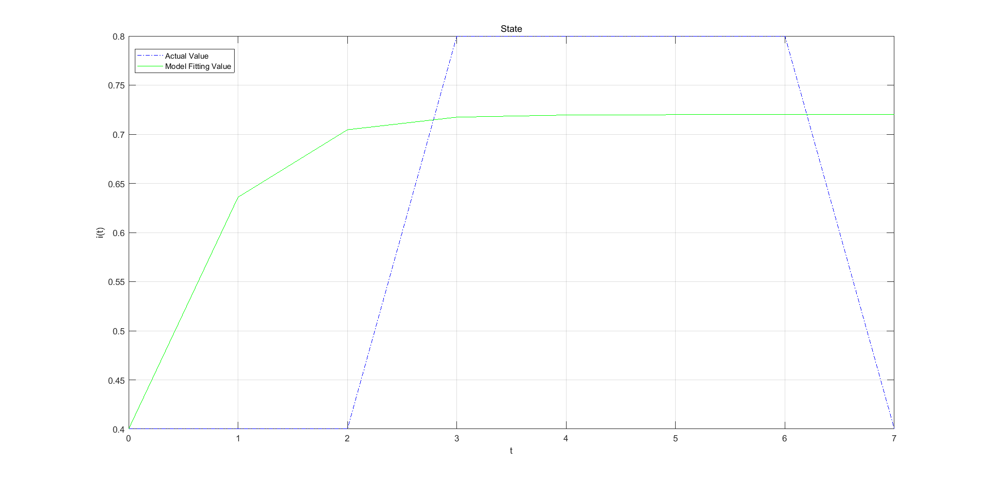

Figure 2-5 Modeling Analysis (2)

And the characteristic is indicated as following:

|  |  |
| --- | --- |
| λ | μ |
| 2.5 | 7 |

Table 2-2 Eigenvalue of Propagation (2)

### 2.4 Model Analysis

Evaluation of threshold levels

The cost of extremely strict drug control can be a big burden to the government and taxpayer, while unlimited drug spread can leads the society to a unstable state. Finding a drug identification threshold level becomes a necessary action. Based the model we developed before, we believe the government should concern when the actual value is bigger than the maximum of the model fitting value.

Location identification and prediction

In the SIS model we built, the proportion of susceptible people to the total population will be stable at a certain value over time. We have calculated approximate value of the ratio of the five states, and based on the data provided, the ratio index is available. With EXCEL's data filtering or data visualization capabilities, the scale fields are filtered to blur the search for states and counties that are close to the critical value.

As long as the spread and characteristics of opioids don’t change significantly, the SIS model still fits to the future situation. With the data of eight years, we are able to evaluate the past and present state of specific county and predict the situation of the county in the future. According to the threshold, the county's use and dependence on drugs can also be predicted and judged.

The model doesn’t consider the intervention of the government as a factor. However, in this paper, we assume that the government would keep an eye on the threshold and according to which change their policy to the state.

## Data Processing And Model Improving

### 3.1 Data preprocessing

By observing the statistical data we’ve got, we process the data from 2010 to 2016. We calculate the average value of every factors that may have an impact in every county in the same state. Only the influence factors that appeared in every year in 2010 to 2016 are kept and factors with no sample observations or too few sample observations are deleted. Finally a data set of influence factor in every year and heroin rate in each five states is available.

### Regression analysis

Take the data of Kentucky State for example, we process the data with R language. Evaluate the logarithm of current value:

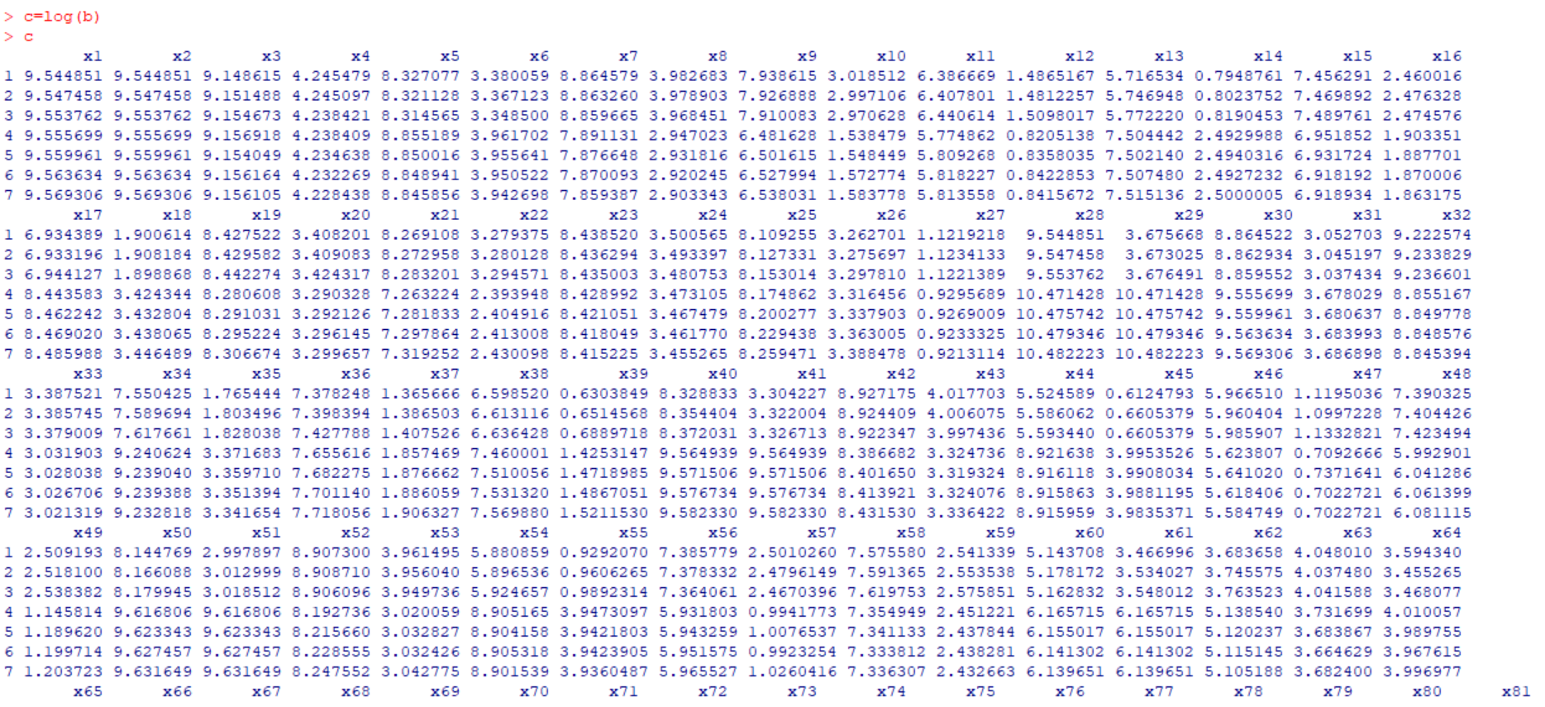

Figure 3-1 Regression Analysis

When establishing multiple linear regression, the NA situation occurs a lot, making the giving up of MLR acceptable.

### Correlation Test

According to the test of correlation, a strong multicollinearity can be observed. Therefore, reducing the dimensionality is necessary to the data set.

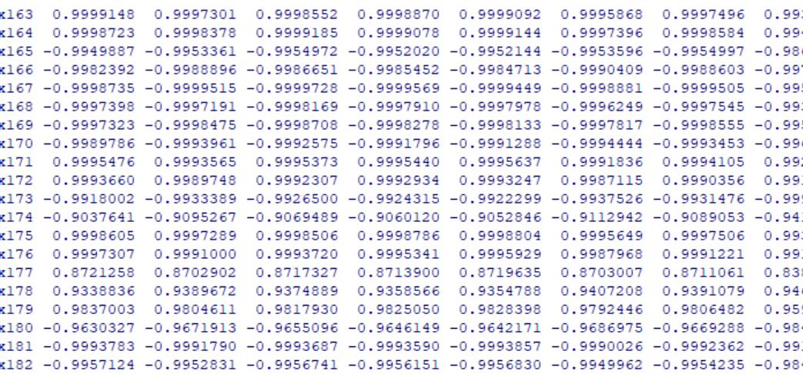

Figure 3-2 Correlation Test

### Principal Component Analysis

Using PCA, we can get:

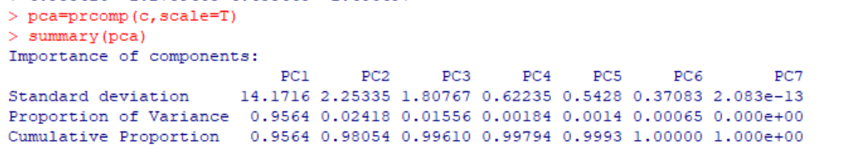

Figure 3-4 Principal Component Analysis

Then we can draw a scree plot:

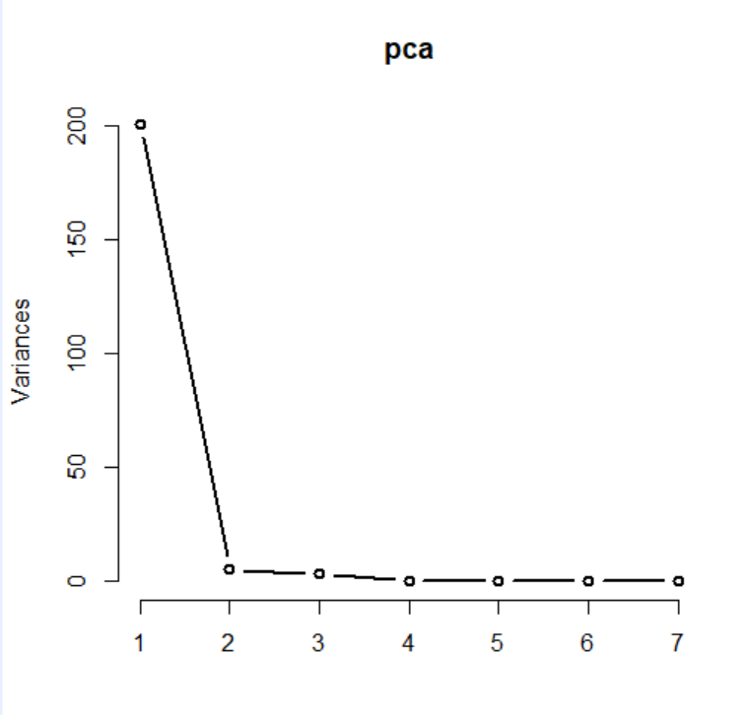

Figure 3-5 Scree Plot

The first two variable has contributes 98.05%, so the first two variable can sufficiently explain the change of heroin rate. Use the first two variables as the principal component, calculate the principal component scores and normalize the corresponding variable:

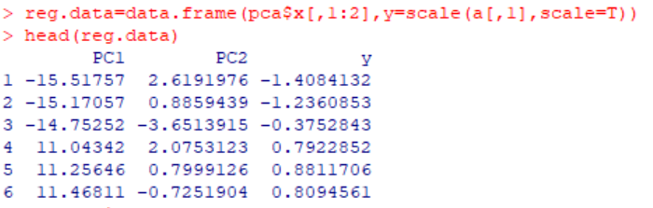

Figure 3-6 Principal Component Scores

The principal component regression is made:

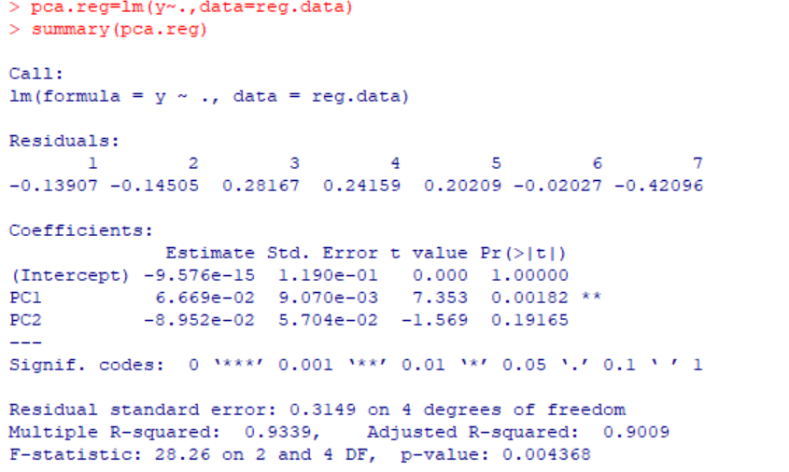

Figure 3-7 Principal Component Regression

The regression coefficient of the three principal components all reach significant level. The regression equation is:

Calculate the principal component loads:

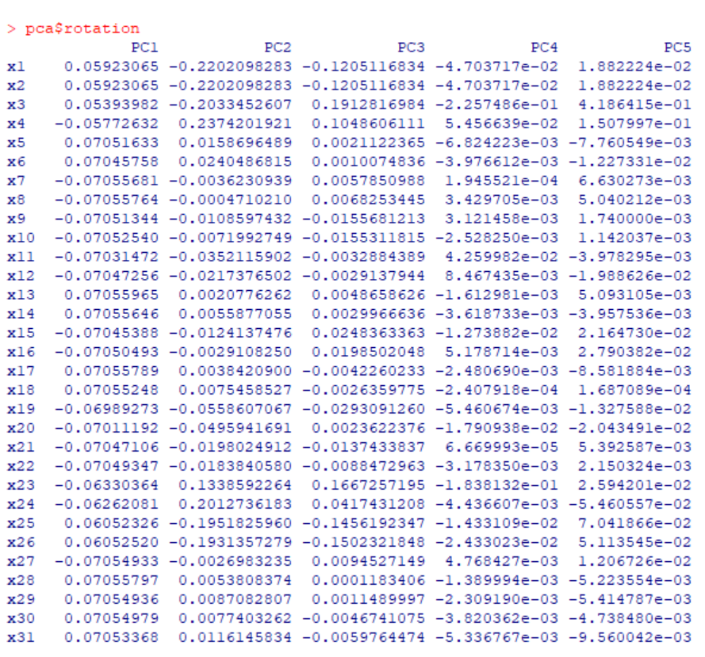

Figure 3-8 Principal Component Loads

Analyze the data with EXCEL:

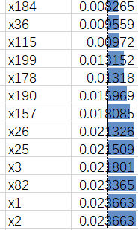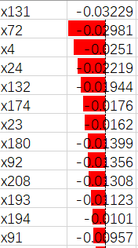

Figure 3-9 Original Data

According to the data bar drawn by the coefficient, X131, x72, x4, x24, x132 and y have strong negative correlation, and x184, x36, x115, x199, x178 and y have strong positive correlation. The influencing factors corresponding to these variables are:

|  |  |
| --- | --- |
| negative correlation | positive correlation |
| Estimate; YEAR OF ENTRY - Entered 2000 or later | Percent; ANCESTRY – Lithuanian |
| Percent; GRANDPARENTS - Responsible for grandchildren - Years responsible for grandchildren - 3 or 4 years | Estimate; RELATIONSHIP – Nonrelatives、 |
| Percent; HOUSEHOLDS BY TYPE - Family households (families) | Estimate; PLACE OF BIRTH - Native - Born in United States |
| Percent; HOUSEHOLDS BY TYPE - Households with one or more people under 18 years | Estimate; ANCESTRY - Subsaharan African |
| Estimate; PLACE OF BIRTH - Foreign born | Percent; ANCESTRY – Hungarian |

Table 3-1 Factors

So the multiple linear regression model we get is:

## Strategy For The Opioid Crisis

In response to the opioid crisis, the U.S. Department of Health and Human Services (HHS) is focusing its efforts on five major priorities:

1. improving access to treatment and recovery services
2. promoting use of overdose-reversing drugs
3. strengthening our understanding of the epidemic through better public health surveillance
4. providing support for cutting-edge research on pain and addiction
5. advancing better practices for pain management

These measures coincide with the recommendations we want to make.

In Part 1, we abstracted states and counties into susceptible or overwhelming populations of heroin epidemics (based on the pharmacological properties and dissemination characteristics of synthetic opioids and heroin, this article abstracts the use and dependence of opioids on the population)，For infectious diseases, we selected the SIS model for the processing and analysis of the proportion of heroin reports in the number of opioid reports in KA, OH, PA, VA, WV and its subordinate counties from 2010 to 2017.

In the previous study of SIS, it was found that the SIS model has a certain guiding role in the prevention and spread of infectious diseases.

In the SIS model, the number of effective contacts of a patient who has been infected with a virus is generally defined as the number of contacts. In the model of Part 1 of this paper, the concept of the number of contacts is used to indicate the number of transmissions between and within states.

According to this model, the US government or state government needs to consider controlling the spread of opioids and heroin. Specifically, it should be explained in two ways, reducing λ and increasing μ. Lowering λ can be explained by improving the level of hygiene and reducing the infection rate; increasing μ can be explained by improving medical level and increasing recovery rate.

Lower λ, that is, the federal government or state government can increase capital investment to ensure that people who use opioid prescription drugs can get enough and affordable supply, so that opioid users can not easily choose cheaper but more dangerous Illegal opioids, such as heroin.

In addition, the government should propose appropriate policy interventions to reduce the market for illegal opioids by limiting the sources of opioids, especially raw materials and finished products of illegal opioids, and the means of transmission. Finally, the government can also prevent the drug users from relying on drugs and abusing opioids to eventually use heroin by stepping up interventional interventions for opioid users.

Increasing μ means improving the level of medical care. On the one hand, it increases the medical subsidy for people who use opioid prescription drugs, and on the other hand, increases the research and development of new medical methods or alternative drugs. Furthermore, through government guidance, the medical level will be improved, the links between policies and medical networks will be strengthened, and guidance and abuse prevention for drug users will be further strengthened.

In the process of modeling, we found that σ = 1 is a threshold. When σ ≤ 1, the proportion i(t) of the sensed population in the total number of people is getting smaller and smaller, and eventually tends to zero. This can be interpreted intuitively from the meaning of σ, that is, the number of people infected during the infection period does not exceed the number of healthy people. When σ ≥ 1, the trend of i(t) varies depending on the size of , and finally is the limit. When σ increases, i(t) also increases. This is because as the proportion of infected people in the infection period increases with the number of healthy people at that time, the proportion of people who have already felt increases. Therefore, the federal government or the state government should control σ stability or below the threshold by improving the level of health and medical care according to the characteristic values of local drug transmission.

## Reference

[1] Brennan, P. L., A. C. Del Re, P. T. Henderson, and J. A. Trafton. 2016. "Healthcare System-Wide Implementation of Opioid-Safety Guideline Recommendations: The Case of Urine Drug Screening and Opioid-Patient Suicide and Overdose-Related Events in the Veterans Health Administration." *Translational Behavioral Medicine* 6(4):605-612.

[2] James Benneyan, Jacqueline Garrahan, Iulian Ilies, Xiaoli Duan.2017. “

MODELING APPROACHES, CHALLENGES, AND PRELIMINARY RESULTS

FOR THE OPIOID AND HEROIN CO-EPIDEMIC CRISIS”

[3] Nicholas A. Battista _ Leigh B. Pearcy _W. Christopher Strickland. “Modeling the opioid epidemic”

[4] National Institute on Drug Abuse “https://www.drugabuse.gov/”

## Memo

From: Team 1909399, MCM 2019

To: Chief Administrator of DEA/NFLIS Database

Date: January 29, 2019

Subject: strategies to opioid crisis

Dear Chief Administrator, we are honored to inform you our achievement after data analysis and modeling.

First, we provide you the time you should concern about the opioid epidemic. During the establishing of our SIS model, we find the threshold is the maximum number of our modeling fitting value.

Then, we offer you our suggestions based on our model. As our model is revised SIR model, you may have a better understanding if you are familiar with it. We strongly suggest that you control λ and μ, which, in this case, represents how fast a county can transferred between susceptible and infectious. More specifically, Lower λ, that is, the federal government or state government can increase capital investment to ensure that people who use opioid prescription drugs can get enough and affordable supply, so that opioid users can not easily choose cheaper but more dangerous Illegal opioids, such as heroin, and increasing μ means improving the level of medical care. In addition, the government should propose appropriate policy interventions to reduce the market for illegal opioids by limiting the sources of opioids, especially raw materials and finished products of illegal opioids, and the means of transmission.

We sincere hope you can control the opioid epidemic with our help.

Please contact us if you have any problems.