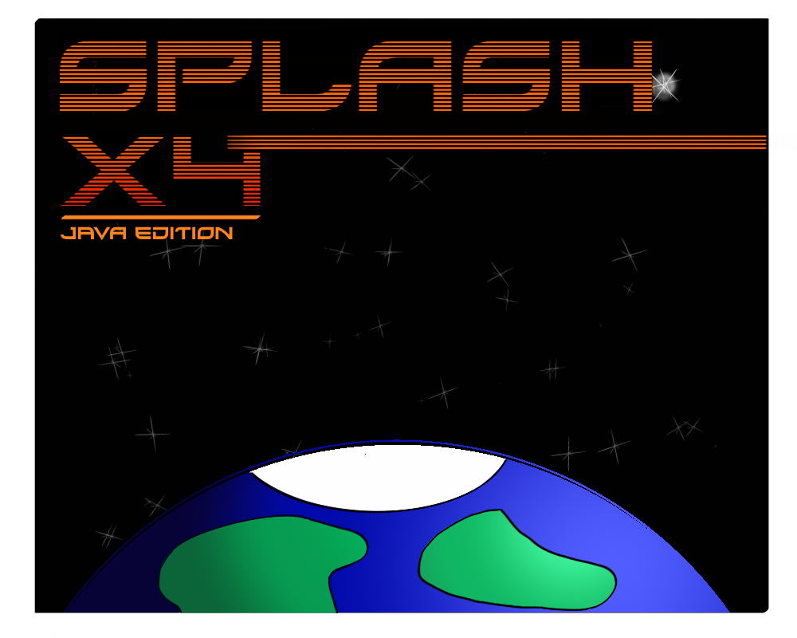

**Splash X4 user’s manual**

As produced by Jordan Gray

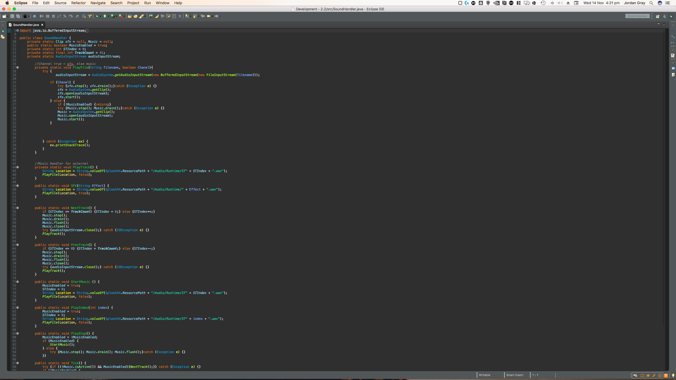

Contents

* Creator’s note Page 2
  + A brief thank you
  + About the author
  + Content licencing
* About development
  + The origins
  + ContDisplay
  + Splash X1

1

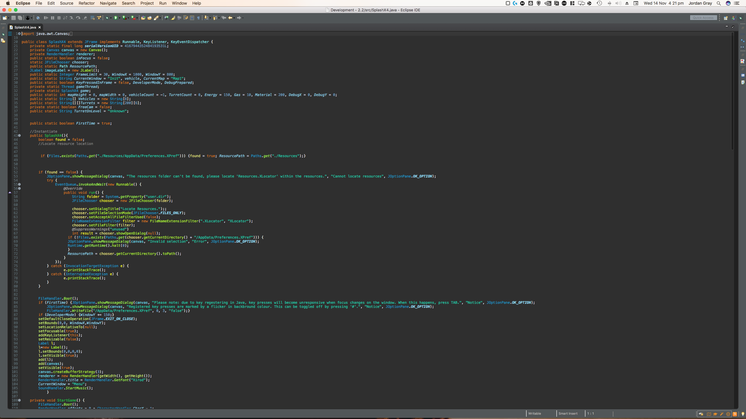Creator’s note

Thanks for grabbing a copy of Splash X4! The creation of this game was a personal challenge that I never intended to end like this – but look how great it is!

This manual walks you through the development of Splash X4, how the game works, how to play it and more! It’s page backgrounds are real snips of the game code from mid-development as well as other development material.

About the author

Hi! I’m Jordan! I’m a 17-year-old college sophomore from the UK, studying Level 3 application development. By no means am I a professional - frankly I’m an amateur who doesn’t know what they’re doing!

All resources used in the creation of the game and its manual were created as a part of the Splash X4 project or are used under the creator’s licences who have been credited appropriately on the menu screen. The typeface used in the game is Xirod by Typodermic Fonts under its Desktop licence.

2

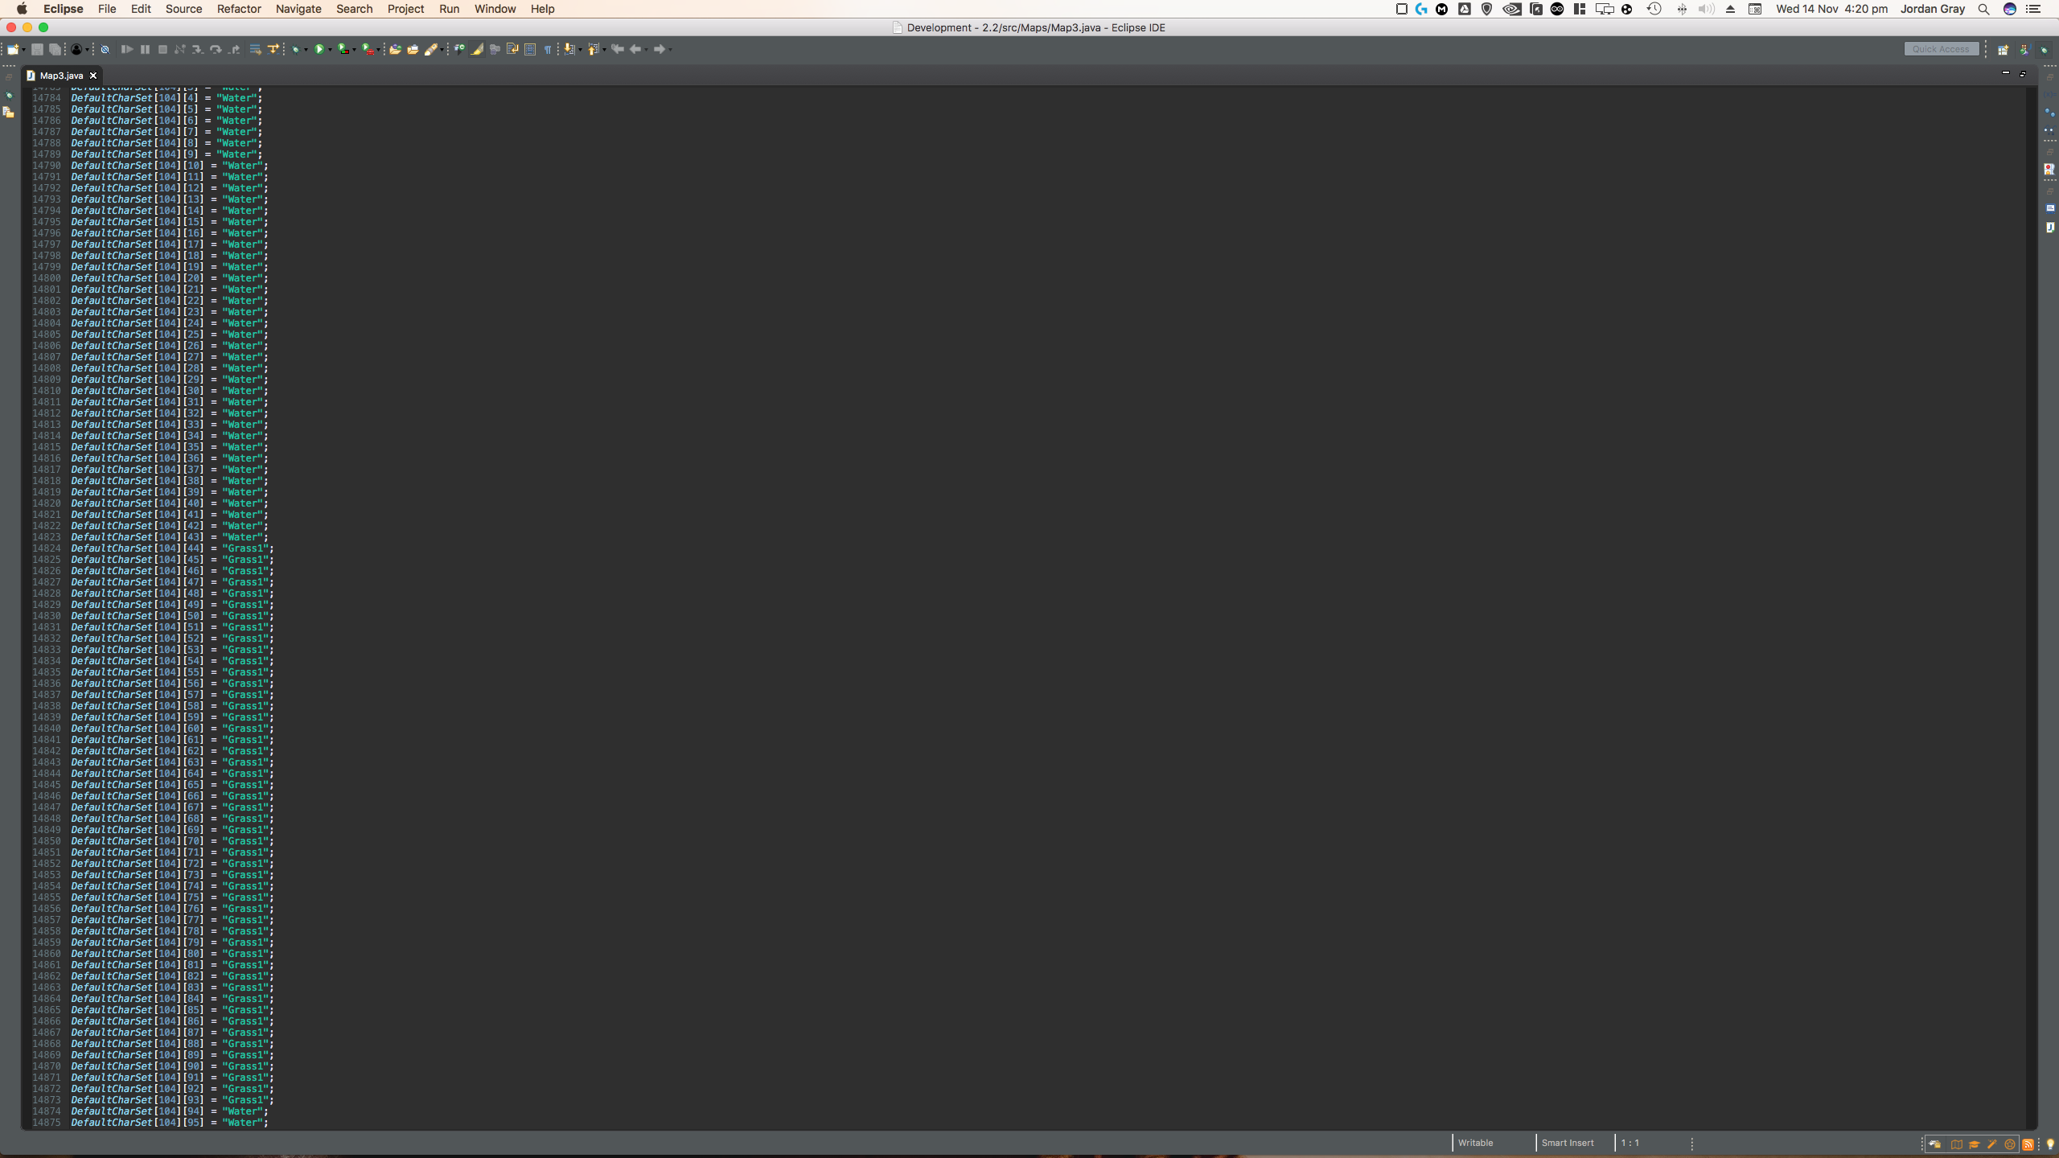About development

The Splash XX Project started back in early 2017 with no intent of creating a game. I wanted to create a display engine which could handle taking instructions and using them to draw graphics to a window, as a challenge to myself since this was in my early days of software creation. I completed this in Visual Basic, as it was my strongest language at the time, given that it was on my syllabus.

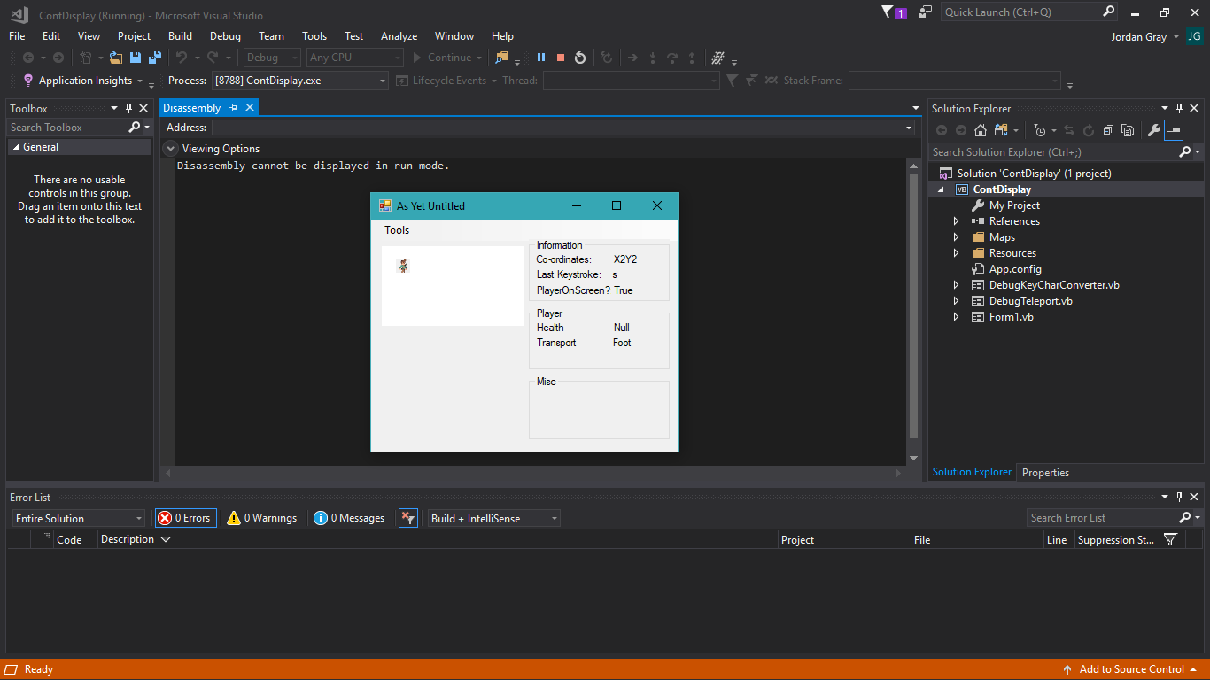

I spent about a day to create a small solution called ContDisplay, short for continuous display. This small program drew a character to a Windows form, who could be moved using WASD - This quickly lead to the idea of using this engine idea to create a game, which is evident with the form on the right, which is what ContDisplay evolved into.

This led to the creation of Splash X1 – the name of which was born from filler text on the splash screen for a name I hadn’t yet created. I threw together my spur-of-the-moment ideas into Splash X1, and eventually ended up with this.

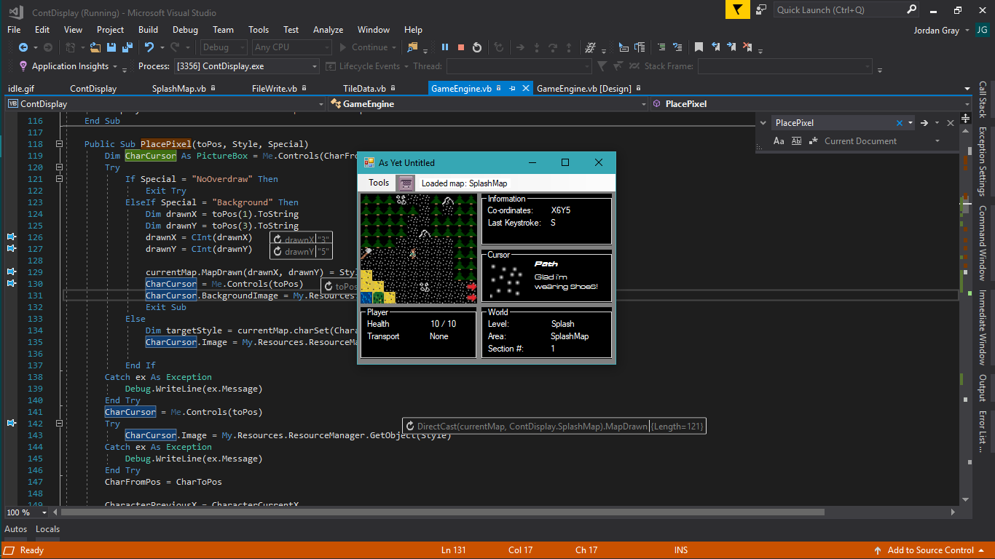Originally, I had the idea of

Implementing a store which users could sell and buy items – but I ditched this as my feel of what I wanted the game to be developed.

During development, I needed a couple of tools to help me code this, so I made some simple forms within the game which allowed me to look at variables, show key identifiers and even a debug break which allowed for changing of preferences or maps files, as well as a couple of other things.

I had evolved the engine to care for tile boundary’s and tile events within this ten by ten grid of picture boxes, which I could use to place a background and foreground image – effectively creating a two-layer map, which is an attribute that has remained since. They also made it extremely easy to utilise animated GIF’s to add some life to the world. This map was hand created and was the only use of segregated classes.

Splash X1 had two hand-typed maps, the second was just blank pathing though. The Idea would be that you could walk around between the maps to beat enemies whilst upgrading and crafting weapons, armour and vehicles but to achieve this in knew I would need some more tools to help me.

3



About development

4

Splash X1’s code wasn’t meant to be a game from the beginning, it had only one class for active code use and was becoming too messy to work with, so I started again from scratch - developing Splash X2 in which I attempted to create different Handler classes for different processes and neaten the code to work efficiently for a game.