

TECHNOLOGICAL EDUCATIONAL INSTITUTE (TEI) OF ATHENS

FACULTY OF TECHNOLOGICAL APLICATIONS

DEPARTMENT OF ELECTRONICS ENGINEERING

MSC:

Design and Development of Advanced Electronic Systems

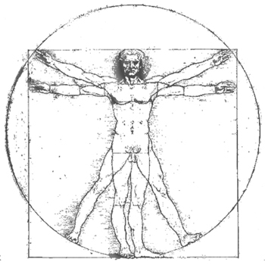

**BODY AREA NETWORK FOR MOVEMENT ANALYSIS BASED ON SENSORS**

DIPLOMA PAPER

PAPAMICHALIS PAVLOS

Athens, March 2015

# Introduction

As the transistor gets smaller the cost and the power of computing improves giving as the opportunity to capture, store, analyze and share large and complex data sets (Big Data [1]). At the same time the cost and power consumption of the Integrated circuits in general decreases as well and as new technologies in batteries, wireless communications and sensors emerges we see lots of electronic technologies to mature and find their way in commercialization. Now we have the opportunity to digitalize large amounts of data and bridge the distance between the digital and the physical world. That way we can understand better our world, the physical, create models and finally improve our lives.

The health sector is usually the last one to adopt all these technological advances, because of the expensive certifications and the time consuming clinical research needed for a medical product to reach the market. But with the rise of new technologies and sensors we can monitor our health with less invasive methods and with the help of actuators we can assist it in a more accurate way compared to classic medicine.

Especially with the aging populations we face the need to monitor the physical condition of the human body and then assist the rehabilitation process. Till now this procedure is mostly based on the therapists observance and it usually takes a studio and a time consuming procedure to monitor and point the patients improvement.

I would like to specially thank Prof George Loudos for managing a big research team (Tei of Athens, Biomedical engineering department) although the difficulties faced in the Greek academic environment. Offering me a position to his team played a key role in extending ------

I want to thank Prof George Hloupis for assisting me throughout the procedure of the project.

I want to thank Dr George Marinakis from the National Greek Rehabilitation Center that supported me with lots of academic references, ideas and helped me on the early experiments.

I want to show my gratitude to all the professors of the master program---------------------

I want to show my respect to the Open Source/Hardware community for contributing in “Democratizing” technology.

I want to thank my parents for giving me the bare minimum and important, letting me evolve my way and being supportive on my decisions throughout this procedure.

Finally I would like to thank the Greek society because although the countless difficulties it still gave us the opportunity to educate and the vision of a better society for the generations to come.



This work is dedicated

to the open hardware community

and all those who believe in the power of sharing.

# Abstract/Περίληψη

Focused on the project the purpose the

# Table of contents

Introduction 2

Abstract/Περίληψη 5

Table of contents 6

Chapter 1 Introduction to Biokinetics 7

1.1 Chapter 1 Introduction 7

1.2 Posture 7

1.3 Balance 7

1.4 Movement 7

Chapter 2 sensors 7

2.1 Introduction to sensors for bio kinetics measurements 7

2.2 Force and flex sensitive 8

2.2.1Force Sensitive Resistors FSR 8

2.2.2 QTC 8

2.2.3 load cell 8

2.2.4 Textile sensors 8

2.2.5 capacitive force sensor 8

2.3 proximity sensors 8

2.3.1 ultrasound 8

2.3.2 IR 8

2.3.3 Hall 8

2.3.4 Potentiometers 8

2.4 3D Sensors 8

2.4.1 Accelerometer 8

2.4.2 Gyroscope 8

2.4.3 Magnetometer 8

Chapter 3 wireless solutions 10

3.1 Chapter 3 introduction 10

3.2 Bluetooth 15

3.3.1 Bluetooth Classic 15

3.3.2 Bluetooth Smart 15

3.4 Radio 24 19

3.5 Wifi 19

3.6 Wireless solutions overall comparison 19

3.7 Module vs custom board solution 19

Chapter 4 Hardware development 19

Chapter 5 Software development 19

Chapter 6 Applications 20

Chapter 7 Conclusion 20

References 20

# Chapter 1 Introduction to Biokinetics

## 1.1 Chapter 1 Introduction

## 1.2 Posture

## 1.3 Balance

## 1.4 Movement

About biokinetics the muscular system. posture balance movement.

# Chapter 2 sensors

## 2.1 Introduction to sensors for bio kinetics measurements

Intro Mems/ nanomaterials

The last decade we

## 2.2 Force and flex sensitive

### 2.2.1Force Sensitive Resistors FSR

#### 2.2.1.1 Commercial sensors

#### 2.2.1.2 Custom Sensors

### 2.2.2 QTC

### 2.2.3 load cell

### 2.2.4 Textile sensors

### 2.2.5 capacitive force sensor

## 2.3 proximity sensors

### 2.3.1 ultrasound

### 2.3.2 IR

### 2.3.3 Hall

### 2.3.4 Potentiometers

## 2.4 3D Sensors

### 2.4.1 Accelerometer

### 2.4.2 Gyroscope

### 2.4.3 Magnetometer

Fiber optics

Proximity force emg load cells

Chapter introduction

The sensors

We want to measure force (ideally from 1N to 50N ) with high sensitivity on the low side. To do this we will either use a force/weight sensor or a proximity sensor.

a)fsr

Force sensitive resistors are widely used in human/machine interfaces (mostly controllers)

+very sensitive

+working out of the box

-hard to mount (mechanical design dependent)

-not very precise

-expensive

b)Load cells (strain gage)

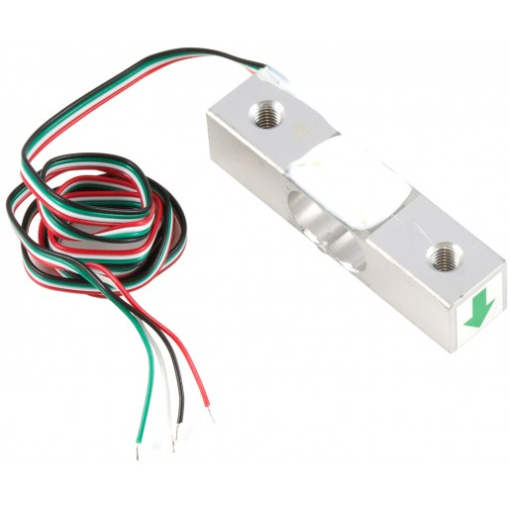Load cells are widely used in scales. They consist of a very sensitive strain metering resistor and come in many different sizes metering from milligrams to tones.

+easy to mount

+stable and precise measurements

-needs additional ic for amplification and voltage booster for 5V supply

-expensive

-no physical feedback

-I think the 5kg is not sensitive in 100g (need to test it)

c) Custom fsr sensor

There are different material and design solutions, like velostats and qtc the characteristics are relevant to the

+cheap

-unstable characteristics

-handmade solution

d) Proximity hall sensor

Hall sensors are used as precise proximity sensors in dirty and demanding environments. They are used in plane piloting joysticks because they are mechanical design independent (long lifetime)

+cheap

+easy to mount on the mechanical design

-needs proximity (physical feedback)

-magnetism might cause problems in same applications

e) Proximity light sensor

+cheap

-interaction with the unit’s light

-needs sophisticated mechanical design

Price table

|  |  |  |  |
| --- | --- | --- | --- |
| A/A | solution | X1 | X1000 |
| Fsr | interlink | £6 | £3.5 |
| Load cell | RB-Phi-118 | £5,5 | £4 |
| Custom fsr | QTC Pill | £0,48 | £? |
| Hall effect | SS39ET +magnet | £0,87 +0,34 | £0,36 + 0,13 |

# Chapter 3 wireless solutions

## 3.1 Chapter 3 introduction

Wireless Communication

1. Wifi
2. Gsm
3. Zigbee
4. Bluetooth
5. Nrf24

Comparison

|  |  |  |  |  |  |
| --- | --- | --- | --- | --- | --- |
|  | Bluetooth | Nrf24 | Zigbee | Gprs/Gsm | Wifi |
| Use | Cable replacement for PAN [1] | Cheap Bt replacement for PAN | WSN[2] solutions | Cellular Network | Cable replacement for Ethernet |
| Applications | Mouse, gamepads, audio in/out, etc | Mouse, gamepads, audio in/out, etc | Agriculture, metric systems, etc | Mobile phones | Computer networks |
| Key attributes | Convenient, industry standard | Cheap on money and power | Reliable, low power | Quality, Reach | Speed, flexibility |
| Nodes per network[3] | 7 | 6 | 255/65.000 | 1000+ | 30+ |
| Data Rate | (2 up to 10)mbps | (0,255,1,2)mbps[4] | (255 512)kbps[4] | 64-128kbps | Up to 50mbps |
| Range[5] | 1-10+ | 1-10+ | 1-75+ | 1000+m | 1-100m |
| Power consumption | (20 up to 50)mah | (10 up to 20)mah | 50 mah | Up to 550mA | 200mAh up to 2Ah |
| Cost (module)[6] | ~15$ | ~2$ | ~30$ | 50$ | 60$ |

Attention! The data beneath are not dogmatic there are lots of variations the table just indicates the average characteristics of the protocols. Most of the protocols come with different variations and editions. For instance Gprs/Gsm is the predecessor of 3G and 4G which have much higher Data Rates (up to 1Gbps) and a bit higher power consumption, Bluetooth2 has up to 10mbps Data Rates and 50 mah power consumption when Bluetooth4 has 2mbps Data Rates and 20 mah.

[1] Personal Area Network

[2] Wireless Sensor Network

[3] Its plausible to add more nodes in more of the protocols but this usually means a more complicated network layer and less Data Rates to the nodes.

[4] Data bandwidth range of reach and power consumption are related

[5] Range is relevant to the antenna type(external, pcb, integrated) but usually it can be improved through external or internal amplification.

[6] the costs of modules usually implies the cost of the ics as well. Of course when you buy a module you buy convenience so some times the costs are different. New ics show up all the time, for instance a Chinese company made serial protocol to wifi ics which are very cheap.

Why we chose Nrf24?

Nrf24 is a wireless solution made by Nordic. In its core it is a bt4 solution (the physical layer, as proposed by the OSI model it’s the exact same) with a simpler Data link and Network layer. By that it is much cheaper and it is proposed as a replacement of the Bluetooth in closed personal area network. By closed we mean that it cannot connect to a Personal computer without a dongle.

The graph points the complexity, cost and power consumption of the protocols compared to their datarates

Complexity, cost, power consumption

11mbps 54mbps

2mbps

32kbps datarates

Wireless solution.

The problem with wireless communication is that it is not real time… the physical layer is not only shared by the network but by other networks and other sources of noise as well. This means delays and latch.

Overview of the basic wireless protocols

Wireless Communications

Wifi

Gsm

Zigbee

Bluetooth

Nrf24

Comparison

|  |  |  |  |  |  |
| --- | --- | --- | --- | --- | --- |
|  | Bluetooth | Nrf24 | Zigbee | Gprs/Gsm | Wifi |
| Use | Cable replacement for PAN [1] | Cheap Bt replacement for PAN | WSN[2] solutions | Cellular Network | Cable replacement for Ethernet |
| Applications | Mouse, gamepads, audio in/out, etc | Mouse, gamepads, audio in/out, etc | Agriculture, metric systems, etc | Mobile phones | Computer networks |
| Key attributes | Convenient, industry standard | Cheap on money and power | Reliable, low power | Quality, Reach | Speed, flexibility |
| Nodes per network[3] | 7 | 6 | 255/65.000 | 1000+ | 30+ |
| Data Rate | (2 up to 10)mbps | (0,255,1,2)mbps[4] | (255 512)kbps[4] | 64-128kbps | Up to 50mbps |
| Range[5] | 1-10+ | 1-10+ | 1-75+ | 1000+m | 1-100m |
| Power consumption | (20 up to 50)mah | (10 up to 20)mah | 50 mah | Up to 550mA | 200mAh up to 2Ah |
| Cost (module)[6] | ~15$ | ~2$ | ~30$ | 50$ | 60$ |

Attention! The data beneath are not dogmatic there are lots of variations the table just indicates the average characteristics of the protocols. Most of the protocols come with different variations and editions. For instance Gprs/Gsm is the predecessor of 3G and 4G which have much higher Data Rates (up to 1Gbps) and a bit higher power consumption, Bluetooth2 has up to 10mbps Data Rates and 50 mah power consumption when Bluetooth4 has 2mbps Data Rates and 20 mah.

[1] Personal Area Network

[2] Wireless Sensor Network

[3] Its plausible to add more nodes in more of the protocols but this usually means a more complicated network layer and less Data Rates to the nodes.

[4] Data bandwidth range of reach and power consumption are related

[5] Range is relevant to the antenna type(external, pcb, integrated) but usually it can be improved through external or internal amplification.

[6] the costs of modules usually implies the cost of the ics as well. Of course when you buy a module you buy convenience so some times the costs are different. New ics show up all the time, for instance a Chinese company made serial protocol to wifi ics which are very cheap.

Why we chose Nrf24 for the prototype?

Nrf24 is a wireless solution made by Nordic. In its core it is a bt4 solution (the physical layer, as proposed by the OSI model it’s the exact same) with a simpler Data link and Network layer. By that it is much cheaper and it is proposed as a replacement of the Bluetooth in closed personal area network. By closed we mean that it cannot connect to a Personal computer without a dongle.

The graph points the complexity, cost and power consumption of the protocols compared to their data rates.

Complexity, cost, power consumption

11mbps 54mbps

2mbps

32kbps datarates

With wireless we have 3 ways to go:

1a) Nrf24 module

We develop the product with nrf24. This means that for one master device we have up to 5 units connected. Having a base for the units is probably unavoidable because first it will help us on addressing the units and secondly the master will either connect to the computer or tablet through usb or bt (which means more costs).

+cheap interface

+quite high datarates

+easy development

-need of a master

-not very stable

2a) BTLE module

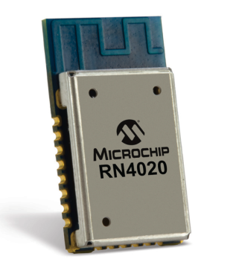We use a btLE module, we forget about after touch effect, we can pair smoothly up to 7 devices but every device is independent.

+no need of a master

+pair and play(probably more familiar to the users)

+more stable

- more expensive

-no hope for after touch

-bigger developing times for the software side

3) Wifi module

We use a wifi module; no need for the master, every device connects to the local router. We can connect a lot of devices in a much more robust protocol.

+robust wireless protocol

+hope for a smoother after touch

+no need of a master

+we can add lots of devices on the same network (up to 250)

-higher latency

-costly

-10 times higher power consumption (need a much bigger battery)

-completely different approach on the software side

Then there are scenarios 1b) and 2b) where we go on a custom board(not a module) and/or a custom firmware. If we go with a custom firmware, we can get rid of the mcu and work with the embedded mcu of either the nrf24 or btle system on the chip. If we are going mass production(>10000 devices) custom board is a must.

+ready for the masses

-big developing times

-certifications and licensing

Price table

|  |  |  |  |  |
| --- | --- | --- | --- | --- |
| A/A | name | Rohs | X1 | X1000 |
| Nrf24 module | Nrf24(china) | no | £1,32 | £0,71 |
| Nrf24 ic | nRF24LE1 with mcu | yes | £3.41 | £2.18 |
| Btle module | BLE112 | yes | £8.98 | £6.52 |
| Btle module | RN4020 | yes | £7.46 | £5.35 |
| Btle ic | nRF51422 with mcu and antenna | yes | £3.38 | £1.69 |
| Wifi module | CC3000 | yes | £19.41 | £12.91 |
| Wifi module | ESP8266 | no | £4,77 | £3,6 |

The main

## 3.2 Bluetooth

### 3.3.1 Bluetooth Classic

### 3.3.2 Bluetooth Smart

**The Bt4 challenge**

**Introduction**

Bluetooth Low Energy (BTLE) known as well as BTSMART or BT4 is a complementary protocol to the Bluetooth 2 and 3(classic BT) specifications. The BT4 specification is based on low power consumption when classic BT on data distribution. In the picture bellow we can see the main differences of the new specification compared to the older one.

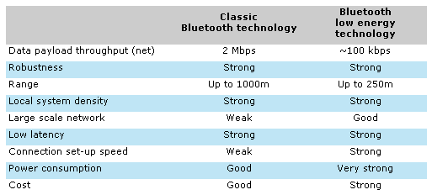

Comparing BT4 over Classic BT:

+lower latency (4ms compared to 10ms)

+fast connection set-up speed

+cheaper modules

+easy to legally market an Apple connected device

+lower power consumption

-slow data throughput

-developing challenges (which we need to discuss)

**Module vs custom solution.**

We use a module solution for the following main reasons:

+No need for certification and licensing.

+No need for pcb Rnd.

+No need for BLE firmware Rnd.

-higher per units costs.

The rule is that if your production is quite higher than 10.000 units you should probably turn to a custom solution.

The problem with

**Developing**

Ble platform support:

* iOS5 + (iOS7+ preferred)
* Android d 4 .3 + (numerous bug fixes in 4.4 +)
* Apple OS X 10.6+
* Windows 8 (XP, Vista and 7 only support Bluetooth 2.1)
* GNU/L inux Vanilla BlueZ 4 .93 +

There are three type of BT devices the Classic which talks with the application with profiles usually SPP(serial port profile) which is considered as a Virtual com device from the host system. The BT Smart (which is a BT4 specification device) and talks to the host system through services according to the data types and finally the smart ready devices which are backward compatible with both specifications and are usually used on the host systems. On the picture below we can see the ozi levels for the three devices.

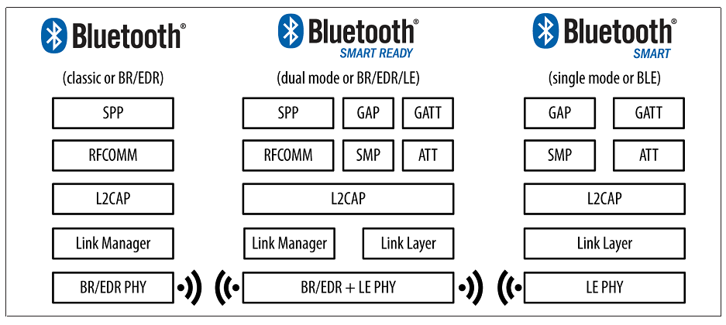

GAP(Generic Access Profile) controls connections and advertising. It is responsible for pairing and determines the way two devices can or can’t interact with each other. In GAP we set the roles (Peripheral and Central) and we can even use broadcasting packets.

In Btle we don’t have a serial profile but a generic profile in which we can create custom services. This is called GATT( Generic Attribute Profile) which defines the way that two Bluetooth LE devices transfer data back and forth using concepts called Services and Characteristics.

GATT uses a generic data protocol called the Attribute Protocol (ATT), which is used to store Services, Characteristics and related data in a simple lookup table using 16-bit IDs for each entry in the table.

GATT comes into play once a dedicated connection is established between two devices which means that comes after GAP and it establishes a connection for one on one communication meaning that one Peripheral can only talk to one Central.

In Gatt the Peripheral device is known as the GATT Server and the Central devise as the GATT Client. All transactions are started by the GATT client which is the Master device(phone/tablet/pc)

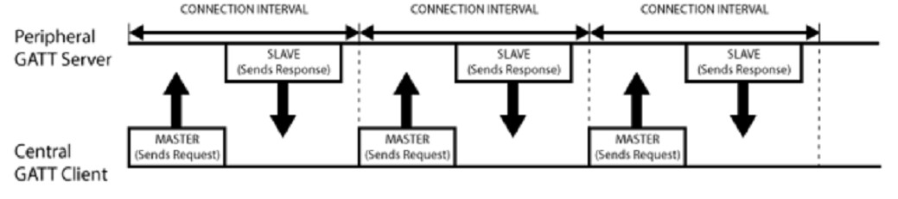

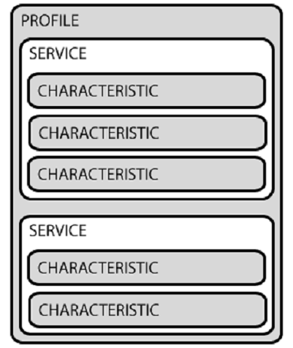

In the picture on the right we see how the GATT transactions in BLE are based on High level, nested objects called Profiles, Services and characteristics:

Profiles doesn’t really exist, they are more like a predefined collection of Services.

Services are used to break data up into logic entities, and contain specific chunks of data called Characteristics.

Characteristics are the lowest level concept in GATT and encapsulates a single data point.

**Modules**

There are two main chipsets the CC2564 from Texas and the nRF8001 from Nordic. Most people prefer to work with the Nordic solution because of the arm architecture of the embedded mcu and the low cost. On the contrary many companies selling certified Btle module solutions usually use the texas ic.

The module solutions usually come in pair with a custom firmware which helps the developer to program the chip with uart AT commands. At the same time most of the times the developer can upload his own firmware as well.

|  |  |  |  |  |  |  |  |  |
| --- | --- | --- | --- | --- | --- | --- | --- | --- |
| name | company | chipset | documentation | Third party tutorials | Data service | application | price | OS |
| RN4020 | Microchip | Microchip | OPEN | NO | MLDP | RN4020demo.apk | 5.63p |  |
| BLE112 | BLUEGIGA | TEXAS | ΟpΕΝ | YES |  | [BLE Android demo App](https://www.bluegiga.com/en-US/download/?file=pfntDAmkS92M2WdPZ4ZUeQ&title=BLE%2520Android%2520demo%2520App%2520%28.apk%2520file%29&filename=Bluegiga.apk) | 7.62p |  |
| [PAN1720](http://na.industrial.panasonic.com/products/wireless-connectivity/bluetooth/bluetooth-smart-low-energy/series/pan1720-series/CS464?reset=1) | Panasonic | texas | Not much | no | ? | Windows demo | 6.43p |  |
| nRF51822 | NORDIC | NORDIC | open | YES | Nrf uart | NRF uart for apk and app | kit |  |
| CC2564 dev board | TEXAS | TEXAS | open | YES | uuid | Sensor tag .apk | kit |  |

Development thus far

I tried the adafruit Low energy module with:

Nexus 7 first edition with android 4.4 but it couldn’t recognize the device(the first edition seems to have a problem with ble compatibility)

Ipad Air with no luck either, because the nrfuart app from nordic is not Air compatible.

Eirinis nexus 7 second edition with android 5.0.1 and although the android could recognize it the Nrf uart 2 app couldn’t.

## 3.4 Radio 24

## 3.5 Wifi

## 3.6 Wireless solutions overall comparison

## 3.7 Module vs custom board solution

# Chapter 4 Hardware development

The nodes reading sensors the different software

4.1 Chapter Introduction

4.2 Prototyping

4.2.1 Choosing the correct prototyping tools: mechanical hardware

4.2.2 Choosing the correct prototyping tools: electronics hardware

4.3 System architecture

4.4 The master

4.5 The nodes

4.5.1 3d sensor

4.5.2 Balance board

4.5.3 Goniometer

4.5.4 Emg

# Chapter 5 Software development

5.1 Software prototyping tools

5.2 Communication between the device and the software

5.3 The labview code

5.4 The matlab code

# Chapter 6 Applications

# Chapter 7 Conclusion

Something changes. It was the Web Age that liberated the bits. Bits are easy to create and as technology advances they travel fast and cheap. This way, with the means of the web anyone can find, create and share information. Although the bits transformed our world

# References

[1] http://en.wikipedia.org/wiki/Big_data

[2] http://en.wikipedia.org/wiki/Center_for_Bits_and_Atoms