FoodPanda Delivery Service

Assignment 2 Documentation

Student(s):

* Laura Nadu

**Group: 30431**

**Contents**

I Project specification 3

II Use-Case model 3

2.1 Users and stakeholders 4

2.2 Package diagram 5

2.3 Class diagram 5

2.4 Database (E-R/Data model) diagram 7

# I Project specification

Implement a delivery service that can incorporate 2 roles: customer and administrator. The customer should be able to order food and see the available options, while the administrator should be able to create new instances of foods and restaurants.

# II Use-Case model

There are two types of users which can access and use the application such as : Restaurant Administrator and Customer.

The Restaurant Administrator should be able to:

* log-in to the application
* add restaurant to the application ( information needed: name, location, available delivery zones)
* select category and add foods for each category
* view menu (with all existing foods, separated into categories)
* accept/decline order
* view orders (with status)
* filter orders by status
* change status of order (in order)

The Customer should be able to:

* register into the application
* log-in into the application
* view restaurants
* view menu for the selected restaurant
* add foods to cart
* place order
* see status of the order
* see history of all orders placed
* search the restaurants by name

## 2.1 Users and stakeholders

Users

* Restaurant Administrator
* Customer

Stakeholders

* Development team
* Quality Assurence
* Product Owner
* Project Manager
* Glovo
* Tazz
* FoodPanda

## 3.2 Package diagram

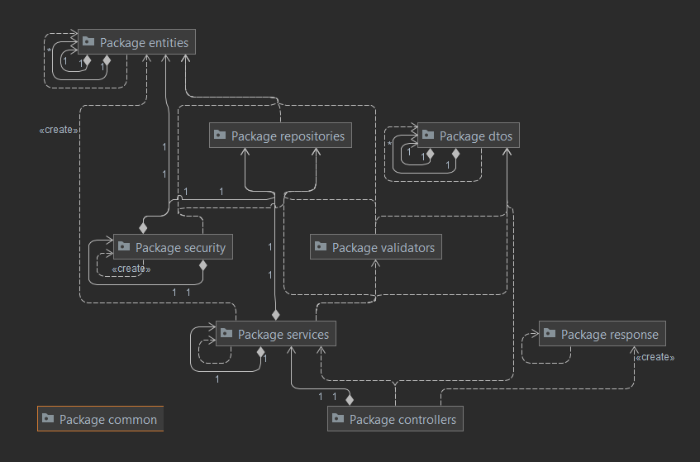

## 3.3 Class diagram

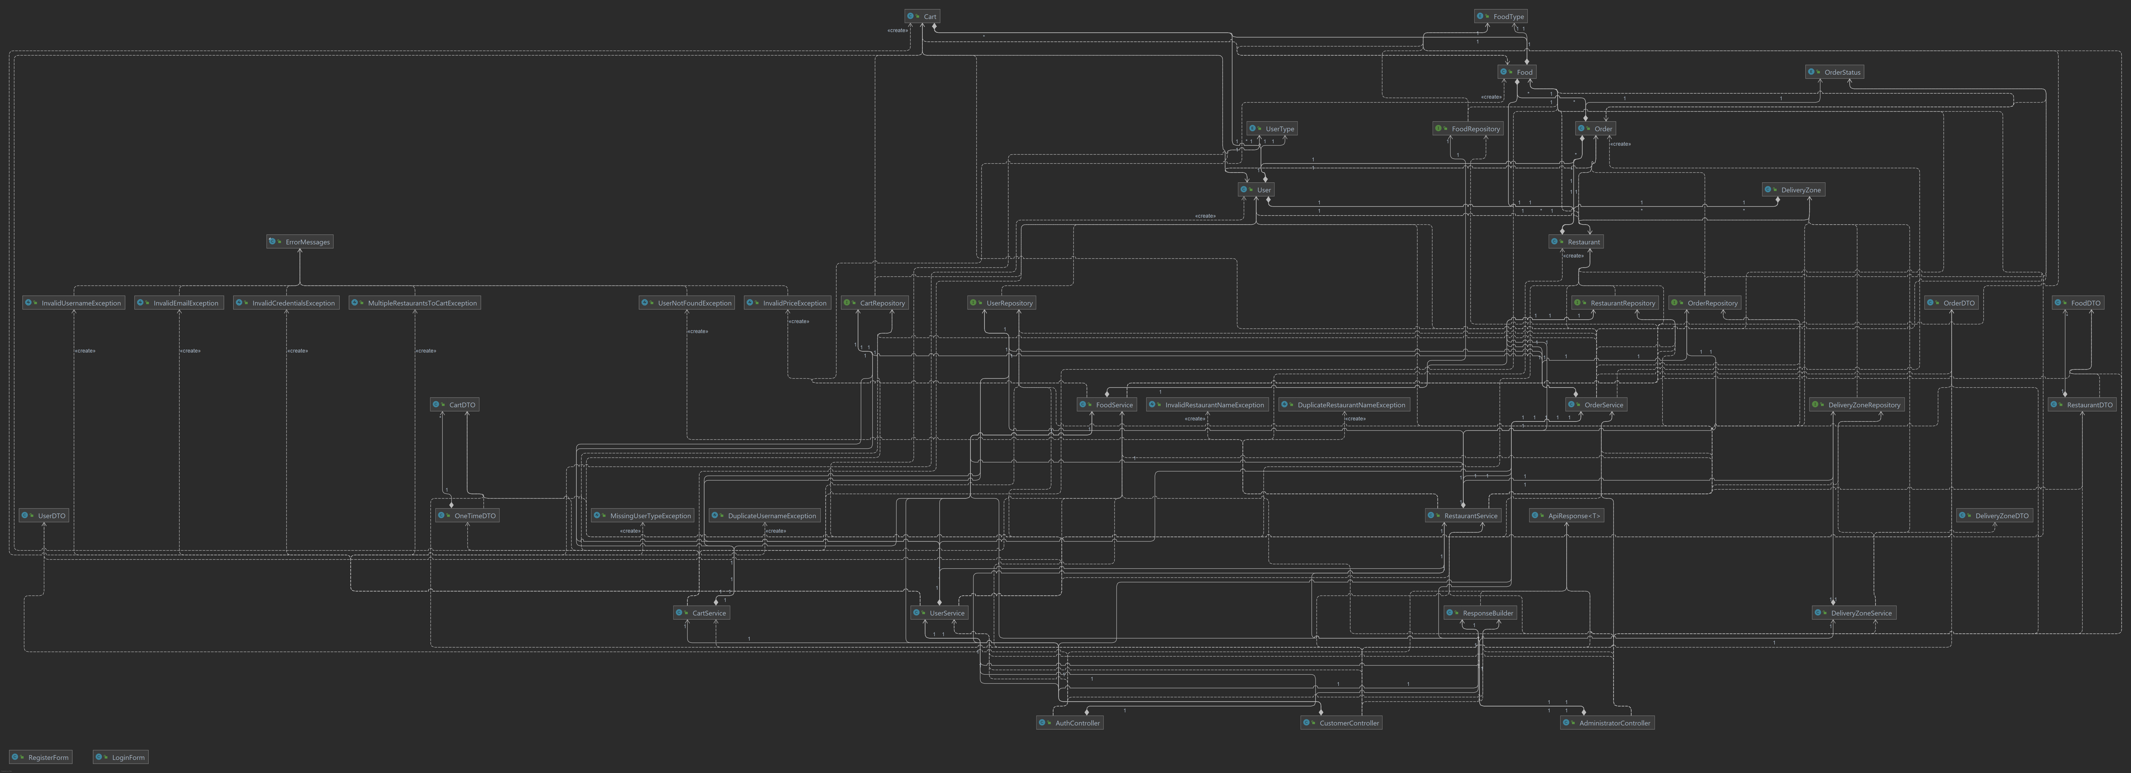

## 3.4 Database (E-R/Data model) diagram

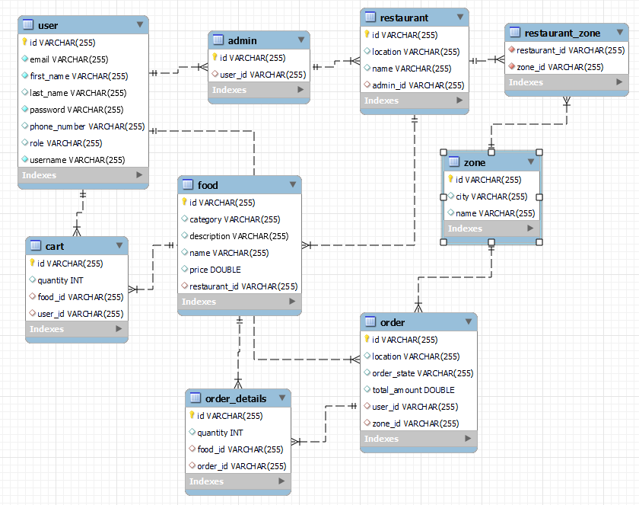

## 

## 3.5 Usecase diagram

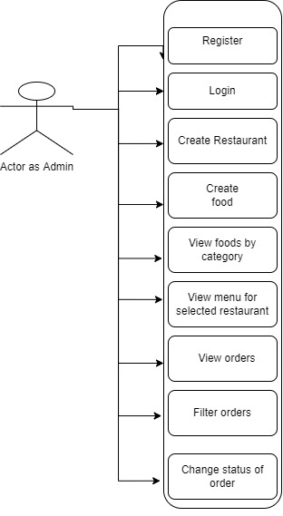

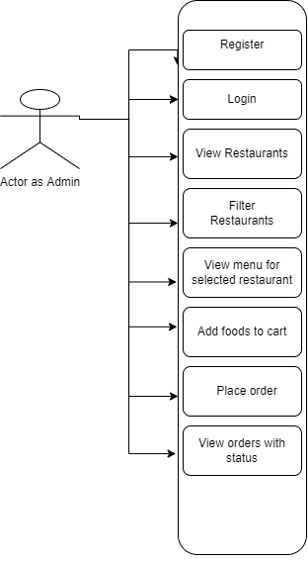

Customer