Photo | Baking Tool / Equipment | Description / Function
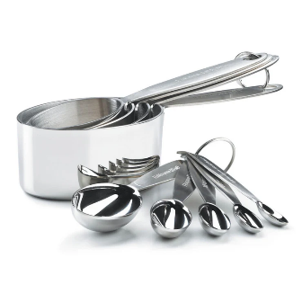 | 1. Measuring Cups and Spoons | Used to measure exact amounts of dry and liquid ingredients. Accurate measurement helps ensure the recipe turns out right.
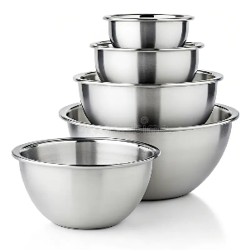 | 2. Mixing Bowls | Containers where ingredients are mixed. Different sizes help separate wet and dry ingredients before combining.
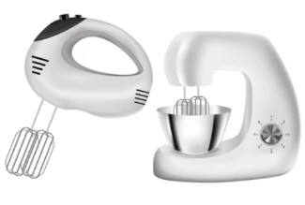 | 3. Hand Mixer or Stand Mixer | Makes mixing faster and more consistent compared to mixing by hand. Ensures batter or dough is smooth and well-combined.
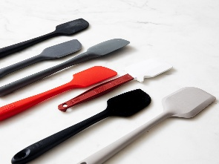 | 4. Rubber Spatula | Ideal for scraping every bit of batter from the bowl and for folding ingredients gently without losing air.
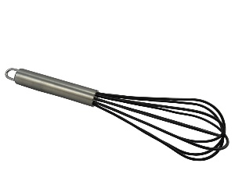 | 5. Whisk | A manual tool for beating eggs, cream, or liquids. It also adds air for a lighter and fluffier texture.
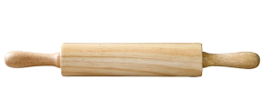 | 6. Rolling Pin | Flattens and shapes dough evenly for cookies, pies, bread, and pastries.
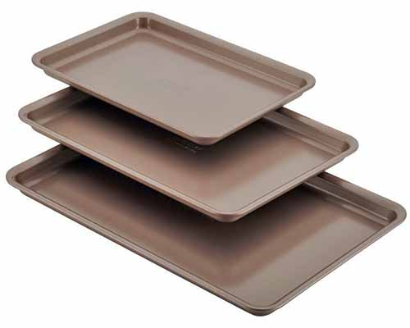 | 7. Baking Sheets and Pans | The trays and molds where dough or batter is placed for baking. Available in different shapes and sizes for various recipes.
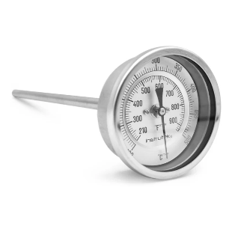 | 8. Oven Thermometer | Ensures the oven temperature is accurate for proper baking results, since oven dials can sometimes be off.
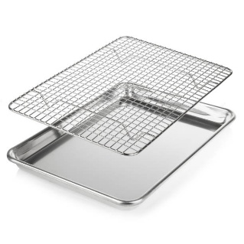 | 9. Cooling Rack | Holds baked goods after baking so air can circulate around them, preventing soggy bottoms.
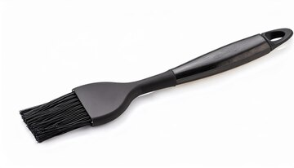 | 10. Pastry Brush | Used to apply egg wash, butter, or glaze on pastries for a shiny and appetizing finish.

