SHINTTOOLS · UNREAL ENGINE 5 · DOCUMENTATION | shint.tools
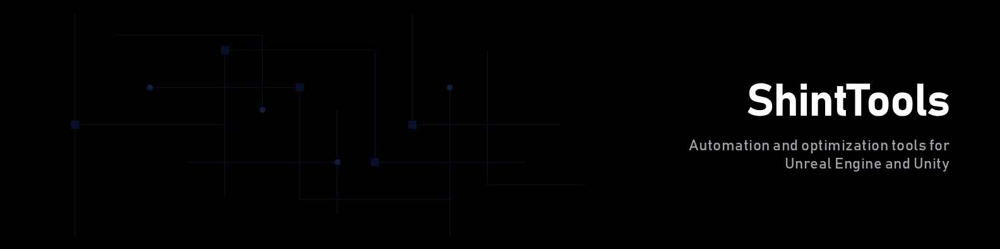
00 — Introduction
ShintTools for Unreal Engine 5
Native editor plugin for Unreal Engine 5.6 that runs the Code Validator, Asset Naming Bot and Quality Score modules entirely on the studio's own hardware. 100% offline. No telemetry. Source code, assets and scan results never leave the machine. ShintTools is under active development, so you may encounter some bugs or issues during use.
⚠ Free license limited to 500 assets per scan and the top 40 code-validator rules.

Contents
Installation 3
Opening the plugin 4
Overview 5
Code Validator 6
Panel actions 6
Issue row anatomy 6
Counters 7
C++ rules — Performance 7
C++ rules — Best Practices 7
C++ rules — Security 7
C++ rules — Maintainability 7
Blueprint rules 7
Asset Naming 9
Recommended prefixes 9
Settings 11
Support 12
01 — Installation

Installation
ShintTools for UE5 requires the following on the workstation:
- Unreal Engine 5.3 or newer (5.6 LTS recommended)
- Docker Desktop (runs the offline Core Engine)
- Python 3.11+ (only used by the installer; not needed at runtime)
- ~1.5 GB free disk for the Core Engine image
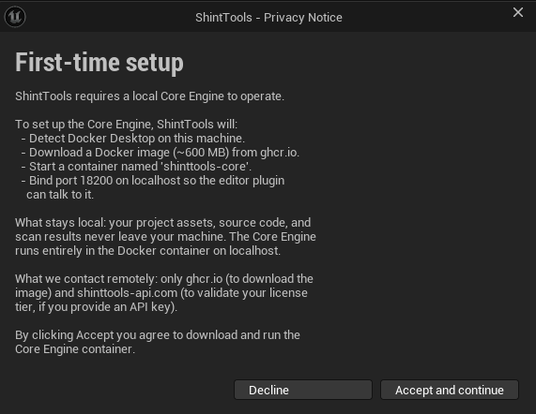
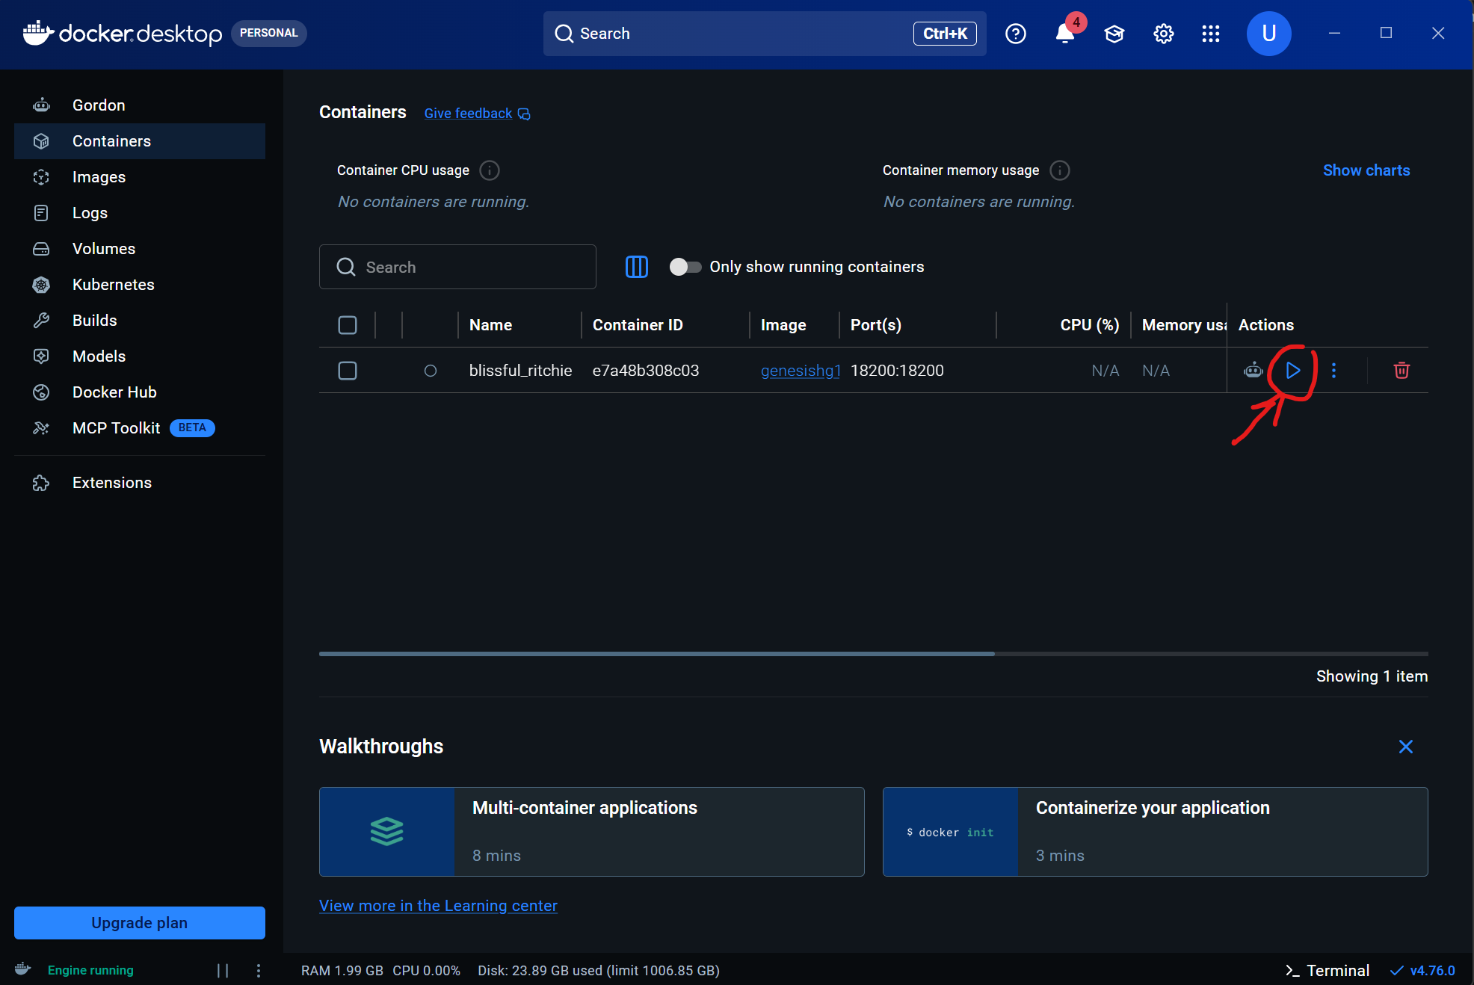
When the plugin loads for the first time the Core Engine wizard appears with a privacy-consent dialog. Click Accept to allow ShintTools to download the Docker image from ghcr.io and start the local AI container on port 18200. Subsequent launches only pull the delta. Docker Desktop must be running.
02 — Window

Opening the plugin
From the Unreal Editor menu bar choose Window > ShintTools, or press Ctrl+Shift+G. A dockable tab opens with a sidebar on the left listing every module:
Sidebar item | What it shows
Overview | Quality dashboard with 4 KPI tiles.
Code Validator | Static analysis for C++ and Blueprints.
Asset Naming | Naming-convention scan for /Game/ assets.
Settings | Paths, exclusions, license keys.
License button | Current tier (Free / Indie) — clicks open shint.tools.
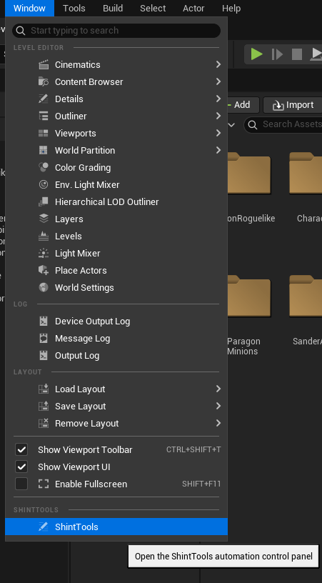  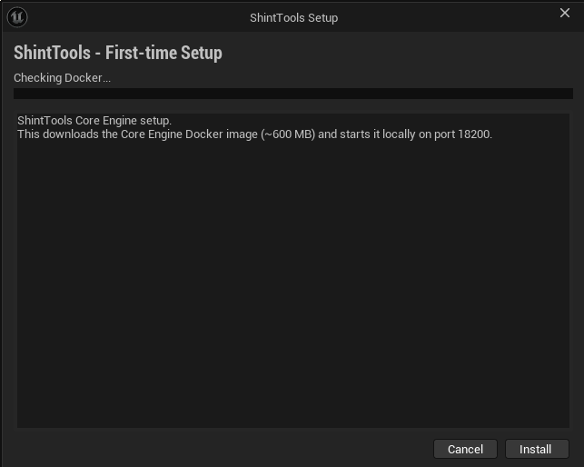  Connection indicator | Green when the local Core Engine answers /health.
03 — Overview

Overview
The Overview tab aggregates the most recent code + asset scan into four KPI tiles that the rest of the panel updates automatically.
Tile | Reading
Quality Score | Overall project score (0–100). Colour-coded green / orange / red.
Total Issues | Code issues + asset naming violations combined.
Errors | Count of error-severity code findings (warnings excluded).
Files Scanned | Total files analysed across both modules.

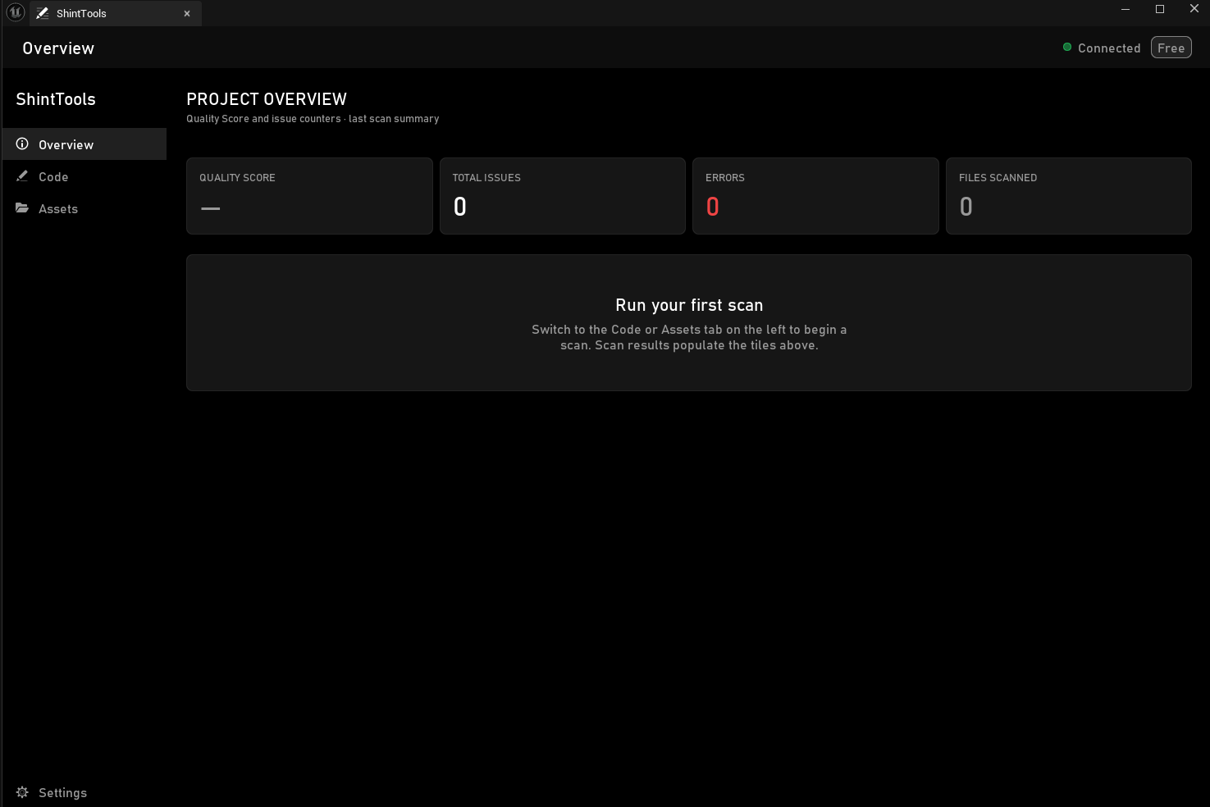
Run any scan from the Code or Asset tabs to populate the tiles. The Quality Score includes a five-bucket breakdown — Performance, Security, Best Practices, Maintainability and Naming — that the Code Validator tab renders inline.
04 — Code Validator

Code Validator
The Code Validator scans C++ source under your project's Source/ folder and every Blueprint asset under /Game/. Results land in a filterable list with severity badges, fix previews and a per-row LLM Explain entry point (Indie tier).

Panel actions
Button | Effect
Scan Project | Recursive analysis of Source/ via the local Core Engine.
Scan Blueprints | Asset-Registry-driven scan of every /Game/ Blueprint.
Apply Fixes | Apply selected tree-sitter + BP fixes in one batch.
Explain | Open the per-issue LLM modal (Indie tier).
Send to Dashboard | Upload the scan result to shint.tools (Indie tier).
Export | Save the results list as JSON.
Select All | Tick every issue in the visible filter.
Deselect All | Untick every issue.
Filter dropdown | Filter by severity, category, file type or rule.

Issue row anatomy
Element | Meaning
Severity badge | Info / Warning / Error pill on the left.
Rule name | Human-readable label parsed from the rule docstring.
Message | What the rule found in this file.
File path | Click to reveal in the Content Browser or open in IDE.
Before / After | Diff preview for tree-sitter fixes (auto-fixable rules).
Fix button | Apply the suggested fix on disk + recompile.
Preview button | Show the diff without writing.
Explain button | Open the LLM explainer dialog (Indie tier only).

Counters
Counter | Source
Files | Total files scanned in the last run.
Errors | Number of error-severity issues.
Warnings | Number of warning-severity issues.
Score | Project Quality Score (0–100).

C++ rules — Performance
- TickComponent overuse — actors with empty Tick + bCanEverTick=true
- GetWorld() in tight loops
- String concatenation in BeginPlay
- TArray::Add in render path
- Heavy logging in shipping builds

C++ rules — Best Practices
- Missing override keyword on virtual
- UFUNCTION/UPROPERTY missing required specifier
- Empty function body
- TODO / FIXME left in shipping code
- Unused #include

C++ rules — Security
- Hardcoded credentials in source
- Unchecked Cast<>
- Raw new without matching delete
- Buffer overflow risk (strcpy, sprintf)
- Insecure HTTP (http:// instead of https://)

C++ rules — Maintainability
- Long methods (>100 lines)
- High cyclomatic complexity
- Deep nesting (>4 levels)
- Long file (>800 lines)
- Public field on UObject without UPROPERTY

Blueprint rules
- BPP001 — empty Tick on bCanEverTick=true actor
- BPM001 — variable declared but never used
- BPM002 — orphan disconnected node
- BPB001 — Blueprint name does not follow convention
- BPB007 — public variable with no Category
- BPB003 — missing Super::BeginPlay call
- BPP004 — Cast<> chain longer than two hops
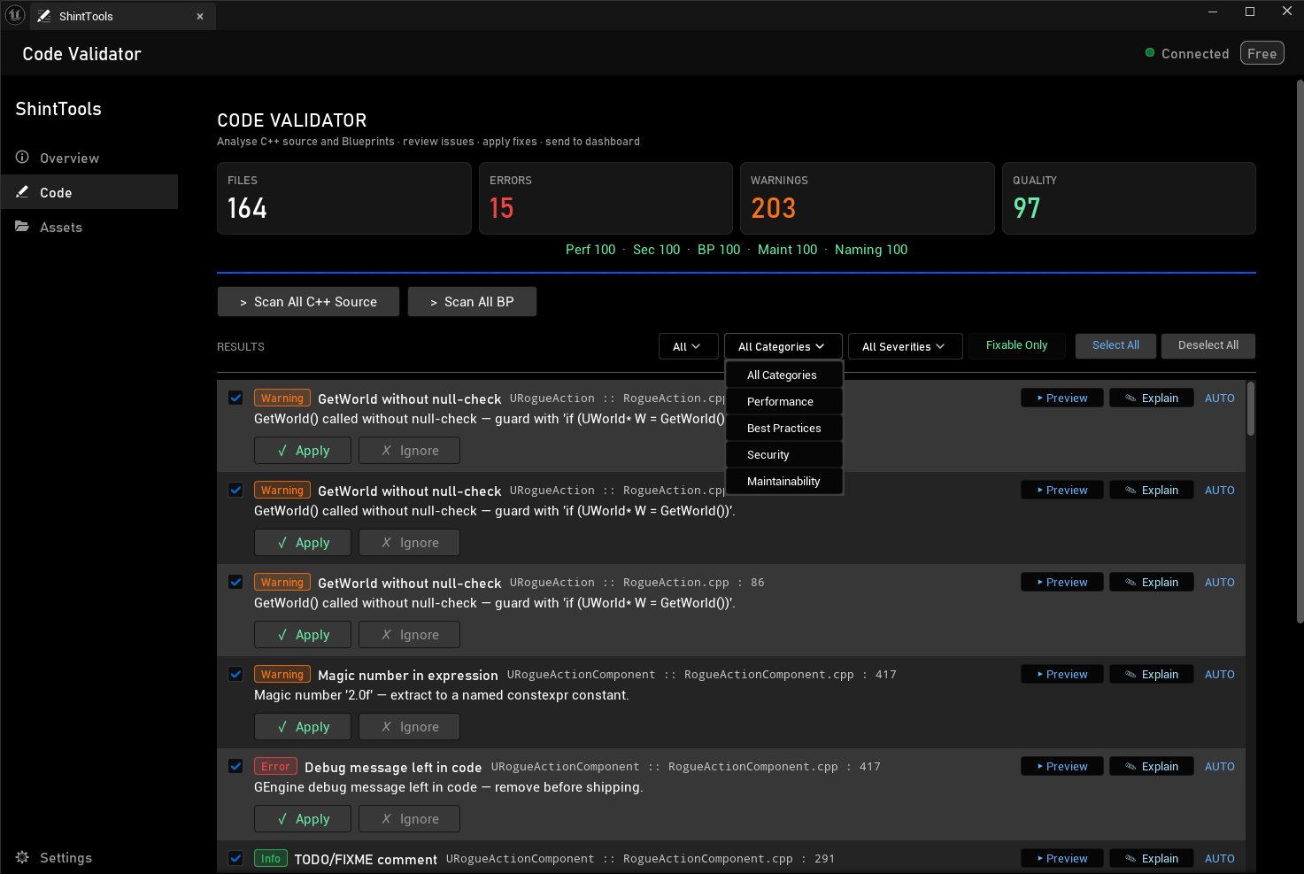
Auto-fixes for BPP001, BPM001, BPM002 and BPB007 apply inside the editor and recompile each affected Blueprint once at the end of the batch. ControlRigBlueprints are skipped automatically because their graph wiring is non-standard.
05 — Asset Naming

Asset Naming
Asset Naming scans every asset under /Game/ via the Asset Registry and flags names that do not follow the project's convention. Auto-rename uses IAssetTools::RenameAssets so all references (soft, hard and CoreRedirects) are kept in sync. Renames trigger a child-Blueprint recompile pass and an auto-save of the touched packages.

Recommended prefixes
Asset type | Prefix
Blueprint | BP_
Widget Blueprint | WBP_
Texture2D | T_
Material | M_
Material Instance | MI_
Material Function | MF_
Static Mesh | SM_
Skeletal Mesh | SK_
Animation Sequence | AS_
Animation Blueprint | ABP_
Animation Montage | AM_
Blend Space | BS_
Sound Wave | SW_
Sound Cue | SC_
Niagara System | FX_
Particle System (legacy) | PS_
Level / Map | L_
Data Table | DT_
Data Asset | DA_
Curve | C_
Camera Shake | CS_
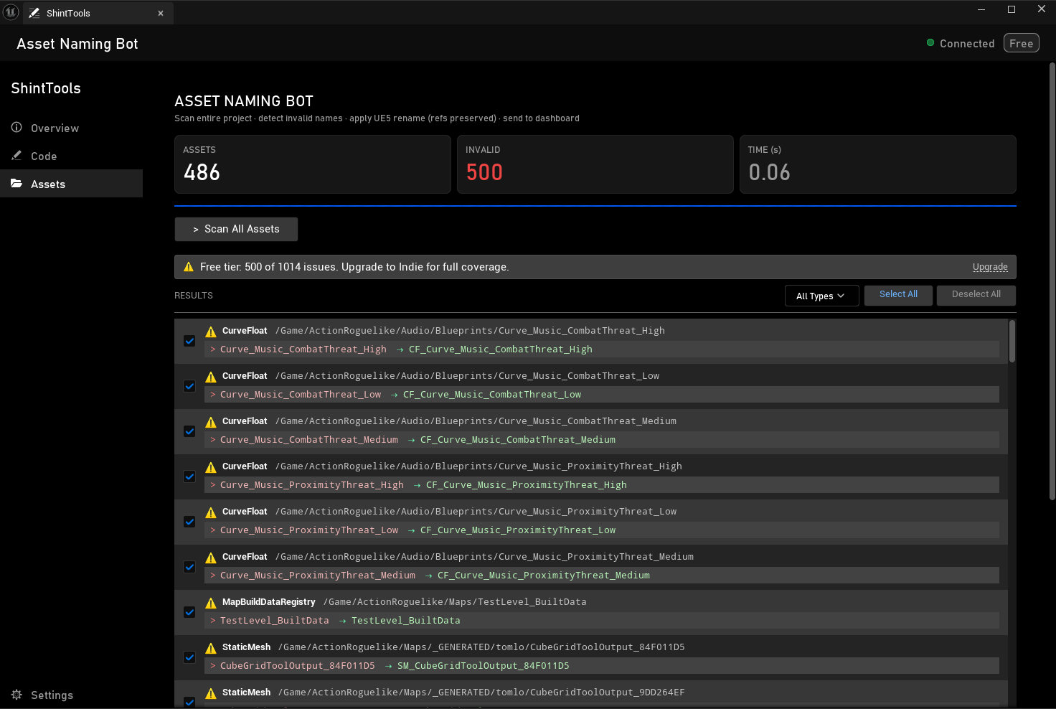  Physical Material | PM_
06 — Settings

Settings
The Settings tab persists into shinttools.config.json at the project root.
Field | Purpose
Core Engine port | Local port the AI listens on. Default 18200.
API Key | License key for Indie features (api_key_mongo).
Dashboard API Key | Per-project Bearer for shint.tools uploads.
Excluded Paths | Folders the validators skip during scans.
Export Path | Default folder for JSON exports.
Where the config lives
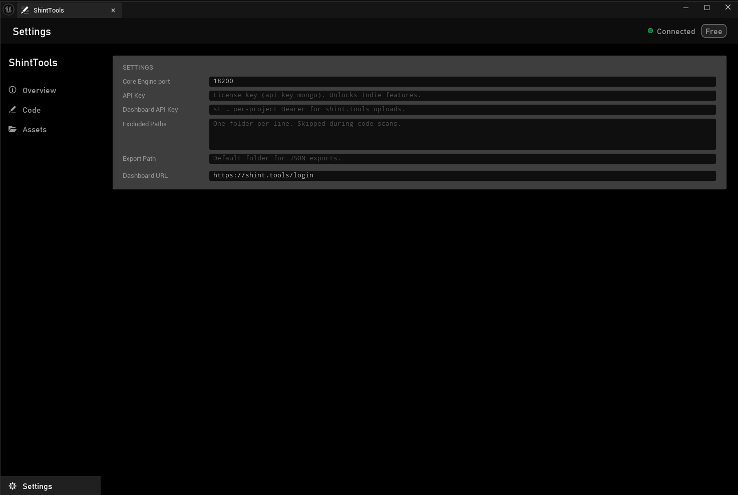
Path: <YourProject>/shinttools.config.json. Safe to commit to version control — no secrets are written there by default; the API keys are local user settings entered through the panel.
07 — Support

Support
Bug reports, feature requests and licence administration:
- Email: support@shint.tools
- Dashboard: https://shint.tools/login
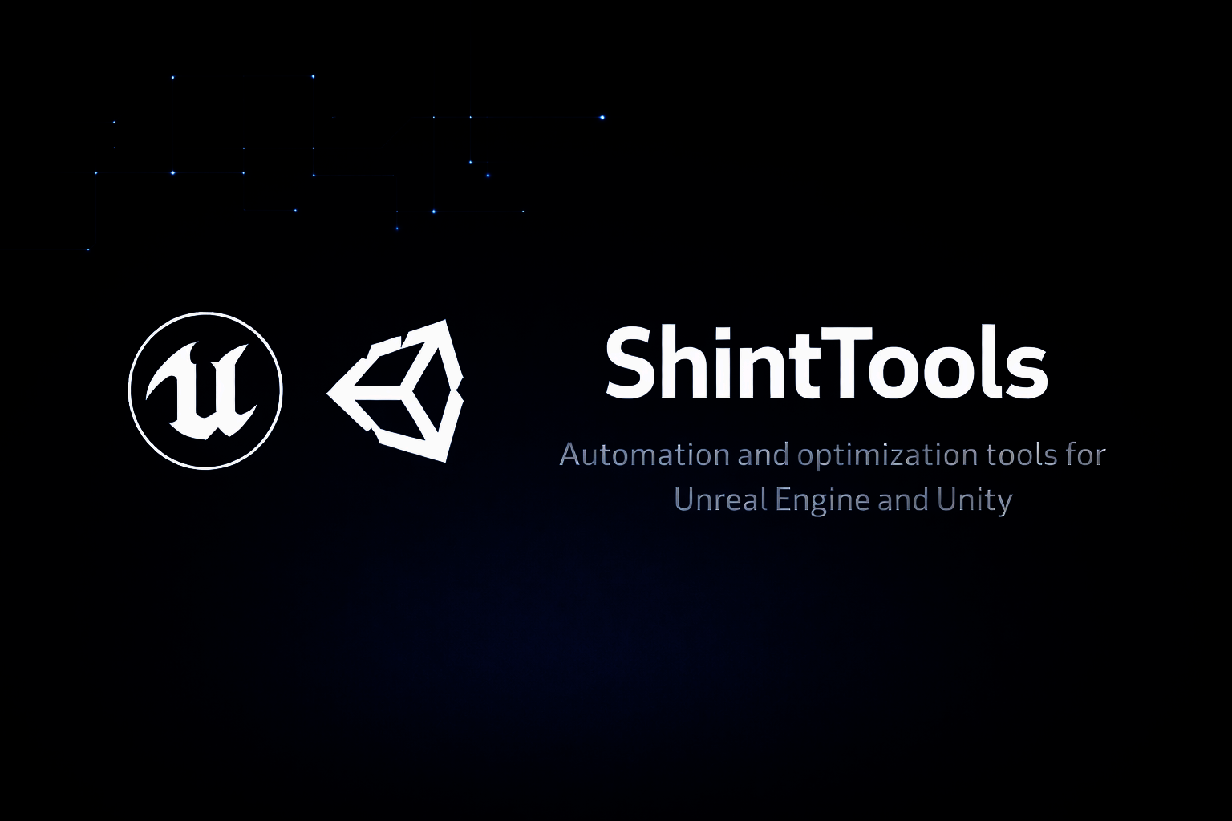
If you find ShintTools useful, please leave a review on the Fab marketplace — feedback drives the roadmap.

