Name: **ALIMAN, EVE SETH E.**

# Section: BSCPE4-01 Schedule:

Class number:

Date:

**Laboratory title: AMPLITUDE MODULATION (AM) SIGNAL Learning Targets:**

1. To create the amplitude modulation (AM) signals using the mathematical equations.
2. To view the AM wave in the time domain using the plot function and frequency domain using the fast Fourier transform (FFT) function.

## INTRODUCTION

In amplitude modulation (AM), the information signal varies the amplitude of the carrier sine wave. The instantaneous value of the carrier amplitude changes in accordance with the amplitude and frequency variations of the modulating signal.

The carrier signal is a (single) high frequency sine wave. It uses the subscript ‘c’ to denote that it is the carrier component for voltage and frequency. The equation for the instantaneous value of the carrier signal appears below:



The modulating signal or intelligence signal contains the information to be transmitted. It uses the subscript ‘m’ to denote that it is the carrier component for voltage and frequency. The equation for the instantaneous value of the modulating signal appears below:



The instantaneous value of the complete modulated wave vam:



For undistorted AM to occur, the modulating signal voltage Vm must be less than the carrier voltage Vc. Therefore, the relationship between the amplitude of the modulating signal and the amplitude of the carrier signal is important. This relationship, known as the modulation index, m, is the ratio below.



## PRE-LAB QUESTIONS

What particular functions in the Fourier transform are needed for the AM signal?

In the Fourier Transform of an AM signal, the key functions are the carrier and sidebands. The transform shows how the original message signal shifts in frequency, creating upper and lower sidebands around the carrier frequency. These sidebands represent the actual information being transmitted in the AM signal.

Name:

# Section: Schedule:

1. **MATERIALS/INSTRUMENTS**

# Class number:

Date:

Computer with MATLAB or Octave pre-installed. The Signal Toolbox (MATLAB) or Signal PKG (Octave) should also be installed. For students who have no computers/laptops at home but can access the internet using cellular phones, they may use the online versions for MATLAB or Octave (requires email registration).

## PROCEDURES

* 1. Type the code found at the end of the module in the MATLAB/Octave editor.
  2. Save the file as ‘expt6_amsignal’.
  3. Run the program.
  4. Take note of MATLAB/Octave errors especially due to spelling errors. If you are unable to resolve the error message(s), ask you instructor for help.

## COMPUTATIONS

Write the AM voltage equation for a 10 V, 5 KHz carrier with a modulation index of 0.5 and a 500 Hz modulating signal.

vam(t)= 10(1+0.5sin(2*pi(500)t))sin(2*pi(5000)t)

Name:

# Section: Schedule:

Class number:

Date:

1. **OBSERVATIONS/OUTPUTS**

For F2F lab activities, the students should show their MATLAB/Octave output screen to the faculty. Draw and label the output signals as seen in the figures.

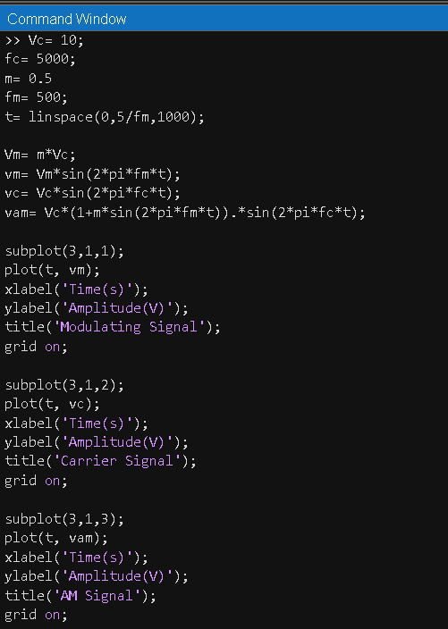

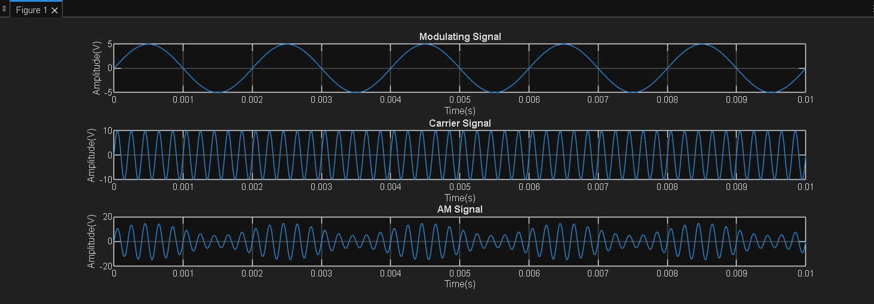

As a FLEX activity, the student will be required to upload the image files of their output.

Name:

# Section: Schedule:

1. **CONCLUSIONS**

# Class number:

Date:

In this experiment, we successfully generated and observed an Amplitude Modulated (AM) signal using MATLAB or Octave. The activity showed how the amplitude of the carrier wave changes according to the modulating signal, forming upper and lower sidebands that carry the actual information. Through the Fourier Transform, we were able to see how the signal’s frequency components are distributed, which helped us better understand how AM transmits data in the frequency domain.

## POST LAB QUESTIONS

Modify the program by changing the values below and take note of the changes in the outputs in the AM wave and AM signal spectrum.

1. Change the value of variable ‘m’ from 0.5 to 1.

|  |  |
| --- | --- |
|  |  |

1. Change the value of variable ‘m’ from 1 to 1.5.

|  |  |
| --- | --- |
|  |  |