１学年２学期　期末考査　数学　**予測問題**

|  |  |  |  |  |  |  |  |  |  |  |  |  |  |  |  |  |  |  |  |  |  |  |  |  |  |  |  |  |  |  |  |  |  |
| --- | --- | --- | --- | --- | --- | --- | --- | --- | --- | --- | --- | --- | --- | --- | --- | --- | --- | --- | --- | --- | --- | --- | --- | --- | --- | --- | --- | --- | --- | --- | --- | --- | --- |
| 1 | (1) |  | | (2) | | |  | | | | | | (3) | |  | | | | (4) | | | | |  | | | | | | (5) | | |  |
| (6) |  | | (7) | | |  | | | | | | (8) | |  | | | | (9) | | | | |  | | | | | | (10) | | |  |
| 2 | (1) |  | | | | | | | | (2) | | |  | | | | | | | | | (3) | | | |  | | | | | | | |
| 3 | (1) |  | | | | | | | | | | | | | | (2) | | | |  | | | | | | | | | | | | | |
| 4 |  | | | | | | | | | | | | | | | | | | | | | | | | | | | | | | | | |
| 5 | (1) |  | | | | (2) | | |  | | | | | | | | (3) | | | |  | | | | | | | (4) | | | |  | |
| (5) |  | | | | (6) | | |  | | | | | | | | (7) | | | |  | | | | | | | (8) | | | |  | |
| 6 | (1) |  | | | | (2) | | |  | | | | | | | | (3) | | | |  | | | | | | | (4) | | | |  | |
| ７ | (1) |  | | | | | | | | | | (2) | |  | | | | | | | | | (3) | | | |  | | | | | | |
| 8 | ㋐ |  | | | 比例定数 | | | | | |  | | | | | | | ㋑ | | |  | | | | 比例定数 | | | | | |  | | |
| ㋒ |  | | | 比例定数 | | | | | |  | | | | | | | ㋓ | | |  | | | | 比例定数 | | | | | |  | | |
| 9 | 裏面に記載 | | | | | | | | | | | | | | | | | | | | | | | | | | | | | | | | |
| 10 | (1) | 裏面に記載 | | | | | | | | | | | | | | | | | | | | | | | | | | | | | | | |
| (2) | ㋐ |  | | | | | 反比例するかしないか | | | | |  | | | ㋑ | | |  | | | | | | | | | | 反比例するかしないか | | | |  |
| ㋒ |  | | | | | 反比例するかしないか | | | | |  | | | ㋓ | | |  | | | | | | | | | | 反比例するかしないか | | | |  |
| (3) | ㋐ |  | | | | | | | | | | | | | ㋑ | | |  | | | | | | | | | | | | | | |
| ㋒ |  | | | | | | | | | | | | | ㋓ | | |  | | | | | | | | | | | | | | |
| (4) |  | | | | | | | | | | | | | | | | | | | | | | | | | | | | | | | |

　　　　　　組　　　　　番号　　名前

|  |  |  |  |
| --- | --- | --- | --- |
| 知・技 |  | 思・判・表 |  |
| 得点 |  | | |

図1

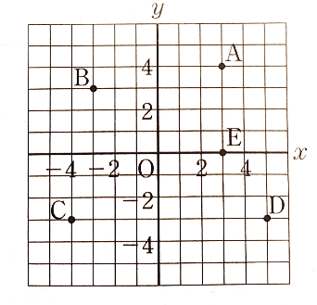

|  |  |  |  |  |  |  |
| --- | --- | --- | --- | --- | --- | --- |
| 9 | A |  | B |  | C |  |
| D |  | E |  |

図2

