令和５年度　１学年３学期　学年末考査　数学　**予測問題**解答用紙

|  |  |  |  |  |  |  |  |  |  |  |  |  |  |  |  |  |  |  |  |  |  |
| --- | --- | --- | --- | --- | --- | --- | --- | --- | --- | --- | --- | --- | --- | --- | --- | --- | --- | --- | --- | --- | --- |
| 1 | (1) |  | | | (2) | |  | | | | | (3) | |  | | | | | (4) | |  |
| (5) |  | | | (6) | |  | | | | | (7) | |  | | | | | (8) | |  |
| 2 | (1) |  | | | | | | (2)① | | |  | | | | | | (2)② | | |  | |
| 3 | (1) |  | | | | | | (2) | |  | | | | | | | (3) |  | | | |
| 4 | (1)  (2)  (3) | C:\Users\e172770\AppData\Local\Packages\Microsoft.Windows.Photos_8wekyb3d8bbwe\TempState\ShareServiceTempFolder\図3.jpeg | | | | | | | | | | | | | | | | | | | |
| 5 | (1)① | | 弧の長さ　　　　　　　　　面積 | | | | | | | | | (1)② | | | | 弧の長さ　　　　　　　　　面積 | | | | | |
| (2)① | | 周りの長さ　　　　　　　　　面積 | | | | | | | | | (2)② | | | | 周りの長さ　　　　　　　　　面積 | | | | | |
| 6 | (1) |  | | | | | | (2) | |  | | | | | | | (3) |  | | | |
| 7 | (1) | ① | |  | | | | ② | |  | | | | | | | ③ |  | | | |
| (2) | ① | |  | | | | | | | | | ② | |  | | | | | | |
| 8 | (1) | ① | |  | | | | ② | |  | | | | | | | ③ |  | | | |
| ④ | |  | | | | ⑤ | |  | | | | | | | ⑥ |  | | | |
| (2) | ① | |  | | ② | | |  | | | | ③ | |  | | | | ④ | |  |
| (3) | ① | |  | | ② | | |  | | | | ③ | |  | | | | ④ | |  |
| 9 | (1) |  | | | | | | | | | | (2) | |  | | | | | | | |

裏面にも問題があります

|  |  |  |  |  |  |  |
| --- | --- | --- | --- | --- | --- | --- |
| 点 | 知技 |  | 思判表 |  | 合計 |  |

　　　　　　組　　　　　　番　名前

大問10作図問題

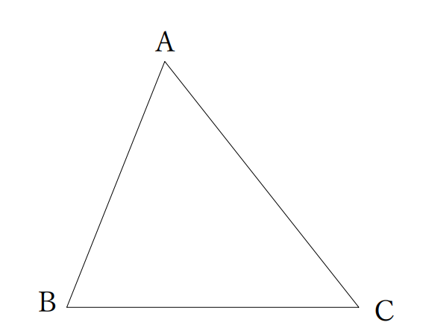(1)

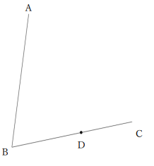(2)